We have to build the QT application named Larynx which work in Raspberry Pi 3B. application should record the camera frames into mp4 file when user touch the "record" button in Touch LCD or press "record" keyboard in outer box. And user should be able to select recorded files by touching the "up", "down" buttons in the Touch LCD or press "up", "down" keyboards in the outer box. And user should be able to playCallSound, pause, stop the recorded video by touching the "play", "pause", "stop" buttons in the Touch LCD or press "play", "pause", "stop" keyboards. - to display the camera frames from USB CameraCapturerConfiguration, I think we have to use opencv. - To save the recorded files into mp4 fileMapCacheDirectory, we have to use corresponded library for it. - To make all it work with the Keyboard, we have to use some IO ports for the keyboards. - To display the UI in 3.5-inch Touch (or no touch) LCD like MPI3508, we have to use the corresponded LCD driver for it. - Write the specification for this project into a md file. - So, build the QT project which include all the featureFlags, so I can build it on omy local easily and port it into the simple Raspberry PI 3B board (not Raspberry Pi 3B+). When build the QT projectRoot, organize the ClipPath, header files to domain DeviceOrientationEvent, And include all the libraries such as opencv etc. And include all the make files and project files and test all the features after write the code.

Larynx — Qt application for Raspberry Pi 3B
The project should use a native Qt/C++ application with a camera preview, MP4 recording, video playback, and dual control through the touchscreen and physical buttons. I'll structure it as a portable Qt project that you can develop on your local computer and then cross-build or compile on the original Raspberry Pi 3B.

1. Proposed technical specification
Component | Proposed implementation
Application | Larynx, C++ with Qt 5
Build system | qmake and Makefiles
Camera preview | OpenCV with USB/V4L2 camera capture
MP4 recording | OpenCV VideoWriter using FFmpeg or GStreamer backend
Video playback | Qt Multimedia, with a GStreamer-backed option
Touchscreen UI | Qt Widgets, adaptable to 480 × 320
Physical buttons | Linux GPIO inputs, with configurable pin assignments
LCD driver | Raspberry Pi OS driver appropriate to the exact MPI3508 display revision
Video storage | Configurable directory, with unique filenames
Testing | Unit tests for controls and recording logic, plus hardware integration tests
Important distinction: OpenCV can capture and display camera frames, but MP4 recording also depends on the installed video codec and backend. Similarly, a touchscreen driver and physical GPIO buttons are separate hardware concerns. The project will isolate these behind configurable components so the UI does not depend directly on the hardware.

2. Project files

Larynx Qt project
C++ · Qt Widgets · OpenCV · qmake
Includes source code, project file, configuration example, documentation, and test checklist.
Download the complete Larynx project ZIP
Project specification
Functional requirements, hardware integration, build instructions, risks, and acceptance criteria.
Download SPECIFICATION.md
README and build guide
Dependencies, keyboard controls, storage settings, and deployment instructions.
Open README.md

3. Source tree
Larynx/
├── Larynx.pro
├── README.md
├── SPECIFICATION.md
├── src/
│ ├── main.cpp
│ └── mainwindow.cpp
├── include/
│ └── mainwindow.h
├── config/
│ └── larynx.ini.example
├── scripts/
│ └── install-deps-pi.sh
└── tests/
└── manual-acceptance.md
The application implements the camera preview, recording, file selection, playback, pause/resume, stop, and keyboard handlers. Static project checks passed, including verification of the required files and control handlers.

4. Build on your local computer
Install Qt 5, a compatible C++ compiler, qmake, and OpenCV development libraries first.
For Ubuntu or Raspberry Pi OS:
sudo apt update
sudo apt install -y \
build-essential \
qtbase5-dev \
qt5-qmake \
libopencv-dev

cd Larynx
qmake Larynx.pro
make -j2
./Larynx
The original Raspberry Pi 3 Model B has a 1 GB RAM limit, so building with -j2 is a sensible starting point.

Raspberry Pi
Testing limitation: I could not compile the application in this environment because qmake is not installed. The project has not yet been validated on a physical Raspberry Pi, camera, or LCD.

5. Hardware decisions before deployment
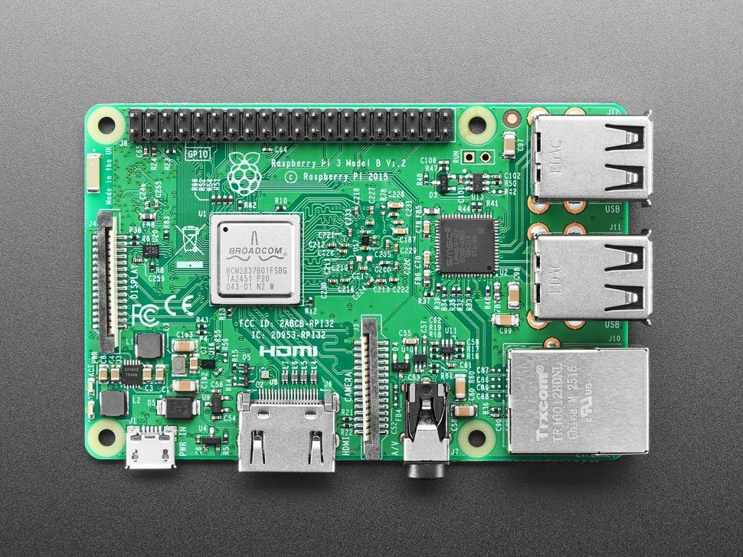
Raspberry Pi 3 Model B
Use the original Model B target and its USB 2.0 ports for the camera. Build against libraries compatible with the Raspberry Pi OS installed on the board.
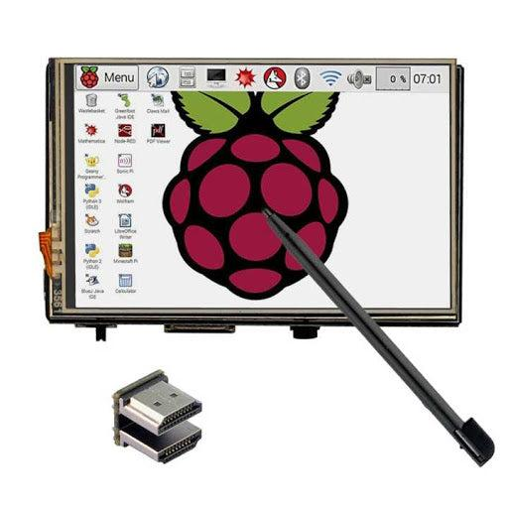
MPI3508 display
Confirm the exact display model and revision. Raspberry Pi 3.5-inch LCDs can use SPI display and touch controllers with specific kernel drivers, so the correct driver must be installed separately from the Qt application. See the Waveshare display documentation.

Waveshare Wiki
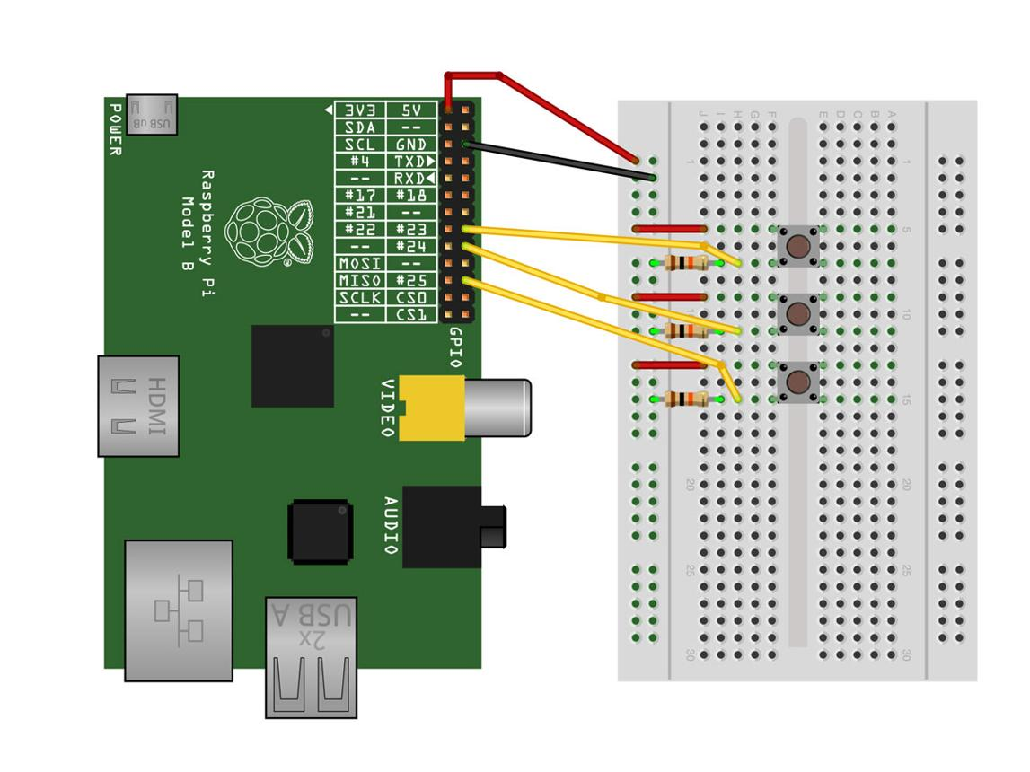
Physical buttons
The application uses keyboard events. Configure GPIO buttons through Linux gpio-keys or an equivalent driver to generate the mapped key events. This avoids hard-coding GPIO assignments before the enclosure wiring is finalized.
One important improvement before production is to verify the MP4 encoding pipeline on the actual Pi. The current code uses OpenCV's VideoWriter; successful MP4 recording depends on the installed codec backend. The supplied acceptance checklist includes checks for recording, playback, physical buttons, and long-running operation.
One question that will help me finalize the hardware-specific configuration: Is your LCD the Waveshare MPI3508 / 3.5-inch SPI model, or a different manufacturer's display with the MPI3508 designation?

