**NAME**:BASMA AHMED SABER MOHAMED

**B.N**:11

**SECTION**:11

**DATE**:8/6/2021

**WEB BAGES LINKS**: First Web page about exambles on { IOT }  
secound Web page about Table of abbreviations for [ IOT ]  
third Web page about Criticism,Problems&Controversies  
forth Web page about { Links I used }

**TOPIC**:INTER NET OF THINGS

**APPLICATION PRIEF**:……..

**What is Internet of Things (IoT) and how can it help your business?**

IoT enables your organization to analyze and act on data, allowing you to make smart decisions in real-time. With the timely and relevant insights about your business and customers that come with these new sources of data, there's great potential for industries of all kinds—including manufacturing, transportation, energy, agriculture, retail, and government—to operate more efficiently and provide new value to customers by implementing the right IoT solution.

## What is the Internet of Things used for?

In short, IoT lets you solve your business problems using your own data. The Internet of Things isn't just about connected devices—it's about the information those devices collect and the powerful, immediate insights that can be garnered from that information. These insights can be used to transform your business and lower costs through improvements like reduction of wasted materials, streamlined operational and mechanical processes, or expansion into new lines of business that are only made possible with reliable real-time data. Create a real competitive advantage by using IoT to turn your data into insights and turn those insights into action.

SCREENSHOTS: 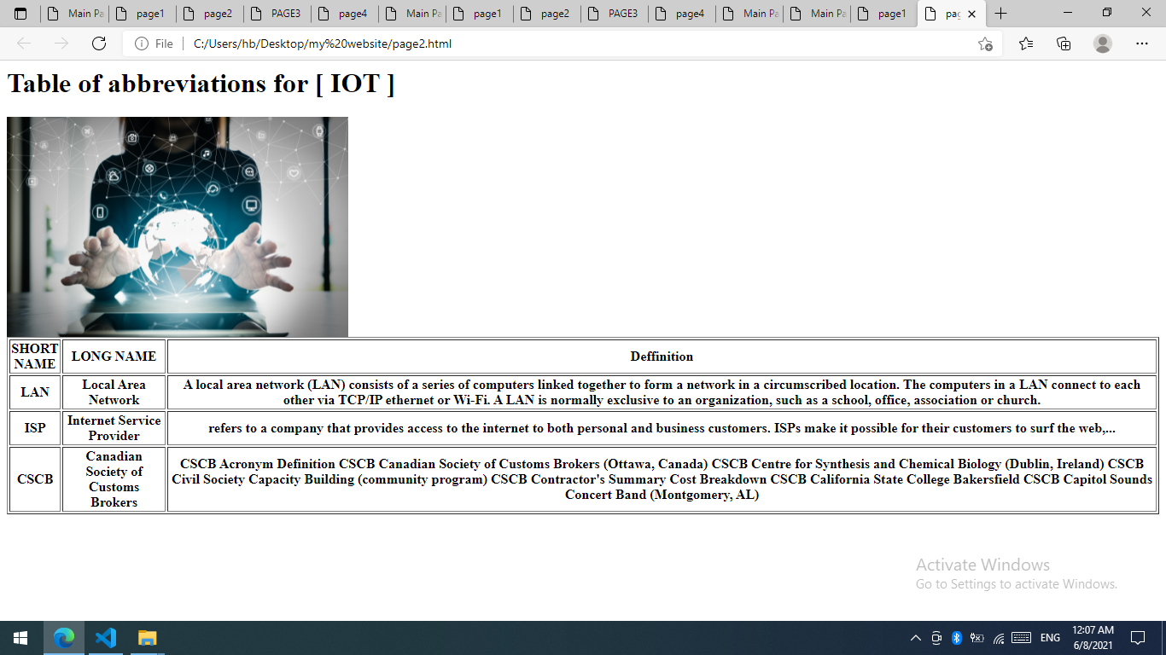

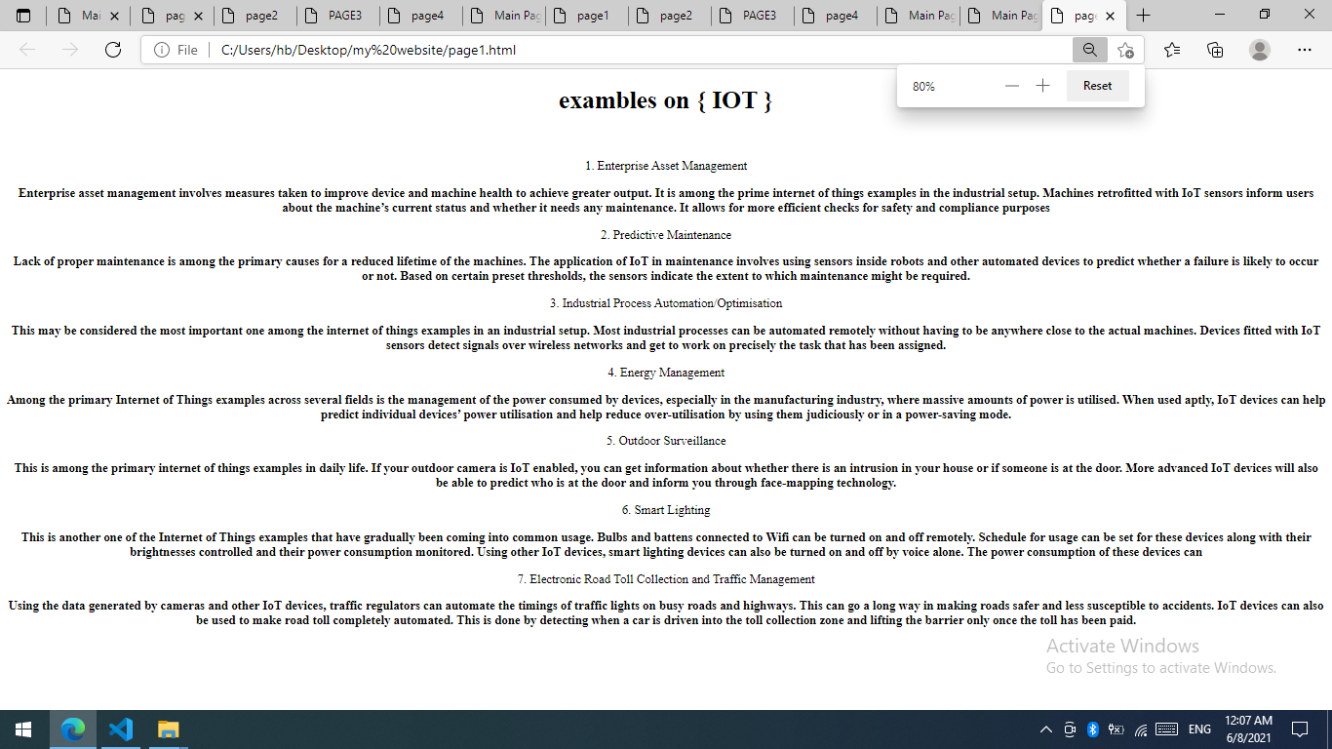

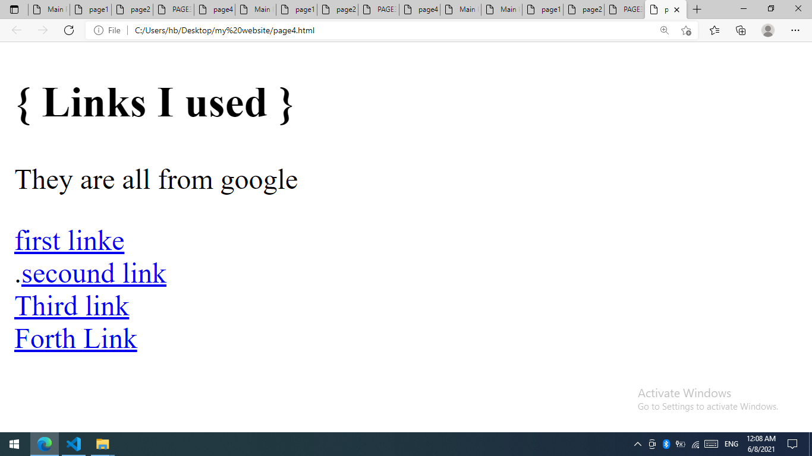SS

