Drag-based Velocity Estimator

– ‘dragspeed’ module –

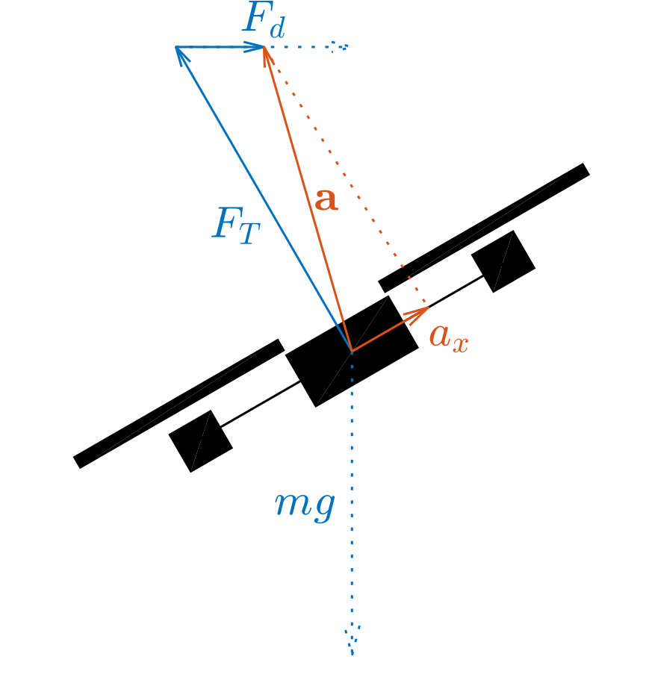During flight, three forces act on the quadrotor: gravity (mg), thrust (FT) and drag (Fd). The drone’s accelerometer measures the acceleration that results from the thrust and drag, but not the gravity[1]. The thrust only acts along the drone’s vertical axis, so the only force that remains to be measured on the horizontal axes is the drag. Using a simple drag model, the drag can be transformed back into the drone’s velocity. In case of quadrotors, the drag force Fd and its resulting acceleration ax grows approximately linear with velocity:

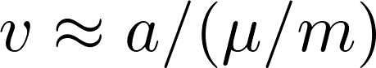with mu the linear drag coefficient.

The drag term (mu/m), defined by DRAGSPEED_COEFF can be found through a short test flight when ground truth velocities are available (e.g. through optitrack).

# Usage instructions

1. Add the dragspeed module to your airframe file
   * By default, the velocity estimates are sent as an ABI message to the INS. Set VEL_DRAGSPEED_ID to ABI_DISABLE to disable this. The velocity estimate can also be read manually from the dragspeed.vel struct.
2. Calibrate the drag coefficient and bias (see below) and set the corresponding defines in the airframe file.
3. Set the low-pass filter strength (“GCS→Settings→dragspeed→filter” or DRAGSPEED_FILTER in the airframe file) to an appropriate value between 0 and 1.
4. Before each flight:
   * Recalibrate the bias (this helps against small changes in battery/hull position and changes in IMU temperature).
   * If the weight of the drone has changed, recalibrate the DRAGSPEED_COEFF.

* The velocity estimated by this module can be compared to the velocity from the INS by plotting the signals in the DRAGSPEED telemetry message.

# Bias calibration

1. Bring the drone to a stationary hover (e.g. with optitrack or optical flow).
2. Under “settings→dragspeed” in the GCS, set “Calibrate Zero” to 1.
3. Keep the drone stationary until the value of “Calibrate Zero” returns back to 0 (click on it to update). This takes approximately one second.
4. (Optional) set the new Zero_X and Zero_Y values (click to update) as defines in the airframe file (DRAGSPEED_ZERO_X and DRAGSPEED_ZERO_Y).

# Drag coefficient calibration

1. Ensure the velocity from the INS is sufficiently accurate (e.g. through optitrack)
2. Under “settings→dragspeed” in the GCS, set “Calibrate Coeff” to 1
3. Fly the drone around (manually or using a flight plan). The drag coefficient is updated while the drone flies faster than 0.5 m/s.
   * Plot the signals in the DRAGSPEED telemetry message to compare the true and estimated velocities.
4. Calibration is finished when “Calibrate Coeff” returns to 0 (click to update).
5. (Optional) set the new Coeff value (click to update) as a define in the airframe file (DRAGSPEED_COEFF).

# Automatic calibration in flightplans

Calibration can be started from the flightplan by calling dragspeed_calibrate_zero() or dragspeed_calibrate_coeff(). Progress of the calibration can be monitored through dragspeed_is_calibrating() which returns TRUE while either calibration routine is in progress.

1. <https://en.wikipedia.org/wiki/Accelerometer>