**Data Preprocessing**

Opencv is used for cropping hindi letters from image.

Image is converted to gray and blurred to apply adaptive thresholding , then thresholded image is again subjected to morphological techniques in open-cv and finally contours are applied to transformed images.

I have experimented with min contour area,kernel size of blurring effects to obtain best results.

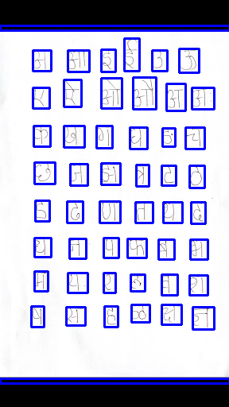

Results are good as it segmented all 48 letters cleanly and additional contours for boundary are generated.

**Choosing a training model**

Supervised learning needs atleast couple of thousand images per each class , since I have very few images even with augmentation I came upon technique of few shot learning for omniglot dataset.

Omniglot dataset has similar challenges like very few samples per class with large number of classes.

Paper on omniglot dataset suggested to train Siamese network comparing features of similar images to dissimilar images.

Indorder to create more images per dataset I have choosen image rotation ,resizing , random cropping techniques .

For each training input a pair of images are randomly choosen and their corresponding similarity encoded as 0 or 1 is used as Y label to tune the model.

Siamese network has initial layers of convolutions and final layer as fully connected to extract embeddings .

Training and testing dataset are organized as

./Marathi

./training

./letter0/0.bmp

./0_rot_45.bmp

./0.rot_15.bmp

./letter1/1.bmp

./1_rot_15.bmp

./testing

./letter0/0.bmp

/0._rot_75.bmp

./letter1/1.bmp

./cropped_1.bmp

**Model Hyperparameters**

Adam optimizer is used for faster convergance.

Batch sizes ranging from 13 , 120 are tried .

I have experimented with epochs from 35 ,76 , 365,467

Common observation is that network stopped learning after few epochs and loss saturated .

Neither batch size or epochs didn’t showed significant result in decrease of loss.

**Loss per training loops.(epochs 365,batch size 112)**

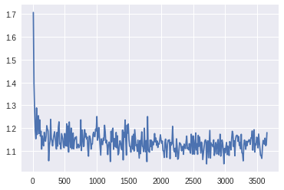

A threshold of 0.5 is taken for dissimilarity to calculate metrics.

F1 accuracy is 0.26

Precision 0.26

Recall 0.26

Accuracy 0.36

Model didn’t recognize same digit even if it is slightly rotated.