Tuesday, March 7, 2023

**Ontology**

Knowledge Based Systems

Spencer – Marc - Jan

**Our Ontology Overview(below):**

**Introduction:**

Our chosen domain is Pokemon and we chose to move forward with this idea because it was a game from our childhood we know enough about the topic that we can easily implement different aspects or come up with new ideas quickly. For those that do not know what Pokemon is, in a parallel universe humans live along creatures that can use different elemental powers. Each of these creatures has a unique name and come from a specific genome, this is all modelled using the ontology. The group had the belief that there would be many resources and libraries related to Pokemon to be able to utilize in the final delivery. For example we will not have to code a library of imaginary creatures or create the list full of 300 Pokemon and our group greatly enjoyed the idea of saving some time. Continuing with this idea, if you have played the games, you will notice that most of the attributes are general such as type, location or evolution method. Some attributes like egg-group will most likely be modified when we are allowed to use actual libraries to something that fits the library chosen. As of now the attribute classification is just a placeholder. Since our ultimate goal is to do a personality test of some sort, the group chose to keep something that would represent what the user was ultimately given. As of now we will base the user in an elemental way, because we are tracking their weather, temperature, and seasonal preferences and history. Also we score the user based upon their level of physicality. Some pokemon and some people are more brain power and other could jump off a building. Our goal is to match them.

Showing taxonomy that includes at least a two level inheritance relationship (below)

1) The first image is the evolution method as Pokemon can evolve in different ways as well as the different types of evolution.

2) The image below shows that Pokemon can be classified different ways.

Do we meet the requirements?

Our 10 Competency questions:

We will want to know about the regions :

1) What species of Pokemon can be found walking in the kanto region?

2) What species of Pokemon can be found fishing in the Johto region?

In the below image we can see that a Pokemon is in a location. This location has a route and method. In this case the method is walking and the route is not specified but we know it can be anywhere in the region.

3) What is the region that has the most fire type Pokemon species?

In the image to question 3 shows that we must relate the location of the Pokemon with the type of fire.

**Egg Groups:**

4) What species of Pokemon can fly?

5) What species of Pokemon is in the aquatic egg group?

As we can see in the below image, the EggGroup class has four subclasses that can be utilized to classify the pokemon. This could relate heavily with the region or type depending on how the library we decide to use is implemented.

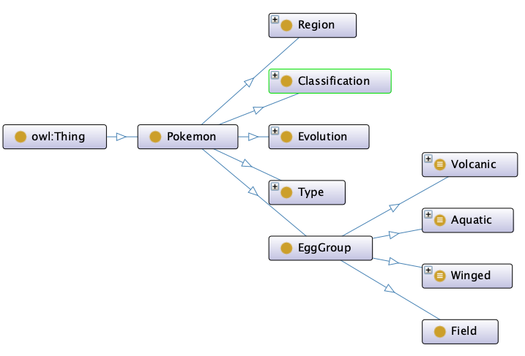

**Evolution Methods:**

6) What species of Pokemon is the evolution of charmander?

7) What species of Pokemon can be evolved by trading

In the below image we demonstrate that the evolution of a pokemon can be achieved in different ways. The group decided to include the new things the games do called ‘mega-evolution’ or ‘dyna-max’. We do this because these pokemon normally have better art work or are publicized heavily so the user could easily identify it if they know the newer games.

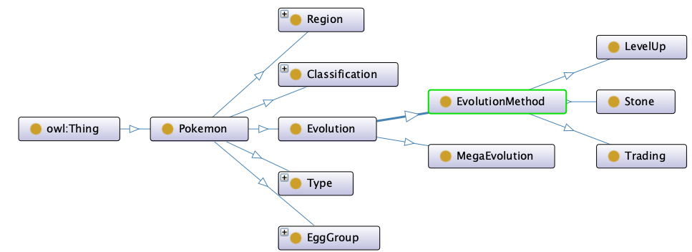

**Our Classification:**

8) What species of Pokemon is classified as Physical Strong?

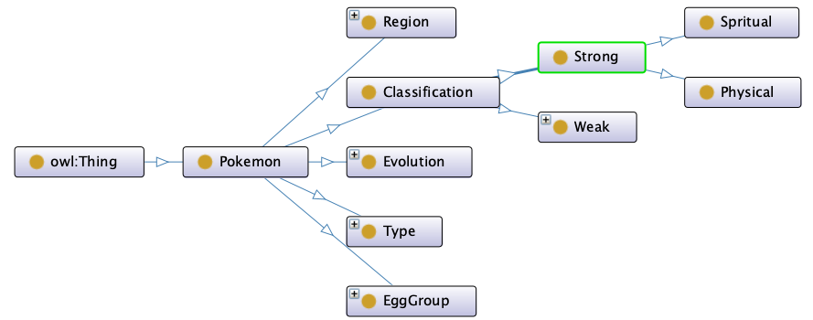

In the above image, we can see that the group has temporarily given our own classification of the species because we needed to be able different the types of people that we would be questions and match this with our metrics. This way we could pick from already decided group and not the other way around.

**Other Questions:**

9) What is the egg group of Pokemon associated with fire type Pokemon?

10) What types of Pokemon are not included in the Field Egg-Group

**Development:**

In section three of the document lists the “Simple Knowledge-Engineering Methodology”. When following these steps it was easy to solidify our ideas on protege. The group was able to determine the domain and scope of the ontology pretty easily, since we had already discussed our topic when reading through the project description. Since we could already answer the questions like “for what we are going to use the ontology” or “For what types of questions the information in the ontology should provide answers” and the group had help from the master class to construct the competency questions, step one was completed pretty rapidly. And these aforementioned attributes are shown earlier in the report. We were in luck because we used everything from a game, our ideas were quite solid and allowed for the group to construct a good foundation that was reliable. For considering reusing existing ontologies, the class was explained during the masterclass the importance of not creating our own but rather reusing an already declared definition. For the group this was of no challenge since it is based upon a publicly released game. To enumerate the important terms and define the classes and hierarchy was pretty simple. From the playing the Pokemon games, it was pretty clear how the top-down approach would be constructed. Since the creature one could encounter would have specific type, region, and family(evolution) we could begin to create more subclasses for each of the already existing subclasses. This provided us with the recently stated top-down approach. Defining the facets of the slots was easily done considering we learned it in DPO and using some of the GRASP techiniques. We decided that we would be incorporating inheritance based off how one can encounter a pokemon or the egg it is hatched by.

Section six was “What’s in a name?” and the consulted document stated that we should define a naming convention for classes and slot and adhere to it. As the group was most recently using upper camel case or PascalCase in java we chose to keep this method. There were many rules related to the naming of the different classes and these rules were pretty standard for us by this point as most of them coincided with how we have been programming and the different languages.

**Changes Made:**

This is in correspondence with the previous section about development. While researching regarding ontologies and if ours was proper, the following changes were implemented. In the below image, one can notice that the attribute, location only has one corresponding subclass, region. As this would not allow step four of the consulted documentation to be executed properly, the second below image shows this fixed. Also consistent naming is mentioned to be important and in the top-below image, the ‘EggGroup’ is not following the format of the other subclasses. The second-below image would show this implementation fixed.

**Outline:**

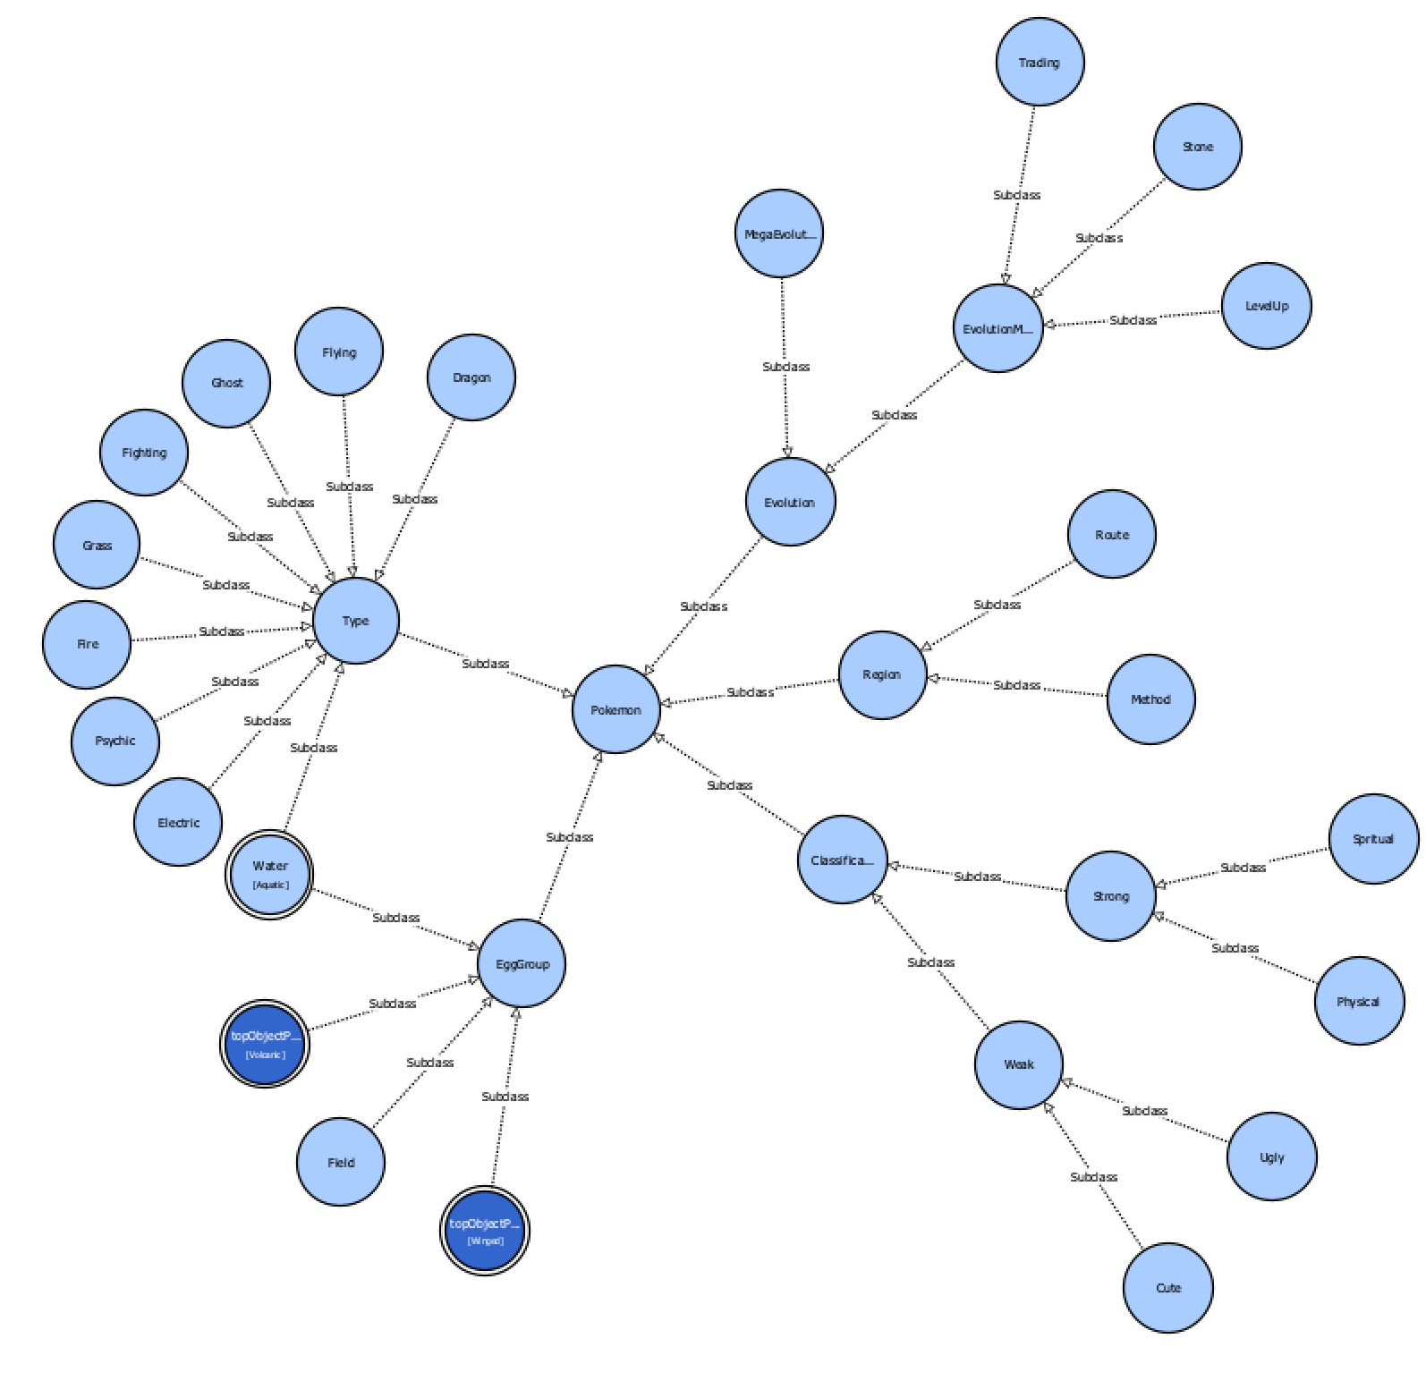

**Examples:**

Some examples of how our ontology could be used to classify various Pokemon types in order to then find a match would be to have a parent class named Pokemon which must be connected to a child class called Type and then some subclasses like Electric, Fire, and Water connected to the Type subclass. Attributes like attack power, defense power, and many others that are used to define Pokemons set would be present for each subclass.

For instance, using the Electric Type class as an example, we can make a Pikachu instance with the necessary properties. Other Pokemon, such as Charmander under the Fire Type class and Squirtle under the Water Type class, can also be categorized according to their respective attributes and characteristics that they have.

Another example would be to group Pokemons according on how they can evolve. A parent class called Pokemon can be connected to a child class called Evolution Method. We would have subclasses here to support what the creators have done with the games. This would include the mega-evolution, new dyna-max, and the normal evolution methods under the Evolution Method class. Each subclass would include characteristics like the criteria to be achieved, the type of evolution processes needed, and the level needed to evolve. When using the Evolution Method Class, we could build an instance of a Pikachu that levels up to a Raichu when it reaches level 25 and a thunderstone is used. Some other examples include the evolution of Eevee into Flaereon with the use of a Fire Stone with no regard to level.

In general, this Pokemon ontology, is a very useful tool to assist players and Pokemon lovers to classify and organize all Pokemon types according to the parameters and features that feature each Pokemon. This instrument makes it simple to evaluate and comprehend their attributes and qualities.

**Conclusion:**

As a result of our enthusiasm for the game and the abundance of material available, our group decided to create this ontology about Pokemon. One benefit of developing our ontology about the Pokemon game is the availability of materials and libraries that are pertinent to it. This helped us save time and ensured the accuracy and completeness of our ontology.

Our objective is to create a personality test that will be coded in Python using this ontology. The goal of this project is to create a valid and reliable personality test that can ask questions to geta general feel of people's personalities in relation to the game by determining the key attributes and characteristics of each Pokemon to then let the user know which character fits him the best.

Beyond personality tests and Pokemon recommendations, we think our ontology has a wide range of possible uses. It might be helpful to develop a recommendation system that creates new Pokemon types based on the user’s interests. It can also be used to build a children's resource or encyclopedia for Pokemon so that people that are interested can learn about the game and its characters. This technology might possibly be extended to other video games that need players to play as a particular character.

Overall, our group is excited to continue developing this ontology to explore its power. We believe that our project has the potential to contribute to existing knowledge about the Pokemon game and hope that it can inspire others to create ontologies for their domains.

**Bibliography:**

*Ontology Development 101: A Guide to Creating Your First ... - Protégé*. https://protege.stanford.edu/publications/ontology_development/ontology101.pdf.