# K-Food 자료집

## Korean cuisine

Korean cuisine is the set of foods and culinary styles which are associated with Korean culture. This cuisine has evolved through centuries of social and political change. Originating from ancient agricultural and nomadic traditions in Korea and southern Manchuria, Korean cuisine reflects a complex interaction of the natural environment and different cultural trends.

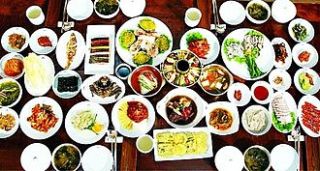

## Kimchi

Kimchi is a traditional Korean side dish (banchan) consisting of salted and fermented vegetables, most often napa cabbage or Korean radish. A wide selection of seasonings are used, including gochugaru, spring onions, garlic, ginger, and jeotgal. Kimchi is also used in a variety of soups and stews. Kimchi is a staple food in Korean cuisine and is eaten as a side dish with almost every Korean meal.

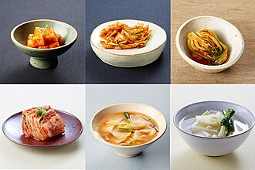

## Bibimbap

Bibimbap, sometimes romanised as bi bim bap or bi bim bop, is a Korean rice dish. It is served as a bowl of warm white rice topped with namul and gochujang. Egg and sliced meat are common additions, stirred together thoroughly just before eating. The term bibim means "mixing" and bap is cooked rice.

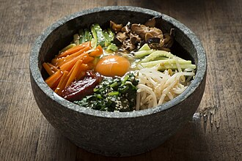

## Bulgogi

Bulgogi is a gui made of thin, marinated slices of meat, most commonly beef, grilled on a barbecue or on a stove-top griddle. It is also often stir-fried in a pan in home cooking. Sirloin and rib eye are frequently used cuts of beef for the dish. Bulgogi is a very popular dish in South Korea, where it can be found anywhere from upscale restaurants to local supermarkets as pan-ready kits.

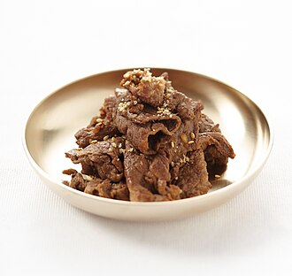

## Tteokbokki

Tteokbokki or simmered rice cake, is a Korean food made from small-sized garae-tteok called tteokmyeon or commonly tteokbokki-tteok. Eomuk, boiled eggs, and scallions are some common ingredients paired with tteokbokki in dishes. It can be seasoned with either spicy gochujang or non-spicy ganjang-based sauce; the former is the more common form, while the latter is less common and sometimes called gungjung-tteokbokki.

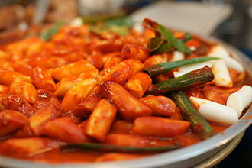

## Jeon

Jeon may refer to:Jeon   
Jeon (food), a Korean pancake  
Jeon or chŏn, a subunit of various currencies of the Korean peninsula, including:  
North Korean won  
South Korean won (1945–1953)  
The former Korean won  
The former Korean yang

## Samgyeopsal

Samgyeopsal, samgyeopsal-gui, or grilled pork belly is a type of gui in Korean cuisine.

