SHY-335a Computer Networks
Χρηστος Παπασταμος csd4569
Assignment 1

- HTTP
By looking in the response of domain.com, we can distinguish 4 files that need to be received: The main HTML file, the main.js file referenced in line 7, the logo.png file from line 10. Finally the analytics.js file needs to be downloaded from x-analytics.com, wich in both cases is going to take 2*RTT+the time needed to transmit the file (one RTT to initiate the TCP connection and one more to request the file)

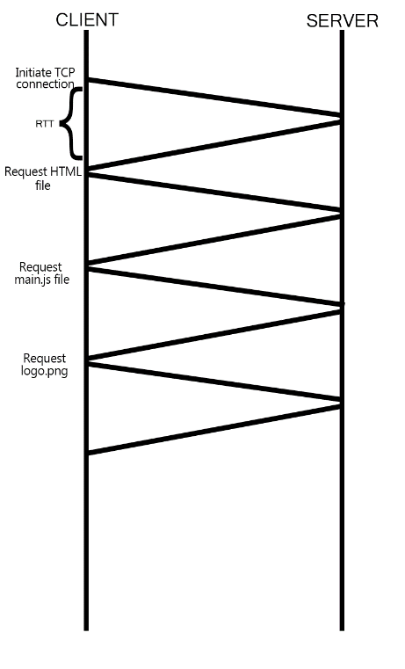  - Using Presistant HTML without pipelining  In this case, the total time used is 4*RTT+ the time needed to transmit the files+2*RTT+ transmit time for analytics.js | - Using Presistant HTML with pipelining  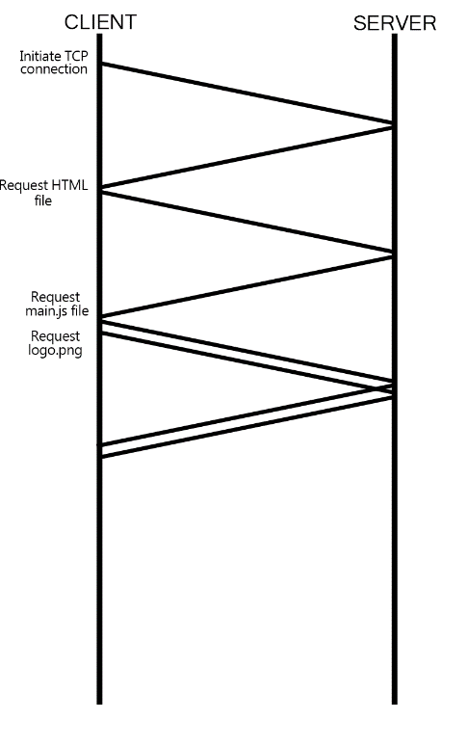  In this case the total time is 3*RTT + the time needed to transmit the files+2*RTT+ transmit time for analytics.js

- DNS

2.1. After checking in the local cashed dns querries, the client will ask its local dns server for the specified domain. If the local dns server does not have the answer, it will go on to ask the higher in hierarchy dns server. The same pattern will happen until someone has an answer to the dns querry and the answer will travel recursively to the host

2.2. After checking in the local cashed dns querries, the client will ask its local dns server for the specified domain. If the local dns server does not have the answer, it will tell the host to ask the higher in hierarchy dns server. The same pattern will happen until someone has an answer to the dns querry and then the host will get the answer to his querry

2.3. The only way for the host to get an answer when he has no connection to a router or the internet is to see if the requested domain still exists in his cashed dns querries

- HTTP pt.2

3.1. curl is a command used to send and/or receive data from a serve. With curl --head https://www,csd.uoc.gr/ we are requesting the HTML data from www.csd.uoc.gr and with the --head we get only the header of the packet in our terminal.

3.2. the command output was the following:

HTTP/1.1 200 OK
Date: Thu, 11 Nov 2021 15:56:03 GMT
Server: Apache/2.4.6 (CentOS) OpenSSL/1.0.2k-fips PHP/5.6.40
X-Powered-By: PHP/5.6.40
Set-Cookie: PHPSESSID=np5bmmgoo3l9hbjk0t24onp6m5; path=/
Expires: Thu, 19 Nov 1981 08:52:00 GMT
Cache-Control: no-store, no-cache, must-revalidate, post-check=0, pre-check=0
Pragma: no-cache
Set-Cookie: template=basic; expires=Fri, 12-Nov-2021 21:56:03 GMT; Max-Age=108000; path=/
Vary: User-Agent
Content-Type: text/html; charset=UTF-8

Every line is a different field of the packet’s header.There are many fields, among them the Date of the request, the Cookie, the packet expiration date, the content type, and the charset.

- DNS pt.2
  - >dig is a command that preforms DNS lookups and reports the answers back to the terminal
  - The lines that don’t start with a ‘;’ are the actual answers to the DNS queries preformed. in our case we have one line: “www.csd.uoc.gr. 0 IN A 147.52.206.199”. This line means that for the domain www.csd.uoc.gr there is an A type answer which leads to the address 147.52.206.199. Also, the 0 indicates that the DNS answer is not cashed
  - The dot at the end of the domain name refers to an absolute domain

- FTP

5.1. As mentioned before, the curl command is used to send/recieve data to/from a server. In this case we are using the ftp protocol.

5.2. The lines starting with ‘>’ are the commands send by the client (us) to the server, requesting the path of the current working directories and listings of different indexes

- SMTP

6.1. From the Received field in the reply we learn information about the sender and the receiver.

6.2. The received email appends in the Received field as it passes through the servers. The sent email does not have a Received field as it hasnt passed yet from any server.

