HY452 – Introduction to Services Technologies
Assignment 3 (mini project)
Christos Papastamos csd4569

Phase A

The Petri net I created for the use case is the following:

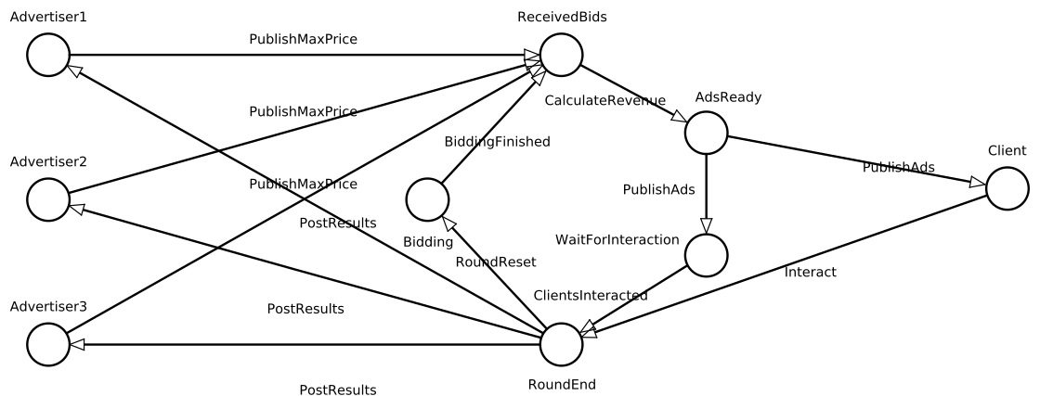

In the above Petri net there can be seen 3 Advertisers (on the left) 1 Client (on the right) and an Ad Service (the five states in the middle).The reachability graph for a vector with definition: (RoundEnd,Advertiser1,Advertiser2,Advertiser3,Bidding,ReceivedBids,AdsReady,Client,WaitForInteraction) would be:

(1,0,0,0,0,0,0,0,0)→(0,1,1,1,1,0,0,0,0)→(0,0,0,0,0,1,0,0,0)→
(0,0,0,0,0,0,0,,1,0)→(0,0,0,0,0,0,0,1,1)→(1,0,0,0,0,0,0,0,0) (back to the first state)
The three states requested can be seen below:
1) The initial state before starting the execution:

2) A middle state after the termination of the first round and:
The finished round state is the same as the round start because the RoundEnd state is both the start and end state of the round

3) the final state when both bidding rounds have finished:

