HY-335a Computer Networks
Χρηστος Παπασταμος csd4569
Assignment 3

Part 1

Question 1

- Checksum is a mechanism TCP uses to confirm that the received packet is correct and that no distortions happened to it during its transmission. Therefore, it is not reliable for the transformation of the packet.
- This statement is false. The value of the ssthresh (after a timeout) is set to half of cwnd (right before the timeout)
- This statement is true. During the slow start phase cwnd is increasing exponentially, until it reaches the value of ssthresh
- A triple duplicate ACK can possibly mean a high congestion in the network, as it reflects on a packet loss
- This statement is true.
- TCP does not support broadcast, therefore it is only possible to send packets to a single host per socket.
- TCP’s flow control is responsible to inform the sender about the free space in the receiver's window
- If the receiver is reading data from its buffer faster than the sender is sending to it, then the flow control has no use in that connection
- TCP and UDP can be used together in streaming services, such as YouTube, Spotify and Netflix
- When using plain UDP, you cannot have guarantees for the data delivery since UDP has no congestion avoidance or flow control mechanisms, unlike TCP

Question 2
- Flow control is responsible for informing the sender of each packet about the remaining size on the receiver’s buffer, unlike congestion control, which is responsible for avoiding overloading the network with packets. Also flow control is achieved through a communication between the two participants through the ACK packets (which contain the remaining buffer size), unlike congestion control which is computed locally by each node
- Unlike TCP, UDP is a much faster protocol which is useful in applications like games and streaming services where lost packets don’t matter that much.
- Duplicate ACKs mean that a previous section is lost and the receiver needs it to continue reading the next packets. Timeout occurs when the connection faulty and no acknowledgment is received for a packet. Due to the above, fast retransition is not considered complimentary to the timeout timer.

Part 2

Question 1

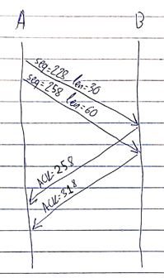
- The sequence number of the second packet is 258 since the seq. number of the previous packet was 228 and had length 30bytes. The sequence number is calculated by adding the previous length to the previous sequence number
- The source port of the ACKs is 80 and the destination port is 306
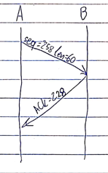
- Host b sends a ACK for the last (valid) packet he received. Therefore after receiving 258 without receiving 228, it answers that it needs 228 first by ACKing it
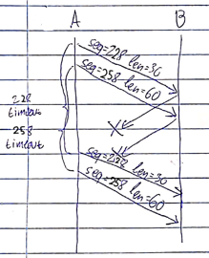
- When the timer of each packet runs out, the fast recovery mechanism will try and resend the packets that were not acknowledged by the receiver. Host A cannot be certain if the packets reached the destination!

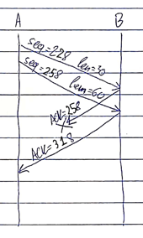
- In this case, there is no need to retransmit the packets, because by acknowledging the second packet (258), the sender can be certain that the first one (228) was received too.

Question 2
- TCP slow start operates from 0 to 6 and from 23 to 26
- TCP congestion avoidance operates from 6 to 16 and from 17 to 22. This can be distinguished by the linear graph seen on these segments. (On slow start the graph is exponential)
- Considering that the drop was to about the half of the cwnd (which is also the ssthresh), there was a triple duplicate ACK detected. This probably means the network is overloaded and the packet was lost somewhere
- The sudden drop got cwnd to 1 MSS, which means there was a packet timeout. A timeout indicates a faulty connection where neither the packet nor its acknowledgment made it across
- The 89th segment was sent at the 6th transmission. This can be seen when you calculate which was the first packet sent at each transmission (#1:1, #2:3, #3:7, #4:15, #5:37, #6:69, #7:102)
- The cwnd at the 17th transmission is 24. Before the drop cwnd was at 42, after the drop ssthresh=cwnd/2=21 and cwnd=ssthresh+3=24
- ssthresh at the 24th transmission is 15. This can be calculated by looking at the last cwnd drop. It went from 29 to 1, so ssthresh was set to cwnd/2=29/2=15
Part 3

For short, let’s call 192.168.1.122 Host A, and 64.238.1.122 Host B

- The host that initiates the connection (sends a SYN packet) is 193.168.1.122 and uses source port 60643 and destination port 80
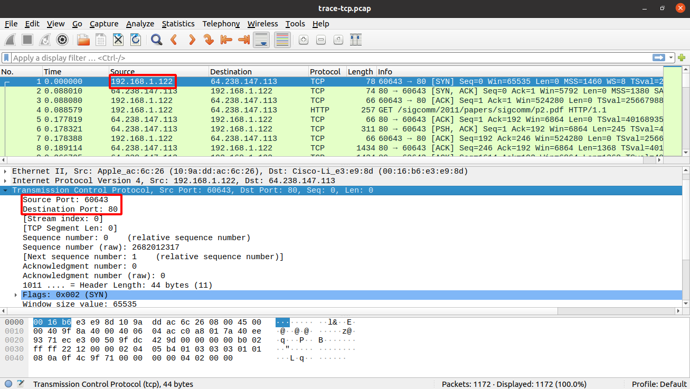
- The SYN packet can be seen in the screenshot above. It is obviously the first packet on the connection. The second packet is sent from B to A and it is a SYN-ACK packet. The third packet is the final step of the 3-way handshake and it is a ACK packet sent from A to B
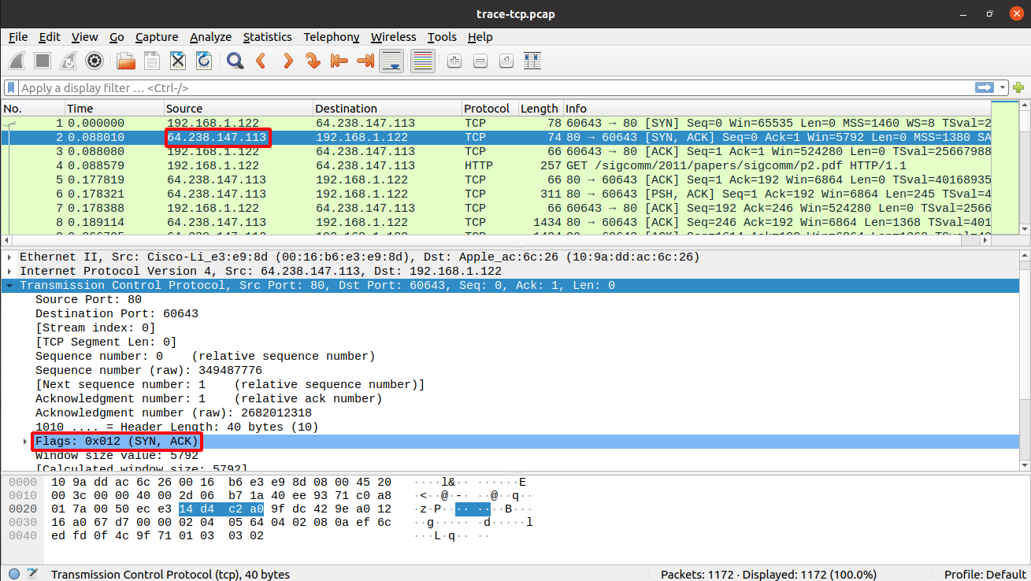
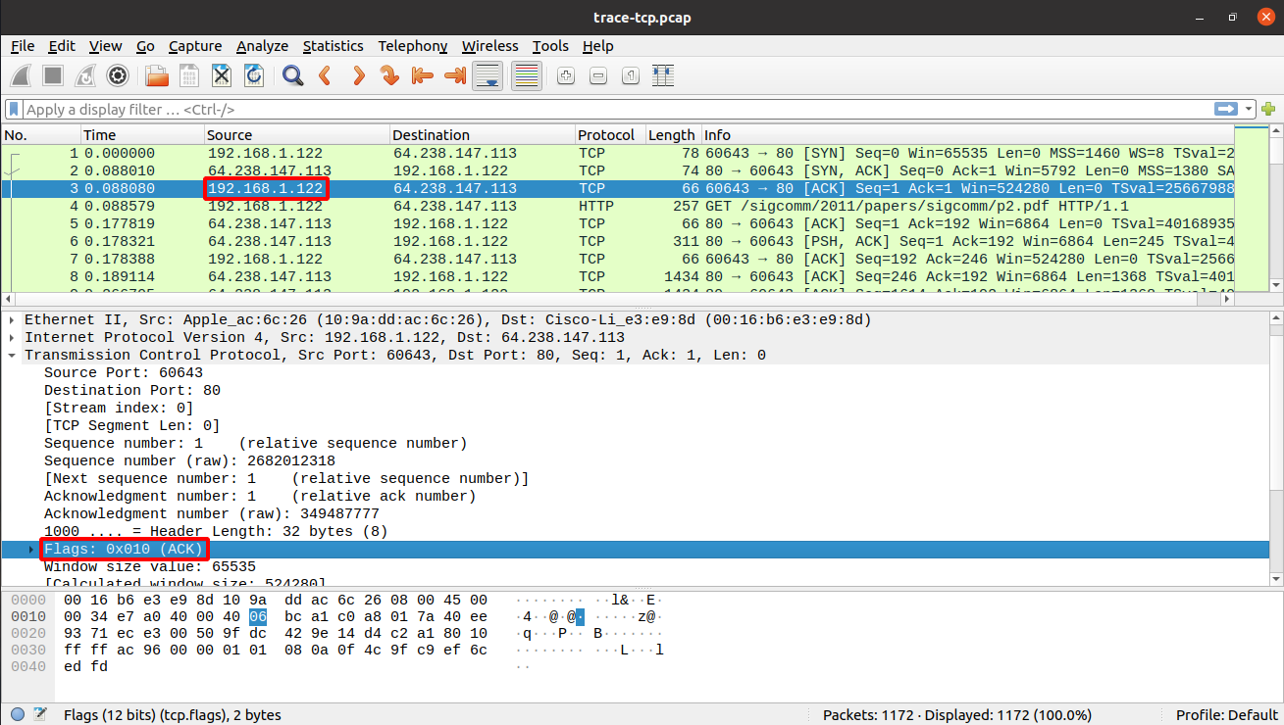
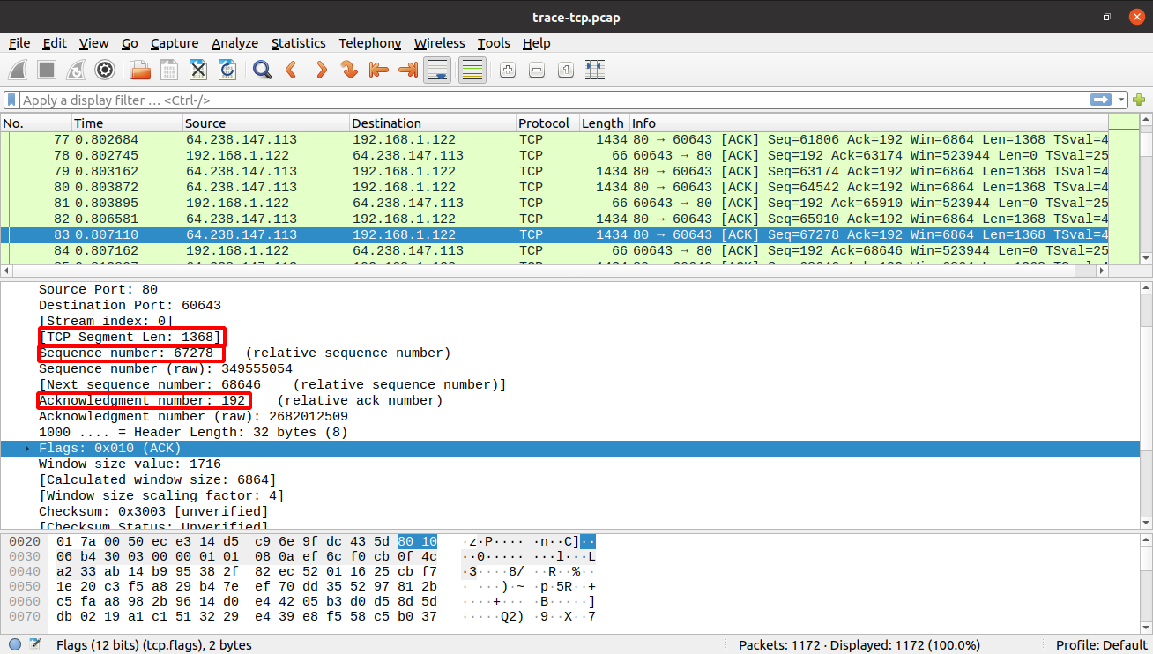
- The selected packet has a sequence number of 67278 and has length of 1368.
Therefore the acknowledgment for this packet has to be 68646

The ACK to the previous packet:
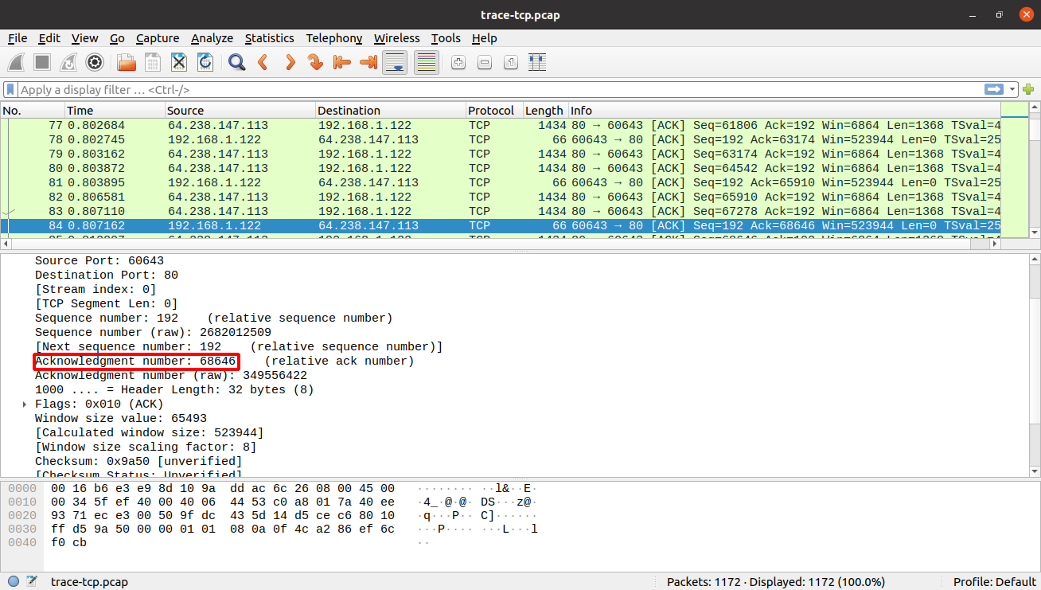

- The length in bytes of all the header fields is 32 bytes, as seen in the header length field:
