HY-335a Computer Networks
Χρηστος Παπασταμος csd4569
Assignment 5

Question 1

- The MAC address is a unique identifier for each network card, often hardwired in order to distinguish it from other devices connected to the internet. On the other hand, the IP address is an identifier for a connection, assigned to each device when it connects to a router. The router pics the IP address of each connection (probably using the DHCP protocol) meaning that a device can have different IP addresses each time it connects to a router.
- 1)The IP address is assigned by the router unlike MAC address which is often hardwired.
2)The IP address is a 32 bit number represented in Dot-decimal notation unlike MAC address which is a 48 bit number represented in hexadecimal notation.
3)A network device can only have one MAC address (specific devices can change their MAC address now tho) unlike IP address where a device can have different IPs each time it connects to a router
4)MAC address is used in the Link layer unlike IP which is used in the network layer
5)IP address is used to connect to a device unlike MAC which is used to identify a device

Question 2

1. | 0 | 1 | 1 | 0 | 0
 | 1 | 1 | 1 | 0 | 1
 | 1 | 1 | 0 | 1 | 1
 | 1 | 0 | 0 | 1 | 0
 | 1 | 1 | 0 | 0

2. | 0 | 1 | 1 | 0 | 0 | The change on the red bit can be detected on the two parity bits marked in blue
 | 1 | 0 | 1 | 0 | 1
 | 1 | 1 | 0 | 1 | 1
 | 1 | 0 | 0 | 1 | 0
 | 1 | 1 | 0 | 0

3. | 0 | 0 | 0 | 0 | 0 | The changed bits can be detected on the two respective parity bits but cannot be fixed using the row parity bit
 | 1 | 1 | 1 | 0 | 1
 | 1 | 1 | 0 | 1 | 1
 | 1 | 0 | 0 | 1 | 0
 | 1 | 1 | 0 | 0

Question 3

1. | 1 | 0 | 1 | 0 | 1 | 1 | 0 | 0 | 1 | 0 | 1 | 0 | 0 | 0 | 0 | Using the divisor’s length, we will first add 3 CRC bits to the right of our data. Next up by dividing the divisor with the message, we get the final CRC bits. The final message is: 11001010110
 |  |  |  |  | 1 | 0 | 1 | 0
 |  |  |  |  |  | 1 | 1 | 0 | 1
 |  |  |  |  |  | 1 | 0 | 1 | 0
 |  |  |  |  |  |  | 1 | 1 | 1 | 0
 |  |  |  |  |  |  | 1 | 0 | 1 | 0
 |  |  |  |  |  |  |  | 1 | 0 | 0 | 1
 |  |  |  |  |  |  |  | 1 | 0 | 1 | 0
 |  |  |  |  |  |  |  |  | 0 | 1 | 1 | 0
 |  |  |  |  |  |  |  |  | 0 | 0 | 0 | 0
 |  |  |  |  |  |  |  |  |  | 1 | 1 | 0 | 0
 |  |  |  |  |  |  |  |  |  | 1 | 0 | 1 | 0
 |  |  |  |  |  |  |  |  |  |  | 1 | 1 | 0 | 0
 |  |  |  |  |  |  |  |  |  |  | 1 | 0 | 1 | 0
 |  |  |  |  |  |  |  |  |  |  |  | 1 | 1 | 0 | 0
 |  |  |  |  |  |  |  |  |  |  |  | 1 | 0 | 1 | 0
 |  |  |  |  |  |  |  |  |  |  |  |  | 1 | 1 | 0

2. | 1 | 0 | 1 | 0 | 1 | 1 | 0 | 0 | 1 | 0 | 1 | 0 | 1 | 1 | 0 | The receiver gets the message and calculates that it has 3 bits of CRC. It then divides the message with the divisor and ends up with a remainder of 0, meaning that the received message is correct
 |  |  |  |  | 1 | 0 | 1 | 0
 |  |  |  |  |  | 1 | 1 | 0 | 1
 |  |  |  |  |  | 1 | 0 | 1 | 0
 |  |  |  |  |  |  | 1 | 1 | 1 | 0
 |  |  |  |  |  |  | 1 | 0 | 1 | 0
 |  |  |  |  |  |  |  | 1 | 0 | 0 | 1
 |  |  |  |  |  |  |  | 1 | 0 | 1 | 0
 |  |  |  |  |  |  |  |  | 0 | 1 | 1 | 0
 |  |  |  |  |  |  |  |  | 0 | 0 | 0 | 0
 |  |  |  |  |  |  |  |  |  | 1 | 1 | 0 | 1
 |  |  |  |  |  |  |  |  |  | 1 | 0 | 1 | 0
 |  |  |  |  |  |  |  |  |  |  | 1 | 1 | 1 | 1
 |  |  |  |  |  |  |  |  |  |  | 1 | 0 | 1 | 0
 |  |  |  |  |  |  |  |  |  |  |  | 1 | 0 | 1 | 0
 |  |  |  |  |  |  |  |  |  |  |  | 1 | 0 | 1 | 0
 |  |  |  |  |  |  |  |  |  |  |  |  | 0 | 0 | 0

3. | 1 | 0 | 1 | 0 | 1 | 0 | 0 | 0 | 1 | 0 | 1 | 0 | 1 | 1 | 0 | The receiver gets the message and calculates that it has 3 bits of CRC. It then divides the message with the divisor and ends up with a remainder of 2 (010), meaning that the received message is false
 |  |  |  |  | 1 | 0 | 1 | 0
 |  |  |  |  |  | 0 | 1 | 0 | 1
 |  |  |  |  |  | 0 | 0 | 0 | 0
 |  |  |  |  |  |  | 1 | 0 | 1 | 0
 |  |  |  |  |  |  | 1 | 0 | 1 | 0
 |  |  |  |  |  |  |  | 0 | 0 | 0 | 1
 |  |  |  |  |  |  |  | 0 | 0 | 0 | 0
 |  |  |  |  |  |  |  |  | 0 | 0 | 1 | 0
 |  |  |  |  |  |  |  |  | 0 | 0 | 0 | 0
 |  |  |  |  |  |  |  |  |  | 0 | 1 | 0 | 1
 |  |  |  |  |  |  |  |  |  | 0 | 0 | 0 | 0
 |  |  |  |  |  |  |  |  |  |  | 1 | 0 | 1 | 1
 |  |  |  |  |  |  |  |  |  |  | 1 | 0 | 1 | 0
 |  |  |  |  |  |  |  |  |  |  |  | 0 | 0 | 1 | 0
 |  |  |  |  |  |  |  |  |  |  |  | 0 | 0 | 0 | 0
 |  |  |  |  |  |  |  |  |  |  |  |  | 0 | 1 | 0

Question 4

- The probability that node A sends its first packet in timeslot 4 is (1-p)(1-p)(1-p)p

Question 5

After the fifth collision, the algorithm selects a value from K from {0,1,2,3,4,5,…,31}, so there are 32 possible numbers K can get. The probability that this number is 4, is 1/32 or 0.03 or 3%. This means that the sender has to wait for 4*512 bits = 2048 bits or 2Gbits. Considering that the link has a speed of 10Mbps, the time needed for retransmition is 2048/10⁷ =2048*10⁻⁷ =204,8 μs.

Question 6

Starting up, the switch table has no entries

1. | 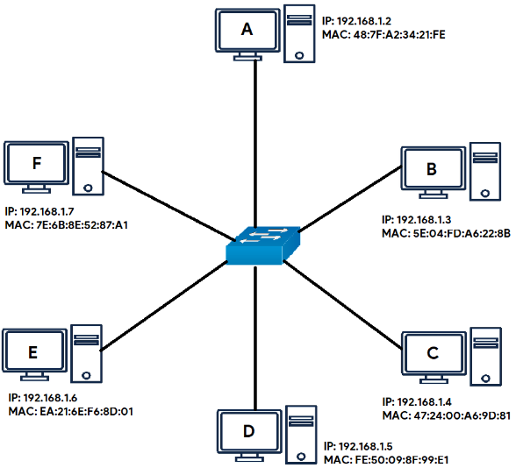 | F sends a packet to C trough the switch. First the switch saves F’s MAC and IP address in its switch table, but it does not know the mac address of C. So it sends out the packet to all the remaining connections hoping to get to C.
2. | 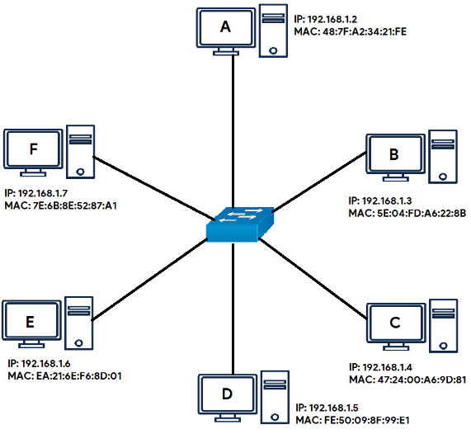 |  | When C replies with a frame for F, the switch adds into its switch table the MAC and IP address of C. Knowing the MAC address of F, it doesn’t need to forward the frame to all connected devices, but directly to F
3. |  |  | D sends a frame to F, so the switch adds D’s MAC and IP address to its switch table. Then needs to forward the frame to F for which it knows the MAC address so it forwards it only to him

4. |  | F replies with a frame for D and because the switch knows both F’s and D’s addresses, doesn’t change its switch table and forwards the frame straight to D

Question 7

- Routers divide a topology into subnets unlike switches which are contained in the same subnet
- Only routers can preform NAT translations
- Switch is a semi-intelligent device unlike routers which is a intelligent device

