HY330 – Telecommunication Systems
Chris Papastamos | csd4569
Assignment 2

Exercise 1
Question 1

The provided signals are transmitted without any loss of information because the system samples at 33kHz. The bandwidth of the system is 12kHz so according to Nyquist the minimum sampling frequency is 24kHz. That can also be confirmed by using a frequency sink and looking at the signal’s frequencies:

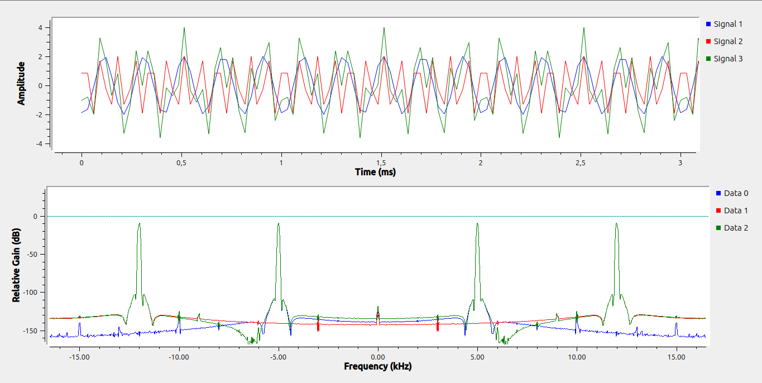
In the screenshot above we can observe the two signal’s frequencies are perfectly preserved through the sampling process.

Question 2
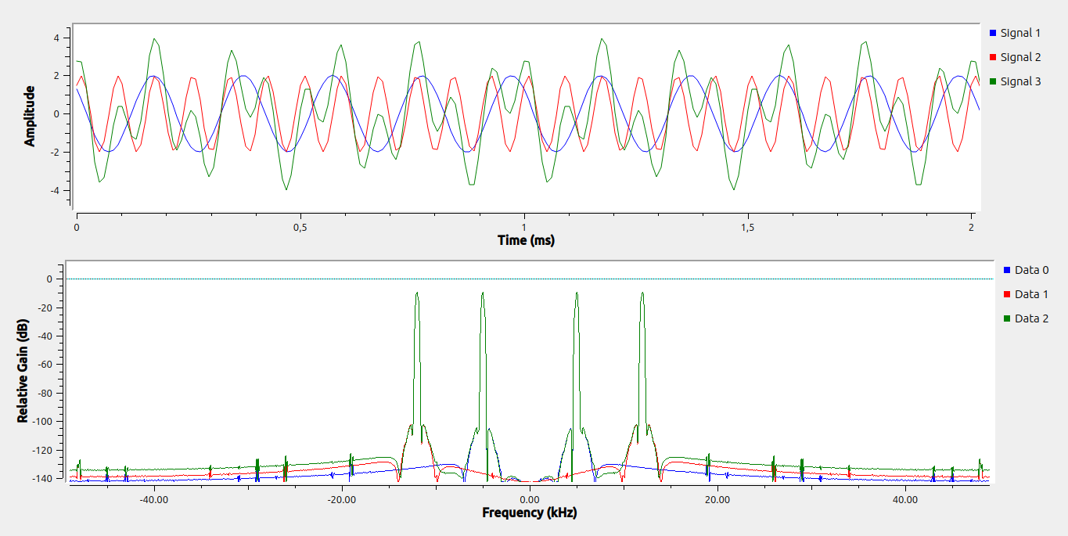
In order to have a smoother visual signal, I will chose a sampling rate of 98kHz which is 4 times the Nyquist frequency of the 12kHz cosine. This way the “fastest” cosine will be sampled 8 times in its period. The output of the new flowgraph can be seen below:
The CPU usage is obviously gonna be higher in the biggest sampling rate case and this can be proven by running htop while the flowgraph is running

Sampling rate 33kHz: (CPU 5%)
Sampling rate 98kHz: (CPU 10.1%)
Question 3
According to Nyquist the minimum sampling frequency is 2 times the bandwidth of the system. Our system consists of a cosine of 5kHz and a cosine of 12kHz. Thus the bandwidth is 12kHz and the minimum sampling frequency according to Nyquist is 24kHz.

Question 4
The sampling rate of the throttle block does not directly affect the signal directly. It affects the “refresh rate” of our flowgraph.

Exercise 2
First up lets change the input variables of each signal source to a variable set by a GUI Range picker. I am gonna name the variables S1_FREQ, S1_AMP, S2_FREQ, S2_AMP. Given that the sampling rate of our flowgraph is 98KHz, the maximum allowed frequency for our signals is 48KHz. The flowgraph now looks like this:
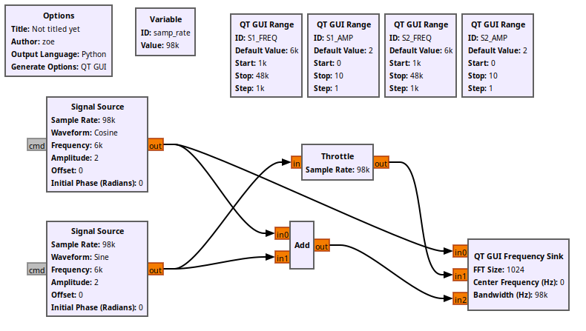
Lets now execute the flowgraph and observe the output:
First up we can observe that the combined signal consists of just one frequency and that is logical because the two combined signals S1 and S2 have the same frequency of 6kHz. Also we can see that although the S1 and S2 signals are diferent (cosine and sine) in the frequency domain appear as (approximately) the same thing. That is because the type of the signal does not differenciate the signal when looked by the frequency domain. Only its frequency and its amplitude can change the frequency graph.
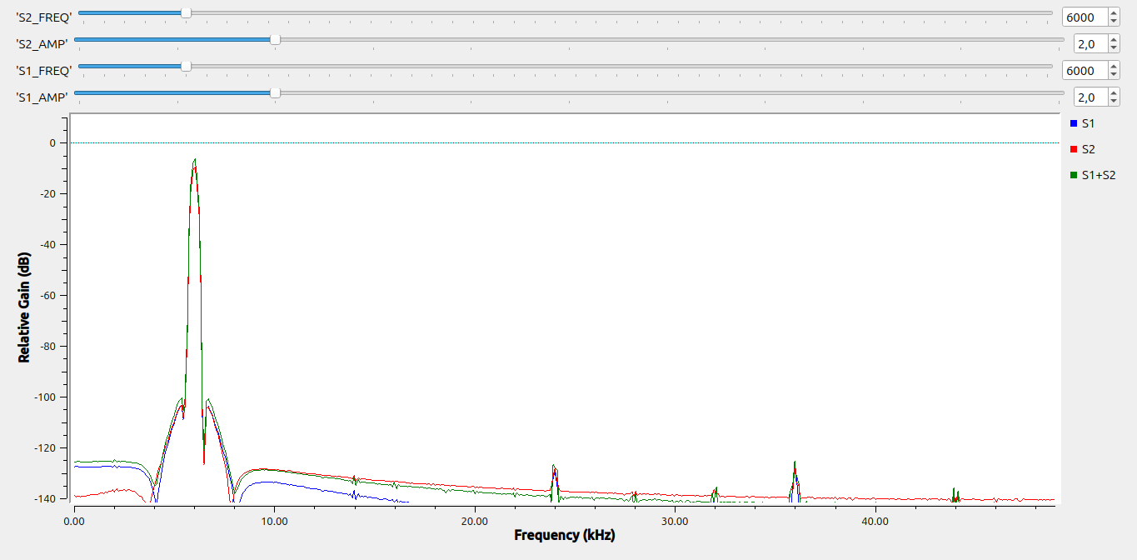
Exercise 3
For this exercise I will connect the flowgraph as it can be seen in the next screenshot. Also I will set the delay to 2 sampling points because this is the amount needed in order to shift the signal by a phase of pi (since in every phase the signal is sampled 4 times)

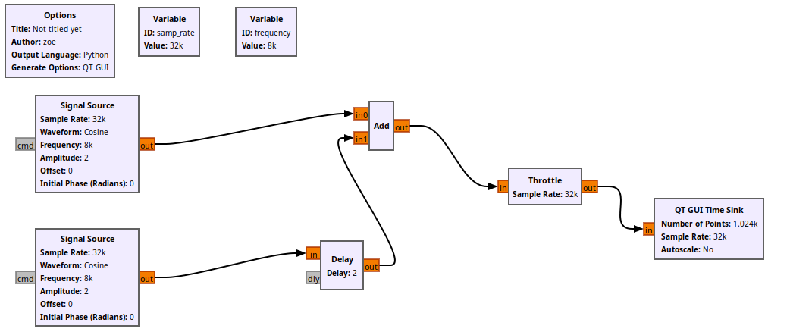
The output of the flowgraph can be seen in the screenshot below. The signal is zero as expected.

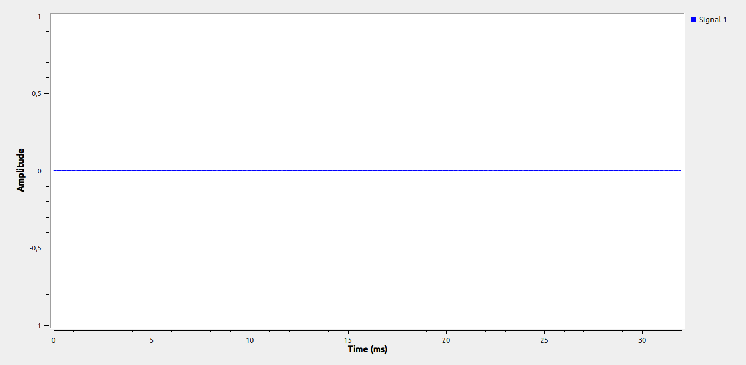
Exercise 4
Starting up, by using the slider to change the frequency, we can observe that the two signals are alike between the frequencies 0-4kHz and 28-30kHz. This happens because the down sampled signal is sampled by a rate of 8kHz, which makes the its bandwidth equal to 4kHz (0-4kHz). The reason for the signal aligning with the down sampled one in the range 28-30kHz is because since the original signal’s sampling rate is 32kHz, the Nyquist frequency is 16kHz. When the frequency is grater than 16kHz, aliases start to appear, which can be seen in the following screenshot (The alias signal decreases in frequency when the signal’s frequency increases) thus when the frequency is at 28kHz the alias frequency is 4kHz which aligns with the down smpled signal.

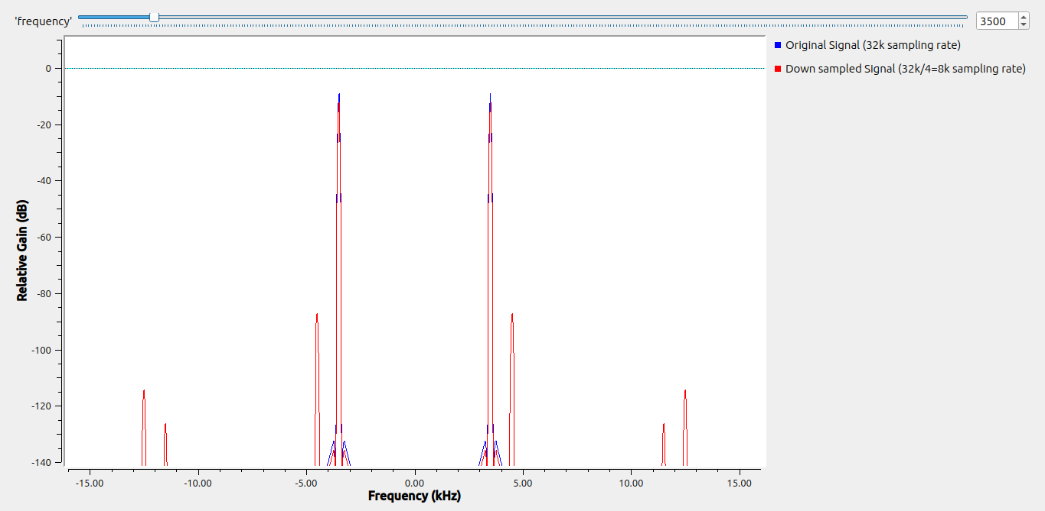
The two siglans aligning when in the range 0-4kHz (3,5kHz)

The alias beginning to appear (at 20kHz, 8kHz more than the max frequency the alias is max frequency-8kHz=13kHz):
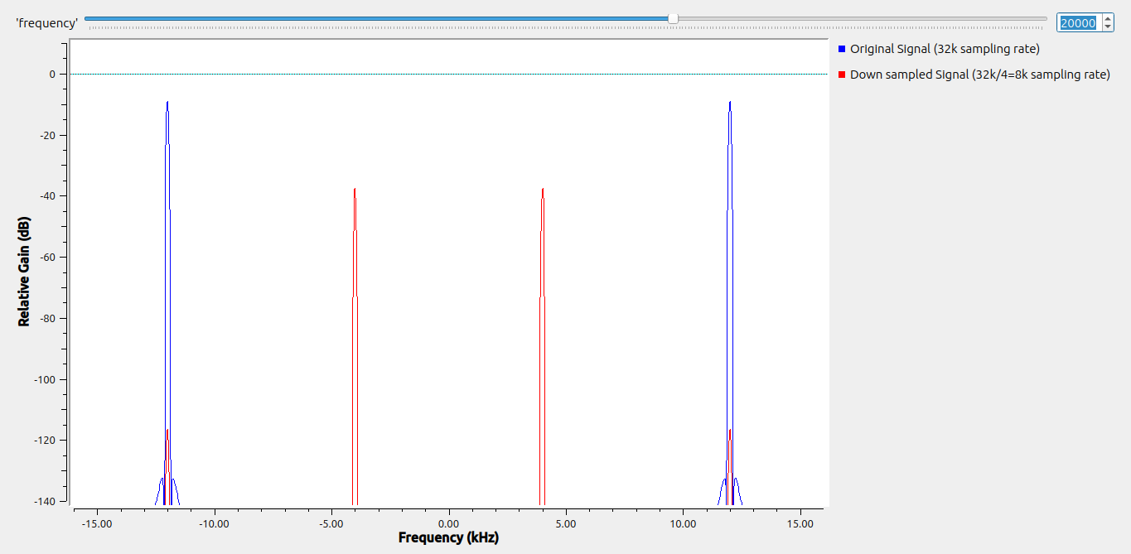
After adding a Low Pass Filter before the signal is “split in half”, the output signal will be almost silenced when the frequency is more than 4kHz.
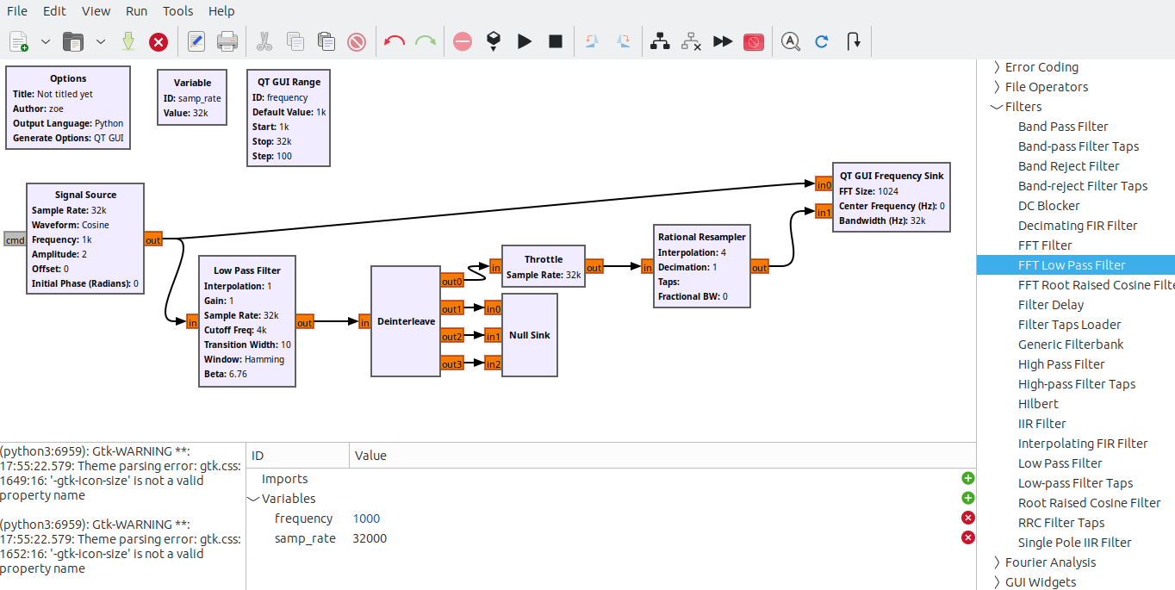

The output of the signal for 6,4kHz can be seen below
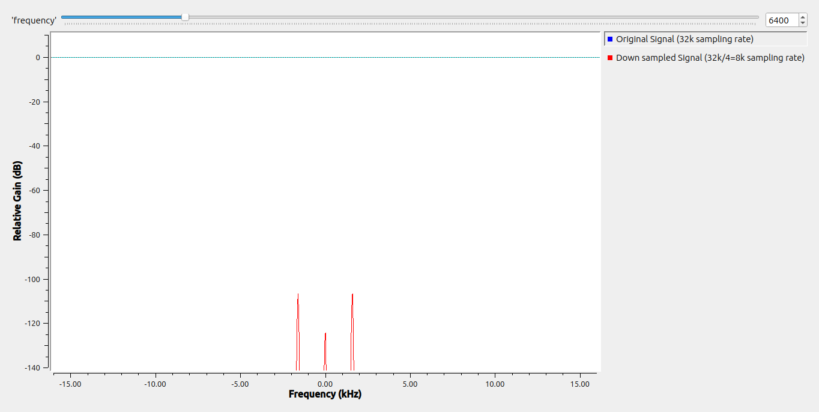
when the signal is more than 28kHz tho, an alias is also present as it is caused by the original sampling rate of 32kHz.
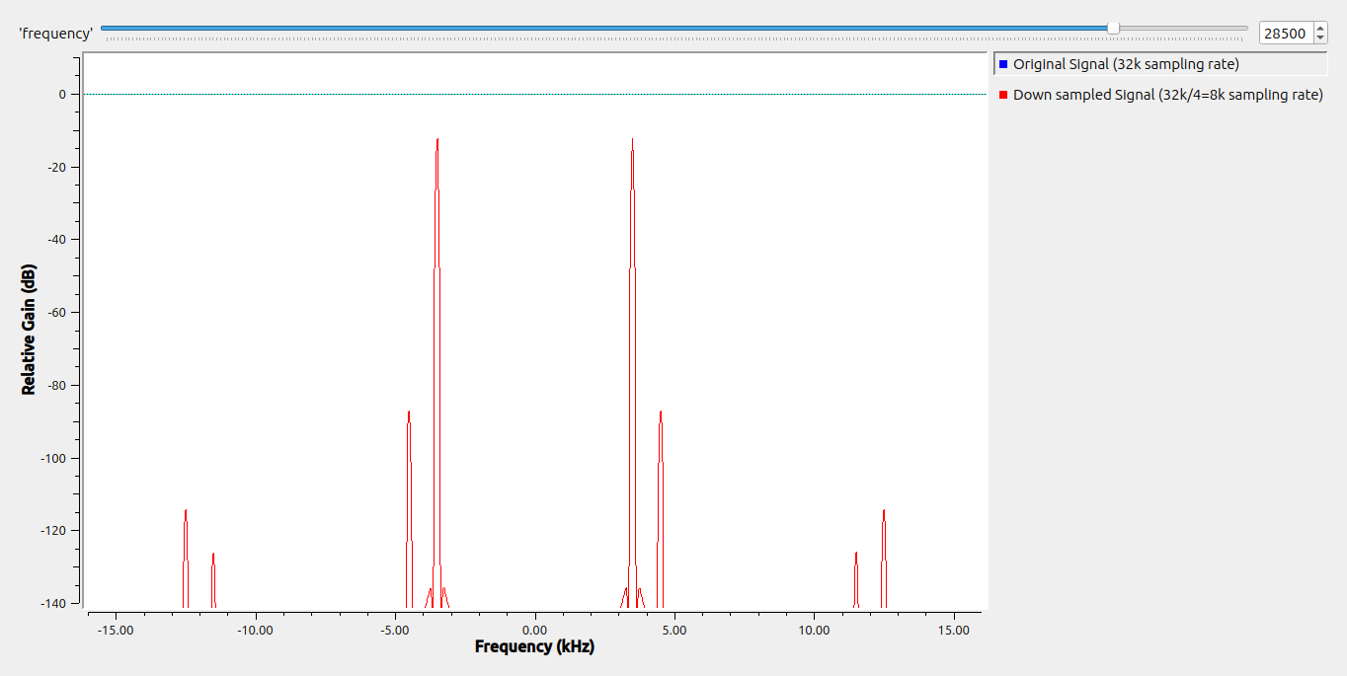
is a frequency that appears when the sampling rate does not satisfy the Nyquist rate of 2 times the bandwidth. The way the is calculated if there is a frequency grater than is by the following formula: = – ( – )

Exercise 5
For the execution of this task I had to run up some calculations first. In order to recreate a triangle wave from a sawtooth wave, we have to analyze the differences between the two in one of their period. The sawtooth signal is creating a constant upwards slope in its period and at the start of the next one it zeroes out. The triangle signal is rising the first half of its period and going to zero for the second half. We can observe that if we sample the sawtooth 2 times in its period (one at the start and one at the half) we will get a triangle like signal like needed. Lets test this theory.
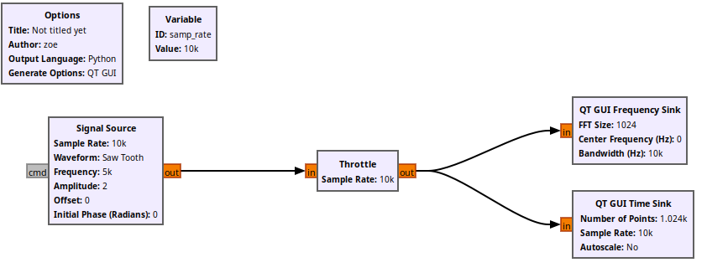
With the original sawtooth frequency being 5kHz, we will set the sampling rate to 10kHz, double the frequency. Lets observe the output signal:
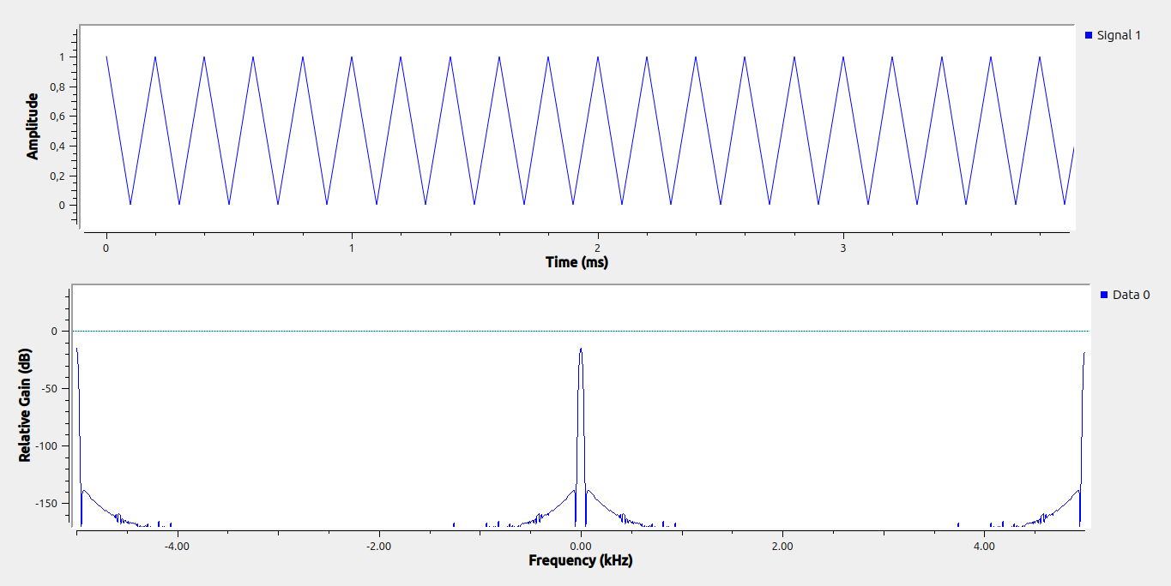
as we can see the output signal is looking like a triangle signal and that can also be seen from the frequency domain

