HY330 – Telecommunication Systems
Chris Papastamos | csd4569
Assignment 3

Exercise 1
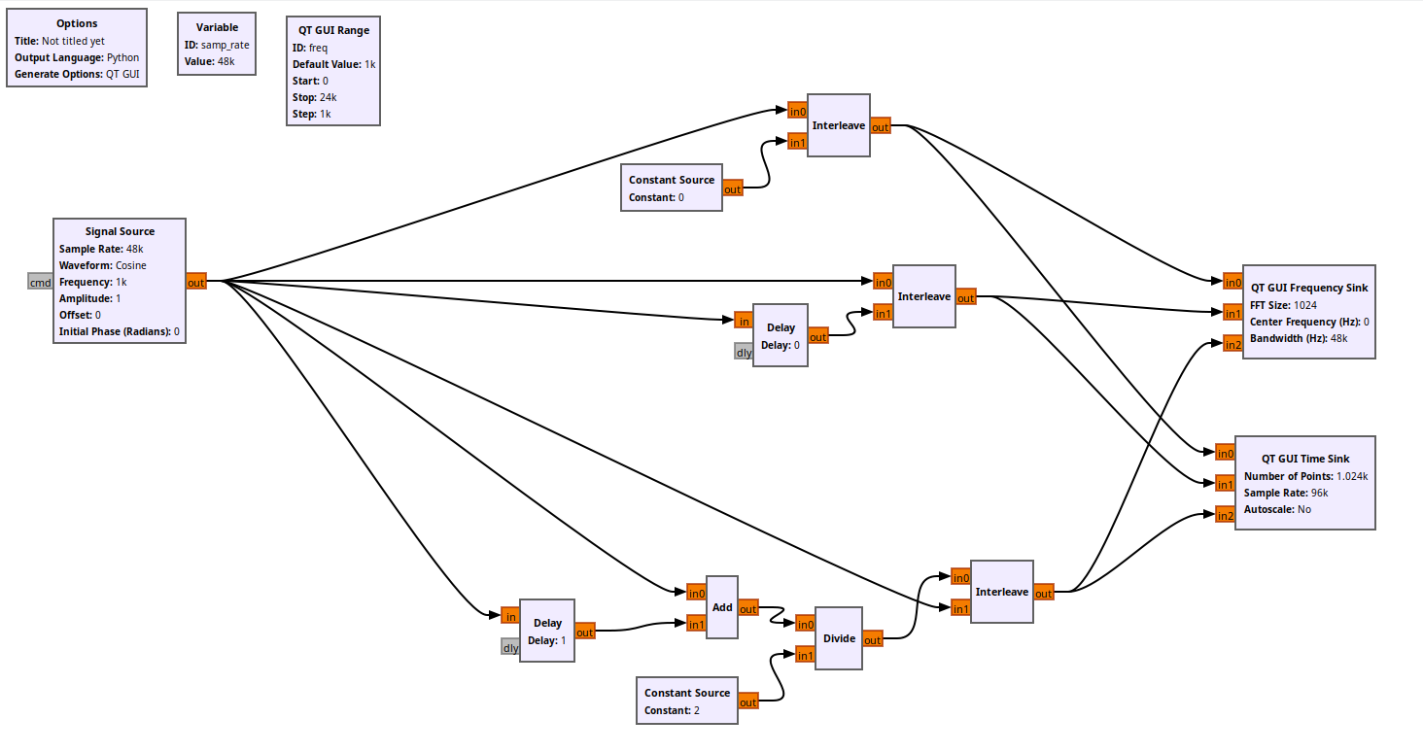
For the purpose of this assignment I will create three systems for the up-sampling of the input signal. The first system (from the top) creates an extra sampling point in between which is a constant of zero. The second system replicates the last input of the signal as the extra sample. The last system is calculating the middle point as the average value of the previous and the next point.
Lets now observe the output of the three systems:
Zero median point:
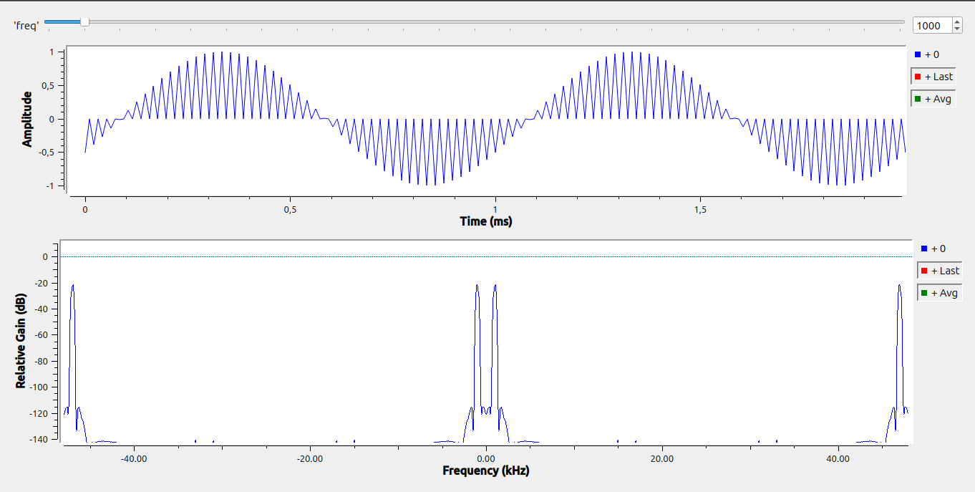

Duplicate median point:
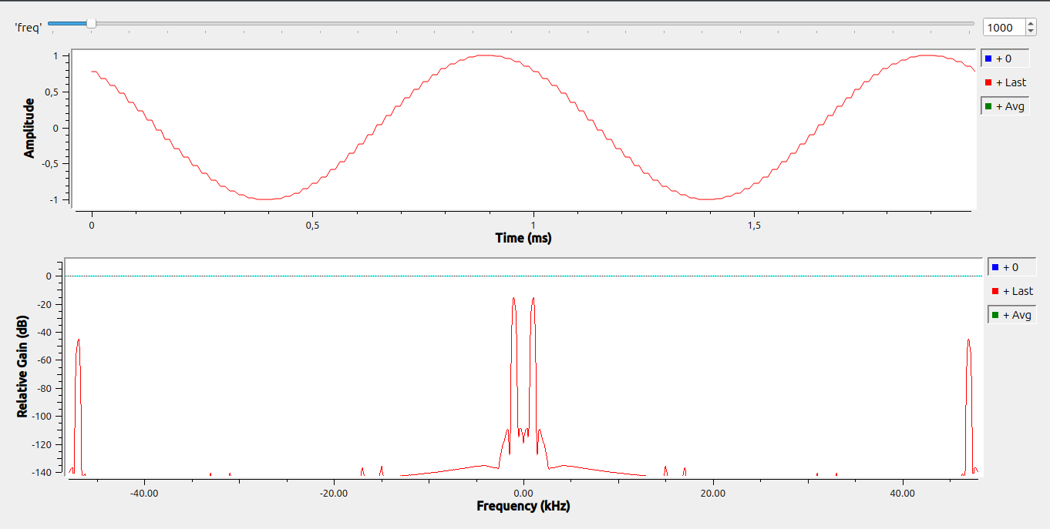
Average median point:
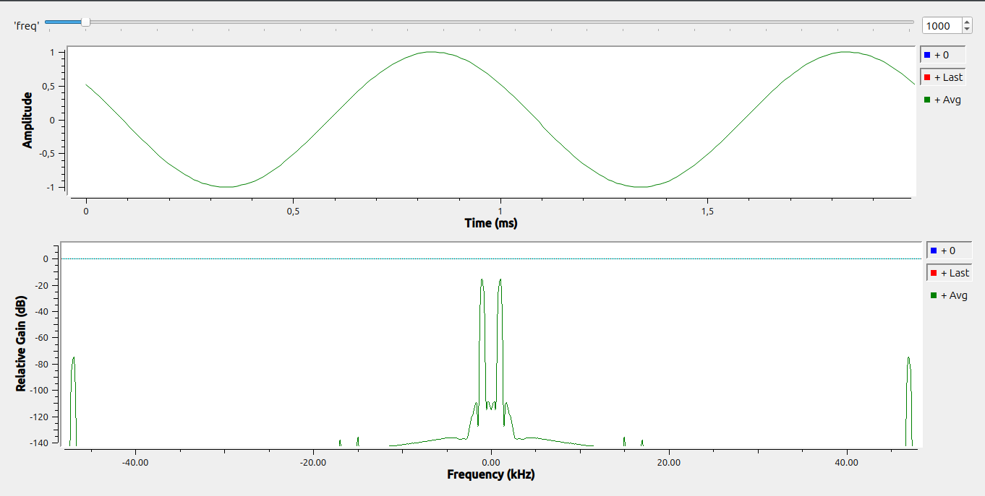
As we can observe, the final signal of every system contains an alias frequency. This is due to the Nyquist theorem which states that the sampling frequency must be double the bandwidth of the system. In this case the bandwidth of the system is 24kHz and the initial sampling frequency is 48kHz. This leads to aliasing appearing in the end of the spectrum. Although each system has some aliasing, we can observe that the one with the last Gain (and the least SNR) is the one with the average median point. If the known signal’s frequency is known tho, we can use a low pass frequency filter in order to cut off any unwanted alias frequency (in this case a filter cutting off >24kHz frequencies)

Exercise 2
For the execution of this assignment I had to implement a up-sampling of 4/3 (from 48kHz to 62.4kHz). I will achieve this with the following two transformations: First up I am going to interpolate the signal by 4 times the sampling rate. This can be achieved by taking the average value of two consecutive sampling points for the 3/4 point, the average of the 1/4 and the 3/4 to calculate the 2/4 point and the average of 3/4 and the 1/4 of the next period. After this interpolation, I am going to decimate the signal by dividing it in 3 and getting rid of the first 2. Finally I am going to filter the output with a low pass filter at 24kHz since this is the maximum allowed frequency according to Nyquist and the sampling rate of the source.

This complex function can be seen in the flowgraph below:

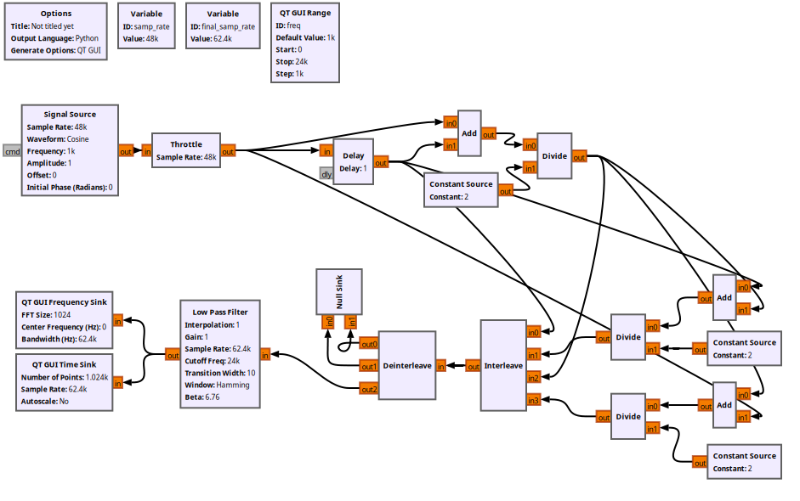
Lets now observe the output of this flowgraph:
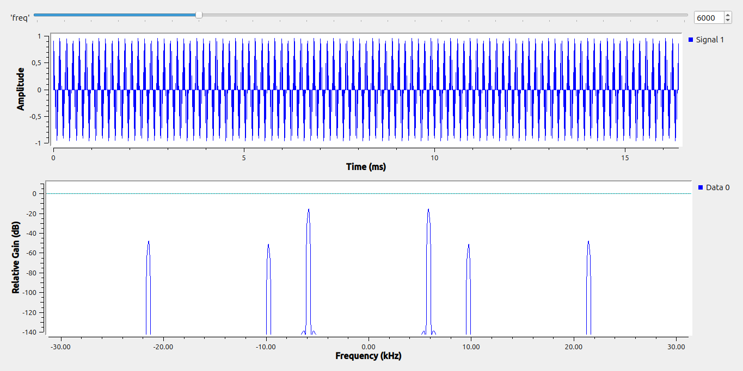
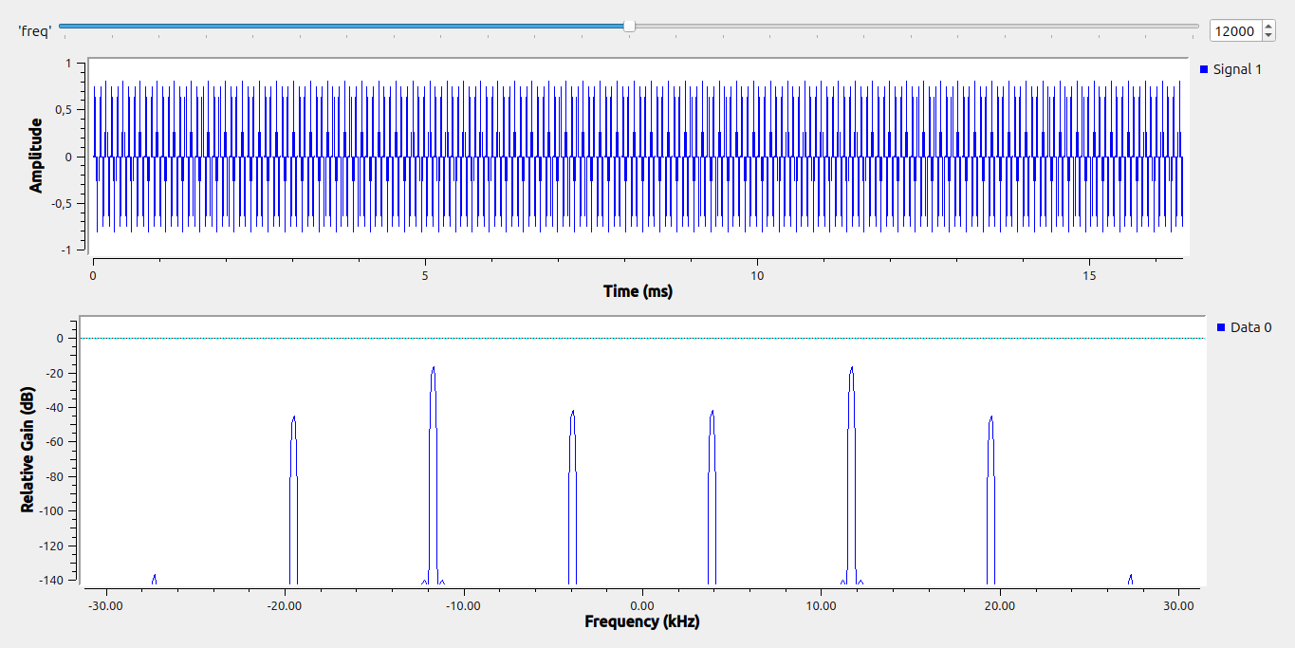

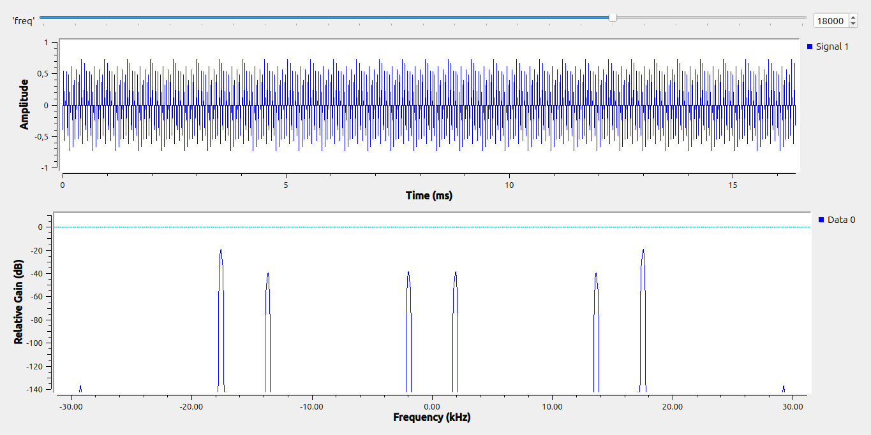
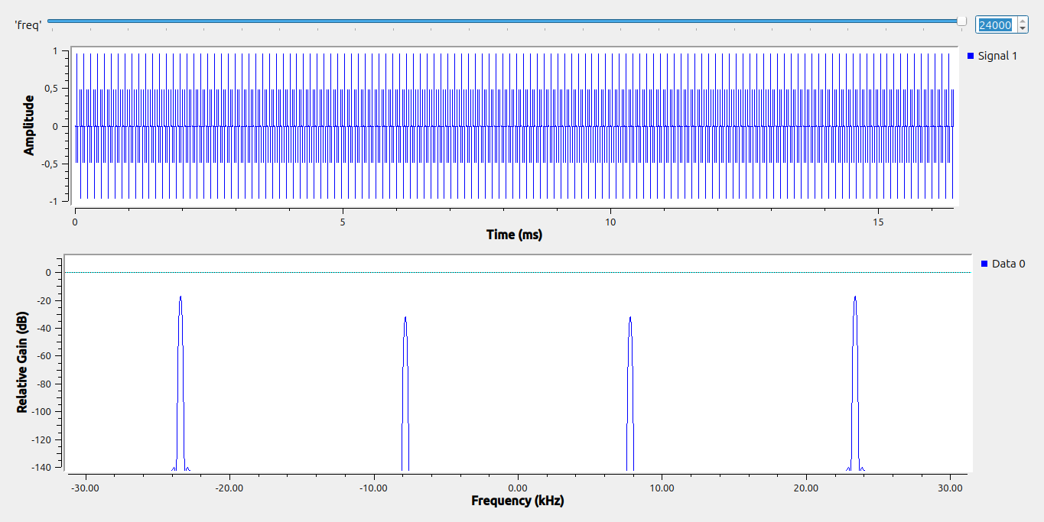
As we can observe from the up-sampled output signal, there exists some alias frequencies. These frequencies are due to the resampling that happened. The alias frequencies grater than 24kHz are being cut off

