HY330 – Telecommunication Systems
Chris Papastamos | csd4569
Assignment 2

Exercise 1
Question 1

The provided signals are transmitted without any loss of information because the system samples at 33kHz. The bandwidth of the system is 12kHz so according to Nyquist the minimum sampling frequency is 24kHz. That can also be confirmed by using a frequency sink and looking at the signal’s frequencies:

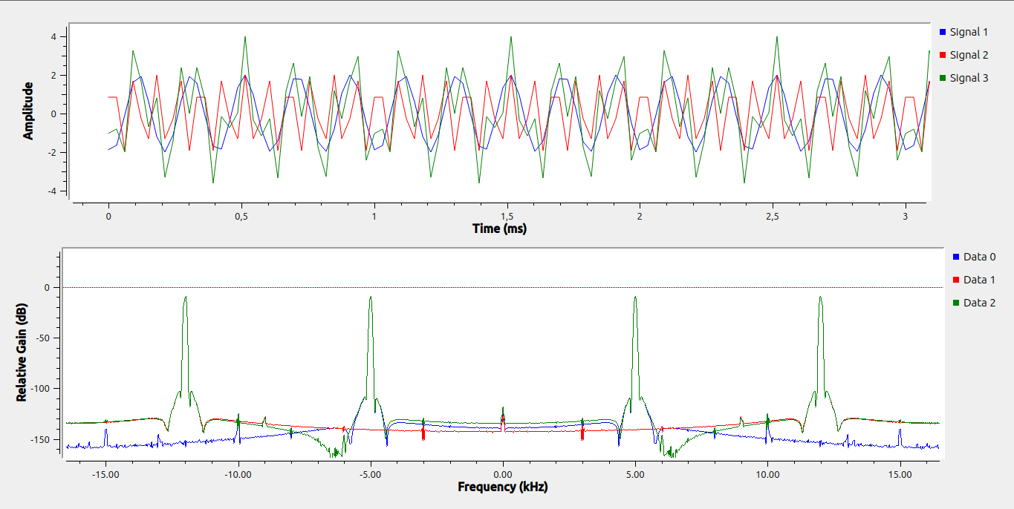
In the screenshot above we can observe the two signal’s frequencies are perfectly preserved through the sampling process.

Question 2
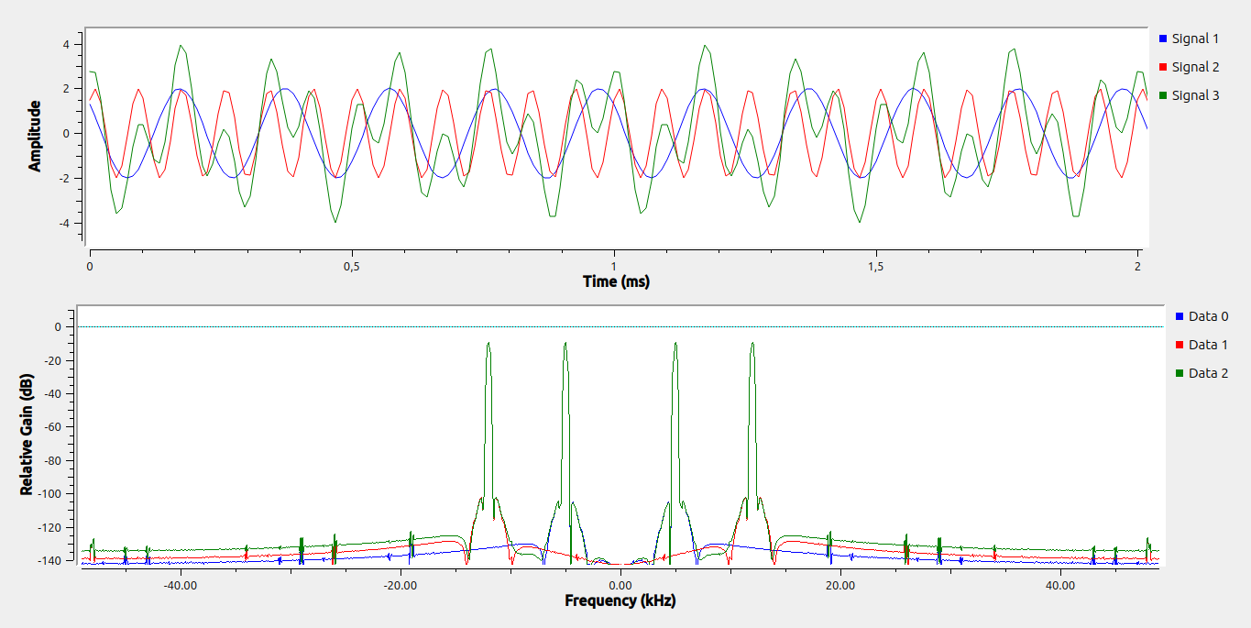
In order to have a smoother visual signal, I will chose a sampling rate of 98kHz which is 4 times the Nyquist frequency of the 12kHz cosine. This way the “fastest” cosine will be sampled 8 times in its period. The output of the new flowgraph can be seen below:
The CPU usage is obviously gonna be higher in the biggest sampling rate case and this can be proven by running htop while the flowgraph is running

Sampling rate 33kHz: (CPU 5%)
Sampling rate 98kHz: (CPU 10.1%)
Question 3
According to Nyquist the minimum sampling frequency is 2 times the bandwidth of the system. Our system consists of a cosine of 5kHz and a cosine of 12kHz. Thus the bandwidth is 12kHz and the minimum sampling frequency according to Nyquist is 24kHz.

Question 4

