HY436 - Software Defined Networks
Assignment 4
Christos Papastamos csd4569

Overview

For the fourt assignment I ran an instance of Artemis using a custom configutation file (code can be found below) to suit the assignment’s needs. In the config file there is a prefix watched (snd_assignment4) which is requested from the assignment. The source AS (sdn_assignment4_asn) and the neighbor AS (sdn_assignment4_neighbor) are also set up and a rule connecting ASes and prefixes is present too. Also a monitor is setup according to the basic config file from the git repository

Configuration File:
#
# ARTEMIS Configuration File (HY436 Assignment4)
#
# Start of Prefix Definitions
prefixes:
sdn_assignment4: &sdn_assignment4
- 184.164.247.0/24
# End of Prefix Definitions

# Start of ASN Definitions
asns:
sdn_assignment4_asn: &sdn_assignment4_asn
- 61574
sdn_assignment4_neighbor: &sdn_assignment4_neighbor
- 47065
# End of ASN Definitions

# Start of Monitor Definitions
monitors:
riperis: ['']
bgpstreamlive:
- routeviews
- ris
bgpstreamkafka:
host: bmp.bgpstream.caida.org
port: 9092
topic: '^openbmp\.router--.+\.peer-as--.+\.bmp_raw'
bgpstreamhist: '/etc/artemis/'
# End of Monitor Definitions

# Start of Rule Definitions
rules:
- prefixes:
- *sdn_assignment4
origin_asns:
- *sdn_assignment4_asn
neighbors:
- *sdn_assignment4_neighbor
mitigation: manual
# End of Rule Definitions

Results

In the screenshots included below are the hijacks found by Artemis. In total two types of hijacks were picked up by my implementation, E|0|-|- and E|1|-|-. E|0|-|- means that there was a hijack for the exact prefix (sdn_assignment4) with an illegal origin. E|1|-|- means that there was a hijack for the exact prefix (sdn_assignment4) with a legal origin but an illegal first hop. In the second screenshot an ongoing hijack can also be noticed!

E|0|-|- hijacks:
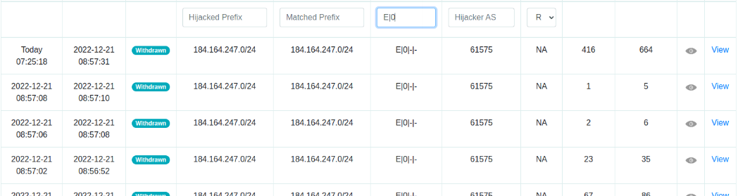
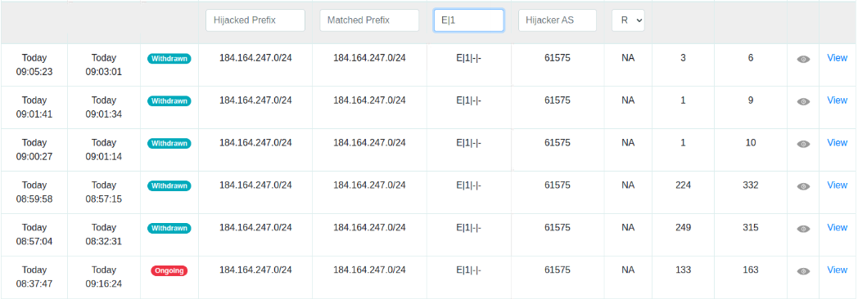
E|1|-|- hijacks:

