HY455 Cyber Security
Assignment 3
Chris Papastamos (csd4569)

Question 1
In order to identify the hash algorithm used on each of the given hases, I used hashid which is a tool used for this exact job. I also used the option -j that show the format code that JTR needs in order to run on these hashes for the next question. This tool cannot pinpoint the exact algorithm used for the hash, but on the contrary it suggests a list of algorithms that could produce a hash like the given.

For the first hash the most possible is some version of the Message Digest (MD) algorithm | 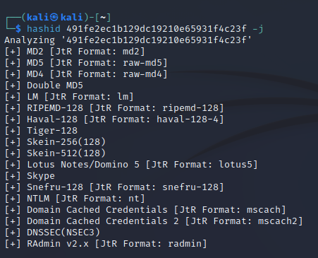
Similar to the first one, the second hash seems to be an MD hash as well | 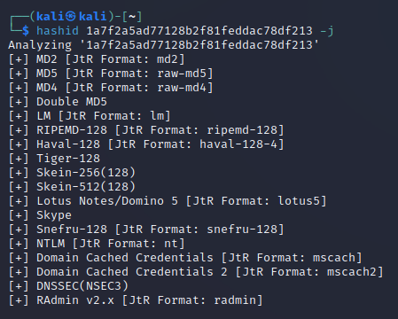
Judging by the different size of the hash it is clear that a different algorithm than the first two is used, hashid suggests SHA-1 among other hash types | 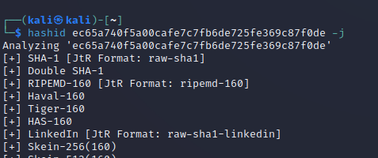

Question 2
For cracking the above hashes I will use the software called John The Ripper (john aka JTR). JTR will do a dictionary attack for each hash which will only work if the given format is indeed the hash algorithm used to create these hashes (I am going to specify the format using –format=[Format from hashid]). I decided not to provide JTR with a wordlist (dictionary) like rockyou.txt as it can use its default one (which seems to get the job done)

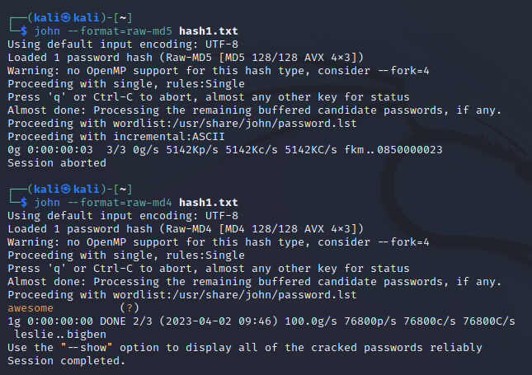

First up, trying to crack the first password the MD5 format didn’t return any results. That either means that the password is not in the dictionary that JTR used to attack, or that the given format does not match the actual algorithm used.

Here we can observe that when we run JTR again with MD4 as format, we get a result. With this we conclude that the first password is “awesome”

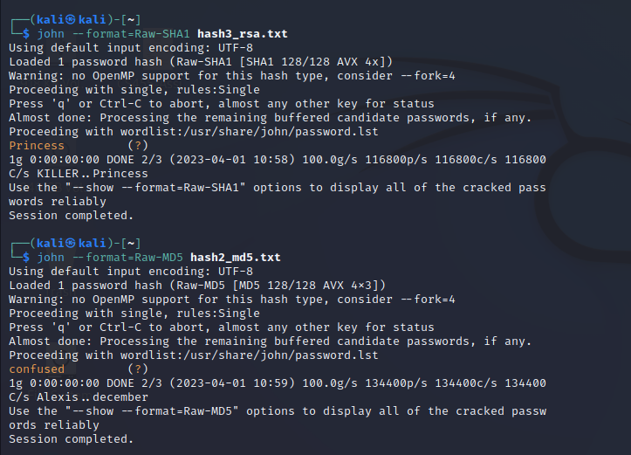

For the last two hashes the process was pretty much the same as I got a hit with the first try.

As it turns out, the password for the second hash is “Princess” and for the third hash it was “confused”.

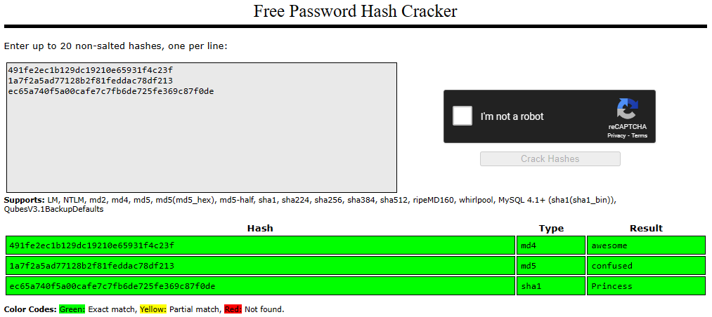
We can verify our findings by running a tool like crackstation.net which has a pre-computed hash lookup table for commonly used passwords

Question 3

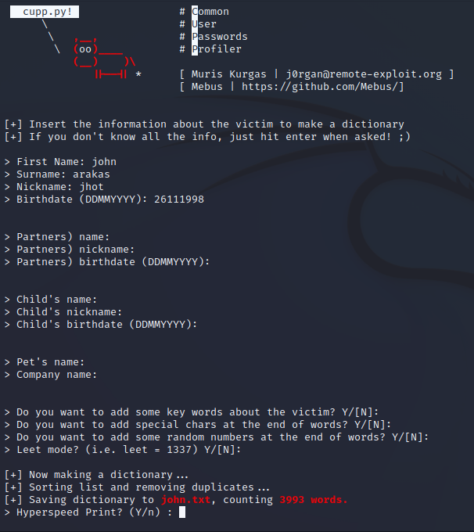

For this question I had to get (clone and run) cupp as the question suggests. After running it, a very easy to use user interface appeared in which I entered the information given about our target (Someone could add more information about a target for a bigger wordlist).

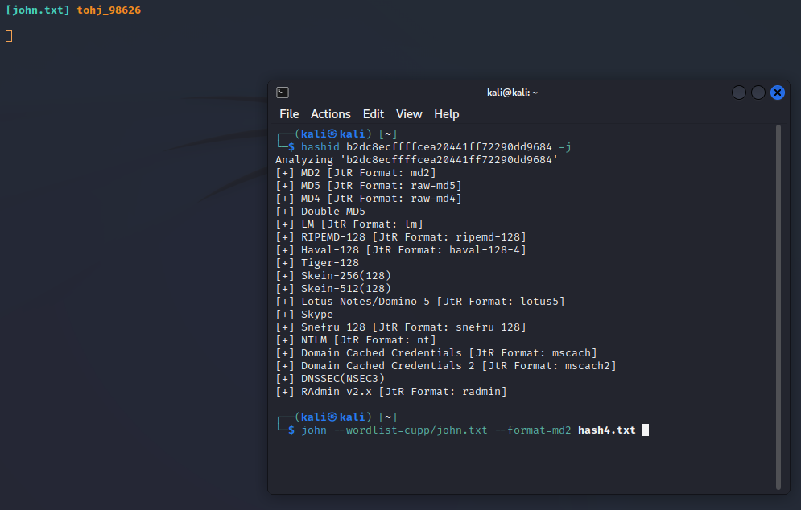
While I was waiting for cupp to finish, I run hashid for the given hash and found out it is most probably a Message Digest hash.

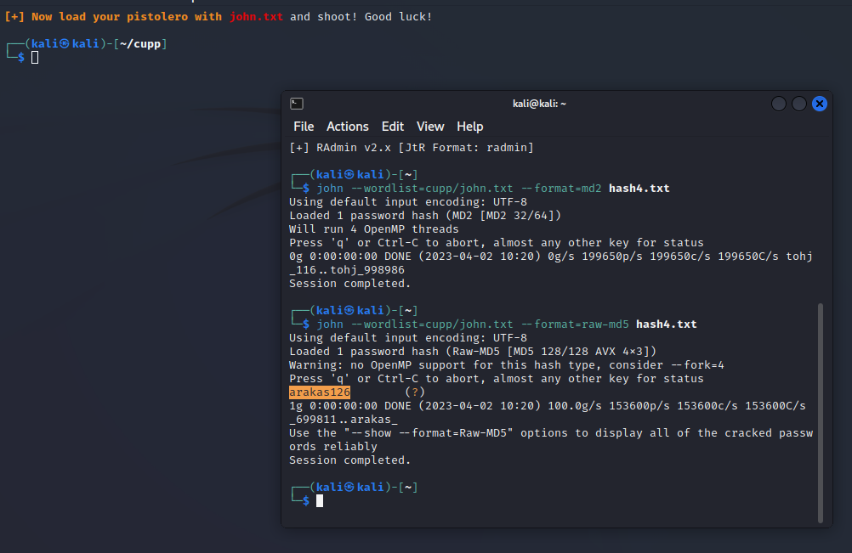

After cupp is finished, we can use the generated wordlist to run a dictionary attack (using JTR) for the given hash. The result that came through was “arakas126”

Question 4
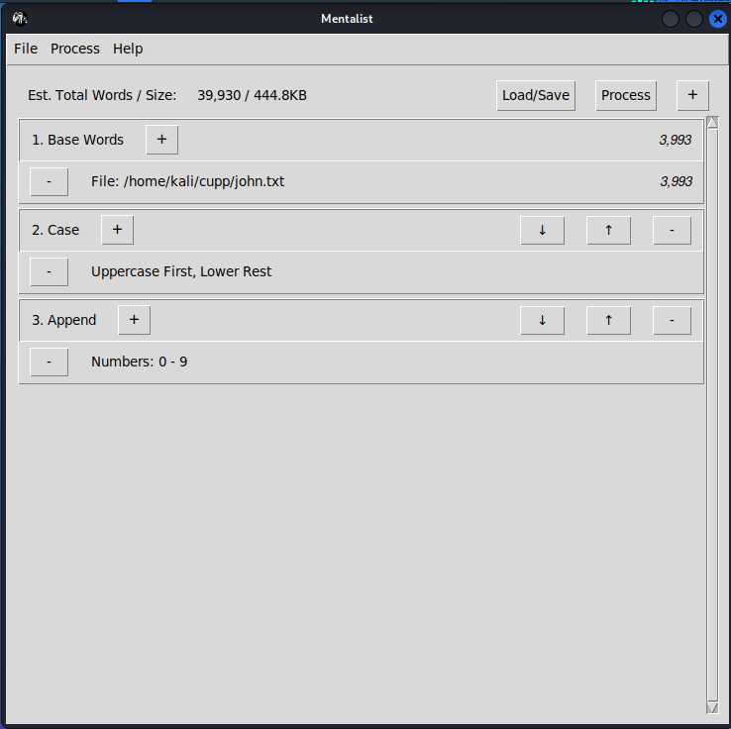
For this question, I used Mentalist as the question suggested. I had to clone the repo and install it as the wiki instructed. After I launched mentalist, all I had to do was to add my basic wordlist from the last question (john.txt). I also had to add two processes, one to use uppercase for the first letter and lowercase for the rest of them, and one to append a number from 0 to 9 in the end of each word.

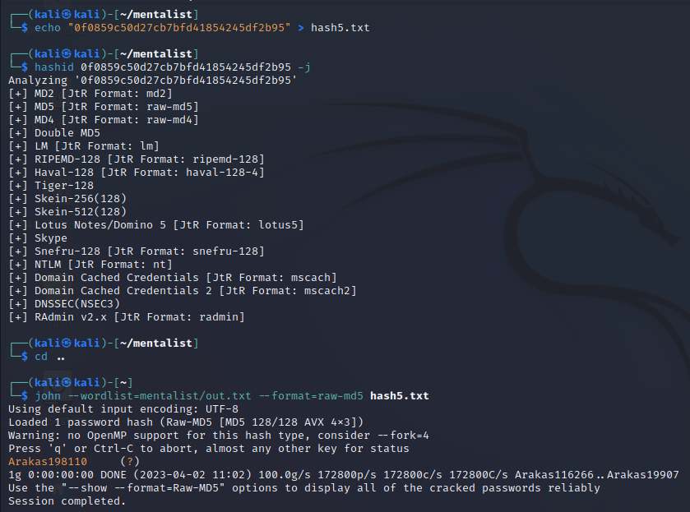

After the new wordlist was created, all I had to do was to run hashid to get the hash type of the given hash and when I figured out it was most probably a MD5 algorithm, I ran JTR for the hash and got the password “Arakas198110”.

Question 5
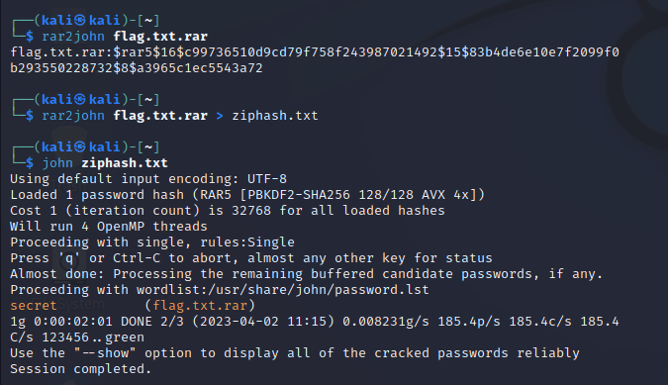

In order to find the password of the .rar file I used rar2john in order to produce the hash of the password. After that, all I had to do was to run JTR with the produced hash in order to get the rar password. As it turns out the password was “secret”.

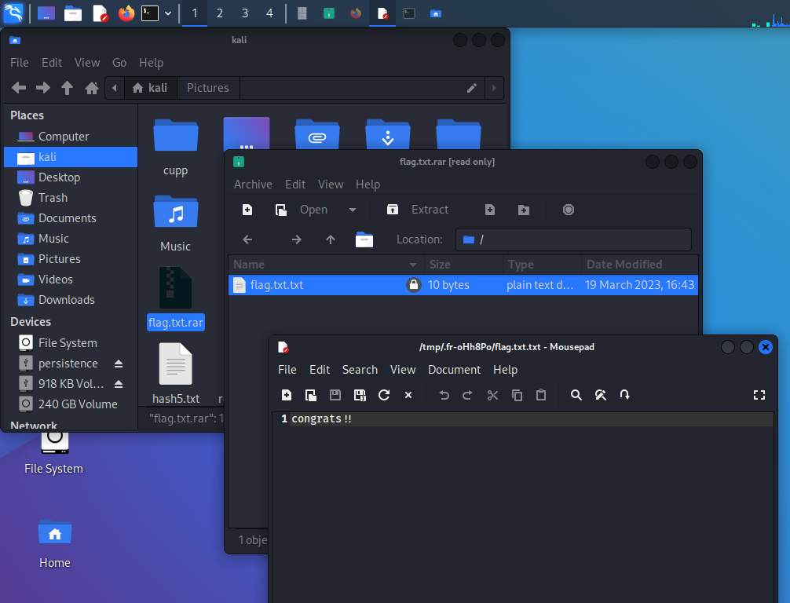

To verify my findings I extracted the file flag.txt.txt from the .rar file using the password “secret” and the txt file contained the flag “congrats!!”

Question 6
JTR has the option –mask whith which you can specify a mask for the words that it is going to include in the dictionary attack. The mask I am going to use is –mask=?d?d?d?d?d?d?d?d which is ordering JTR to search only for 8-digit words. For demonstrating this functonality of JTR I am going to hash the password “12345678” using an online MD5 generator. The hash I got and used is “25d55ad283aa400af464c76d713c07ad”. Passing this to JTR as well as the mask and the format, results in getting the password we initially hashed using MD5.
