HY455 Cyber Security
Assignment 4
Chris Papastamos (csd4569)

Question 1
The process of cracking this password manager open was fairly simple. First up I had to decompile the executable to reveal the code
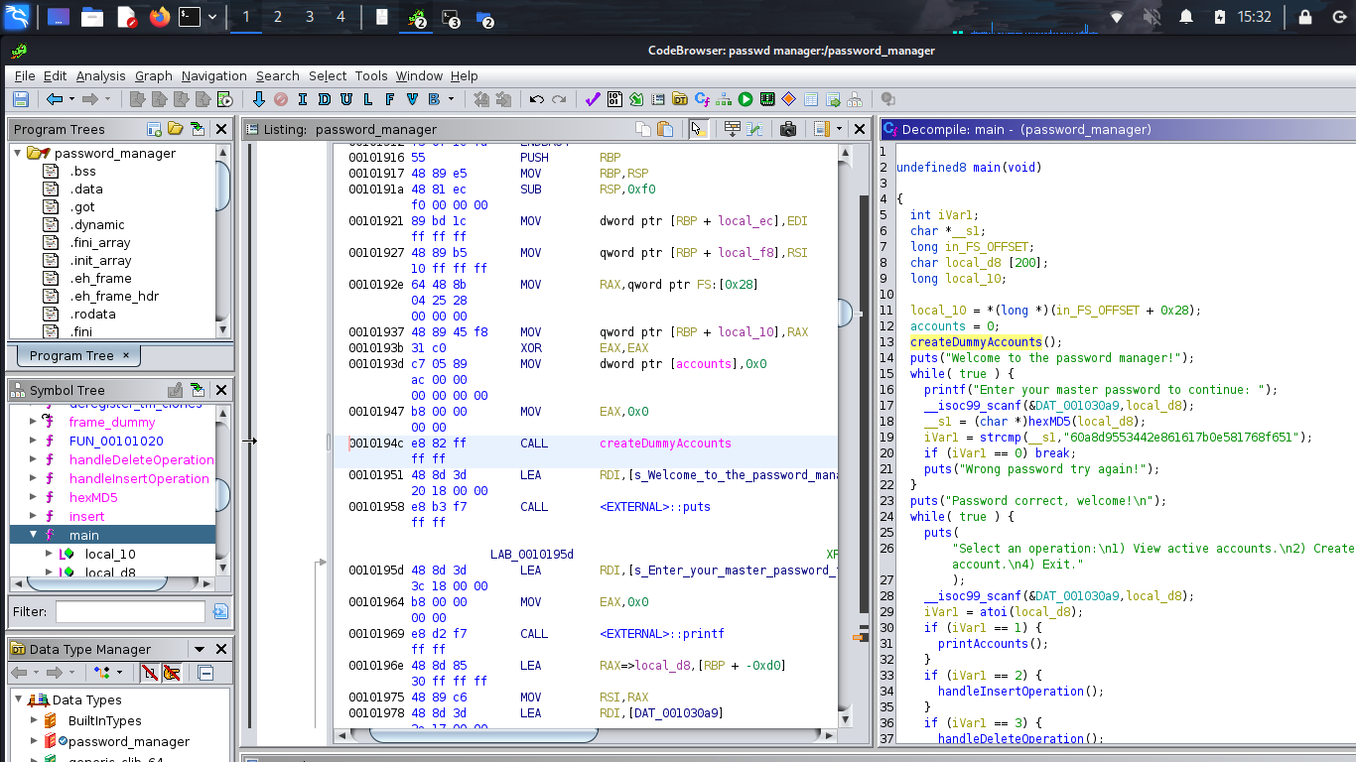
We can quickly observe from the 18’th line that the master password is hashed using MD5. Lets keep on digging further tho. Lets examine this “createDummyAccounts” function, maybe we will find something there.
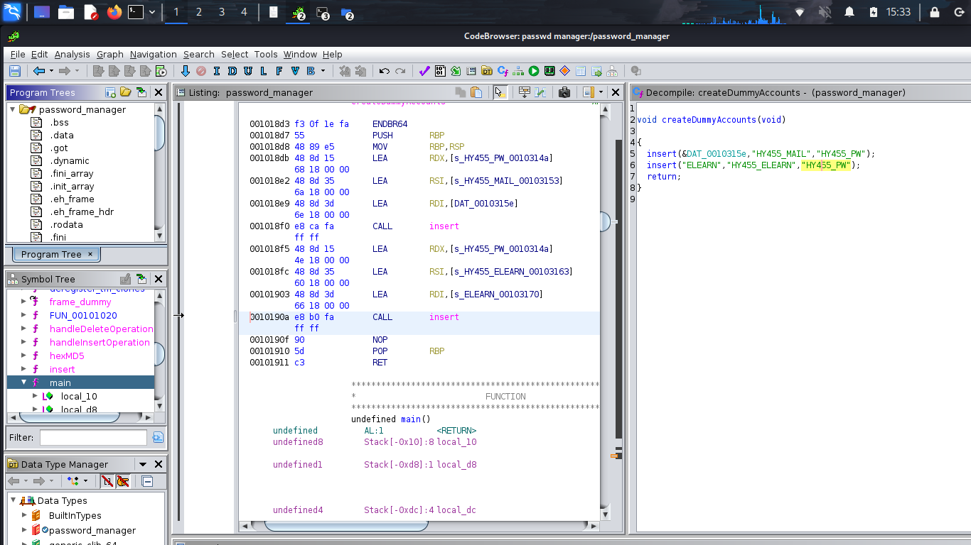
As we can see this function inserts the passwords of the two accounts without any encryption. That provides us the two accounts of the user.

