DIGITAL ELECTRONICS PROJECT
QUIZ SYSTEM

DONE BY:-PRADEEPTA RANJAN CHOUDHURY(B215041)
SALONA DASH(B215047)
ROHAN SAHOO(B215045)
SHISHA CHOTTRAY(B215039)

Topic:
Quiz buzzer system using D flip flop
Objective
To develop a system in which the display glows only of the switch that is clicked first and subsequent clicks do not show any display until next round.
Apparatus Required :
1.2 input AND gate
2.4 input AND gate
3.4input OR gate
4.Resistor(1k)
5.Push button switch(spst)
6.LED(blue,green,yellow,red)
7.D flip flop
8.Buzzer
9.12V source

Circuit Diagram
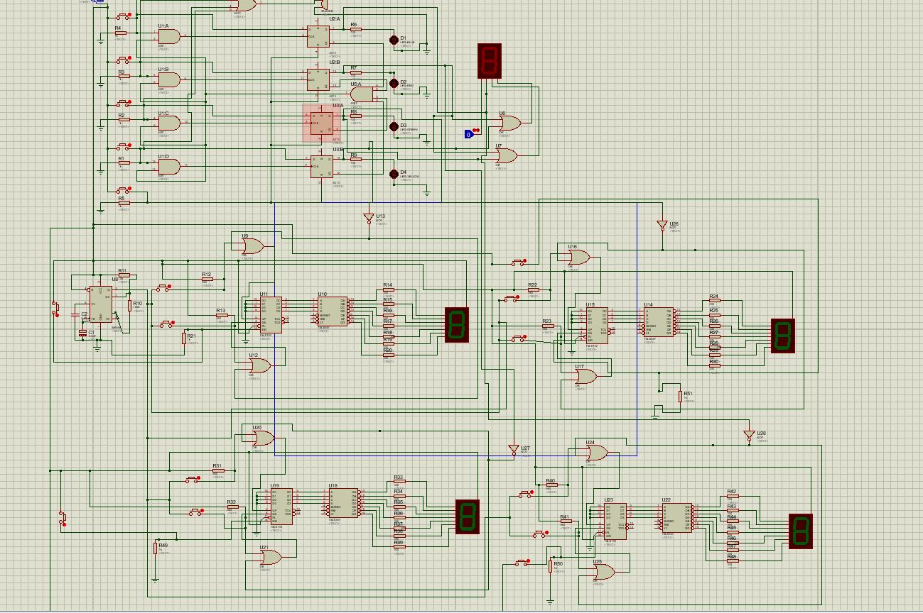
Principle
The main component which governs the system is the D flip flop.Initially all the inputs given to the AND gate is one so the output is also one which is going to all the input terminals of the two terminal AND gate.When the first switch is clicked,high pulse is given to the other input.The output of that gate becomes one and a clock goes to the D flip flop & the state of Q of the D flip flop becomes high & that makes the display glow. Then for the next round,reset is clicked which makes the entire set up go to its initial state.
Working
4-player quiz buzzer is based on three IC’s, namely-
1. IC CD4013 is a flip flops which exist in one of two states and can store information. Each module is further equipped with a group of pin outs assigned as data, set, reset, clock input and a couple complementary output Q and . As we know, output changes or toggles state as response to trigger applied to input terminals.
2. IC7408 is a quad 2-input AND gate. It will give you output as high or logic one when both the inputs are high otherwise we will receive low output. Quad 2 input AND gate has four independent AND gates on a single IC.
3. IC7421 is a Dual 4-input AND gate. To understand the working of circuit, one must know the truth table of 7421 IC. It will give you output as high or logic one when all four inputs are high otherwise we will receive low output. Dual 4- input AND gate has two independent AND gates on a single IC.
Working :. Initially it may possible all or may two LED will be glowing for that you have to first clear the flip flop by pressing reset switch. Under this condition Q output of IC2 and IC1 become low.
When no switch is pressed output of Q’ is high because it is receiving input from IC1 and IC2 Qbar which is high(CD4013 produces complimentary output). This shows that no switch is pressed and none of the LED will glow.
As soon as anybody from four candidates presses the switch, its corresponding LED would glow and other connection would be left disabled. Suppose candidate 1 presses the switch , making input pin1 of NI1go high(it is connected to power supply) and pin 2 of NI1 is also high and from the truth table of NANA gate is both the inputs are high we will receive a high output at pin3 of NI1, this will make the pin 6 of IC1 high which in turn on the LED1. This indicates that output pin1 of IC1 (Q) has become high. If Q is high then Qbar must be low. And if one low is supplied to IC3 it will make the output pin 6 of IC3 to go low hence further switching of switch is not allowed. Now no another candidate is allowed to press the switch until you have press the reset switch.
Similar phenomenon occur when another candidate press the switch. The candidate who presses the switch respective IC output goes high and LED glows to indicate this and others are not allowed to press the switch
Advantages
1. Real life implication is possible.
2. In-expensive.
Conclusion
The practical use of D flip flop is demonstrated and a circuit is designed which can be used in quiz.

