The Spine — Foundation patterns every module reuses
Read this once. The platform is a Laravel 11 modular monolith (nwidart/laravel-modules): 17 domain modules under Modules/*, each with its own providers, routes/api.php, database/migrations, Models, Services, Events, Listeners, Workflow handlers and tests. Everything cross-cutting lives in app/Foundation. Master these ~7 patterns and every module reads as "business logic on top of the spine."

🎬 One worked example — "Jane activates her subscription"
Follow this once; it touches every pattern below. (Proven by Subscription/tests/Feature/SubscriptionApiTest::test_activate_runs_workflow_and_sets_active.)
- Request (a back-office agent clicks "Activate"):
- POST /api/subscriptions/sub_123/activate
Authorization: Bearer <sanctum token>
Idempotency-Key: act-sub_123-1
- Middleware chain (pattern 1,2,7): auth:sanctum → permission:subscription.activate → (scope if declared) → idempotency (no prior key → proceeds) → ResolveOperatorContext pinned Context::operatorCode() = WIK.
- Service (OperationController → OperationFramework::trigger('ACTIVATE')): checks idempotency
  - single-in-flight, then in one DB transaction writes a subscription_operation row (current_state=INITIATED) and publishes SubscriptionOperationStarted to the outbox (pattern 3 — the row and the event commit together or not at all).
- Starts the workflow (pattern 4): WorkflowEngine::start('sub-activate', businessKey=sub_123, {subscriptionId, operationId, …}) creates a ProcessInstance + ExternalTask rows. HTTP returns 202 with the operation id. Nothing else has happened synchronously.
- Outbox dispatch (every minute, or artisan sophix:outbox:dispatch in tests): fires OutboxEventPublished → Reporting projector counts it, Notification may notify. (Inbox dedupe means a re-run won't double-count.)
- Workflow worker (sophix:workflow:work) drains the tasks, one handler per topic: ValidateActivationHandler → BillingIntentHandler (if there's an activation fee and it's pay-first, this parks the flow on a ful-payment-received catch until InvoicePaid arrives — pattern 3 again) → ActivateHandler calls SubscriptionService::transitionStatus(ACTIVE) which emits SubscriptionActivated → FulfillmentCallHandler calls ProvisioningService::broadcast().
- Reconcile: when the instance ends, ProcessInstanceEnded → SyncOperationFromProcess closes the subscription_operation ledger (final_state, emits SubscriptionOperationCompleted).
- Downstream of SubscriptionActivated: Billing anchors the first cycle, Reporting increments subscriptions_activated, Notification sends the welcome notice — all as reactions, none called synchronously from step 3.
The shape never changes: thin controller → service (mutate + emit in one tx) → async dispatch → listeners/workflow react. Learn it here; every module repeats it.
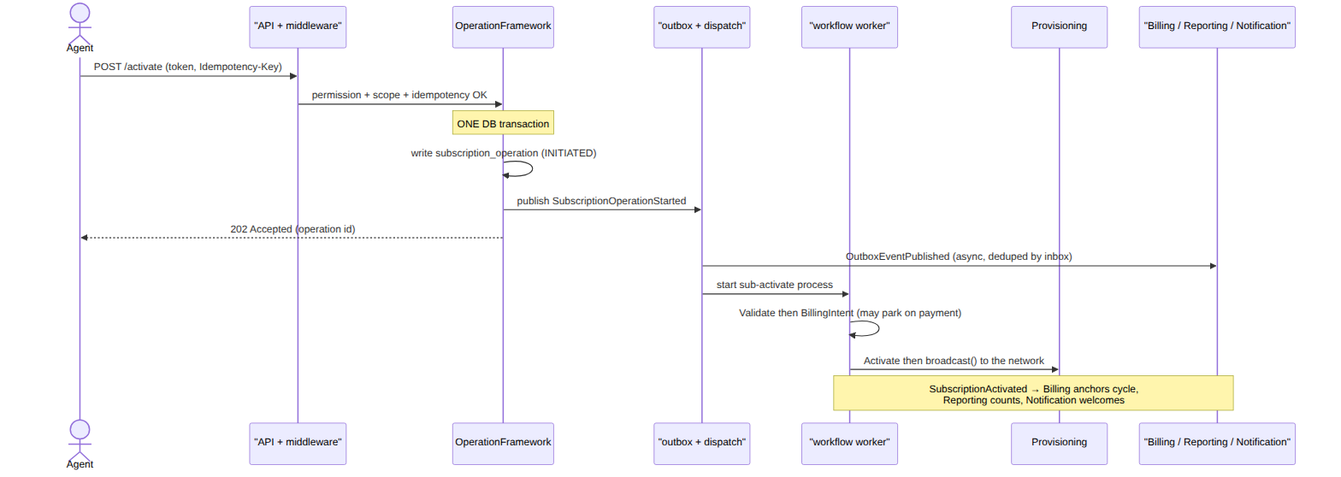

1. Tenancy & Context — who and which operator
- App\Foundation\Support\Context holds the per-request operator code and correlation id. Resolved server-side by ResolveOperatorContext middleware; the X-Operator-Code header only widens scope for a principal with platform.cross_operator.
- App\Foundation\Tenancy\BelongsToOperator (model trait) adds a global query scope filtering every read by operator_code, and pins operator_code on create from Context — so tenant isolation is automatic and can't be bypassed by a client-supplied value.
- Takeaway: you almost never filter by operator by hand; the trait does it.

2. HTTP & errors — thin controllers, one error model
- Controllers validate + delegate to a service; responses go through App\Foundation\Http\ApiResponse (item / created / paginated / error).
- Business failures throw App\Foundation\Errors\DomainException (carries errorCode, status, nextAction, fieldErrors). bootstrap/app.php renders the SOPHIX standard error model for all api/* requests (DD_API-00 §8).
- Route guards stack: auth:sanctum → permission:<code> → scope:<type>,<key> (optional) → idempotency (optional) → controller.

3. Events — the integration backbone (transactional outbox)
- App\Foundation\Events\EventBus is the interface; the default Drivers\OutboxEventBus::publish() only writes an outbox_events row, inside the same DB transaction as the state change.
- A scheduler command sophix:outbox:dispatch (DispatchOutboxCommand, every minute) forwards committed rows by firing OutboxEventPublished in-process (native driver) or to Kafka.
- Module listeners subscribe to OutboxEventPublished, switch on $published->event->event_type, and react. Consumers dedupe through an inbox (InboxEvent, one row per event_id+consumer) so replays never double-process (e.g. Reporting\Projectors\ReportMetricProjector).
Why an outbox? Writing the state change and "sending" the event in the same DB transaction means they can never disagree — if the transaction rolls back, the event was never queued either. A separate dispatcher then delivers it, and the inbox makes re-delivery safe.
- Pattern: publish a DomainEvent(type, topic, payload, aggregateType, aggregateId) from inside your service's transaction; never call another module synchronously for a side-effect that can be a reaction. In tests, drive it with $this->artisan('sophix:outbox:dispatch').

4. Workflow — config-defined processes, external-task workers
- Long/multi-step processes are data: a process_definition graph (authored in the Studio), not code. Modules\Workflow\Engine\WorkflowEngine::start(processKey, businessKey, variables, operator) creates a ProcessInstance and ExternalTask rows per service-task node.
- Each step is a TaskHandler (interface: topic(), label(), handle(TaskContext): TaskResult) registered into the TaskRegistry by a module's *WorkflowProvider.
- A shared worker sophix:workflow:work (--once = drain) fetch-and-locks CREATED tasks by topic, runs the handler, and completes/fails them. sophix:workflow:tick fires due timers and reaps dead locks.
- Message catches resume via WorkflowEngine::correlateMessage(name, businessKey, vars) — used to wake a parked flow on an event (e.g. WorkOrderFinalized, CustomerKycApproved).
- Mantra: new flow = compose registered topics (config); new step = register one handler (code).
The loop in a picture: start an instance → the engine drops a task on a queue → a worker drains it and runs the handler → the flow advances. When a step must wait, it parks until a message wakes it.
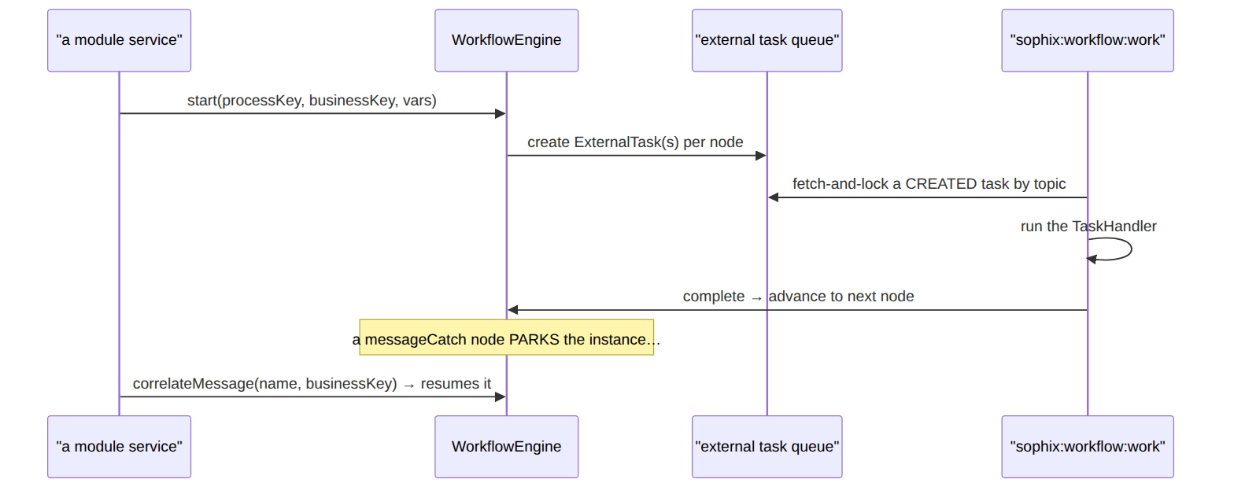

5. Approvals — EM-CFG-04, config-driven maker-checker as an ordered chain
- approval_definition is purely the policy header (WHEN: operator + entity_type + optional action
  - threshold_amount). approval_stage is the only place approver config lives (WHO, in order) — no duplicated approver columns on the definition.
- App\Foundation\Approvals\ApprovalService::request($data) matches a definition. No matching policy (or amount below threshold_amount) ⇒ auto-approved; otherwise ⇒ PENDING on the first stage.
- Approval is an ordered chain of stages, not a flat count. Each stage targets either a platform ROLE (any of approver_roles) or a specific named USER (approver_user_ref/approver_email — a senior like a director who holds no platform role, just an invited login; POST /api/approval-approvers/invite provisions one). A stage carries its own quorum (required_approvals) and self-approval toggle (allow_requester).
- decide($request, $approve, $actorUser) acts on the current stage only: it enforces segregation of duties (requester can't self-approve unless that stage's allow_requester), the stage's approver target (role membership or being the named user; SUPER_ADMIN may always act), and a distinct-approver guard (one person can't fill two slots in the same stage — 409 DUPLICATE_STAGE_APPROVER). Every action writes an immutable approval_decision row tagged with its stage_sequence. When a stage's quorum is met it advances (emits ApprovalStageAdvanced); the final stage flips to APPROVED (emits ApprovalApproved, topic platform.approvals). A reject at any stage fails the whole chain (ApprovalRejected).
- Every approval is a chain. All policies declare an explicit chain via ApprovalDefinition::defineChain($op, $entityType, $action, [$stage, …]) — a single-stage chain where one approver suffices (force-sync, field-audit), a multi-stage one for a hierarchy (CVM high-value retention: CVM_MANAGER → named director). A definition with no stages is a misconfiguration; the engine still gates it with one open stage rather than silently auto-approving.
- Owning modules resume on the outcome via a listener (e.g. Ilm\Listeners\ResumeCvmOfferOnApproval, Osr PO decide, Provisioning force-sync). The notification side is bridged to ICN-01 (NotifyApproversOnApprovalRequested), which alerts the current stage's approvers on the initial request and on each advance: a ROLE stage notifies its approver_roles as candidate groups; a USER stage is sent a direct message to the named person's address (StaffNotificationService:: dispatchDirect, EMAIL today) so an approver who belongs to no group is still reached.
- Pattern: gate a sensitive action with request(), store the request_id, resume on ApprovalApproved/ApprovalRejected.
- The distinct-approver guard is within a stage; cross-stage separation comes from each stage targeting a different role/person.
Worked example — "manager then director": a 2-stage chain. Stage 1 is a ROLE (CVM_MANAGER), stage 2 is a named USER (a director with an invited login, no platform role). The request only reaches the director after a manager clears stage 1.
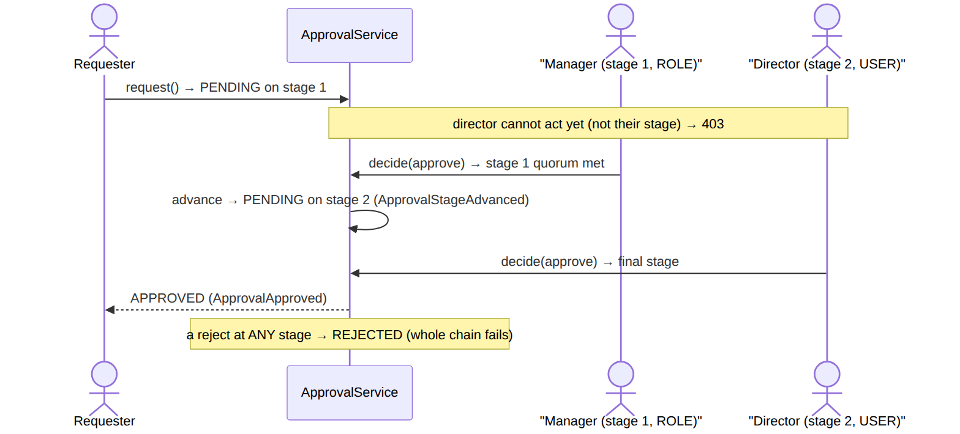

6. Rules — operator-overridable decision tables
- App\Foundation\Rules\RuleEngine::evaluate('rules.<package>', $facts) returns a decision. The package is a decision_table (data) when deployed, else a registered code fallback (e.g. rules.billing.adjustment-approval, rules.tax-applicability, rules.cvm.offer).
- Pattern: branch on policy through a rules package, never a hardcoded if for operator-varying behaviour.

7. Idempotency & scope — safe retries, data scope
- idempotency middleware (EnforceIdempotency, opt-in per route): with an Idempotency-Key, same key+body replays the stored response; same key+different body ⇒ 409.
- scope:<type>,<key> middleware (Rbac\Http\Middleware\EnforceScope): after permission, checks the target value (route/body) is within the caller's RBAC scope (GLOBAL/OPERATOR/SUPER_ADMIN bypass).

The life of … (trace these once)
A write request: HTTP → auth:sanctum → permission → scope? → idempotency? → Controller (validate) → Service (DB tx: mutate + publish DomainEvent to outbox) → ApiResponse. Then async: sophix:outbox:dispatch → OutboxEventPublished → module listeners react.
A workflow operation: Service.trigger() → WorkflowEngine.start(process_definition) → ExternalTask rows → sophix:workflow:work drains → TaskHandler.handle → complete → next node → … → ProcessInstanceEnded → operation ledger reconciled.
An approval: Service → ApprovalService.request() → (PENDING) → decide endpoint → ApprovalApproved (outbox) → owning-module resume listener applies the outcome.

📖 Foundation scenarios (the patterns at work)

1. Tenancy isolation (pattern 1)
A WIK-scoped user GET /api/customers — BelongsToOperator's global scope silently adds where operator_code='WIK', so MSA rows are invisible. A client can't widen this with a body field; only X-Operator-Code + the platform.cross_operator permission changes the Context operator.

2. Outbox publish + dispatch (pattern 3)
SubscriptionService::transitionStatus(ACTIVE) runs inside a DB transaction: it updates the row and inserts an outbox_events row for SubscriptionActivated. If the tx rolls back, neither happens. A minute later sophix:outbox:dispatch picks up the unpublished row, fires OutboxEventPublished, and stamps published_at. Atomic state+event, then async fan-out.

3. Inbox dedupe (pattern 3)
ReportMetricProjector receives the event, does inbox_events.firstOrCreate(event_id, consumer); the row's processed_at is null → it projects and stamps it. A re-dispatch of the same event_id finds processed_at set → returns immediately. At-most-once per consumer.

4. Approval auto-approves when no policy (pattern 5)
ApprovalService::request({entity_type:'PURCHASE_ORDER'}) with no matching approval_definition → the request is created AUTO_APPROVED and emits ApprovalAutoApproved. Out-of-the-box flows aren't blocked; an operator opts into gating by adding a definition row.

5. Approval gated as an ordered chain + segregation of duties (pattern 5)
With a definition, the request is PENDING on stage 1. The requester calling decide(approve:true) → SELF_APPROVAL_NOT_ALLOWED (403) unless that stage's allow_requester. A CVM_MANAGER clears stage 1 → an approval_decision (stage_sequence:1) is written and the request advances to stage 2 (ApprovalStageAdvanced), still PENDING. Stage 2 targets a named director (approver_kind:USER) — the manager cannot act on it (403), and the director (an invited login, no role) approves → request flips APPROVED, emits ApprovalApproved. A second approval from the same person within one stage → 409 DUPLICATE_STAGE_APPROVER; a reject at any stage → REJECTED for the whole chain. Proven by ApprovalChainTest + CvmTest.

6. Idempotent retry replays (pattern 7)
POST …/activate with Idempotency-Key: k1 stores {key, request_hash, response, status} in idempotency_keys. The client times out and retries with the same key + same body → the middleware returns the stored response, the controller never runs twice.

7. Idempotency conflict (pattern 7)
The same Idempotency-Key: k1 with a different body → request_hash mismatch → 409 (a key may not be reused for a different request).

8. Scope gate (pattern 7)
A region-scoped dispatcher POST /api/work-orders {tech_region_id:'KE-NRB-KAREN'} → scope:TECH_REGION, tech_region_id calls withinScope → true (exact match) → allowed; KE-MSA-NYALI → 403 OUT_OF_SCOPE; a SUPER_ADMIN bypasses.

9. Rules: table else fallback (pattern 6)
RuleEngine::evaluate('rules.tax-applicability', facts) returns a deployed decision_table match; rules.billing.adjustment-approval with no table deployed → the registered code fallback answers. A package always resolves deterministically.

10. Workflow start → drain → correlate (pattern 4)
OperationFramework::trigger('PAUSE') → WorkflowEngine.start('sub-pause') creates workflow_external_task rows; sophix:workflow:work drains them; a messageCatch parks until correlateMessage('sub-payment-confirmed', …) (fired by a listener on InvoicePaid) resumes it.

Foundation data model — sample rows + readings
Convention (applies to every doc): each sample row shows every domain column (nullables included, as null). The Laravel surrogate id and the created_at/updated_at audit timestamps are omitted by convention — no reading ever depends on them.

outbox_events (the transactional outbox)
Columns: event_id, event_type, topic, aggregate_type, aggregate_id, operator_code, correlation_id, payload, headers, published_at, attempts.
{ "event_id":"evt_1","event_type":"SubscriptionActivated","topic":"subscription.lifecycle","aggregate_type":"Subscription","aggregate_id":"sub_1","operator_code":"WIK","correlation_id":"corr_88","payload":{"subscriptionId":"sub_1"},"headers":null,"published_at":"2026-06-20T10:01:00Z","attempts":1 }
{ "event_id":"evt_2","event_type":"InvoiceGenerated","topic":"billing.money","aggregate_type":"Invoice","aggregate_id":"inv_9","operator_code":"WIK","correlation_id":"corr_90","payload":{"invoiceId":"inv_9","total":"5000"},"headers":null,"published_at":null,"attempts":0 }
{ "event_id":"evt_3","event_type":"ApprovalRequested","topic":"platform.approvals","aggregate_type":"ApprovalRequest","aggregate_id":"appr_5","operator_code":"WIK","correlation_id":"corr_91","payload":{"requestId":"appr_5","entityType":"PURCHASE_ORDER","status":"PENDING"},"headers":null,"published_at":"2026-06-20T10:02:00Z","attempts":1 }
{ "event_id":"evt_4","event_type":"WorkOrderFinalized","topic":"workorder.field","aggregate_type":"WorkOrder","aggregate_id":"wo_1","operator_code":"WIK","correlation_id":"corr_92","payload":{"workOrderId":"wo_1"},"headers":null,"published_at":null,"attempts":2 }
Read each row — this data means this:
Row | What it means in plain English
evt_1 | A SubscriptionActivated event that was already delivered (published_at set) on the first try (attempts:1).
evt_2 | An InvoiceGenerated event written but not yet sent (published_at:null, attempts:0) — it committed together with the invoice; the dispatcher will pick it up next run.
evt_3 | An ApprovalRequested event, delivered; its payload carries the request id + status the listeners need.
evt_4 | A WorkOrderFinalized event still unsent after two failed tries (attempts:2, published_at:null) — it keeps retrying.
The columns that did the work: published_at = sent or not · attempts = retry count · correlation_id threads one business action across events · topic = the channel · payload = what listeners read.

inbox_events (per-consumer dedupe)
Columns: event_id, consumer, event_type, processed_at.
{ "event_id":"evt_1","consumer":"reporting.metrics","event_type":"SubscriptionActivated","processed_at":"2026-06-20T10:01:05Z" }
{ "event_id":"evt_1","consumer":"notification.bridge","event_type":"SubscriptionActivated","processed_at":"2026-06-20T10:01:06Z" }
{ "event_id":"evt_4","consumer":"fulfillment.resume","event_type":"WorkOrderFinalized","processed_at":"2026-06-20T10:03:00Z" }
{ "event_id":"evt_4","consumer":"workforce.capacity","event_type":"WorkOrderFinalized","processed_at":null }
Read each row — this data means this:
Row | What it means in plain English
evt_1 · reporting.metrics | Reporting has already counted this activation (processed_at set).
evt_1 · notification.bridge | The same event, processed independently by Notification — its own dedupe row, so both ran once.
evt_4 · fulfillment.resume | Fulfillment has already handled this WorkOrderFinalized.
evt_4 · workforce.capacity | Workforce claimed it but hasn't finished (processed_at:null) — and a redelivery to any consumer whose processed_at is set is a no-op.
Dedupe is per (event_id, consumer) — that's why one event can have four rows.

approval_definition (the policy header — WHEN approval is needed)
Columns: definition_id, operator_code, entity_type, action, threshold_amount, active. No approver columns — who approves lives only in approval_stage (below). Every definition has ≥1 stage.
{ "definition_id":"appd_1","operator_code":"WIK","entity_type":"PROVISIONING_FORCE_SYNC","action":"FORCE_SYNC","threshold_amount":null,"active":true }
{ "definition_id":"appd_2","operator_code":"WIK","entity_type":"ADJUSTMENT","action":null,"threshold_amount":10000.00,"active":true }
{ "definition_id":"appd_3","operator_code":"WIK","entity_type":"CVM_OFFER","action":"CVM_HIGH_VALUE_RETENTION_OFFER","threshold_amount":null,"active":true }
{ "definition_id":"appd_5","operator_code":"WIK","entity_type":"PURCHASE_ORDER","action":"PO_APPROVAL","threshold_amount":500000.00,"active":true }
{ "definition_id":"appd_4","operator_code":"WIK","entity_type":"DISCOUNT","action":null,"threshold_amount":50000.00,"active":false }
Read each row — this data means this:
Row | What it means in plain English
appd_1 | A force-sync always needs approval (threshold_amount:null = no free pass).
appd_2 | Any ADJUSTMENT (action:null = all actions) of 10,000 or more needs approval; below that it auto-approves.
appd_3 | Every high-value CVM retention offer needs approval — its approver chain is in approval_stage below.
appd_5 | A purchase order of 500,000 or more needs approval — chain below.
appd_4 | A DISCOUNT policy that is switched off (active:false) → ignored; discounts auto-approve until it's re-enabled.
Who approves is entirely in the approval_stage rows — one stage for a simple gate, several for a hierarchy.

approval_stage (the ordered chain) · approver_kind: ROLE | USER
Columns: stage_id, operator_code, definition_id, sequence, name, approver_kind, approver_roles, approver_user_ref, approver_email, required_approvals, allow_requester.
{ "stage_id":"appds_1","operator_code":"WIK","definition_id":"appd_3","sequence":1,"name":"CVM manager review","approver_kind":"ROLE","approver_roles":["CVM_MANAGER"],"approver_user_ref":null,"approver_email":null,"required_approvals":1,"allow_requester":false }
{ "stage_id":"appds_2","operator_code":"WIK","definition_id":"appd_3","sequence":2,"name":"Director sign-off","approver_kind":"USER","approver_roles":null,"approver_user_ref":"usr_dir9","approver_email":"cvm.director@wik.sn","required_approvals":1,"allow_requester":false }
{ "stage_id":"appds_3","operator_code":"WIK","definition_id":"appd_5","sequence":1,"name":"Finance lead","approver_kind":"ROLE","approver_roles":["BILLING_LEAD"],"approver_user_ref":null,"approver_email":null,"required_approvals":2,"allow_requester":false }
{ "stage_id":"appds_4","operator_code":"WIK","definition_id":"appd_5","sequence":2,"name":"Finance director","approver_kind":"USER","approver_roles":null,"approver_user_ref":"usr_findir","approver_email":"fin.director@wik.sn","required_approvals":1,"allow_requester":false }
Read each row — this data means this:
Row | What it means in plain English
appds_1 | appd_3 stage 1: any CVM_MANAGER (a ROLE) signs first.
appds_2 | appd_3 stage 2: only the named director cvm.director@wik.sn (a USER, no platform role, invited login) signs last.
appds_3 | appd_5 stage 1: needs two distinct BILLING_LEADs (required_approvals:2) before it moves on.
appds_4 | appd_5 stage 2: then the named finance director signs.
So appd_3 reads "CVM manager → director" and appd_5 reads "two finance leads → finance director". The chain always runs in sequence order — a later stage opens only after the earlier one's quorum is met.

approval_request (an instance) · status: PENDING|AUTO_APPROVED|APPROVED|REJECTED
Columns: request_id, operator_code, entity_type, action, entity_ref, amount, payload, status, current_stage, total_stages, approvals_count, stages_snapshot, requested_by, decided_by, decision_reason, decided_at. The active stage (its approver target, quorum, SoD toggle) is read from stages_snapshot[current_stage] — not duplicated on the row.
{ "request_id":"appr_5","operator_code":"WIK","entity_type":"PROVISIONING_FORCE_SYNC","action":"FORCE_SYNC","entity_ref":"pfs_2","amount":null,"payload":{"target":"GPON"},"status":"PENDING","current_stage":1,"total_stages":1,"approvals_count":0,"stages_snapshot":[{"sequence":1,"approver_kind":"ROLE","approver_roles":[],"required_approvals":1,"allow_requester":false}],"requested_by":"u_noc1","decided_by":null,"decision_reason":null,"decided_at":null }
{ "request_id":"appr_6","operator_code":"WIK","entity_type":"CVM_OFFER","action":"CVM_GOODWILL_CREDIT","entity_ref":"cvo_2","amount":null,"payload":{"discountPercent":5},"status":"AUTO_APPROVED","current_stage":1,"total_stages":1,"approvals_count":0,"stages_snapshot":null,"requested_by":"u_agent","decided_by":null,"decision_reason":null,"decided_at":"2026-06-20T09:00:00Z" }
{ "request_id":"appr_10","operator_code":"WIK","entity_type":"CVM_OFFER","action":"CVM_HIGH_VALUE_RETENTION_OFFER","entity_ref":"cvo_7","amount":null,"payload":{"discountPercent":25},"status":"PENDING","current_stage":2,"total_stages":2,"approvals_count":0,"stages_snapshot":[{"sequence":1,"approver_kind":"ROLE","approver_roles":["CVM_MANAGER"],"required_approvals":1,"allow_requester":false},{"sequence":2,"approver_kind":"USER","approver_user_ref":"usr_dir9","approver_email":"cvm.director@wik.sn","required_approvals":1,"allow_requester":false}],"requested_by":"u_agent","decided_by":"u_cvmmgr","decision_reason":null,"decided_at":null }
{ "request_id":"appr_9","operator_code":"WIK","entity_type":"ADJUSTMENT","action":null,"entity_ref":"adj_4","amount":1500.00,"payload":{},"status":"REJECTED","current_stage":1,"total_stages":1,"approvals_count":0,"stages_snapshot":[{"sequence":1,"approver_kind":"ROLE","approver_roles":["BILLING_LEAD"],"required_approvals":2,"allow_requester":false}],"requested_by":"u_agent","decided_by":"u_lead2","decision_reason":"out of policy","decided_at":"2026-06-20T11:05:00Z" }
Read each row — this data means this:
Row | What it means in plain English
appr_5 | A force-sync request parked PENDING on its single stage — nobody has decided yet (approvals_count:0).
appr_6 | A goodwill credit with no policy → AUTO_APPROVED instantly (stages_snapshot:null = no chain to walk).
appr_10 | Mid-chain: the CVM manager cleared stage 1, so it advanced to stage 2 (current_stage:2, count reset) — now waiting on the director.
appr_9 | An adjustment REJECTED at stage 1 (decision_reason:"out of policy") — one reject fails the whole chain.
The request only carries the frozen chain (stages_snapshot) + progress (current_stage, approvals_count); the active stage is read from the snapshot, never copied onto the row, and the snapshot is frozen at request time so later policy edits don't change an in-flight request.

approval_decision (immutable audit) · decision: APPROVE|REJECT|REQUEST_REVISION|CANCEL
Columns: decision_id, request_id, operator_code, decision, stage_sequence, actor_user_id, comment, decided_at.
{ "decision_id":"appdec_1","request_id":"appr_8","operator_code":"WIK","decision":"APPROVE","stage_sequence":1,"actor_user_id":"u_lead1","comment":"ok","decided_at":"2026-06-20T10:55:00Z" }
{ "decision_id":"appdec_2","request_id":"appr_8","operator_code":"WIK","decision":"APPROVE","stage_sequence":1,"actor_user_id":"u_lead2","comment":"second sign","decided_at":"2026-06-20T11:00:00Z" }
{ "decision_id":"appdec_3","request_id":"appr_10","operator_code":"WIK","decision":"APPROVE","stage_sequence":1,"actor_user_id":"u_cvmmgr","comment":"manager ok","decided_at":"2026-06-20T11:02:00Z" }
{ "decision_id":"appdec_4","request_id":"appr_9","operator_code":"WIK","decision":"REJECT","stage_sequence":1,"actor_user_id":"u_lead2","comment":"out of policy","decided_at":"2026-06-20T11:05:00Z" }
Read each row — this data means this:
Row | What it means in plain English
appdec_1 | u_lead1 approved appr_8 stage 1 (the first of two needed).
appdec_2 | u_lead2 — a different person — also approved appr_8 stage 1, so the quorum of 2 is met.
appdec_3 | u_cvmmgr approved appr_10 stage 1, which advanced that request to stage 2.
appdec_4 | u_lead2 rejected appr_9 at stage 1.
One immutable row per decision, tagged with stage_sequence. A second APPROVE by the same person in the same stage is refused (409 DUPLICATE_STAGE_APPROVER). The request's count/stage/status is derived from these rows; this audit is never edited.

idempotency_keys
Columns: key, operator_code, request_hash, response_status, response_body.
{ "key":"act-sub_1-1","operator_code":"WIK","request_hash":"a1b2c3d4e5","response_status":202,"response_body":"{\"operation_id\":\"op_2\"}" }
{ "key":"pay-acc_1-9","operator_code":"WIK","request_hash":"9f8e7d6c5b","response_status":201,"response_body":"{\"payment_id\":\"pay_1\"}" }
{ "key":"order-c","operator_code":"WIK","request_hash":"33aa55bb77","response_status":500,"response_body":"{\"error\":\"INTERNAL\"}" }
{ "key":"in-flight-1","operator_code":"WIK","request_hash":"77bcd9ee11","response_status":null,"response_body":null }
Read each row — this data means this:
Row | What it means in plain English
act-sub_1-1 | A successful activate (response_status:202) — a retry with the same body replays the stored 202, the handler never runs twice.
pay-acc_1-9 | A successful payment (201) — replays the stored payment_id on retry.
order-c | A request that ended 500 — a retry replays the error, not re-runs it (the business write may already have committed).
in-flight-1 | A key reserved but not finished (response_status:null) — a concurrent duplicate gets 409 "still being processed".
A different request_hash for the same key → 409 conflict. There is no status enum — a null response_status is the in-flight marker.

Scheduled workers (routes/console.php)
Outbox dispatch + workflow tick (every minute); billing cycle-close (30 min); provisioning poll-async (5 min) / reconcile (hourly); subscription operation-timeouts (every minute); stock reservation-expiry (10 min); dunning / pro-forma / generation-retry / wallet-expiry (daily / 15 min). These are the heartbeat that advances async state — if "nothing happens," check the relevant worker.

