Billing — As-Built Design
Capability codes: BIL-01 (charging), BIL-02-GEN-01 (invoice generation), BIL-02-ADJ-01 (adjustments), BIL-02-TAX-01 (fiscal tax invoices), BIL-03 (cycle close), BIL-04 (dunning), BIL-05 (wallets), BIL-CFG-01 (billable-event catalog) · Module path: Modules/Billing Tests: CycleClose, CycleBilling, Payment, Dunning, Adjustment, ProForma, BulkReversalAndFailureQueue, Tax01, Wallet*, BillableEventCatalog, UsageTariff, MediationRating

1. Purpose & boundaries
- Owns: all money state — invoices & lines, payments & allocations, wallets & transactions, dunning, adjustments (credit/debit notes), fiscal tax invoices, account credit balance, the billable-event catalog, the generation-failure queue.
- Does NOT own: prices/tax/discount config (Catalog), the subscription master (Subscription), the payment rail (PaymentGateway). It computes + settles; reads config; reacts to events.
- Job: compute → invoice → collect → dun → adjust, keeping POSTPAID (invoice) and PREPAID (wallet) distinct.

📖 Scenarios (service + Foundation involvement)
The one big idea: Billing turns each subscription's monthly cycle into money. For a postpaid sub it raises an invoice to be paid later; for a prepaid sub it debits a wallet now. Money never moves silently — every charge, payment, credit, and dunning step is a row you can audit.

1. Postpaid triple-play cycle closes → two invoices
The story in plain English: A customer on a Triple Play (internet + TV + voice) reaches the end of their billing month. A scheduled job "closes" the cycle: it adds up the package fee plus any voice usage, works out the tax, and produces invoices. Because internet/TV and voice are routed to different wallets, the customer gets two invoices — one for internet+TV, one for voice.
Who does what:
- sophix:billing:cycle-close (Foundation/Console schedule, every 30 min) → CycleCloseService::closeCycle.
- ChargeComputeService::cycleCharges computes the package fee + VOICE usage.
- InvoiceService::generateFromCharges reads grouping_dimension=WALLET → writes two invoice rows, each tax-decomposed via Catalog TaxComputeService.
- Emits InvoiceGenerated (via the outbox); the cycle anchor advances; the voice rated_event rows are stamped billed=true and linked to the voice invoice.
Sample — one close, two invoices:
Invoice | grouping_key | contents | subtotal | tax | total
inv_1 | MAIN | Internet 100M + IPTV Premium | 4310.34 | 689.66 | 5000.00
inv_2 | VOICE | 150 min voice usage | 1293.10 | 206.90 | 1500.00
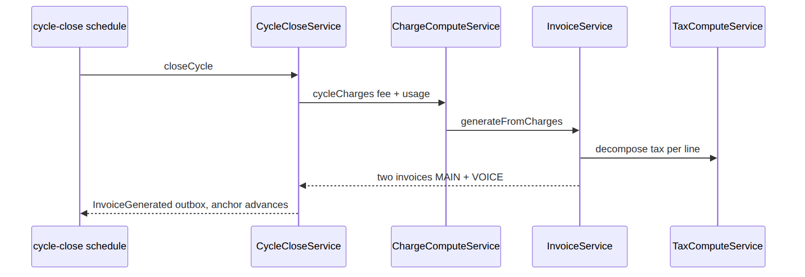
Proven by CycleCloseTest.

2. Prepaid cycle, wallet short → freeze + enter dunning
The story in plain English: A prepaid customer's wallet doesn't have enough for this month. The system tries to take the money from the wallet, can't, so it does not advance the billing cycle (it freezes) and starts the dunning (debt-chasing) process at level 1.
Who does what:
- Same close, PREPAID: WalletService::settleFromWallets finds the balance short.
- closeCycle does not advance the anchor; emits CyclePaymentMissed.
- DunningEventBridge (a listener on OutboxEventPublished) → DunningService enters the account at level 1, emitting SubscriptionEnteredDunning.
Foundation: outbox → listener. Proven by CycleCloseTest, DunningTest.

3. M-Pesa payment lands → allocate → confirm intent
The story in plain English: A customer pays via M-Pesa. The payment arrives as an event. Billing records it, applies it to the open invoices, and marks them paid. If that payment was the thing a parked subscription job was waiting for (e.g. a pay-first activation), confirming it wakes that job back up.
Who does what:
- PaymentGateway emits PaymentReceived → PaymentService writes a payment_ledger row.
- It allocates to open invoices (payment_invoice_allocation), marks the invoice PAID, emits InvoicePaid.
- Subscription's ConfirmBillingIntentOnPayment confirms a pay-first billing_intent and correlates a workflow message (Foundation/Workflow) to resume the parked operation.
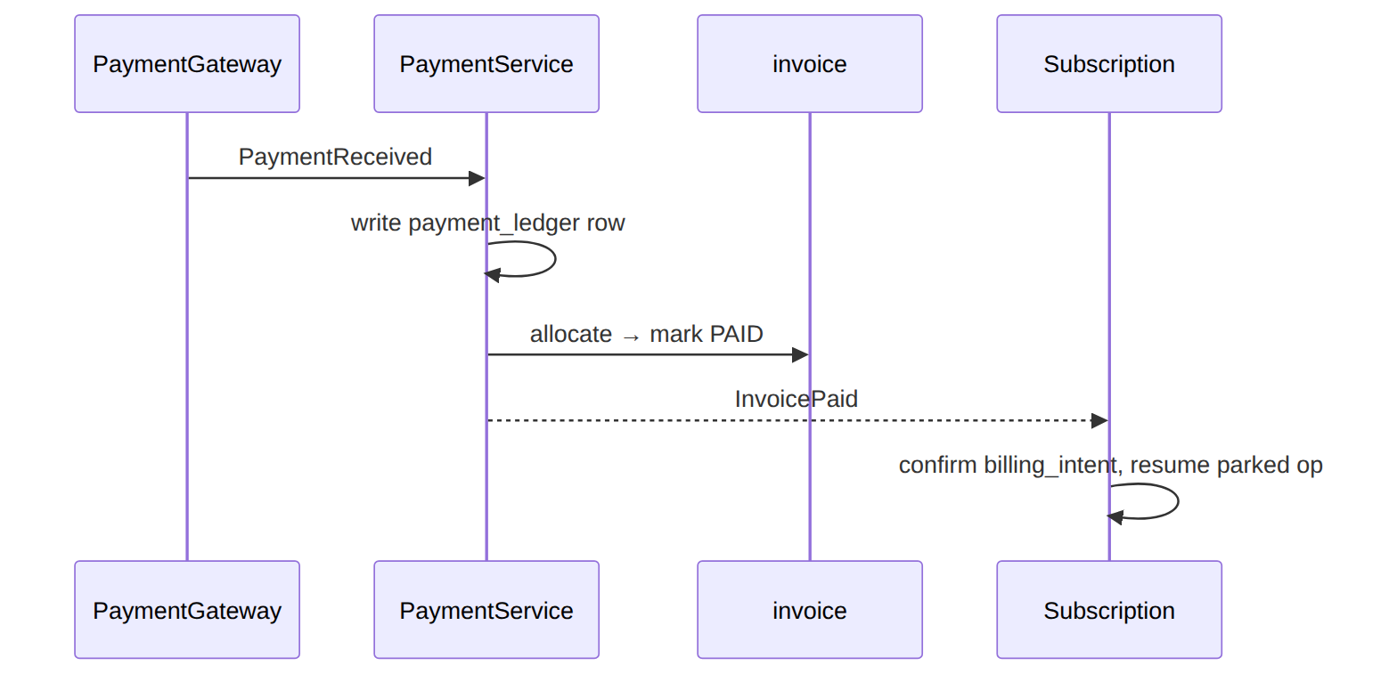
Proven by PaymentApplicationTest.

4. Overpayment → account credit → auto-draw next invoice
The story in plain English: A customer pays more than they owe. The extra isn't lost — it's parked as an account credit balance, and the next invoice automatically draws it down.
Who does what: A payment exceeds the invoice → PaymentService posts the surplus to account_credit_balance (emits OverpaymentPendingReview/CreditBalanceAdjusted). The next InvoiceGenerated → ApplyCreditBalanceOnInvoice (listener) auto-draws the credit. Foundation: event-driven credit application.

5. Paid reconnection fee flips the subscription ACTIVE (state_callback)
The story in plain English: A suspended customer pays a reconnection fee to get back online. The fee charge carries a built-in instruction: "once this is paid, switch the subscription back to ACTIVE." When the payment lands, Billing reads that instruction and flips the subscription on.
Who does what: A RECONNECTION_FEE_AFTER_DUNNING billable_event has state_callback{targetStatus:ACTIVE}. BillingIntentService::emit raises it pay-first (billing_intent.status=PENDING); on InvoicePaid, confirm() reads the pinned callback → SubscriptionService::transitionStatus(ACTIVE). Proven by BillableEventCatalogTest::test_paid_state_callback_transitions_the_subscription.

6. Credit-note adjustment → propose → approve → apply
The story in plain English: An agent wants to credit a customer (say, for an outage). They propose the credit with a reason. Depending on the amount, the system may require one or more approvers to sign off (and the proposer can't approve their own). Once enough people sign, Billing issues a credit note and applies it.
Who does what:
- AdjustmentService::propose (reason mandatory) asks rules.billing.adjustment-approval (Foundation/Rules) how many stepsRequired.
- If >0 ⇒ adjustment_request.status=PENDING_APPROVAL.
- Approvers sign steps (separation of duties); when the count is met → approveAndApply issues a CREDIT_NOTE invoice (GEN-01) and applies it (CN-01).
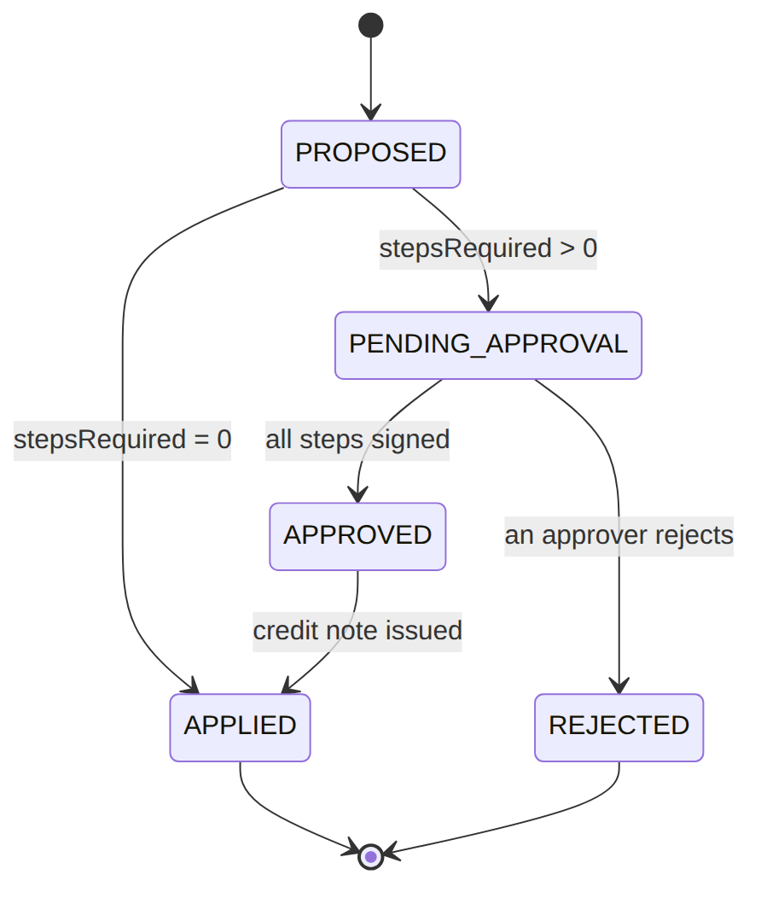
Proven by AdjustmentTest.

7. Dunning escalates faster on an NPD flag, then suspends
The story in plain English: A customer in debt also has a "non-performing debtor" flag from ILM. Normally dunning waits a grace period between escalation levels; with this flag, the wait is waived and the customer is escalated immediately. The new level can add a restriction or suspend the service.
Who does what: sophix:billing:dunning-run → DunningService::assessAccount: an ILM affects_dunning flag (AccountService::hasDunningAccelerantFlag) waives the grace window → advance a level now; the level action fires RESTRICTION_ADD/SUSPEND_NP via Subscription OperationFramework. Cross-module read + workflow. Proven by DunningTest.

8. Cycle generation fails → retry queue → give up
The story in plain English: Closing a cycle can fail (e.g. the tax service is down). Instead of losing the work, the failure goes into a retry queue with a backoff. A scheduled job retries it; if it keeps failing, it's marked "gave up" so a human can look.
Who does what: closeCycle throws (snapshot/tax/BIL01 unavailable) → GenerationFailureService::enqueue writes a generation_failure_queue row (PENDING_RETRY, backoff). sophix:billing:generation-retry (every 15 min) re-invokes the generator; persistent failure → GAVE_UP_AUTO for human review. Proven by BulkReversalAndFailureQueueTest.

(bonus) 9. Tax invoice signed asynchronously
The story in plain English: When a payment moment happens, a fiscal tax invoice is produced and must be digitally signed by the tax authority's system. Signing happens asynchronously: a scanner job calls the signer; if it fails it backs off and retries, eventually giving up.
Who does what: A payment moment → TaxEventBridge → TaxInvoiceGenerator issues a tax_invoice (inclusive decomposition), then sophix:billing:tax-sign-scan calls the signer; failure → tax-retry-scan backoff → TaxInvoiceSigningGaveUp. Proven by Tax01Test.

2. Data model — ≥4 complete sample rows + readings
Completeness: each row lists every domain column (nullables shown as null). The surrogate primary key shown is the real one (a string business key, e.g. invoice_id); created_at/updated_at are omitted by convention. Several tables grew via ALTER migrations — the new columns are flagged in each table's note.

invoice · type: STANDARD|TAX|CREDIT_NOTE|DEBIT_NOTE · status: OPEN|PARTIALLY_PAID|PAID|VOID|OVERDUE
grouping_dimension/grouping_key_values added by the structured-lines migration; customer_snapshot by the snapshot migration. (status has exactly the five enum values above — a fully-applied note sits PAID with amount_due=0.)
{ "invoice_id":"inv_1","legal_invoice_number":"INV-WIK-2026-000123","account_id":"acc_1","customer_snapshot":{"name":"Jane Mwangi","taxId":"A012345678Z"},"customer_id":"cust_1","subscription_id":"sub_123","operator_code":"WIK","type":"STANDARD","grouping_dimension":"WALLET","grouping_key_values":"MAIN","currency":"KES","billing_mode":"POSTPAID","status":"OPEN","original_invoice_id":null,"issue_date":"2026-06-30T00:00:00Z","due_date":"2026-07-15T00:00:00Z","subtotal_amount":4310.34,"tax_amount_total":689.66,"tax_summary":{"VAT16":689.66},"total_amount":5000.00,"amount_paid":0.00,"amount_due":5000.00 }
{ "invoice_id":"inv_2","legal_invoice_number":"INV-WIK-2026-000124","account_id":"acc_1","customer_snapshot":{"name":"Jane Mwangi","taxId":"A012345678Z"},"customer_id":"cust_1","subscription_id":"sub_123","operator_code":"WIK","type":"STANDARD","grouping_dimension":"WALLET","grouping_key_values":"VOICE","currency":"KES","billing_mode":"POSTPAID","status":"PAID","original_invoice_id":null,"issue_date":"2026-06-30T00:00:00Z","due_date":"2026-07-15T00:00:00Z","subtotal_amount":1293.10,"tax_amount_total":206.90,"tax_summary":{"VAT16":206.90},"total_amount":1500.00,"amount_paid":1500.00,"amount_due":0.00 }
{ "invoice_id":"inv_3","legal_invoice_number":"CN-WIK-2026-000007","account_id":"acc_1","customer_snapshot":{"name":"Jane Mwangi","taxId":"A012345678Z"},"customer_id":"cust_1","subscription_id":"sub_123","operator_code":"WIK","type":"CREDIT_NOTE","grouping_dimension":"SINGLE","grouping_key_values":null,"currency":"KES","billing_mode":"POSTPAID","status":"PAID","original_invoice_id":"inv_1","issue_date":"2026-07-01T00:00:00Z","due_date":null,"subtotal_amount":800.00,"tax_amount_total":0.00,"tax_summary":null,"total_amount":800.00,"amount_paid":0.00,"amount_due":0.00 }
{ "invoice_id":"inv_4","legal_invoice_number":"TAX-WIK-2026-000045","account_id":"acc_2","customer_snapshot":{"name":"Acme Ltd","taxId":"P051234567X"},"customer_id":"cust_3","subscription_id":"sub_9","operator_code":"WIK","type":"TAX","grouping_dimension":"SINGLE","grouping_key_values":null,"currency":"KES","billing_mode":"POSTPAID","status":"PAID","original_invoice_id":"inv_2","issue_date":"2026-06-30T00:00:00Z","due_date":null,"subtotal_amount":4310.34,"tax_amount_total":689.66,"tax_summary":{"VAT16":689.66},"total_amount":5000.00,"amount_paid":5000.00,"amount_due":0.00 }
Read each row as a sentence — this data means this:
Row | What it means in plain English
inv_1 | A KES 5000 internet bill that's still owed (status=OPEN, amount_due=5000, due 15 Jul → becomes dunnable once past due).
inv_2 | A KES 1500 voice bill, fully paid (status=PAID, amount_due=0). It's a separate document from inv_1 because grouping_dimension=WALLET split internet from voice.
inv_3 | A credit note against inv_1 (type=CREDIT_NOTE, original_invoice_id=inv_1) — so inv_1 can't be bulk-reversed; the note carries tax_amount_total=0 (inclusive treatment, §10).
inv_4 | A TAX invoice (type=TAX) — immutable, never adjusted (you adjust the commercial invoice instead).
The columns that did the work:
- Owed vs settled = status + amount_due.
- Note vs original = type + original_invoice_id (a note links back; the original is locked).
- Why two documents = grouping_dimension/grouping_key_values (WALLET put internet and voice on separate invoices).
- Frozen bill-to identity = customer_snapshot.
Status lifecycle. An invoice starts OPEN, takes payments, and lands PAID when fully settled (a fully-applied credit note also rests PAID with amount_due=0):
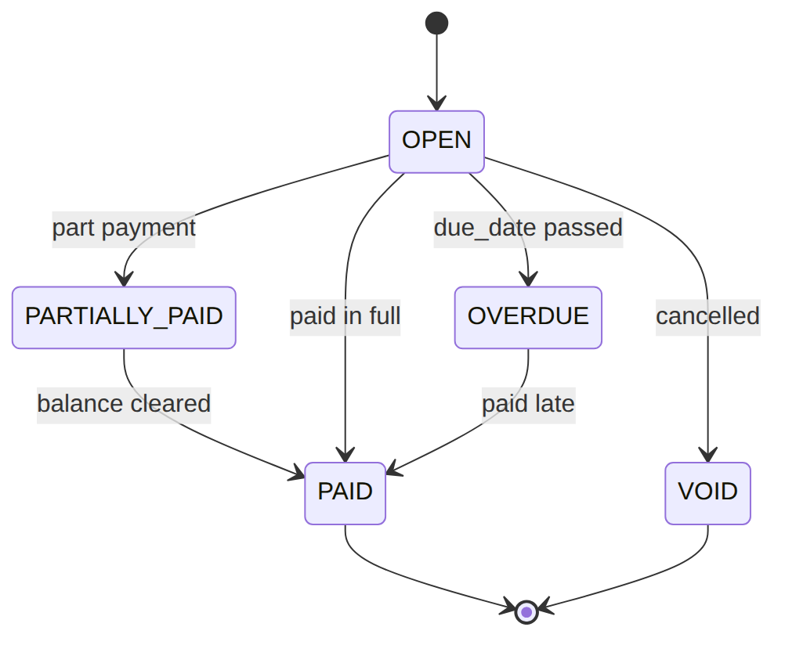
Worked example — how inv_1's totals are built (the figures are inclusive of 16% VAT, so the displayed total_amount already contains the tax; Billing decomposes it back into subtotal + tax):
Line | gross (total) | subtotal = gross ÷ 1.16 | tax = gross − subtotal
Internet 100M | 3480.00 | 3000.00 | 480.00
IPTV Premium | 1392.00 | 1200.00 | 192.00
inv_1 totals | 5000.00 | rounds to 4310.34 | 689.66
(The line subtotals shown in invoice_line — 3000.00 / 1200.00 — are the catalog ex-tax prices; the invoice header sums to subtotal_amount=4310.34, tax_amount_total=689.66, total_amount=5000.00.)

invoice_line · line_type: SUMMARY|DETAIL
All of line_type/parent_summary_line_id/service_category_code/package_ref/wallet_type_code/ tax_breakdown/sort_order were added by the structured-lines migration.
{ "id":"il_1","invoice_id":"inv_1","line_type":"SUMMARY","parent_summary_line_id":null,"service_category_code":"SUBSCRIPTION","package_ref":"pkg_triple","wallet_type_code":null,"description":"Triple Play monthly","service_ref":null,"quantity":1.00,"unit_price":4200.00,"subtotal":4200.00,"tax_amount":672.00,"tax_breakdown":{"VAT16":672.00},"sort_order":0 }
{ "id":"il_2","invoice_id":"inv_1","line_type":"DETAIL","parent_summary_line_id":"il_1","service_category_code":"INTERNET","package_ref":"pkg_triple","wallet_type_code":null,"description":"Internet 100M","service_ref":"svc_inet","quantity":1.00,"unit_price":3000.00,"subtotal":3000.00,"tax_amount":480.00,"tax_breakdown":{"VAT16":480.00},"sort_order":1 }
{ "id":"il_3","invoice_id":"inv_1","line_type":"DETAIL","parent_summary_line_id":"il_1","service_category_code":"TV","package_ref":"pkg_triple","wallet_type_code":null,"description":"IPTV Premium","service_ref":"svc_tv","quantity":1.00,"unit_price":1200.00,"subtotal":1200.00,"tax_amount":192.00,"tax_breakdown":{"VAT16":192.00},"sort_order":2 }
{ "id":"il_4","invoice_id":"inv_2","line_type":"DETAIL","parent_summary_line_id":null,"service_category_code":"VOICE","package_ref":null,"wallet_type_code":"VOICE_WALLET","description":"Voice usage","service_ref":"svc_voice","quantity":150.00,"unit_price":2.00,"subtotal":300.00,"tax_amount":48.00,"tax_breakdown":{"EXC20":50.00,"VAT16":48.00},"sort_order":1 }
Read each row as a sentence — this data means this:
Row | What it means in plain English
il_1 | The customer-facing summary line on inv_1: "Triple Play monthly" priced as the whole package (line_type=SUMMARY, parent_summary_line_id=null).
il_2 | A detail line under il_1 (line_type=DETAIL, parent_summary_line_id=il_1): the Internet 100M component, KES 3000 ex-tax.
il_3 | The other detail line under il_1: the IPTV Premium component, KES 1200 ex-tax.
il_4 | Voice usage on a different invoice (inv_2): 150 min × KES 2, routed to VOICE_WALLET (wallet_type_code) — WALLET grouping put voice on its own document.
The columns that did the work:
- Summary vs detail = line_type + parent_summary_line_id (details hang off their summary).
- Which invoice / wallet = invoice_id + wallet_type_code.
- Per-line tax components = tax_breakdown; presentation order = sort_order.

payment_ledger · method: MPESA|VISA|BANK_TRANSFER|OFFLINE · status: RECEIVED|APPLIED|PARTIALLY_APPLIED|REVERSED
customer_id/payment_reference/reversal_of_payment_id/reversal_reason_code/reversed_by added by the payment-application alignment migration (which also adds the (account_id, payment_reference) dedup unique).
{ "payment_id":"pay_1","account_id":"acc_1","customer_id":"cust_1","operator_code":"WIK","method":"MPESA","gateway_ref":"MPESA-QGR7Xk","payment_reference":"QGR7Xk","currency":"KES","paid_amount":5000.00,"unallocated_amount":0.00,"status":"APPLIED","reversal_of_payment_id":null,"reversal_reason_code":null,"reversed_by":null,"received_at":"2026-07-02T10:00:00Z" }
{ "payment_id":"pay_2","account_id":"acc_1","customer_id":"cust_1","operator_code":"WIK","method":"MPESA","gateway_ref":"MPESA-QGR8Zz","payment_reference":"QGR8Zz","currency":"KES","paid_amount":6000.00,"unallocated_amount":1000.00,"status":"PARTIALLY_APPLIED","reversal_of_payment_id":null,"reversal_reason_code":null,"reversed_by":null,"received_at":"2026-07-03T10:00:00Z" }
{ "payment_id":"pay_3","account_id":"acc_2","customer_id":"cust_3","operator_code":"WIK","method":"OFFLINE","gateway_ref":null,"payment_reference":"cash-rcpt-9","currency":"KES","paid_amount":1500.00,"unallocated_amount":0.00,"status":"APPLIED","reversal_of_payment_id":null,"reversal_reason_code":null,"reversed_by":null,"received_at":"2026-07-04T09:00:00Z" }
{ "payment_id":"pay_4","account_id":"acc_1","customer_id":"cust_1","operator_code":"WIK","method":"VISA","gateway_ref":"VISA-9931","payment_reference":"VISA-9931","currency":"KES","paid_amount":5000.00,"unallocated_amount":0.00,"status":"REVERSED","reversal_of_payment_id":"pay_1","reversal_reason_code":"CHARGEBACK","reversed_by":"u_fin1","received_at":"2026-07-05T11:00:00Z" }
Read each row as a sentence — this data means this:
Row | What it means in plain English
pay_1 | A KES 5000 M-Pesa payment fully applied (status=APPLIED, unallocated_amount=0), deduped by payment_reference=QGR7Xk.
pay_2 | A KES 6000 M-Pesa payment that overpaid — KES 1000 left over (unallocated_amount=1000, status=PARTIALLY_APPLIED) posts to account_credit_balance.
pay_3 | A KES 1500 cash payment (method=OFFLINE, no gateway ref; the receipt number is the payment_reference).
pay_4 | A VISA payment that was reversed as a chargeback (status=REVERSED, reversal_of_payment_id=pay_1, reversed_by=u_fin1 for the audit trail).
The columns that did the work:
- No double-apply = payment_reference (gateway ref or Idempotency-Key) — a retried callback dedups.
- Overpayment = unallocated_amount (surplus → account_credit_balance).
- Reversal trail = reversal_of_payment_id + reversal_reason_code + reversed_by (separation-of-duties).

billing_intent · intent_type: PRORATION|PAUSE_FEE|RECONNECTION_FEE|DEPOSIT_REFUND|… · status: PENDING|CHARGED|CONFIRMED|WAIVED|REFUNDED · settlement_channel: INVOICE|WALLET|CREDIT|NONE
settlement_channel added by the settlement-channel migration; state_callback (JSON) by the state-callback migration. (intent_type is not an enforced enum — it is a free-form code resolved against the billable_event catalog; the four values above are illustrative.)
{ "intent_id":"bint_1","operator_code":"WIK","subscription_id":"sub_1","account_id":"acc_1","operation_id":"op_up_1","intent_type":"PRORATION","amount":350.00,"currency":"KES","pay_first":false,"status":"CONFIRMED","settlement_channel":"INVOICE","state_callback":null,"invoice_id":"inv_7","confirmed_at":"2026-06-15T12:00:00Z" }
{ "intent_id":"bint_2","operator_code":"WIK","subscription_id":"sub_1","account_id":"acc_1","operation_id":"op_recon_1","intent_type":"RECONNECTION_FEE","amount":500.00,"currency":"KES","pay_first":true,"status":"PENDING","settlement_channel":"INVOICE","state_callback":{"transitionCode":"RECONNECT_AFTER_FEE","targetStatus":"ACTIVE"},"invoice_id":"inv_9","confirmed_at":null }
{ "intent_id":"bint_3","operator_code":"WIK","subscription_id":"sub_2","account_id":"acc_2","operation_id":"op_term_3","intent_type":"DEPOSIT_REFUND","amount":-2500.00,"currency":"KES","pay_first":false,"status":"CONFIRMED","settlement_channel":"CREDIT","state_callback":null,"invoice_id":null,"confirmed_at":"2026-06-18T09:00:00Z" }
{ "intent_id":"bint_4","operator_code":"WIK","subscription_id":"sub_3","account_id":"acc_3","operation_id":"op_pause_4","intent_type":"PAUSE_FEE","amount":0.00,"currency":"KES","pay_first":false,"status":"CONFIRMED","settlement_channel":"NONE","state_callback":null,"invoice_id":null,"confirmed_at":"2026-06-19T09:00:00Z" }
Read each row as a sentence — this data means this:
Row | What it means in plain English
bint_1 | A mid-cycle proration charge of KES 350, already settled on invoice inv_7 (status=CONFIRMED, settlement_channel=INVOICE).
bint_2 | A pay-first reconnection fee: it stays PENDING until inv_9 is paid (pay_first=true), then its state_callback flips the sub ACTIVE.
bint_3 | A negative amount (KES -2500 deposit refund) posted as account credit (settlement_channel=CREDIT, no invoice).
bint_4 | A zero pause fee — the event fired but there was nothing to charge (amount=0, settlement_channel=NONE).
The columns that did the work:
- Charge now vs wait for payment = pay_first (pay-first stays PENDING; state_callback carries the resulting sub transition).
- Where it settles = settlement_channel (INVOICE / WALLET / CREDIT / NONE); a negative amount is a credit.
- What raised it = operation_id (the Subscription operation behind every intent).
Worked example — bint_1's PRORATION amount. When a customer upgrades mid-cycle, the charge is only for the remaining days at the price difference. Suppose a 30-day cycle, upgraded with 21 days left, from a 2500.00/mo plan to a 3000.00/mo plan:
Input | value
cycle length | 30 days
days remaining | 21 days
monthly price difference | 3000.00 − 2500.00 = 500.00
proration = diff × (remaining ÷ cycle) | 500.00 × (21 ÷ 30) = 350.00
→ bint_1.amount = 350.00, settled on the next invoice (settlement_channel=INVOICE).

billable_event · amount_sign_policy: POSITIVE_ONLY|NEGATIVE_ONLY|SIGNED · trigger_type: SAGA_INTENT|LIFECYCLE_EVENT|ADMIN_ACTION|CUSTOMER_PURCHASE|EXTERNAL_PAYMENT|SCHEDULED · applicability: PREPAID_ONLY|POSTPAID_ONLY|ANY · status: DRAFT|ACTIVE|RETIRED
{ "id":"bev_1","operator_code":"WIK","code":"RECONNECTION_FEE_AFTER_DUNNING","description":"Reconnection fee after dunning","category_code":"FEE","service_refs":["svc_inet"],"currency":"KES","applicability":"ANY","amount_sign_policy":"POSITIVE_ONLY","pay_first_required":true,"trigger_type":"EXTERNAL_PAYMENT","trigger_intent_code":null,"trigger_event_type":null,"trigger_filter_drl":null,"trigger_schedule":null,"state_callback":{"transitionCode":"RECONNECT_AFTER_FEE","targetStatus":"ACTIVE"},"eligibility_franchise_refs":null,"eligibility_package_refs":null,"eligibility_segment_refs":null,"display_order":100,"status":"ACTIVE","notes":null,"created_by":"u_admin","updated_by":"u_admin","retired_at":null }
{ "id":"bev_2","operator_code":"WIK","code":"INSTALLATION_FEE","description":"One-off installation fee","category_code":"FEE","service_refs":["svc_inet"],"currency":"KES","applicability":"ANY","amount_sign_policy":"POSITIVE_ONLY","pay_first_required":true,"trigger_type":"SAGA_INTENT","trigger_intent_code":"INSTALL_FEE_INTENT","trigger_event_type":null,"trigger_filter_drl":null,"trigger_schedule":null,"state_callback":null,"eligibility_franchise_refs":["fr_nrb"],"eligibility_package_refs":null,"eligibility_segment_refs":null,"display_order":100,"status":"ACTIVE","notes":null,"created_by":"u_admin","updated_by":null,"retired_at":null }
{ "id":"bev_3","operator_code":"WIK","code":"DEPOSIT_REFUND","description":"Refund of installation deposit","category_code":"REFUND","service_refs":null,"currency":"KES","applicability":"ANY","amount_sign_policy":"NEGATIVE_ONLY","pay_first_required":false,"trigger_type":"LIFECYCLE_EVENT","trigger_intent_code":null,"trigger_event_type":"SubscriptionTerminated","trigger_filter_drl":null,"trigger_schedule":null,"state_callback":null,"eligibility_franchise_refs":null,"eligibility_package_refs":null,"eligibility_segment_refs":null,"display_order":100,"status":"ACTIVE","notes":null,"created_by":"u_admin","updated_by":null,"retired_at":null }
{ "id":"bev_4","operator_code":"WIK","code":"GOODWILL_CREDIT","description":"Discretionary goodwill credit","category_code":"CREDIT","service_refs":null,"currency":"KES","applicability":"POSTPAID_ONLY","amount_sign_policy":"NEGATIVE_ONLY","pay_first_required":false,"trigger_type":"ADMIN_ACTION","trigger_intent_code":null,"trigger_event_type":null,"trigger_filter_drl":null,"trigger_schedule":null,"state_callback":null,"eligibility_franchise_refs":null,"eligibility_package_refs":null,"eligibility_segment_refs":null,"display_order":200,"status":"DRAFT","notes":"awaiting finance sign-off","created_by":"u_admin","updated_by":null,"retired_at":null }
Read each row as a sentence — this data means this:
Row | What it means in plain English
bev_1 | A reconnection fee: pay-first (pay_first_required=true), fired by an EXTERNAL_PAYMENT, with a state_callback that reconnects the sub to ACTIVE. Live (status=ACTIVE).
bev_2 | An installation fee fired by a SAGA_INTENT (trigger_intent_code=INSTALL_FEE_INTENT) and limited to one franchise (eligibility_franchise_refs=[fr_nrb]).
bev_3 | A deposit refund — negative only (amount_sign_policy=NEGATIVE_ONLY, a positive amount is rejected), fired by a lifecycle event (trigger_event_type=SubscriptionTerminated).
bev_4 | A goodwill credit that's not chargeable yet (status=DRAFT) and only for postpaid (applicability=POSTPAID_ONLY).
The columns that did the work:
- Chargeable or not = status (only ACTIVE; an intent that doesn't resolve to an ACTIVE event is rejected) + applicability (prepaid/postpaid/any).
- What fires it = trigger_type (+ trigger_intent_code/trigger_event_type).
- Sign + pay-first = amount_sign_policy + pay_first_required (+ state_callback for the resulting sub transition).
- Who's eligible = eligibility_*; currency is derived from service_refs and immutable.

dunning_program (billing_mode: POSTPAID|PREPAID|PREPAYMENT) — versioned catalog
PK is the ULID id; uniqueness is (code, version). level_definitions is the ordered escalation JSON (no default — always present).
{ "id":"dprg_1","code":"wik_postpaid_standard","version":1,"description":"WIK postpaid standard dunning","operator_code":"WIK","billing_mode":"POSTPAID","level_definitions":[{"level":1,"name":"WARNING","grace_period_days":7,"action_workflow_intent":"WARNING_ONLY"},{"level":2,"name":"RESTRICTED","grace_period_days":7,"action_workflow_intent":"RESTRICTION_ADD"},{"level":3,"name":"SUSPENDED","grace_period_days":14,"action_workflow_intent":"SUSPEND_NP"},{"level":4,"name":"TERMINATED","action_workflow_intent":"TERMINATION"}],"pre_termination_review_required":true,"published_at":"2026-01-01T00:00:00Z","retired_at":null,"created_by":"u_admin" }
{ "id":"dprg_2","code":"wik_prepaid_standard","version":1,"description":"WIK prepaid standard dunning","operator_code":"WIK","billing_mode":"PREPAID","level_definitions":[{"level":1,"name":"WARNING","grace_period_days":0,"action_workflow_intent":"WARNING_ONLY"},{"level":2,"name":"SUSPENDED","grace_period_days":3,"action_workflow_intent":"SUSPEND_NP"}],"pre_termination_review_required":false,"published_at":"2026-01-01T00:00:00Z","retired_at":null,"created_by":"u_admin" }
{ "id":"dprg_3","code":"wik_postpaid_standard","version":2,"description":"WIK postpaid standard dunning v2","operator_code":"WIK","billing_mode":"POSTPAID","level_definitions":[{"level":1,"name":"WARNING","grace_period_days":5,"action_workflow_intent":"WARNING_ONLY"},{"level":2,"name":"SUSPENDED","grace_period_days":10,"action_workflow_intent":"SUSPEND_NP"},{"level":3,"name":"TERMINATED","action_workflow_intent":"TERMINATION"}],"pre_termination_review_required":true,"published_at":"2026-06-01T00:00:00Z","retired_at":null,"created_by":"u_admin" }
{ "id":"dprg_old","code":"wik_legacy","version":1,"description":"Retired legacy program","operator_code":"WIK","billing_mode":"POSTPAID","level_definitions":[{"level":1,"name":"WARNING","action_workflow_intent":"WARNING_ONLY"}],"pre_termination_review_required":false,"published_at":"2024-01-01T00:00:00Z","retired_at":"2026-01-01T00:00:00Z","created_by":"u_admin" }

dunning_state (status: ACTIVE|CLEARED|SUSPENDED_BY_PAUSE|PENDING_TERMINATION_REVIEW|RECOVERY_FAILED|ARCHIVED, current_level int 0..4)
The dd-alignment migration added billing_mode/triggering_event_type/next_evaluation_at/ review_due_at/last_workflow_failure_code; the program-catalog migration added the program pinning (dunning_program_ref/_version), entered_dunning_at, outstanding_debt_currency, applied_restriction_codes, triggering_event_ref, the workflow-failure backoff trio, and cleared_at/archived_at.
{ "dunning_id":"dun_1","operator_code":"WIK","account_id":"acc_1","subscription_id":"sub_123","billing_mode":"POSTPAID","triggering_event_type":"InvoiceOverdue","current_level":1,"entered_level_at":"2026-07-16T00:00:00Z","entered_dunning_at":"2026-07-16T00:00:00Z","outstanding_debt_amount":5000.00,"outstanding_debt_currency":"KES","status":"ACTIVE","last_scanned_at":"2026-07-16T01:00:00Z","next_evaluation_at":"2026-07-23T00:00:00Z","review_due_at":null,"last_workflow_failure_code":null,"dunning_program_ref":"wik_postpaid_standard","dunning_program_version":1,"applied_restriction_codes":[],"triggering_event_ref":"inv_1","last_workflow_failure_at":null,"workflow_failure_attempts":0,"cleared_at":null,"archived_at":null }
{ "dunning_id":"dun_2","operator_code":"WIK","account_id":"acc_2","subscription_id":"sub_9","billing_mode":"POSTPAID","triggering_event_type":"InvoiceOverdue","current_level":3,"entered_level_at":"2026-07-10T00:00:00Z","entered_dunning_at":"2026-06-20T00:00:00Z","outstanding_debt_amount":12000.00,"outstanding_debt_currency":"KES","status":"ACTIVE","last_scanned_at":"2026-07-16T01:00:00Z","next_evaluation_at":"2026-07-24T00:00:00Z","review_due_at":null,"last_workflow_failure_code":null,"dunning_program_ref":"wik_postpaid_standard","dunning_program_version":1,"applied_restriction_codes":["OUTGOING_VOICE_BARRED"],"triggering_event_ref":"inv_55","last_workflow_failure_at":null,"workflow_failure_attempts":0,"cleared_at":null,"archived_at":null }
{ "dunning_id":"dun_3","operator_code":"WIK","account_id":"acc_3","subscription_id":"sub_5","billing_mode":"PREPAID","triggering_event_type":"CyclePaymentMissed","current_level":0,"entered_level_at":null,"entered_dunning_at":"2026-06-01T00:00:00Z","outstanding_debt_amount":0.00,"outstanding_debt_currency":"KES","status":"CLEARED","last_scanned_at":"2026-07-01T01:00:00Z","next_evaluation_at":null,"review_due_at":null,"last_workflow_failure_code":null,"dunning_program_ref":"wik_prepaid_standard","dunning_program_version":1,"applied_restriction_codes":[],"triggering_event_ref":"cycle_2026_06_sub_5","last_workflow_failure_at":null,"workflow_failure_attempts":0,"cleared_at":"2026-07-01T01:00:00Z","archived_at":null }
{ "dunning_id":"dun_4","operator_code":"WIK","account_id":"acc_4","subscription_id":"sub_7","billing_mode":"POSTPAID","triggering_event_type":"InvoiceOverdue","current_level":4,"entered_level_at":"2026-07-12T00:00:00Z","entered_dunning_at":"2026-06-10T00:00:00Z","outstanding_debt_amount":30000.00,"outstanding_debt_currency":"KES","status":"PENDING_TERMINATION_REVIEW","last_scanned_at":"2026-07-16T01:00:00Z","next_evaluation_at":null,"review_due_at":"2026-07-19T00:00:00Z","last_workflow_failure_code":"FULFILLMENT_TIMEOUT","dunning_program_ref":"wik_postpaid_standard","dunning_program_version":1,"applied_restriction_codes":["OUTGOING_VOICE_BARRED"],"triggering_event_ref":"inv_77","last_workflow_failure_at":"2026-07-15T00:00:00Z","workflow_failure_attempts":2,"cleared_at":null,"archived_at":null }
Read each row as a sentence — this data means this:
Row | What it means in plain English
dun_1 | An account just into dunning at the WARNING step (current_level=1, status=ACTIVE), owing KES 5000, pinned to program wik_postpaid_standard v1.
dun_2 | Escalated to SUSPENDED (current_level=3) with a restriction applied (applied_restriction_codes=[OUTGOING_VOICE_BARRED]), owing KES 12000.
dun_3 | A prepaid account that paid up and recovered (status=CLEARED, current_level=0, cleared_at set, debt 0).
dun_4 | Reached the terminate level (current_level=4) but is parked for mandatory review (status=PENDING_TERMINATION_REVIEW, review_due_at set) and backing off after a workflow failure (workflow_failure_attempts=2).
The columns that did the work:
- Where in the ladder = current_level + status; cleared/recovered shows in cleared_at/status.
- Pinned policy = dunning_program_ref+dunning_program_version (R-BIL-04-C-1) — publishing a new program version (e.g. dprg_3) never disturbs in-flight episodes.
- Restrictions applied = applied_restriction_codes; review hold = review_due_at.
- Scan cadence + backoff = next_evaluation_at + workflow_failure_attempts.
Status lifecycle (dunning_state):
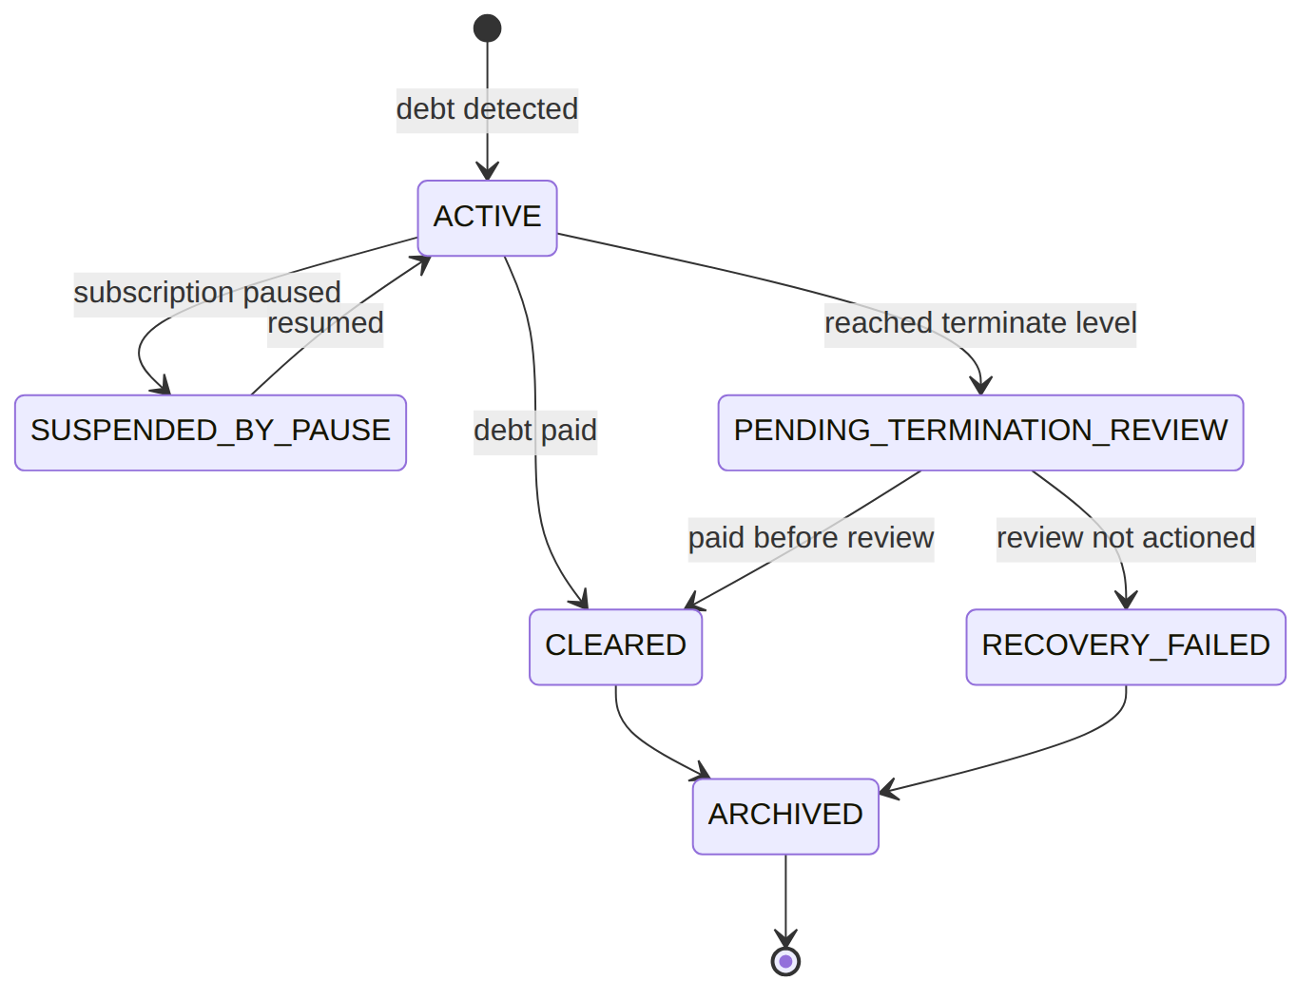
Worked escalation — program wik_postpaid_standard v1 (dun_1's pinned program). Each level waits its grace_period_days before the next pass advances; an ILM affects_dunning flag waives that wait (Scenario 7), collapsing the timeline:
Level | name | grace_period_days | action_workflow_intent
1 | WARNING | 7 | WARNING_ONLY
2 | RESTRICTED | 7 | RESTRICTION_ADD
3 | SUSPENDED | 14 | SUSPEND_NP
4 | TERMINATED | — | TERMINATION
So a normal postpaid debtor is warned on day 0, restricted ~day 7, suspended ~day 14, and reaches the termination review ~day 28; with an NPD flag the grace is waived and each pass advances immediately.

adjustment_request · direction: CREDIT|DEBIT · scope: FULL|LINE|AMOUNT · status: PROPOSED|PENDING_APPROVAL|APPROVED|APPLIED|REJECTED|APPLICATION_FAILED|CANCELLED_BY_PROPOSER
required_approvals/approval_rule_id added by the required-approvals migration.
{ "adjustment_id":"adj_1","operator_code":"WIK","customer_id":"cust_1","account_id":"acc_1","subscription_id":"sub_123","parent_invoice_id":"inv_1","target_wallet_ref":null,"billing_mode":"POSTPAID","direction":"CREDIT","scope":"FULL","line_ref":null,"service_category_code":null,"amount":5000.00,"currency":"KES","reason_code":"SLA_COMPENSATION","justification":"3-day outage credit","status":"APPLIED","required_approvals":1,"approval_rule_id":"rule_adj_std","proposed_by":"u_csr1","note_invoice_id":"inv_3","limit_overridden":false,"failure_reason":null,"applied_at":"2026-07-01T00:00:00Z" }
{ "adjustment_id":"adj_2","operator_code":"WIK","customer_id":"cust_1","account_id":"acc_1","subscription_id":"sub_123","parent_invoice_id":"inv_2","target_wallet_ref":null,"billing_mode":"POSTPAID","direction":"DEBIT","scope":"LINE","line_ref":"il_4","service_category_code":null,"amount":300.00,"currency":"KES","reason_code":"BILLING_ERROR","justification":"under-billed voice","status":"PENDING_APPROVAL","required_approvals":2,"approval_rule_id":"rule_adj_debit","proposed_by":"u_csr2","note_invoice_id":null,"limit_overridden":false,"failure_reason":null,"applied_at":null }
{ "adjustment_id":"adj_3","operator_code":"WIK","customer_id":"cust_2","account_id":"acc_5","subscription_id":null,"parent_invoice_id":null,"target_wallet_ref":null,"billing_mode":"POSTPAID","direction":"CREDIT","scope":"AMOUNT","line_ref":null,"service_category_code":"GOODWILL","amount":1000.00,"currency":"KES","reason_code":"GOODWILL","justification":"retention gesture","status":"PROPOSED","required_approvals":1,"approval_rule_id":"rule_adj_std","proposed_by":"u_csr1","note_invoice_id":null,"limit_overridden":false,"failure_reason":null,"applied_at":null }
{ "adjustment_id":"adj_4","operator_code":"WIK","customer_id":"cust_1","account_id":"acc_1","subscription_id":"sub_123","parent_invoice_id":"inv_2","target_wallet_ref":null,"billing_mode":"POSTPAID","direction":"CREDIT","scope":"FULL","line_ref":null,"service_category_code":null,"amount":1500.00,"currency":"KES","reason_code":"DISPUTE","justification":"customer dispute rejected","status":"REJECTED","required_approvals":2,"approval_rule_id":"rule_adj_high","proposed_by":"u_csr2","note_invoice_id":null,"limit_overridden":false,"failure_reason":null,"applied_at":null }
Read each row as a sentence — this data means this:
Row | What it means in plain English
adj_1 | A KES 5000 credit for an outage, applied (status=APPLIED) — a credit note inv_3 was issued (note_invoice_id=inv_3), needing 1 approval.
adj_2 | A KES 300 debit to fix an under-billed voice line (scope=LINE, line_ref=il_4), waiting on 2 sign-offs (status=PENDING_APPROVAL, required_approvals=2).
adj_3 | A KES 1000 goodwill credit still just proposed (status=PROPOSED, scope=AMOUNT → free-form, service_category_code=GOODWILL) — not yet in the approval queue.
adj_4 | A KES 1500 dispute credit that was turned down (status=REJECTED).
The columns that did the work:
- Where the amount comes from = scope (FULL=parent total, LINE=a capped line_ref, AMOUNT=free-form needing service_category_code).
- How many approvals = required_approvals (distinct approvers, not the proposer).
- The audit basics = reason_code (mandatory) + direction (must match the note direction); the issued note is note_invoice_id.
- Prepaid target / override = target_wallet_ref directs a note at a wallet; limit_overridden records a /override-limit.
Worked example — how many approvals each request needs. rules.billing.adjustment-approval returns a required_approvals count; the request only applies once that many distinct approvers (not the proposer) have signed:
Request | amount | rule | required_approvals | signed so far | status
adj_1 | 5000.00 | rule_adj_std | 1 | 1 | APPLIED
adj_2 | 300.00 | rule_adj_debit | 2 | 0 | PENDING_APPROVAL
adj_3 | 1000.00 | rule_adj_std | 1 | 0 | PROPOSED
adj_4 | 1500.00 | rule_adj_high | 2 | — | REJECTED
(adj_3 is still PROPOSED — it hasn't entered the approval queue yet; adj_2 is waiting on 2 sign-offs; adj_4 was turned down. The diagram in Scenario 6 shows these transitions.)

wallet (status: ACTIVE|FROZEN|CLOSED) & wallet_transaction (PREPAID)
The multiwallet migration added wallet_code/customer_id and re-keyed uniqueness to (subscription_id, wallet_code); the expiry migration added expires_at. (The routing key is the catalog wallet_code, not a wallet_type_code column.)
{ "wallet_id":"wal_1","subscription_id":"sub_2","wallet_code":"MAIN_WALLET","account_id":"acc_2","customer_id":"cust_3","operator_code":"WIK","currency":"KES","balance":1200.00,"status":"ACTIVE","expires_at":"2026-09-01T00:00:00Z" }
{ "wallet_id":"wal_2","subscription_id":"sub_2","wallet_code":"VOICE_WALLET","account_id":"acc_2","customer_id":"cust_3","operator_code":"WIK","currency":"KES","balance":0.00,"status":"ACTIVE","expires_at":null }
{ "wallet_id":"wal_3","subscription_id":"sub_5","wallet_code":"MAIN_WALLET","account_id":"acc_5","customer_id":"cust_2","operator_code":"WIK","currency":"KES","balance":50.00,"status":"CLOSED","expires_at":"2026-06-01T00:00:00Z" }
// wallet_transaction (direction: CREDIT|DEBIT ; reason: TOPUP|CYCLE_CHARGE|REFUND|BONUS|CORRECTION|RECOVERY)
{ "id":"wtx_1","wallet_id":"wal_1","direction":"CREDIT","reason":"TOPUP","amount":1000.00,"balance_after":1200.00,"reference":"MPESA-QGR9aa" }
{ "id":"wtx_2","wallet_id":"wal_1","direction":"DEBIT","reason":"CYCLE_CHARGE","amount":300.00,"balance_after":900.00,"reference":"cycle_2026_06_sub_2" }
Read each row as a sentence — this data means this:
Row | What it means in plain English
wal_1 | A live main money wallet for sub_2 holding KES 1200 (wallet_code=MAIN_WALLET, status=ACTIVE); cycle close debits this one.
wal_2 | A live but empty voice wallet (wallet_code=VOICE_WALLET, balance=0) — a voice cycle charge would freeze it (Scenario 2).
wal_3 | A closed wallet (status=CLOSED) — its expires_at passed and the balance was swept.
wtx_1 | A ledger move: a KES 1000 top-up credit into wal_1 (direction=CREDIT, reason=TOPUP, balance_after=1200).
wtx_2 | A ledger move: a KES 300 cycle-charge debit from wal_1 (direction=DEBIT, reason=CYCLE_CHARGE, balance_after=900).
The columns that did the work:
- Which wallet gets charged = wallet_code (a sub can carry several typed wallets).
- Usable or not = status + balance (empty → freeze; expires_at passed → CLOSED/swept).
- The audit of every move = wallet_transaction rows: direction/reason/balance_after.
Wallet status lifecycle:
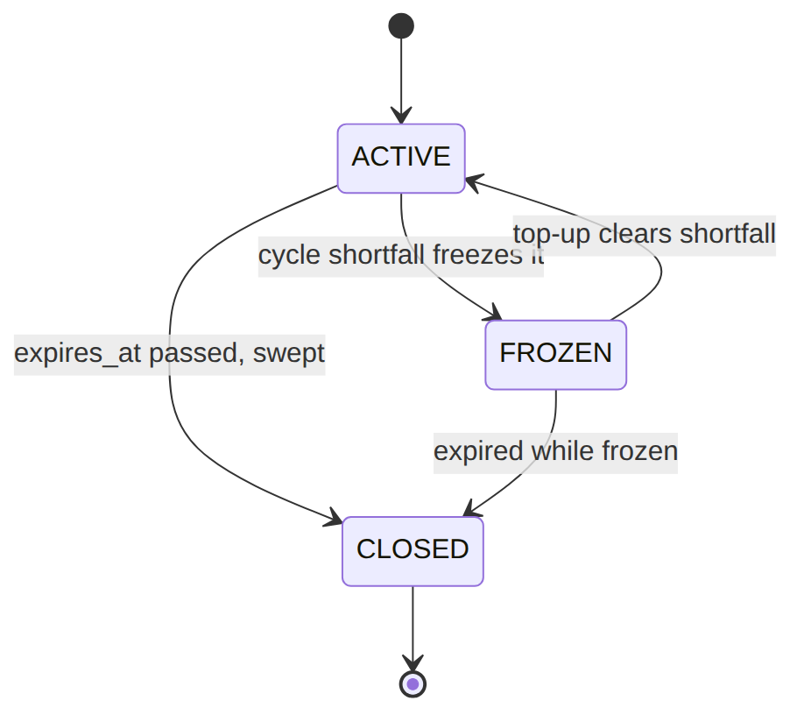

pro_forma (status: ACTIVE|SUPERSEDED), rated_event, account_credit_balance
rated_event.invoice_id (the POSTPAID settlement ref) added by the link-rated-events migration. account_credit_balance PK is account_id (one balance row per account).
{ "pro_forma_id":"pf_1","operator_code":"WIK","subscription_id":"sub_2","customer_id":"cust_3","currency":"KES","total_amount":1500.00,"lines":[{"desc":"Internet 100M","amount":1500.00}],"customer_snapshot":{"name":"Acme Ltd"},"cycle_end":"2026-07-01T00:00:00Z","idempotency_cycle_key":"cycle_2026_07_sub_2","status":"ACTIVE","superseded_by":null }
{ "pro_forma_id":"pf_0","operator_code":"WIK","subscription_id":"sub_2","customer_id":"cust_3","currency":"KES","total_amount":1400.00,"lines":[{"desc":"Internet 100M","amount":1400.00}],"customer_snapshot":{"name":"Acme Ltd"},"cycle_end":"2026-07-01T00:00:00Z","idempotency_cycle_key":"cycle_2026_07_sub_2_v0","status":"SUPERSEDED","superseded_by":"pf_1" }
// rated_event
{ "rated_id":"rat_1","operator_code":"WIK","usage_id":"usg_1","subscription_id":"sub_1","tariff_code":"VOICE_LOCAL","rate":2.0000,"amount":12.5000,"currency":"KES","billed":false,"invoice_id":null }
{ "rated_id":"rat_2","operator_code":"WIK","usage_id":"usg_2","subscription_id":"sub_1","tariff_code":"VOICE_INTL_UK","rate":15.0000,"amount":45.0000,"currency":"KES","billed":true,"invoice_id":"inv_2" }
// account_credit_balance (PK account_id)
{ "account_id":"acc_1","operator_code":"WIK","currency":"KES","balance":1000.00 }
Read each row as a sentence — this data means this:
Row | What it means in plain English
pf_1 | The current prepaid pro forma projecting next cycle for sub_2 (status=ACTIVE, superseded_by=null), keyed by idempotency_cycle_key.
pf_0 | The earlier pro forma it replaced (status=SUPERSEDED, superseded_by=pf_1) — the chain is kept.
rat_1 | A rated voice event not yet billed (billed=false, invoice_id=null) — the next cycle close will sweep it.
rat_2 | A rated event already settled on inv_2 (billed=true, invoice_id=inv_2).
account_credit_balance | One credit-balance row for acc_1 holding KES 1000 — auto-drawn on the next invoice.
The columns that did the work:
- Current vs replaced pro forma = status + superseded_by (the supersede chain), deduped by idempotency_cycle_key.
- Billed yet? = rated_event.billed + invoice_id (false = swept at next close).
- Spare credit = account_credit_balance.balance (one row per account).

3. Services (worked calls)
Service | Responsibility
ChargeComputeService | cycleCharges() (fee + usage), recurringFee() (price + days-proration)
CycleCloseService | closeCycle() — settle, advance anchor, idempotent per window
InvoiceService | assemble structured invoices, grouping, issue notes
BillingIntentService | lifecycle-fee gate (emit/confirm, state_callback)
AdjustmentService | propose → approve (rules-routed) → issue note → apply
DunningService (+DunningProgramResolver) | level state machine + actions
WalletService | wallet debit/credit/topup/expiry
ProFormaService / GenerationFailureService / PaymentService / TaxInvoiceGenerator / BulkReversalService | pro forma · retry queue · allocation · fiscal signing · dual-controlled reversal

4. API surface
Invoices, payments, wallets, adjustments, billable-events, bulk-reversals, dunning-run under /api/; resource-scoped permissions (invoice.read|manage, payment.read|apply|reverse, wallet.read|manage, adjustment.create|approve, dunning.admin, catalog.read|manage, tax.compliance — there is no billing.* wildcard); adjustment POST …/adjustments/{id}/override-limit (adjustment.approve); payment posting idempotent (gateway_ref or Idempotency-Key).

5. Integration (events) — topic billing.money
- Emits: Invoice{Generated,Paid,Cancelled}, Cycle{Closed,Activated,PaymentMissed}, Payment{Received,Applied,Reversed}, Wallet{Credited,Debited,ToppedUp}, TaxInvoice{Issued,Signed}, DunningStageAdvanced/DunningCleared/SubscriptionSuspendedForNonPayment, Adjustment{Proposed, Approved,Rejected} + note events.
- Consumes: TaxEventBridge, DunningEventBridge, RetryFrozenCycleOnTopup, ApplyCreditBalanceOnInvoice, EvictPlmCatalogCache.

6. Processes (scheduled workers)
cycle-close (30m), dunning-run (daily), pro-forma (daily), generation-retry (15m), wallet:expire, tax-sign-scan/tax-retry-scan, rate-usage. The money heartbeat.

7. Policy & config
rules.billing.adjustment-approval; billable_event catalog; versioned dunning_program; adjustment_reason_code/limits; tax via Catalog; cycle cadence on the sub; invoice grouping_dimension.

8. Cross-module dependencies
- Reads → Catalog (package/service charges, TaxComputeService, discount engine).
- Drives → Subscription (state_callback, dunning suspend/restrict), OSR (deposit forfeiture), Notification (dunning/tax notices). Reacts to → Subscription lifecycle, Payment events.

9. Invariants & rules
Rule | Statement | Enforced in
R-BIL-03-C-5 | a window closes at most once | CycleCloseService::closeCycle
R-BIL-03-C-3/W-1 | prepaid miss freezes anchor + dunning; unfreezes on top-up | CycleCloseService, RetryFrozenCycleOnTopup
R-BIL-04-C-1 | dunning program version pinned at entry | DunningService
R-BIL-04-D-2 | dunning advances one level per pass | assessAccount
R-GEN-01-Q-2/3 | failed generations retried then GAVE_UP_AUTO | GenerationFailureService::retryDue
R-BIL-01-SC-1 | settled state_callback transitions the subscription | BillingIntentService
R-GEN-01-R-1 | bulk reversal dual-controlled (requester ≠ approver) | BulkReversalService

10. Open items / deltas
- Discount auto-application at cycle close is the one real revenue-path item — discounts reach customers via the adjustment/credit path, not an auto invoice line (see catalog.md).
- Notes write tax_amount=0 (inclusive treatment) — a modelling choice to revisit.
- recurringFee prorates the cycle fee; mid-cycle MACD proration runs via the BillingIntent path.
- Advisory-only columns by design: billable_event_category.is_credit, gl_account_hint.

