Catalog — As-Built Design (the config substrate)
Capability codes: PLM-CFG-01..07 (products/services/wallets/tax/voice), SIP-01/02 (bundles/ launch), PLM-CFG-04/SIP-DA (discounts), RLM-CFG-01 (HomePass) · Module path: Modules/Catalog Tests: CatalogApi, ConfigCatalog, Tax{Compute,Config}, Discount{Compute,Assignment}, BundleAndCampaign, PackageLaunch, VoiceTariff, WalletCatalog, UsageRating

1. Purpose & boundaries
- Owns: the reference/config substrate everything prices and sells against — packages & versions, services, bundles, voice/usage tariffs, discounts & promotions, tax groups/rules, wallet catalog, HomePass topology + tech regions, network nodes.
- Does NOT own: money (Billing), subscriptions (Subscription), the network (Provisioning). It is read-mostly config; other modules query it at decision time.
- Job: the single, operator-scoped, governed source of "what can be sold, at what price, with what tax/discount, where" — tunable as data, with maker-checker on risky launches.

📖 Scenarios (service + Foundation involvement)

1. Launch a package (with maker-checker approval)
The story in plain English: A product manager builds a new package and a priced version of it — but it stays a draft, not on sale yet. To go live they open a launch plan. The system runs pre-flight checks; if the launch is risky (e.g. a first launch or a price cutover) it needs a second person to approve before the package can be sold. Once a different approver signs off, the package flips to ACTIVE and is sellable.
Who does what:
- CatalogService creates the package (status DRAFT) and a priced package_version (status PENDING).
- PackageLaunchService opens a package_launch_plan and validates it → READY_FOR_REVIEW.
- A risky launch raises an EM-CFG-04 approval request (Foundation/Approvals) → plan PENDING_APPROVAL, event PackageLaunchApprovalRequired.
- A different approver approves → the ApplyPackageLaunchApproval listener runs → plan APPROVED then ACTIVE, the package flips to ACTIVE, event PackageActivated. (A rejection → plan REJECTED, package stays DRAFT.)
Sample — the launch plan as it moves:
{ "launch_plan_id":"plp_1","package_id":"pkg_promo","launch_type":"FIRST_LAUNCH","status":"PENDING_APPROVAL","requested_launch_at":"2026-07-01T00:00:00Z","approval_request_id":"appr_77","requested_by_user_id":"u_pm1" }
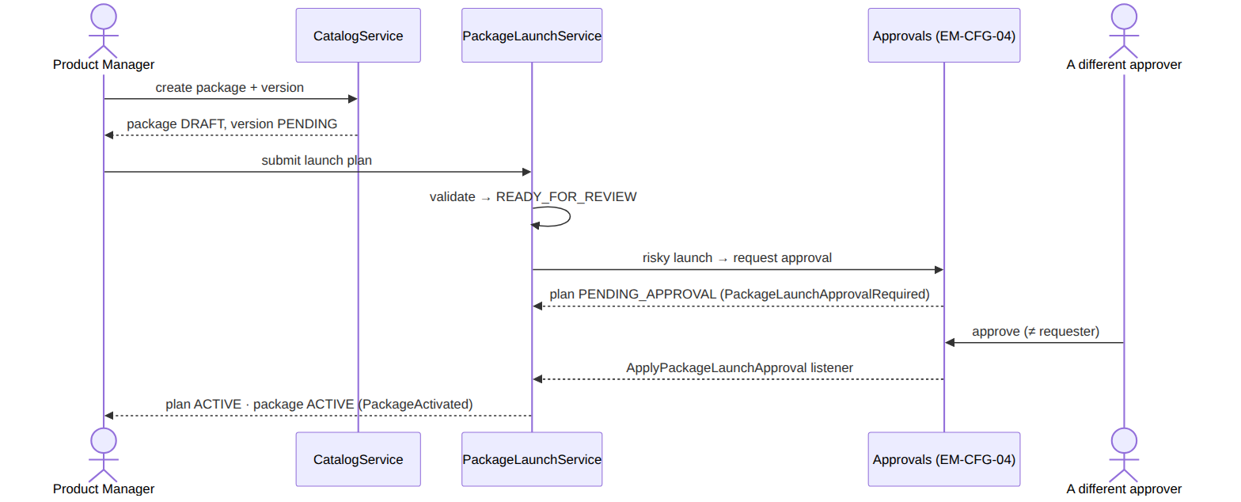
The plan's own lifecycle:
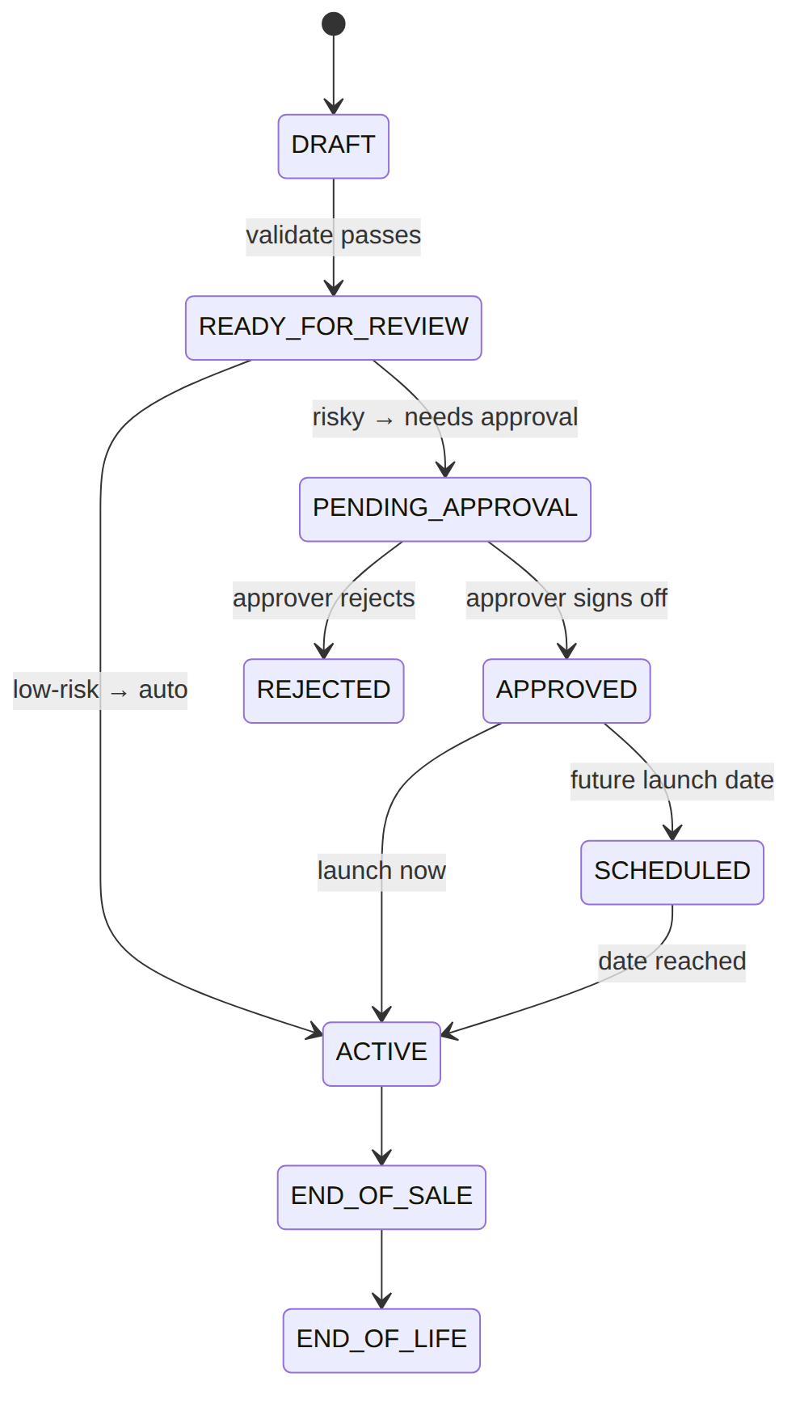
Proven by PackageLaunchTest.

2. Tax on a 5,000 KES internet package
The story in plain English: When Billing prices an internet line, it asks Catalog "what tax goes on this?" Catalog picks the right tax group for the product, runs that group's rules in order, and hands back the subtotal and the tax. (The full mechanics, with worked numbers, are in the tax_group/ tax_rule section of the data model below.)
Who does what: Billing calls TaxComputeService::compute({taxableKind:'PACKAGE', customerCategory:'RES', baseAmount:5000}). It evaluates rules.tax-applicability (Foundation/Rules) → a tax_group; iterates its tax_rule rows by order_within_group, computing each per base_method (BASE/BASE_PLUS_PRIOR cascade); a NONE applicability ⇒ exempt. Returns {subtotal, taxTotal, taxLines}. Proven by TaxComputeTest. (See the tax cascade worked example below for the full numbers.)

3. Grant a discount (EM-CFG-04 if high-value)
The story in plain English: An agent gives a customer a discount. The system first refuses if the customer already has the same discount live (no double-granting). Then, if the discount is high-value (or long-running, or manually granted), it can't just take effect — it needs a separate approval. Until that approval lands the grant sits pending; once approved it goes live.
Who does what:
- DiscountAssignmentService::create blocks a duplicate active grant (R-SIP-DA-05).
- It asks EM-CFG-04 whether approval is needed (R-SIP-DA-07/11).
- High value → discount_assignment.status=PENDING_APPROVAL (emits DiscountAssignmentApprovalRequired).
- Approval → status ACTIVATED.
Sample — a campaign grant awaiting approval:
{ "assignment_id":"dasg_2","discount_code":"WELCOME_500","scope_type":"CAMPAIGN_COHORT","status":"PENDING_APPROVAL","approval_request_id":"appr_44","assignment_mode":"CAMPAIGN" }
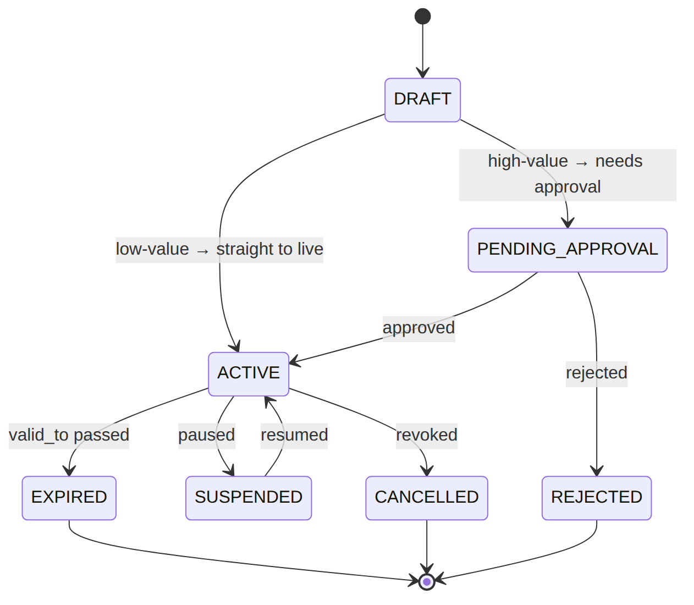
Proven by DiscountAssignmentTest.

4. Resolve effective discount(s) at billing time (stacking)
The story in plain English: At billing time a customer might have several discounts that could apply. The system decides which ones actually combine ("stack") and in what order, then returns the net effect. A direct (manually granted) discount beats a campaign one when they're otherwise tied.
Who does what: DiscountComputeService::compute(operator, baseAmount, context) finds the applicable assignments, applies stacking + priority (DIRECT beats CAMPAIGN on a tie), and returns the effective discount. Proven by DiscountComputeTest.
Worked example — base price KES 1,000, two candidate discounts:
Discount | type | value | stackable | applied on | discount | running total
STAFF_50 (DIRECT, prio 10) | PERCENT | 50% | no | 1000.00 | 500.00 | 500.00
WELCOME_500 (CAMPAIGN, prio 100) | FIXED | 500 | yes | — | skipped (non-stackable winner already applied) | 500.00
(Here the non-stackable DIRECT discount wins by priority, so the campaign one is not added. If the winning discount were stackable, the next stackable one would apply to the reduced amount.)

5. Bundle launch (maker-checker)
The story in plain English: A marketer builds a commercial bundle (a package wrapped for a purpose, e.g. an acquisition offer). Like a package launch, it can't go live by itself — it walks a review-and- approval lifecycle before it becomes ACTIVE and sellable.
Who does what: BundleService walks a commercial_bundle DRAFT → READY_FOR_REVIEW → APPROVED → ACTIVE with launch checks; approval gated. Proven by BundleAndCampaignTest.
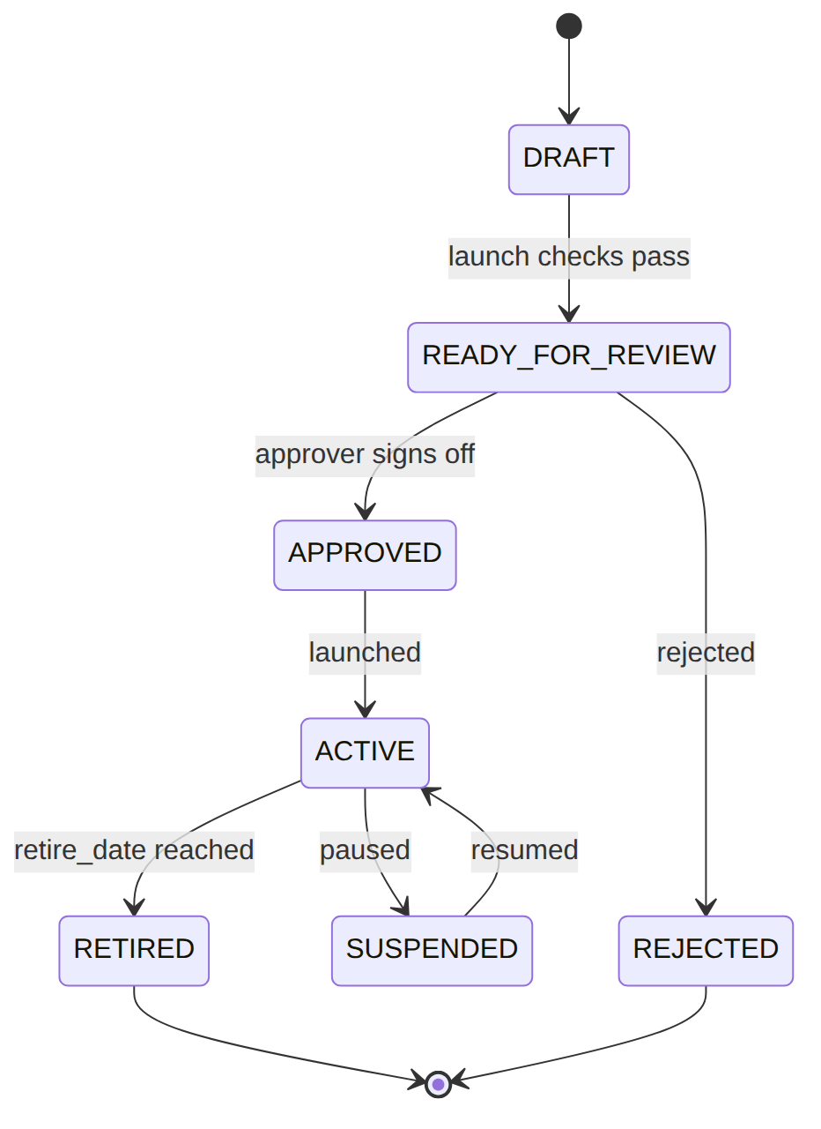

6. Voice rating (longest-prefix match)
The story in plain English: To price a phone call, the system looks at the number dialled and finds the most specific matching prefix in its prefix table. The longest matching prefix wins, which points to a destination zone, and the zone's rate is what the call is charged at.
Who does what: VoiceTariffService rates a call by matching the dialled number against voice_destination_prefix (longest prefix wins via match_priority) → its voice_destination_zone rate. UsageRatingService does the same for data/SMS tariffs. Proven by VoiceTariffTest, UsageRatingTest.
Worked example — dialling +447700900123:
Candidate prefix | matches? | length | zone
+2547 | no | 5 | (LOCAL)
+44 | yes | 3 | INTL_UK
→ longest matching prefix is +44 → zone INTL_UK → its rate applies.
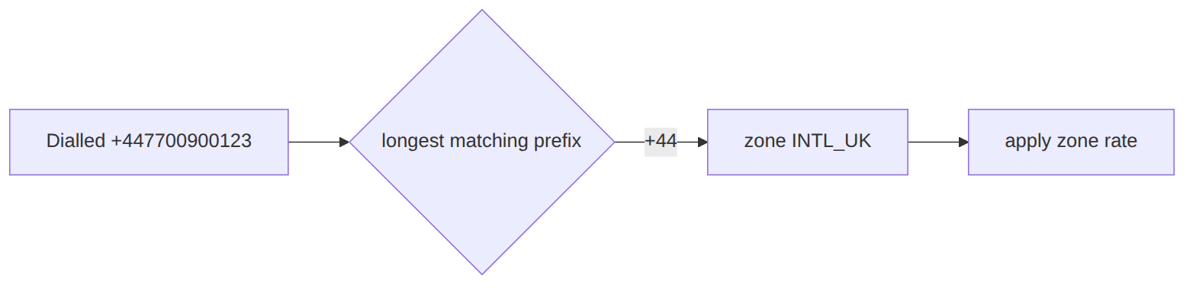

7. HomePass becomes sellable (approval-gated transition)
The story in plain English: A "homepass" is a physical premises the network can reach. While it's still being built it can't be sold. Moving it to "sellable" is gated by an approval; once approved, the system flips it and announces it so Fulfillment can start taking orders for that address.
Who does what: HomePassTopologyService transitions a homepass UNDER_CONSTRUCTION → SELLABLE; an EM-CFG-04 gate (RLM-CFG-01 H-5) → ApplyHomePassTransitionOnApproval applies it → emits HomePassReachedSellable (Fulfillment can now take orders for it). Proven by ConfigCatalogTest.
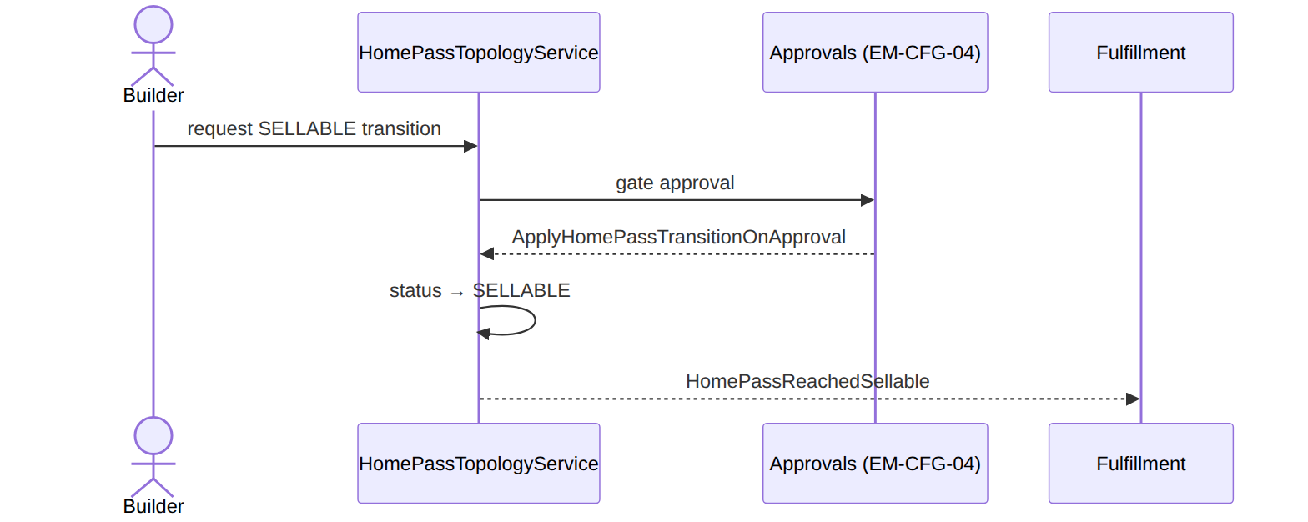

8. Wallet catalog feeds Billing
The story in plain English: Catalog defines the kinds of prepaid wallet that exist (main wallet, voice wallet, loyalty points) and their behaviour. Billing then creates actual wallets of those kinds for customers and routes usage to the right one by its code.
Who does what: WalletCatalogService defines wallet_type rows (allow_negative, auto_debit); Billing creates prepaid wallets of those types and routes usage by wallet_type_code. Cross-module config handoff.

(bonus) 9. Any catalog change evicts stale read-models
CatalogCacheInvalidator (listener) + Billing's EvictPlmCatalogCache drop cached snapshots on catalog lifecycle events (Foundation/Cache).

2. Data model — ≥4 complete sample rows + readings
Completeness: each row lists every domain column (nullables shown as null). The surrogate primary key shown is the real one (a string ULID business key, e.g. id/discount_id); created_at/updated_at are omitted by convention. homepass is Catalog-owned and ~50 columns wide — its full-width rows live here (provisioning.md projects it).

package (status: DRAFT|ACTIVE|INACTIVE|END_OF_LIFE) & package_version (status: PENDING|ACTIVE|SUPERSEDED)
{ "id":"pkg_triple","operator_code":"WIK","code":"TRIPLE_PLAY","name":"Triple Play","display_name":"Triple Play 100M","description":"Internet + TV + Voice","status":"ACTIVE","billing_frequency_days":30,"default_wallet_ref":null,"default_tax_group_ref":"KE_INTERNET","target_franchises":["fr_nrb"],"target_tech_regions":["KE-NRB-KAREN"],"current_version_id":"pv_1","retired_at":null }
{ "id":"pkg_inet","operator_code":"WIK","code":"INET_100","name":"Internet 100M","display_name":null,"description":null,"status":"ACTIVE","billing_frequency_days":30,"default_wallet_ref":null,"default_tax_group_ref":"KE_INTERNET","target_franchises":null,"target_tech_regions":null,"current_version_id":"pv_2","retired_at":null }
{ "id":"pkg_promo","operator_code":"WIK","code":"BLACK_FRIDAY","name":"Black Friday","display_name":"Black Friday 2026","description":"Seasonal acquisition","status":"DRAFT","billing_frequency_days":30,"default_wallet_ref":null,"default_tax_group_ref":null,"target_franchises":null,"target_tech_regions":null,"current_version_id":null,"retired_at":null }
{ "id":"pkg_old","operator_code":"WIK","code":"INET_50","name":"Internet 50M","display_name":null,"description":null,"status":"INACTIVE","billing_frequency_days":30,"default_wallet_ref":null,"default_tax_group_ref":"KE_INTERNET","target_franchises":null,"target_tech_regions":null,"current_version_id":"pv_old","retired_at":"2026-05-01T00:00:00Z" }
// version (the priced thing proration reads)
{ "id":"pv_1","package_id":"pkg_triple","price":5000.00,"currency":"KES","target_franchises":["fr_nrb"],"target_tech_regions":null,"effective_from":"2026-01-01T00:00:00Z","effective_until":null,"status":"ACTIVE" }
{ "id":"pv_old","package_id":"pkg_old","price":2500.00,"currency":"KES","target_franchises":null,"target_tech_regions":null,"effective_from":"2025-01-01T00:00:00Z","effective_until":"2026-05-01T00:00:00Z","status":"SUPERSEDED" }
Read each row as a sentence — this data means this:
Row | What it means in plain English
pkg_triple | A live, sellable bundle "Triple Play" (status=ACTIVE) priced by its version pv_1 (current_version_id), and only sold in Nairobi/Karen (target_franchises/target_tech_regions).
pkg_inet | A live "Internet 100M" sold everywhere (target_franchises/target_tech_regions=null = no restriction), priced by version pv_2.
pkg_promo | A Black Friday package still being built — not sellable (status=DRAFT, current_version_id=null = no priced version yet).
pkg_old | A retired "Internet 50M": withdrawn from sale (status=INACTIVE, retired_at stamped) — existing subs keep it, no new orders.
pv_1 | The live priced version of pkg_triple: KES 5000.00 (price), in effect since Jan 2026 with no end (effective_until=null, status=ACTIVE).
pv_old | An old priced version that was replaced: status=SUPERSEDED, effective_until set — kept so old invoices still recompute.
The columns that did the work:
- The price lives on the version (pv_1.price), not the package; current_version_id points at the live one.
- Sellable or not = status (only ACTIVE takes new orders; retired_at stamps the withdrawal).
- A price change = a brand-new package_version row; the old one goes SUPERSEDED (history preserved).
- Where it may be sold = target_franchises/target_tech_regions.
package status lifecycle (the launch flow that drives DRAFT → ACTIVE is Scenario 1):
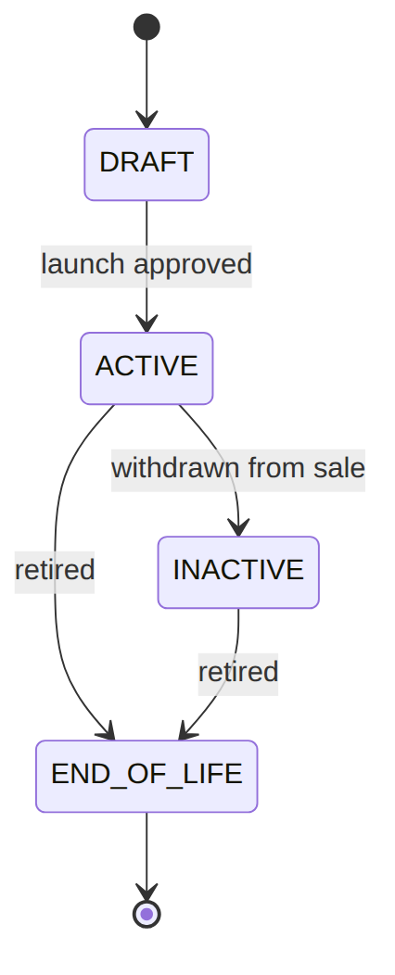
package_version status lifecycle (a price change supersedes the old version):
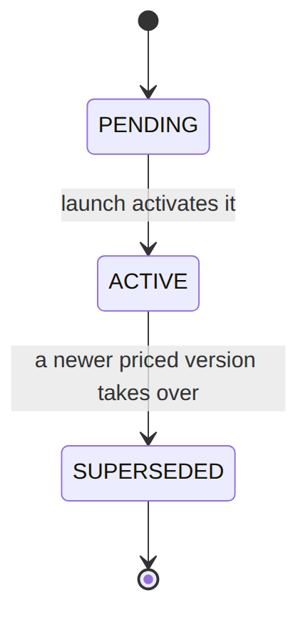

service (consumption_model: FLAT|USAGE)
{ "id":"svc_inet","operator_code":"WIK","name":"Internet","code":"INTERNET","description":"Broadband access","service_class_id":"scls_inet","service_group":"BROADBAND","is_addressable":true,"equipment_requirement_ref":"eqr_ont","consumption_model":"FLAT","revenue_category":"INTERNET","network_profile_shape":{"speed":"100M","vlan":101},"provisioner_key":"gpon_inet","default_wallet_ref":null,"default_tax_group_ref":"KE_INTERNET","status":"ACTIVE","retired_at":null }
{ "id":"svc_tv","operator_code":"WIK","name":"TV","code":"TV","description":"IPTV bouquet","service_class_id":"scls_tv","service_group":"VIDEO","is_addressable":true,"equipment_requirement_ref":"eqr_stb","consumption_model":"FLAT","revenue_category":"TV","network_profile_shape":{"bouquet":"PREMIUM"},"provisioner_key":"iptv","default_wallet_ref":null,"default_tax_group_ref":"KE_INTERNET","status":"ACTIVE","retired_at":null }
{ "id":"svc_voice","operator_code":"WIK","name":"Voice","code":"VOICE","description":"Fixed voice","service_class_id":"scls_voice","service_group":"VOICE","is_addressable":false,"equipment_requirement_ref":null,"consumption_model":"USAGE","revenue_category":"VOICE","network_profile_shape":null,"provisioner_key":"sip","default_wallet_ref":"VOICE_WALLET","default_tax_group_ref":"KE_VOICE","status":"ACTIVE","retired_at":null }
{ "id":"svc_data","operator_code":"WIK","name":"Mobile Data","code":"DATA","description":"Metered data","service_class_id":"scls_data","service_group":"DATA","is_addressable":false,"equipment_requirement_ref":null,"consumption_model":"USAGE","revenue_category":"DATA","network_profile_shape":null,"provisioner_key":null,"default_wallet_ref":"DATA_WALLET","default_tax_group_ref":null,"status":"ACTIVE","retired_at":null }
Read each row as a sentence — this data means this:
Row | What it means in plain English
svc_inet | Internet: a flat-fee service (consumption_model=FLAT, billed as the package price). It gets provisioned (is_addressable=true) with profile {speed:100M, vlan:101} (network_profile_shape) via the gpon_inet plane (provisioner_key).
svc_tv | IPTV: also flat-fee and provisioned (is_addressable=true), with bouquet PREMIUM over the iptv plane.
svc_voice | Voice: metered (consumption_model=USAGE) — usage is rated and lands its own charge, routed to VOICE_WALLET (default_wallet_ref), and grouped under revenue_category=VOICE (its own invoice).
svc_data | Mobile Data: metered too, routed to DATA_WALLET, not provisioned (is_addressable=false, provisioner_key=null).
The columns that did the work:
- Flat vs metered = consumption_model (FLAT = the package fee; USAGE = rated events → own charge).
- Does it get provisioned = is_addressable; the profile sent to Provisioning = network_profile_shape + provisioner_key.
- How Billing groups it = revenue_category (this is how voice lands on its own invoice); every service rolls up to a service_class_id.

discount table is discount_catalog (discount_type: PERCENT|FIXED · applies_to: INVOICE|PACKAGE|SERVICE)
{ "discount_id":"disc_ret25","operator_code":"WIK","code":"RET_25","name":"Retention 25%","discount_type":"PERCENT","value":0.2500,"applies_to":"INVOICE","stackable":false,"priority":50,"max_redemptions":null,"status":"ACTIVE","effective_from":"2026-01-01T00:00:00Z","effective_until":null }
{ "discount_id":"disc_wel500","operator_code":"WIK","code":"WELCOME_500","name":"Welcome KES 500","discount_type":"FIXED","value":500.0000,"applies_to":"INVOICE","stackable":true,"priority":100,"max_redemptions":1,"status":"ACTIVE","effective_from":"2026-01-01T00:00:00Z","effective_until":null }
{ "discount_id":"disc_staff","operator_code":"WIK","code":"STAFF_50","name":"Staff 50%","discount_type":"PERCENT","value":0.5000,"applies_to":"PACKAGE","stackable":false,"priority":10,"max_redemptions":null,"status":"ACTIVE","effective_from":"2026-01-01T00:00:00Z","effective_until":null }
{ "discount_id":"disc_old","operator_code":"WIK","code":"LAUNCH_10","name":"Launch 10%","discount_type":"PERCENT","value":0.1000,"applies_to":"INVOICE","stackable":true,"priority":100,"max_redemptions":null,"status":"INACTIVE","effective_from":"2025-01-01T00:00:00Z","effective_until":"2026-01-01T00:00:00Z" }

discount_assignment (scope_type: CUSTOMER|ACCOUNT|SUBSCRIPTION|ORDER|PACKAGE|FRANCHISE|CAMPAIGN_COHORT · status: DRAFT|PENDING_APPROVAL|ACTIVE|SUSPENDED|EXPIRED|CANCELLED|REJECTED · assignment_mode: DIRECT|CAMPAIGN)
SIP-03 grew this table: scope_type/scope_ref_id/typed refs/status/valid_*/approval all added by the SIP-03 lifecycle migration; assignment_mode by a later ALTER. The original scope/scope_ref/ active columns remain as LEGACY (kept in sync; new code reads scope_type).
{ "assignment_id":"dasg_1","operator_code":"WIK","discount_code":"RET_25","scope":"CUSTOMER","scope_ref":"cust_1","campaign_code":null,"active":true,"redemptions":0,"discount_id":"disc_ret25","scope_type":"CUSTOMER","scope_ref_id":"cust_1","customer_id":"cust_1","account_id":null,"subscription_id":null,"package_ref":null,"campaign_id":null,"franchise_id":null,"reason_code":"RETENTION","source_channel":"BACKOFFICE","valid_from":"2026-06-01","valid_to":null,"status":"ACTIVE","assignment_priority":50,"stacking_group_code":null,"approval_request_id":null,"metadata_json":null,"created_by_user_id":"u_csr1","activated_at":"2026-06-01T09:00:00Z","cancelled_at":null,"assignment_mode":"DIRECT" }
{ "assignment_id":"dasg_2","operator_code":"WIK","discount_code":"WELCOME_500","scope":"CAMPAIGN","scope_ref":null,"campaign_code":"Q3_ACQ","active":false,"redemptions":0,"discount_id":"disc_wel500","scope_type":"CAMPAIGN_COHORT","scope_ref_id":"camp_q3","customer_id":null,"account_id":null,"subscription_id":null,"package_ref":null,"campaign_id":"camp_q3","franchise_id":null,"reason_code":"ACQUISITION","source_channel":"CAMPAIGN","valid_from":"2026-07-01","valid_to":"2026-09-30","status":"PENDING_APPROVAL","assignment_priority":100,"stacking_group_code":"WELCOME","approval_request_id":"appr_44","metadata_json":{"cohortSize":5000},"created_by_user_id":"u_mkt1","activated_at":null,"cancelled_at":null,"assignment_mode":"CAMPAIGN" }
{ "assignment_id":"dasg_3","operator_code":"WIK","discount_code":"STAFF_50","scope":"SUBSCRIPTION","scope_ref":"sub_123","campaign_code":null,"active":true,"redemptions":1,"discount_id":"disc_staff","scope_type":"SUBSCRIPTION","scope_ref_id":"sub_123","customer_id":"cust_50","account_id":"acc_1","subscription_id":"sub_123","package_ref":"pkg_triple","campaign_id":null,"franchise_id":null,"reason_code":"STAFF_BENEFIT","source_channel":"BACKOFFICE","valid_from":"2026-01-01","valid_to":null,"status":"ACTIVE","assignment_priority":10,"stacking_group_code":null,"approval_request_id":null,"metadata_json":null,"created_by_user_id":"u_hr1","activated_at":"2026-01-01T00:00:00Z","cancelled_at":null,"assignment_mode":"DIRECT" }
{ "assignment_id":"dasg_4","operator_code":"WIK","discount_code":"LAUNCH_10","scope":"ALL","scope_ref":null,"campaign_code":null,"active":false,"redemptions":12,"discount_id":"disc_old","scope_type":"FRANCHISE","scope_ref_id":"fr_nrb","customer_id":null,"account_id":null,"subscription_id":null,"package_ref":null,"campaign_id":null,"franchise_id":"fr_nrb","reason_code":"LAUNCH","source_channel":"BATCH","valid_from":"2025-01-01","valid_to":"2026-01-01","status":"EXPIRED","assignment_priority":100,"stacking_group_code":null,"approval_request_id":null,"metadata_json":null,"created_by_user_id":"u_mkt1","activated_at":"2025-01-01T00:00:00Z","cancelled_at":null,"assignment_mode":"CAMPAIGN" }
Read each row as a sentence — this data means this:
Row | What it means in plain English
dasg_1 | Customer cust_1 gets 25% off (the RET_25 rule). A person granted it by hand (assignment_mode=DIRECT, source_channel=BACKOFFICE) for retention, and it's live right now (status=ACTIVE, valid_to=null = no end date).
dasg_2 | A whole campaign cohort (camp_q3, ~5000 people) is offered KES 500 off. Nothing is applied yet — it's waiting for a manager to approve (status=PENDING_APPROVAL, approval_request_id=appr_44). It would only run Jul–Sep 2026 (valid_from/valid_to).
dasg_3 | One subscription (sub_123) gets STAFF_50. Live, already used once (redemptions=1), and it wins ties when combining (lowest assignment_priority=10).
dasg_4 | A franchise-wide launch discount that is now dead: its valid_to (2026-01-01) is in the past, so status=EXPIRED. It applies to nothing anymore.
The columns that did that work:
- Who it applies to = scope_type + scope_ref_id (CUSTOMER→cust_1, CAMPAIGN_COHORT→camp_q3, SUBSCRIPTION→sub_123, FRANCHISE→fr_nrb). The matching FK is also filled for convenience (customer_id/subscription_id/franchise_id/campaign_id).
- Live or not = status (+ valid_from/valid_to dates). Only ACTIVE and in-window grants apply.
- How two live grants combine = the discount's stackable flag (on discount_catalog) + the assignment's stacking_group_code, and assignment_priority orders them (lower wins — dasg_3's 10 beats dasg_1's 50).
- The scope/scope_ref/active columns are LEGACY (kept in sync; new code reads scope_type/status).
(Delta: grants reach the invoice via Billing's adjustment/credit path, not an auto cycle-close line — see billing.md §10.)

tax_group & tax_rule — how tax is stacked on a price
The idea in one line: a group is an ordered list of rules; billing runs the rules in that order and adds up the tax. A simple product (internet) has a group with one rule; voice has a group with two rules that stack.
Two order_within_group columns — don't confuse them. They have the same name but mean different things:
- on tax_group it's a JSON list of rule codes — which rules run, and in what order (this is the one the engine actually iterates).
- on tax_rule it's a plain integer — a per-rule sequence number (legacy/advisory; the group's list is authoritative).
// GROUPS — each lists the rule codes to run, in order
{ "tax_group_id":"txg_inet","operator_code":"WIK","code":"KE_INTERNET","name":"KE Internet","order_within_group":["WIK_INTERNET_VAT"],"regulator_reference":"KRA-VAT" }
{ "tax_group_id":"txg_voice","operator_code":"WIK","code":"KE_VOICE","name":"KE Voice","order_within_group":["WIK_EXCISE","WIK_VOICE_VAT"],"regulator_reference":"KRA-EXC-VAT" }
// RULES — each is one tax: a rate, and what it is charged ON (base_method)
{ "tax_rule_id":"txr_ivat","operator_code":"WIK","code":"WIK_INTERNET_VAT","name":"Internet VAT","taxable_category":"INTERNET","rate":0.1600,"base_method":"BASE","order_within_group":1,"rounding_mode":"HALF_UP","rounding_scale":2,"regulator":"KRA","regulator_tax_code":"VAT16","effective_from":"2026-01-01T00:00:00Z","effective_until":null }
{ "tax_rule_id":"txr_exc","operator_code":"WIK","code":"WIK_EXCISE","name":"Voice Excise","taxable_category":"VOICE","rate":0.2000,"base_method":"BASE","order_within_group":1,"rounding_mode":"HALF_UP","rounding_scale":2,"regulator":"KRA","regulator_tax_code":"EXC20","effective_from":"2026-01-01T00:00:00Z","effective_until":null }
{ "tax_rule_id":"txr_vvat","operator_code":"WIK","code":"WIK_VOICE_VAT","name":"Voice VAT","taxable_category":"VOICE","rate":0.1600,"base_method":"BASE_PLUS_PRIOR","order_within_group":2,"rounding_mode":"HALF_UP","rounding_scale":2,"regulator":"KRA","regulator_tax_code":"VAT16","effective_from":"2026-01-01T00:00:00Z","effective_until":null }
base_method is the whole trick:
- BASE → the rule is charged on the original price.
- BASE_PLUS_PRIOR → the rule is charged on the price + every tax already added before it (it stacks on top). This is how "VAT on top of excise" works.
Worked example — internet, price KES 100.00 (group KE_INTERNET, one rule):
# | Rule | Rate | Charged on (base_method) | Base | Tax
1 | WIK_INTERNET_VAT | 16% | BASE = 100.00 | 100.00 | 16.00
 |  |  |  | Total tax | 16.00
→ customer pays 116.00.
Worked example — voice, price KES 100.00 (group KE_VOICE, two rules that stack):
# | Rule | Rate | Charged on (base_method) | Base | Tax
1 | WIK_EXCISE | 20% | BASE = 100.00 | 100.00 | 20.00
2 | WIK_VOICE_VAT | 16% | BASE_PLUS_PRIOR = 100.00 + 20.00 | 120.00 | 19.20
 |  |  |  | Total tax | 39.20
→ customer pays 139.20. (VAT is 19.20, not 16.00, because it's charged on the price plus the excise — Kenya's telecoms tax stack.)
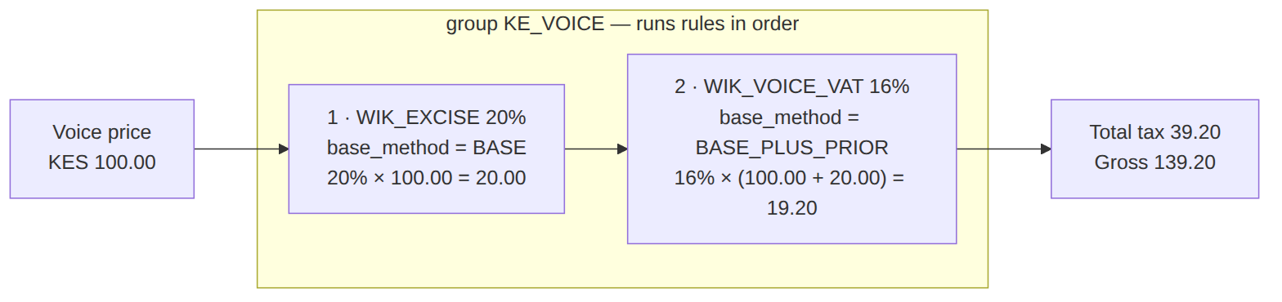
Read each row as a sentence — this data means this:
Row | What it means in plain English
txg_inet | The internet tax group: run exactly one rule, WIK_INTERNET_VAT (order_within_group).
txg_voice | The voice tax group: run two rules in this order — WIK_EXCISE then WIK_VOICE_VAT (order_within_group) — so they stack.
txr_ivat | Internet VAT: charge 16% (rate) on the original price (base_method=BASE).
txr_exc | Voice excise: charge 20% on the original price (base_method=BASE) — runs first.
txr_vvat | Voice VAT: charge 16% on the price plus the excise already added (base_method=BASE_PLUS_PRIOR) — this is why VAT comes out at 19.20, not 16.00.
The columns that did the work:
- Which rules run, in what order = the group's order_within_group rule-code list (rules.tax-applicability picks the group per line).
- What each rule is charged on = base_method (BASE = original price; BASE_PLUS_PRIOR = price + tax-so-far).
- Rounding = rounding_mode/rounding_scale each step; a group resolving to NONE ⇒ exempt; rules are closed with effective_until (never deleted) so old invoices still recompute.

voice_tariff (legacy simple catalog · destination: ONNET|OFFNET|INTERNATIONAL) and the PLM-CFG-07 voice_destination_zone / voice_destination_prefix (longest-prefix model)
{ "voice_tariff_id":"vtar_local","operator_code":"WIK","code":"VOICE_LOCAL","name":"Local","destination":"ONNET","rate_per_min":2.0000,"setup_fee":0.0000,"min_charge_seconds":0 }
{ "voice_tariff_id":"vtar_intl","operator_code":"WIK","code":"VOICE_INTL_UK","name":"International UK","destination":"INTERNATIONAL","rate_per_min":15.0000,"setup_fee":1.0000,"min_charge_seconds":30 }
// voice_destination_zone (zone_type: ON_NET|NATIONAL|REGIONAL|INTERNATIONAL|TOLL_FREE|EMERGENCY|PREMIUM ; default_charge_policy: CHARGEABLE|ZERO_RATED|BLOCKED|QUARANTINE)
{ "zone_id":"vdz_local","operator_code":"WIK","zone_code":"LOCAL","zone_name":"Kenya Mobile","zone_type":"NATIONAL","default_charge_policy":"CHARGEABLE","status":"ACTIVE" }
{ "zone_id":"vdz_uk","operator_code":"WIK","zone_code":"INTL_UK","zone_name":"United Kingdom","zone_type":"INTERNATIONAL","default_charge_policy":"CHARGEABLE","status":"ACTIVE" }
// voice_destination_prefix (longest-prefix wins via match_priority)
{ "prefix_id":"vdp_254","operator_code":"WIK","prefix":"+2547","zone_id":"vdz_local","match_priority":10,"status":"ACTIVE","effective_from":"2026-01-01T00:00:00Z","effective_to":null,"notes":null }
{ "prefix_id":"vdp_44","operator_code":"WIK","prefix":"+44","zone_id":"vdz_uk","match_priority":5,"status":"ACTIVE","effective_from":"2026-01-01T00:00:00Z","effective_to":null,"notes":"UK fixed+mobile" }
Read each row as a sentence — this data means this:
Row | What it means in plain English
vtar_local | Legacy simple tariff: an on-net local call costs KES 2.00/min (rate_per_min), no setup fee, no minimum.
vtar_intl | Legacy simple tariff: an international UK call costs KES 15.00/min with a KES 1.00 setup fee and a 30s minimum (setup_fee/min_charge_seconds).
vdz_local | The new model's priced bucket for Kenya Mobile — a chargeable national zone (zone_type=NATIONAL, default_charge_policy=CHARGEABLE).
vdz_uk | The priced bucket for the UK — a chargeable international zone.
vdp_254 | A dial-string → zone mapping: numbers starting +2547 belong to the LOCAL zone (zone_id=vdz_local), ranked by match_priority=10.
vdp_44 | Numbers starting +44 belong to the UK zone (zone_id=vdz_uk); a call to +447… matches this prefix → INTL_UK zone, its rate applies.
The columns that did the work:
- Which zone a number lands in = longest matching prefix wins (match_priority breaks ties); the prefix points at a zone_id.
- What a call costs = the zone (the priced bucket) vs the legacy flat voice_tariff (rate_per_min/setup_fee/min_charge_seconds). PLM-CFG-07 split the old single catalog into voice_destination_zone + voice_destination_prefix.

wallet_type (catalog consumed by Billing) & homepass (the premises — full width)
homepass.status is not a hardcoded enum — it is a code from the homepass_status_code catalog whose flags (is_sellable/is_active/…) drive behaviour; the codes below (RFS/WAI/RETIRED) are illustrative. homepass accreted address/building/GIS/RoE/topology columns across several RLM migrations (network_path/services_supported/service_management_endpoints from the topology migration; the structured address + property_type/RoE from the address-lifecycle migration; geo_* from the geo-placeholder migration; has_been_sellable from the status-catalog migration).
{ "wallet_type_id":"wtyp_main","operator_code":"WIK","code":"MAIN_WALLET","name":"Main Wallet","unit":"currency","currency":"KES","allow_negative":false,"auto_debit":true }
{ "wallet_type_id":"wtyp_voice","operator_code":"WIK","code":"VOICE_WALLET","name":"Voice Wallet","unit":"currency","currency":"KES","allow_negative":false,"auto_debit":true }
{ "wallet_type_id":"wtyp_pts","operator_code":"WIK","code":"LOYALTY_POINTS","name":"Loyalty Points","unit":"points","currency":"KES","allow_negative":false,"auto_debit":false }
// homepass — every domain column (created_at/updated_at omitted)
{ "id":"hp_1","operator_code":"WIK","code":"HP-NRB-0001","address":"12 Karen Rd","country":"KE","region":"Nairobi","region_l1":"Nairobi","region_l2":null,"city":"Nairobi","area":"Karen","sub_area_1":"Bogani","sub_area_2":null,"road_name":"Karen Rd","building_number":"12","building_name":null,"apartment_number":null,"floor":null,"building_num_floors":1,"building_num_apartments":1,"property_type":"RES","owner_occupied":true,"outlets":2,"active_termination_points":1,"latitude":-1.3194000,"longitude":36.7062000,"altitude":1680.00,"map_code":null,"map_link":null,"google_place_id":"ChIJ_karen_001","not_serviceable_reason":null,"perm_date":"2025-11-01","survey_date":"2025-10-15","roe_signed_date":"2025-11-10","roe_document_link":"files://roe/hp_1.pdf","legacy_status_code":null,"directions":"Gate with red door","comments":null,"tech_region_id":"KE-NRB-KAREN","technology":"GPON","status":"RFS","has_been_active":true,"has_been_sellable":true,"network_nodes":["ONT-77","OLT-NRB-WTL-01"],"network_path":{"captureMode":"AUTO","nodes":[{"type":"ONT","code":"ONT-77","role":"LEAF","port":1}]},"service_management_endpoints":{"DATA":{"nodeCode":"OLT-NRB-WTL-01","port":1}},"services_supported":["DATA","VOICE","IPTV_MULTICAST"],"geo_lat":-1.3194000,"geo_lng":36.7062000,"geo_footprint":null,"geo_source":"CGIS_2026Q1","geo_imported_at":"2026-02-01T00:00:00Z" }
{ "id":"hp_2","operator_code":"WIK","code":"HP-NRB-0002","address":"14 Karen Rd","country":"KE","region":"Nairobi","region_l1":"Nairobi","region_l2":null,"city":"Nairobi","area":"Karen","sub_area_1":"Bogani","sub_area_2":null,"road_name":"Karen Rd","building_number":"14","building_name":null,"apartment_number":null,"floor":null,"building_num_floors":1,"building_num_apartments":1,"property_type":"RES","owner_occupied":false,"outlets":0,"active_termination_points":0,"latitude":null,"longitude":null,"altitude":null,"map_code":null,"map_link":null,"google_place_id":null,"not_serviceable_reason":"under construction","perm_date":null,"survey_date":"2026-05-01","roe_signed_date":null,"roe_document_link":null,"legacy_status_code":null,"directions":null,"comments":null,"tech_region_id":"KE-NRB-KAREN","technology":"GPON","status":"WAI","has_been_active":false,"has_been_sellable":false,"network_nodes":[],"network_path":null,"service_management_endpoints":null,"services_supported":null,"geo_lat":null,"geo_lng":null,"geo_footprint":null,"geo_source":null,"geo_imported_at":null }
{ "id":"hp_3","operator_code":"WIK","code":"HP-MSA-0007","address":"7 Nyali Rd","country":"KE","region":"Mombasa","region_l1":"Mombasa","region_l2":null,"city":"Mombasa","area":"Nyali","sub_area_1":null,"sub_area_2":null,"road_name":"Nyali Rd","building_number":"7","building_name":"Palm Court","apartment_number":"3B","floor":"3","building_num_floors":6,"building_num_apartments":24,"property_type":"MIXED","owner_occupied":false,"outlets":4,"active_termination_points":2,"latitude":-4.0100000,"longitude":39.7000000,"altitude":15.00,"map_code":"MSA-NYL-07","map_link":null,"google_place_id":"ChIJ_nyali_007","not_serviceable_reason":null,"perm_date":"2025-09-01","survey_date":"2025-08-20","roe_signed_date":"2025-09-05","roe_document_link":"files://roe/hp_3.pdf","legacy_status_code":"OLD_RFS","directions":null,"comments":"HFC plant","tech_region_id":"KE-MSA-NYALI","technology":"HFC","status":"RFS","has_been_active":true,"has_been_sellable":true,"network_nodes":["CM-12","DN-3"],"network_path":{"captureMode":"MANUAL","nodes":[{"type":"MODEM","code":"CM-12","role":"LEAF","port":1}]},"service_management_endpoints":{"DATA":{"nodeCode":"DN-3","port":2}},"services_supported":["DATA","VOICE"],"geo_lat":-4.0100000,"geo_lng":39.7000000,"geo_footprint":null,"geo_source":"CGIS_2026Q1","geo_imported_at":"2026-02-01T00:00:00Z" }
{ "id":"hp_4","operator_code":"WIK","code":"HP-NRB-0099","address":"99 Karen Rd","country":"KE","region":"Nairobi","region_l1":"Nairobi","region_l2":null,"city":"Nairobi","area":"Karen","sub_area_1":null,"sub_area_2":null,"road_name":"Karen Rd","building_number":"99","building_name":null,"apartment_number":null,"floor":null,"building_num_floors":1,"building_num_apartments":1,"property_type":"RES","owner_occupied":true,"outlets":1,"active_termination_points":0,"latitude":-1.3200000,"longitude":36.7100000,"altitude":1675.00,"map_code":null,"map_link":null,"google_place_id":null,"not_serviceable_reason":"decommissioned","perm_date":null,"survey_date":null,"roe_signed_date":null,"roe_document_link":null,"legacy_status_code":null,"directions":null,"comments":null,"tech_region_id":"KE-NRB-KAREN","technology":"GPON","status":"RETIRED","has_been_active":true,"has_been_sellable":true,"network_nodes":["ONT-3"],"network_path":null,"service_management_endpoints":null,"services_supported":["DATA"],"geo_lat":-1.3200000,"geo_lng":36.7100000,"geo_footprint":null,"geo_source":null,"geo_imported_at":null }
Read each row as a sentence — this data means this:
Row | What it means in plain English
wtyp_main | The main money wallet kind: holds currency (unit=currency, KES), can't go negative, debits automatically each cycle (allow_negative=false, auto_debit=true).
wtyp_voice | The voice money wallet kind: same currency behaviour, auto-debited.
wtyp_pts | Loyalty points: counted in points, not money (unit=points), and never auto-debited (auto_debit=false).
hp_1 | A premises in Karen that's ready to sell and live (status=RFS, GPON), with full topology (network_path/services_supported) and CGIS coordinates (geo_*).
hp_2 | A premises still under construction — can't take an order (status=WAI = waiting), no topology yet, never been sellable (has_been_sellable=false).
hp_3 | A ready Mombasa premises on HFC (technology=HFC → the CMTS plane, vs GPON→OLT).
hp_4 | A decommissioned premises (status=RETIRED, not_serviceable_reason=decommissioned) — no orders.
The columns that did the work:
- Can it take an order = the status code's is_sellable flag (RFS yes; WAI/RETIRED no).
- Which provisioning plane = technology (GPON→OLT, HFC→CMTS — see provisioning.md).
- The wallet kind's behaviour = unit/allow_negative/auto_debit (Billing instantiates real wallets from these).
- Uniqueness / one-time latch = the structured address tuple (country…apartment_number) is the deployment-wide key; has_been_sellable latches HomePassReachedSellable to fire once; geo_* (CGIS) supersede the deprecated latitude/longitude.

commercial_bundle (status: DRAFT|READY_FOR_REVIEW|APPROVED|ACTIVE|SUSPENDED|RETIRED|REJECTED|CANCELLED · bundle_type: ACQUISITION|RETENTION|MIGRATION|BUSINESS|STAFF|GENERAL)
{ "bundle_id":"bun_triple","operator_code":"WIK","bundle_code":"TRIPLE_SAVER","display_name":"Triple Saver","description":"Triple play acquisition bundle","status":"ACTIVE","bundle_type":"ACQUISITION","currency_code":"KES","launch_date":"2026-01-01","retire_date":null,"created_by_user_id":"u_mkt1" }
{ "bundle_id":"bun_win","operator_code":"WIK","bundle_code":"WINBACK","display_name":"Winback","description":"Lapsed-customer retention","status":"READY_FOR_REVIEW","bundle_type":"RETENTION","currency_code":"KES","launch_date":null,"retire_date":null,"created_by_user_id":"u_mkt2" }
{ "bundle_id":"bun_staff","operator_code":"WIK","bundle_code":"STAFF_PLAN","display_name":"Staff Plan","description":"Internal staff bundle","status":"ACTIVE","bundle_type":"STAFF","currency_code":"KES","launch_date":"2026-02-01","retire_date":null,"created_by_user_id":"u_hr1" }
{ "bundle_id":"bun_oldbiz","operator_code":"WIK","bundle_code":"OLD_BIZ","display_name":"Old Business","description":"Retired SME bundle","status":"RETIRED","bundle_type":"BUSINESS","currency_code":"KES","launch_date":"2024-01-01","retire_date":"2026-03-01","created_by_user_id":"u_mkt1" }
Read each row as a sentence — this data means this:
Row | What it means in plain English
bun_triple | A live acquisition bundle "Triple Saver" (status=ACTIVE, bundle_type=ACQUISITION), on sale since Jan 2026 with no retire date (launch_date/retire_date).
bun_win | A retention "Winback" bundle still in the launch pipeline — not live yet (status=READY_FOR_REVIEW, launch_date=null).
bun_staff | A live internal staff bundle (bundle_type=STAFF, status=ACTIVE).
bun_oldbiz | A retired SME bundle (status=RETIRED, retire_date=2026-03-01 passed) — off sale.
The columns that did the work:
- Live or not = status (a launch lifecycle with review/approval; only ACTIVE sells).
- Sale window = launch_date/retire_date; commercial purpose = bundle_type.
- (Package and channel links live in child tables — commercial_bundle is just the header.)

3. Services
Service | Responsibility
CatalogService | packages/services/versions CRUD + lifecycle
PackageLaunchService | SIP-02 maker-checker launch (EM-CFG-04 + ApplyPackageLaunchApproval)
BundleService / CampaignService | bundles + promotions
DiscountAssignmentService / DiscountComputeService | grant create() (dup-block + EM-CFG-04) / compute() effective discount (stacking)
TaxComputeService / TaxConfigService | compute() via rules.tax-applicability cascade / tax config
VoiceTariffService / UsageRatingService | rate metered events (longest-prefix)
WalletCatalogService | wallet-type catalog (PLM-CFG-03)
HomePassTopologyService / NetworkCatalogService / TechCoverageService | premises, plant, coverage

4. API surface
Reference CRUD under /api/ (packages, services, bundles, discounts, campaigns, tax-groups/rules, voice-tariffs, wallets, homepass, tech-regions). permission:catalog.manage (reads catalog.read); package/bundle launch via an approve/decide pair.

5. Integration (events) — topic catalog.reference
- Emits: package/service/version lifecycle, HomePassStatusChanged/…ReachedSellable, DiscountAssignment{Created,Activated,Cancelled,Expired,Rejected,ApprovalRequired}, wallet, bundle, campaign, PackageLaunch{…}, voice-tariff.
- Consumes (platform.approvals): ApplyHomePassTransitionOnApproval, ApplyPackageLaunchApproval.
- Cache: CatalogCacheInvalidator (+ Billing's EvictPlmCatalogCache).

6. Processes
Service-level governance (approval-gated launches + HomePass transitions); no BPMN.

7. Policy & config
rules.tax-applicability; every catalog table is config (prices/versions, discounts/campaigns, tariffs, tax groups/rules, wallet types, HomePass status model, tech regions). Wananchi = re-seed.

8. Cross-module dependencies
- Consumed by → Billing (charges/tax/discount), Subscription (package refs), Fulfillment (package), Provisioning/WorkOrder (tech region, HomePass, service profile).
- Calls → Foundation Approvals (launch/discount/HomePass), Rules, Cache.

9. Invariants & rules
Rule | Statement | Enforced in
R-PLM-02-AP-2/3 | explicit NONE tax group = exempt; else rule group then product default | TaxComputeService::compute
R-SIP-DA-05 | block a duplicate active discount grant | DiscountAssignmentService
R-SIP-DA-07/11 | high-value/long/manual grants route through EM-CFG-04 | DiscountAssignmentService
SIP-02 R-05 | package launch is maker-checker | PackageLaunchService + listener

10. Open items / deltas
- Discount → invoice line: the engine computes/grants (wallet/credit/invoice targets) but Billing's recurring run doesn't auto-insert a discount line (see billing.md §10). The one optional revenue enhancement.
- TechContractorSkill/TechRegionContractor here vs Workforce's skill_catalog are intentionally distinct (contractor config vs EM-02 capacity), not duplication.

