Fulfillment — As-Built Design (the golden path)
Capability codes: FUL-02 (order capture & journey), FUL-02-FRAMEWORK · Module path: Modules/Fulfillment · Test: FulfillmentJourneyTest
Read this module first as a new dev — it orchestrates Subscription, WorkOrder, ILM (KYC) and Billing in one config-defined journey: the best end-to-end tour of the platform.

1. Purpose & boundaries
- Owns: the order (fulfillment_order) + its step ledger — the orchestration root turning "customer wants service" into an active subscription.
- Does NOT own: the artifacts it creates (subscription, WO, billing) — it triggers their owners and tracks progress. The journey is config (ful-order-capture process definition), not code.
- Job: capture → (deposit gate) → create subscription + install WO → await install → KYC gate → trigger activation → complete; with compensation on cancel.

📖 Scenarios (service + Foundation involvement)
The big picture first. A fulfillment order is a checklist that turns "a customer wants service" into a working, billed subscription. The order doesn't do the work itself — it asks other modules (Subscription, WorkOrder, KYC, Billing) to do their part, then waits ("parks") until each part reports back. The order's status always tells you exactly which part it is waiting on. If anything goes wrong, the order can undo what it already created (cancel the WorkOrder, end the half-built subscription) — that undo is called compensation.
The whole journey at a glance — this is scenarios 1, 3 and 5 stitched together end to end:
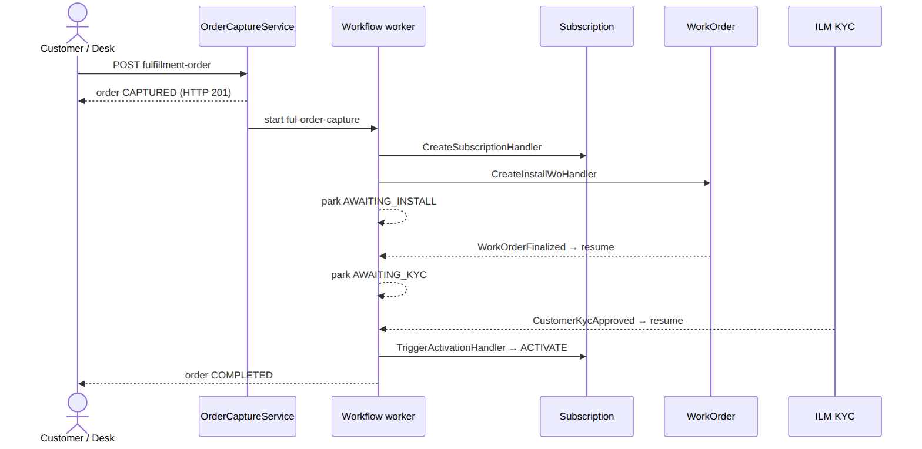

1. Happy path — capture to live
The story: A desk agent submits an order for a customer. The system says "got it" and quietly kicks off a behind-the-scenes checklist: it creates the subscription, then creates an install work order for a technician, then pauses to wait for the install to happen.
Who does what:
- POST /api/fulfillment-orders {customer_id,account_id,homepass_id,package_ref} → OrderCaptureService::capture (order CAPTURED, starts the ful-order-capture flow, HTTP 201).
- The sophix:workflow:work worker drains the flow: CreateSubscriptionHandler (→ Subscription, stores subscription_id) → CreateInstallWoHandler (→ WorkOrder, stores work_order_id).
- The flow then parks at AWAITING_INSTALL, waiting for the technician.
Sample — the order right after capture, now parked for install:
{ "order_id":"order_2","status":"AWAITING_INSTALL","current_step":"INSTALL","subscription_id":"sub_2","work_order_id":"wo_2","payment_ref":null }
Proven by FulfillmentJourneyTest.

2. Deposit required → park AWAITING_PAYMENT → resume
The story: Some orders need a deposit paid up front. If the request says a deposit is due and none has been paid yet, the order stops before building anything — no work order, no waste — and waits for the money. Once the deposit lands, it picks up where it left off.
Who does what:
- With deposit_required:true and no payment_ref, DepositGateHandler parks the flow on a ful-payment-received catch → status AWAITING_PAYMENT. No install WO is created yet.
- confirmDepositPaid correlates the waiting message → the flow proceeds to create the WO.
Foundation: workflow message catch. Proven by FulfillmentJourneyTest::test_deposit_required_order_parks_awaiting_payment_then_resumes_on_deposit.

3. Install finalized (event) resumes automatically
The story: While the order is parked waiting for install, the technician out in the field finishes the job and closes their work order. That closure automatically wakes the parked order up — nobody at the desk has to do anything.
Who does what: the tech finalizes the WO → WorkOrderFinalized (outbox) → ResumeOrderOnInstallFinalized correlates the ful-install-finalized catch → the flow resumes and moves on to the KYC gate. Foundation: outbox listener + message correlation.

4. Desk completes the install (manual path)
The story: Sometimes the work-order event isn't the trigger — a desk agent confirms the install manually instead. Either way reaches the exact same waiting point and resumes it.
Who does what: POST …/{id}/complete → OrderCaptureService::complete correlates the same ful-install-finalized message (the desk equivalent of the WO event). Shows: two ways to resume one catch.

5. KYC gate parks, then approval resumes
The story: Before the service can go live, the customer's identity check (KYC) must pass. If it's still pending, the order waits at the KYC gate. When compliance approves the customer, the order wakes up, walks back through the gate (now passing), and activates the service.
Who does what:
- KycGateHandler: customer is PENDING → park at AWAITING_KYC.
- Final KYC approval → CustomerKycApproved → ResumeOrderOnKycApproved → the flow loops back through the gate (now APPROVED) → activation.
Proven by FulfillmentJourneyTest::test_activation_is_gated_on_customer_kyc.

6. KYC rejected → cancel + compensate
The story: If the identity check fails, the order can't go live — and it has already built a subscription and a work order that now need to be torn down. The system cancels the order and cleanly undoes everything it created.
Who does what: KYC REJECTED → CustomerKycRejected → CancelOrderOnKycRejected → OrderCaptureService::cancel: interrupts the workflow, cancels the install WO, terminates the half-built subscription. Order → CANCELLED.
Proven by FulfillmentJourneyTest::test_kyc_rejection_cancels_the_parked_order_and_compensates.

7. Fraud flag blocks activation
The story: Even with everything else green, the system won't switch a customer on if they've been flagged as a fraud risk. The order sits un-activated until the flag is cleared.
Who does what: TriggerActivationHandler checks ILM hasProvisioningBlockingFlag; a FRAUD_SUSPECTED flag blocks activation (R-ILM-F-4) — the order stays un-activated until cleared. Proven by FulfillmentJourneyTest.

8. Cancel mid-flight → compensate
The story: A desk agent can cancel an order at any point. Whatever has been built so far gets undone in reverse order — the work order is cancelled, then the subscription is terminated — so nothing is left dangling.
Who does what: POST …/{id}/cancel → cancel interrupts the running process_instance, then compensate() cancels a cancellable WO and terminates a non-terminated subscription (reverse creation order).
Proven by FulfillmentJourneyTest::test_cancelling_an_order_compensates_its_install_wo_and_subscription.

2. Data model — ≥4 complete sample rows + readings
Completeness: each row lists every domain column (nullables shown as null). The string business key shown is the real primary key; created_at/updated_at are omitted by convention.

fulfillment_order · status: CAPTURED|AWAITING_PAYMENT|AWAITING_INSTALL|AWAITING_KYC|ACTIVATING|COMPLETED|CANCELLED · billing_mode: PREPAID|POSTPAID
{ "order_id":"order_1","operator_code":"WIK","customer_id":"cust_50","account_id":"acct_50","homepass_id":"hp_1","package_ref":"pkg_triple","package_version_id":"pkgv_3","billing_mode":"POSTPAID","status":"COMPLETED","current_step":"ACTIVATION","subscription_id":"sub_1","work_order_id":"wo_1","payment_ref":"pay_1","created_by":"u_desk1","completed_at":"2026-06-20T11:00:00Z","process_instance_id":"pi_1" }
{ "order_id":"order_2","operator_code":"WIK","customer_id":"cust_51","account_id":"acct_51","homepass_id":"hp_2","package_ref":"pkg_inet","package_version_id":"pkgv_2","billing_mode":"POSTPAID","status":"AWAITING_INSTALL","current_step":"INSTALL","subscription_id":"sub_2","work_order_id":"wo_2","payment_ref":null,"created_by":"u_desk1","completed_at":null,"process_instance_id":"pi_2" }
{ "order_id":"order_3","operator_code":"WIK","customer_id":"cust_52","account_id":"acct_52","homepass_id":"hp_3","package_ref":"pkg_inet","package_version_id":"pkgv_2","billing_mode":"POSTPAID","status":"AWAITING_KYC","current_step":"KYC","subscription_id":"sub_3","work_order_id":"wo_3","payment_ref":null,"created_by":"u_desk2","completed_at":null,"process_instance_id":"pi_3" }
{ "order_id":"order_4","operator_code":"WIK","customer_id":"cust_53","account_id":"acct_53","homepass_id":"hp_4","package_ref":"pkg_triple","package_version_id":"pkgv_3","billing_mode":"PREPAID","status":"AWAITING_PAYMENT","current_step":"PAYMENT","subscription_id":null,"work_order_id":null,"payment_ref":null,"created_by":"u_desk2","completed_at":null,"process_instance_id":"pi_4" }
{ "order_id":"order_5","operator_code":"WIK","customer_id":"cust_54","account_id":"acct_54","homepass_id":"hp_5","package_ref":"pkg_inet","package_version_id":null,"billing_mode":"POSTPAID","status":"CANCELLED","current_step":"KYC","subscription_id":"sub_5","work_order_id":"wo_5","payment_ref":null,"created_by":"u_desk1","completed_at":null,"process_instance_id":"pi_5" }
Read each row as a sentence — this data means this:
Row | What it means in plain English
order_1 | A POSTPAID triple-play order (billing_mode=POSTPAID, package_ref=pkg_triple) that is finished and live (status=COMPLETED, completed_at stamped) — it created subscription sub_1 and install wo_1.
order_2 | A POSTPAID internet order waiting for the technician (status=AWAITING_INSTALL, current_step=INSTALL); subscription sub_2 and wo_2 already exist, but it hasn't paid yet (payment_ref=null).
order_3 | A POSTPAID internet order held on the identity check (status=AWAITING_KYC, current_step=KYC); it has its subscription sub_3 and wo_3 but isn't done.
order_4 | A PREPAID triple-play order stuck at the deposit gate (billing_mode=PREPAID, status=AWAITING_PAYMENT, current_step=PAYMENT) — so it has no subscription_id and no work_order_id yet (nothing is created before the deposit is paid).
order_5 | A cancelled order (status=CANCELLED) whose subscription sub_5 and wo_5 were compensated (undone); it never got a package_version_id.
The columns that did the work:
- status says where the journey is parked; current_step is the live cursor.
- subscription_id / work_order_id are the artifacts the order created — stored precisely so a cancel can undo them later.
- process_instance_id is the workflow driving it; package_version_id is the exact catalog version sold; billing_mode decides whether a deposit gate applies.
The order's lifecycle — each status is a parking spot waiting on one thing:
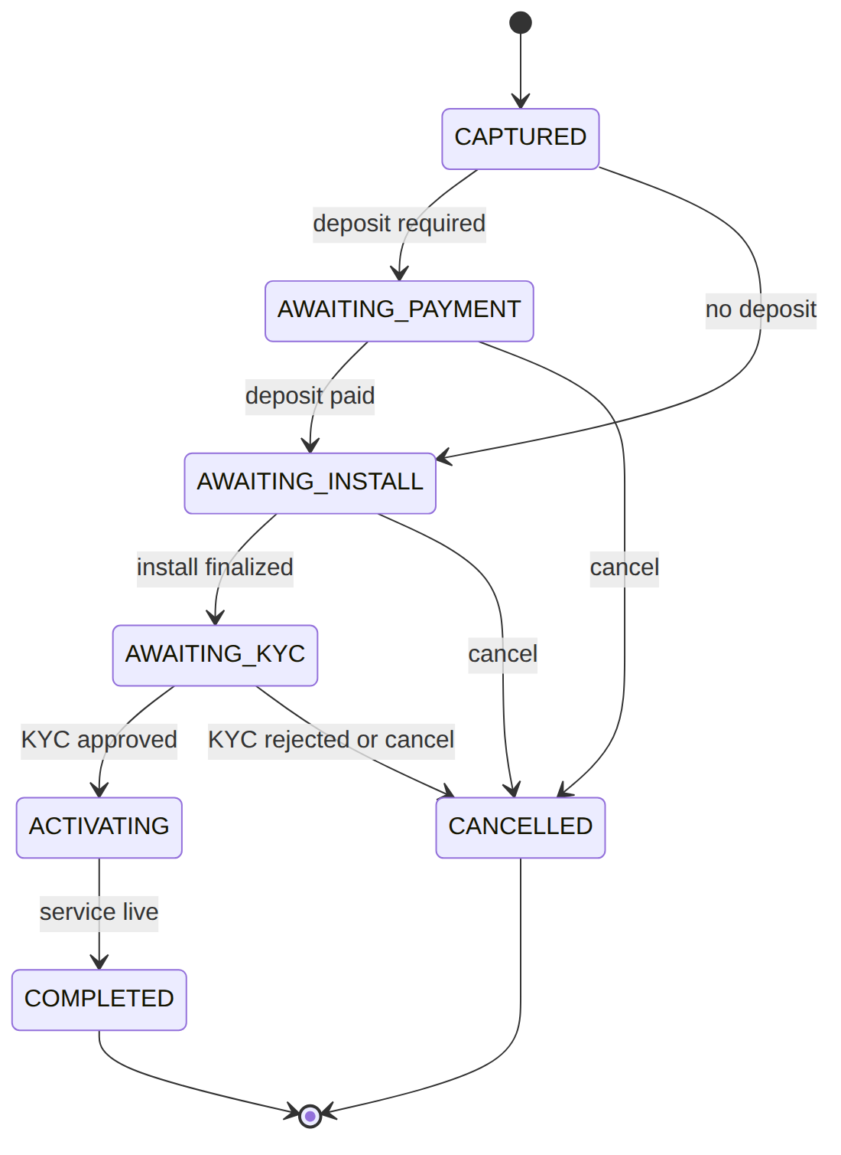

fulfillment_order_step (append-only ledger) · step: CAPTURE|VALIDATE|SUBSCRIPTION|DEPOSIT|PAYMENT|INSTALL|KYC|ACTIVATION · status: PENDING|DONE|FAILED
{ "id":"st_1","order_id":"order_1","step":"CAPTURE","status":"DONE","result":null,"completed_at":"2026-06-20T09:00:00Z" }
{ "id":"st_2","order_id":"order_1","step":"SUBSCRIPTION","status":"DONE","result":{"subscriptionId":"sub_1"},"completed_at":"2026-06-20T09:01:00Z" }
{ "id":"st_3","order_id":"order_1","step":"INSTALL","status":"DONE","result":{"workOrderId":"wo_1"},"completed_at":"2026-06-20T10:30:00Z" }
{ "id":"st_4","order_id":"order_1","step":"KYC","status":"DONE","result":{"kycStatus":"APPROVED"},"completed_at":"2026-06-20T10:55:00Z" }
Read each row as a sentence — this data means this:
Row | What it means in plain English
st_1 | Order order_1's CAPTURE step finished cleanly (status=DONE) at 09:00, producing no payload (result=null).
st_2 | Its SUBSCRIPTION step succeeded and produced subscription sub_1 (result.subscriptionId=sub_1).
st_3 | Its INSTALL step succeeded and produced work order wo_1 (result.workOrderId=wo_1).
st_4 | Its KYC step succeeded with the identity check approved (result.kycStatus=APPROVED).
The columns that did the work:
- Every journey step appends a row carrying its result and completed_at — an audit trail of what the workflow did, what it produced, and when, so an order's whole history reconstructs without opening the workflow engine.
- Each step row starts PENDING, then ends DONE or FAILED.
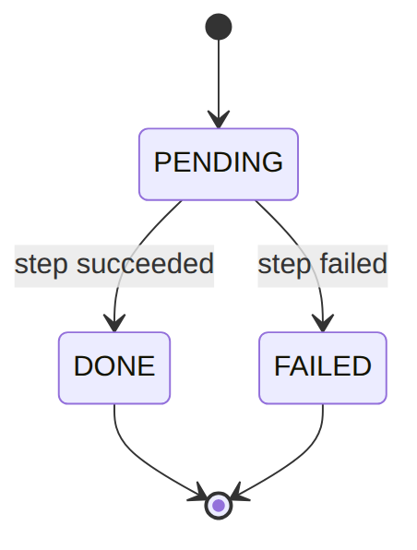

3. Services
Service | Responsibility
OrderCaptureService | capture() (create + start flow), complete()/confirmDepositPaid() (correlate messages), cancel() (interrupt + compensate()), recordStep()

4. API surface
POST /api/fulfillment-orders (idempotent), …/{id}/complete (idempotent), …/{id}/cancel, GET …. permission:fulfillment.manage.

5. Integration (events) — topic fulfillment.order
- Emits: OrderCaptured, OrderStepCompleted, OrderCompleted, OrderCancelled.
- Consumes: ResumeOrderOnInstallFinalized (WorkOrderFinalized), ResumeOrderOnKycApproved (CustomerKycApproved), CancelOrderOnKycRejected (CustomerKycRejected).

6. Processes (the journey, as data)
- Flow: ful-order-capture (FulfillmentFlowSeeder) — extend in the Studio, not code.
- Handlers: ValidateOrderHandler, CreateSubscriptionHandler, CreateInstallWoHandler, DepositGateHandler (catch ful-payment-received), KycGateHandler (gateway → catch ful-kyc-approved), TriggerActivationHandler (→ Subscription ACTIVATE; FUL-03 flag block), CompleteOrderHandler.

7. Policy & config
The flow graph; deposit-required + package come from the request/catalog.

8. Cross-module dependencies
- Calls → Subscription (create + activate), WorkOrder (install WO), ILM (flag check at activation).
- Reacts to → WorkOrder (install finalized), ILM (KYC approved/rejected).

9. Invariants & rules
Rule | Statement | Enforced in
FUL-02 §1.8 | cancel interrupts the journey and compensates (WO + sub) | OrderCaptureService::cancel+compensate
R-ILM-F-4 | a provisioning-blocking flag blocks activation | TriggerActivationHandler
idempotency | capture + complete are idempotent | route idempotency middleware

10. Open items / deltas
- KYC-rejection now cancels the parked order (was a hang) — fixed.
- Deposit-refund-on-cancel isn't modelled (cancel undoes WO + subscription; a paid-deposit refund would be an added BIL-02-ADJ path).

