ILM — As-Built Design (Customer & CVM)
Capability codes: ILM-CFG-01 (customer/account/360/KYC/flags), EM-03 (CVM retention) · Module path: Modules/Ilm · Tests: CustomerApi, CustomerOverview, AccountFlag, Cvm, CvmFlagEvaluator

1. Purpose & boundaries
- Owns: the customer & customer-account masters, the KYC chain, the account-flag & sub-status catalogs, the interaction timeline, and the CVM engine (segments/activities/offers).
- Does NOT own: subscriptions, money, equipment. It is the system of record for "who the customer is and what state the account is in" and the source of the shared routing context.
- Job: authoritative customer/account data + a data-driven flag/sub-status model + governed CVM.

📖 Scenarios (service + Foundation involvement)
The one big idea: ILM is the system of record for who the customer is and what state their account is in. Two patterns recur: (1) catalogs as data — flags, sub-statuses, and KYC authority are rows an operator edits, not code; and (2) those rows carry effect flags that quietly steer other modules (dunning, provisioning, notification).

1. Create a customer and run two-step KYC
The story in plain English: A new customer signs up. Before they can be activated, their identity documents must be checked and approved — and not by just one person. Two approvers at two levels must sign off, moving the customer from PENDING up to fully APPROVED. Only then can a parked order proceed.
Who does what:
- POST /api/customers → CustomerService::create (emits CustomerCreated). KYC docs uploaded via the Foundation/Files store.
- recordKycDecision(customer, level, 'APPROVED') — who may approve each level is config (kyc_approval_role).
- Two approvals flip kyc_status PENDING → L1_APPROVED → APPROVED and emit CustomerKycApproved.
- Cross-module: Fulfillment's ResumeOrderOnKycApproved resumes the parked order.
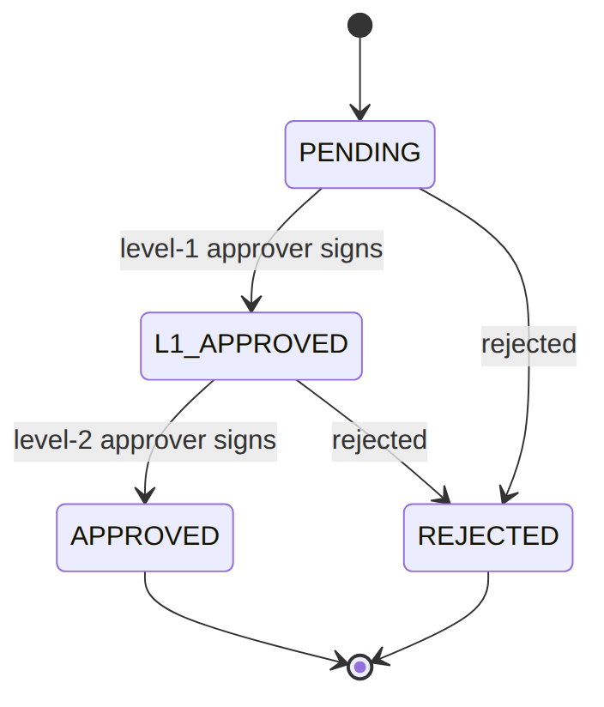
Proven by CustomerApiTest.

2. Sub-status change driven by the catalog (approval-gated)
The story in plain English: An agent wants to put an account "on hold". They don't type a free-form status — they pick a code from a catalog. The catalog row says what the coarse status becomes (hold → INACTIVE) and whether the change needs approval. "Hold" needs approval, so the change is rejected unless an approval reference is supplied.
Who does what: PATCH /api/customer-accounts/acc_1 {sub_status:'hold'} → AccountService::update: the customer_sub_status_catalog validates the code, derives main_status (clone), and because requires_approval=true it rejects without an approval_reference (R-ILM-S-2). With one it commits, writes account_status_history, and emits CustomerAccountStatusChanged. Proven by AccountFlagTest.

3. Raise an NPD flag → attention banner + faster dunning
The story in plain English: Risk flags a customer as a non-performing debtor (NPD). The flag puts an attention banner on the account, and — because the catalog says this flag affects dunning — the next debt-chasing scan in Billing skips the usual grace period and escalates faster.
Who does what: PUT /api/customer-accounts/acc_3/flags/NPD → setFlag: catalog-gated; sets attention_banner and emits CustomerAccountFlagSet. Because the catalog marks NPD affects_dunning=true, BIL-04's next scan calls hasDunningAccelerantFlag → waives the grace window (R-ILM-F-3). Cross-module read. Proven by AccountFlagTest, DunningTest.

4. FRAUD_SUSPECTED flag blocks activation
The story in plain English: An account is flagged as possible fraud. Because that flag is marked as affecting provisioning, Fulfillment refuses to activate the service until the flag is cleared.
Who does what: A FRAUD_SUSPECTED flag (affects_provisioning=true) → Fulfillment's TriggerActivationHandler calls hasProvisioningBlockingFlag → refuses to activate (R-ILM-F-4) until cleared. Proven by FulfillmentJourneyTest::test_fraud_suspected_flag_blocks_activation.

5. Account status change cascades to the network + the customer
The story in plain English: When an account's status changes in a way that affects service, one event fans out to two places: Provisioning re-syncs the network, and Notification tells the customer.
Who does what: A provisioning-affecting status change emits CustomerAccountStatusChanged{affectsProvisioning, customerVisible} to the outbox → Provisioning's SyncProvisioningOnAccountStatusChanged re-broadcasts the network, and Notification's AccountStatusNotificationBridge notifies the customer. Foundation: one event, two reactions.
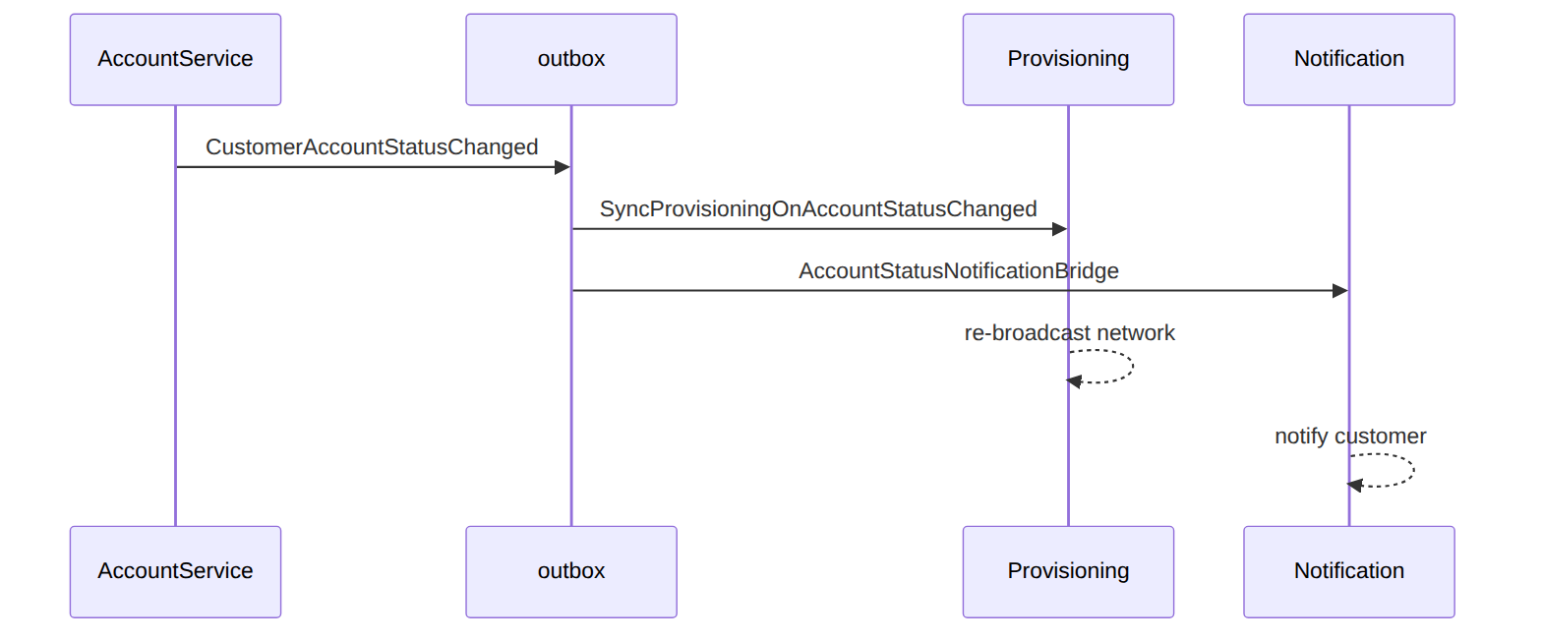
Proven by ReconciliationTest, Not01PipelineTest.

6. CVM evaluate → segment → activity (idempotent)
The story in plain English: CVM (customer value management) watches signals about a customer, scores their churn risk, drops them into a segment (e.g. "high retention risk"), and opens a follow-up task for an agent. The same triggering event always produces the same task — no duplicates.
Who does what: POST /api/cvm/customers/CUS-1/evaluate {signals} → CvmEvaluationService: writes a cvm_customer_signal_profile, computes a churn score, assigns a cvm_segment_membership (e.g. RETENTION_HIGH_RISK), and opens a cvm_activity — idempotent by source event (same event → same activity). Emits CvmCustomerEvaluated/CvmActivityCreated. Proven by CvmTest.

7. Retention offer over threshold → EM-CFG-04 → accept → SIP-03
The story in plain English: To keep a churn-risk customer, an agent proposes a 25% retention discount. Because it's over a threshold, the offer needs approval first — trying to accept it before approval is bounced. Once approved, the offer becomes acceptable; accepting it creates a real discount assignment in Catalog and records the outcome.
Who does what:
- CvmOfferService::propose (25% discount): rules.cvm.offer says over threshold → requireApproval → offer PENDING_APPROVAL (an EM-CFG-04 request).
- accept() returns 409 while pending.
- Approval → ResumeCvmOfferOnApproval → applyApprovalOutcome releases it PROPOSED.
- accept then creates a Catalog DiscountAssignment (SIP-03) and records a cvm_outcome.
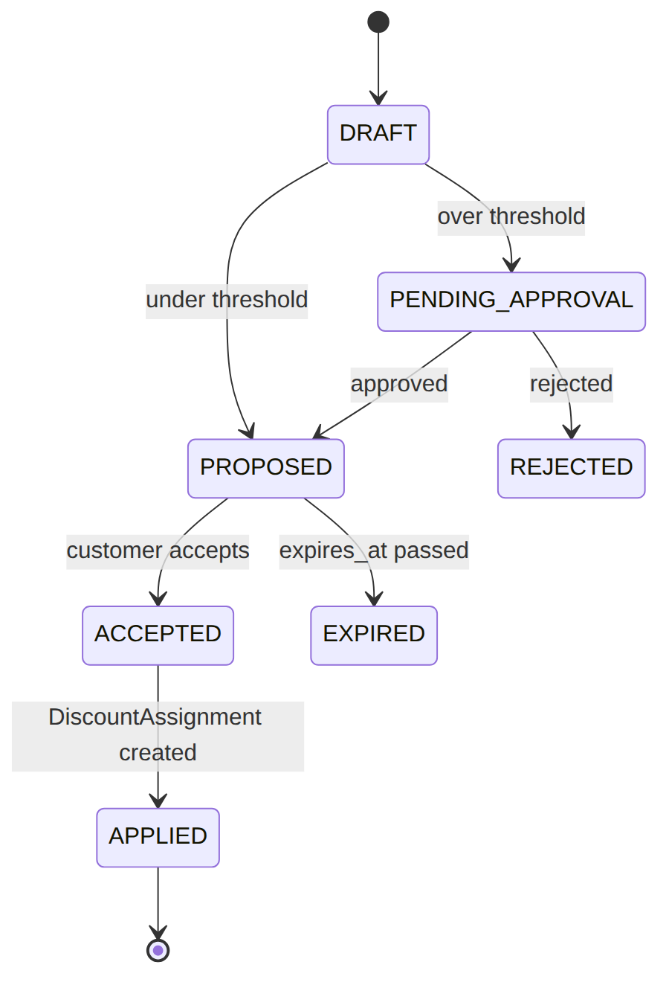
Proven by CvmTest.

8. routingContext — the shared fact set
The story in plain English: Other modules constantly need to know "what kind of customer/account is this?" to make decisions. Rather than every module reaching into ILM's tables, ILM hands out one tidy fact map they can drop straight into their rules engine.
Who does what: AccountService::routingContext(accountId) returns a plain map (operator, serviceClass, accountStatus, subStatus, customerType, vip, flags…) so any module can feed a complete fact set into its rules engine without reading ILM tables directly. Shows: the cross-module decision-context pattern.

(bonus) 9. KYC rejected → the order is cancelled
The story in plain English: If KYC is rejected, the parked order can't go ahead — Fulfillment cancels and unwinds it.
Who does what: recordKycDecision(..,'REJECTED') emits CustomerKycRejected → Fulfillment CancelOrderOnKycRejected cancels + compensates the parked order. Proven by FulfillmentJourneyTest.

2. Data model — ≥4 complete sample rows + readings
Completeness: each row lists every domain column (nullables shown as null). The surrogate primary key shown is the real one (a ULID business key, e.g. customer_id; the catalogs use a composite operator_code+code key); created_at/updated_at are omitted by convention.

customer (type: RES|COM · kyc_status: PENDING|L1_APPROVED|APPROVED|REJECTED)
tax_identifier added by the tax-identifier migration.
{ "customer_id":"cust_1","operator_code":"WIK","type":"RES","tax_identifier":"A012345678Z","name":"Jane Mwangi","identification_type_1":"NATIONAL_ID","identification_number_1":"22334455","identification_type_2":null,"identification_number_2":null,"date_of_birth":"1990-04-12","business_reg_date":null,"primary_msisdn":"+254712000111","email":"jane@example.com","preferred_language":"en","kyc_status":"APPROVED" }
{ "customer_id":"cust_2","operator_code":"WIK","type":"RES","tax_identifier":null,"name":"Otieno","identification_type_1":"NATIONAL_ID","identification_number_1":"99887766","identification_type_2":null,"identification_number_2":null,"date_of_birth":"1985-09-30","business_reg_date":null,"primary_msisdn":"+254722000222","email":null,"preferred_language":"sw","kyc_status":"PENDING" }
{ "customer_id":"cust_3","operator_code":"WIK","type":"COM","tax_identifier":"P051234567X","name":"Acme Ltd","identification_type_1":"BUSINESS_REG","identification_number_1":"BRS-2020-771","identification_type_2":"KRA_PIN","identification_number_2":"P051234567X","date_of_birth":null,"business_reg_date":"2020-02-01","primary_msisdn":"+254733000333","email":"ops@acme.co.ke","preferred_language":"en","kyc_status":"L1_APPROVED" }
{ "customer_id":"cust_4","operator_code":"WIK","type":"RES","tax_identifier":null,"name":"Fraudster","identification_type_1":"PASSPORT","identification_number_1":"X1234567","identification_type_2":null,"identification_number_2":null,"date_of_birth":"1979-01-01","business_reg_date":null,"primary_msisdn":"+254744000444","email":null,"preferred_language":"en","kyc_status":"REJECTED" }
Read each row as a sentence — this data means this:
Row | What it means in plain English
cust_1 | A residential customer (type=RES) cleared to be activated (kyc_status=APPROVED), with a tax ID, a national ID, and a contact MSISDN.
cust_2 | A residential customer whose KYC is still pending (kyc_status=PENDING) — fulfillment can't proceed yet.
cust_3 | A business customer (type=COM) at the mid-chain KYC step (kyc_status=L1_APPROVED, still needs L2), identified by business reg + KRA PIN.
cust_4 | A customer whose KYC was rejected (kyc_status=REJECTED) — the order is cancelled.
The columns that did the work:
- Can fulfillment activate = kyc_status (only APPROVED proceeds; L1_APPROVED needs L2; REJECTED cancels).
- RES vs COM = type — a segment proxy used in routing; it also picks which identity fields apply (date_of_birth for RES, business_reg_date for COM).
- Billing + contact keys = tax_identifier (read by the tax invoice) + primary_msisdn (required contact).

customer_account (status: ACTIVE|INACTIVE)
{ "account_id":"acc_1","account_number":"WIK-100001","payment_account_number":"PAY-100001","customer_id":"cust_1","operator_code":"WIK","homepass_id":"hp_1","service_address":"12 Karen Rd","status":"ACTIVE","sub_status":"active","sub_status_reason":null,"sub_status_changed_at":"2026-01-01T08:00:00Z","service_class_1":"GOLD","service_class_2":null,"service_class_3":null,"attention_banner":null,"subscription_id":"sub_123","start_bill_date":"2026-01-01","install_date":"2025-12-28","disconnect_date":null,"account_manager_id":"u_am1","franchise_code":"fr_nrb" }
{ "account_id":"acc_2","account_number":"WIK-100002","payment_account_number":"PAY-100002","customer_id":"cust_1","operator_code":"WIK","homepass_id":"hp_9","service_address":"12 Karen Rd Annex","status":"ACTIVE","sub_status":"vip","sub_status_reason":"loyal customer","sub_status_changed_at":"2026-03-01T08:00:00Z","service_class_1":"PLATINUM","service_class_2":null,"service_class_3":null,"attention_banner":null,"subscription_id":"sub_126","start_bill_date":"2026-03-01","install_date":"2026-02-25","disconnect_date":null,"account_manager_id":"u_am1","franchise_code":"fr_nrb" }
{ "account_id":"acc_3","account_number":"WIK-100003","payment_account_number":null,"customer_id":"cust_3","operator_code":"WIK","homepass_id":"hp_3","service_address":"7 Nyali Rd","status":"INACTIVE","sub_status":"hold","sub_status_reason":"docs pending","sub_status_changed_at":"2026-06-10T00:00:00Z","service_class_1":"SILVER","service_class_2":null,"service_class_3":null,"attention_banner":"On hold pending docs","subscription_id":null,"start_bill_date":null,"install_date":null,"disconnect_date":null,"account_manager_id":null,"franchise_code":"fr_msa" }
{ "account_id":"acc_4","account_number":"WIK-100004","payment_account_number":"PAY-100004","customer_id":"cust_4","operator_code":"WIK","homepass_id":null,"service_address":"99 Karen Rd","status":"INACTIVE","sub_status":"churned","sub_status_reason":"non-payment","sub_status_changed_at":"2026-05-20T00:00:00Z","service_class_1":null,"service_class_2":null,"service_class_3":null,"attention_banner":null,"subscription_id":"sub_7","start_bill_date":"2026-04-01","install_date":"2026-03-28","disconnect_date":"2026-05-20","account_manager_id":null,"franchise_code":"fr_nrb" }
Read each row as a sentence — this data means this:
Row | What it means in plain English
acc_1 | A live GOLD account (status=ACTIVE, sub_status=active) linked 1:1 to sub_123 (subscription_id), with its operational and gateway-callback keys (account_number/payment_account_number).
acc_2 | A second live account for the same customer cust_1, flagged VIP (sub_status=vip, with a sub_status_reason) — a customer may hold several accounts.
acc_3 | An account on hold (sub_status=hold → status=INACTIVE) with a customer-facing attention_banner and no subscription yet (subscription_id=null).
acc_4 | A churned account (sub_status=churned → status=INACTIVE) with its disconnect_date stamped.
The columns that did the work:
- The 2-value main status = status, derived from sub_status (e.g. hold/churned clone to INACTIVE — never trusted from the caller).
- Operator nuance = sub_status (+ sub_status_reason/sub_status_changed_at); the attention_banner is set by an attention-surfacing flag.
- The keys + link = account_number/payment_account_number (operational + gateway) and subscription_id (1:1 to SUB-LM-01).

customer_account_flag_catalog (composite PK operator_code+flag_code · value_kind: BOOLEAN|SCORE_0_100|TIER|COUNT · evaluator: MANUAL|DROOLS|EVENT_DRIVEN)
affects_dunning/affects_provisioning/customer_visible added by the flag-catalog-effect-columns migration.
{ "operator_code":"WIK","flag_code":"NPD","name":"Non-Performing Debtor","value_kind":"BOOLEAN","evaluator":"DROOLS","surfaces_attention":true,"affects_dunning":true,"affects_provisioning":false,"customer_visible":false,"active":true }
{ "operator_code":"WIK","flag_code":"FRAUD_SUSPECTED","name":"Fraud Suspected","value_kind":"BOOLEAN","evaluator":"MANUAL","surfaces_attention":true,"affects_dunning":false,"affects_provisioning":true,"customer_visible":false,"active":true }
{ "operator_code":"WIK","flag_code":"LOYALTY_TIER","name":"Loyalty Tier","value_kind":"TIER","evaluator":"EVENT_DRIVEN","surfaces_attention":false,"affects_dunning":false,"affects_provisioning":false,"customer_visible":true,"active":true }
{ "operator_code":"WIK","flag_code":"CHURN_RISK","name":"Churn Risk Score","value_kind":"SCORE_0_100","evaluator":"DROOLS","surfaces_attention":false,"affects_dunning":false,"affects_provisioning":false,"customer_visible":false,"active":true }

customer_account_flag (the per-account instance · state: ACTIVE|CLEARED)
{ "id":"caf_1","operator_code":"WIK","account_id":"acc_3","flag_code":"NPD","bool_value":true,"score_value":null,"text_value":null,"state":"ACTIVE","source":"DROOLS","set_by":"system","set_at":"2026-06-10T00:00:00Z" }
{ "id":"caf_2","operator_code":"WIK","account_id":"acc_4","flag_code":"FRAUD_SUSPECTED","bool_value":true,"score_value":null,"text_value":null,"state":"ACTIVE","source":"MANUAL","set_by":"u_risk1","set_at":"2026-05-15T00:00:00Z" }
{ "id":"caf_3","operator_code":"WIK","account_id":"acc_1","flag_code":"LOYALTY_TIER","bool_value":null,"score_value":null,"text_value":"GOLD","state":"ACTIVE","source":"loyalty.tier-changed","set_by":"system","set_at":"2026-04-01T00:00:00Z" }
{ "id":"caf_4","operator_code":"WIK","account_id":"acc_2","flag_code":"CHURN_RISK","bool_value":null,"score_value":72,"text_value":null,"state":"CLEARED","source":"DROOLS","set_by":"system","set_at":"2026-03-01T00:00:00Z" }
Read each row as a sentence — this data means this:
Row | What it means in plain English
caf_1 | acc_3 is flagged a Non-Performing Debtor (flag_code=NPD, bool_value=true, state=ACTIVE), set by the rules engine (source=DROOLS).
caf_2 | acc_4 is flagged Fraud Suspected (bool_value=true, state=ACTIVE), set by hand (source=MANUAL, set_by=u_risk1).
caf_3 | acc_1 carries a loyalty tier of GOLD — a text value (text_value=GOLD, the column matching value_kind=TIER), set by a loyalty event.
caf_4 | acc_2 had a churn-risk score of 72 (score_value=72), now state=CLEARED.
The columns that did the work:
- What the flag does = the catalog effect columns: affects_dunning (BIL-04 escalates faster), affects_provisioning (FUL-03 blocks activation), customer_visible, surfaces_attention (drives the banner).
- Who may set it = evaluator (MANUAL = back-office only).
- The instance's typed value = whichever column matches the catalog value_kind — bool_value (NPD/FRAUD), score_value (CHURN_RISK), text_value (LOYALTY_TIER).
- Live or not = state (ACTIVE/CLEARED), unique per (account_id, flag_code).

customer_sub_status_catalog (composite PK operator_code+sub_status_code)
requires_approval/approval_roles_jsonb/affects_provisioning/customer_visible added by the sub-status-catalog-config-columns migration (approval_roles_jsonb is JSON).
{ "operator_code":"WIK","sub_status_code":"active","main_status":"ACTIVE","requires_approval":false,"approval_roles_jsonb":null,"affects_provisioning":true,"customer_visible":true,"display_name":"Active","active":true }
{ "operator_code":"WIK","sub_status_code":"vip","main_status":"ACTIVE","requires_approval":true,"approval_roles_jsonb":["ACCOUNT_MANAGER","REGION_HEAD"],"affects_provisioning":false,"customer_visible":false,"display_name":"VIP","active":true }
{ "operator_code":"WIK","sub_status_code":"hold","main_status":"INACTIVE","requires_approval":true,"approval_roles_jsonb":["BACKOFFICE_SUPERVISOR"],"affects_provisioning":true,"customer_visible":false,"display_name":"On Hold","active":true }
{ "operator_code":"WIK","sub_status_code":"churned","main_status":"INACTIVE","requires_approval":true,"approval_roles_jsonb":["BACKOFFICE_SUPERVISOR"],"affects_provisioning":true,"customer_visible":true,"display_name":"Churned","active":true }
Read each row as a sentence — this data means this:
Row | What it means in plain English
active | The "Active" sub-status maps to main status ACTIVE (main_status), needs no approval, and is customer-visible.
vip | "VIP" also clones to ACTIVE but needs approval (requires_approval=true) from an Account Manager or Region Head (approval_roles_jsonb).
hold | "On Hold" clones to INACTIVE, needs a Back-Office Supervisor's approval, and affects provisioning (affects_provisioning=true).
churned | "Churned" clones to INACTIVE, needs approval, affects provisioning, and is shown to the customer (customer_visible=true).
The columns that did the work:
- The derived main status = main_status — a sub-status clones it, so the 2-value main status is never trusted from the caller.
- Approval gate = requires_approval + approval_roles_jsonb (which roles may sign).
- Provisioning impact = affects_provisioning (the change emits CustomerAccountStatusChanged for FUL-03).
- An operator adds a state by adding a row — no code.

cvm_offer_instance (offer_type: RETENTION_DISCOUNT|UPGRADE_OFFER|WINBACK_PACKAGE|GOODWILL_CREDIT|PAYMENT_REMINDER · status: DRAFT|PENDING_APPROVAL|PROPOSED|ACCEPTED|REJECTED|EXPIRED|APPLIED|FAILED)
{ "offer_instance_id":"cvo_1","operator_code":"WIK","activity_id":"cva_1","customer_id":"CUS-1","subscription_id":"sub_123","offer_type":"RETENTION_DISCOUNT","campaign_code":null,"discount_ref":"disc_ret25","discount_percent":10.00,"status":"APPLIED","approval_request_id":null,"expires_at":"2026-07-31T00:00:00Z" }
{ "offer_instance_id":"cvo_2","operator_code":"WIK","activity_id":"cva_1","customer_id":"CUS-1","subscription_id":"sub_123","offer_type":"RETENTION_DISCOUNT","campaign_code":null,"discount_ref":null,"discount_percent":25.00,"status":"PROPOSED","approval_request_id":"appr_9","expires_at":"2026-07-31T00:00:00Z" }
{ "offer_instance_id":"cvo_3","operator_code":"WIK","activity_id":null,"customer_id":"CUS-3","subscription_id":null,"offer_type":"UPGRADE_OFFER","campaign_code":"Q3_UPSELL","discount_ref":null,"discount_percent":null,"status":"DRAFT","approval_request_id":null,"expires_at":null }
{ "offer_instance_id":"cvo_4","operator_code":"WIK","activity_id":null,"customer_id":"CUS-9","subscription_id":"sub_50","offer_type":"WINBACK_PACKAGE","campaign_code":"WINBACK","discount_ref":null,"discount_percent":null,"status":"EXPIRED","approval_request_id":null,"expires_at":"2026-05-01T00:00:00Z" }

cvm_activity (activity_type: RETENTION_CALL|PAYMENT_RECOVERY|UPSELL_OFFER|WINBACK|SERVICE_RECOVERY · priority: LOW|MEDIUM|HIGH|CRITICAL · status: OPEN|IN_PROGRESS|WAITING_CUSTOMER|COMPLETED|CANCELLED|EXPIRED)
The EM-03 full-model migration added activity_type/account_id/source_event_ref (idempotency unique (operator_code, source_event_ref)), assigned_to_user_id/assigned_team_id/priority/ due_at/closed_at, and relaxed the legacy type column to nullable (kept as type). (The status vocabulary is the CvmActivity model lifecycle OPEN→IN_PROGRESS→WAITING_CUSTOMER→COMPLETED/CANCELLED/ EXPIRED; the DB column default remains the legacy 'OFFERED', overwritten on the first write.)
{ "activity_id":"cva_1","operator_code":"WIK","account_id":"acc_1","activity_type":"PAYMENT_RECOVERY","customer_id":"CUS-1","subscription_id":"sub_123","type":"RECOVERY","trigger_reason":"NON_PAYMENT","source_event_ref":"DunningStageAdvanced:acc_1:3","offer_code":null,"offer_details":null,"status":"OPEN","channel":"OUTBOUND_CALL","assigned_to":null,"assigned_to_user_id":"u_ret1","assigned_team_id":"team_ret","priority":"HIGH","due_at":"2026-06-22T17:00:00Z","outcome_reason":null,"expires_at":"2026-06-30T00:00:00Z","decided_at":null,"closed_at":null }
{ "activity_id":"cva_2","operator_code":"WIK","account_id":"acc_3","activity_type":"UPSELL_OFFER","customer_id":"CUS-3","subscription_id":null,"type":null,"trigger_reason":"UPSELL","source_event_ref":"CvmCustomerEvaluated:CUS-3:2026-06","offer_code":"UPGRADE_200M","offer_details":{"toPackage":"pkg_inet_200"},"status":"IN_PROGRESS","channel":"SMS","assigned_to":null,"assigned_to_user_id":null,"assigned_team_id":"team_sales","priority":"MEDIUM","due_at":null,"outcome_reason":null,"expires_at":"2026-07-15T00:00:00Z","decided_at":null,"closed_at":null }
{ "activity_id":"cva_3","operator_code":"WIK","account_id":"acc_2","activity_type":"RETENTION_CALL","customer_id":"CUS-1","subscription_id":"sub_126","type":"RETENTION","trigger_reason":"CHURN_RISK","source_event_ref":"CvmCustomerEvaluated:CUS-1:2026-05","offer_code":"RET_25","offer_details":{"percent":25},"status":"COMPLETED","channel":"OUTBOUND_CALL","assigned_to":null,"assigned_to_user_id":"u_ret1","assigned_team_id":"team_ret","priority":"CRITICAL","due_at":"2026-05-20T17:00:00Z","outcome_reason":"customer accepted","expires_at":"2026-05-31T00:00:00Z","decided_at":"2026-05-19T10:00:00Z","closed_at":"2026-05-19T10:05:00Z" }
{ "activity_id":"cva_4","operator_code":"WIK","account_id":"acc_4","activity_type":"WINBACK","customer_id":"CUS-9","subscription_id":"sub_50","type":"WINBACK","trigger_reason":"CHURNED","source_event_ref":"CvmCustomerEvaluated:CUS-9:2026-04","offer_code":"WINBACK","offer_details":null,"status":"EXPIRED","channel":"EMAIL","assigned_to":null,"assigned_to_user_id":null,"assigned_team_id":null,"priority":"LOW","due_at":null,"outcome_reason":"no response","expires_at":"2026-05-01T00:00:00Z","decided_at":null,"closed_at":"2026-05-01T00:00:00Z" }
Read each row as a sentence — this data means this:
Row | What it means in plain English
cvo_1 | A 10% retention discount that applied straight through (status=APPLIED, approval_request_id=null — under threshold).
cvo_2 | A 25% offer that needed approval: it carries an approval_request_id=appr_9 and sits status=PROPOSED after the approval released it.
cvo_3 | An upgrade offer still being prepared (status=DRAFT), tied to campaign Q3_UPSELL.
cvo_4 | A winback offer that lapsed unused (status=EXPIRED, its expires_at passed).
cva_1 | A high-priority payment-recovery task opened by a dunning signal (activity_type=PAYMENT_RECOVERY, trigger_reason=NON_PAYMENT, status=OPEN), assigned to an agent with a due_at.
cva_2 | An upsell task for a healthy account (activity_type=UPSELL_OFFER), in progress over SMS.
cva_3 | A retention call that completed (status=COMPLETED) — the customer accepted (outcome_reason), with decided_at/closed_at stamped.
cva_4 | A winback task that expired with no response (status=EXPIRED, outcome_reason="no response").
The columns that did the work:
- Did the offer need approval = approval_request_id (set ⇒ EM-CFG-04 gate) + status.
- Why a task exists = activity_type/trigger_reason; each activity is idempotent by source_event_ref (same event → same row).
- Worklist routing + closure = priority/due_at/assigned_* route it; decided_at/closed_at close it out.
- The legacy type column survives nullable alongside the new activity_type.
Activity status lifecycle (the CvmActivity model vocabulary; the DB default 'OFFERED' is overwritten on the first write):
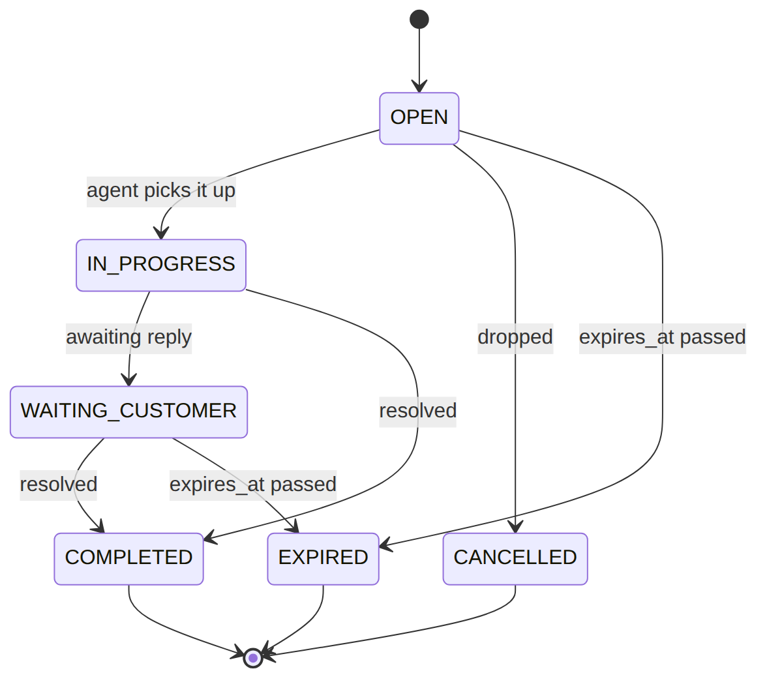

3. Services
Service | Responsibility
CustomerService | customer CRUD; recordKycDecision() (two-step, config authority)
AccountService | only writer of the account master — update (catalog-driven), setFlag/clearFlag (+ banner), hasProvisioningBlockingFlag/hasDunningAccelerantFlag, routingContext()
CustomerOverviewService | Customer 360 (degrades per panel)
CvmEvaluationService / CvmFlagEvaluatorService / CvmActivityService | signals→segments→activity; rules-driven flags; timeline
CvmOfferService | retention offers (EM-CFG-04 gated; resume; SIP-03 on accept)

4. API surface
/api/customers, /api/customer-accounts/{account} (+ …/flags/{flagCode}, …/kyc), /api/customers/{id}/overview, /api/cvm/customers/{id}/evaluate, /api/cvm-offers/{id}/accept. Resource-scoped permissions customer.read|create|update (no customer.* wildcard; all mutations use customer.update); KYC decisions config-gated.

5. Integration (events)
- Topic ilm.customer: CustomerCreated/Updated, CustomerKyc{Approved,Rejected}, CustomerAccountCreated, CustomerAccountStatusChanged, CustomerAccountFlag{Set,Cleared}.
- Topic em03.cvm: CvmCustomerEvaluated, CvmActivity{Created,Closed}, CvmOffer{Proposed, Accepted,Applied}.
- Consumes: ResumeCvmOfferOnApproval. Downstream of ILM: Provisioning, Notification, Fulfillment.

6. Processes
No BPMN; KYC + CVM offer governance via EM-CFG-04; sophix:cvm:evaluate-flags daily worker.

7. Policy & config
rules.cvm.offer + flag-evaluation rules; the flag/sub-status/KYC-authority catalogs — operator data.

8. Cross-module dependencies
- Consumed by → everyone (routingContext); flags steer BIL-04 + FUL-03; status change steers Provisioning + Notification; KYC gates Fulfillment.
- Calls → Foundation Approvals, Rules, Files; Catalog (DiscountAssignment on offer accept).

9. Invariants & rules
Rule | Statement | Enforced in
R-ILM-S-2 | a requires_approval sub-status change needs an approval reference | AccountService::update
R-ILM-S-3 | affects_provisioning change emits CustomerAccountStatusChanged for FUL-03 | AccountService + listener
R-ILM-F-3/F-4 | affects_dunning/affects_provisioning flags steer BIL-04 / FUL-03 | hasDunningAccelerantFlag/hasProvisioningBlockingFlag
R-ILM-K-3 | KYC approval authority per level is operator config | recordKycDecision

10. Open items / deltas
- CustomerAccountFlagSet/Cleared + CustomerKycRejected now have consumers (FUL-03 block, order cancel) — earlier orphans, fixed.
- Customer-facing surfacing of customer_visible flags (R-ILM-F-5) is data-modelled; a dedicated customer endpoint is optional.

