Notification — As-Built Design (NOT-01 + ICN-01)
Capability codes: NOT-01 (customer), ICN-01 (staff) · Module path: Modules/Notification Tests: Not01Pipeline, Icn01, NotificationApi, TemplateStudio

1. Purpose & boundaries
- Owns: two pipelines — NOT-01 (customer: route → preference → regulatory → render → dispatch → audit) and ICN-01 (staff: candidate-group fan-out) — plus the template/routing catalogs.
- Does NOT own: the trigger events (other modules), contact details (reads CRM), the transport (channel adapters).
- Job: turn a domain event into rendered, dispatched, audited notifications — channels from config (routing rules + prefs), never hardcoded.

📖 Scenarios (service + Foundation involvement)

1. Customer-visible account suspension → notify
The story in plain English: Something happens to a customer's account that they should hear about — say it gets suspended. We turn that one event into the right messages on the right channels. Along the way we check the customer's preferences and the regulatory rules, render the templates, send them, and write down exactly what we did.
Who does what: ILM CustomerAccountStatusChanged{customerVisible:true} → AccountStatusNotificationBridge → NotificationOrchestrator::ingest runs the NOT-01 pipeline:
- route — a notification_routing_rule maps the event to channels (EMAIL+SMS) and purpose ACCOUNT_STATUS_CHANGE.
- preference filter — drop channels the customer opted out of (marketing only).
- regulatory filter — apply category rules (transactional ignores opt-out).
- render — fill the templates for each surviving channel.
- dispatch — send via the channel adapters.
- audit — write notification_log (DISPATCHED).
Sample — the audit row written at the end:
{ "id":"nl_1","customer_id":"cust_1","event_type":"InvoiceIssued","source_event_id":"evt_900","channels_attempted":["EMAIL","SMS"],"final_status":"DISPATCHED","dispatched_at":"2026-06-20T09:00:02Z" }
Proven by Not01PipelineTest.

2. An approval awaits a back-office group (ICN)
The story in plain English: An approval is waiting and a whole back-office team can act on it. We tell the entire team at once, each person on whatever channel they prefer. The first to acknowledge takes it; the rest are stood down.
Who does what: any EM-CFG-04 ApprovalRequested/ApprovalStageAdvanced → NotifyApproversOnApprovalRequested → for a ROLE stage StaffNotificationService::dispatch(template:'approval-needed', candidateGroup:<approver role>) → the group's members get EMAIL/SLACK/IN_APP_PUSH per their prefs.
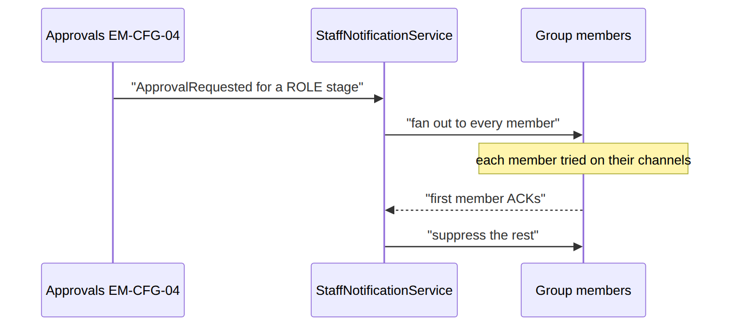
Proven by Icn01Test.

(bonus) 2b. A named approver who's in no group (direct send)
A USER stage (e.g. an invited director) has no candidate group, so the bridge calls StaffNotificationService::dispatchDirect(template:'approval-needed', recipients:[{channel:'EMAIL', address:<director email>}]) — the explicit address rides on the delivery row (recipient_identity) and the channel adapter sends straight to it. Works for any address/channel (email, WhatsApp/MSISDN, webhook id). Proven by Icn01Test::test_user_stage_approval_emails_the_named_director_directly + …direct_send_reaches_an_explicit_address.

3. Dunning notice — channels from routing, not code
BIL-04 DunningStageAdvanced → DunningNotificationBridge → orchestrator routes per the operator's notification_routing_rule (swap WhatsApp in by editing a row). Proven by Not01PipelineTest.

4. Marketing opt-out suppresses
A PromoBlast (category MARKETING) to a customer with sms_opt_in:false → preference filter drops it → notification_log SUPPRESSED + NotificationSuppressed. Proven by Not01PipelineTest.

5. Transactional ignores opt-out
A PtpRegistered (TRANSACTIONAL) to the same opted-out customer → sent anyway (opt-out doesn't apply to transactional). Shows: category-driven regulatory rule.

6. Render failure → retry queue
A missing template variable → render_failure_queue row; sophix:notification:retry-render re-renders later. Foundation: scheduled retry.

7. Permanent bounce → fall back to the next channel
EMAIL hard-bounces → BounceService marks it; the orchestrator's per-channel fallback dispatches the next channel → notification_log PARTIALLY_DISPATCHED. Proven by Not01PipelineTest.

8. ICN first-ack suppresses the rest
The story in plain English: A staff alert went to four supervisors. We do not want four people doing the same job. The moment one of them acknowledges, the others' still-pending messages are cancelled and the notification is marked done.
Who does what: a staff notification fanned to 4 supervisors; the first to ACK → AckService suppresses the other pending deliveries → notification ACKNOWLEDGED.
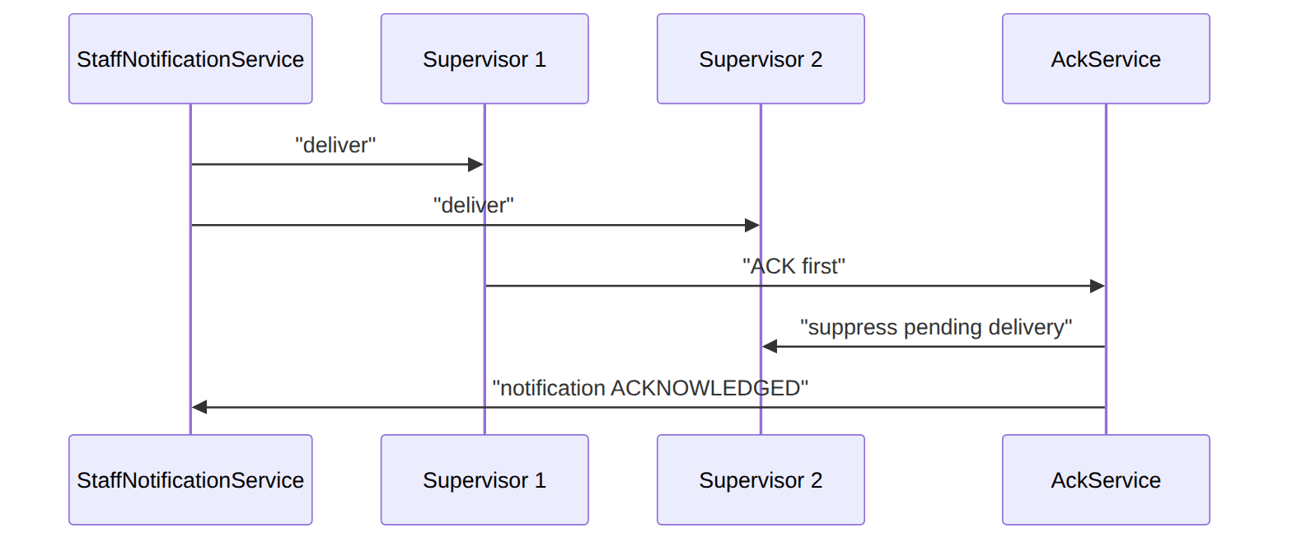
Proven by Icn01Test.

(bonus) 9. Idempotency by source event
The orchestrator processes a source_event_id once (Redis/cache) — a re-dispatch is a no-op.

2. Data model — ≥4 complete sample rows + readings per table
Completeness: each row lists every domain column (nullables shown as null). The surrogate string primary key shown is the real one; created_at/updated_at are omitted by convention. These tables are the DD seven-table NOT-01 core + ICN-01 staff fabric (they coexist with the legacy notification/notification_template studio tables, not shown here).

notification_routing_rule (event_type → channels + purpose)
{ "id":"nrr_1","operator_code":"WIK","event_type":"InvoiceIssued","channel":"EMAIL","template_purpose_code":"INVOICE_CYCLE_POSTPAID","priority":1,"urgency":"NORMAL","category":"TRANSACTIONAL","conditions":null,"enabled":true,"needs_pdf":true }
{ "id":"nrr_2","operator_code":"WIK","event_type":"InvoiceIssued","channel":"SMS","template_purpose_code":"INVOICE_CYCLE_POSTPAID","priority":2,"urgency":"NORMAL","category":"TRANSACTIONAL","conditions":null,"enabled":true,"needs_pdf":false }
{ "id":"nrr_3","operator_code":"WIK","event_type":"DunningStageAdvanced","channel":"SMS","template_purpose_code":"DUNNING_NOTICE","priority":1,"urgency":"URGENT","category":"TRANSACTIONAL","conditions":{"stage":">=2"},"enabled":true,"needs_pdf":false }
{ "id":"nrr_4","operator_code":"WIK","event_type":"PromoBlast","channel":"SMS","template_purpose_code":"PROMO_GENERIC","priority":1,"urgency":"NORMAL","category":"MARKETING","conditions":null,"enabled":false,"needs_pdf":false }
Read each row as a sentence — this data means this:
Row | What it means in plain English
nrr_1 | When an invoice is issued, send the postpaid invoice template by EMAIL first (priority=1) and render a PDF (needs_pdf=true); it's transactional, so it ignores marketing opt-out.
nrr_2 | The second channel for the same event: an SMS (priority=2), same template, no PDF — the fallback/companion to the email.
nrr_3 | A dunning notice goes by SMS at URGENT urgency (so it bypasses the customer's quiet-hours window), but only fires when conditions={"stage":">=2"} matches the payload.
nrr_4 | A promo blast (SMS, MARKETING) that is paused (enabled=false) — and being marketing, it would obey opt-out when on.
The columns that did that work:
- Ordering = priority orders the channels tried for an event; adding a channel is just another row, not code.
- Regulatory filter = category (TRANSACTIONAL ignores marketing opt-out, MARKETING obeys it); urgency=URGENT bypasses the customer time-window.
- Gates = conditions gates a rule on the payload; enabled=false pauses a rule (O-6); needs_pdf triggers PDF rendering.

notification_log · final_status: DISPATCHED|PARTIALLY_DISPATCHED|SUPPRESSED|ESCALATED|UNDELIVERABLE & notification_delivery_attempt · status: SENT|FAILED|PENDING_RETRY|ESCALATED
{ "id":"nl_1","operator_code":"WIK","customer_id":"cust_1","event_type":"InvoiceIssued","source_event_id":"evt_900","source_entity_id":"inv_55","channels_attempted":["EMAIL","SMS"],"final_status":"DISPATCHED","dispatched_at":"2026-06-20T09:00:02Z","manual_resend_by":null,"original_notification_id":null }
{ "id":"nl_2","operator_code":"WIK","customer_id":"cust_2","event_type":"InvoiceIssued","source_event_id":"evt_901","source_entity_id":"inv_56","channels_attempted":["EMAIL","SMS"],"final_status":"PARTIALLY_DISPATCHED","dispatched_at":"2026-06-20T09:01:00Z","manual_resend_by":null,"original_notification_id":null }
{ "id":"nl_3","operator_code":"WIK","customer_id":"cust_M","event_type":"PromoBlast","source_event_id":"evt_902","source_entity_id":null,"channels_attempted":[],"final_status":"SUPPRESSED","dispatched_at":"2026-06-20T09:02:00Z","manual_resend_by":null,"original_notification_id":null }
{ "id":"nl_4","operator_code":"WIK","customer_id":"cust_2","event_type":"InvoiceIssued","source_event_id":null,"source_entity_id":"inv_56","channels_attempted":["EMAIL"],"final_status":"DISPATCHED","dispatched_at":"2026-06-20T11:00:00Z","manual_resend_by":"agent_7","original_notification_id":"nl_2" }
{ "id":"att_1","notification_id":"nl_1","operator_code":"WIK","channel":"EMAIL","template_id":"tpl_inv_html","recipient":"a@x.com","attempt_number":1,"status":"SENT","failure_category":null,"failure_detail":null,"channel_response":{"messageId":"m-1"},"external_reference":"m-1","dispatch_context":null,"attempted_at":"2026-06-20T09:00:02Z","next_attempt_at":null }
{ "id":"att_2","notification_id":"nl_2","operator_code":"WIK","channel":"EMAIL","template_id":"tpl_inv_html","recipient":"bounce@x.com","attempt_number":1,"status":"FAILED","failure_category":"PERMANENT_RECIPIENT","failure_detail":"hard bounce","channel_response":{"code":"550"},"external_reference":null,"dispatch_context":{"retryable":false},"attempted_at":"2026-06-20T09:01:00Z","next_attempt_at":null }
{ "id":"att_3","notification_id":"nl_2","operator_code":"WIK","channel":"SMS","template_id":"tpl_inv_sms","recipient":"+254700000002","attempt_number":1,"status":"SENT","failure_category":null,"failure_detail":null,"channel_response":{"dlr":"ok"},"external_reference":"dlr-77","dispatch_context":null,"attempted_at":"2026-06-20T09:01:01Z","next_attempt_at":null }
{ "id":"att_4","notification_id":"nl_1","operator_code":"WIK","channel":"SMS","template_id":"tpl_inv_sms","recipient":"+254700000001","attempt_number":2,"status":"PENDING_RETRY","failure_category":"TRANSIENT","failure_detail":"gateway 503","channel_response":{"code":"503"},"external_reference":null,"dispatch_context":{"retryable":true},"attempted_at":"2026-06-20T09:00:05Z","next_attempt_at":"2026-06-20T09:05:00Z" }
The final_status the log settles on, recomputed from the per-channel attempts (all good → DISPATCHED; some channels failed → PARTIALLY_DISPATCHED; preference/regulatory dropped it → SUPPRESSED):
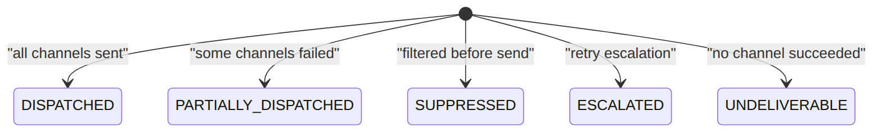
Read each row as a sentence — this data means this:
The log (one aggregate row per notification event):
Row | What it means in plain English
nl_1 | An invoice notification to cust_1 that fully succeeded (channels_attempted=[EMAIL,SMS], final_status=DISPATCHED).
nl_2 | An invoice notification to cust_2 that only partly got through (final_status=PARTIALLY_DISPATCHED) — one of its two channels failed.
nl_3 | A promo to cust_M that was never sent (channels_attempted=[], final_status=SUPPRESSED) — preference/regulatory filtering dropped it.
nl_4 | A manual resend of nl_2: manual_resend_by=agent_7 and original_notification_id=nl_2 point back, and this time EMAIL alone went out and DISPATCHED.
The attempts (one row per channel try):
Row | What it means in plain English
att_1 | nl_1's EMAIL attempt SENT on try 1 (external_reference=m-1).
att_2 | nl_2's EMAIL attempt hard-bounced (status=FAILED, failure_category=PERMANENT_RECIPIENT); dispatch_context.retryable=false means no retry — this is why nl_2 is only partial.
att_3 | nl_2's SMS attempt SENT — the channel that did get through.
att_4 | nl_1's SMS attempt hit a transient gateway 503 (status=PENDING_RETRY, failure_category=TRANSIENT), so it's scheduled to retry at next_attempt_at.
The columns that did that work:
- Aggregate vs detail = the log's final_status is recomputed from the latest attempt per channel; channels_attempted lists which were tried.
- Resend trail = manual_resend_by + original_notification_id link a resend to its original.
- Retry data = failure_category/dispatch_context decide if an attempt retries; next_attempt_at schedules it.

template (format-decomposed, versioned) · status: ACTIVE|DRAFT|ARCHIVED|DISABLED & customer_notification_preference · email_status: VALID|SOFT_BOUNCED|INVALID
{ "id":"tpl_1","operator_code":"WIK","template_format":"EMAIL_SUBJECT","template_purpose_code":"DUNNING_NOTICE","locale":"en","version":1,"status":"ACTIVE","engine_type":"HANDLEBARS","template_payload":"Payment overdue","placeholder_schema":{"name":"string"},"sample_data":{"name":"Asha"},"created_by":"studio_admin" }
{ "id":"tpl_2","operator_code":"WIK","template_format":"SMS_TEXT","template_purpose_code":"DUNNING_NOTICE","locale":"en","version":1,"status":"ACTIVE","engine_type":"HANDLEBARS","template_payload":"Your bill is overdue","placeholder_schema":null,"sample_data":null,"created_by":"studio_admin" }
{ "id":"tpl_3","operator_code":"WIK","template_format":"EMAIL_HTML","template_purpose_code":"INVOICE_CYCLE_POSTPAID","locale":"sw","version":2,"status":"DRAFT","engine_type":"HTML_TO_PDF","template_payload":"<html>…</html>","placeholder_schema":{"total":"number"},"sample_data":null,"created_by":"studio_admin" }
{ "id":"tpl_4","operator_code":"WIK","template_format":"PDF","template_purpose_code":"INVOICE_CYCLE_POSTPAID","locale":"en","version":1,"status":"ARCHIVED","engine_type":"HTML_TO_PDF","template_payload":"…","placeholder_schema":null,"sample_data":null,"created_by":null }
{ "id":"cnp_1","customer_id":"cust_M","operator_code":"WIK","email_opt_in":true,"sms_opt_in":false,"locale":"en","preferred_time_window_start":"08:00:00","preferred_time_window_end":"20:00:00","email_status":"VALID" }
{ "id":"cnp_2","customer_id":"cust_1","operator_code":"WIK","email_opt_in":true,"sms_opt_in":true,"locale":"sw","preferred_time_window_start":null,"preferred_time_window_end":null,"email_status":"SOFT_BOUNCED" }
{ "id":"cnp_3","customer_id":"cust_2","operator_code":"WIK","email_opt_in":false,"sms_opt_in":true,"locale":"en","preferred_time_window_start":null,"preferred_time_window_end":null,"email_status":"VALID" }
{ "id":"cnp_4","customer_id":"cust_3","operator_code":"WIK","email_opt_in":false,"sms_opt_in":false,"locale":"en","preferred_time_window_start":null,"preferred_time_window_end":null,"email_status":"INVALID" }
Read each row as a sentence — this data means this:
Templates (decomposed by format + locale + version):
Row | What it means in plain English
tpl_1 | The English email subject part of the dunning notice, ACTIVE v1 (Handlebars), with a {name} placeholder.
tpl_2 | The English SMS text part of the same dunning notice, ACTIVE v1 — a different format of the same purpose.
tpl_3 | A Swahili EMAIL_HTML invoice template still in DRAFT at v2 (engine_type=HTML_TO_PDF), so it can't be picked to render yet.
tpl_4 | An English PDF invoice template that is ARCHIVED (retired, no longer rendered).
Customer preferences:
Row | What it means in plain English
cnp_1 | cust_M takes email but not SMS (sms_opt_in=false) and only within a 08:00–20:00 quiet-hours window; their email address is VALID.
cnp_2 | cust_1 is opted into both channels, prefers Swahili (locale=sw), but their email soft-bounced (email_status=SOFT_BOUNCED) so email may be skipped.
cnp_3 | cust_2 takes SMS only (email opt-out); email address still VALID.
cnp_4 | cust_3 has opted out of everything and their email is INVALID — only transactional sends would reach them at all.
The columns that did that work:
- Rendering = a format needs all its parts present at an ACTIVE version to render; engine_type picks the render engine.
- Preference gating = email_opt_in/sms_opt_in gate the MARKETING channels (transactional sends regardless); locale picks the language; the time-window bounds the send; email_status lets a bounced address be skipped.

ICN: staff_notification (status: PROCESSING|DISPATCHED|ACKNOWLEDGED|EXPIRED) & staff_group_membership
{ "notification_id":"sn_1","operator_code":"WIK","source_module":"EM-CFG-04","source_task_id":"task_11","source_process_instance":"pi_1","source_business_key":"appr_77","candidate_group":"kenya-l1-kyc","template_code":"approval-needed","template_variables":{"customer":"cust_9"},"urgency":"high","fallback_mode_override":null,"deeplink_url":"/approvals/appr_77","ack_window_hours":24,"expected_recipients":4,"status":"DISPATCHED","expiry_reason":null,"acknowledged_by":null,"acknowledged_at":null,"idempotency_key":"appr_77","expires_at":"2026-06-21T09:00:00Z" }
{ "notification_id":"sn_2","operator_code":"WIK","source_module":"FUL-02","source_task_id":"task_12","source_process_instance":"pi_2","source_business_key":"kyc_55","candidate_group":"kenya-l1-kyc","template_code":"kyc-l1-approval-needed","template_variables":{"kyc":"kyc_55"},"urgency":"medium","fallback_mode_override":"SEQUENTIAL_UNTIL_ACK","deeplink_url":null,"ack_window_hours":12,"expected_recipients":3,"status":"ACKNOWLEDGED","expiry_reason":null,"acknowledged_by":"sup_01","acknowledged_at":"2026-06-20T10:05:00Z","idempotency_key":"kyc_55","expires_at":"2026-06-20T21:00:00Z" }
{ "notification_id":"sn_3","operator_code":"WIK","source_module":"BIL-04","source_task_id":null,"source_process_instance":null,"source_business_key":"refund_3","candidate_group":"finance","template_code":"refund-approval-needed","template_variables":{"amount":5000},"urgency":"high","fallback_mode_override":null,"deeplink_url":null,"ack_window_hours":null,"expected_recipients":0,"status":"EXPIRED","expiry_reason":"NO_RECIPIENTS","acknowledged_by":null,"acknowledged_at":null,"idempotency_key":"refund_3","expires_at":null }
{ "notification_id":"sn_4","operator_code":"WIK","source_module":"WO-01","source_task_id":"task_14","source_process_instance":"pi_4","source_business_key":"wo_9","candidate_group":"noc-team","template_code":"wo-stuck","template_variables":{"wo":"wo_9"},"urgency":"low","fallback_mode_override":null,"deeplink_url":null,"ack_window_hours":24,"expected_recipients":2,"status":"PROCESSING","expiry_reason":null,"acknowledged_by":null,"acknowledged_at":null,"idempotency_key":null,"expires_at":"2026-06-21T12:00:00Z" }
{ "id":1,"operator_code":"WIK","group_code":"kenya-l1-kyc","user_id":"sup_01" }
{ "id":2,"operator_code":"WIK","group_code":"kenya-l1-kyc","user_id":"sup_02" }
{ "id":3,"operator_code":"WIK","group_code":"finance","user_id":"fin_01" }
{ "id":4,"operator_code":"WIK","group_code":"noc-team","user_id":"noc_01" }
The staff notification's own lifecycle (it starts PROCESSING, gets DISPATCHED to the group, ends ACKNOWLEDGED when someone acts, or EXPIRED if nobody does / there were no recipients):
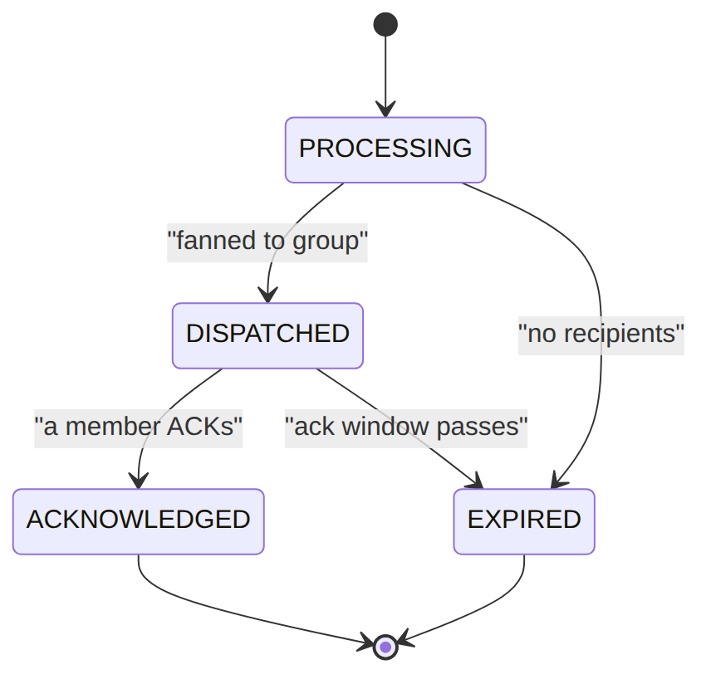
Read each row as a sentence — this data means this:
Row | What it means in plain English
sn_1 | A high-urgency approval fanned to the kenya-l1-kyc group (expected_recipients=4); it's DISPATCHED and nobody has ACKed yet (acknowledged_by=null), with a 24h ack window (expires_at).
sn_2 | A KYC approval to the same group that someone acted on: status=ACKNOWLEDGED, acknowledged_by=sup_01 at acknowledged_at — so peers are no longer needed.
sn_3 | A refund approval to finance that expired immediately because there was no one to send to (expected_recipients=0, status=EXPIRED, expiry_reason=NO_RECIPIENTS).
sn_4 | A low-urgency "WO stuck" alert to noc-team still PROCESSING (not yet fanned out); note idempotency_key=null here.
The group membership (the recipient roster) maps group_code → user_id: kenya-l1-kyc has sup_01 and sup_02, finance has fin_01, noc-team has noc_01.
The columns that did that work:
- Fan-out target = candidate_group + the membership rows; first member to act flips status to ACKNOWLEDGED (recorded by acknowledged_by), suppressing the rest.
- No-recipient expiry = expected_recipients=0 drives EXPIRED with expiry_reason=NO_RECIPIENTS.
- Idempotency / provenance = idempotency_key makes a re-dispatch a no-op; source_business_key threads back to the originating module/flow.

ICN: staff_notification_delivery (one row per recipient × channel) · status: PENDING|DISPATCHED|ACKNOWLEDGED|FAILED|TERMINALLY_FAILED|SUPPRESSED
{ "delivery_id":"deliv_1","notification_id":"sn_1","operator_code":"WIK","recipient_user_id":"sup_01","recipient_identity":null,"channel":"IN_APP_PUSH","channel_priority_idx":0,"status":"DISPATCHED","attempts":1,"last_attempt_at":"2026-06-20T09:00:01Z","provider_message_id":"push-1","provider_response":{"ok":true},"failure_reason":null,"acknowledged_at":null,"next_retry_at":null }
{ "delivery_id":"deliv_2","notification_id":"sn_1","operator_code":"WIK","recipient_user_id":"sup_02","recipient_identity":null,"channel":"EMAIL","channel_priority_idx":1,"status":"SUPPRESSED","attempts":0,"last_attempt_at":null,"provider_message_id":null,"provider_response":null,"failure_reason":null,"acknowledged_at":null,"next_retry_at":null }
{ "delivery_id":"deliv_3","notification_id":"sn_2","operator_code":"WIK","recipient_user_id":"sup_01","recipient_identity":null,"channel":"SLACK","channel_priority_idx":0,"status":"ACKNOWLEDGED","attempts":1,"last_attempt_at":"2026-06-20T10:00:00Z","provider_message_id":"slack-77","provider_response":{"ts":"123.45"},"failure_reason":null,"acknowledged_at":"2026-06-20T10:05:00Z","next_retry_at":null }
{ "delivery_id":"deliv_4","notification_id":"sn_dir","operator_code":"WIK","recipient_user_id":"director_9","recipient_identity":{"channel":"EMAIL","address":"director@wik.example"},"channel":"EMAIL","channel_priority_idx":0,"status":"DISPATCHED","attempts":1,"last_attempt_at":"2026-06-20T11:00:00Z","provider_message_id":"m-dir","provider_response":{"ok":true},"failure_reason":null,"acknowledged_at":null,"next_retry_at":null }
The status a single delivery row moves through (it starts PENDING; if a peer ACKs first it ends SUPPRESSED; retries that never succeed end TERMINALLY_FAILED):
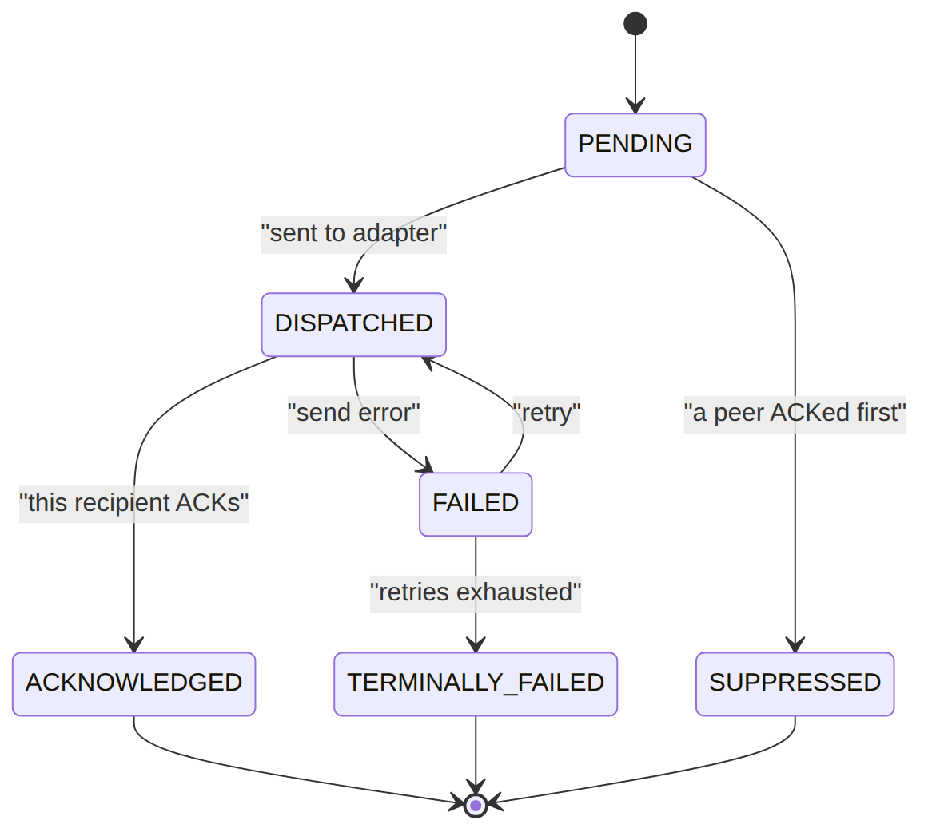
Read each row as a sentence — this data means this:
Row | What it means in plain English
deliv_1 | For sn_1, sup_01's first-choice channel (channel_priority_idx=0, IN_APP_PUSH) was DISPATCHED (provider_message_id=push-1), not yet acked.
deliv_2 | For sn_1, sup_02's EMAIL (a lower-priority channel, idx 1) was SUPPRESSED with 0 attempts — never tried because the notification's need was met elsewhere.
deliv_3 | For sn_2, sup_01's SLACK delivery was ACKNOWLEDGED (acknowledged_at set) — this is the ACK that resolved sn_2.
deliv_4 | A DIRECT send (notification sn_dir) to a named approver in no group: recipient_identity={channel:EMAIL,address:director@wik.example} is carried explicitly and handed straight to the adapter — DISPATCHED.
The columns that did that work:
- Channel order = channel_priority_idx orders the channels a recipient is tried on (per channel-config try-order / fallback mode).
- First-ACK suppression = an ACKNOWLEDGED row (deliv_3) suppresses the other still-pending rows (deliv_2 → SUPPRESSED).
- Address resolution = recipient_identity is normally null (resolved from the user's channel-identity); a DIRECT send carries an explicit {channel,address} so the dispatcher skips the directory lookup.
- Retries = failure_reason codes explain a FAILED/TERMINALLY_FAILED row; next_retry_at drives the retry sweep. The (notification_id, recipient_user_id, channel) tuple is unique.

3. Services
Service | Responsibility
NotificationOrchestrator | NOT-01 pipeline (idempotency→route→preference→regulatory→render→dispatch→audit)
TemplateService | template CRUD (Studio)
RenderRetryService/RetryScheduler/BounceService | render retry, dispatch retry/escalation, bounce
Icn/Services/StaffNotificationService (+ DeliveryDispatcher, AckService, directory) | ICN-01 group fan-out (dispatch) + direct-address send (dispatchDirect — explicit {channel,address} recipients on recipient_identity, no group); DeliveryDispatcher resolves the adapter + identity and sends each staff_notification_delivery row

4. API surface
NOT-01: GET/PUT /api/notifications/preferences (selfcare.access), /api/admin/notifications/{send, resend,dashboard,failure-queue,routing/pause,bounces} + render-failures/{id}/retry (notification.manage), /api/admin/templates/* (notification.template.manage), GET/POST /api/notifications (notification.read/notification.send). ICN-01: POST /api/staff-notifications (staff_notification.dispatch), …/inbox + …/{id}/ack (own inbox, any staff user), plus the staff-notification-* catalog (staff_notification.manage).

5. Integration (events)
- Consumes (bridges): DunningNotificationBridge, AccountStatusNotificationBridge, NotifyApproversOnApprovalRequested.
- Emits: Notification{Dispatched,Suppressed,Escalated,Undeliverable}, ICN StaffNotification{…}.

6. Processes
Scheduled workers: sophix:notification:retry-dispatch (NOT-01 dispatch retry/escalation), sophix:notification:retry-render (re-render the render_failure_queue), sophix:icn:retry (ICN delivery retry), sophix:icn:expire (ICN ack-window expiry sweep).

7. Policy & config
Routing rules, templates, channel config, customer & staff prefs, ICN groups + adapter bindings — all per-operator data.

8. Cross-module dependencies
- Reacts to → Billing (dunning/tax), ILM (account status), Foundation Approvals (ICN). Reads → ILM/CRM for contacts. Connector seam → channel adapters.

9. Invariants & rules
Rule | Statement | Enforced in
R-6 | an event with no routing rule produces no customer notice | NotificationOrchestrator
idempotency | a source_event_id is processed once | orchestrator cache
transactional override | TRANSACTIONAL ignores marketing opt-out | preference filter

10. Open items / deltas
- Legacy NotificationService::send coexists with the orchestrator (back-compat) — not a duplicate.
- The approver-notification + account-status bridges were wired during hardening (approval templates were orphaned).

