OSR — As-Built Design (Equipment & Stock)
Capability codes: OSR-01 (stock chain), OSR-INSTANCE-01 (serialized instances), OSR-02 (procurement), OSR-05 (inventory audit), OSR-RMA-01 (swap/RMA), PLM-CFG-06 (SKUs) · Module path: Modules/Osr · Tests: OsrApi, ProcurementAudit, StockReasonAndBom, StockReservation, StockRules, SwapRequest

1. Purpose & boundaries
- Owns: the stock chain (locations/balances/movements/reservations), the serialized instance registry, procurement (POs), inventory audit (counts), and equipment swap/RMA.
- Does NOT own: field work (WorkOrder), the network (Provisioning), money (Billing) — it calls them. Stock authority stays here.
- Job: authoritative equipment/stock state with governed movements, procurement, and swaps.

📖 Scenarios (service + Foundation involvement)

1. Buy stock (EM-CFG-04 gated) → receive it
The story in plain English: A buyer raises a purchase order to restock equipment. Because real money is involved, a big order can't be approved by the same person who raised it — a second person has to sign off. Once the goods arrive, the system records the new stock and gives every serialised unit its own identity card.
Who does what:
- ProcurementService::create makes a purchase_order in status DRAFT.
- approve opens a PURCHASE_ORDER EM-CFG-04 approval request (Foundation/Approvals). With a policy it parks the PO at PENDING_APPROVAL; otherwise it auto-approves to APPROVED.
- A different approver decides via …/approvals/{req}/decide (separation of duties) → PO APPROVED or REJECTED.
- receive posts a GOODS_RECEIPT stock_movement (+qty) and registers each serial as an equipment_instance in state IN_MAIN_WAREHOUSE.
Sample — a PO parked waiting on a second approver:
{ "po_id":"po_2","status":"PENDING_APPROVAL","supplier":"Casa","total_value":900000,"approval_request_id":"appr_70","created_by":"u_proc1" }
Proven by ProcurementAuditTest.

2. Reserve stock for an install WO → consume / release (event-driven)
The story in plain English: Before a technician's job, the system sets aside the cable and parts that job will need, so two jobs can't both promise the same stock. When the job finishes the parts are used up; if the job is cancelled they go back on the shelf; and if a hold is forgotten about, it eventually times out and is released automatically.
Who does what:
- StockService::reserve(wo_id, sku, location, qty) writes a stock_reservation in status ACTIVE (this raises the location's qty_reserved).
- On WorkOrderFinalized the ConsumeReservationOnWoLifecycle listener (running on the outbox) flips the reservation to CONSUMED; on WorkOrderCancelled it flips to RELEASED.
- A hold left un-actioned past expires_at is swept to EXPIRED by the sophix:stock:expire-reservations command (registered for periodic invocation; the module's own schedule wiring is currently disabled).
Foundation: outbox listener + sweep command. Proven by StockReservationTest.

3. A damaged write-off needs approval
The story in plain English: Throwing away damaged stock loses the company money, so it needs a sign-off first. Plain stock receipts don't — they just post straight away. Whether a given reason needs approval is a setting, not hard-coded.
Who does what:
- POST /api/stock-movements with reason WRITE_OFF — its stock_reason_code has requires_approval=true, so StockService::submit holds it as an EM-CFG-04 approval request (auto-approving only when there is no policy).
- A movement with a RECEIPT reason (requires_approval=false) posts immediately, no approval.
Shows: config-driven approval per reason code. Proven by StockRulesTest.

4. Inventory count → reconcile (idempotent)
The story in plain English: Staff physically count what's on a shelf and compare it to what the system thinks is there. If the numbers differ, the system makes one correcting adjustment to bring them in line. Running the correction a second time does nothing — the books are already right.
Who does what:
- InventoryAuditService::open(location) starts a count session.
- count(session, lines) records system quantity vs counted quantity per SKU.
- reconcile posts one INVENTORY_AUDIT_ADJUSTMENT stock_movement for the variance; a second reconcile is a no-op (R-OSR-05-09).
Shows: idempotent correction. Proven by ProcurementAuditTest.

5. Instance lifecycle: warehouse → van → field
The story in plain English: A serialised device (an ONT or set-top box) is tracked individually as it moves: it starts in the warehouse, gets loaded onto a technician's van, and ends up installed at a customer's home. Every move is logged so you always know where each unit is.
Who does what:
- EquipmentInstanceService::transition walks the state machine: IN_MAIN_WAREHOUSE → (issue to van) IN_CONTRACTOR_STOCK → (install) IN_FIELD_ACTIVE, now bound to a customer_id/subscription_id.
- Each step emits an EquipmentInstanceStateChanged event.
Shows: the serialized state machine + events. (See the equipment_instance state diagram in §2.)

6. HFC swap (recovered) → completed, charged
The story in plain English: A customer's box is faulty, so a technician visits to swap it for a new one and brings the old one back. The whole visit is driven by a step-by-step workflow. If the swap is an upgrade or the old box was out of warranty, the customer gets a charge; if it was a normal in-warranty fault, it's free.
Who does what:
- SwapRequestService starts the osr-swap workflow.
- ValidateSwapEligibilityHandler checks the swap is allowed → ReserveSlotHandler books a field slot → CreateSwapWorkOrderHandler creates the WorkOrder.
- The technician visits and recovers the old unit → RecoverSourceHandler marks the swap SOURCE_RECOVERED.
- CompleteSwapHandler finishes the swap → status COMPLETED. If the swap is chargeable (out-of-warranty / upgrade) it raises the SKU deposit as a BIL-01 billing intent.
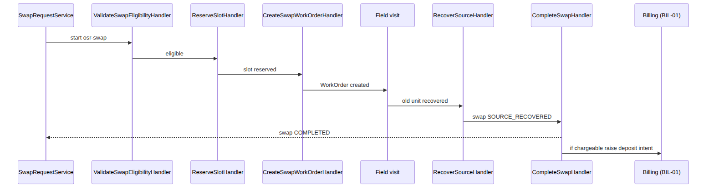
Foundation: workflow + Billing call. Proven by SwapRequestTest.

7. EQR — customer refuses return → deposit forfeited
The story in plain English: Sometimes a customer won't hand back the old equipment. The swap is then recorded as "completed but nothing recovered", the old box stays where it is, and the customer loses the deposit they paid on it — the system bills the forfeited deposit.
Who does what:
- On the field visit recovered=false → CompleteWithoutRecoveryHandler runs.
- The swap goes to status COMPLETED_WITHOUT_RECOVERY; the unit stays IN_FIELD_ACTIVE.
- The deposit is forfeited — it resolves the SKU deposit_amount and raises a DEPOSIT_FORFEITURE BIL-01 intent, emitting EquipmentSwapCompleted{depositForfeited:true}.
Sample — the forfeiture swap (no target installed, deposit billed):
{ "swap_id":"swp_3","status":"COMPLETED_WITHOUT_RECOVERY","chargeable":true,"charge_code":"DEPOSIT_FORFEITURE","charge_amount":3000,"target_instance_id":null,"flow_payload":{"recovered":false} }
Proven by SwapRequestTest::test_eqr_….

8. A movement can never drive on-hand negative
The story in plain English: You can never take more stock out than you actually have. If a withdrawal would push the on-hand count below zero, the system refuses it outright.
Who does what:
- StockService::move rejects up front when a debit would push stock_balance.quantity below 0 (R-OSR-SC-8), throwing a DomainException.
Shows: a hard stock invariant. Proven by StockRulesTest.

(bonus) 9. Defective recovered unit → vendor RMA
The story in plain English: When a faulty unit comes back, the system notes it down so it can later be shipped to the vendor in a batch.
A swap completed with defectConfirmed records a vendor_rma_stub row with batch_ref='PENDING_BATCH' for the v1.0 batch handoff (a real vendor-RMA integration is a connector).

2. Data model — ≥4 complete sample rows + readings
Completeness: each row lists every domain column (nullables shown as null). The string business key shown is the real primary key (or the surrogate id where the table has no business key, e.g. stock_movement/stock_balance); created_at/updated_at are omitted by convention.

equipment_sku (PLM-CFG-06) · category: ROUTER|ONT|STB|SPLITTER|CABLE|WALL_SOCKET|MOUNT_KIT|SMARTCARD · ownership_semantics: RETURNABLE|CONSUMABLE|RENTED
{ "sku_id":"WIK-ONT-HUAWEI-EG8145V5","operator_code":"WIK","name":"Huawei EG8145V5 ONT","category":"ONT","is_serialized":true,"ownership_semantics":"RETURNABLE","deposit_amount":5000,"warranty_days":365,"active":true }
{ "sku_id":"WIK-STB-4K","operator_code":"WIK","name":"4K Android STB","category":"STB","is_serialized":true,"ownership_semantics":"RENTED","deposit_amount":3000,"warranty_days":365,"active":true }
{ "sku_id":"WIK-CABLE-CAT6","operator_code":"WIK","name":"Cat6 Drop Cable (m)","category":"CABLE","is_serialized":false,"ownership_semantics":"CONSUMABLE","deposit_amount":0,"warranty_days":0,"active":true }
{ "sku_id":"WIK-ONT-OLD","operator_code":"WIK","name":"Legacy ONT (retired)","category":"ONT","is_serialized":true,"ownership_semantics":"RETURNABLE","deposit_amount":4000,"warranty_days":90,"active":false }
Read each row as a sentence — this data means this:
Row | What it means in plain English
WIK-ONT-HUAWEI-EG8145V5 | A Huawei ONT, serialized (is_serialized=true) and returnable (ownership_semantics=RETURNABLE), carrying a KES 5,000 deposit and a 365-day warranty, live (active=true).
WIK-STB-4K | A 4K STB, serialized and rented (ownership_semantics=RENTED), KES 3,000 deposit, 365-day warranty, live.
WIK-CABLE-CAT6 | Drop cable sold by the metre, non-serialized and consumable (is_serialized=false, ownership_semantics=CONSUMABLE) — no deposit, no warranty (deposit_amount=0, warranty_days=0).
WIK-ONT-OLD | A retired legacy ONT (active=false) — still returnable with a KES 4,000 deposit, but no new stock.
The columns that did the work:
- is_serialized decides whether each unit is tracked as an equipment_instance (ONT/STB) or only as bulk stock_balance (cable).
- deposit_amount is what an EQR forfeiture or out-of-warranty swap charges; ownership_semantics says returnable/rented (deposit-bearing) vs consumed; active=false retires a SKU.

equipment_instance · state: IN_MAIN_WAREHOUSE|IN_CONTRACTOR_STOCK|RESERVED_FOR_WO|IN_FIELD_ACTIVE|IN_FIELD_DEFECTIVE|RECOVERED_BY_CONTRACTOR|RETURNED|FAULTY|RETIRED
{ "instance_id":"eqi_1","operator_code":"WIK","sku_id":"WIK-ONT-HUAWEI-EG8145V5","serial":"SN-001","mac_address":"AC:DE:48:00:00:01","state":"IN_MAIN_WAREHOUSE","location_id":"WIK-WAREHOUSE-MAIN","customer_id":null,"subscription_id":null,"active":true }
{ "instance_id":"eqi_2","operator_code":"WIK","sku_id":"WIK-ONT-HUAWEI-EG8145V5","serial":"SN-002","mac_address":"AC:DE:48:00:00:02","state":"IN_CONTRACTOR_STOCK","location_id":"WIK-VAN-ctr_9","customer_id":null,"subscription_id":null,"active":true }
{ "instance_id":"eqi_3","operator_code":"WIK","sku_id":"WIK-STB-4K","serial":"SN-100","mac_address":null,"state":"IN_FIELD_ACTIVE","location_id":null,"customer_id":"cust_1","subscription_id":"sub_1","active":true }
{ "instance_id":"eqi_4","operator_code":"WIK","sku_id":"WIK-ONT-OLD","serial":"SN-900","mac_address":"AC:DE:48:00:09:00","state":"IN_FIELD_DEFECTIVE","location_id":null,"customer_id":"cust_2","subscription_id":"sub_9","active":true }
Read each row as a sentence — this data means this:
Row | What it means in plain English
eqi_1 | A Huawei ONT (serial SN-001) sitting as sellable warehouse stock (state=IN_MAIN_WAREHOUSE, location_id=WIK-WAREHOUSE-MAIN), not yet assigned to anyone (customer_id/subscription_id null).
eqi_2 | An identical ONT (SN-002) loaded on contractor ctr_9's van (state=IN_CONTRACTOR_STOCK, location_id=WIK-VAN-ctr_9).
eqi_3 | A 4K STB (SN-100) installed and live at a customer (state=IN_FIELD_ACTIVE, bound to cust_1/sub_1), with location_id=null because it's now in the field.
eqi_4 | A legacy ONT (SN-900) defective in the field (state=IN_FIELD_DEFECTIVE, bound to cust_2/sub_9) — a swap candidate.
The columns that did the work:
- state tells you where the unit physically is, plus its condition; once in the field location_id is null and customer_id/subscription_id carry the binding.
A swap moves the source instance through RESERVED_FOR_WO → RECOVERED_BY_CONTRACTOR (or it stays in the field on an EQR refusal). active only flips to false once the instance reaches the terminal RETIRED state — the transition that emits EquipmentInstanceDecommissioned.
The realistic life of one unit (warehouse → van → field → recover → retire, with the defective branch):
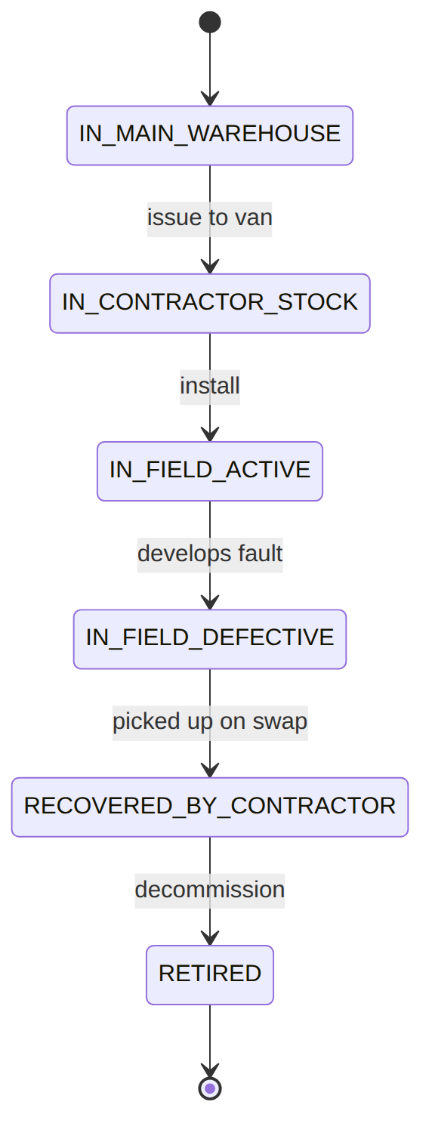

stock_location (type: WAREHOUSE|CONTRACTOR_VAN)
{ "location_id":"WIK-WAREHOUSE-MAIN","operator_code":"WIK","type":"WAREHOUSE","name":"Main Warehouse (Nairobi)","contractor_id":null,"active":true }
{ "location_id":"WIK-VAN-ctr_9","operator_code":"WIK","type":"CONTRACTOR_VAN","name":"Van — Contractor ctr_9","contractor_id":"ctr_9","active":true }
{ "location_id":"WIK-WAREHOUSE-MSA","operator_code":"WIK","type":"WAREHOUSE","name":"Mombasa Warehouse","contractor_id":null,"active":true }
{ "location_id":"WIK-VAN-ctr_4","operator_code":"WIK","type":"CONTRACTOR_VAN","name":"Van — Contractor ctr_4 (retired)","contractor_id":"ctr_4","active":false }
Read each row as a sentence — this data means this:
Row | What it means in plain English
WIK-WAREHOUSE-MAIN | The main Nairobi warehouse (type=WAREHOUSE), live, with no contractor_id (warehouses aren't tied to a contractor).
WIK-VAN-ctr_9 | Contractor ctr_9's rolling stock (type=CONTRACTOR_VAN, contractor_id=ctr_9), live.
WIK-WAREHOUSE-MSA | The Mombasa warehouse, live, no contractor_id.
WIK-VAN-ctr_4 | Contractor ctr_4's van that is decommissioned (active=false) — no new movements post to it.
The columns that did the work:
- Stock lives at locations; type=CONTRACTOR_VAN is a contractor's rolling stock (keyed to contractor_id), a WAREHOUSE has none, and active=false retires a location.

stock_balance (derived projection per (location, sku); available = quantity − qty_reserved)
{ "id":"sb_1","operator_code":"WIK","location_id":"WIK-WAREHOUSE-MAIN","sku_id":"WIK-CABLE-CAT6","quantity":4200,"qty_reserved":150 }
{ "id":"sb_2","operator_code":"WIK","location_id":"WIK-VAN-ctr_9","sku_id":"WIK-CABLE-CAT6","quantity":300,"qty_reserved":0 }
{ "id":"sb_3","operator_code":"WIK","location_id":"WIK-WAREHOUSE-MSA","sku_id":"WIK-CABLE-CAT6","quantity":80,"qty_reserved":80 }
{ "id":"sb_4","operator_code":"WIK","location_id":"WIK-WAREHOUSE-MAIN","sku_id":"WIK-ONT-HUAWEI-EG8145V5","quantity":0,"qty_reserved":0 }
Read each row as a sentence — this data means this:
Row | What it means in plain English
sb_1 | The main warehouse holds 4,200 metres of Cat6 cable, 150 reserved (quantity=4200, qty_reserved=150) → 4,050 available.
sb_2 | Contractor ctr_9's van holds 300 metres of cable, none reserved → all 300 available.
sb_3 | The Mombasa warehouse holds 80 metres of cable, all 80 reserved (quantity=80, qty_reserved=80) → nothing available.
sb_4 | The ONT balance row stays 0 (quantity=0) because serialized ONTs are counted by their instances, not here.
The columns that did the work:
- stock_balance is on-hand per (location, sku) for non-serialized SKUs; quantity is the on-hand total and qty_reserved the held-but-unavailable portion (so available = quantity − qty_reserved).

stock_movement (append-only ledger) · reason_code (catalog stock_reason_code: direction IN/OUT/EITHER, requires_approval)
{ "id":"sm_1","operator_code":"WIK","sku_id":"WIK-CABLE-CAT6","location_id":"WIK-WAREHOUSE-MAIN","quantity":5000,"reason_code":"GOODS_RECEIPT","reference":"po_1","approved_by":null }
{ "id":"sm_2","operator_code":"WIK","sku_id":"WIK-CABLE-CAT6","location_id":"WIK-VAN-ctr_9","quantity":-50,"reason_code":"TRANSFER_OUT","reference":"transfer_7","approved_by":null }
{ "id":"sm_3","operator_code":"WIK","sku_id":"WIK-CABLE-CAT6","location_id":"WIK-WAREHOUSE-MAIN","quantity":-10,"reason_code":"WRITE_OFF","reference":"appr_55","approved_by":"u_stockmgr2" }
{ "id":"sm_4","operator_code":"WIK","sku_id":"WIK-CABLE-CAT6","location_id":"WIK-WAREHOUSE-MSA","quantity":-3,"reason_code":"INVENTORY_AUDIT_ADJUSTMENT","reference":"scs_2","approved_by":"u_stockmgr1" }
Read each row as a sentence — this data means this:
Row | What it means in plain English
sm_1 | A goods receipt of +5,000 cable into the main warehouse (reason_code=GOODS_RECEIPT, quantity=5000) against PO po_1 (reference), no approval needed (approved_by=null).
sm_2 | A transfer out of −50 cable to ctr_9's van (reason_code=TRANSFER_OUT, quantity=-50, reference=transfer_7), no approval.
sm_3 | An approval-gated write-off of −10 cable (reason_code=WRITE_OFF) where reference=appr_55 is the approval id and approved_by=u_stockmgr2 is the second-person approver (R-OSR-SC-9).
sm_4 | The single audit adjustment a reconcile posted: −3 cable at the Mombasa warehouse (reason_code=INVENTORY_AUDIT_ADJUSTMENT, reference=scs_2 = the count session), approved by u_stockmgr1.
The columns that did the work:
- Movements are the immutable ledger; quantity is signed (+ inbound, − outbound) and reason_code fixes the sign/direction and whether approval was needed.
- The catalog stock_reason_code seeds RECEIPT|ISSUE|TRANSFER_IN|TRANSFER_OUT|INSTALL|RETURN|ADJUST|WRITE_OFF (ADJUST/WRITE_OFF carry requires_approval=true); services also post the literal flow codes GOODS_RECEIPT, TRANSFER_OUT/TRANSFER_IN and INVENTORY_AUDIT_ADJUSTMENT.
(stock_movement has only created_at — no updated_at on this append-only ledger.)

stock_reason_code (operator catalog, composite-unique (operator_code, code)) · direction: IN|OUT|EITHER
{ "id":1,"operator_code":"WIK","code":"RECEIPT","description":"Goods received into stock","direction":"IN","requires_approval":false,"active":true }
{ "id":5,"operator_code":"WIK","code":"INSTALL","description":"Consumed on a customer install","direction":"OUT","requires_approval":false,"active":true }
{ "id":7,"operator_code":"WIK","code":"ADJUST","description":"Inventory adjustment (count variance)","direction":"EITHER","requires_approval":true,"active":true }
{ "id":8,"operator_code":"WIK","code":"WRITE_OFF","description":"Damaged/lost write-off","direction":"OUT","requires_approval":true,"active":true }
Read each row as a sentence — this data means this:
Row | What it means in plain English
RECEIPT | Goods received into stock — an inbound code (direction=IN), no approval (requires_approval=false), active.
INSTALL | Stock consumed on a customer install — an outbound code (direction=OUT), no approval, active.
ADJUST | A count-variance adjustment that can go either way (direction=EITHER) and requires approval (requires_approval=true), active.
WRITE_OFF | A damaged/lost write-off — outbound (direction=OUT) and requires approval, active.
The columns that did the work:
- This operator-scoped catalog governs stock_movement.reason_code: direction fixes the allowed sign and requires_approval=true (ADJUST, WRITE_OFF) routes the movement through EM-CFG-04 before it posts.
- When a catalog exists for the operator, StockService::move rejects any non-catalog code (UNKNOWN_STOCK_REASON). Seeded codes: RECEIPT|ISSUE|TRANSFER_IN|TRANSFER_OUT|INSTALL|RETURN|ADJUST|WRITE_OFF.

stock_reservation · status: ACTIVE|CONSUMED|RELEASED|EXPIRED
{ "reservation_id":"rsv_1","operator_code":"WIK","sku_id":"WIK-CABLE-CAT6","location_id":"WIK-WAREHOUSE-MAIN","qty":150,"wo_id":"wo_1","reference":"FTTH_INSTALL","status":"ACTIVE","expires_at":"2026-07-21T09:00:00Z","resolved_at":null }
{ "reservation_id":"rsv_2","operator_code":"WIK","sku_id":"WIK-CABLE-CAT6","location_id":"WIK-WAREHOUSE-MAIN","qty":40,"wo_id":"wo_1","reference":"FTTH_INSTALL","status":"CONSUMED","expires_at":"2026-07-20T09:00:00Z","resolved_at":"2026-06-20T12:30:00Z" }
{ "reservation_id":"rsv_3","operator_code":"WIK","sku_id":"WIK-CABLE-CAT6","location_id":"WIK-WAREHOUSE-MAIN","qty":25,"wo_id":"wo_5","reference":null,"status":"RELEASED","expires_at":"2026-07-19T09:00:00Z","resolved_at":"2026-06-21T11:45:00Z" }
{ "reservation_id":"rsv_4","operator_code":"WIK","sku_id":"WIK-CABLE-CAT6","location_id":"WIK-WAREHOUSE-MSA","qty":80,"wo_id":"wo_8","reference":null,"status":"EXPIRED","expires_at":"2026-06-18T09:00:00Z","resolved_at":"2026-06-18T09:05:00Z" }
Read each row as a sentence — this data means this:
Row | What it means in plain English
rsv_1 | A live hold of 150 cable in the main warehouse for wo_1 (status=ACTIVE, qty=150) — currently raising that location's qty_reserved.
rsv_2 | A 40-cable hold for wo_1 that was used up when the WO finalized (status=CONSUMED, resolved_at stamped).
rsv_3 | A 25-cable hold for wo_5 that was freed when the WO was cancelled (status=RELEASED, resolved_at stamped).
rsv_4 | An 80-cable hold for wo_8 that was swept after its expires_at (2026-06-18) passed un-actioned (status=EXPIRED, resolved_at stamped).
The columns that did the work:
- A reservation holds stock for a WO (raising the location's qty_reserved): ACTIVE → CONSUMED (WO finalized) or RELEASED (WO cancelled) via the lifecycle listener; an un-actioned hold past expires_at is swept EXPIRED (R-OSR-SC-7), and resolved_at records the terminal transition.
- This is how install stock is promised without double-allocating. (Serialized SKUs reserve the instance; bulk SKUs like cable reserve a qty.)

purchase_order · status: DRAFT|PENDING_APPROVAL|APPROVED|RECEIVED|REJECTED
{ "po_id":"po_1","operator_code":"WIK","supplier":"Huawei","location_id":"WIK-WAREHOUSE-MAIN","status":"RECEIVED","approval_request_id":"appr_60","approval_mode":null,"total_value":150000,"created_by":"u_proc1" }
{ "po_id":"po_2","operator_code":"WIK","supplier":"Casa","location_id":"WIK-WAREHOUSE-MAIN","status":"PENDING_APPROVAL","approval_request_id":"appr_70","approval_mode":null,"total_value":900000,"created_by":"u_proc1" }
{ "po_id":"po_3","operator_code":"WIK","supplier":"Local","location_id":"WIK-WAREHOUSE-MSA","status":"APPROVED","approval_request_id":"appr_71","approval_mode":null,"total_value":20000,"created_by":"u_proc2" }
{ "po_id":"po_4","operator_code":"WIK","supplier":"FiberHome","location_id":"WIK-WAREHOUSE-MAIN","status":"REJECTED","approval_request_id":"appr_72","approval_mode":null,"total_value":50000,"created_by":"u_proc2" }
Read each row as a sentence — this data means this:
Row | What it means in plain English
po_1 | A KES 150,000 Huawei PO into the main warehouse that is fully received (status=RECEIVED) — stock posted and serials registered; it cleared an approval (approval_request_id=appr_60).
po_2 | A KES 900,000 Casa PO parked awaiting approval (status=PENDING_APPROVAL, approval_request_id=appr_70) because policy made the request PENDING.
po_3 | A KES 20,000 PO that was approved on the SoD decision (status=APPROVED) and may now be received.
po_4 | A KES 50,000 FiberHome PO that was rejected on the SoD decision (status=REJECTED).
The columns that did the work:
- approve() opens an EM-CFG-04 request and stamps approval_request_id; a PENDING policy parks the PO in PENDING_APPROVAL, otherwise it auto-approves; decide() flips a parked PO to APPROVED or REJECTED. A receive is only allowed from APPROVED.
(approval_mode is a reserved EM-CFG-04 snapshot column — present in the schema but not yet written by the service, so always null.)

purchase_order_line (PO detail, FK → purchase_order cascade)
{ "po_line_id":"pol_1","po_id":"po_1","sku_id":"WIK-ONT-HUAWEI-EG8145V5","quantity_ordered":100,"quantity_received":100,"unit_cost":1500 }
{ "po_line_id":"pol_2","po_id":"po_2","sku_id":"WIK-STB-4K","quantity_ordered":300,"quantity_received":0,"unit_cost":3000 }
{ "po_line_id":"pol_3","po_id":"po_3","sku_id":"WIK-CABLE-CAT6","quantity_ordered":5000,"quantity_received":0,"unit_cost":4 }
{ "po_line_id":"pol_4","po_id":"po_4","sku_id":"WIK-ONT-HUAWEI-EG8145V5","quantity_ordered":40,"quantity_received":0,"unit_cost":1500 }
Read each row as a sentence — this data means this:
Row | What it means in plain English
pol_1 | 100 Huawei ONTs at KES 1,500 each on po_1, fully received (quantity_ordered=100, quantity_received=100).
pol_2 | 300 STBs at KES 3,000 on po_2, none received yet (quantity_received=0) — its PO is still pending approval.
pol_3 | 5,000 metres of cable at KES 4 on po_3, none received yet.
pol_4 | 40 Huawei ONTs at KES 1,500 on po_4, none received (its PO was rejected).
The columns that did the work:
- Each line is a SKU on a PO; receive posts a GOODS_RECEIPT movement per line and bumps quantity_received (serialized lines also register one equipment_instance per serial). unit_cost × quantity_ordered rolls up to purchase_order.total_value.

stock_count_session · status: OPEN|COUNTED|RECONCILED · & stock_count_line
{ "session_id":"scs_1","operator_code":"WIK","location_id":"WIK-WAREHOUSE-MAIN","status":"RECONCILED","variance_lines":1,"created_by":"u_stockmgr1","reconciled_at":"2026-06-19T16:00:00Z" }
{ "session_id":"scs_2","operator_code":"WIK","location_id":"WIK-WAREHOUSE-MSA","status":"COUNTED","variance_lines":1,"created_by":"u_stockmgr1","reconciled_at":null }
{ "count_line_id":"scl_1","session_id":"scs_1","sku_id":"WIK-CABLE-CAT6","system_qty":4200,"counted_qty":4200,"variance":0 }
{ "count_line_id":"scl_2","session_id":"scs_2","sku_id":"WIK-CABLE-CAT6","system_qty":83,"counted_qty":80,"variance":-3 }
Read each row as a sentence — this data means this:
Row | What it means in plain English
scs_1 | A main-warehouse count session that is fully reconciled (status=RECONCILED, reconciled_at stamped) and found 1 variance line (variance_lines=1).
scs_2 | A Mombasa count session that is counted but not yet reconciled (status=COUNTED, reconciled_at=null), also with 1 variance line.
scl_1 | A count line under scs_1: cable counted 4,200 vs system 4,200 → no variance (variance=0).
scl_2 | A count line under scs_2: cable counted 80 vs system 83 → −3 variance (this is what produced movement sm_4).
The columns that did the work:
- InventoryAuditService walks a session open → count → reconcile; count records system_qty vs counted_qty per SKU (variance is the delta, variance_lines counts non-zero lines).
- reconcile posts ONE INVENTORY_AUDIT_ADJUSTMENT movement per variance line and stamps reconciled_at; a second reconcile is a no-op (R-OSR-05-09).

equipment_swap_request · kind: SWAP_HFC|SWAP_GPON|EQP|EQU · status: CREATED|AWAITING_SLOT|WO_CREATED|FIELD_VISIT_IN_PROGRESS|SOURCE_RECOVERED|COMPLETED|COMPLETED_WITHOUT_RECOVERY|FAILED
{ "swap_id":"swp_1","operator_code":"WIK","kind":"SWAP_GPON","source_instance_id":"eqi_4","target_instance_id":"eqi_1","subscription_id":"sub_9","customer_id":"cust_2","homepass_id":"hp_7","recovery_contractor_id":"ctr_9","status":"COMPLETED","chargeable":false,"charge_code":null,"charge_amount":null,"failure_code":null,"flow_payload":{"warranty":"in_warranty"},"work_order_id":"wo_30","slot_commitment_id":"sc_5","process_instance_id":"pi_30" }
{ "swap_id":"swp_2","operator_code":"WIK","kind":"EQU","source_instance_id":"eqi_5","target_instance_id":"eqi_6","subscription_id":"sub_10","customer_id":"cust_3","homepass_id":"hp_8","recovery_contractor_id":"ctr_9","status":"COMPLETED","chargeable":true,"charge_code":"UPGRADE_FEE","charge_amount":5000,"failure_code":null,"flow_payload":{"upgrade":"wifi6"},"work_order_id":"wo_31","slot_commitment_id":"sc_6","process_instance_id":"pi_31" }
{ "swap_id":"swp_3","operator_code":"WIK","kind":"EQP","source_instance_id":"eqi_7","target_instance_id":null,"subscription_id":"sub_11","customer_id":"cust_4","homepass_id":"hp_9","recovery_contractor_id":"ctr_4","status":"COMPLETED_WITHOUT_RECOVERY","chargeable":true,"charge_code":"DEPOSIT_FORFEITURE","charge_amount":3000,"failure_code":null,"flow_payload":{"recovered":false},"work_order_id":"wo_32","slot_commitment_id":"sc_7","process_instance_id":"pi_32" }
{ "swap_id":"swp_4","operator_code":"WIK","kind":"SWAP_HFC","source_instance_id":"eqi_8","target_instance_id":null,"subscription_id":"sub_12","customer_id":"cust_5","homepass_id":"hp_3","recovery_contractor_id":"ctr_4","status":"FIELD_VISIT_IN_PROGRESS","chargeable":false,"charge_code":null,"charge_amount":null,"failure_code":null,"flow_payload":null,"work_order_id":"wo_33","slot_commitment_id":"sc_8","process_instance_id":"pi_33" }
Read each row as a sentence — this data means this:
Row | What it means in plain English
swp_1 | A free in-warranty GPON swap (kind=SWAP_GPON, chargeable=false): defective eqi_4 replaced by new eqi_1, done with the old unit recovered (status=COMPLETED, target_instance_id=eqi_1).
swp_2 | An upgrade swap (kind=EQU) that is chargeable KES 5,000 (chargeable=true, charge_code=UPGRADE_FEE, charge_amount=5000), completed, recovering eqi_5 for new eqi_6.
swp_3 | An EQR forfeiture pickup (kind=EQP) completed without recovery (status=COMPLETED_WITHOUT_RECOVERY, target_instance_id=null) — the deposit was billed (charge_code=DEPOSIT_FORFEITURE, charge_amount=3000).
swp_4 | An HFC swap (kind=SWAP_HFC) mid field-visit (status=FIELD_VISIT_IN_PROGRESS), not chargeable yet, no target installed.
The columns that did the work:
- kind selects the flow (GPON/HFC defective swap, EQP pickup, EQU upgrade); chargeable/charge_code/charge_amount carry any billed fee (via BIL-01).
- Each swap stores its work_order_id, slot_commitment_id and process_instance_id (the driving workflow); flow_payload carries per-flow specifics; failure_code is set only on a FAILED swap.
The swap's status lifecycle (the happy path branches three ways at the end — recovered, refused, or failed):
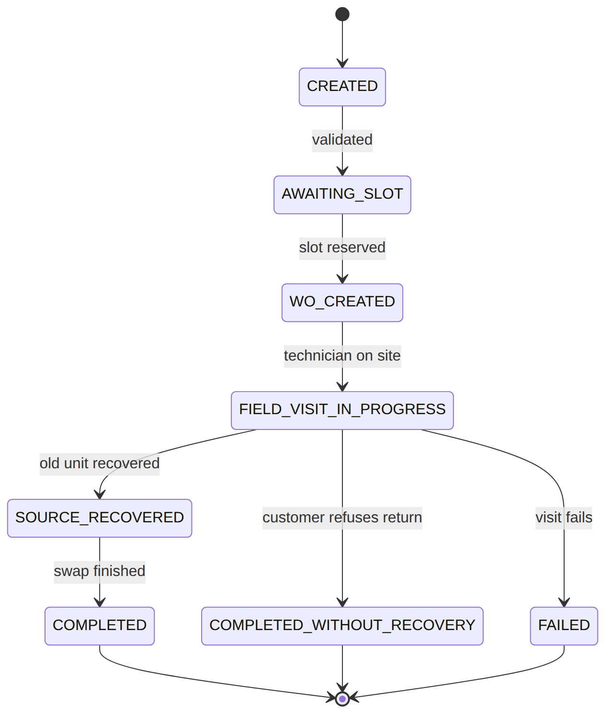

vendor_rma_stub (v1.0 vendor-handoff stub)
{ "id":"vrma_1","operator_code":"WIK","swap_id":"swp_1","source_instance_id":"eqi_4","vendor_ref":null,"batch_ref":"PENDING_BATCH","shipped_at":null }
{ "id":"vrma_2","operator_code":"WIK","swap_id":"swp_2","source_instance_id":"eqi_5","vendor_ref":null,"batch_ref":"PENDING_BATCH","shipped_at":null }
Read each row as a sentence — this data means this:
Row | What it means in plain English
vrma_1 | A vendor-handoff stub for swap swp_1's recovered unit eqi_4, batched but not yet shipped (batch_ref=PENDING_BATCH, vendor_ref=null, shipped_at=null).
vrma_2 | The same for swap swp_2's recovered unit eqi_5 — batch_ref=PENDING_BATCH, not yet shipped.
The columns that did the work:
- When a swap completes with defectConfirmed, CompleteSwapHandler records one stub per recovered defective unit with batch_ref='PENDING_BATCH'; vendor_ref/shipped_at stay null until a real vendor-RMA connector batches and ships it. There is no status column — the row's existence + batch_ref is the whole record in v1.0.

3. Services (worked calls)
Service | Responsibility
StockService | submit() (gate write-offs via EM-CFG-04) / move() (raw poster, R-OSR-SC-8) / reserve·consume·release / availability
EquipmentInstanceService | register + transition() serialized instances
ProcurementService | PO create / approve (EM-CFG-04) / receive (serial registration)
InventoryAuditService | open / count / reconcile
SwapRequestService | OSR-RMA-01 swap request + the osr-swap workflow

4. API surface
/api/equipment-skus, /api/stock-{locations,balances,movements,reservations}, /api/equipment-instances, /api/purchase-orders (+…/approvals/{req}/decide), /api/stock-counts, /api/swap-requests. Reads under permission:stock.read; writes under permission:stock.manage (+ idempotency on stock-movements, equipment-instances/swap-requests creates, purchase-order receive).

5. Integration (events) — topic osr.equipment
- Emits: StockMoved, StockReserved, StockReservation{Consumed,Released,Expired}, EquipmentInstance{Registered,StateChanged,RecoveredByContractor,BoundToCustomer,UnboundFromCustomer,Decommissioned}, EquipmentSkuCreated, EquipmentSourceRecovered, EquipmentSwap{Requested,Rejected,Completed} (Completed carries depositForfeited+amount).
- Consumes: ConsumeReservationOnWoLifecycle (WO finalize→consume / cancel→release).

6. Processes (swap workflow)
Handlers: ValidateSwapEligibility, ReserveSlot, CreateSwapWorkOrder, RecoverSource, ProvisionSwap, CompleteSwap (chargeable→BIL-01), CompleteWithoutRecovery (EQR→forfeit), FailSwap.

7. Policy & config
stock_reason_code (sign/direction + requires_approval), SKU catalog, EM-CFG-04 definitions for write-offs/POs. All per-operator data.

8. Cross-module dependencies
- Calls → WorkOrder (swap WO), Billing (BillingIntentService for swap charge / deposit forfeiture), Provisioning (swap provision), Foundation Approvals.
- Reacts to → WorkOrder lifecycle (reservation consume/release).

9. Invariants & rules
Rule | Statement | Enforced in
R-OSR-SC-8 | a movement may never drive on-hand negative | StockService::move
R-OSR-SC-9 | approval-required reasons gate via EM-CFG-04 | StockService::submit
R-OSR-02-04 | PO approval gated via EM-CFG-04 (SoD) | ProcurementService::approve
R-OSR-02-07/08 | receipt posts a movement + registers serials | ProcurementService::receive
R-OSR-05-09 | a second reconcile posts no second correction | InventoryAuditService::reconcile
OSR-RMA EQR | refused return forfeits the deposit (BIL-01) | CompleteWithoutRecoveryHandler

10. Open items / deltas
- PO approval (EM-CFG-04) and EQR deposit-forfeiture billing were wired during hardening.
- vendor_rma_stub is a v1.0 batch stub pending a real vendor-RMA integration (connector).

