PaymentGateway — As-Built Design
Capability codes: payment-rail ingress (M-Pesa / cards / bank) · Module path: Modules/PaymentGateway · Test: GatewayCallbackTest

1. Purpose & boundaries
- Owns: the inbound callback boundary — receive, de-duplicate, record provider payment notifications, resolve the billing account, then hand the money to Billing (PaymentService::receiveAndApply) and emit a GatewayCallback* audit event.
- Does NOT own: allocation/ledger or billing-mode routing (Billing PaymentService — POSTPAID→invoices, PREPAID→wallet top-up) or outbound initiation (a connector).
- Job: the safe, idempotent front door for money-in from external rails.

📖 Scenarios (service + Foundation involvement)

1. M-Pesa STK success lands
The story in plain English: A customer pays with M-Pesa. The phone network calls back into our system to say "this much money arrived from this number". We write the notification down, figure out which billing account it belongs to, hand the money to Billing to apply, and then stamp the notification as done. The whole point is to do this safely and only once.
Who does what:
- The provider calls POST /api/payment-gateway/mpesa/callbacks.
- GatewayCallbackService::handle records a payment_gateway_callback row (RECEIVED).
- It resolves the billing account from the ILM payment_account_number.
- It calls Billing PaymentService::receiveAndApply, which allocates the money.
- The callback flips to PROCESSED and emits GatewayCallbackProcessed (topic paymentgateway.callback).
Sample — the callback once applied:
{ "callback_id":"pgcb_1","provider":"MPESA","external_ref":"QGR7Xk12","account_ref":"254700000001","resolved_account_id":"acct_50","amount":5000.00,"status":"PROCESSED","payment_id":"pay_91","reject_reason":null }
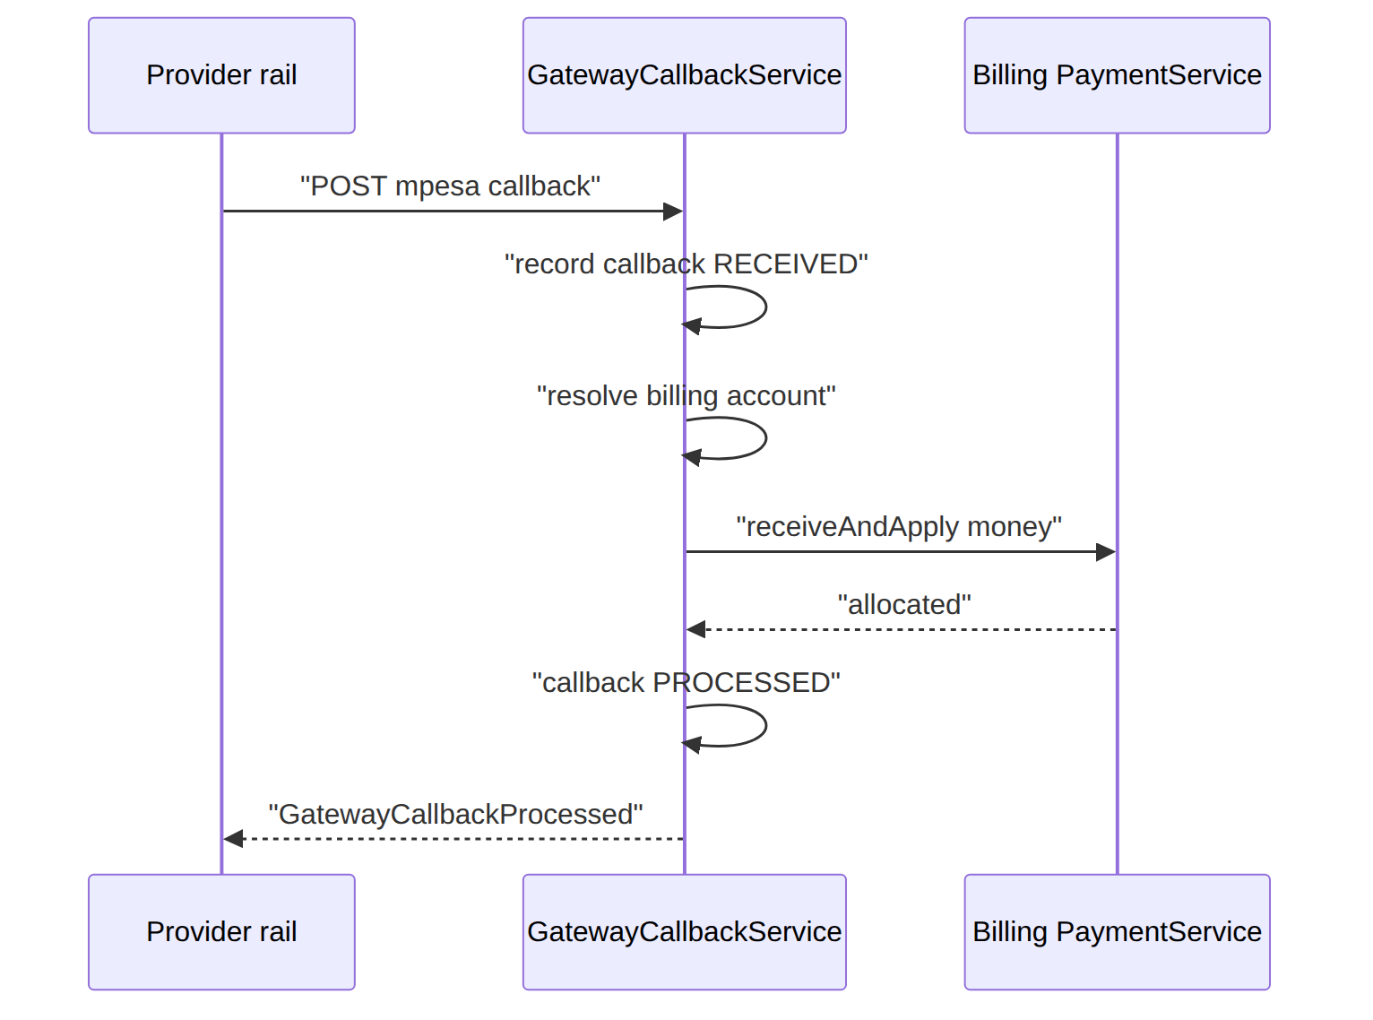
Proven by GatewayCallbackTest::test_mpesa_callback_resolves_account_and_applies_payment.

2. Retried callback is ignored (dedup)
The story in plain English: Providers love to re-send the same notification. If we acted on it twice we would credit the customer twice. So the same payment reference is only ever acted on once — a repeat is recognised and quietly ignored.
Who does what: the provider re-posts the same (provider, external_ref) → the dedup key hits → the existing callback row is returned (no new row), only a GatewayCallbackDuplicate audit event fires, and receiveAndApply is not called again. Proven by GatewayCallbackTest::test_duplicate_callback_is_deduped.

3. Prepaid vs postpaid routing (Billing-owned)
The story in plain English: Where the money lands depends on how the customer is billed. A postpaid customer's money pays down their invoices; a prepaid customer's money tops up their wallet. The gateway does not decide this — it just hands the money to Billing, which routes it.
Who does what: receiveAndApply routes by billing mode — a POSTPAID account's payment is applied to invoices, a PREPAID subscription's money is a wallet top-up (BIL-05). The gateway owns no ledger.
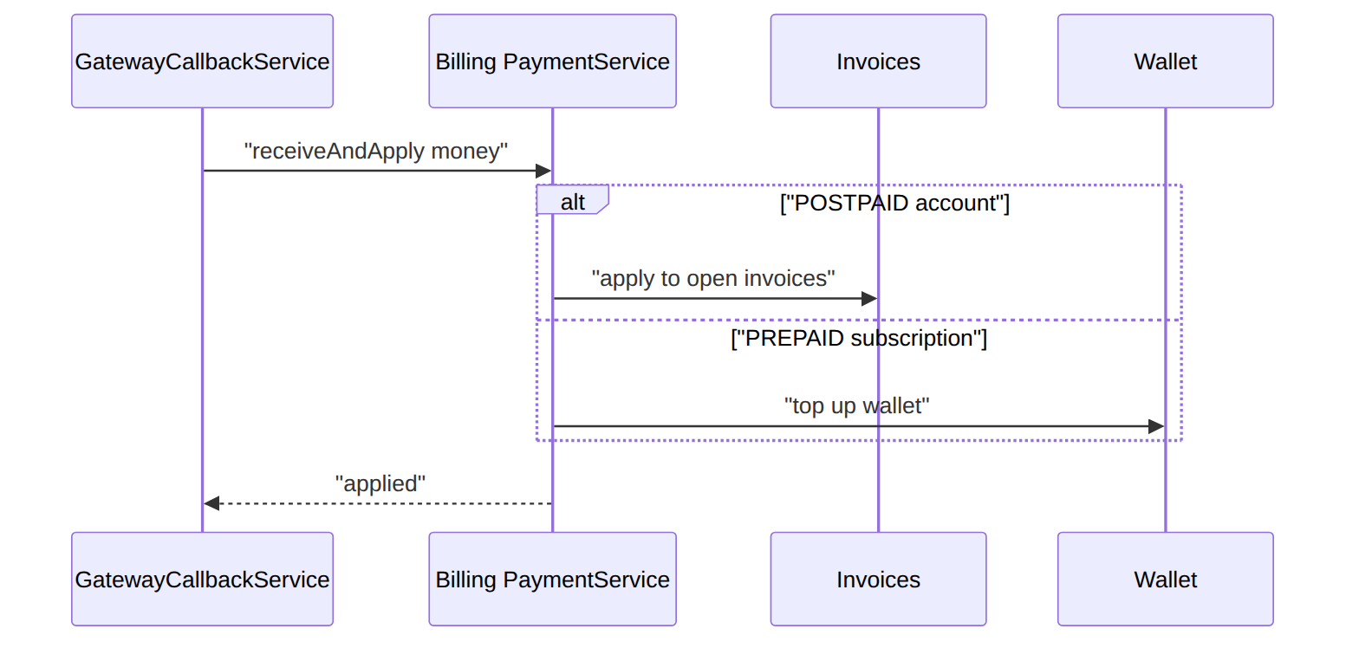
Proven by GatewayCallbackTest::test_prepaid_callback_tops_up_the_wallet_not_an_invoice.

4. Card PSP callback
POST /api/payment-gateway/visa/callbacks → same path, different provider parsing (adapter/config).

5. Bank-transfer notification
A bank feed posts a transfer → recorded + applied (method BANK_TRANSFER).

6. Account cannot be resolved → REJECTED
The story in plain English: Money arrives but we cannot tell whose account it belongs to. We do not apply it to anyone — we mark the notification rejected and keep the raw details so a human can sort it out.
Who does what: a callback whose account_ref resolves to no billing account → callback REJECTED (reject_reason=ACCOUNT_NOT_FOUND), GatewayCallbackRejected emitted, no money applied. Proven by GatewayCallbackTest::test_unresolvable_account_is_rejected.

7. Apply fails downstream → REJECTED
If receiveAndApply throws, the callback is recorded REJECTED with the exception message as reject_reason; the raw payload is kept for audit.

8. Admin audits callbacks
GET /api/payment-gateway/callbacks[/{id}] lists/inspects raw + parsed notifications.

2. Data model — ≥4 complete sample rows + readings per table
Completeness: each row lists every domain column (nullables shown as null); the string primary key shown is the real one and created_at/updated_at are omitted by convention.

payment_gateway_callback · provider: MPESA|VISA|BANK_TRANSFER · status: RECEIVED|PROCESSED|REJECTED|DUPLICATE
{ "callback_id":"pgcb_1","operator_code":"WIK","provider":"MPESA","external_ref":"QGR7Xk12","account_ref":"254700000001","resolved_account_id":"acct_50","amount":5000.00,"currency":"KES","raw":{"TransID":"QGR7Xk12","TransAmount":"5000"},"status":"PROCESSED","payment_id":"pay_91","reject_reason":null,"received_at":"2026-06-20T09:00:00Z" }
{ "callback_id":"pgcb_2","operator_code":"WIK","provider":"VISA","external_ref":"ch_88","account_ref":"UNKNOWN","resolved_account_id":null,"amount":2500.00,"currency":"KES","raw":{"id":"ch_88"},"status":"REJECTED","payment_id":null,"reject_reason":"ACCOUNT_NOT_FOUND","received_at":"2026-06-20T09:30:00Z" }
{ "callback_id":"pgcb_3","operator_code":"WIK","provider":"VISA","external_ref":"ch_99","account_ref":"254700000003","resolved_account_id":null,"amount":2500.00,"currency":"KES","raw":{"id":"ch_99","status":"declined"},"status":"REJECTED","payment_id":null,"reject_reason":"card declined","received_at":"2026-06-20T10:00:00Z" }
{ "callback_id":"pgcb_4","operator_code":"WIK","provider":"BANK_TRANSFER","external_ref":"bt_7781","account_ref":"PAYBILL-22","resolved_account_id":null,"amount":12000.00,"currency":"KES","raw":{"ref":"bt_7781"},"status":"RECEIVED","payment_id":null,"reject_reason":null,"received_at":"2026-06-21T08:00:00Z" }
The status a callback can hold (a fresh row is RECEIVED; applying it makes it PROCESSED; a failure to resolve or apply makes it REJECTED; DUPLICATE is only ever an event, never a saved retry row):
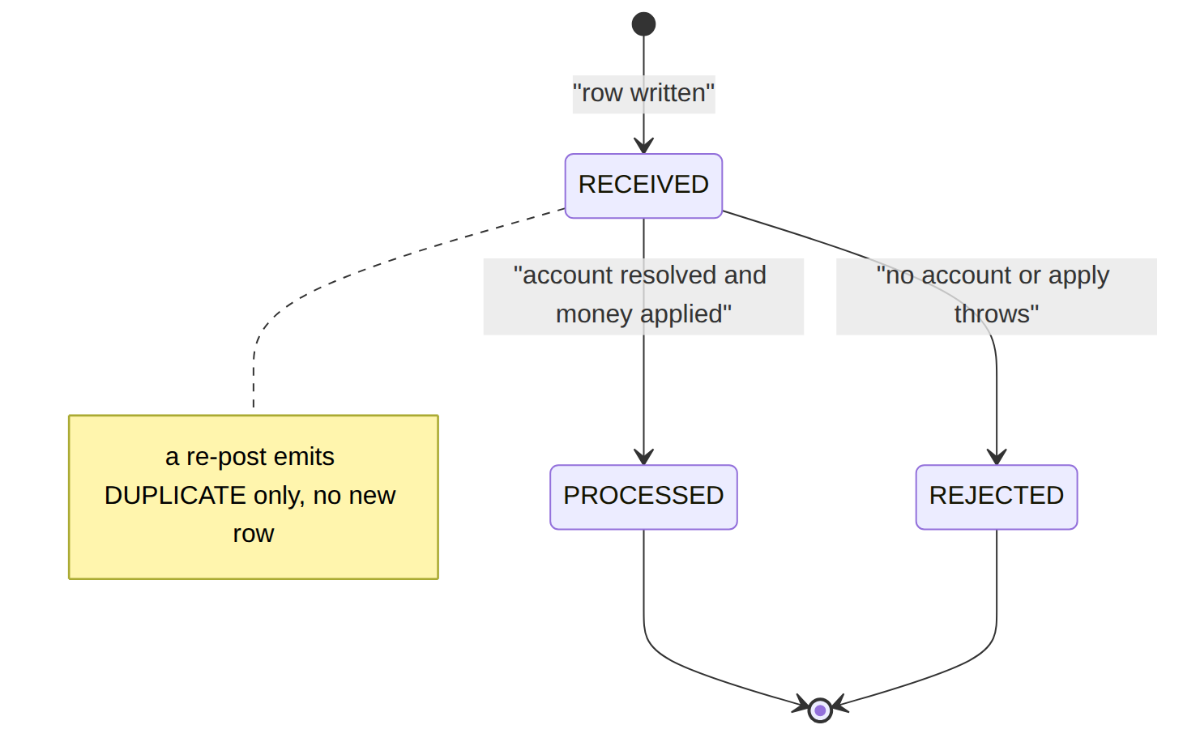
Read each row as a sentence — this data means this:
Row | What it means in plain English
pgcb_1 | An M-Pesa payment of KES 5000 landed and succeeded: it was matched to account acct_50 and applied as payment pay_91 (status=PROCESSED, so both resolved_account_id and payment_id are filled).
pgcb_2 | A KES 2500 Visa charge arrived but couldn't find an account (account_ref=UNKNOWN, resolved_account_id=null), so it was REJECTED with reject_reason=ACCOUNT_NOT_FOUND and no payment was created.
pgcb_3 | Another Visa charge for KES 2500 was REJECTED because the card declined — the apply step threw and reject_reason holds the exception message ("card declined"); no payment_id.
pgcb_4 | A KES 12000 bank transfer just landed and is still RECEIVED — the handler hasn't run yet, so it has no payment_id and no reject_reason.
The columns that did that work:
- Dedup = (provider, external_ref) is a DB unique constraint, so a re-post never inserts a second row; the existing record is returned and only a GatewayCallbackDuplicate event fires (money is never double-credited — no persisted DUPLICATE row).
- Applied or not = only status=PROCESSED fills payment_id + resolved_account_id; reject_reason explains a REJECTED row.
- Audit = the full provider body is kept verbatim in raw.

3. Services
Service | Responsibility
GatewayCallbackService::handle | ingest + dedupe a provider callback, resolve the account, call Billing PaymentService::receiveAndApply, emit a GatewayCallback* event

4. API surface
POST /api/payment-gateway/{provider}/callbacks (webhook, permission:payment.apply; {provider} is one of MPESA|VISA|BANK_TRANSFER, else 404), GET /api/payment-gateway/callbacks[/{id}] (permission:payment.read). All under auth:sanctum.

5. Integration (events) — topic paymentgateway.callback
- Emits: GatewayCallback{Received,Processed,Rejected,Duplicate}. Calls: Billing PaymentService::receiveAndApply synchronously (not via an event). Consumes: none (ingress edge).

6. Processes
Stateless ingress; no workflow.

7. Policy & config
Per-provider parsing/credentials are adapter/config at deployment (the connector seam).

8. Cross-module dependencies
- Drives → Billing (PaymentService). Connector seam → each rail (M-Pesa STK/paybill, card PSP, bank feed).

9. Invariants & rules
Rule | Statement | Enforced in
dedupe | a provider reference is acted once | GatewayCallbackService

10. Open items / deltas
- Outbound rails (refunds, M-Pesa B2C) + provider statement/reconciliation feeds are deployment connectors (not yet built — by design).

