Provisioning — As-Built Design (Network Broadcast & Reconciliation)
Capability codes: PROV-INT-01 · Module path: Modules/Provisioning (topology in Modules/Catalog) · Tests: ProvisioningTest, ReconciliationTest, AdapterRoutingTest
⭐ The vendor-binding module. Every real NMS/OLT/CMTS/VoIP integration plugs in here behind one interface. Understand §2.1 (the path) and §4 (the adapter contract) cold.

1. Purpose & boundaries
- Owns: the command ledger, desired-vs-observed reconciliation, governed force-sync, and the adapter registry routing each command to its vendor plane.
- Does NOT own: what to provision (Subscription), the premises/plant topology (Catalog homepass/network_node), the vendor protocol (the adapter, at deployment).
- Job: push BSS-desired state to the network via a swappable per-target adapter, detect drift, let NOC correct it — all audited.

2.1 ⭐ How a service binds to vendor technology — the path
Subscription (sub_123, package_ref=pkg_triple) ← WHAT the customer bought
└ service (svc_inet, provisioner_key, network_profile_shape={speed,vlan}) ← the provisionable unit
served at HomePass (hp_1), at the leaf of the node chain (GPON):
ONT(ONT-77) → FAT(F12) → SPLITTER(S1H) → OLT(OLT-NRB-WTL-01) → HEADEND → NMS
ProvisioningService.broadcast('sub_123','ACTIVATE',[{ target_code, service_ref, desired_state }])
→ provisioning_command{ target_code=HUAWEI_NCE_GPON_KE, ← WHICH vendor plane (matches the serving OLT)
service_ref=svc_inet,
desired_state={desiredStatus:ACTIVE, speedProfile:'100M', vlan:101} }
→ dispatch() → AdapterRegistry.forCommand(): adapter_config[target].adapter_class
→ new HuaweiNceGponAdapter() ← HOW (the only code a vendor needs)
→ adapter.dispatch(): session to the OLT, subscriber_key="sub_123:svc_inet", returns external_ref
→ recordDesiredState() → provisioning_desired_state ← the reconcile baseline
In words: the service (what) + the HomePass/node path (where) pick a target plane (which vendor system); adapter_config binds that plane to a ProvisioningAdapter (how); the adapter addresses the subscriber by subscriber_key and pushes desired_profile. Swap adapter_class → the same command drives a different vendor, no platform change.
The same path as a picture — read it left to right as what → where → which → how → network:

📖 Scenarios (service + Foundation involvement)

1. Activate internet on a sync GPON OLT
The story in plain English: A customer's subscription goes live, so we have to tell the network. We write down the command we are about to send, pick the right vendor adapter for that OLT, send it, and the OLT confirms straight away. We record that it worked and remember the desired state so we can later check the network still matches.
Who does what:
- ActivateServiceHandler (a Subscription workflow step, Foundation/Workflow) calls ProvisioningService::broadcast('sub_123','ACTIVATE',[…]).
- broadcast writes a provisioning_command (PENDING).
- dispatch() resolves the Huawei adapter via ProvisioningAdapterRegistry::forCommand.
- adapter.dispatch confirms inline → command CONFIRMED, external_ref stored, a provisioning_command_attempt (SUCCESS) logged.
- recordDesiredState() writes the reconcile baseline; emits ProvisioningCommandConfirmed to the outbox. Handler returns provisioned:true; the subscription flow commits ACTIVE.
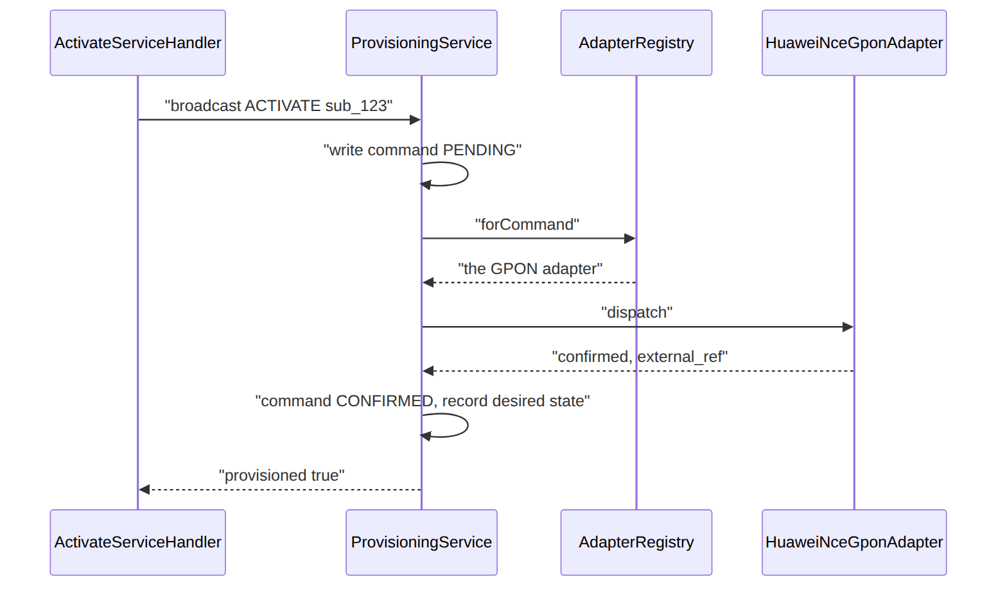
(AdapterRoutingTest: a GPON command resolves the GPON adapter.)

2. Activate on an async OLT (accept → poll → confirm)
The story in plain English: Some vendors do not answer immediately — they just say "got it, working on it". The command sits in an accepted state and the subscription flow waits. A small worker checks back every few minutes until the vendor reports it is really done.
Who does what: same broadcast, but adapter_config.execution_mode_default=ASYNC_ACCEPTED. adapter.dispatch returns accepted → command ACCEPTED (external_ref set), and the flow's ActivateServiceHandler sees not-yet-confirmed. The scheduled worker sophix:provisioning:poll-async (a Foundation/Console scheduled command, every 5 min) calls adapter.pollStatus → CONFIRMED. The parked workflow advances on the next tick. Shows: async vendors + the poll worker resolving terminal state.

3. Speed change (MODIFY) mid-cycle
A subscription upgrade flow broadcasts action:MODIFY with desired_state.speedProfile:'200M'. dispatch pushes it; recordDesiredState updates the existing provisioning_desired_state (updateOrCreate on subscriber_key) so the new profile is the reconcile baseline. Shows: the same seam handles changes, and desired-state is the single baseline.

4. Account suspended in ILM → the network follows (cross-module via the outbox)
The story in plain English: When a customer's account is suspended (say for non-payment) in another module, the network should follow without anyone re-typing anything. The account-status change ripples out through the event backbone and every service that customer had provisioned gets re-pushed as suspended.
Who does what: ILM AccountService emits CustomerAccountStatusChanged{affectsProvisioning:true,status:INACTIVE} to the outbox. sophix:outbox:dispatch fires OutboxEventPublished → SyncProvisioningOnAccountStatusChanged looks up the account's subscriptions and re-broadcasts each provisioned target at SUSPENDED (action ACCOUNT_STATUS_SYNC). Shows: a domain event in one module driving provisioning, the whole Foundation event backbone (R-ILM-S-3). (ReconciliationTest::test_account_status_change_syncs_provisioning.)

5. Terminate → desired NOT_PRESENT
Termination broadcasts action:DEACTIVATE, desired_state.desiredStatus:NOT_PRESENT. recordDesiredState sets desired_status=NOT_PRESENT — so reconciliation now expects the subscriber to not exist on the plane, and a still-present subscriber is flagged as drift. Shows: enum-driven behaviour (NOT_PRESENT inverts the reconcile check).

6. Reconcile — clean run (no drift)
sophix:provisioning:reconcile (hourly) → ReconciliationService::run() loads each provisioning_desired_state, calls adapter.fetchObserved(target, subscriber_key, …), upserts provisioning_observed_state, and compares. All match → run COMPLETED, mismatch_count=0, any prior OPEN items auto-resolve (MATCHED_SINCE). Emits ProvisioningReconciliationRunCompleted. (ReconciliationTest::test_clean_reconciliation_has_no_mismatch.)

7. Reconcile drift → force-sync (EM-CFG-04 + SoD)
The story in plain English: Reconciliation finds the network and the BSS disagree — the OLT says a subscriber is active when we wanted them suspended. The system never quietly fixes this itself; that would be risky. Instead it opens a drift item for a human in the NOC. To push a correction, the NOC asks for it, and a different person must approve it before it runs — two pairs of eyes on anything that touches the live network.
Who does what:
- A target reports SUSPENDED while desired is ACTIVE → run() opens a provisioning_reconciliation_item (OPEN) and emits …ItemOpened; it does not auto-fix (R-PROV-08).
- NOC POST …/items/{item}/force-sync → requestForceSync opens an EM-CFG-04 (Foundation/Approvals) request → force-sync PENDING_APPROVAL, item IN_REVIEW.
- Trying to execute before approval → 409.
- A different approver …/approve (SoD: requester can't self-approve) → APPROVED.
- …/execute re-broadcasts the desired state; item RESOLVED.
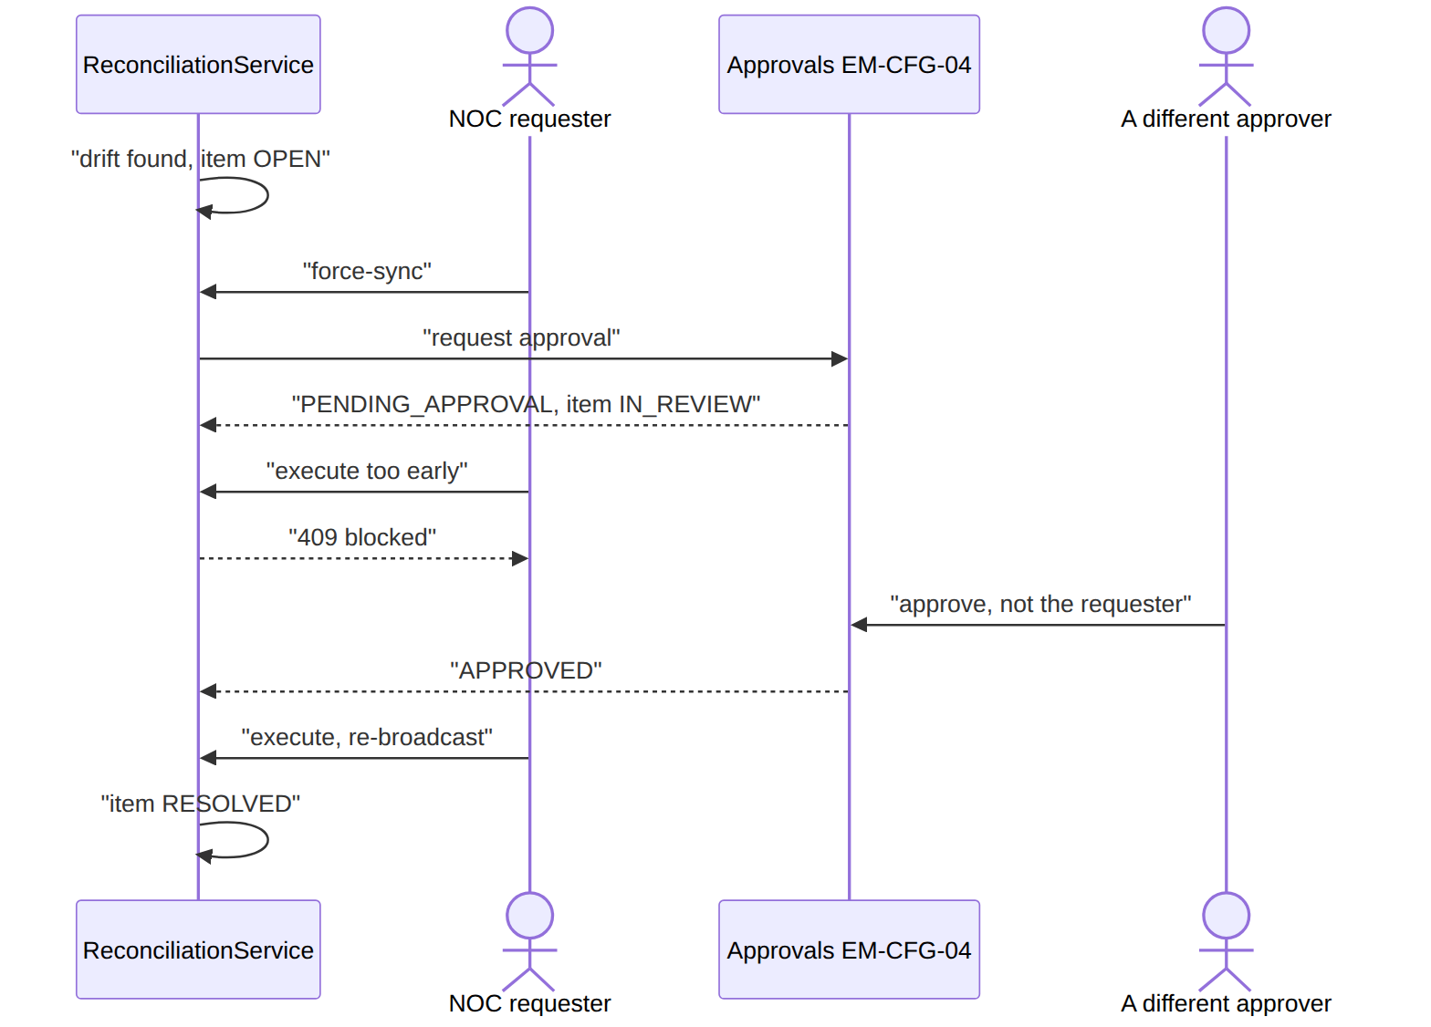
(ReconciliationTest::test_drift_opens_item_and_force_sync_resolves.)

8. Vendor rejects the command → retry → give up
adapter.dispatch returns failed (or throws) → command FAILED, a provisioning_command_attempt (FAILED_RETRYABLE, error_code) logged. The retry policy (adapter_config.retry_policy_json {baseSeconds:30, factor:2}) backs off; persistent failure → FAILED_FINAL. Shows: the attempt ledger + per-target retry policy as the resilience seam.

9. Bind a real vendor (the deployment task — config only)
Implement class HuaweiNceGponAdapter implements ProvisioningAdapter (§4), seed one provisioning_adapter_config{target_code, adapter_class:HuaweiNceGponAdapter::class} row. Every command for that target now drives the OLT. No platform code change.

2. Data model — ≥4 complete sample rows + readings per table
Completeness: each row lists every domain column (nullables shown as null). The surrogate primary key shown is the real one; created_at/updated_at are omitted by convention. network_node and homepass are Catalog-owned — shown here only as the path context; their full-width sample rows live in catalog.md (homepass is ~50 columns of structured address/GIS/RoE, projected below to the columns provisioning's path resolution actually reads).

network_node (Catalog — the plant tree)
type: HEADEND|OLT|SPLITTER|FAT|FDT|ONT (GPON) · DISTRIBUTION_NODE|AMPLIFIER|LINE_EXTENDER (HFC) · VOIPSWITCH|NMS|OTHER. Tree via parent_node_code. status: DRAFT|ACTIVE|RETIRED (default ACTIVE).
{ "node_id":"nnode_he","operator_code":"WIK","code":"HEADEND-NRB","type":"HEADEND","name":"Nairobi Headend","parent_node_code":null,"description":"Westlands core","metadata":{"site":"WTL"},"status":"ACTIVE" }
{ "node_id":"nnode_olt","operator_code":"WIK","code":"OLT-NRB-WTL-01","type":"OLT","name":"Westlands OLT 01","parent_node_code":"HEADEND-NRB","description":null,"metadata":{"ports":16},"status":"ACTIVE" }
{ "node_id":"nnode_fat","operator_code":"WIK","code":"FAT-F12","type":"FAT","name":"FAT F12","parent_node_code":"SPLITTER-S1H","description":null,"metadata":null,"status":"ACTIVE" }
{ "node_id":"nnode_ont","operator_code":"WIK","code":"ONT-77","type":"ONT","name":"ONT 77","parent_node_code":"FAT-F12","description":"customer leaf","metadata":null,"status":"ACTIVE" }
Read each row as a sentence — this data means this:
Row | What it means in plain English
HEADEND-NRB | The root of the plant tree (parent_node_code=null) — the Nairobi headend everything hangs off.
OLT-NRB-WTL-01 | An OLT that sits under the headend (parent_node_code=HEADEND-NRB); this is the GPON box that maps a HomePass to the GPON plane.
FAT-F12 | A fibre access terminal hanging off a splitter (parent_node_code=SPLITTER-S1H) — a mid-tree node.
ONT-77 | The customer leaf (type=ONT, parent_node_code=FAT-F12) — the box at the premises.
The columns that did that work:
- The tree = parent_node_code links each node to its parent; walking it from the leaf (ONT→FAT→…→OLT→HEADEND) gives the physical path, and the serving OLT maps to the GPON target plane.
- An HFC HomePass would chain modem→AMPLIFIER→DISTRIBUTION_NODE→HEADEND and map to a CMTS target instead.

homepass (Catalog — the premises) · projected to provisioning-relevant columns
Full ~50-column schema (structured address, building, GIS lat/lng, RoE dates) is in catalog.md. status is not a hardcoded enum — it's a code from the homepass_status_code catalog whose flags (is_sellable, is_active, …) drive behaviour; the codes below are illustrative.
{ "id":"hp_1","operator_code":"WIK","code":"HP-NRB-0001","status":"RFS","technology":"GPON","house_type_code":"M2M","network_nodes":["ONT-77","OLT-NRB-WTL-01"],"tech_region_id":"KE-NRB-KAREN","has_been_active":true,"has_been_sellable":true }
{ "id":"hp_2","operator_code":"WIK","code":"HP-NRB-0002","status":"WAI","technology":"GPON","house_type_code":"S1H","network_nodes":[],"tech_region_id":"KE-NRB-KAREN","has_been_active":false,"has_been_sellable":false }
{ "id":"hp_3","operator_code":"WIK","code":"HP-MSA-0007","status":"RFS","technology":"HFC","house_type_code":"M2M","network_nodes":["CM-12","DN-3"],"tech_region_id":"KE-MSA-NYALI","has_been_active":true,"has_been_sellable":true }
{ "id":"hp_4","operator_code":"WIK","code":"HP-NRB-0099","status":"RETIRED","technology":"GPON","house_type_code":"OFF","network_nodes":["ONT-3"],"tech_region_id":"KE-NRB-KAREN","has_been_active":true,"has_been_sellable":true }
Read each row as a sentence — this data means this:
Row | What it means in plain English
hp_1 | A GPON premises that is ready for service (status=RFS) and can take an order; its cached node path is [ONT-77, OLT-NRB-WTL-01], and it has previously been sellable/active.
hp_2 | A GPON premises still under construction (status=WAI), with no node path yet (network_nodes=[]) and never sellable/active — an order can't land here.
hp_3 | An HFC (cable) premises that's RFS and orderable; its path runs through cable nodes (network_nodes=[CM-12, DN-3]), so it maps to a CMTS plane, not GPON.
hp_4 | A decommissioned premises (status=RETIRED) — not orderable now even though it was sellable/active in the past.
The columns that did that work:
- Can it take an order = whether status's catalog flag is_sellable is set (RFS yes; WAI/RETIRED no).
- Which plane = technology (GPON→OLT vs HFC→CMTS); network_nodes is the cached leaf→…→headend path.
- Scope & latch = tech_region_id ties to RBAC scope; has_been_sellable is the latch that makes HomePassReachedSellable fire only once.

provisioning_target (the vendor plane) · type: GPON|HFC|VOIP|NMS
{ "target_code":"HUAWEI_NCE_GPON_KE","operator_code":"WIK","type":"GPON","name":"Huawei NCE GPON","endpoint":"https://nce.wik:18002","active":true }
{ "target_code":"CMTS_HFC_KE","operator_code":"WIK","type":"HFC","name":"Casa CMTS (Clearcable NOMS)","endpoint":"https://noms.wik","active":true }
{ "target_code":"SIP_VOICE_KE","operator_code":"WIK","type":"VOIP","name":"VoipSwitch","endpoint":"sip://vs.wik","active":true }
{ "target_code":"DEFAULT_NMS","operator_code":"WIK","type":"NMS","name":"Default NMS","endpoint":null,"active":true }
Read each row as a sentence — this data means this:
Row | What it means in plain English
HUAWEI_NCE_GPON_KE | The live GPON plane (type=GPON, active=true) — where internet provisioning lands, reachable at its endpoint.
CMTS_HFC_KE | The live HFC/cable plane (type=HFC) — where cable-modem services land.
SIP_VOICE_KE | The live VOIP plane (type=VOIP) — where voice lines land.
DEFAULT_NMS | The catch-all NMS plane (type=NMS, endpoint=null) that the POC seeds point at when no real vendor applies.
A triple-play subscription touches several of these (internet→GPON, voice→VOIP); there's one plane per technology.

provisioning_adapter_config (⭐ the vendor binding) · execution_mode_default: SYNC_REQUIRED|ASYNC_ACCEPTED · status: ACTIVE|SUSPENDED
{ "adapter_config_id":"pac_1","operator_code":"WIK","provisioner_key":"GPON_INET","target_code":"HUAWEI_NCE_GPON_KE","adapter_class":"…\\HuaweiNceGponAdapter","execution_mode_default":"ASYNC_ACCEPTED","timeout_ms":25000,"max_retry_count":5,"retry_policy_json":{"baseSeconds":30,"factor":2},"status":"ACTIVE" }
{ "adapter_config_id":"pac_2","operator_code":"WIK","provisioner_key":null,"target_code":"SIP_VOICE_KE","adapter_class":"…\\SipVoiceAdapter","execution_mode_default":"SYNC_REQUIRED","timeout_ms":15000,"max_retry_count":3,"retry_policy_json":null,"status":"ACTIVE" }
{ "adapter_config_id":"pac_3","operator_code":"WIK","provisioner_key":null,"target_code":"DEFAULT_NMS","adapter_class":"…\\StubProvisioningAdapter","execution_mode_default":"SYNC_REQUIRED","timeout_ms":25000,"max_retry_count":5,"retry_policy_json":null,"status":"ACTIVE" }
{ "adapter_config_id":"pac_4","operator_code":"WIK","provisioner_key":null,"target_code":"CMTS_HFC_KE","adapter_class":"…\\CasaCmtsAdapter","execution_mode_default":"ASYNC_ACCEPTED","timeout_ms":40000,"max_retry_count":8,"retry_policy_json":{"baseSeconds":60,"factor":2},"status":"SUSPENDED" }
Read each row as a sentence — this data means this:
Row | What it means in plain English
pac_1 | Binds the GPON plane to the Huawei NCE adapter for a specific service (provisioner_key=GPON_INET); it's async (execution_mode_default=ASYNC_ACCEPTED, so commands sit ACCEPTED until polled) and ACTIVE, with its own timeout/retry knobs.
pac_2 | Binds the voice plane to the SIP adapter, synchronously (SYNC_REQUIRED, so commands confirm inline) — provisioner_key=null means it applies to the whole target.
pac_3 | The default seed: the NMS plane bound to the stub adapter (sync), so flows run with no real hardware.
pac_4 | The CMTS/HFC binding, but SUSPENDED (status=SUSPENDED) — that plane is parked (e.g. maintenance) and the registry treats it as unavailable.
The columns that did that work:
- The swappable seam = adapter_class — change it to repoint a plane; the optional provisioner_key refines the binding to a specific PLM service provisioner.
- Sync vs async = execution_mode_default (ASYNC_ACCEPTED ⇒ commands sit ACCEPTED until the poll worker confirms).
- Availability & resilience = status parks a plane; timeout_ms/max_retry_count/retry_policy_json are the per-target knobs.

provisioning_desired_state (the reconcile baseline) · desired_status: ACTIVE|SUSPENDED|RESTRICTED|TERMINATED|NOT_PRESENT
{ "desired_state_id":"pds_1","operator_code":"WIK","subscription_id":"sub_123","customer_id":"cust_50","homepass_id":"hp_1","service_ref":"svc_inet","target_code":"HUAWEI_NCE_GPON_KE","subscriber_key":"sub_123:svc_inet","desired_status":"ACTIVE","desired_profile":{"speedProfile":"100M","vlan":101},"source_module":"Subscription","source_ref":"subop_991","effective_from":"2026-06-20T09:00:00Z" }
{ "desired_state_id":"pds_2","operator_code":"WIK","subscription_id":"sub_123","customer_id":"cust_50","homepass_id":"hp_1","service_ref":"svc_voice","target_code":"SIP_VOICE_KE","subscriber_key":"sub_123:svc_voice","desired_status":"ACTIVE","desired_profile":{"callerId":true},"source_module":"Subscription","source_ref":"subop_991","effective_from":"2026-06-20T09:00:00Z" }
{ "desired_state_id":"pds_3","operator_code":"WIK","subscription_id":"sub_9","customer_id":"cust_12","homepass_id":"hp_7","service_ref":"svc_inet","target_code":"HUAWEI_NCE_GPON_KE","subscriber_key":"sub_9:svc_inet","desired_status":"SUSPENDED","desired_profile":{},"source_module":"Ilm","source_ref":"acct_status_sync","effective_from":"2026-06-18T00:00:00Z" }
{ "desired_state_id":"pds_4","operator_code":"WIK","subscription_id":"sub_7","customer_id":"cust_8","homepass_id":null,"service_ref":"svc_inet","target_code":"HUAWEI_NCE_GPON_KE","subscriber_key":"sub_7:svc_inet","desired_status":"NOT_PRESENT","desired_profile":{},"source_module":"Subscription","source_ref":"term_55","effective_from":"2026-06-15T00:00:00Z" }
Read each row as a sentence — this data means this:
Row | What it means in plain English
pds_1 | BSS wants sub_123's internet service ACTIVE on the GPON plane at the 100M/vlan-101 profile — the baseline reconcile checks the network against.
pds_2 | The same subscription's voice service, wanted ACTIVE on the VOIP plane (desired_profile.callerId=true) — same source_ref=subop_991, i.e. the other half of one triple-play activation.
pds_3 | BSS wants sub_9's internet SUSPENDED (desired_status=SUSPENDED, set by the Ilm account-status sync) — reconcile expects the plane to report SUSPENDED.
pds_4 | BSS wants sub_7 gone (desired_status=NOT_PRESENT, homepass_id=null, from a termination) — the subscriber should be absent, so a present subscriber here is drift.
The columns that did that work:
- One baseline per = (subscription_id, service_ref, target_code) keyed by subscriber_key; desired_status + desired_profile are what the network should match.
- Provenance = source_module/source_ref record who set the baseline (Subscription activation vs Ilm status sync vs termination).

provisioning_command (the dispatch ledger) · action: ACTIVATE|MODIFY|DEACTIVATE|SUSPEND|RESUME · status: PENDING→SENT→CONFIRMED|ACCEPTED|FAILED|MISMATCH · execution_mode: SYNC|ASYNC_ACCEPTED
{ "command_id":"pcmd_1","operator_code":"WIK","broadcast_id":"bcast_1","subscription_id":"sub_123","service_ref":"svc_inet","action":"ACTIVATE","target_code":"HUAWEI_NCE_GPON_KE","desired_state":{"desiredStatus":"ACTIVE","speedProfile":"100M"},"observed_state":null,"status":"CONFIRMED","external_ref":"NMS-AB12","request":{"op":"create-sub"},"response":{"ok":true},"attempts":1,"last_error":null,"correlation_id":"corr_77","sent_at":"2026-06-20T09:00:01Z","confirmed_at":"2026-06-20T09:00:02Z","execution_mode":"SYNC","accepted_at":null }
{ "command_id":"pcmd_2","operator_code":"WIK","broadcast_id":"bcast_1","subscription_id":"sub_123","service_ref":"svc_voice","action":"ACTIVATE","target_code":"SIP_VOICE_KE","desired_state":{"desiredStatus":"ACTIVE","callerId":true},"observed_state":null,"status":"ACCEPTED","external_ref":"VS-7781","request":{"op":"add-line"},"response":{"queued":true},"attempts":1,"last_error":null,"correlation_id":"corr_77","sent_at":"2026-06-20T09:00:01Z","confirmed_at":null,"execution_mode":"ASYNC_ACCEPTED","accepted_at":"2026-06-20T09:00:01Z" }
{ "command_id":"pcmd_3","operator_code":"WIK","broadcast_id":"bcast_4","subscription_id":"sub_5","service_ref":"svc_inet","action":"ACTIVATE","target_code":"HUAWEI_NCE_GPON_KE","desired_state":{"desiredStatus":"ACTIVE","speedProfile":"1G"},"observed_state":null,"status":"FAILED","external_ref":null,"request":{"op":"create-sub"},"response":{"error":"profile unknown"},"attempts":3,"last_error":"OLT rejected: profile unknown","correlation_id":"corr_88","sent_at":"2026-06-20T10:00:00Z","confirmed_at":null,"execution_mode":"SYNC","accepted_at":null }
{ "command_id":"pcmd_4","operator_code":"WIK","broadcast_id":"bcast_9","subscription_id":"sub_9","service_ref":"svc_inet","action":"SUSPEND","target_code":"HUAWEI_NCE_GPON_KE","desired_state":{"desiredStatus":"SUSPENDED"},"observed_state":null,"status":"CONFIRMED","external_ref":"NMS-CD34","request":{"op":"suspend"},"response":{"ok":true},"attempts":1,"last_error":null,"correlation_id":"corr_90","sent_at":"2026-06-18T00:00:01Z","confirmed_at":"2026-06-18T00:00:02Z","execution_mode":"SYNC","accepted_at":null }
The command's own lifecycle — a sync vendor jumps straight to CONFIRMED; an async vendor parks at ACCEPTED until the poll worker confirms it; a vendor rejection ends FAILED; reconciliation can later flag a confirmed command's subscriber as MISMATCH:
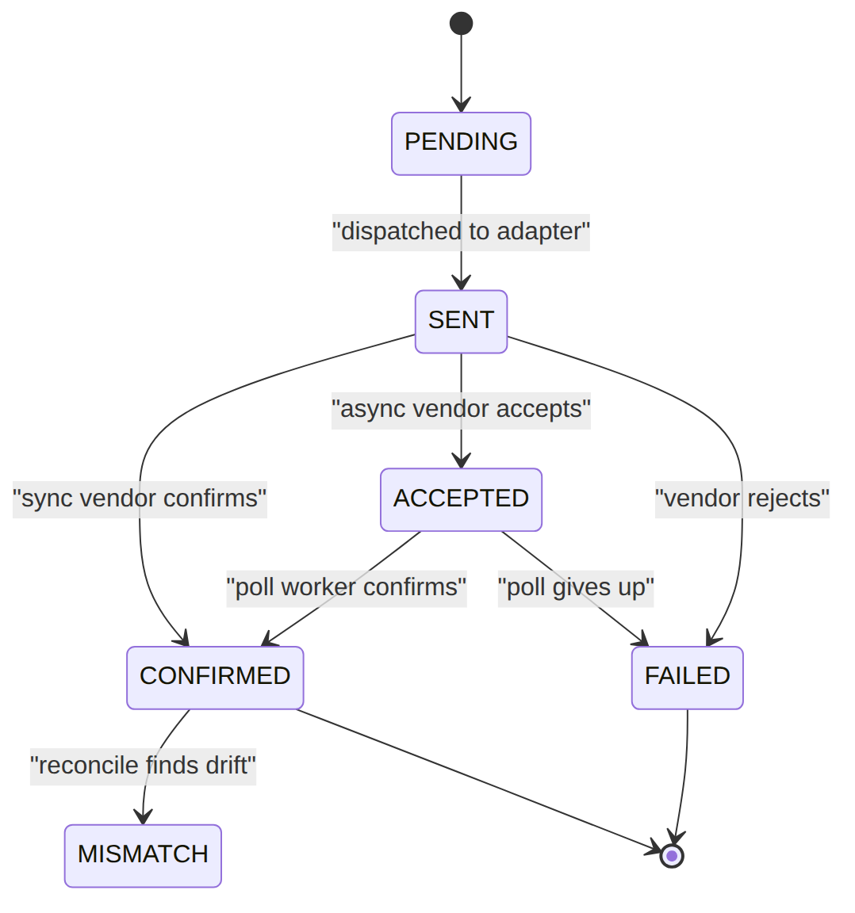
Read each row as a sentence — this data means this:
Row | What it means in plain English
pcmd_1 | An ACTIVATE of internet on the GPON plane that the vendor confirmed inline (execution_mode=SYNC, status=CONFIRMED, confirmed_at set) — done in one attempt.
pcmd_2 | The voice half of the same broadcast (broadcast_id=bcast_1): the SIP vendor accepted it async (execution_mode=ASYNC_ACCEPTED, status=ACCEPTED, accepted_at set, confirmed_at still null) — waiting for the poll worker to confirm.
pcmd_3 | An ACTIVATE that the OLT rejected: after retrying (attempts=3) it ended FAILED with last_error="OLT rejected: profile unknown" and no external_ref.
pcmd_4 | A SUSPEND on the GPON plane, confirmed inline (SYNC, CONFIRMED) in one attempt.
The columns that did that work:
- Grouping = broadcast_id groups the commands from one multi-plane action (pcmd_1 + pcmd_2 = one triple-play ACTIVATE).
- Sync vs async outcome = execution_mode + status; confirmed_at (sync) vs accepted_at then poll (async).
- Failure & trace = attempts/last_error record an exhausted retry; correlation_id threads back to the originating flow. The row is the audit of what was sent to which plane and how it went.

provisioning_command_attempt (per-try audit) · status: SUCCESS|FAILED_RETRYABLE|FAILED_FINAL|TIMEOUT
(created_at uses the DB default; omitted by convention along with the audit timestamps.)
{ "attempt_id":"pcma_1","operator_code":"WIK","command_id":"pcmd_1","attempt_no":1,"adapter_class":"…\\HuaweiNceGponAdapter","status":"SUCCESS","response_payload":{"externalRef":"NMS-AB12"},"vendor_status_code":"OK","duration_ms":420,"error_code":null }
{ "attempt_id":"pcma_2","operator_code":"WIK","command_id":"pcmd_3","attempt_no":1,"adapter_class":"…\\HuaweiNceGponAdapter","status":"FAILED_RETRYABLE","response_payload":{"err":"busy"},"vendor_status_code":"503","duration_ms":1500,"error_code":"ADAPTER_REJECTED" }
{ "attempt_id":"pcma_3","operator_code":"WIK","command_id":"pcmd_3","attempt_no":3,"adapter_class":"…\\HuaweiNceGponAdapter","status":"FAILED_FINAL","response_payload":{"err":"profile unknown"},"vendor_status_code":"422","duration_ms":1300,"error_code":"PROFILE_UNKNOWN" }
{ "attempt_id":"pcma_4","operator_code":"WIK","command_id":"pcmd_2","attempt_no":1,"adapter_class":"…\\SipVoiceAdapter","status":"TIMEOUT","response_payload":null,"vendor_status_code":null,"duration_ms":15000,"error_code":"VENDOR_TIMEOUT" }
Read each row as a sentence — this data means this:
Row | What it means in plain English
pcma_1 | pcmd_1's single try succeeded (status=SUCCESS, vendor_status_code=OK) in 420 ms — fast and clean.
pcma_2 | pcmd_3's first try was a retryable failure (attempt_no=1, status=FAILED_RETRYABLE, vendor 503 "busy", error_code=ADAPTER_REJECTED).
pcma_3 | pcmd_3's third try finally gave up (attempt_no=3, status=FAILED_FINAL, vendor 422, error_code=PROFILE_UNKNOWN) — this is why the command ended FAILED.
pcma_4 | pcmd_2's try timed out (status=TIMEOUT, error_code=VENDOR_TIMEOUT) after a full 15000 ms — no vendor response at all.
The columns that did that work:
- Per-try outcome = attempt_no + status; error_code/vendor_status_code say why and who rejected it.
- Timing = duration_ms flags the slow TIMEOUT (15 s) vs a ~0.4 s success — invaluable for vendor-integration debugging.

provisioning_observed_state (last poll — mirror of what the plane reports)
{ "observed_state_id":"pos_1","operator_code":"WIK","target_code":"HUAWEI_NCE_GPON_KE","subscriber_key":"sub_123:svc_inet","observed_status":"ACTIVE","observed_profile":{"speedProfile":"100M"},"source_run_id":"prr_1","collected_at":"2026-06-21T01:00:00Z" }
{ "observed_state_id":"pos_2","operator_code":"WIK","target_code":"HUAWEI_NCE_GPON_KE","subscriber_key":"sub_9:svc_inet","observed_status":"ACTIVE","observed_profile":{},"source_run_id":"prr_1","collected_at":"2026-06-21T01:00:00Z" }
{ "observed_state_id":"pos_3","operator_code":"WIK","target_code":"SIP_VOICE_KE","subscriber_key":"sub_123:svc_voice","observed_status":"ACTIVE","observed_profile":{"callerId":true},"source_run_id":"prr_1","collected_at":"2026-06-21T01:00:00Z" }
{ "observed_state_id":"pos_4","operator_code":"WIK","target_code":"HUAWEI_NCE_GPON_KE","subscriber_key":"sub_7:svc_inet","observed_status":null,"observed_profile":null,"source_run_id":"prr_1","collected_at":"2026-06-21T01:00:00Z" }
Read each row as a sentence — this data means this:
Row | What it means in plain English
pos_1 | The GPON plane reports sub_123's internet as ACTIVE at 100M — matches its desired row (pds_1), so it's clean.
pos_2 | The GPON plane reports sub_9's internet as ACTIVE — but pds_3 wants it SUSPENDED, so this row is drift.
pos_3 | The VOIP plane reports sub_123's voice as ACTIVE with caller-ID — matches pds_2, clean.
pos_4 | The GPON plane reports nothing for sub_7 (observed_status=null) — which matches pds_4's NOT_PRESENT, so absence is the correct observation here.
The columns that did that work:
- One mirror row per = (target_code, subscriber_key), upserted each run; source_run_id/collected_at show which pass wrote it.
- Drift = comparing observed_status/observed_profile against the matching desired row; a null observation means absent, which only counts as drift if the desired row wanted the subscriber present.

provisioning_reconciliation_run (one pass) · scope_type: FULL_TARGET|REGION|SUBSCRIPTION|SERVICE_CLASS · status: RUNNING|COMPLETED|FAILED|PARTIAL
{ "run_id":"prr_1","operator_code":"WIK","target_code":"HUAWEI_NCE_GPON_KE","scope_type":"FULL_TARGET","scope_value":null,"status":"COMPLETED","desired_count":120,"observed_count":120,"mismatch_count":1,"started_at":"2026-06-21T01:00:00Z","completed_at":"2026-06-21T01:03:00Z" }
{ "run_id":"prr_2","operator_code":"WIK","target_code":null,"scope_type":"FULL_TARGET","scope_value":null,"status":"RUNNING","desired_count":0,"observed_count":0,"mismatch_count":0,"started_at":"2026-06-21T02:00:00Z","completed_at":null }
{ "run_id":"prr_3","operator_code":"WIK","target_code":"HUAWEI_NCE_GPON_KE","scope_type":"SUBSCRIPTION","scope_value":"sub_9","status":"COMPLETED","desired_count":1,"observed_count":1,"mismatch_count":1,"started_at":"2026-06-20T12:00:00Z","completed_at":"2026-06-20T12:00:05Z" }
{ "run_id":"prr_4","operator_code":"WIK","target_code":"SIP_VOICE_KE","scope_type":"FULL_TARGET","scope_value":null,"status":"FAILED","desired_count":30,"observed_count":0,"mismatch_count":0,"started_at":"2026-06-21T01:00:00Z","completed_at":"2026-06-21T01:00:30Z" }
Read each row as a sentence — this data means this:
Row | What it means in plain English
prr_1 | A full sweep of the GPON plane that COMPLETED: 120 desired = 120 observed, with 1 mismatch found (mismatch_count=1).
prr_2 | An all-targets pass (target_code=null) still RUNNING — counts are all zero because it hasn't finished.
prr_3 | A scoped rerun of just sub_9 (scope_type=SUBSCRIPTION, scope_value=sub_9), e.g. after a fix — COMPLETED with 1 mismatch.
prr_4 | A full sweep of the SIP plane that FAILED — the plane was unreachable (observed_count=0), so no mismatches were opened (a failed fetch isn't treated as drift).
The columns that did that work:
- Scope = scope_type + scope_value (FULL_TARGET vs a single SUBSCRIPTION; target_code=null = all planes).
- Result = status plus the desired_count/observed_count/mismatch_count tallies; a FAILED run with observed_count=0 opens nothing.

provisioning_reconciliation_item (one mismatch) · status: OPEN|RESOLVED|IGNORED (UI surfaces IN_REVIEW once a force-sync is raised) · resolution: FORCE_SYNCED|MANUAL|MATCHED_SINCE
{ "item_id":"pri_1","operator_code":"WIK","run_id":"prr_1","target_code":"HUAWEI_NCE_GPON_KE","subscription_id":"sub_9","service_ref":"svc_inet","subscriber_key":"sub_9:svc_inet","desired_status":"SUSPENDED","observed_status":"ACTIVE","diff":{"desiredStatus":"SUSPENDED","observedStatus":"ACTIVE"},"status":"OPEN","resolution":null,"resolved_by":null,"resolved_at":null }
{ "item_id":"pri_2","operator_code":"WIK","run_id":"prr_3","target_code":"HUAWEI_NCE_GPON_KE","subscription_id":"sub_5","service_ref":"svc_inet","subscriber_key":"sub_5:svc_inet","desired_status":"ACTIVE","observed_status":"SUSPENDED","diff":{"desiredStatus":"ACTIVE","observedStatus":"SUSPENDED"},"status":"RESOLVED","resolution":"FORCE_SYNCED","resolved_by":"u_noc2","resolved_at":"2026-06-20T12:30:00Z" }
{ "item_id":"pri_3","operator_code":"WIK","run_id":"prr_1","target_code":"HUAWEI_NCE_GPON_KE","subscription_id":"sub_3","service_ref":"svc_inet","subscriber_key":"sub_3:svc_inet","desired_status":"ACTIVE","observed_status":null,"diff":{"desiredStatus":"ACTIVE","observedStatus":null},"status":"IGNORED","resolution":"MANUAL","resolved_by":"u_noc1","resolved_at":"2026-06-21T08:00:00Z" }
{ "item_id":"pri_4","operator_code":"WIK","run_id":"prr_3","target_code":"HUAWEI_NCE_GPON_KE","subscription_id":"sub_9","service_ref":"svc_inet","subscriber_key":"sub_9:svc_inet","desired_status":"SUSPENDED","observed_status":"SUSPENDED","diff":null,"status":"RESOLVED","resolution":"MATCHED_SINCE","resolved_by":null,"resolved_at":"2026-06-20T13:00:00Z" }
A drift item's lifecycle — it opens OPEN, the UI shows IN_REVIEW once a force-sync is raised, and it closes either RESOLVED (fixed or matched again on a later run) or IGNORED (a NOC decided to leave it):
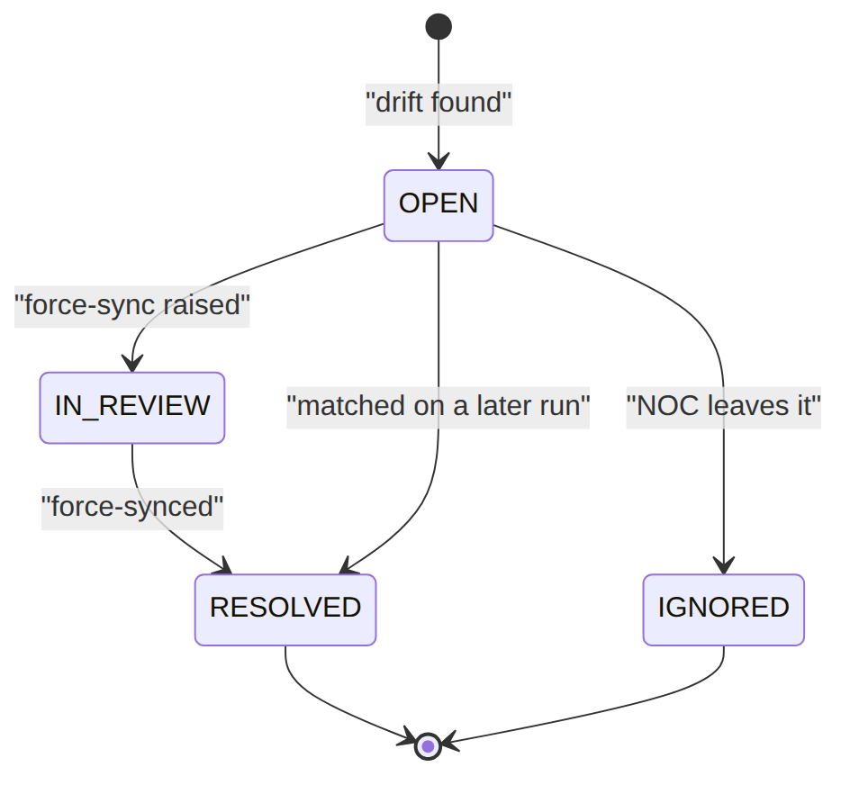
Read each row as a sentence — this data means this:
Row | What it means in plain English
pri_1 | Live drift, still OPEN: BSS wants SUSPENDED but the network shows ACTIVE (diff records both), no resolution yet.
pri_2 | A drift that was fixed by a force-sync: status=RESOLVED, resolution=FORCE_SYNCED, signed off by resolved_by=u_noc2.
pri_3 | A drift (observed null) that a NOC chose to leave: status=IGNORED, resolution=MANUAL, by resolved_by=u_noc1.
pri_4 | An auto-close: a later run found desired==observed (diff=null), so the item resolved MATCHED_SINCE with no human (resolved_by=null).
The columns that did that work:
- What drifted = desired_status vs observed_status, captured in diff.
- How it closed = status + resolution (FORCE_SYNCED = pushed a fix, MANUAL = NOC decided, MATCHED_SINCE = self-healed); resolved_by=null marks the automatic close.

provisioning_force_sync_request · sync_direction: BSS_TO_NETWORK|NETWORK_TO_BSS|MARK_IGNORE · status: PENDING_APPROVAL|APPROVED|RUNNING|COMPLETED|FAILED|CANCELLED
{ "force_sync_id":"pfs_1","operator_code":"WIK","source_item_id":"pri_1","subscription_id":"sub_9","service_ref":"svc_inet","target_code":"HUAWEI_NCE_GPON_KE","sync_direction":"BSS_TO_NETWORK","requested_action":"REAPPLY_PROFILE","status":"PENDING_APPROVAL","approval_request_id":"appr_77","requested_by_user_id":"u_noc1","approved_by_user_id":null,"command_id":null,"reason":null }
{ "force_sync_id":"pfs_2","operator_code":"WIK","source_item_id":"pri_2","subscription_id":"sub_5","service_ref":"svc_inet","target_code":"HUAWEI_NCE_GPON_KE","sync_direction":"BSS_TO_NETWORK","requested_action":"REAPPLY_PROFILE","status":"COMPLETED","approval_request_id":"appr_78","requested_by_user_id":"u_noc1","approved_by_user_id":"u_noc2","command_id":"pcmd_88","reason":null }
{ "force_sync_id":"pfs_3","operator_code":"WIK","source_item_id":"pri_3","subscription_id":"sub_3","service_ref":"svc_inet","target_code":"HUAWEI_NCE_GPON_KE","sync_direction":"NETWORK_TO_BSS","requested_action":null,"status":"APPROVED","approval_request_id":"appr_79","requested_by_user_id":"u_noc1","approved_by_user_id":"u_noc2","command_id":null,"reason":"network is source of truth here" }
{ "force_sync_id":"pfs_4","operator_code":"WIK","source_item_id":null,"subscription_id":null,"service_ref":null,"target_code":"HUAWEI_NCE_GPON_KE","sync_direction":"MARK_IGNORE","requested_action":null,"status":"CANCELLED","approval_request_id":null,"requested_by_user_id":"u_noc1","approved_by_user_id":null,"command_id":null,"reason":"expected during migration" }
A force-sync request's lifecycle — it waits PENDING_APPROVAL, a different approver moves it to APPROVED, execution runs it (RUNNING then COMPLETED), or it is CANCELLED/FAILED:
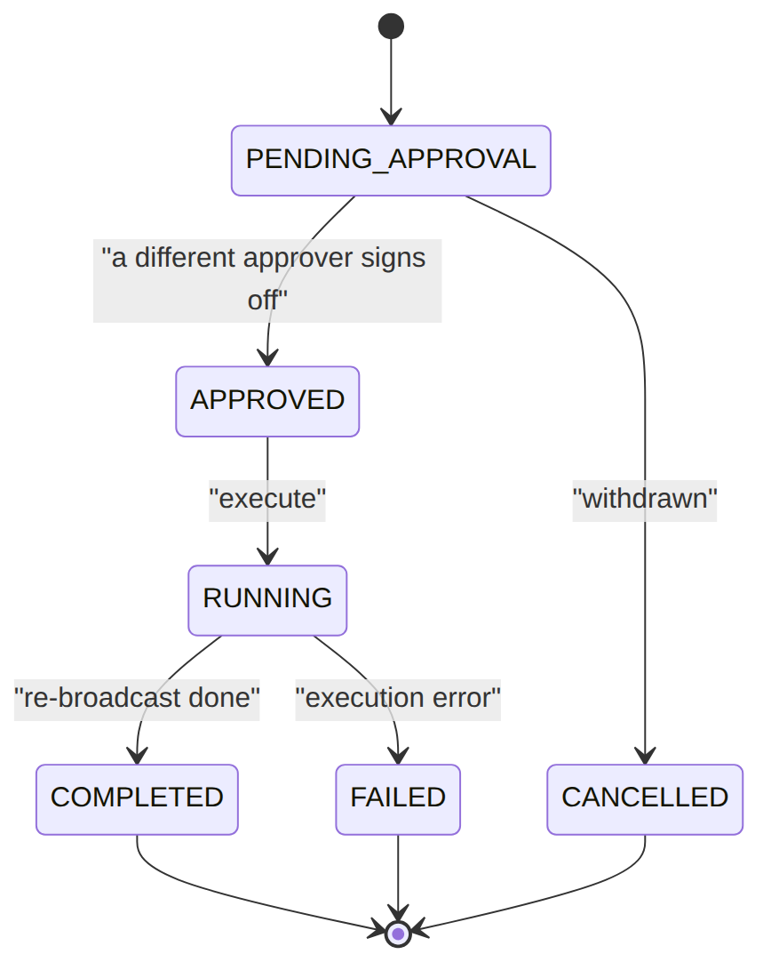
Read each row as a sentence — this data means this:
Row | What it means in plain English
pfs_1 | A request to re-push BSS's desired to the network (sync_direction=BSS_TO_NETWORK, requested_action=REAPPLY_PROFILE) for pri_1's drift — still PENDING_APPROVAL (approval_request_id=appr_77), no approver or command yet.
pfs_2 | A completed BSS→network fix: COMPLETED, with the separation-of-duties trail (requested_by_user_id=u_noc1 ≠ approved_by_user_id=u_noc2) and the corrective command_id=pcmd_88 it produced.
pfs_3 | A NETWORK_TO_BSS request (update BSS to match the network, "network is source of truth here"), already APPROVED but not yet run (command_id=null).
pfs_4 | A MARK_IGNORE request (accept the diff rather than fix it), CANCELLED — withdrawn as "expected during migration" (not tied to a specific item, source_item_id=null).
The columns that did that work:
- Which way to sync = sync_direction (BSS_TO_NETWORK re-pushes desired; NETWORK_TO_BSS updates BSS; MARK_IGNORE accepts the diff).
- Approval & SoD = status + approval_request_id (links the EM-CFG-04 decision); requested_by_user_id ≠ approved_by_user_id enforces separation of duties; command_id is the corrective command once it runs.

3. Services (worked calls)
Service | Responsibility
ProvisioningService | broadcast()/dispatch()/pollAsyncCommands()/recordDesiredState()
ProvisioningAdapterRegistry | forCommand($cmd)/forTarget($op,$code) → the vendor adapter (the seam)
ReconciliationService | run()/requestForceSync()/approveForceSync() (EM-CFG-04)/executeForceSync()
broadcast('sub_123','ACTIVATE',[$spec]) → create command (PENDING) → dispatch() → forCommand resolves adapter → adapter.dispatch() → confirmed/accepted/failed → log attempt → recordDesiredState() on success.

4. ⭐ The vendor-adapter contract (Contracts/ProvisioningAdapter)
interface ProvisioningAdapter {
public function dispatch(ProvisioningCommand $command): ProvisioningResult; // push desired_state to the vendor
public function fetchObserved(string $targetCode, string $subscriberKey, string $desiredStatus, array $desiredProfile = []): ?array; // read back (null = not present)
public function pollStatus(ProvisioningCommand $command): ?ProvisioningResult; // resolve an ASYNC command (null = still pending)
}
ProvisioningResult::confirmed(externalRef, response) / accepted(externalRef, response) / failed(error, final). StubProvisioningAdapter is the default (logs + mirrors desired; honours forceFail/simulateAsync/simulateObservedStatus/ simulateNotPresent). A real driver translates command.desired_state into the vendor API.

5. Integration (events) — topic provisioning.command
- Emits: ProvisioningCommand{Sent,Confirmed,Failed}, ProvisioningReconciliation{RunCompleted, ItemOpened}, ProvisioningForceSync{Requested,Approved,Completed,Cancelled}.
- Consumes: SyncProvisioningOnAccountStatusChanged (ILM CustomerAccountStatusChanged).

6. Processes (workers + handler)
- Workers (Foundation/Console schedule): sophix:provisioning:poll-async (5 min, resolve ACCEPTED via pollStatus), :reconcile (hourly).
- Handler — ActivateServiceHandler (topic provisioning.activate-service): reads the subscription business key + packageRef var + node config (target/speedProfile/serviceRef); does broadcast('ACTIVATE'); outputs {provisioned, provisioningRefs}; on fail TaskResult::fail(retryable:true).

7. Policy & config
provisioning_target + provisioning_adapter_config (the connector binding), retry_policy_json, EM-CFG-04 force-sync definition (seeded gated by default), Catalog topology (network_node,homepass).

8. Cross-module dependencies
- Called by → Subscription (FulfillmentCallHandler/ActivateServiceHandler), OSR (ProvisionSwapHandler), ILM (account-status sync).
- Reads → Catalog topology + service network_profile_shape/provisioner_key to shape desired_profile.
- Connector seam → vendor adapters (Huawei NCE, FiberHome UNM2000, Casa CMTS, VoipSwitch, Verimatrix) at deployment behind ProvisioningAdapterRegistry.

9. Invariants & rules
Rule | Statement | Enforced in
R-PROV-08 | a mismatch never auto-fixes; NOC drives force-sync | ReconciliationService::run
R-PROV-07 | destructive force-sync gated by EM-CFG-04 (SoD + audit) | requestForceSync/approveForceSync
§10.2 | each command dispatched through ITS target's adapter | ProvisioningAdapterRegistry::forCommand
§7.2 | ASYNC commands resolved by the poll worker | pollAsyncCommands + pollStatus

10. Open items / deltas
- Force-sync EM-CFG-04 + account-status→provisioning cascade were wired during hardening.
- A typed desired_state contract + a Headend/Hub routing model (derive target_code from the HomePass node chain, not flow config) are the refinements for when real adapters land — today target_code comes from the flow node config.
- Only StubProvisioningAdapter ships; all vendor adapters are deployment connectors.

