RBAC — As-Built Design (EM-CFG-03)
Capability codes: EM-CFG-03 (roles, permissions, scopes, frontend matrix) · Module path: Modules/Rbac Tests: RbacApiTest, WorkOrderApiTest (scope) · Engine: spatie/laravel-permission · Guard: web (single guard for both Inertia sessions and Sanctum API). See 00_SPINE.md §7.

1. Purpose & boundaries
- Owns: the access model in four layers —
  - roles → permissions (spatie: roles, permissions, role_has_permissions) — what a role can do,
  - user → role/permission (spatie: model_has_roles, model_has_permissions) — who has it,
  - data scopes (rbac_user_scope_assignment) — where it applies (operator/franchise/region/…),
  - the frontend action matrix (rbac_frontend_action + rbac_role_frontend_action) — what the UI shows. Plus catalog metadata (rbac_role_meta, rbac_permission_meta) and an immutable change audit.
- Does NOT own: authentication (Sanctum/Keycloak via SOPHIX_AUTH_DRIVER). It answers what can this principal do, where, and which UI actions to render — never who they are.
- Job: "JWT → permission → scope" is the request guard; "permissions → frontend actions" is the UI guard.
Two questions this doc answers head-on: “Where do I set what a role can do?” → the role_has_permissions pivot (§2), written by PUT /api/rbac/roles/{code}/permissions (Role::syncPermissions) at runtime or the RbacSeeder role matrix at bootstrap. “Where are the UI actions?” → rbac_frontend_action (the catalog) + rbac_role_frontend_action (role→action visibility), resolved per user by GET …/navigation (§2/§3).
The big picture in plain English: access has two guards. On every request the API asks three things in order — who are you (the JWT/auth), are you allowed to do this action (the permission), and does it apply here (the data scope). Separately, the UI asks a softer question — which buttons and menus should I even draw for this user (the frontend actions). The UI guard is convenience only; the request guard is the real security, and it re-checks every time.
Guard order on a request — JWT → permission → scope:
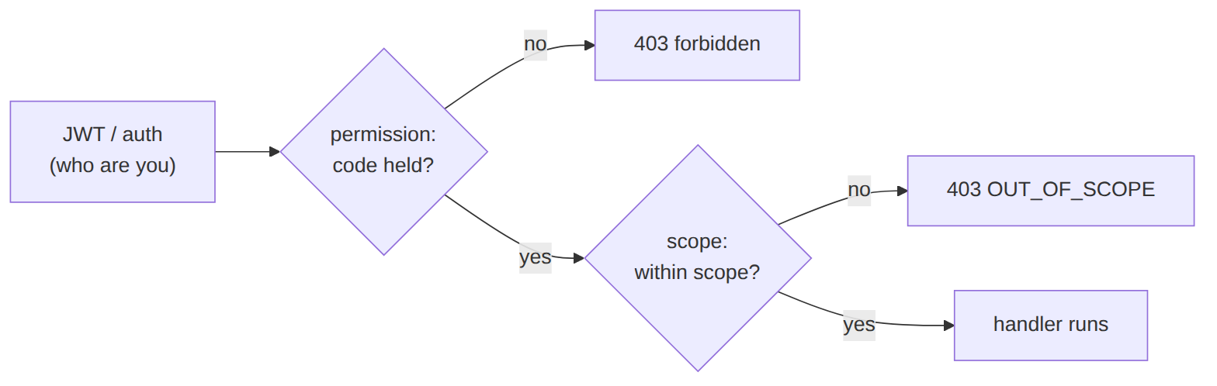
The grant model — where a user gets what a role can do. A user does not hold permissions directly (usually); they hold roles, and roles hold permissions. Follow the pivots left-to-right:
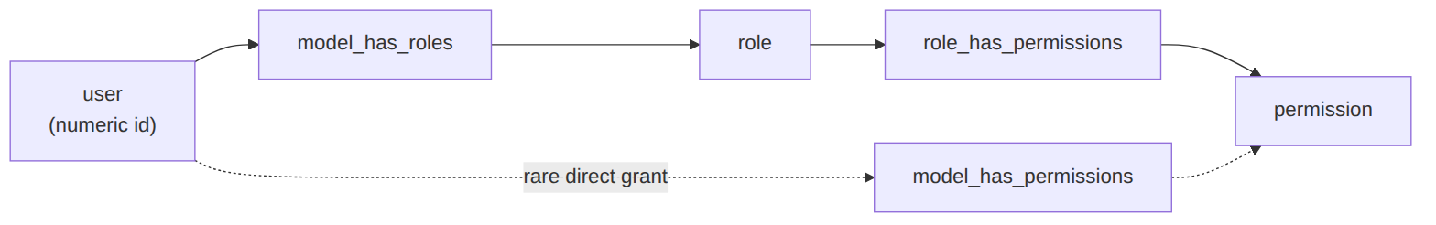
A user's effective permissions = the union of role_has_permissions across all their model_has_roles roles, plus any direct model_has_permissions grants.

📖 Scenarios (service + Foundation involvement)

1. Create a role and grant it permissions
POST /api/rbac/roles {code:'DISPATCHER', permissions:['workorder.read','workorder.assign','fulfillment.read','workforce.read']} → Role::findOrCreate('DISPATCHER','web') + syncPermissions(...) writes the role_has_permissions rows (the catalog grows: each unknown permission is findOrCreated). Audited ROLE_CREATED.

2. Change what a role can do (the answer to “where”)
PUT /api/rbac/roles/DISPATCHER/permissions {permissions:[…]} → Role::syncPermissions replaces that role's role_has_permissions rows. Anti-escalation: a non-SUPER_ADMIN actor cannot grant a permission they don't themselves hold (403 PERMISSION_CEILING). Writes a ROLE_PERMISSIONS_SYNCED audit with before/after. This pivot is the single source of truth for “what a role can do”.

3. Assign a role to a user
POST /api/rbac/users/{u}/roles {roles:['DISPATCHER']} → User::syncRoles writes model_has_roles (model_id = the user's numeric id). Anti-escalation ceiling: only SUPER_ADMIN may grant SUPER_ADMIN, and a non-super actor may only assign roles they hold. Audited USER_ROLE_ASSIGNED.

4. Permission check on a route
A route's permission:workorder.assign middleware (spatie, guard web) blocks a CUSTOMER_CARE_AGENT (403) but passes a DISPATCHER — because DISPATCHER's role_has_permissions includes workorder.assign.

5. Scope gate allows within-region / blocks out-of-region
The region-scoped dispatcher POST /api/work-orders {tech_region_id:'KE-NRB-KAREN'} → after permission, scope:TECH_REGION,tech_region_id (EnforceScope) → withinScope true → allowed. Posting KE-MSA-NYALI → withinScope false → 403 OUT_OF_SCOPE. Proven by WorkOrderApiTest::test_tech_region_scope_gates_work_order_creation.

6. SUPER_ADMIN / GLOBAL bypass
A SUPER_ADMIN (or a GLOBAL/OPERATOR scope holder) bypasses the scope check entirely.

7. UI action visibility (the frontend matrix — “where are the UI actions”)
The story in plain English: When the back-office app loads, it asks the server "which menus and buttons should I show this user?" The server keeps the list of all renderable actions and the permission each one needs, then hands back only the ones this user's permissions unlock. So a dispatcher sees the "Assign technician" button and a care agent doesn't — but this is only about drawing the screen, not about security.
Who does what: GET /api/rbac/users/{u}/navigation → loads rbac_frontend_action (ACTIVE), keeps each action whose required_permission_code is in the user's effective permissions, returns {actionCode, type, displayName, app}. So the “Assign technician” BUTTON (required_permission_code: workorder.assign) renders for a DISPATCHER but is hidden for a CUSTOMER_CARE_AGENT. The BO SPA calls this to build the menu and show/hide controls. Visibility is UX, never security — the API still enforces permission:/scope: regardless.
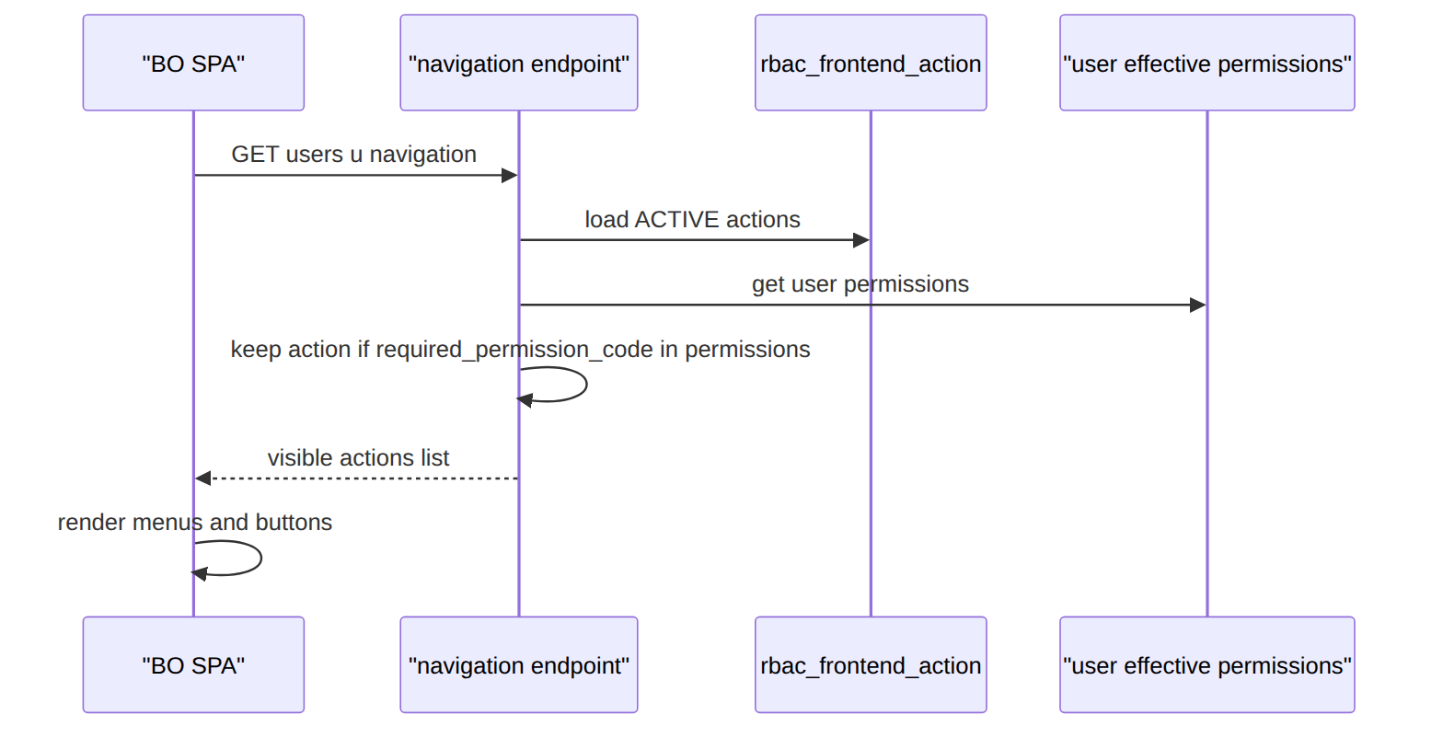

8. Manage the frontend action catalog
POST /api/rbac/frontend-actions {app_code, action_code, action_type:'BUTTON', display_name, required_permission_code} upserts an rbac_frontend_action; rbac_role_frontend_action is the precomputed role→action visibility matrix.

9. Effective access (debug/admin view)
GET /api/rbac/users/{u}/effective-access → {roles, permissions (getAllPermissions), scopes} — the flattened answer to “what can this user actually do and where”.

10. Revoke a scope (audited)
RbacScopeService::revoke deactivates a scope (active:false + effective_to) + audits it; the user immediately loses access to that region.

2. Data model — ≥4 complete sample rows + readings

spatie permissions & roles (the catalogs, guard web)
// permissions
{ "id":11,"name":"workorder.read","guard_name":"web" }
{ "id":12,"name":"workorder.assign","guard_name":"web" }
{ "id":21,"name":"fulfillment.read","guard_name":"web" }
{ "id":40,"name":"rbac.manage","guard_name":"web" }
// roles
{ "id":4,"name":"DISPATCHER","guard_name":"web" }
{ "id":2,"name":"BILLING_LEAD","guard_name":"web" }
{ "id":1,"name":"SUPER_ADMIN","guard_name":"web" }
{ "id":9,"name":"CUSTOMER_CARE_AGENT","guard_name":"web" }
Read each row as a sentence — this data means this:
Row | What it means in plain English
perm #11 | A permission code named workorder.read exists in the catalog, on guard web.
perm #12 | A permission code named workorder.assign exists, guard web.
perm #21 | A permission code named fulfillment.read exists, guard web.
perm #40 | A permission code named rbac.manage exists, guard web.
role #4 | A role code named DISPATCHER exists, guard web.
role #2 | A role code named BILLING_LEAD exists, guard web.
role #1 | A role code named SUPER_ADMIN exists, guard web.
role #9 | A role code named CUSTOMER_CARE_AGENT exists, guard web.
The columns that did the work: just id, name, guard_name — everything is guard web (one guard serves both Inertia sessions and Sanctum tokens). These rows grant nothing on their own; the grants are the pivots below.

role_has_permissions — ⭐ WHAT A ROLE CAN DO (set here)
{ "role_id":4, "permission_id":11 } // DISPATCHER → workorder.read
{ "role_id":4, "permission_id":12 } // DISPATCHER → workorder.assign
{ "role_id":4, "permission_id":21 } // DISPATCHER → fulfillment.read
{ "role_id":2, "permission_id":12 } // BILLING_LEAD does NOT have this (illustrative absence) — only rows that exist are grants
Read each row as a sentence — this data means this:
Row | What it means in plain English
Row 1 | role_id=4 (DISPATCHER) can workorder.read (permission_id=11) — the grant exists.
Row 2 | DISPATCHER can workorder.assign (permission_id=12).
Row 3 | DISPATCHER can fulfillment.read (permission_id=21).
Row 4 | role_id=2 (BILLING_LEAD) paired with permission_id=12 — shown only to illustrate absence: in real data only existing rows are grants, so to deny something you simply have no row for it.
The columns that did the work: a row's mere existence (role_id + permission_id) is the grant — this pivot is the single source of truth for "what a role can do." You set/change it via PUT /api/rbac/roles/{code}/permissions → Role::syncPermissions() (replaces the role's rows, audited, with the anti-escalation ceiling), or at bootstrap via the RbacSeeder matrix (§7).

model_has_roles — USER → ROLE (who has the role)
{ "role_id":4, "model_type":"App\\Models\\User", "model_id":57 } // user #57 IS a DISPATCHER
{ "role_id":2, "model_type":"App\\Models\\User", "model_id":57 } // …and also BILLING_LEAD
{ "role_id":1, "model_type":"App\\Models\\User", "model_id":1 } // user #1 is SUPER_ADMIN
{ "role_id":9, "model_type":"App\\Models\\User", "model_id":83 } // user #83 is a care agent
Read each row as a sentence — this data means this:
Row | What it means in plain English
Row 1 | User #57 (model_id) is a DISPATCHER (role_id=4).
Row 2 | The same user #57 is also a BILLING_LEAD (role_id=2) — users can hold many roles.
Row 3 | User #1 is SUPER_ADMIN (role_id=1).
Row 4 | User #83 is a CUSTOMER_CARE_AGENT (role_id=9).
The columns that did the work: model_id is the user's numeric id (the morph key), not uid; model_type is the morph class. Written by User::syncRoles(). A user's effective permissions = the union of role_has_permissions across all their roles here (+ any direct grants below).

model_has_permissions — USER → PERMISSION directly (rare escape hatch)
{ "permission_id":40, "model_type":"App\\Models\\User", "model_id":1 } // user #1 granted rbac.manage directly
{ "permission_id":11, "model_type":"App\\Models\\User", "model_id":57 } // a one-off grant outside any role
{ "permission_id":21, "model_type":"App\\Models\\User", "model_id":83 }
{ "permission_id":12, "model_type":"App\\Models\\User", "model_id":99 }
Read each row as a sentence — this data means this:
Row | What it means in plain English
Row 1 | User #1 was granted rbac.manage (permission_id=40) directly, outside any role.
Row 2 | User #57 has a one-off workorder.read grant (permission_id=11) not coming from a role.
Row 3 | User #83 was granted fulfillment.read (permission_id=21) directly.
Row 4 | User #99 was granted workorder.assign (permission_id=12) directly.
The columns that did the work: model_id (the user) + permission_id — a direct grant that bypasses roles, used sparingly for exceptions. getAllPermissions() unions these with the role-derived ones.

rbac_role_meta (role display/family/lifecycle — metadata, not a grant)
{ "role_code":"DISPATCHER","operator_code":"GLOBAL","display_name":"Dispatcher","role_family":"FIELD_OPS","description":"Assigns and tracks field work","status":"ACTIVE","keycloak_role_name":"dispatcher" }
{ "role_code":"BILLING_LEAD","operator_code":"GLOBAL","display_name":"Billing Lead","role_family":"BILLING","description":"Billing supervisor","status":"ACTIVE","keycloak_role_name":"billing-lead" }
{ "role_code":"CVM_MANAGER","operator_code":"WIK","display_name":"CVM Manager","role_family":"COMMERCIAL","description":"Retention & offers","status":"ACTIVE","keycloak_role_name":null }
{ "role_code":"LEGACY_OPS","operator_code":"GLOBAL","display_name":"Legacy Ops","role_family":null,"description":"Decommissioned","status":"RETIRED","keycloak_role_name":null }
Read each row as a sentence — this data means this:
Row | What it means in plain English
DISPATCHER | A platform role (operator_code=GLOBAL) shown as "Dispatcher", grouped under role_family=FIELD_OPS, ACTIVE, and mirrored into the IdP as dispatcher (keycloak_role_name).
BILLING_LEAD | A platform role "Billing Lead", family BILLING, ACTIVE, mirrored as billing-lead.
CVM_MANAGER | A WIK-only role (operator_code=WIK) "CVM Manager", family COMMERCIAL, ACTIVE, with no IdP mirror (keycloak_role_name=null).
LEGACY_OPS | A platform role "Legacy Ops" that is RETIRED (status) with no family — hidden from the admin picker.
The columns that did the work: this is metadata about a role code (the spatie roles row is the enforcement identity). status=RETIRED hides a role from the picker; keycloak_role_name mirrors it into the IdP when SOPHIX_AUTH_DRIVER=keycloak; operator_code=GLOBAL means a platform role.

rbac_permission_meta (permission metadata — does NOT grant) · risk_level: LOW|MEDIUM|HIGH|CRITICAL
{ "permission_code":"workorder.assign","module_code":"WorkOrder","action_group":"assignment","risk_level":"MEDIUM","description":"Assign a work order to a technician","scope_required":true,"status":"ACTIVE" }
{ "permission_code":"invoice.manage","module_code":"Billing","action_group":"billing","risk_level":"HIGH","description":"Manage invoices/credit notes","scope_required":false,"status":"ACTIVE" }
{ "permission_code":"customer.read","module_code":"Ilm","action_group":"customer","risk_level":"LOW","description":"Read customer records","scope_required":false,"status":"ACTIVE" }
{ "permission_code":"rbac.manage","module_code":"Rbac","action_group":"admin","risk_level":"CRITICAL","description":"Manage roles, permissions and scopes","scope_required":false,"status":"ACTIVE" }
Read each row as a sentence — this data means this:
Row | What it means in plain English
workorder.assign | A MEDIUM-risk WorkOrder permission ("Assign a work order to a technician") that is region-scoped — scope_required=true, so its routes should carry a scope: gate; ACTIVE.
invoice.manage | A HIGH-risk Billing permission ("Manage invoices/credit notes"), not scope-required, ACTIVE.
customer.read | A LOW-risk Ilm permission ("Read customer records"), not scope-required, ACTIVE.
rbac.manage | A CRITICAL-risk Rbac permission ("Manage roles, permissions and scopes") — its risk drives a re-auth/confirm prompt in the back office; ACTIVE.
The columns that did the work: metadata about a permission, never a grant — scope_required flags which routes need a scope: gate, risk_level drives BO confirmation UX (CRITICAL prompts re-auth). Upserted via PUT /api/rbac/permissions/{code}/meta.

rbac_frontend_action — ⭐ THE UI ACTIONS CATALOG · action_type: MENU|SCREEN|BUTTON|TAB|FIELD
{ "frontend_action_id":"fea_1","app_code":"FE-APP-01","action_code":"backoffice.workorders","action_type":"MENU","display_name":"Work Orders","required_permission_code":"workorder.read","feature_flag":null,"status":"ACTIVE" }
{ "frontend_action_id":"fea_2","app_code":"FE-APP-01","action_code":"backoffice.workorders.assign","action_type":"BUTTON","display_name":"Assign technician","required_permission_code":"workorder.assign","feature_flag":null,"status":"ACTIVE" }
{ "frontend_action_id":"fea_3","app_code":"FE-APP-01","action_code":"backoffice.billing","action_type":"MENU","display_name":"Billing","required_permission_code":"invoice.read","feature_flag":null,"status":"ACTIVE" }
{ "frontend_action_id":"fea_4","app_code":"FE-APP-02","action_code":"selfcare.usage.tab","action_type":"TAB","display_name":"Usage","required_permission_code":null,"feature_flag":"usage_v2","status":"ACTIVE" }
Read each row as a sentence — this data means this:
Row | What it means in plain English
fea_1 | A back-office (app_code=FE-APP-01) MENU item "Work Orders" whose visibility is gated by required_permission_code=workorder.read; ACTIVE, no feature flag.
fea_2 | A back-office BUTTON "Assign technician" gated by workorder.assign; ACTIVE.
fea_3 | A back-office MENU "Billing" gated by invoice.read; ACTIVE.
fea_4 | A self-care (FE-APP-02) TAB "Usage" with no permission gate (required_permission_code=null = always visible) but hidden behind the usage_v2 feature flag.
The columns that did the work: one row per renderable element (action_type), keyed by action_code, scoped to a frontend app_code (FE-APP-01 back-office, FE-APP-02 self-care); required_permission_code gates visibility (null = always visible) and feature_flag hides it behind a rollout. Visibility ≠ security: the API still enforces the permission server-side — this only controls what the SPA renders. Managed via GET/POST /api/rbac/frontend-actions.

rbac_role_frontend_action — role → UI action visibility matrix (precomputed)
{ "role_action_id":"rfa_1","role_code":"DISPATCHER","frontend_action_id":"fea_1","visible":true } // sees Work Orders menu
{ "role_action_id":"rfa_2","role_code":"DISPATCHER","frontend_action_id":"fea_2","visible":true } // …and the Assign button
{ "role_action_id":"rfa_3","role_code":"CUSTOMER_CARE_AGENT","frontend_action_id":"fea_2","visible":false } // care agent: button hidden
{ "role_action_id":"rfa_4","role_code":"BILLING_LEAD","frontend_action_id":"fea_3","visible":true } // sees Billing menu
Read each row as a sentence — this data means this:
Row | What it means in plain English
rfa_1 | DISPATCHER sees the fea_1 action (Work Orders menu) — visible=true.
rfa_2 | DISPATCHER sees fea_2 (the Assign-technician button).
rfa_3 | CUSTOMER_CARE_AGENT has fea_2 explicitly hidden (visible=false) — the Assign button is pinned off for care agents.
rfa_4 | BILLING_LEAD sees fea_3 (Billing menu).
The columns that did the work: a role_code+frontend_action_id+visible triple — this is the precomputed role→action matrix, an admin-tunable override of the live GET …/navigation derivation (which otherwise infers visibility from each action's required_permission_code vs the user's permissions). visible=false explicitly hides an action for a role.

rbac_user_scope_assignment — WHERE access applies · scope_type: GLOBAL|OPERATOR|FRANCHISE|TECH_REGION|CONTRACTOR|TEAM|CHANNEL
{ "scope_assignment_id":"usa_1","operator_code":"WIK","auth_user_id":"u_1","scope_type":"TECH_REGION","scope_value":"KE-NRB-KAREN","scope_label":"Karen","effective_from":"2026-06-01T00:00:00Z","effective_to":null,"active":true,"created_by_user_id":"admin_1" }
{ "scope_assignment_id":"usa_2","operator_code":"WIK","auth_user_id":"u_2","scope_type":"OPERATOR","scope_value":"WIK","scope_label":"Wik Telecom","effective_from":null,"effective_to":null,"active":true,"created_by_user_id":"admin_1" }
{ "scope_assignment_id":"usa_3","operator_code":"WIK","auth_user_id":"u_3","scope_type":"GLOBAL","scope_value":"*","scope_label":null,"effective_from":null,"effective_to":null,"active":true,"created_by_user_id":"admin_1" }
{ "scope_assignment_id":"usa_4","operator_code":"WIK","auth_user_id":"u_1","scope_type":"TECH_REGION","scope_value":"KE-MSA-NYALI","scope_label":"Nyali","effective_from":"2026-06-01T00:00:00Z","effective_to":"2026-06-15T00:00:00Z","active":false,"created_by_user_id":"admin_2" }
Read each row as a sentence — this data means this:
Row | What it means in plain English
usa_1 | User u_1 is scoped to the Karen tech region (scope_type=TECH_REGION, scope_value=KE-NRB-KAREN) — active=true, no end date (effective_to=null).
usa_2 | User u_2 is scoped to the whole WIK operator (scope_type=OPERATOR, scope_value=WIK), active.
usa_3 | User u_3 has platform-wide scope (scope_type=GLOBAL, scope_value=*), active.
usa_4 | User u_1 once had the Nyali region too, but it's revoked — active=false with an effective_to (2026-06-15) in the past.
The columns that did the work: this is the data-scope axis (permission says what, scope says where). withinScope(user, type, value) is true if the user holds GLOBAL, an OPERATOR scope matching the tenant, or an exact scope_type+scope_value; active/effective_to decide whether a row still counts. auth_user_id is the user uid (unlike the spatie morph key). SUPER_ADMIN bypasses.

rbac_change_audit (immutable) · change_type: ROLE_CREATED|ROLE_PERMISSIONS_SYNCED|PERMISSION_CREATED|USER_ROLE_ASSIGNED|USER_SCOPE_{ASSIGNED,REVOKED}
{ "audit_id":"rba_1","operator_code":"WIK","change_type":"USER_SCOPE_ASSIGNED","target_type":"USER_ROLE","target_id":"u_1","actor_user_id":"admin_1","before_json":null,"after_json":{"scopeType":"TECH_REGION","scopeValue":"KE-NRB-KAREN"},"reason_code":"ONBOARDING" }
{ "audit_id":"rba_2","operator_code":"WIK","change_type":"ROLE_PERMISSIONS_SYNCED","target_type":"ROLE","target_id":"DISPATCHER","actor_user_id":"admin_1","before_json":{"permissions":["workorder.read"]},"after_json":{"permissions":["workorder.read","workorder.assign"]},"reason_code":null }
{ "audit_id":"rba_3","operator_code":"WIK","change_type":"USER_SCOPE_REVOKED","target_type":"USER_ROLE","target_id":"u_1","actor_user_id":"admin_2","before_json":{"scopeValue":"KE-MSA-NYALI"},"after_json":{"active":false},"reason_code":"TRANSFER" }
{ "audit_id":"rba_4","operator_code":"WIK","change_type":"USER_ROLE_ASSIGNED","target_type":"USER_ROLE","target_id":"u_2","actor_user_id":"admin_1","before_json":null,"after_json":{"role":"BILLING_LEAD"},"reason_code":null }
Read each row as a sentence — this data means this:
Row | What it means in plain English
rba_1 | admin_1 assigned a scope to user u_1 (change_type=USER_SCOPE_ASSIGNED) — after_json shows TECH_REGION/KE-NRB-KAREN, before_json=null (new), reason ONBOARDING.
rba_2 | admin_1 changed what DISPATCHER can do (ROLE_PERMISSIONS_SYNCED on target_id=DISPATCHER) — before_json/after_json show workorder.assign was added.
rba_3 | admin_2 revoked user u_1's Nyali scope (USER_SCOPE_REVOKED) — after_json flips active to false, reason TRANSFER.
rba_4 | admin_1 assigned the BILLING_LEAD role to u_2 (USER_ROLE_ASSIGNED) — after_json.role=BILLING_LEAD, before_json=null.
The columns that did the work: every grant/revoke/role-permission change writes an append-only row — who (actor_user_id), what (change_type on target_type/target_id), the diff (before_json/after_json), and an optional reason_code. This table is never updated, only inserted.

3. Services, models & middleware
Component | Responsibility
spatie Role/Permission (+ User HasRoles) | the enforcement engine — syncPermissions/syncRoles/hasPermissionTo/getAllPermissions (guard web)
RbacController | the admin API: role & permission CRUD, syncPermissions (set what a role can do), assignRoles, scopes, meta upserts, frontend-action catalog, navigation, effectiveAccess
RbacScopeService | assign/revoke/scopesFor/withinScope (GLOBAL/OPERATOR/exact + SUPER_ADMIN bypass), permissionRequiresScope
RbacFrontendAction (model) | the UI action catalog; navigation() filters ACTIVE actions by required_permission_code ∈ user permissions
Http/Middleware/EnforceScope (scope) | request-time data-scope gate scope:{type},{key} (runs after permission)
spatie permission: middleware | the permission gate on every protected route
Anti-escalation (both grant paths): syncPermissions rejects granting a permission the actor doesn't hold (PERMISSION_CEILING); assignRoles rejects assigning a role the actor doesn't hold (only SUPER_ADMIN grants SUPER_ADMIN).

4. API surface (all under permission:rbac.manage)
Method + path | Purpose
GET/POST /api/rbac/roles | list / create a role (with permissions)
PUT /api/rbac/roles/{code}/permissions | set what a role can do (role_has_permissions)
GET/POST /api/rbac/permissions | list / create a permission
POST /api/rbac/users/{user}/roles | assign roles to a user (model_has_roles)
GET /api/rbac/users/{user}/effective-access | flattened roles + permissions + scopes
GET/POST /api/rbac/users/{user}/scopes, POST /api/rbac/scopes/{scope}/revoke, GET …/within-scope | data scopes
PUT /api/rbac/roles/{code}/meta, PUT /api/rbac/permissions/{code}/meta | catalog metadata
GET/POST /api/rbac/frontend-actions | the UI action catalog
GET /api/rbac/users/{user}/navigation | the UI actions this user may see
GET /api/rbac/audit | the change-audit trail

5. Integration
- Emits: UserScope{Assigned,Revoked} + rbac_change_audit rows on every change.
- Used by → every protected route (permission: + optional scope:); the BO/self-care SPA calls …/navigation to build menus and show/hide controls.

6. Processes
Synchronous guards; no workflow.

7. Policy & config (the seeded role → permission matrix)
- RbacSeeder is the canonical bootstrap: a PERMISSIONS list + a ROLES map (role → granted permission codes) that seeds role_has_permissions. Examples: DISPATCHER → [workorder.read, workorder.assign, fulfillment.read, workforce.read]; BILLING_LEAD → [invoice.*, payment.*, dunning.admin, adjustment.approve, …]; SUPER_ADMIN → ['*'] (all). This map is where the default “what a role can do” is defined; runtime edits go through PUT …/permissions.
- Single guard web; SOPHIX_AUTH_DRIVER (sanctum|keycloak) selects the authn front end.
- Frontend actions + role-matrix + scope assignments are operator data.

8. Cross-module dependencies
- Used by → all modules (the permission/scope middleware aliases in bootstrap/app.php).
- Mirrors to → Keycloak (keycloak_role_name) when that auth driver is active.

9. Invariants & rules
Rule | Statement | Enforced in
JWT → permission → scope | the documented guard order | route middleware stack
role grants live in one place | “what a role can do” = role_has_permissions only | Role::syncPermissions
anti-escalation (permission) | can't grant a permission you don't hold | RbacController::syncPermissions (PERMISSION_CEILING)
anti-escalation (role) | can't assign a role you don't hold; only SUPER_ADMIN grants SUPER_ADMIN | assignRoles ceiling
EM-CFG-03 §8.5 | a scope-sensitive route checks the target is within the caller's scopes | EnforceScope+withinScope
UI ≠ security | frontend actions only control rendering; the API re-checks | navigation vs permission: middleware
audited | every RBAC change writes an immutable audit row | RbacChangeAudit

10. Open items / deltas
- Request-time scope enforcement (scope middleware) + the SUPER_ADMIN bypass were wired during hardening (previously withinScope was only called by a debug endpoint). Routes opt in per-need.
- rbac_role_frontend_action is a precomputed/override matrix; the live navigation endpoint derives visibility from required_permission_code, so the two can drift — the matrix is advisory today.

