Rules — As-Built Design (decision engine)
Module path: Modules/Rules + app/Foundation/Rules · Tests: DecisionTableTest, DroolsRuleEngineTest · See 00_SPINE.md §6.

1. Purpose & boundaries
- Owns: the decision engine (FOUNDATION_DROOLS): operator-overridable decision tables evaluated by a package name, plus a registered code-fallback when no table is deployed.
- Does NOT own: the facts (the caller supplies) or the action (the caller applies). It only decides.
- Job: keep operator-varying policy out of ifs — branch through a named rules package.
The big picture in plain English: a caller asks a named question (a rule package like rules.tax-applicability) and hands over some facts. The engine looks up the deployed decision table for that package and operator, walks its rows top-to-bottom, and returns the outcome of the row whose when conditions match. If no row matches, it returns the table's default_output. If no table is even deployed, a registered code fallback answers so the caller always gets a deterministic decision. The engine only decides — the caller supplies the facts and applies the result.
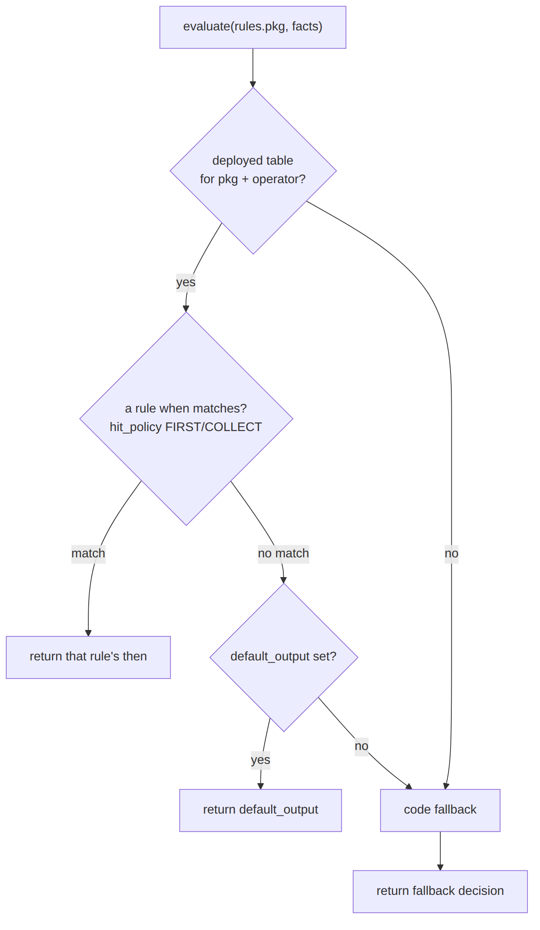

📖 Scenarios (service + Foundation involvement)

1. "How much tax applies?" as data
The story in plain English: Billing needs to know which tax group applies to a charge — but the answer varies by operator and by what is being sold. Instead of hard-coding it, the caller asks the rules engine, which looks up a table and returns the right tax group.
Who does what: Catalog TaxComputeService calls RuleEngine::evaluate('rules.tax-applicability', {taxableKind, customerCategory}) → a deployed decision_table's rows match the facts → returns the tax group. Proven by consumers' tests + DecisionTableTest.
Worked example — which row matches (using deployed table dt_1, rule_set: rules.tax-applicability, hit_policy: FIRST):
Given facts { "taxableKind":"USAGE", "serviceCategory":"VOICE" } — the engine walks the rows in order:
Row | when | Matches these facts?
1 | taxableKind = PACKAGE AND customerCategory = RES | no (taxableKind is USAGE)
2 | taxableKind = USAGE AND serviceCategory = VOICE | yes → stop (FIRST)
3 | taxableKind = USAGE AND serviceCategory = DATA | not reached
Returned then: { "taxGroup":"KE_VOICE" }. (Had the facts been {taxableKind:"USAGE", serviceCategory:"DATA"}, row 3 would have returned {taxGroup:"NONE"} — i.e. tax-exempt. Facts matching no row fall to default_output: {taxGroup:"NONE"}.)

2. Fallback when no table is deployed
The story in plain English: Someone asks a question for which no operator has authored a table yet. Rather than fail, the engine runs a built-in code rule so the caller still gets a sensible, deterministic answer.
Who does what: rules.billing.adjustment-approval with no table → the registered fallback derives stepsRequired from adjustment_limits_config. Foundation: deterministic answer out-of-the-box. Proven by AdjustmentTest.

3. Author a table in the Studio
POST /api/rules/decision-tables (rows of conditions→outcome) → POST /api/rules/{ruleSet}/evaluate tests it against sample facts before consumers use it.

4. Operator override
The story in plain English: A specific operator wants a different policy than the platform default. They author their own table for the same package; for that operator it wins, while everyone else keeps the default.
Who does what: A WIK-scoped table (operator_code:WIK) for a package overrides the platform default (operator_code:null) for that operator. Shows: per-operator policy without code.

5. CVM offer threshold
The story in plain English: A retention offer should need a manager's approval once the discount gets large. The rule package decides the threshold so it can be tuned without code.
Who does what: rules.cvm.offer({offerType, discountPercent}) → {requireApproval, approvalPolicy} drives EM-CFG-04.
Worked example (deployed table dt_3, rule_set: rules.cvm.offer, hit_policy: FIRST): facts { "offerType":"WINBACK", "discountPercent":25 } → row 1 when discountPercent >= 20 matches → returns { "requireApproval":true, "approvalPolicy":"CVM_HIGH_VALUE" }. A 10% offer matches no row → default_output: { "requireApproval":false }. Proven by CvmTest.

6. Field-audit discrepancy routing
rules.field_audit.equipment.discrepancy({discrepancyType}) → {severity, routeAction}. Proven by FieldAuditCampaignTest.

7. Dunning routing knobs
Dunning grace/levels come from the dunning_program (catalog), but rule packages can refine routing — the same evaluate seam.

8. Test-evaluate endpoint
POST /api/rules/{ruleSet}/evaluate {facts} returns the decision — used to validate a table before deploy.

2. Data model — ≥4 sample rows + readings

decision_table · hit_policy: FIRST|COLLECT · status: DRAFT|DEPLOYED|RETIRED
{ "table_id":"dt_1","rule_set":"rules.tax-applicability","version":1,"operator_code":"WIK","name":"Tax applicability","description":"Tax group by taxable kind","hit_policy":"FIRST","inputs":["taxableKind","customerCategory","serviceCategory"],"rules":[{"when":[{"var":"taxableKind","op":"=","value":"PACKAGE"},{"var":"customerCategory","op":"=","value":"RES"}],"then":{"taxGroup":"KE_INTERNET"}},{"when":[{"var":"taxableKind","op":"=","value":"USAGE"},{"var":"serviceCategory","op":"=","value":"VOICE"}],"then":{"taxGroup":"KE_VOICE"}},{"when":[{"var":"taxableKind","op":"=","value":"USAGE"},{"var":"serviceCategory","op":"=","value":"DATA"}],"then":{"taxGroup":"NONE"}}],"default_output":{"taxGroup":"NONE"},"status":"DEPLOYED","created_by":"u_studio" }
{ "table_id":"dt_2","rule_set":"rules.tax-applicability","version":1,"operator_code":null,"name":"Tax applicability (default)","description":null,"hit_policy":"FIRST","inputs":["taxableKind"],"rules":[{"when":[{"var":"taxableKind","op":"=","value":"PACKAGE"}],"then":{"taxGroup":"KE_INTERNET"}}],"default_output":{"taxGroup":"NONE"},"status":"DEPLOYED","created_by":"u_studio" }
{ "table_id":"dt_3","rule_set":"rules.cvm.offer","version":2,"operator_code":"WIK","name":"CVM offer approval","description":"High-value discount gate","hit_policy":"FIRST","inputs":["offerType","discountPercent"],"rules":[{"when":[{"var":"discountPercent","op":">=","value":20}],"then":{"requireApproval":true,"approvalPolicy":"CVM_HIGH_VALUE"}}],"default_output":{"requireApproval":false},"status":"DEPLOYED","created_by":"u_studio" }
{ "table_id":"dt_4","rule_set":"rules.field_audit.equipment.discrepancy","version":1,"operator_code":"WIK","name":"Discrepancy routing","description":null,"hit_policy":"COLLECT","inputs":["discrepancyType"],"rules":[{"when":[{"var":"discrepancyType","op":"=","value":"MISSING"}],"then":{"severity":"HIGH","routeAction":"ESCALATE"}}],"default_output":null,"status":"DRAFT","created_by":"u_studio" }
Read each row as a sentence — this data means this:
Row | What it means in plain English
dt_1 | WIK's tax-applicability table (operator_code=WIK), live (status=DEPLOYED): it picks a taxGroup from inputs — a residential package → KE_INTERNET, voice usage → KE_VOICE, data usage → NONE (tax-exempt) — and FIRST match wins.
dt_2 | The platform-default version of the same table (operator_code=null), DEPLOYED but simpler: a package → KE_INTERNET, otherwise the default_output of NONE. WIK's dt_1 overrides this one.
dt_3 | WIK's cvm.offer gate, DEPLOYED: any offer with discountPercent >= 20 returns requireApproval=true; everything else falls through to default_output (requireApproval=false).
dt_4 | WIK's field-audit discrepancy router — still DRAFT, so it does not evaluate yet. It uses COLLECT (gather all matches) and would route a MISSING discrepancy to severity=HIGH/ESCALATE.
The columns that did the work:
- Which package, whose version = rule_set (the rule package) + operator_code (WIK overrides null default) + version.
- Live or not = status — only DEPLOYED tables evaluate.
- How matches are picked = hit_policy (FIRST=first match wins, COLLECT=gather all), falling back to default_output when nothing matches.
Table lifecycle — a table only evaluates once DEPLOYED:
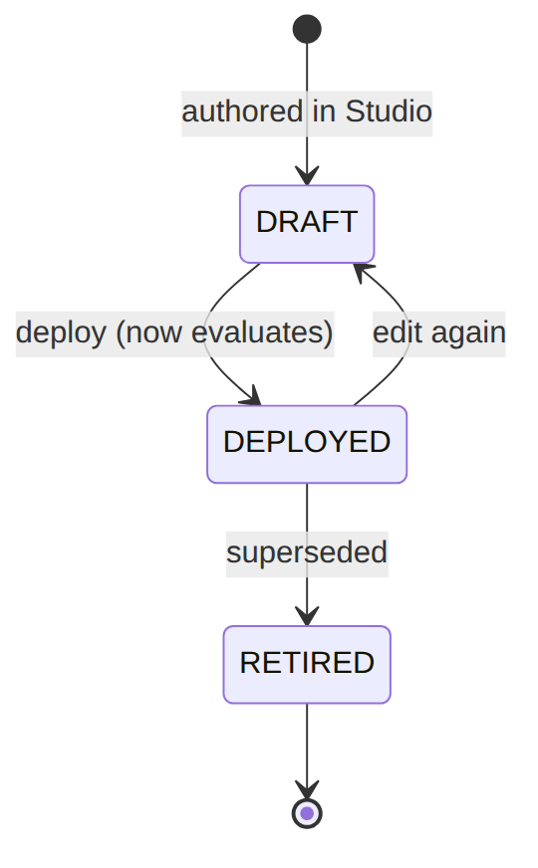

3. Engine
Component | Responsibility
Foundation/Rules/RuleEngine | evaluate('rules.<pkg>', $facts) → decision; register(pkg, fn) fallbacks

4. API surface
/api/rules/decision-tables[/{id}] (CRUD/Studio), /api/rules/{ruleSet}/evaluate (test). permission:rules.*.

5. Integration
- Consumed by → Billing (adjustment-approval), Catalog (tax-applicability), ILM (cvm.offer, flag eval), WorkOrder (field_audit.*), and more.

6. Processes
Synchronous evaluation; no workflow.

7. Policy & config
The decision tables are the config; a registered fallback guarantees a deterministic answer when no table is deployed; SOPHIX_RULES_DRIVER selects the engine.

8. Cross-module dependencies
- Used by → most domains for policy branching.

9. Invariants & rules
Rule | Statement | Enforced in
table-or-fallback | a package always resolves | RuleEngine::evaluate
operator override | an operator's table overrides the default | decision-table scope

10. Open items / deltas
- New policy = a new package + (optionally) a table; the engine driver is env-selectable.

