Subscription — As-Built Design
Capability codes: SUB-LM-01 (master), SUB-WF-FRAMEWORK-01, SUB-WF-* (operations), SUB-WF-RESTRICT-01 · Module path: Modules/Subscription · Tests: Modules/Subscription/tests/Feature/*

1. Purpose & boundaries
- Owns: the subscription master row (subscription) — the single writer of status_code and the cycle anchor — and the operation ledger (subscription_operation).
- Does NOT own: money (Billing), network (Provisioning), field work (WorkOrder), catalog (Catalog). It orchestrates them via workflow + events.
- Job: turn a lifecycle command into a governed, idempotent, single-in-flight operation whose steps are config-defined.

📖 Scenarios (service + Foundation involvement)
The one big idea: every lifecycle change to a subscription (pause, activate, upgrade, terminate…) is run as an operation — a tracked, retry-safe job. The subscription row holds the current state; the subscription_operation row is the receipt for one change-in-progress. A subscription may have only one such job running at a time (except restrictions, which are special).

1. Pause an active subscription
The story in plain English: A customer is travelling and wants to pause their service for a while. A call-centre agent hits Pause. The system doesn't flip the subscription off instantly — it first marks it "pause in progress", does the work, then settles it into a paused (suspended) rest state. Pausing is not its own status; a paused subscription simply sits in SUSPENDED with a pause reason attached.
Who does what:
- POST /api/subscriptions/sub_123/pause {reason_code:'CUSTOMER_TRAVEL'} → OperationFramework::trigger('PAUSE').
- trigger checks no other job is running, writes a subscription_operation row (INITIATED), and starts the sub-pause workflow.
- EnterPendingStatusHandler flips the master to the transient PENDING_PAUSE.
- PauseHandler commits SUSPENDED (with the pause reason) and writes subscription_pause_history. Emits SubscriptionPaused.
Sample — the subscription as it moves:
Moment | status_code | current_transition_type | meaning
before | ACTIVE | null | live, billable
during | PENDING_PAUSE | PAUSE | job in flight, blocks other jobs
after | SUSPENDED | null | paused (rest state)
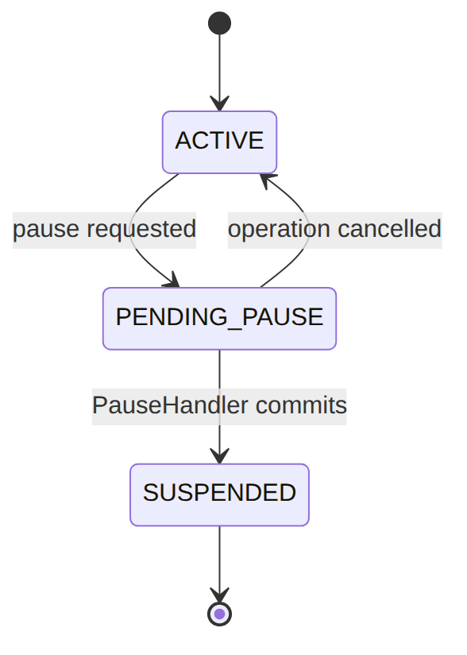
Proven by SubscriptionApiTest.

2. Concurrency — a second job is rejected (409)
The story in plain English: While the pause above is still running, someone tries to upgrade the same subscription. The system refuses — only one change job may run at a time, so the upgrade is bounced with a "wait for the other operation to finish" error. (A restriction would be the exception: it is allowed to run alongside another job.)
Who does what: An upgrade while the pause is still in flight (final_state IS NULL) → trigger throws conflict(WAIT_FOR_OPERATION) → HTTP 409. A RESTRICT op would be allowed because it is non-exclusive (R-SUB-WF-FW-2).

3. Idempotent retry
The story in plain English: The agent's browser times out and the pause request is sent twice with the same idempotency key. The system does not start a second pause — it just hands back the first one.
Who does what: Same Idempotency-Key → trigger returns the original subscription_operation row, and no second workflow is started.

4. Activate a new subscription (full workflow, pay-first park)
The story in plain English: A new customer's subscription is created but not yet live. To activate it the system validates everything, and if there is an activation fee that must be paid up front, it pauses and waits for the money to land before switching the service on. Once paid (or if no fee), it flips the subscription ACTIVE and tells the network to provision it.
Who does what:
- …/activate → trigger('ACTIVATE') → sub-activate workflow.
- ValidateActivationHandler checks preconditions.
- BillingIntentHandler — if an activation fee is pay-first, parks the operation in AWAITING_PAYMENT on a ful-payment-received catch until InvoicePaid arrives.
- ActivateHandler runs transitionStatus(ACTIVE) and emits SubscriptionActivated.
- FulfillmentCallHandler broadcasts to Provisioning.
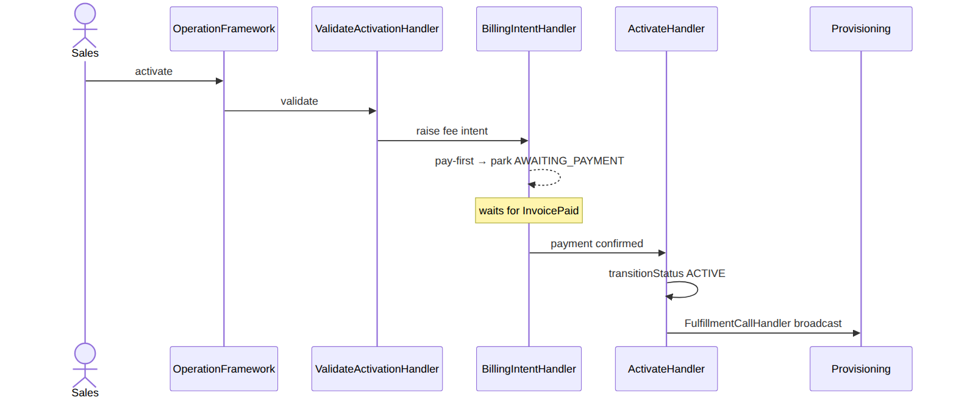
Foundation: workflow + outbox + pay-first parking. Proven by SubscriptionApiTest.

5. Upgrade (mid-cycle MACD)
The story in plain English: A customer on a basic plan upgrades to a bigger one halfway through the month. The system works out the part-month price difference (proration), swaps the package on the subscription, and records the change.
Who does what: …/upgrade {package_ref} → sub-upgrade: ValidatePackageChangeHandler → BillingIntentHandler (mid-cycle proration via the BillingIntent path) → ChangePackageHandler (swaps package_ref/package_version_id) → SubscriptionUpgraded.

6. Terminate
The story in plain English: A customer leaves. The system arranges to pick up the equipment, then switches the subscription to TERMINATED and tells Billing and Reporting it has ended.
Who does what: …/terminate → sub-terminate: EquipmentPickupHandler (raises an OSR pickup) → TerminateHandler (transitionStatus(TERMINATED) + SubscriptionTerminated, which Billing/Reporting consume).

7. Add a restriction (non-exclusive)
The story in plain English: A customer is over their limit, so the operator bars outgoing voice without cutting off the whole service. This is a partial restriction — the subscription stays in whatever status it was; only the bar is added. Because it doesn't change status, it can run even while another job is in flight.
Who does what: POST …/{id}/restrictions {code:'OUTGOING_VOICE_BARRED'} → RestrictionService (the one op that does not change status_code): writes a subscription_restriction, broadcasts to Provisioning, emits SubscriptionRestrictionAdded. Runs even with another op in flight (R-SUB-WF-FW-2).

8. Cancel an in-flight job → compensation
The story in plain English: A change job is stuck or was started by mistake, so an operator cancels it. The system stops the running workflow and, if the subscription was sitting in a temporary "PENDING_…" state, rolls it back to whatever status it had before the job started.
Who does what: POST /api/subscription-operations/{op}/cancel → OperationFramework::cancel: cancels the running process_instance and, if the master sits in a transient PENDING_*, reverts it to prior_subscription_status (R-SUB-WF-FW-3). Emits SubscriptionOperationCancelled.
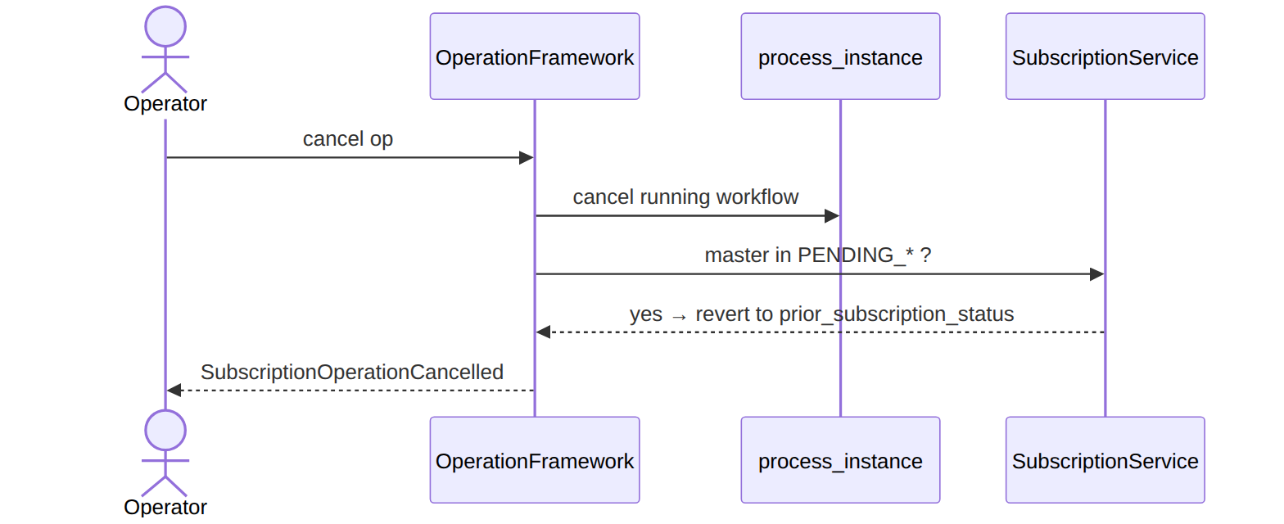

2. Data model — ≥4 complete sample rows + readings
Completeness: each row lists every domain column (nullables shown as null). The surrogate primary key shown is the real one (a string business key, e.g. subscription_id); created_at/ updated_at are omitted by convention.

subscription (the master)
Enum legend — status_code: rest states CREATED|PENDING_ACTIVATION|ACTIVE|SUSPENDED|RESTRICTED| TERMINATED|RETIRED (the PAUSED constant survives @deprecated — pause now resolves to SUSPENDED with a pause reason); transient PENDING_{PAUSE,RESUME,SUSPEND_NP,UPGRADE,DOWNGRADE,RELOCATION, MIGRATION,TERMINATION} (= an operation is mid-flight; cancel reverts to prior). Only ACTIVE is billable. billing_mode = POSTPAID(invoice)|PREPAID(wallet); cycle_model = CALENDAR|ANNIVERSARY. (current_cycle_*/last_cycle_closed_window_end/next_cycle_charge_invoice_id added by the cycle-window migration.)
Status lifecycle. Each rest state is reached through a transient PENDING_* state while the job runs; cancelling a job in a PENDING_* state rolls back to where it was. (Transient states collapsed below for readability.)
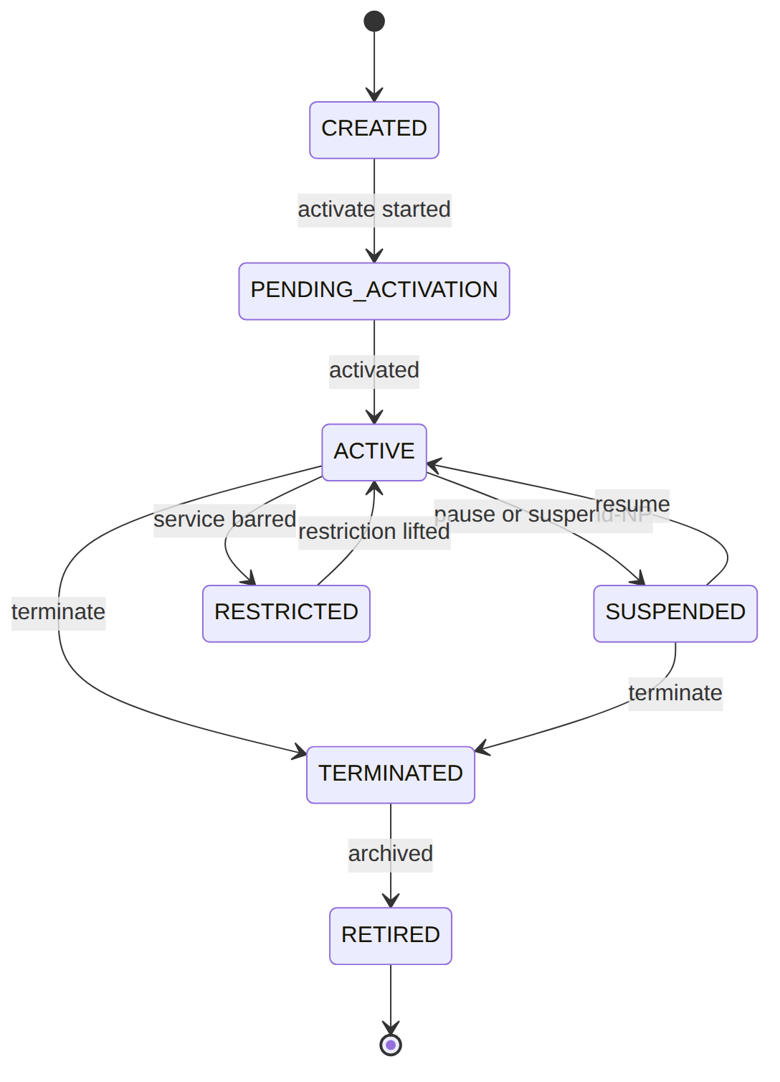
{ "subscription_id":"sub_123","customer_id":"cust_50","account_id":"acc_1","operator_code":"WIK","homepass_id":"hp_1","previous_homepass_id":null,"package_ref":"pkg_triple","package_version_id":"pv_1","previous_package_ref":null,"previous_package_version_id":null,"status_code":"ACTIVE","billing_mode":"POSTPAID","currency":"KES","cycle_model":"ANNIVERSARY","cycle_anchor_day":1,"cycle_period_days":30,"cycle_frequency_months":1,"active_restrictions":[],"current_transition_type":null,"current_transition_reason_code":null,"last_failure":null,"activated_at":"2026-01-01T08:00:00Z","suspended_at":null,"resumed_at":null,"terminated_at":null,"last_status_changed_at":"2026-01-01T08:00:00Z","start_date":"2026-01-01","end_date":null,"created_by":"u_sales1","updated_by":"system","retired_at":null,"current_cycle_start":"2026-06-01","current_cycle_end":"2026-07-01","last_cycle_closed_window_end":"2026-06-01","next_cycle_charge_invoice_id":null }
{ "subscription_id":"sub_124","customer_id":"cust_50","account_id":"acc_1","operator_code":"WIK","homepass_id":"hp_1","previous_homepass_id":null,"package_ref":"pkg_inet","package_version_id":"pv_2","previous_package_ref":null,"previous_package_version_id":null,"status_code":"PENDING_PAUSE","billing_mode":"POSTPAID","currency":"KES","cycle_model":"CALENDAR","cycle_anchor_day":1,"cycle_period_days":30,"cycle_frequency_months":1,"active_restrictions":[],"current_transition_type":"PAUSE","current_transition_reason_code":"CUSTOMER_TRAVEL","last_failure":null,"activated_at":"2026-02-01T08:00:00Z","suspended_at":null,"resumed_at":null,"terminated_at":null,"last_status_changed_at":"2026-06-20T09:00:00Z","start_date":"2026-02-01","end_date":null,"created_by":"u_sales1","updated_by":"u_csr2","retired_at":null,"current_cycle_start":"2026-06-01","current_cycle_end":"2026-07-01","last_cycle_closed_window_end":"2026-06-01","next_cycle_charge_invoice_id":null }
{ "subscription_id":"sub_125","customer_id":"cust_51","account_id":"acc_2","operator_code":"WIK","homepass_id":"hp_7","previous_homepass_id":null,"package_ref":"pkg_inet","package_version_id":"pv_2","previous_package_ref":null,"previous_package_version_id":null,"status_code":"SUSPENDED","billing_mode":"PREPAID","currency":"KES","cycle_model":"CALENDAR","cycle_anchor_day":null,"cycle_period_days":30,"cycle_frequency_months":1,"active_restrictions":[],"current_transition_type":null,"current_transition_reason_code":"NON_PAYMENT","last_failure":null,"activated_at":"2026-03-01T08:00:00Z","suspended_at":"2026-06-10T00:00:00Z","resumed_at":null,"terminated_at":null,"last_status_changed_at":"2026-06-10T00:00:00Z","start_date":"2026-03-01","end_date":null,"created_by":"u_sales3","updated_by":"system","retired_at":null,"current_cycle_start":"2026-06-01","current_cycle_end":"2026-07-01","last_cycle_closed_window_end":"2026-06-01","next_cycle_charge_invoice_id":null }
{ "subscription_id":"sub_126","customer_id":"cust_52","account_id":"acc_3","operator_code":"WIK","homepass_id":"hp_9","previous_homepass_id":"hp_8","package_ref":"pkg_triple","package_version_id":"pv_1","previous_package_ref":null,"previous_package_version_id":null,"status_code":"RESTRICTED","billing_mode":"POSTPAID","currency":"KES","cycle_model":"ANNIVERSARY","cycle_anchor_day":15,"cycle_period_days":30,"cycle_frequency_months":1,"active_restrictions":["OUTGOING_VOICE_BARRED"],"current_transition_type":null,"current_transition_reason_code":null,"last_failure":{"code":"FULFILLMENT_TIMEOUT","at":"2026-05-02T11:00:00Z"},"activated_at":"2026-04-01T08:00:00Z","suspended_at":null,"resumed_at":null,"terminated_at":null,"last_status_changed_at":"2026-06-01T10:00:00Z","start_date":"2026-04-01","end_date":null,"created_by":"u_sales1","updated_by":"system","retired_at":null,"current_cycle_start":"2026-06-15","current_cycle_end":"2026-07-15","last_cycle_closed_window_end":"2026-06-15","next_cycle_charge_invoice_id":null }
Read each row as a sentence — this data means this:
Row | What it means in plain English
sub_123 | A live, billable subscription (status_code=ACTIVE, billing_mode=POSTPAID → cycle close raises an invoice). No job in flight (current_transition_type=null).
sub_124 | Mid-pause: a PAUSE job is running (status_code=PENDING_PAUSE, current_transition_type=PAUSE) — it blocks any second job, and cancelling reverts it to ACTIVE.
sub_125 | A prepaid sub suspended for non-payment (status_code=SUSPENDED, current_transition_reason_code=NON_PAYMENT, suspended_at set).
sub_126 | Still served but with outgoing voice barred (status_code=RESTRICTED, active_restrictions=[OUTGOING_VOICE_BARRED]), and it carries a last_failure from an earlier op.
The columns that did the work:
- Live / billable = status_code (only ACTIVE bills) + billing_mode (POSTPAID invoices; PREPAID debits a wallet and freezes on shortfall).
- A job in flight = current_transition_type (a transient PENDING_* blocks a second op; cancel reverts).
- Why suspended / what's barred = current_transition_reason_code / active_restrictions.
- Cycle timing = cycle_period_days/cycle_model/cycle_anchor_day drive proration + the current_cycle_* window the close worker reads.

subscription_operation (per-command ledger)
Enum legend — operation_kind: ACTIVATE|PAUSE|RESUME|TERMINATE|UPGRADE|DOWNGRADE|RELOCATION| MIGRATION|SUSPEND_NP|RESTRICT (RESTRICT = non-exclusive; the kind persisted is RELOCATION/MIGRATION even though the route paths are …/relocate/…/migrate). current_state (granular narration vocabulary): INITIATED|VALIDATING| PENDING_STATE_FLIP|BILLING_CALL|AWAITING_PAYMENT|FULFILLMENT_CALL|AWAITING_FULFILLMENT_RESPONSE| AWAITING_USER_TASK|COMMITTING_FINAL_STATE|EMITTING_EVENT|REVERTING|COMPLETED|FAILED|CANCELLED (the older PENDING/RUNNING survive @deprecated). final_state: NULL=in-flight (the single-in-flight key) else the resulting status_code, or FAILED|CANCELLED. (cancel_actor_user_id added by the operation-config migration alongside the partial in-flight unique indexes.)
Operation current_state lifecycle — the narration of one change job. While final_state is NULL the job is in flight (this is the single-in-flight key); it ends in COMPLETED, FAILED, or CANCELLED. (Optional parking/reverting steps shown; not every job hits every state.)
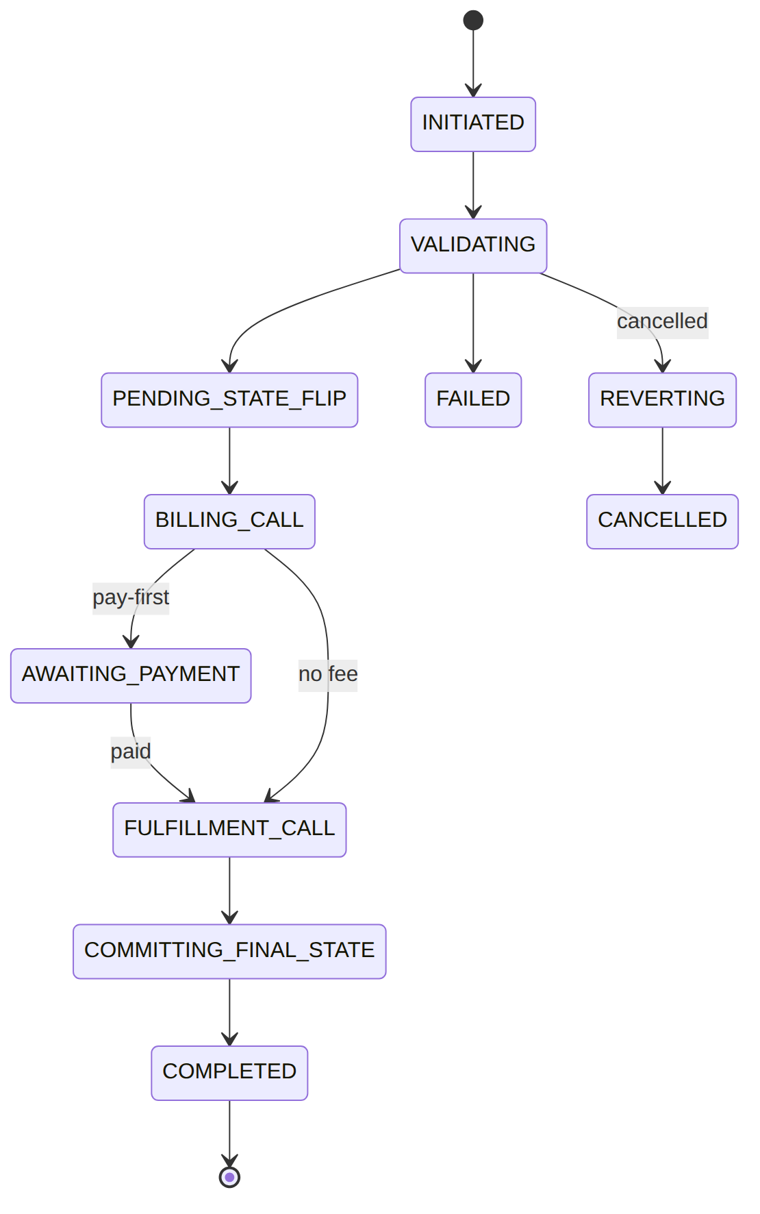
{ "operation_id":"op_1","operator_code":"WIK","subscription_id":"sub_124","operation_kind":"PAUSE","bpmn_process_key":"sub-pause","bpmn_process_instance_id":"pi_5501","initiating_actor_user_id":"u_csr2","initiating_actor_role":"CSR","idempotency_key":"pause-sub_124-1","idempotency_request_hash":"9f2c…ab","correlation_id":"corr_124","prior_subscription_status":"ACTIVE","current_state":"VALIDATING","final_state":null,"failure_reason_code":null,"failure_reason_detail":null,"cancel_reason_code":null,"cancel_actor_user_id":null,"input":{"reasonCode":"CUSTOMER_TRAVEL"},"started_at":"2026-06-20T09:00:00Z","completed_at":null,"duration_ms":null }
{ "operation_id":"op_2","operator_code":"WIK","subscription_id":"sub_123","operation_kind":"ACTIVATE","bpmn_process_key":"sub-activate","bpmn_process_instance_id":"pi_4400","initiating_actor_user_id":"u_sales1","initiating_actor_role":"SALES","idempotency_key":"activate-sub_123-1","idempotency_request_hash":"1a0e…77","correlation_id":"corr_123","prior_subscription_status":"PENDING_ACTIVATION","current_state":"COMPLETED","final_state":"COMPLETED","failure_reason_code":null,"failure_reason_detail":null,"cancel_reason_code":null,"cancel_actor_user_id":null,"input":{"packageRef":"pkg_triple"},"started_at":"2026-01-01T07:59:00Z","completed_at":"2026-01-01T08:00:00Z","duration_ms":60000 }
{ "operation_id":"op_3","operator_code":"WIK","subscription_id":"sub_125","operation_kind":"SUSPEND_NP","bpmn_process_key":"sub-suspend-np","bpmn_process_instance_id":"pi_6600","initiating_actor_user_id":null,"initiating_actor_role":"SYSTEM","idempotency_key":"suspendnp-sub_125-1","idempotency_request_hash":"77be…01","correlation_id":"corr_dun_2","prior_subscription_status":"ACTIVE","current_state":"COMPLETED","final_state":"COMPLETED","failure_reason_code":null,"failure_reason_detail":null,"cancel_reason_code":null,"cancel_actor_user_id":null,"input":{"dunningLevel":3},"started_at":"2026-06-10T00:00:00Z","completed_at":"2026-06-10T00:00:02Z","duration_ms":2000 }
{ "operation_id":"op_4","operator_code":"WIK","subscription_id":"sub_126","operation_kind":"RESTRICT","bpmn_process_key":"sub-restrict","bpmn_process_instance_id":null,"initiating_actor_user_id":"u_csr1","initiating_actor_role":"CSR","idempotency_key":"restrict-sub_126-1","idempotency_request_hash":"c4d2…9a","correlation_id":"corr_126","prior_subscription_status":"ACTIVE","current_state":"COMPLETED","final_state":"COMPLETED","failure_reason_code":null,"failure_reason_detail":null,"cancel_reason_code":null,"cancel_actor_user_id":null,"input":{"code":"OUTGOING_VOICE_BARRED"},"started_at":"2026-06-01T10:00:00Z","completed_at":"2026-06-01T10:00:01Z","duration_ms":1000 }
Read each row as a sentence — this data means this:
Row | What it means in plain English
op_1 | A PAUSE job still running on sub_124 (final_state=null, current_state=VALIDATING) — it blocks any other non-RESTRICT op, and if cancelled it rolls the sub back to prior_subscription_status=ACTIVE.
op_2 | A finished activation (final_state=COMPLETED), started by a salesperson (initiating_actor_role=SALES).
op_3 | A system-driven non-payment suspension (operation_kind=SUSPEND_NP, initiating_actor_user_id=null, role SYSTEM), now COMPLETED.
op_4 | A RESTRICT that completed — being non-exclusive, it could have run alongside another job.
The columns that did the work:
- In-flight or done = final_state (null = still running, the single-in-flight key; else COMPLETED/FAILED/CANCELLED); current_state is the fine-grained narration.
- Who started it = initiating_actor_user_id/initiating_actor_role (null user = SYSTEM).
- Rollback target = prior_subscription_status on cancel.
- Retry safety = idempotency_key/idempotency_request_hash make a duplicate return the same row.

Config tables (no-code knobs)
subscription_operation_config (composite PK operator_code+operation_kind) and subscription_pause_config (PK operator_code) are one-row-per-operator(-kind) policy. subscription_restriction is the restriction catalog (the activated bars, by restriction_code).
{ "subscription_operation_config":{ "operator_code":"WIK","operation_kind":"MIGRATION","default_bpmn_process_key":"sub-migration","operation_timeout_seconds":90,"billing_call_timeout_seconds":30,"fulfillment_call_timeout_seconds":60,"feature_flags":null,"enabled":false,"updated_by":"u_admin" } }
{ "subscription_operation_config":{ "operator_code":"WIK","operation_kind":"PAUSE","default_bpmn_process_key":"sub-pause-wik","operation_timeout_seconds":120,"billing_call_timeout_seconds":30,"fulfillment_call_timeout_seconds":60,"feature_flags":{"requireFee":true},"enabled":true,"updated_by":"u_admin" } }
{ "subscription_pause_config":{ "operator_code":"WIK","customer_self_service_enabled":true,"scheduled_pause_enabled":true,"max_future_scheduled_resume_days":90,"min_pause_hours":24,"customer_notification_enabled":true,"updated_by":"u_admin" } }
{ "subscription_restriction":{ "restriction_id":"srest_voice","operator_code":"WIK","restriction_code":"OUTGOING_VOICE_BARRED","name":"Outgoing voice barred","fulfillment_action":"AAA_RESTRICT_OUTGOING_VOICE","customer_self_service_eligible":false,"admin_only":true,"is_active":true } }
Read each row as a sentence — this data means this:
Row | What it means in plain English
operation_config · MIGRATION | This operator has migrations turned off (enabled=false) — so trigger rejects a MIGRATION outright.
operation_config · PAUSE | Pause is on (enabled=true) and runs a custom workflow (default_bpmn_process_key=sub-pause-wik), with a 120s timeout and a requireFee feature flag — pure config.
pause_config | The voluntary-pause policy: customers may self-serve (customer_self_service_enabled=true), schedule a resume up to 90 days out, pause for at least 24h, and get notified.
restriction · srest_voice | The "outgoing voice barred" bar: when applied, FUL-04 broadcasts fulfillment_action=AAA_RESTRICT_OUTGOING_VOICE; only an admin may set it (admin_only=true, customer_self_service_eligible=false).
The columns that did the work:
- On/off + which workflow = enabled + default_bpmn_process_key (a disabled kind is rejected by trigger).
- Pause policy knobs = the subscription_pause_config switches (self-service, scheduled window, minimum, notify).
- A restriction's effect + who may apply it = fulfillment_action + customer_self_service_eligible/admin_only.

3. Services
Service | Responsibility | Key methods
SubscriptionService | the only writer of the master | create, setPendingStatus (transient flip), transitionStatus (commit a rest state + timestamp + event)
OperationFramework | start + track every operation | trigger (idempotency + single-in-flight + process key + workflow + ledger), cancel (cancel instance + revert transient)
RestrictionService | partial-service restrictions (no status_code change) | non-exclusive

4. API surface
Method + path | Permission | Idempotent | →service
POST /api/subscriptions | subscription.create | yes | SubscriptionService::create
POST …/{id}/activate | subscription.activate | — | trigger('ACTIVATE')
POST …/{id}/{pause|resume|terminate|upgrade|downgrade|relocate|migrate|suspend-np} | subscription.manage | — | trigger(<KIND>)
POST/DELETE …/{id}/restrictions[/{code}] | subscription.manage | yes | RestrictionService
POST /api/subscription-operations/{op}/cancel | subscription.manage | — | OperationFramework::cancel
Worked request — OperationController@pause: POST /api/subscriptions/sub_124/pause {reason_code} → 202 {operation_id, operation_kind:'PAUSE', current_state:'VALIDATING'} (accepted; runs async).

5. Integration (events) — topic subscription.lifecycle
- Emits: Subscription{Created,Activated,Suspended,SuspendedForNonPayment,Paused,Resumed,Terminated, StatusChanged}, Subscription{Upgraded,Downgraded,Relocated,Migrated} (+*Rejected), SubscriptionRestriction{Added,Removed}, SubscriptionOperation{Started,Completed,Failed,Cancelled}.
- Consumers: Billing (cycle anchoring + subscriptions_* metrics), Reporting, Notification.
- Consumes: Billing InvoicePaid → ConfirmBillingIntentOnPayment confirms a pay-first intent + correlates sub-payment-confirmed to resume a parked operation.

6. Processes — with handler examples
- Trigger: OperationFramework::trigger() (process key from subscription_operation_config).
- Reconcile: SyncOperationFromProcess on ProcessInstanceEnded closes the ledger.
- Handlers: Validate{Operation,Activation,PackageChange,HomePassChange}, EnterPendingStatusHandler, Activate/Pause/Resume/Suspend/Terminate, Change{Package,HomePass}, PutActiveRestrictionsHandler, FulfillmentCallHandler, BillingIntentHandler, EquipmentPickupHandler, CreateShiftingWoHandler.
BillingIntentHandler (topic billing-intent): reads {subscriptionId, operationKind} + fee config; calls BillingIntentService::emit(); pay-first → parks AWAITING_PAYMENT; outputs {intentConfirmed}. ActivateHandler (topic activate): transitionStatus(ACTIVE) + emit; fail retryable:true.

7. Policy & config
subscription_operation_config (enable/disable/custom BPMN per kind), per-operation config tables, cycle cadence on the master.

8. Cross-module dependencies
- Calls → Provisioning (FulfillmentCallHandler), Billing (BillingIntentHandler), WorkOrder (CreateShiftingWoHandler).
- Called by → Fulfillment (ACTIVATE), Billing dunning (suspend-NP/restrict), ILM account sync.

9. Invariants & rules
Rule | Statement | Enforced in
R-SUB-WF-FW-1 | ≤ 1 in-flight non-RESTRICT op per subscription | trigger + partial unique index on final_state IS NULL
R-SUB-WF-FW-2 | RESTRICT is non-exclusive | trigger(exclusive:false)
R-SUB-WF-FW-3 | cancel reverts a transient PENDING_* to prior_subscription_status | cancel
R-SUB-WF-FW-7 | process key is config-resolved; disabled kind rejected | resolveProcessKey
(single writer) | only SubscriptionService writes status_code | by construction

10. Open items / deltas
- Some subscription_upgrade_config/pause_config fields are config-ahead-of-wiring (no gap today).
- Mid-cycle proration runs through the BillingIntent path, distinct from the cycle-fee proration in Billing/ChargeComputeService (see billing.md).
- SUB-WF flow ordering lives in process_definition data (the authored graph is the spec).

