Ticketing — As-Built Design
Capability codes: TCK (tickets + SLA), ASR (service requests) · Module path: Modules/Ticketing · Tests: TicketApi, Asr

1. Purpose & boundaries
- Owns: customer tickets (categories, SLA, comments, timeline) and ASRs (requests that spawn work).
- Does NOT own: field work (WorkOrder) — it links to it and resolves when it finishes.
- Job: capture, categorise, SLA-track and resolve customer issues; turn an ASR into a work order.

📖 Scenarios (service + Foundation involvement)

1. Create a ticket (SLA stamped from policy)
The story in plain English: A customer reports a fault. We open a ticket and immediately put a clock on it — a deadline to respond and a deadline to resolve — taken from the operator's SLA rules for that kind of problem. From that moment the ticket is being timed.
Who does what: POST /api/tickets {category:'NO_INTERNET', subcategory:'NO_SIGNAL', subscription_id} → TicketService::create opens the ticket OPEN and stamps the SLA due-times from the matching sla_policy. Emits TicketCreated.
Sample — a freshly created ticket:
{ "ticket_id":"tck_1","ticket_number":"TKT-2026-000101","category":"TECHNICAL","subcategory":"NO_SIGNAL","priority":"URGENT","status":"OPEN","queue":"noc-l1","sla_due_at":"2026-06-20T16:00:00Z","first_response_due_at":"2026-06-20T13:00:00Z","assignee_id":null }
Proven by TicketApiTest.

2. Escalate to a truck roll → linked WO
The story in plain English: Some problems cannot be fixed from a desk — they need a technician to visit. The agent raises a work order from the ticket, the two are linked, and the ticket goes into a "waiting on the field crew" holding state.
Who does what: POST …/{id}/work-orders creates a WO-01 support WO linked back (source_type=TICKET), writes a ticket_link (relation=CREATED_FROM_TICKET), and moves the ticket to WAITING_WORK_ORDER. Gated by the category's wo_allowed (TCK-3). Emits TicketWorkOrderCreated. Cross-module: WorkOrder. Proven by TicketApiTest::test_technical_ticket_raises_work_order.

3. WO finalized → auto-resolve (event-driven)
The story in plain English: The technician finishes the job. We do not make an agent re-open the ticket to close it — the work order finishing automatically resolves the waiting ticket. If the category needs a supervisor's eye, it parks in review instead; if the work was cancelled, the ticket goes back into the work queue.
Who does what: WorkOrderFinalized (outbox) → ResolveTicketOnWorkOrderFinalized → onWorkOrderFinalized moves the linked ticket out of WAITING_WORK_ORDER to RESOLVED (or, if the category's review_required is set, to UNDER_REVIEW). A WorkOrderCancelled instead sends it back to ASSIGNED/WAITING_INTERNAL with requires_review. Foundation: outbox listener.
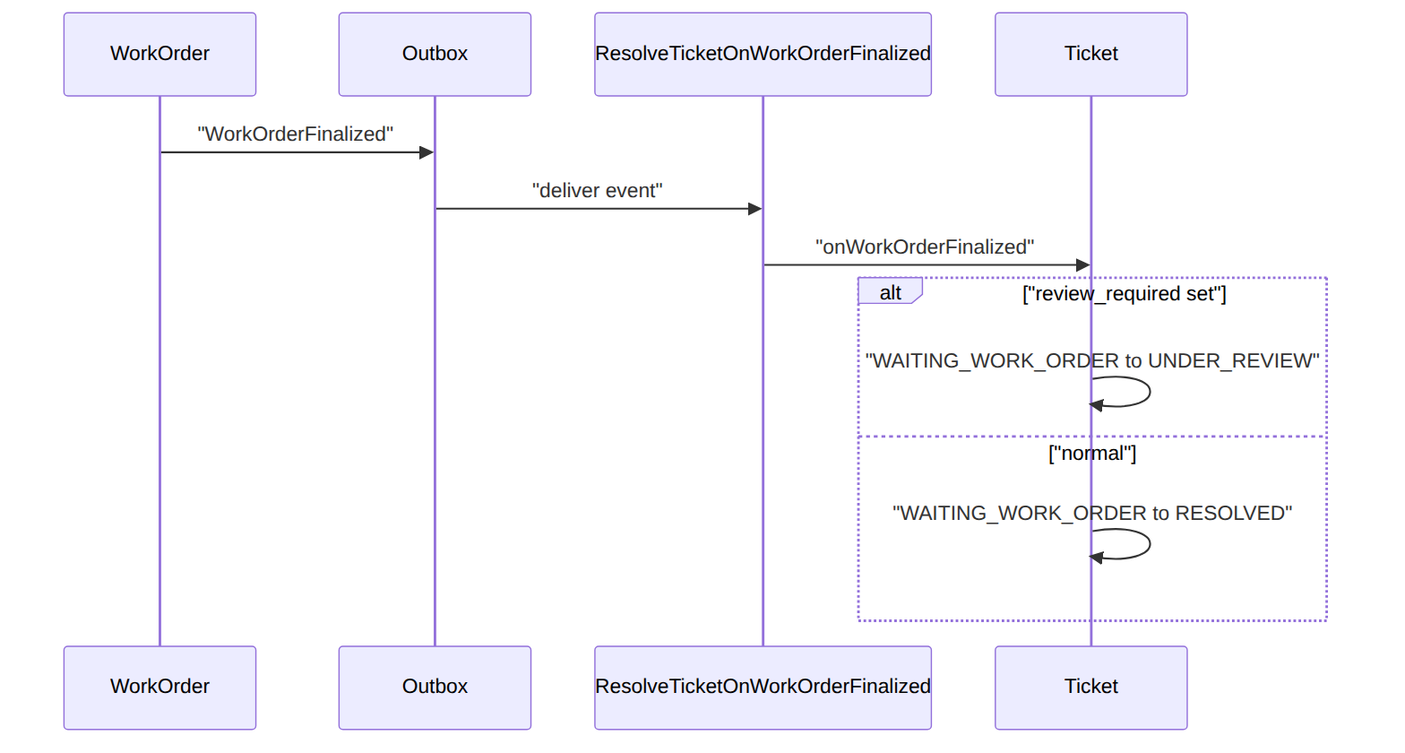
Proven by TicketApiTest::test_finalizing_the_work_order_resolves_the_ticket.

4. Conversation on the timeline
POST …/{id}/comments appends a ticket_comment + a ticket_timeline row (append-only audit).

5. ASR — a typed service request (idempotent)
The story in plain English: Some intake comes in as a structured "service request" rather than a free ticket. We validate its type, run the operator's routing rules to pick a queue and priority, and create a ticket from it. Certain technical-trouble requests automatically spin up a field work order.
Who does what: POST /api/asr (idempotent) → AsrService::create validates an asr_type, applies rules.asr.routing (queue + priority + auto-actions), and creates an ASR-typed ticket; a TECHNICAL_TROUBLE whose routing sets autoCreateWorkOrder auto-raises a support WO. Proven by AsrTest::test_technical_trouble_routes_to_noc_and_raises_work_order.

6. SLA breach surfaces on the NOC
Past-due open tickets appear in ItOps GET /api/noc/sla-overdue (reads ticket SLA timestamps).

7. Assign to an agent
POST …/{id}/assign records the owner; the timeline captures the change.

8. Category drives SLA + routing
The ticket_category_catalog fixes the SLA matrix + default priority — an operator tunes SLAs as data.

2. Data model — ≥4 complete sample rows + readings per table
Completeness: each row lists every domain column (nullables shown as null). The string primary key shown is the real one; created_at/updated_at (and ticket_timeline's created_at, which uses the DB default) are omitted by convention. sla_policy/ticket_category_catalog show their natural keys (the surrogate auto-increment id on sla_policy is omitted as it has a composite key).

ticket · status: OPEN|TRIAGED|ASSIGNED|IN_PROGRESS|WAITING_CUSTOMER|WAITING_INTERNAL|WAITING_WORK_ORDER|UNDER_REVIEW|RESOLVED|CLOSED|CANCELLED (PENDING_WO is a legacy alias of WAITING_WORK_ORDER) · priority: LOW|NORMAL|HIGH|URGENT · category: TECHNICAL|BILLING|INFORMATION|COMPLAINT|SERVICE_REQUEST · asr_type: TECHNICAL_TROUBLE|INFORMATION_REQUEST|COMPLAINT|SERVICE_REQUEST
{ "ticket_id":"tck_1","ticket_number":"TKT-2026-000101","operator_code":"WIK","category":"TECHNICAL","asr_type":"TECHNICAL_TROUBLE","subcategory":"NO_SIGNAL","priority":"URGENT","status":"OPEN","customer_id":"cust_1","account_id":"acct_1","subscription_id":"sub_1","subject":"No signal since morning","description":"Modem all red lights","queue":"noc-l1","assignee_id":null,"sla_due_at":"2026-06-20T16:00:00Z","first_response_due_at":"2026-06-20T13:00:00Z","first_response_at":null,"work_order_id":null,"resolution_code":null,"reopened_count":0,"requires_review":false,"resolution_note":null,"opened_by":"agent_7","resolved_at":null,"closed_at":null,"cancelled_at":null }
{ "ticket_id":"tck_2","ticket_number":"TKT-2026-000102","operator_code":"WIK","category":"BILLING","asr_type":"INFORMATION_REQUEST","subcategory":null,"priority":"NORMAL","status":"IN_PROGRESS","customer_id":"cust_2","account_id":"acct_2","subscription_id":null,"subject":"Invoice query","description":null,"queue":"billing","assignee_id":"agent_3","sla_due_at":"2026-06-22T09:00:00Z","first_response_due_at":"2026-06-20T17:00:00Z","first_response_at":"2026-06-20T15:00:00Z","work_order_id":null,"resolution_code":null,"reopened_count":0,"requires_review":false,"resolution_note":null,"opened_by":"agent_3","resolved_at":null,"closed_at":null,"cancelled_at":null }
{ "ticket_id":"tck_3","ticket_number":"TKT-2026-000103","operator_code":"WIK","category":"TECHNICAL","asr_type":"TECHNICAL_TROUBLE","subcategory":"NO_SIGNAL","priority":"HIGH","status":"RESOLVED","customer_id":"cust_3","account_id":"acct_3","subscription_id":"sub_3","subject":"Intermittent drops","description":null,"queue":"noc-l1","assignee_id":"agent_7","sla_due_at":"2026-06-19T16:00:00Z","first_response_due_at":"2026-06-19T13:00:00Z","first_response_at":"2026-06-19T12:30:00Z","work_order_id":"wo_2","resolution_code":"FIXED_ON_SITE","reopened_count":1,"requires_review":false,"resolution_note":"Replaced ONT","opened_by":"agent_7","resolved_at":"2026-06-19T15:00:00Z","closed_at":null,"cancelled_at":null }
{ "ticket_id":"tck_4","ticket_number":"TKT-2026-000104","operator_code":"WIK","category":"COMPLAINT","asr_type":"COMPLAINT","subcategory":null,"priority":"LOW","status":"CLOSED","customer_id":"cust_4","account_id":"acct_4","subscription_id":null,"subject":"Rude agent","description":null,"queue":"complaints","assignee_id":"sup_2","sla_due_at":"2026-06-18T16:00:00Z","first_response_due_at":"2026-06-18T13:00:00Z","first_response_at":"2026-06-18T12:00:00Z","work_order_id":null,"resolution_code":"APOLOGY_ISSUED","reopened_count":0,"requires_review":true,"resolution_note":"Escalated, apology sent","opened_by":"agent_1","resolved_at":"2026-06-18T14:00:00Z","closed_at":"2026-06-19T09:00:00Z","cancelled_at":null }
The ticket's own lifecycle (the holding state WAITING_WORK_ORDER is where a ticket sits while a linked field job runs; WAITING_CUSTOMER/WAITING_INTERNAL are other holds):
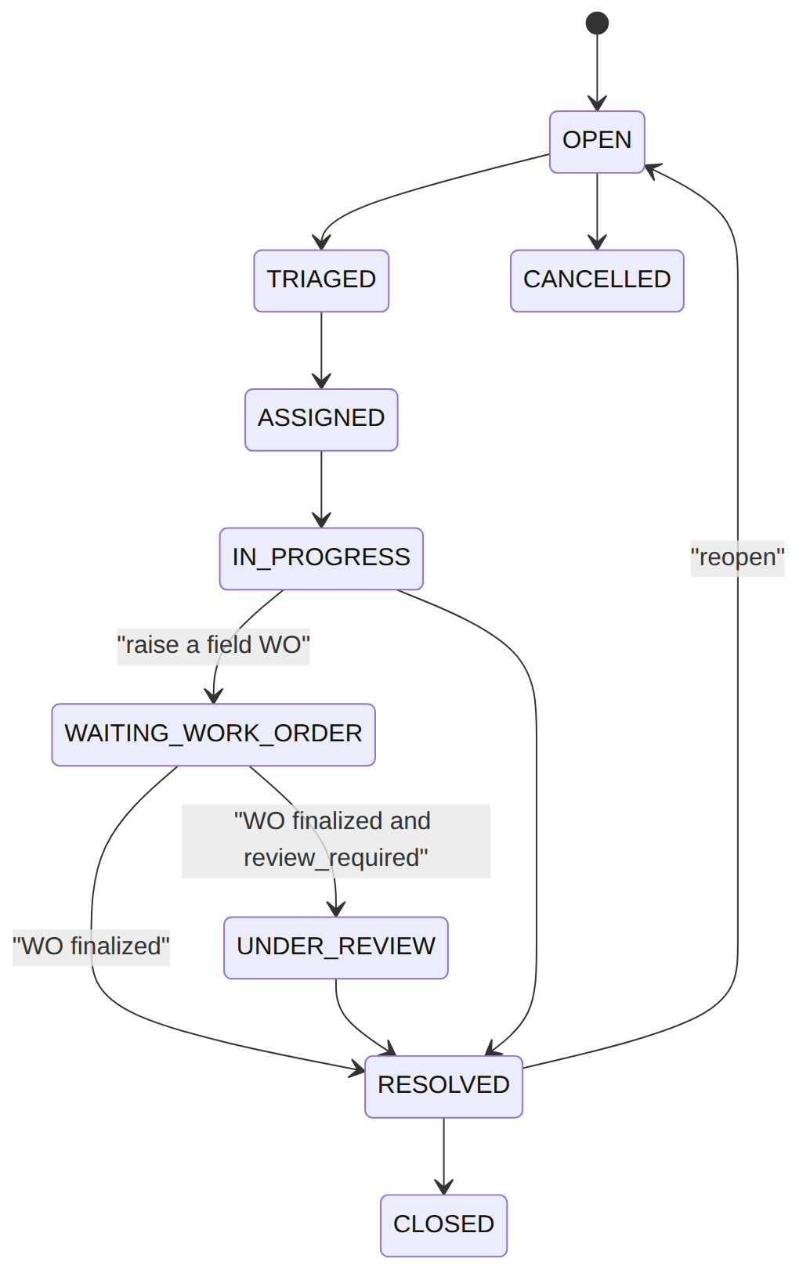
Read each row as a sentence — this data means this:
Row | What it means in plain English
tck_1 | A brand-new URGENT "no signal" technical ticket: it's OPEN, nobody's picked it up yet (assignee_id=null, first_response_at=null), and its clocks are already ticking (sla_due_at/first_response_due_at stamped at create).
tck_2 | A billing info-request, now IN_PROGRESS with agent_3 working it; the agent has already responded once (first_response_at is filled, before first_response_due_at), so the response SLA was met.
tck_3 | A technical ticket that's RESOLVED: it was fixed via a linked field job (work_order_id=wo_2, resolution_code=FIXED_ON_SITE, note "Replaced ONT"), and it had bounced once before (reopened_count=1).
tck_4 | A complaint that's already CLOSED (resolved_at then closed_at), but flagged for a supervisor gate (requires_review=true, resolution_code=APOLOGY_ISSUED).
The columns that did that work:
- Where it is = status (the resolution lifecycle), plus assignee_id and the *_at timestamps showing who has it and what's happened.
- SLA clocks = sla_due_at/first_response_due_at stamped at create from the matching sla_policy; first_response_at records when the response clock was actually met. A past-due OPEN ticket is what the NOC SLA-overdue view surfaces.
- Specialisation = asr_type tags the ASR-01..04 family; requires_review is the supervisor gate; reopened_count counts re-opens.

ticket_category_catalog (operator category config) & sla_policy (response-hours matrix)
{ "operator_code":"WIK","category_code":"NO_INTERNET","display_name":"No internet","type_code":"TECHNICAL_SUPPORT","default_priority":"HIGH","default_queue":"TECH_SUPPORT_L1","default_asr_type":"TECHNICAL_TROUBLE","default_sla_policy":null,"wo_allowed":true,"default_wo_kind":"SUPPORT","review_required":false,"active":true }
{ "operator_code":"WIK","category_code":"BILLING_DISPUTE","display_name":"Billing dispute","type_code":"BILLING_COMPLAINT","default_priority":"NORMAL","default_queue":"BILLING_QUEUE","default_asr_type":"COMPLAINT","default_sla_policy":null,"wo_allowed":false,"default_wo_kind":null,"review_required":false,"active":true }
{ "operator_code":"WIK","category_code":"INSTALL_INCOMPLETE","display_name":"Install incomplete","type_code":"INSTALLATION_FOLLOWUP","default_priority":"HIGH","default_queue":"TECH_SUPPORT_L1","default_asr_type":"SERVICE_REQUEST","default_sla_policy":null,"wo_allowed":true,"default_wo_kind":"SUPPORT","review_required":true,"active":true }
{ "operator_code":"WIK","category_code":"GENERAL_INQUIRY","display_name":"General inquiry","type_code":"GENERAL_INQUIRY","default_priority":"LOW","default_queue":"CARE_QUEUE","default_asr_type":"INFORMATION_REQUEST","default_sla_policy":null,"wo_allowed":false,"default_wo_kind":null,"review_required":false,"active":false }
{ "operator_code":"WIK","category":"NO_INTERNET","priority":"URGENT","response_hours":1 }
{ "operator_code":"WIK","category":"BILLING_DISPUTE","priority":"NORMAL","response_hours":8 }
{ "operator_code":"WIK","category":null,"priority":"HIGH","response_hours":4 }
{ "operator_code":null,"category":null,"priority":"NORMAL","response_hours":24 }
Read each row as a sentence — this data means this:
The category catalog (operator config — picking a category pre-fills a new ticket's defaults):
Row | What it means in plain English
NO_INTERNET | A "no internet" technical category: new tickets default to HIGH priority in the TECH_SUPPORT_L1 queue, may raise a field WO (wo_allowed=true, default_wo_kind=SUPPORT), and a finalized WO does not need review (review_required=false). It's live (active=true).
BILLING_DISPUTE | A billing-complaint category, NORMAL/BILLING_QUEUE, that can't spawn a WO (wo_allowed=false) — billing disputes stay desk-side.
INSTALL_INCOMPLETE | An install follow-up, HIGH/TECH_SUPPORT_L1, that may raise a WO and does require review afterwards (review_required=true), so a finalized WO parks the ticket in UNDER_REVIEW.
GENERAL_INQUIRY | A retired category (active=false) — it no longer appears as a choice; shown here only to illustrate the flag.
The SLA policy (resolves response_hours by most-specific match):
Row | What it means in plain English
NO_INTERNET + URGENT | The most specific rule: an urgent no-internet ticket must get a first response within 1 hour.
BILLING_DISPUTE + NORMAL | A normal billing dispute gets 8 hours.
(any) + HIGH | A priority-only fallback: any HIGH ticket with no category match gets 4 hours.
(any) + (any) | The all-null operator default — anything else gets 24 hours.
The columns that did that work:
- Catalog defaults = default_priority/default_queue/default_asr_type pre-fill a ticket; wo_allowed (+ default_wo_kind) gates TCK-3; review_required decides the UNDER_REVIEW park; type_code is the operator type family (distinct from default_asr_type); active=false retires a category.
- SLA match order = category+priority > priority-only > the all-null default; editing rows tunes SLAs with no code.

ticket_comment / ticket_timeline (append-only)
{ "id":"tc_1","ticket_id":"tck_1","author_id":"agent_7","visibility":"INTERNAL","body":"Dispatching tech.","internal":true }
{ "id":"tc_2","ticket_id":"tck_1","author_id":"agent_7","visibility":"CUSTOMER_VISIBLE","body":"A technician is on the way.","internal":false }
{ "id":"tc_3","ticket_id":"tck_2","author_id":"cust_2","visibility":"CUSTOMER_VISIBLE","body":"Any update?","internal":false }
{ "id":"tc_4","ticket_id":"tck_3","author_id":"agent_7","visibility":"INTERNAL","body":"ONT swapped on site.","internal":true }
{ "id":"tl_1","ticket_id":"tck_1","event_type":"CREATED","from_status":null,"to_status":"OPEN","actor_id":"agent_7","meta":null }
{ "id":"tl_2","ticket_id":"tck_1","event_type":"ASSIGNED","from_status":"OPEN","to_status":"ASSIGNED","actor_id":"sup_1","meta":{"assignee":"agent_7"} }
{ "id":"tl_3","ticket_id":"tck_3","event_type":"WorkOrderCreatedFromTicket","from_status":"ASSIGNED","to_status":"WAITING_WORK_ORDER","actor_id":"agent_7","meta":{"workOrderId":"wo_2"} }
{ "id":"tl_4","ticket_id":"tck_3","event_type":"LINKED_WORK_ORDER_FINALIZED","from_status":"WAITING_WORK_ORDER","to_status":"RESOLVED","actor_id":null,"meta":{"workOrderId":"wo_2","finalReason":"FIXED_ON_SITE"} }
Read each row as a sentence — this data means this:
Comments (the conversation):
Row | What it means in plain English
tc_1 | An internal-only note on tck_1 from agent_7 — "Dispatching tech." (visibility=INTERNAL, internal=true), so the customer never sees it.
tc_2 | A customer-visible reply on tck_1 — "A technician is on the way." (visibility=CUSTOMER_VISIBLE).
tc_3 | The customer themself (cust_2) asking "Any update?" on tck_2 — customer-visible.
tc_4 | An internal note on tck_3 — "ONT swapped on site."
Timeline (the immutable status history):
Row | What it means in plain English
tl_1 | tck_1 was CREATED by agent_7 (from_status=null → to_status=OPEN).
tl_2 | tck_1 was ASSIGNED by sup_1 (OPEN → ASSIGNED), with meta recording the new assignee (agent_7).
tl_3 | tck_3 raised a field WO (ASSIGNED → WAITING_WORK_ORDER), meta linking workOrderId=wo_2.
tl_4 | tck_3's linked WO finalized (WAITING_WORK_ORDER → RESOLVED) — a system action (actor_id=null), meta carrying the finalReason=FIXED_ON_SITE.
The columns that did that work:
- Conversation gating = visibility (INTERNAL vs CUSTOMER_VISIBLE) and the legacy internal flag decide who sees a comment.
- Audit trail = each timeline row carries the from_status/to_status transition + actor_id + meta; this is the history a supervisor reads.

ticket_link (multi-entity links — TCK-2) · entity_type: SUBSCRIPTION|INVOICE|WORK_ORDER|TICKET|CUSTOMER|… · relation: RELATED|DUPLICATE_OF|CAUSED_BY|CREATED_FROM_TICKET|…
{ "link_id":"tlnk_1","ticket_id":"tck_3","entity_type":"WORK_ORDER","entity_ref":"wo_2","relation":"CREATED_FROM_TICKET","linked_by":"agent_7" }
{ "link_id":"tlnk_2","ticket_id":"tck_1","entity_type":"SUBSCRIPTION","entity_ref":"sub_1","relation":"RELATED","linked_by":"agent_7" }
{ "link_id":"tlnk_3","ticket_id":"tck_2","entity_type":"INVOICE","entity_ref":"inv_56","relation":"RELATED","linked_by":"agent_3" }
{ "link_id":"tlnk_4","ticket_id":"tck_4","entity_type":"TICKET","entity_ref":"tck_2","relation":"DUPLICATE_OF","linked_by":"sup_2" }
Read each row as a sentence — this data means this:
Row | What it means in plain English
tlnk_1 | tck_3 is linked to work order wo_2 with relation CREATED_FROM_TICKET — the auditable join inserted when the ticket raised that WO.
tlnk_2 | tck_1 is linked to subscription sub_1 as merely RELATED (the affected service).
tlnk_3 | tck_2 is linked to invoice inv_56 as RELATED (the invoice being queried).
tlnk_4 | tck_4 is marked a DUPLICATE_OF ticket tck_2 — a ticket-to-ticket link.
The columns that did that work:
- What it points at = entity_type + entity_ref; how = relation.
- The TCK-2 rule = a ticket must reference at least one business entity — either a column on ticket (customer/account/subscription/work_order) or a ticket_link row, or be an explicit internal category.
- Idempotent = the (ticket_id, entity_type, entity_ref, relation) tuple is unique (via updateOrInsert).

ticket_attachment (file references — TCK-9) · visibility: INTERNAL|CUSTOMER_VISIBLE
{ "attachment_id":"tatt_1","ticket_id":"tck_1","file_id":"file_77","file_name":"modem.jpg","content_type":"image/jpeg","size_bytes":48211,"visibility":"INTERNAL","uploaded_by":"agent_7" }
{ "attachment_id":"tatt_2","ticket_id":"tck_3","file_id":"file_78","file_name":"site-report.pdf","content_type":"application/pdf","size_bytes":102400,"visibility":"CUSTOMER_VISIBLE","uploaded_by":"agent_7" }
{ "attachment_id":"tatt_3","ticket_id":"tck_2","file_id":"file_79","file_name":"invoice-scan.png","content_type":"image/png","size_bytes":20480,"visibility":"INTERNAL","uploaded_by":"cust_2" }
{ "attachment_id":"tatt_4","ticket_id":"tck_4","file_id":"file_80","file_name":"complaint.txt","content_type":null,"size_bytes":null,"visibility":"INTERNAL","uploaded_by":"sup_2" }
Read each row as a sentence — this data means this:
Row | What it means in plain English
tatt_1 | An internal JPEG ("modem.jpg", 48211 bytes) on tck_1, uploaded by agent_7 — only staff can see it (visibility=INTERNAL).
tatt_2 | A customer-visible PDF site report on tck_3 (visibility=CUSTOMER_VISIBLE), so self-care can open it.
tatt_3 | A PNG invoice scan on tck_2 uploaded by the customer (cust_2), kept INTERNAL.
tatt_4 | A text file on tck_4 where the store gave back no content_type/size_bytes (both null) — those are taken from the file store, not the caller.
The columns that did that work:
- Reference only = TCK keeps a file_id; the binary lives in FOUNDATION_FILE_STORAGE (file_object). addAttachment resolves file_id there (404 if missing) and copies the authoritative file_name/content_type/size_bytes from the store rather than trusting the caller (TCK-9: object keys carry no PII).
- Who can see it = visibility gates whether self-care can open the file.
A gap-free human ticket_number is minted by the per-(operator, fiscal_year) ticket_number_sequence counter at create.

3. Services
Service | Responsibility
TicketService | ticket lifecycle (create/assign/comment/addAttachment/linkEntity/createWorkOrder/resolve/reopen/cancel/close), SLA + first-response capture, gap-free ticket_number, WO linkage, onWorkOrderFinalized/onWorkOrderCancelled
AsrService::create | ASR-typed intake; applies rules.asr.routing, creates the ticket, auto-raises a WO when routing says so

4. API surface
/api/tickets (+ /{id}/assign, /comments, /attachments, /links, /work-orders, /resolve, /reopen, /cancel, /close), /api/asr, /api/sla-policies (GET + POST). Permissions: ticket.read (reads), ticket.create (create/comment/attach/asr), ticket.assign (assign), ticket.manage (links/WO/resolve/reopen/cancel/close/SLA-policy write); create + raise-WO + ASR are idempotency-guarded.

5. Integration (events) — topic ticketing.case
- Emits: TicketCreated, TicketAssigned, TicketStatusChanged, TicketResolved, TicketClosed, TicketWorkOrderCreated, TicketReopened, TicketCancelled. (ASR intake emits no separate event — it just creates a ticket, so the ticket events above fire.)
- Consumes: WorkOrderFinalized → resolve the linked ticket; WorkOrderCancelled → send it back for review (ResolveTicketOnWorkOrderFinalized).

6. Processes
Service-level; ASR may start a fulfillment/WO flow.

7. Policy & config
ticket_category_catalog + sla_policy (operator SLA matrix), per-category routing — data.

8. Cross-module dependencies
- Calls → WorkOrder (support WO from a ticket). Reacts to → WorkOrder finalize (auto-resolve); Notification for customer updates.

9. Invariants & rules
Rule | Statement | Enforced in
SLA-on-create | ticket SLA captured from the category policy | TicketService::create
WO-resolve | a finalized linked WO resolves its ticket | ResolveTicketOnWorkOrderFinalized

10. Open items / deltas
- Unified interaction timeline across modules (CUST-INT-01) is a projection opportunity (additive).

