Workflow — As-Built Design (the process engine)
Module path: Modules/Workflow · Test: WorkflowEngineTest · See 00_SPINE.md §4 — this doc adds the engine internals behind that pattern.

1. Purpose & boundaries
- Owns: the native process engine (FOUNDATION_CAMUNDA): process definitions (graphs), instances, external tasks, message subscriptions, timers, user tasks — and the Studio API to author/validate/ deploy flows.
- Does NOT own: the business steps — those are TaskHandlers each module registers.
- Job: run config-defined, multi-step, retry-safe processes. new flow = compose registered topics; new step = register one handler.
The big picture in plain English: think of a flow as a recipe drawn as boxes and arrows. The engine keeps the recipe (a process_definition), starts a copy of it for each subscription or order (a process_instance), and for every "do something" box it drops a ticket on a queue (a workflow_external_task). A background worker picks tickets off the queue, runs the matching handler, and tells the engine to move to the next box. When a box needs to wait — for a message, a timer, or a human — the flow parks until that wait is satisfied, then resumes exactly where it left off.

📖 Scenarios (service + Foundation involvement)

1. Author → validate → deploy a flow (no code for the flow)
The story in plain English: An author draws a flow in the Studio — boxes (steps) joined by arrows. Before it can run, the system checks the drawing makes sense: every step points at a real handler, every input is wired, nothing dangles. Only then can the flow be deployed and used.
Who does what:
- POST /api/workflow/definitions saves the node graph as a process_definition (status DRAFT).
- POST …/validate runs the graph validator — every node topic must be registered in TaskRegistry, inputs must be wired, no dangling nodes or bad edges.
- POST …/deploy flips the definition to DEPLOYED — now it can start instances.
Proven by WorkflowEngineTest.

2. Start → external task → worker drains it → completes
The story in plain English: Something kicks off a flow (say, a new subscription). The engine creates a running instance and, for the first "do something" step, drops a ticket on a work queue. A background worker grabs the ticket, runs the real step, and reports back — and the engine advances the flow to the next step.
Who does what:
- WorkflowEngine::start('sub-activate', businessKey, vars) creates a process_instance (RUNNING) plus a workflow_external_task (CREATED) for each service node it reaches.
- The worker command sophix:workflow:work fetch-and-locks a CREATED task by topic (status → LOCKED, stamps worker_id + locked_until).
- It runs the TaskHandler for that topic, then completeExternalTask marks the task COMPLETED and advances to the next node (which may create the next CREATED task).
Sample — a task as the worker drains it:
{ "task_id":"et_1","instance_id":"pi_1","node_id":"activate","topic":"activate","status":"LOCKED","worker_id":"wf-w-1","locked_until":"2026-06-20T10:01:00Z","retries":3 }
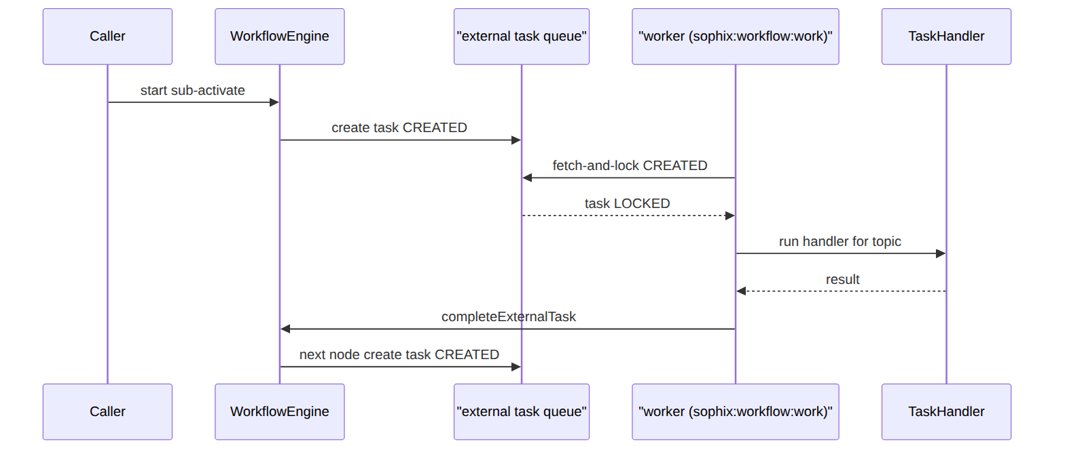

3. Worker drains a task (the lock detail)
sophix:workflow:work fetch-and-locks CREATED tasks by topic, runs the handler, completeExternalTask advances to the next node. (See scenario 2 for the full loop.)

4. Exclusive gateway branches on a variable
The story in plain English: A flow reaches a fork in the road. Which way it goes depends on a value it is carrying — for example, "was KYC approved?". The engine reads that value and picks the matching arrow.
Who does what: A gateway routes on {kycApproved: true} vs default — the engine evaluates the condition against the instance variables. Proven by WorkflowEngineTest::test_exclusive_gateway_branches_on_variables.

5. Input mapping wires an upstream output into a downstream input
The story in plain English: An early step produces a value (say a provisioning reference). A later step needs it. Input mapping is the wire that carries that output forward into the later step's input.
Who does what: A node's declared output ({provisioningRef}) is mapped into a later node's input. Proven by WorkflowEngineTest::test_input_mapping_wires_an_upstream_output_into_a_downstream_input.

6. Message catch parks → correlate resumes
The story in plain English: A flow reaches a step that says "wait until the install is finished." It pauses there. Later, when the install really finishes elsewhere, a message arrives with the matching key and the flow wakes up and carries on.
Who does what:
- A messageCatch node creates a workflow_message_subscription keyed by message_name + correlation_key; the instance parks (SUSPENDED).
- correlateMessage('ful-install-finalized', businessKey, vars) — e.g. from a WorkOrderFinalized listener — matches the subscription and resumes the flow (RUNNING).
Sample — the parked subscription:
{ "id":11,"instance_id":"pi_3","node_id":"await-install","message_name":"ful-install-finalized","correlation_key":"order_2" }

7. Timer fires
A timer node creates a workflow_timer; sophix:workflow:tick fires due timers (when fire_at passes) and reaps dead locks.

8. Strict outputs rejects an undeclared key
The story in plain English: A step is only allowed to hand back the values it promised. If a handler tries to sneak in an extra value it never declared, the engine refuses it — keeping the data flowing through the flow honest and predictable.
Who does what: With SOPHIX_WORKFLOW_STRICT_OUTPUTS, a handler returning a key it didn't declare is rejected. Proven by WorkflowEngineTest::test_strict_outputs_rejects_a_handler_that_returns_undeclared_keys.

(bonus) 9. Reconcile on end
ProcessInstanceEnded lets a module close its ledger (e.g. Subscription SyncOperationFromProcess).

2. Data model — ≥4 sample rows + readings

process_instance · status: RUNNING|COMPLETED|FAILED|CANCELLED|SUSPENDED & workflow_external_task · status: CREATED|LOCKED|COMPLETED|FAILED|INCIDENT
{ "instance_id":"pi_1","definition_id":"pdef_1","process_key":"sub-activate","definition_version":1,"operator_code":"WIK","business_key":"sub_1","variables":{"subscriptionId":"sub_1"},"status":"RUNNING","active_nodes":["activate"],"correlation_id":"sub_1","error_message":null,"started_at":"2026-06-20T10:00:00Z","ended_at":null }
{ "instance_id":"pi_2","definition_id":"pdef_3","process_key":"ful-order-capture","definition_version":1,"operator_code":"WIK","business_key":"order_1","variables":{"orderId":"order_1"},"status":"COMPLETED","active_nodes":[],"correlation_id":"order_1","error_message":null,"started_at":"2026-06-20T09:00:00Z","ended_at":"2026-06-20T09:05:00Z" }
{ "instance_id":"pi_6","definition_id":"pdef_1","process_key":"sub-activate","definition_version":1,"operator_code":"WIK","business_key":"sub_9","variables":{"subscriptionId":"sub_9"},"status":"FAILED","active_nodes":["activate"],"correlation_id":"sub_9","error_message":"NMS rejected provisioning","started_at":"2026-06-20T10:10:00Z","ended_at":null }
{ "et_1":{ "task_id":"et_1","instance_id":"pi_1","node_id":"activate","topic":"activate","operator_code":"WIK","business_key":"sub_1","variables":{"subscriptionId":"sub_1"},"status":"LOCKED","worker_id":"wf-w-1","locked_until":"2026-06-20T10:01:00Z","retries":3,"error_message":null,"completed_at":null } }
{ "et_2":{ "task_id":"et_2","instance_id":"pi_1","node_id":"billing-intent","topic":"billing-intent","operator_code":"WIK","business_key":"sub_1","variables":null,"status":"CREATED","worker_id":null,"locked_until":null,"retries":3,"error_message":null,"completed_at":null } }
Read each row as a sentence — this data means this:
Row | What it means in plain English
pi_1 | A subscription-activation flow for sub_1 (business_key) is live (status=RUNNING) and parked at the activate node (active_nodes); it carries subscriptionId=sub_1 in variables.
pi_2 | An order-capture flow for order_1 finished cleanly (status=COMPLETED, active_nodes=[], ended_at set, error_message=null).
pi_6 | Another activation flow, for sub_9, is a stuck activation — it FAILED because the NMS rejected provisioning (status=FAILED, see error_message), still pointing at the activate node.
et_1 | The work ticket for pi_1's activate node is claimed: worker wf-w-1 holds it (status=LOCKED, worker_id) until locked_until, with 3 retries left; its topic=activate routes it to a handler.
et_2 | pi_1's next ticket (billing-intent) is runnable but unclaimed (status=CREATED, worker_id=null) — no worker has picked it up yet.
The columns that did the work:
- What flow / what it's about = definition_id+definition_version (the flow) and business_key (the subscription/order it runs for).
- Live, done, or broken = status; active_nodes shows where it's parked and error_message why it failed.
- A ticket's state = status (CREATED=runnable, LOCKED=claimed by worker_id until locked_until); a dead worker's lock is reaped by :tick, decrementing retries (0 → INCIDENT).
Instance lifecycle — one running flow, from start to finish:
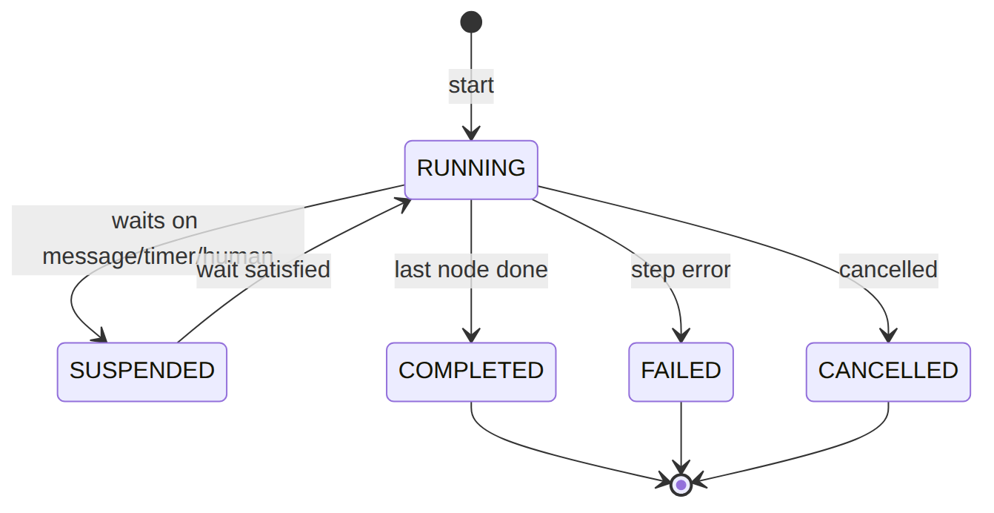
External-task lifecycle — one ticket on the queue (note INCIDENT when retries run out):
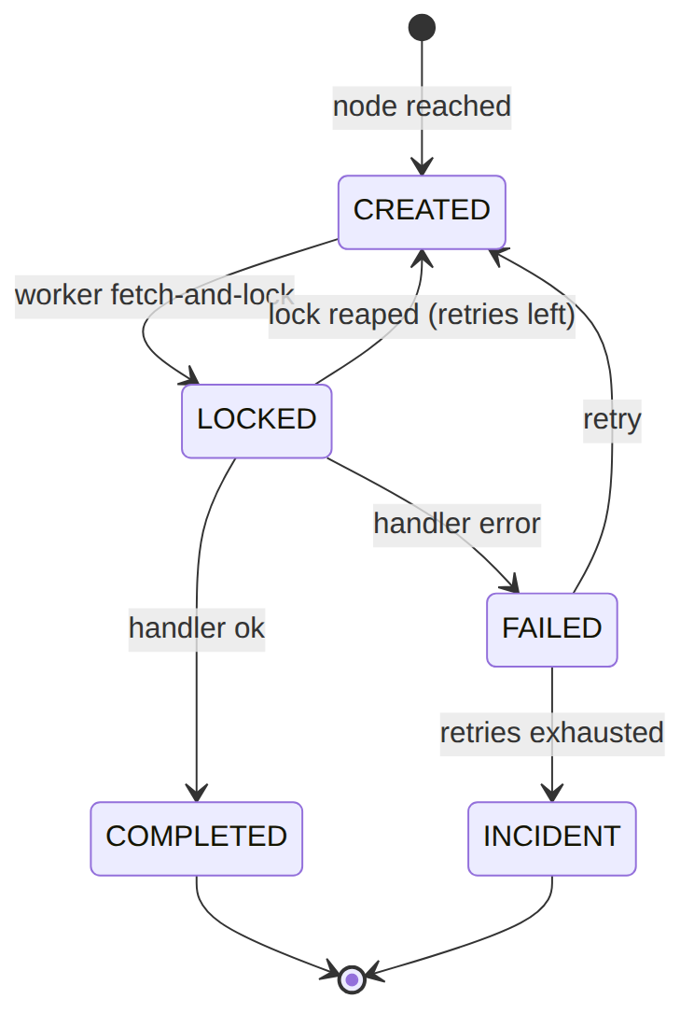

process_definition (the flow graph, versioned + per-operator override)
{ "definition_id":"pdef_1","process_key":"sub-activate","version":1,"operator_code":null,"name":"Subscription Activation","description":"Default activation flow","graph":{"nodes":[],"edges":[]},"status":"DEPLOYED","created_by":"u_studio","deployed_at":"2026-06-01T00:00:00Z" }
{ "definition_id":"pdef_2","process_key":"sub-activate","version":2,"operator_code":"WIK","name":"Subscription Activation (WIK)","description":"WIK override","graph":{"nodes":[],"edges":[]},"status":"DEPLOYED","created_by":"u_studio","deployed_at":"2026-06-10T00:00:00Z" }
{ "definition_id":"pdef_3","process_key":"ful-order-capture","version":1,"operator_code":null,"name":"Order Capture","description":null,"graph":{"nodes":[],"edges":[]},"status":"DEPLOYED","created_by":"u_studio","deployed_at":"2026-06-02T00:00:00Z" }
{ "definition_id":"pdef_4","process_key":"sub-pause","version":1,"operator_code":null,"name":"Subscription Pause","description":null,"graph":{"nodes":[],"edges":[]},"status":"DRAFT","created_by":"u_studio","deployed_at":null }
Read each row as a sentence — this data means this:
Row | What it means in plain English
pdef_1 | The platform-default sub-activate flow (operator_code=null), version 1, live (status=DEPLOYED) — it can start instances.
pdef_2 | A WIK-specific override of the same sub-activate flow (operator_code=WIK, version 2) — an operator forked the flow without code; also DEPLOYED.
pdef_3 | The platform-default ful-order-capture flow (operator_code=null), DEPLOYED.
pdef_4 | A sub-pause flow that is still being authored (status=DRAFT, deployed_at=null) — it cannot start instances yet.
The columns that did the work:
- Whose flow = operator_code (null = platform default, WIK = operator override of the same process_key).
- Can it run = status — only DEPLOYED definitions start instances.
- The flow itself = graph, the React-Flow node/edge JSON authored in the Studio.

workflow_message_subscription / workflow_timer · status: PENDING|FIRED|CANCELLED / workflow_user_task · status: OPEN|CLAIMED|COMPLETED|CANCELLED
{ "msg":{ "id":11,"instance_id":"pi_3","node_id":"await-install","message_name":"ful-install-finalized","correlation_key":"order_2" } }
{ "msg":{ "id":12,"instance_id":"pi_7","node_id":"await-kyc","message_name":"kyc-decision","correlation_key":"sub_4" } }
{ "timer":{ "id":21,"instance_id":"pi_4","node_id":"grace-window","fire_at":"2026-06-21T00:00:00Z","status":"PENDING" } }
{ "ut":{ "task_id":"ut_1","instance_id":"pi_5","node_id":"manual-review","name":"Manual review","candidate_group":"billing-lead","assignee":null,"variables":{"reason":"high-value"},"status":"OPEN","due_at":"2026-06-22T00:00:00Z","completed_at":null } }
Read each row as a sentence — this data means this:
Row | What it means in plain English
msg #11 | Instance pi_3 is parked waiting for a message named ful-install-finalized matched on correlation_key=order_2 — it resumes when that message arrives (correlateMessage).
msg #12 | Instance pi_7 is parked waiting for a kyc-decision message matched on correlation_key=sub_4.
timer #21 | Instance pi_4 is parked on a timer at node grace-window; it's PENDING and will fire on :tick once fire_at (2026-06-21) passes.
ut_1 | Instance pi_5 is parked for a human — a manual review task that is OPEN (assignee=null), waiting for someone in candidate_group=billing-lead to claim it (which sets assignee and flips it to CLAIMED), due by due_at.
The columns that did the work: these are the three "wait" mechanisms a flow can park on — a message catch (keyed by message_name+correlation_key), a timer (fire_at), or a human task (OPEN until a candidate_group member claims it via the Studio inbox).

3. Engine
Component | Responsibility
Engine/WorkflowEngine | start, complete/failExternalTask, correlateMessage, timers
Engine/TaskRegistry | topic → TaskHandler registry (modules register steps)
graph validator | rejects unknown topics, unwired inputs, bad edges
WorkflowWorkerCommand / tick | the shared worker (drain) + timer/lock-reaper

4. API surface (the Studio)
/api/workflow/{palette,definitions,definitions/{id}/validate,definitions/{id}/deploy,instances}. permission:workflow.*.

5. Integration
- Emits: ProcessInstanceEnded. Driven by: every orchestrating module (*WorkflowProvider).

6. Processes
The engine itself; sophix:workflow:work + :tick are its heartbeat.

7. Policy & config
Flows are data (operator override by definition row); worker --max/--sleep tune throughput; SOPHIX_WORKFLOW_DRIVER selects the engine.

8. Cross-module dependencies
- Used by → Subscription, Fulfillment, OSR, WorkOrder (their flows + handlers).

9. Invariants & rules
Rule | Statement | Enforced in
strict outputs | a handler returns only declared keys (when enabled) | engine
retry-safe | a dead worker's locked tasks are reaped + re-queued | :tick
validated deploy | a flow can't deploy with an unknown topic / unwired input | graph validator

10. Open items / deltas
- The native engine is the default; a Camunda driver is a seam for later.

