Workforce — As-Built Design (EM-02 Capacity)
Capability codes: EM-02 §3.x (contractor capacity & coverage) · Module path: Modules/Workforce · Tests: WorkforceApi, SlotCommitmentLifecycle

1. Purpose & boundaries
- Owns: the field capacity model — contractors, teams, staff, availability slots, region/skill coverage, and the slot-commitment ledger that reserves capacity for a work order.
- Does NOT own: the work (WorkOrder). It answers "who can do this job, where, with spare capacity" and atomically books it.
- Job: capacity registry + atomic commit/consume/release tied to WO lifecycle.

📖 Scenarios (service + Foundation involvement)
The whole module is one idea worth holding in your head before the scenarios: a slot is a recurring window where some contractor can do work, and max_concurrent is how many jobs that window can hold at once. Booking a job into a slot writes a commitment (a hold). Here is the life of one hold:
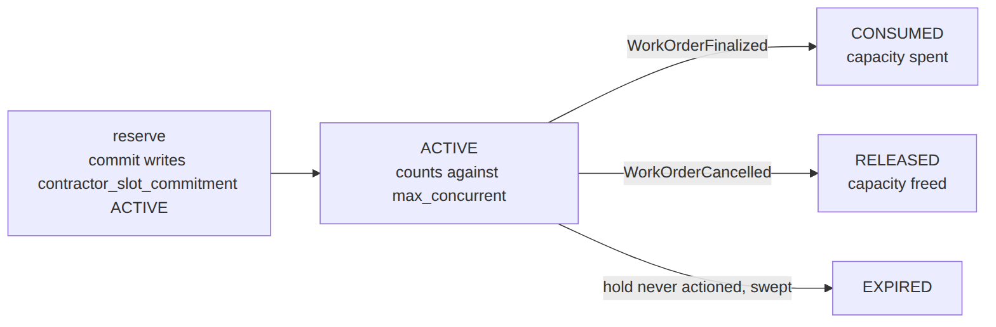

1. Register a contractor + teams + staff
The story: Someone in the back office is setting up who can do field work. They add an outside company, its crews, and the individual technicians. Separately, an operator pre-loads where each contractor works, what they are qualified for, and which hours they are free — this part is data the operator seeds, not something you click through an API.
Who does what:
- POST /api/contractors, …/{contractor}/teams, and POST /api/staff write the contractor registry (the companies, crews, and technicians).
- The coverage rows — contractor_availability_slot, contractor_region_skill, contractor_region_scope, skill_catalog — are operator seed data with no write API. They define the bookable windows (max_concurrent), the certifications, and the region coverage.
- Operator config.

2. Match + atomically commit capacity for a WO
The story: A work order needs a field tech. The system finds a contractor who covers that area, has the right skill, and still has a free spot in their schedule — then books that spot for this job, all in one safe step so two jobs can never grab the same last place.
Who does what:
- WorkOrder's autoAssign calls ContractorAvailabilityService::resolve(...) to rank candidates by region + skill + spare capacity.
- It then calls commit(slot, wo_id, when), which atomically reserves one of the slot's max_concurrent places and writes a contractor_slot_commitment row with status ACTIVE.
- Foundation: a DB transaction guarantees no over-booking. Proven by WorkforceApiTest.
Sample — the hold this writes (one place taken in a slot that allows five):
{ "commitment_id":"sc_1","slot_id":"slot_1","wo_id":"wo_1","qty":1,"status":"ACTIVE" }
Slot slot_1 has max_concurrent:5, so after this commit four places remain.

3. Slot full → no commit → caller falls back
The story: The best contractor's schedule is already full. Rather than overbook them, the system quietly moves on to the next-best option, and if no outside contractor has room, it uses an in-house technician.
Who does what:
- If the slot is already at max_concurrent, commit returns no hold.
- WorkOrder then tries the next contractor, and finally an in-house StaffMember.
- Shows: capacity is a hard limit that drives the dispatch strategy.

4. WO finalized → consume capacity
The story: The job is done and signed off. The hold that was reserving a spot now turns into "spot used" — that place is spent, not given back.
Who does what:
- The WorkOrderFinalized event (via the outbox) reaches ResolveSlotCommitmentOnWoLifecycle.
- That listener calls consumeForWorkOrder(wo_id), flipping the commitment ACTIVE → CONSUMED (capacity spent).
- Foundation: an outbox listener. Proven by SlotCommitmentLifecycleTest.

5. WO cancelled → release capacity
The story: The job got cancelled, so the spot it was holding should go back into the pool for someone else to book.
Who does what:
- The WorkOrderCancelled event reaches the same listener, which calls releaseForWorkOrder(wo_id).
- That flips the commitment to RELEASED (capacity restored, the place is bookable again).
- Proven by SlotCommitmentLifecycleTest.

6. Re-running consume/release is a no-op
The story: Sometimes the same "job finished" message arrives twice. The second time should change nothing — no double-counting, no errors.
Who does what:
- A duplicate WorkOrderFinalized (event replay) calls consumeForWorkOrder again.
- It finds no ACTIVE commitment for that work order, so it makes 0 changes.
- Foundation: an idempotent reaction. Proven by SlotCommitmentLifecycleTest.

7. Emergency-only slots
The story: Some contractor windows are reserved strictly for emergencies. Routine jobs are never booked into them, so there is always room when something urgent comes in.
Who does what:
- A slot with emergency_only=true is only matched for URGENT work orders.
- This keeps routine work off the emergency window.
- Config-driven matching.

8. In-house staff matching
The story: When no outside contractor can take the job, the system falls back to the operator's own employees, picking one whose skills fit.
Who does what:
- When no contractor fits, the matcher uses a StaffMember whose skills cover the job.
- Shows: the two-tier (outsourced → in-house) model.

2. Data model — ≥4 complete sample rows + readings
Completeness: each row lists every domain column (nullables shown as null). The string business / composite key shown is the real primary key; created_at/updated_at are omitted by convention.

contractor (the registry root) · type: INTERNAL|EXTERNAL · status: ACTIVE|SUSPENDED|RETIRED
{ "contractor_id":"ctr_9","operator_code":"WIK","code":"FIBERCO","name":"FiberCo Ltd","type":"EXTERNAL","skills":["fiber-install","diagnostics"],"status":"ACTIVE" }
{ "contractor_id":"ctr_4","operator_code":"WIK","code":"COASTNET","name":"CoastNet Engineers","type":"EXTERNAL","skills":["coax-install"],"status":"ACTIVE" }
{ "contractor_id":"ctr_1","operator_code":"WIK","code":"INHOUSE","name":"WIK In-House Field","type":"INTERNAL","skills":null,"status":"ACTIVE" }
{ "contractor_id":"ctr_0","operator_code":"WIK","code":"OLDCO","name":"OldCo (retired)","type":"EXTERNAL","skills":null,"status":"RETIRED" }
Read each row as a sentence — this data means this:
Row | What it means in plain English
ctr_9 | An outsourced contractor "FiberCo" (type=EXTERNAL, code=FIBERCO), live (status=ACTIVE), summarised as doing fiber installs + diagnostics (skills).
ctr_4 | An outsourced contractor "CoastNet" (code=COASTNET), live, summarised for coax installs.
ctr_1 | The operator's in-house field crew (type=INTERNAL, code=INHOUSE), live, with no skills summary (skills=null).
ctr_0 | A retired outsourced contractor "OldCo" (status=RETIRED) — kept on record, not deleted.
The columns that did the work:
- A contractor is who a job gets dispatched to; type splits outsourced (EXTERNAL) from in-house (INTERNAL), status retires one without deleting it, and code is the operator-unique short handle ((operator,code) is unique).
- The real per-(contractor, region, skill) certification lives in contractor_region_skill; the skills JSON here is only a coarse summary.

contractor_team · status: ACTIVE|… · & staff_member · role: TECHNICIAN|TEAM_LEAD|SUPERVISOR
{ "team_id":"team_2","contractor_id":"ctr_4","operator_code":"WIK","code":"NYALI-A","name":"Nyali Crew A","skills":["coax-install"],"status":"ACTIVE" }
{ "staff_id":"stf_7","operator_code":"WIK","contractor_id":null,"team_id":null,"name":"Asha Mwangi","role":"TECHNICIAN","msisdn":"+254700000007","skills":["diagnostics"],"status":"ACTIVE" }
{ "staff_id":"stf_9","operator_code":"WIK","contractor_id":"ctr_4","team_id":"team_2","name":"Juma Otieno","role":"TEAM_LEAD","msisdn":"+254700000009","skills":["coax-install"],"status":"ACTIVE" }
{ "staff_id":"stf_3","operator_code":"WIK","contractor_id":"ctr_9","team_id":null,"name":"Wanjiru Kamau","role":"TECHNICIAN","msisdn":null,"skills":["fiber-install"],"status":"ACTIVE" }
Read each row as a sentence — this data means this:
Row | What it means in plain English
team_2 | A crew "Nyali Crew A" (team_id=team_2, code=NYALI-A) belonging to contractor ctr_4, active, skilled in coax installs (skills).
stf_7 | An in-house technician Asha Mwangi (staff_id=stf_7, contractor_id=null, team_id=null, role=TECHNICIAN) skilled in diagnostics — the fallback tier when no outsourced contractor has capacity.
stf_9 | A team lead Juma Otieno (role=TEAM_LEAD) on contractor ctr_4's crew team_2, skilled in coax installs.
stf_3 | A technician Wanjiru Kamau on contractor ctr_9, no team (team_id=null), skilled in fiber installs, with no phone on file (msisdn=null).
The columns that did the work:
- A contractor_team (team_id) is a crew owned by a contractor; a staff_member (staff_id) is one named technician — in-house when contractor_id is null, otherwise that crew's tech.
- skills drives skill matching; role ranks people within a team.

contractor_availability_slot · day_of_week: MONDAY..SUNDAY|ALL_WEEK · service_scope: INSTALL|SUPPORT|MAINTENANCE|RECOVERY|AUDIT
{ "slot_id":"slot_1","operator_code":"WIK","contractor_id":"ctr_9","tech_region_id":"KE-NRB-KAREN","service_scope":"INSTALL","day_of_week":"ALL_WEEK","hour_start":"08:00:00","hour_end":"17:00:00","timezone":"Africa/Nairobi","max_concurrent":5,"emergency_only":false,"active":true,"effective_from":"2026-01-01","effective_to":null }
{ "slot_id":"slot_2","operator_code":"WIK","contractor_id":"ctr_9","tech_region_id":"KE-NRB-KAREN","service_scope":"SUPPORT","day_of_week":"MONDAY","hour_start":"09:00:00","hour_end":"13:00:00","timezone":"Africa/Nairobi","max_concurrent":3,"emergency_only":false,"active":true,"effective_from":null,"effective_to":null }
{ "slot_id":"slot_3","operator_code":"WIK","contractor_id":"ctr_4","tech_region_id":"KE-MSA-NYALI","service_scope":"INSTALL","day_of_week":"ALL_WEEK","hour_start":"00:00:00","hour_end":"23:59:00","timezone":"Africa/Nairobi","max_concurrent":2,"emergency_only":true,"active":true,"effective_from":"2026-03-01","effective_to":null }
{ "slot_id":"slot_4","operator_code":"WIK","contractor_id":"ctr_4","tech_region_id":"KE-MSA-NYALI","service_scope":"SUPPORT","day_of_week":"SUNDAY","hour_start":"08:00:00","hour_end":"12:00:00","timezone":"Africa/Nairobi","max_concurrent":1,"emergency_only":false,"active":false,"effective_from":"2026-01-01","effective_to":"2026-05-31" }
Read each row as a sentence — this data means this:
Row | What it means in plain English
slot_1 | Contractor ctr_9 is bookable for installs in Karen all week 08:00–17:00 (service_scope=INSTALL, day_of_week=ALL_WEEK), holding 5 jobs at once (max_concurrent=5), live since 2026-01-01 (active=true, effective_to=null).
slot_2 | The same contractor's support window in Karen, Mondays 09:00–13:00, capacity 3, with no effective-date bounds (effective_from/effective_to null).
slot_3 | Contractor ctr_4's install window in Nyali, all week, but emergency-only (emergency_only=true) so it matches URGENT WOs only, capacity 2.
slot_4 | Contractor ctr_4's Sunday support window that is not bookable: active=false and its effective_to (2026-05-31) has already lapsed.
The columns that did the work:
- A slot is a bookable window = region (tech_region_id) + service_scope + a day/hour range (in timezone) + max_concurrent (how many jobs the window holds at once).
- To match a slot the matcher needs region + skill + scope + a free place in max_concurrent, all inside the slot's effective window.

contractor_slot_commitment · status: ACTIVE|CONSUMED|RELEASED|EXPIRED
{ "commitment_id":"sc_1","operator_code":"WIK","slot_id":"slot_1","contractor_id":"ctr_9","wo_id":"wo_1","committed_for_datetime":"2026-06-22T09:00:00Z","qty":1,"status":"ACTIVE","consumed_at":null,"released_at":null,"expired_at":null }
{ "commitment_id":"sc_2","operator_code":"WIK","slot_id":"slot_1","contractor_id":"ctr_9","wo_id":"wo_2","committed_for_datetime":"2026-06-20T10:00:00Z","qty":1,"status":"CONSUMED","consumed_at":"2026-06-20T12:30:00Z","released_at":null,"expired_at":null }
{ "commitment_id":"sc_3","operator_code":"WIK","slot_id":"slot_2","contractor_id":"ctr_9","wo_id":"wo_5","committed_for_datetime":"2026-06-21T11:00:00Z","qty":1,"status":"RELEASED","consumed_at":null,"released_at":"2026-06-21T11:45:00Z","expired_at":null }
{ "commitment_id":"sc_4","operator_code":"WIK","slot_id":"slot_1","contractor_id":"ctr_9","wo_id":"wo_7","committed_for_datetime":"2026-06-22T14:00:00Z","qty":1,"status":"EXPIRED","consumed_at":null,"released_at":null,"expired_at":"2026-06-22T15:00:00Z" }
Read each row as a sentence — this data means this:
Row | What it means in plain English
sc_1 | Work order wo_1 holds 1 place on slot_1 (qty=1), and the hold is live (status=ACTIVE) — so it counts against capacity.
sc_2 | wo_2's hold on slot_1 was used up when the WO finalized (status=CONSUMED, consumed_at stamped) — no longer occupies a place.
sc_3 | wo_5's hold on slot_2 was freed when the WO was cancelled (status=RELEASED, released_at stamped).
sc_4 | wo_7's hold on slot_1 was never actioned and got swept (status=EXPIRED, expired_at stamped).
The columns that did the work:
- Each row is one work order's hold on a slot, taking qty places out of the slot's max_concurrent.
- Only ACTIVE rows still count, so on slot_1 (capacity 5) the ACTIVE sc_1 is the only one occupying a place — the CONSUMED/EXPIRED rows leave room for new bookings. The matching *_at timestamp records which terminal transition fired.
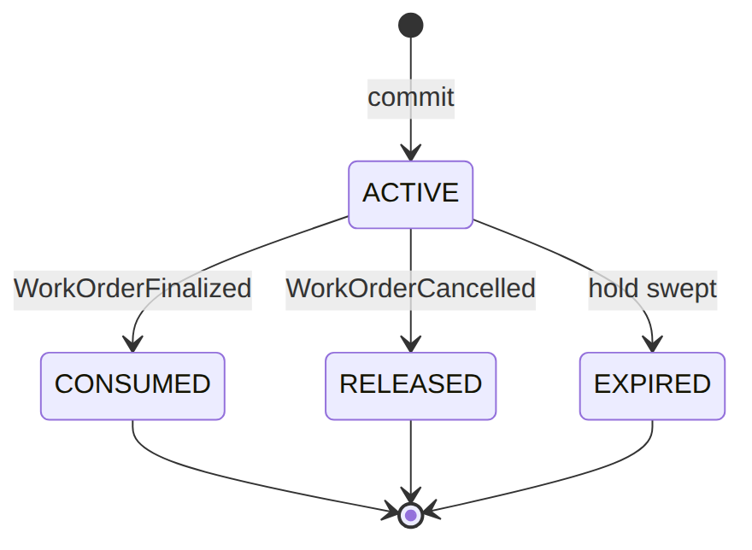

skill_catalog (operator-extensible, EM-02 §3.3) · composite PK (operator_code, skill_code) · category: TECHNICAL_INSTALL|TECHNICAL_SUPPORT|SOFT_SKILL|…
{ "operator_code":"WIK","skill_code":"fiber-install","display_name":"FTTH installation","category":"TECHNICAL_INSTALL","active":true }
{ "operator_code":"WIK","skill_code":"coax-install","display_name":"HFC installation","category":"TECHNICAL_INSTALL","active":true }
{ "operator_code":"WIK","skill_code":"diagnostics","display_name":"Fault diagnostics","category":"TECHNICAL_SUPPORT","active":true }
{ "operator_code":"WIK","skill_code":"vip-handling","display_name":"VIP customer handling","category":"SOFT_SKILL","active":false }
Read each row as a sentence — this data means this:
Row | What it means in plain English
fiber-install | A live install skill "FTTH installation" (category=TECHNICAL_INSTALL, active=true).
coax-install | A live install skill "HFC installation" (category=TECHNICAL_INSTALL).
diagnostics | A live support skill "Fault diagnostics" (category=TECHNICAL_SUPPORT).
vip-handling | A retired soft skill "VIP customer handling" (category=SOFT_SKILL, active=false) — kept as a code, not deleted.
The columns that did the work:
- The skill catalog is operator-extensible and deliberately distinct from Catalog's TechContractorSkill (that is contractor config; this is capacity); category groups skills and active=false retires a code without deleting it.

contractor_region_skill (the WO routing filter, EM-02 §3.4) · composite PK (contractor_id, tech_region_id, skill_code)
{ "contractor_id":"ctr_9","tech_region_id":"KE-NRB-KAREN","operator_code":"WIK","skill_code":"fiber-install","active":true }
{ "contractor_id":"ctr_9","tech_region_id":"KE-NRB-KAREN","operator_code":"WIK","skill_code":"diagnostics","active":true }
{ "contractor_id":"ctr_4","tech_region_id":"KE-MSA-NYALI","operator_code":"WIK","skill_code":"coax-install","active":true }
{ "contractor_id":"ctr_4","tech_region_id":"KE-MSA-NYALI","operator_code":"WIK","skill_code":"fiber-install","active":false }
Read each row as a sentence — this data means this:
Row | What it means in plain English
ctr_9 · Karen · fiber-install | Contractor ctr_9 is certified (active=true) for fiber installs in Karen.
ctr_9 · Karen · diagnostics | The same contractor is also certified for diagnostics in Karen.
ctr_4 · Nyali · coax-install | Contractor ctr_4 is certified for coax installs in Nyali.
ctr_4 · Nyali · fiber-install | Contractor ctr_4 is de-certified for fiber installs in Nyali (active=false) — it will not match for fiber there.
The columns that did the work:
- These rows are exactly what the auto-assign matcher requires before it can pick a contractor: certification is per (contractor, region, skill), and active=false removes that one capability without touching the others.

contractor_region_scope (per-region service coverage, EM-02 §3.2) · service_scope: INSTALL|SUPPORT|MAINTENANCE|RECOVERY|AUDIT · coverage_role: PRIMARY|BACKUP|EXCLUSIVE
{ "coverage_id":"cov_1","operator_code":"WIK","contractor_id":"ctr_9","tech_region_id":"KE-NRB-KAREN","service_scope":"INSTALL","coverage_role":"PRIMARY","effective_from":"2026-01-01","effective_to":null }
{ "coverage_id":"cov_2","operator_code":"WIK","contractor_id":"ctr_9","tech_region_id":"KE-NRB-KAREN","service_scope":"SUPPORT","coverage_role":"PRIMARY","effective_from":"2026-01-01","effective_to":null }
{ "coverage_id":"cov_3","operator_code":"WIK","contractor_id":"ctr_4","tech_region_id":"KE-MSA-NYALI","service_scope":"INSTALL","coverage_role":"PRIMARY","effective_from":"2026-03-01","effective_to":null }
{ "coverage_id":"cov_4","operator_code":"WIK","contractor_id":"ctr_4","tech_region_id":"KE-MSA-NYALI","service_scope":"RECOVERY","coverage_role":"BACKUP","effective_from":"2026-03-01","effective_to":"2026-06-30" }
Read each row as a sentence — this data means this:
Row | What it means in plain English
cov_1 | Contractor ctr_9 is the primary install provider in Karen (service_scope=INSTALL, coverage_role=PRIMARY), open-ended (effective_to=null).
cov_2 | The same contractor is also the primary support provider in Karen, open-ended.
cov_3 | Contractor ctr_4 is the primary install provider in Nyali, live since 2026-03-01.
cov_4 | Contractor ctr_4 is a backup recovery provider in Nyali (coverage_role=BACKUP, service_scope=RECOVERY) that lapses end of June (effective_to=2026-06-30).
The columns that did the work:
- Coverage says which contractor serves which region for which service, scoped per (contractor, region, service_scope) and time-versioned via effective_from/effective_to.
- coverage_role ranks contractors: PRIMARY first, BACKUP as fallback, EXCLUSIVE locks the region to one contractor.

3. Services
Service | Responsibility
ContractorAvailabilityService | resolve() (rank contractors by region+skill+spare capacity), remainingCapacity(); commit() (atomic), consume()/release(), consumeForWorkOrder()/releaseForWorkOrder() (by WO id)

4. API surface
/api/contractors (+…/{contractor}/teams), /api/staff, /api/contractor-availability (capacity query), /api/contractor-slot-commitments (+…/{id}/consume, DELETE …/{id} = release). Reads under permission:workforce.read; writes under permission:workforce.manage (+ idempotency on commit/consume/release).

5. Integration (events)
- Emits (topic em.cs): ContractorSlotCommitment{Created,Consumed,Released} on commit/consume/release.
- Consumes: ResolveSlotCommitmentOnWoLifecycle (listener on OutboxEventPublished, matched by event_type) — WorkOrderFinalized→consume, WorkOrderCancelled→release.
- Consumed by → WorkOrder auto-assign (synchronous capacity query + commit).

6. Processes
No BPMN; service + the WO-lifecycle event listener.

7. Policy & config
Slots, coverage, skills, teams — operator data; max_concurrent is the capacity knob; emergency_only reserves capacity for URGENT work.

8. Cross-module dependencies
- Called by → WorkOrder (autoAssign commits capacity).
- Reacts to → WorkOrder finalize/cancel.

9. Invariants & rules
Rule | Statement | Enforced in
EM-02 §3.6 | a finalized WO consumes its slot; a cancelled WO releases it | ResolveSlotCommitmentOnWoLifecycle
atomicity | a commit can't exceed max_concurrent | ContractorAvailabilityService::commit (DB tx)
idempotency | re-running consume/release on resolved commitments is a no-op | consume/releaseForWorkOrder

10. Open items / deltas
- Slot-commitment lifecycle (consume/release on WO finalize/cancel) was wired during hardening — previously committed capacity leaked. Fixed.

