WorkOrder — As-Built Design (Field Ops)
Capability codes: WO-01 (lifecycle + dispatch), WO-01-FLOW-SUPPORT/-SHIFTING, FA-01/02/03 (field audits) · Module path: Modules/WorkOrder · Tests: WorkOrderApi, AutoAssign, Framework, Support/ShiftingFlow, SlaSkills, FieldAudit*

1. Purpose & boundaries
- Owns: the work order lifecycle (create → assign → start → finalize/cancel), its history, job-type catalog, finalization checklist, and the field-audit capability.
- Does NOT own: the workforce capacity it consumes (Workforce), the equipment (OSR), the order it serves (Fulfillment). It executes field/desk work.
- Job: dispatch + track field work with SLA & skills, and run FA inspections.

📖 Scenarios (service + Foundation involvement)
What a "work order" is: a single job a field technician (or a desk agent) has to carry out — install a customer, fix a fault, relocate a service, inspect equipment. Each work order moves through a fixed set of statuses from the moment it is created until it is finished or cancelled (see the lifecycle diagram in the Data model section).

1. Create + auto-assign an install WO (scope-gated)
The story: A new customer has ordered an internet install. A dispatcher creates a job for it, and the system tries to immediately hand that job to a technician who works the right area, has the right skills, and has a free slot in their day. If it finds one, the job is booked to them automatically.
Who does what:
- POST /api/work-orders {type:INSTALLATION, tech_region_id:'KE-NRB-KAREN'} must pass permission:workorder.assign and scope:TECH_REGION,tech_region_id (Rbac/EnforceScope). A dispatcher scoped to Karen cannot create a Mombasa work order.
- The work order is created as PENDING, and its SLA due-time is stamped from its priority.
- autoAssign asks Workforce for a contractor in the right region, with the right skill, and spare capacity, then atomically commits one of their slots → the work order moves to ASSIGNED.
Proven by WorkOrderApiTest, WorkOrderAutoAssignTest.

2. Auto-assign falls back to in-house staff
The story: Sometimes every outside contractor in that area is already fully booked. Rather than leave the job stuck, the system looks at the operator's own employees and gives the job to a qualified one of them instead.
Who does what:
- If no OUTSOURCED contractor has capacity, autoAssign matches an in-house StaffMember on skills. This is the second leg of the dispatch strategy and shows the Workforce dependency.
Proven by WorkOrderAutoAssignTest.

3. Support flow — resolve or escalate
The story: A customer reports a fault. A technician visits, and either fixes it on the spot or decides the problem is bigger than a normal visit can solve. If it is fixed, the job closes. If it is not, the system opens a fresh quality-control job to chase the deeper problem.
Who does what:
- startSupportFlow runs the support process steps: SiteVisitDecisionHandler → ResolutionGateHandler.
- If resolved → FinalizeSupportHandler closes it out.
- If not resolved → MarkEscalationHandler spawns a QCS (quality-control) work order as a child of the original.
This is built on the Foundation workflow toolbox. Proven by WorkOrderSupportFlowTest.

4. Shifting flow — phased relocation
The story: A customer is moving their service to a new premises. That cannot happen in one step — it runs through several phases (e.g. de-install, re-install, reconnect). The system walks the job through each phase and records what was bound where.
Who does what:
- startShiftingFlow walks the phases via MarkPhaseHandler / CaptureBindingsHandler / FinalizeShiftingHandler, emitting PHASE_TRANSITIONED as it advances and SHIFTING_COMPLETED at the end.
Proven by WorkOrderShiftingFlowTest.

5. Field audit — clean observation closes the task
The story: As part of an audit, a technician is sent to check a customer's equipment against what the records say should be there. They scan the device, the serial matches the expected one, nothing is wrong, and the audit task simply closes.
Who does what:
- POST …/field-audit-tasks/{id}/observations with the expected serial → FieldAuditCampaignService finds no discrepancy → the task moves to CLOSED and emits FieldAuditTaskClosed.
Proven by FieldAuditCampaignTest.

6. Field audit — missing unit → HIGH → RMA recovery
The story: The technician goes to check a device and it is simply not there. That is a serious problem, so the system flags it as high-severity and kicks off a recovery request to get the missing hardware accounted for.
Who does what:
- presenceStatus:MISSING → a MISSING discrepancy is raised.
- rules.field_audit.equipment.discrepancy (Foundation rules) rates it HIGH and routes it CREATE_RMA_RECOVERY.
- An OSR RMA request is emitted for the owning module to act on. This is a safe route, so it goes straight through with no approval.
Proven by FieldAuditCampaignTest.

7. Field audit — wrong serial → EM-CFG-04 → OSR correction
The story: The technician finds a device, but its serial number does not match the one on record. The fix is to correct the equipment record — but because changing equipment records is risky, the system will not do it on one person's say-so. It parks the change until a second, different person approves it; only then is the correction sent out.
Who does what:
- A wrong serial → a WRONG_SERIAL discrepancy routed REQUEST_OSR_CORRECTION (a risky route).
- An EM-CFG-04 approval request is raised → the discrepancy goes PENDING_APPROVAL.
- A different approver signs off → the OSR correction is emitted.
Sample — the parked discrepancy (fad_2) waiting on approval:
{ "discrepancy_id":"fad_2","discrepancy_type":"WRONG_SERIAL","severity":"MEDIUM","status":"PENDING_APPROVAL","route_action":"REQUEST_OSR_CORRECTION","approval_request_id":"appr_3" }
How a submitted observation is rated and routed — safe routes go straight, risky ones wait for a second person:
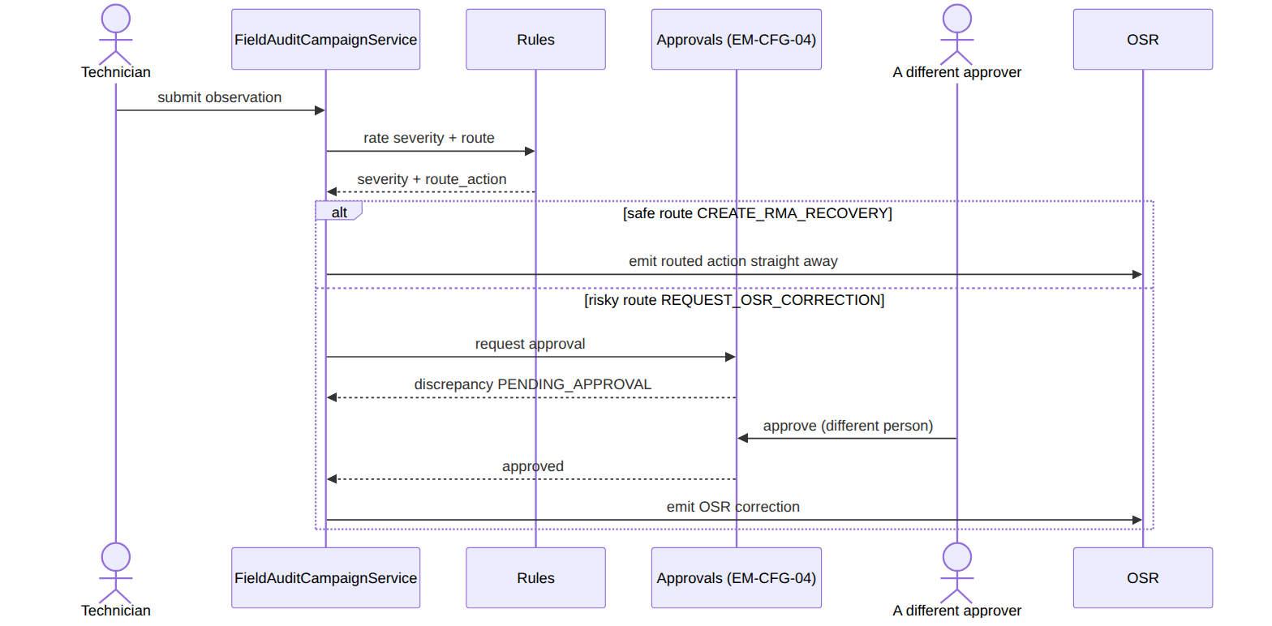
Proven by FieldAuditCampaignTest::test_wrong_serial_requires_em_cfg_04_approval_before_osr_correction.

8. A WO-backed audit creates its work order
The story: Some audit tasks need a technician physically dispatched, not just a desk check. When such a task is set up, the system automatically creates a real field work order for it and links the two together so the dispatch can happen.
Who does what:
- A task created with createWorkOrder=true emits FieldAuditWorkOrderRequested.
- The CreateFieldAuditWorkOrder listener (an outbox listener, Foundation) builds a FIELD_AUDIT work order, links it back via wo_id, and moves the task to ASSIGNED.
Proven by FieldAuditCampaignTest.

(bonus) 9. Finalization is gated on a checklist
finalize is rejected unless the wo_finalization_requirements items are satisfied (R-WO finalize gate).

2. Data model — ≥4 complete sample rows + readings
Completeness: each row lists every domain column (nullables shown as null). The string business key shown is the real primary key; created_at/updated_at are omitted by convention.

work_order · type: INSTALLATION|SUPPORT|SHIFTING|RELOCATION|EQUIPMENT|NOC|FIELD_AUDIT · status: PENDING|ASSIGNED|IN_PROGRESS|FINALIZATION_PENDING|COMPLETED|CANCELLED · priority: LOW|NORMAL|HIGH|URGENT · source_type: TICKET|SUBSCRIPTION_OP|FULFILLMENT|MANUAL|FIELD_AUDIT · link_type: PARENT_CHILD|DEPENDENCY
{ "work_order_id":"wo_1","operator_code":"WIK","type":"INSTALLATION","kind":null,"job_type_code":"FTTH_INSTALL","current_phase":null,"status":"COMPLETED","priority":"NORMAL","account_id":"acct_50","subscription_id":"sub_1","customer_id":"cust_50","homepass_id":"hp_1","tech_region_id":"KE-NRB-KAREN","contractor_id":"ctr_9","team_id":null,"assigned_technician_id":"tech_3","source_type":"FULFILLMENT","source_ref":"order_1","master_wo_id":null,"originating_context_type":null,"initial_reason":null,"escalation_candidate":false,"link_type":null,"scheduled_at":"2026-06-20T08:00:00Z","sla_due_at":"2026-06-21T08:00:00Z","assigned_at":"2026-06-20T07:30:00Z","first_response_at":"2026-06-20T08:05:00Z","started_at":"2026-06-20T09:00:00Z","finalized_at":"2026-06-20T10:30:00Z","warranty_until":"2026-09-18T00:00:00Z","resolution_code":"INSTALL_OK","final_reason":null,"required_skills":["fiber-install"],"findings":{"ontSerial":"SN-001"},"created_by":"u_desk1" }
{ "work_order_id":"wo_2","operator_code":"WIK","type":"SUPPORT","kind":"SUPPORT","job_type_code":"NO_SIGNAL","current_phase":"SITE_VISIT","status":"IN_PROGRESS","priority":"URGENT","account_id":"acct_51","subscription_id":"sub_2","customer_id":"cust_51","homepass_id":"hp_2","tech_region_id":"KE-NRB-KAREN","contractor_id":null,"team_id":null,"assigned_technician_id":"staff_7","source_type":"TICKET","source_ref":"tkt_9","master_wo_id":null,"originating_context_type":"TICKET","initial_reason":"no signal at ONT","escalation_candidate":false,"link_type":null,"scheduled_at":"2026-06-21T10:00:00Z","sla_due_at":"2026-06-21T14:00:00Z","assigned_at":"2026-06-21T09:30:00Z","first_response_at":"2026-06-21T10:10:00Z","started_at":"2026-06-21T10:15:00Z","finalized_at":null,"warranty_until":null,"resolution_code":null,"final_reason":null,"required_skills":["diagnostics"],"findings":null,"created_by":"u_desk2" }
{ "work_order_id":"wo_3","operator_code":"WIK","type":"SHIFTING","kind":"SHIFTING","job_type_code":null,"current_phase":"PHASE_1","status":"ASSIGNED","priority":"NORMAL","account_id":"acct_52","subscription_id":"sub_3","customer_id":"cust_52","homepass_id":"hp_3","tech_region_id":"KE-MSA-NYALI","contractor_id":"ctr_4","team_id":"team_2","assigned_technician_id":null,"source_type":"SUBSCRIPTION_OP","source_ref":"subop_77","master_wo_id":null,"originating_context_type":null,"initial_reason":null,"escalation_candidate":false,"link_type":null,"scheduled_at":"2026-06-23T08:00:00Z","sla_due_at":"2026-06-30T08:00:00Z","assigned_at":"2026-06-21T12:00:00Z","first_response_at":null,"started_at":null,"finalized_at":null,"warranty_until":null,"resolution_code":null,"final_reason":null,"required_skills":["fiber-install"],"findings":null,"created_by":"u_desk1" }
{ "work_order_id":"wo_4","operator_code":"WIK","type":"FIELD_AUDIT","kind":"FIELD_AUDIT","job_type_code":null,"current_phase":null,"status":"PENDING","priority":"LOW","account_id":null,"subscription_id":null,"customer_id":"cust_60","homepass_id":null,"tech_region_id":"KE-NRB-KAREN","contractor_id":null,"team_id":null,"assigned_technician_id":null,"source_type":"FIELD_AUDIT","source_ref":"fat_1","master_wo_id":null,"originating_context_type":null,"initial_reason":null,"escalation_candidate":false,"link_type":null,"scheduled_at":null,"sla_due_at":"2026-06-28T08:00:00Z","assigned_at":null,"first_response_at":null,"started_at":null,"finalized_at":null,"warranty_until":null,"resolution_code":null,"final_reason":null,"required_skills":[],"findings":null,"created_by":"u_audit1" }
{ "work_order_id":"wo_5","operator_code":"WIK","type":"SUPPORT","kind":"SUPPORT","job_type_code":"QCS","current_phase":"ESCALATED","status":"CANCELLED","priority":"HIGH","account_id":"acct_53","subscription_id":"sub_4","customer_id":"cust_53","homepass_id":"hp_4","tech_region_id":"KE-NRB-KAREN","contractor_id":"ctr_9","team_id":null,"assigned_technician_id":"tech_3","source_type":"SUBSCRIPTION_OP","source_ref":"subop_88","master_wo_id":"wo_2","originating_context_type":"TICKET","initial_reason":"repeat fault — quality control","escalation_candidate":true,"link_type":"PARENT_CHILD","scheduled_at":null,"sla_due_at":"2026-06-22T00:00:00Z","assigned_at":"2026-06-21T13:00:00Z","first_response_at":null,"started_at":null,"finalized_at":null,"warranty_until":null,"resolution_code":null,"final_reason":"CANCELLED_BY_DESK","required_skills":["diagnostics"],"findings":null,"created_by":"u_desk2" }
The status column moves through this lifecycle:
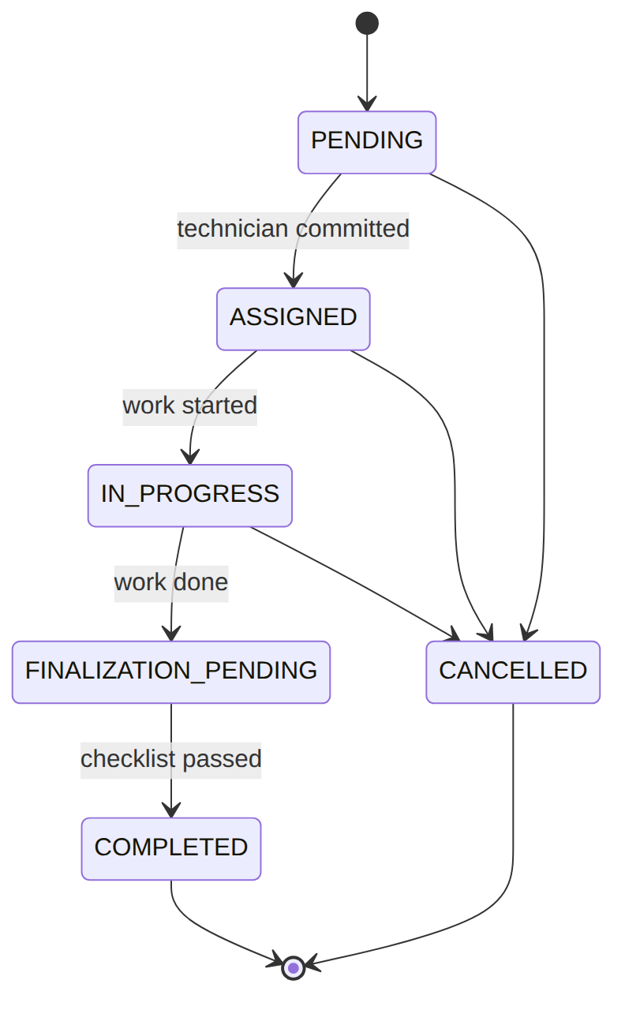
Read each row as a sentence — this data means this:
Row | What it means in plain English
wo_1 | A NORMAL FTTH install (type=INSTALLATION, job_type_code=FTTH_INSTALL) raised by a fulfillment order (source_type=FULFILLMENT, source_ref=order_1), done (status=COMPLETED), worked by contractor ctr_9's tech tech_3, closed with resolution_code=INSTALL_OK, the ONT serial in findings, and a warranty running to warranty_until.
wo_2 | An URGENT no-signal support call (type=SUPPORT, job_type_code=NO_SIGNAL, priority=URGENT) from a ticket (source_type=TICKET, source_ref=tkt_9), in progress (status=IN_PROGRESS, current_phase=SITE_VISIT), assigned to in-house staff_7, reason "no signal at ONT".
wo_3 | A NORMAL shifting job (type=SHIFTING) from a subscription op (source_ref=subop_77), assigned to a team not a person (team_id=team_2, assigned_technician_id=null, status=ASSIGNED, current_phase=PHASE_1) in the Nyali region.
wo_4 | A LOW-priority field audit (type=FIELD_AUDIT, source_type=FIELD_AUDIT, source_ref=fat_1) still unassigned and waiting (status=PENDING); it has only a customer, no account/subscription/homepass.
wo_5 | A cancelled escalation child (status=CANCELLED, final_reason=CANCELLED_BY_DESK): a HIGH-priority QCS support WO spawned off wo_2 (master_wo_id=wo_2, link_type=PARENT_CHILD, escalation_candidate=true).
The columns that did the work:
- type/kind pick the flow and skills; required_skills is what auto-assign filters on; current_phase is the flow cursor for SUPPORT and SHIFTING jobs.
- source_type/source_ref record where the job came from — the back-link the other module resumes on once work is done.
- priority sets the SLA window at create time (sla_due_at: URGENT = 4h … LOW = 168h); first_response_at records the SLA first-touch.
- assigned_* / started_at / finalized_at track the lifecycle above; warranty_until links a finalized install to its warranty window; findings captures close-out evidence.

wo_job_type_catalog (operator job-type config) · kind: SUPPORT|SHIFTING|INSTALLATION · network_type: GPON|HFC|…
{ "id":"jtc_1","operator_code":"WIK","job_type_code":"FTTH_INSTALL","kind":"INSTALLATION","display_name":"FTTH Installation","description":"GPON new install","network_type":"GPON","requires_site_visit":true,"warranty_days":90 }
{ "id":"jtc_2","operator_code":"WIK","job_type_code":"HFC_INSTALL","kind":"INSTALLATION","display_name":"HFC Installation","description":null,"network_type":"HFC","requires_site_visit":true,"warranty_days":90 }
{ "id":"jtc_3","operator_code":"WIK","job_type_code":"NO_SIGNAL","kind":"SUPPORT","display_name":"No Signal Diagnostics","description":"loss-of-service fault","network_type":null,"requires_site_visit":true,"warranty_days":30 }
{ "id":"jtc_4","operator_code":"WIK","job_type_code":"RPT","kind":"SUPPORT","display_name":"Remote Password/Profile Tweak","description":"desk-only fix","network_type":null,"requires_site_visit":false,"warranty_days":30 }
Read each row as a sentence — this data means this:
Row | What it means in plain English
jtc_1 | The operator's FTTH install job-type (job_type_code=FTTH_INSTALL, kind=INSTALLATION) on a GPON network (network_type=GPON), needs a site visit (requires_site_visit=true) and carries a 90-day warranty (warranty_days=90).
jtc_2 | The HFC install job-type (kind=INSTALLATION, network_type=HFC), also a site-visit job with a 90-day warranty; no description set (description=null).
jtc_3 | The no-signal support job-type (job_type_code=NO_SIGNAL, kind=SUPPORT), a site-visit job with a 30-day warranty, network-agnostic (network_type=null).
jtc_4 | A desk-only support fix (job_type_code=RPT, kind=SUPPORT, requires_site_visit=false) — no technician dispatched — 30-day warranty.
The columns that did the work:
- The job-type catalog is per-operator config; requires_site_visit drives the site-visit-decision gateway, warranty_days feeds the warranty linkage, and job_type_code drives skill-matching for auto-assign.
(The earlier required_skills / sla_hours sample columns were a doc shorthand and don't exist on this table — required skills live on work_order.required_skills, and the SLA is computed from priority.)

wo_finalization_requirements (the close-out checklist) · kind: INSTALLATION|SUPPORT|SHIFTING
{ "id":"finr_1","operator_code":"WIK","kind":"INSTALLATION","job_type_code":"FTTH_INSTALL","required_note_kinds":["findings","ont_serial"],"required_attachment_categories":["ont_photo","speedtest"],"min_attachments_per_category":{"ont_photo":1,"speedtest":1} }
{ "id":"finr_2","operator_code":"WIK","kind":"INSTALLATION","job_type_code":null,"required_note_kinds":["findings"],"required_attachment_categories":["site_photo"],"min_attachments_per_category":{"site_photo":1} }
{ "id":"finr_3","operator_code":"WIK","kind":"SUPPORT","job_type_code":null,"required_note_kinds":["findings","solution","final_reason_set"],"required_attachment_categories":null,"min_attachments_per_category":null }
{ "id":"finr_4","operator_code":"WIK","kind":"SHIFTING","job_type_code":null,"required_note_kinds":["findings","bindings_captured"],"required_attachment_categories":["new_premises_photo"],"min_attachments_per_category":{"new_premises_photo":2} }
Read each row as a sentence — this data means this:
Row | What it means in plain English
finr_1 | The FTTH-specific install checklist (kind=INSTALLATION, job_type_code=FTTH_INSTALL): must capture findings + ont_serial notes and at least one ont_photo and one speedtest attachment (min_attachments_per_category).
finr_2 | The default install checklist (job_type_code=null): just a findings note and one site_photo.
finr_3 | The default support checklist (kind=SUPPORT, job_type_code=null): three notes (findings, solution, final_reason_set) and no attachments required (required_attachment_categories=null).
finr_4 | The default shifting checklist (kind=SHIFTING): findings + bindings_captured notes and two new_premises_photo attachments (min_attachments_per_category=2).
The columns that did the work:
- This is the per-(operator, kind, job_type_code) checklist the 2-step finalize enforces at the second-confirm step: required note kinds plus required attachment categories and their minimum counts.
- job_type_code=null is the default for that kind; a job-type-specific row (finr_1) overrides the default.

field_audit_task · audit_type: EQUIPMENT|NETWORK|KYC · task_type: CUSTOMER_PREMISES|FIELD_SITE|POST_SWAP|INVESTIGATION · status: CREATED|ASSIGNED|IN_PROGRESS|SUBMITTED|DISCREPANCY_OPEN|CLOSED|CANCELLED
{ "audit_task_id":"fat_1","operator_code":"WIK","campaign_id":"fac_1","audit_type":"EQUIPMENT","task_type":"CUSTOMER_PREMISES","customer_id":"cust_60","account_id":"acct_60","subscription_id":"sub_60","homepass_id":"hp_10","wo_id":null,"assigned_to_user_id":null,"assigned_team_id":null,"status":"CREATED","source_event_ref":"evt_aa1","due_at":"2026-06-28T17:00:00Z","submitted_at":null,"closed_at":null }
{ "audit_task_id":"fat_2","operator_code":"WIK","campaign_id":"fac_1","audit_type":"EQUIPMENT","task_type":"POST_SWAP","customer_id":"cust_61","account_id":"acct_61","subscription_id":"sub_61","homepass_id":"hp_11","wo_id":"wo_4","assigned_to_user_id":"tech_3","assigned_team_id":null,"status":"DISCREPANCY_OPEN","source_event_ref":"evt_aa2","due_at":"2026-06-25T17:00:00Z","submitted_at":"2026-06-24T15:00:00Z","closed_at":null }
{ "audit_task_id":"fat_3","operator_code":"WIK","campaign_id":"fac_2","audit_type":"NETWORK","task_type":"FIELD_SITE","customer_id":null,"account_id":null,"subscription_id":null,"homepass_id":null,"wo_id":null,"assigned_to_user_id":"staff_7","assigned_team_id":"team_2","status":"CLOSED","source_event_ref":"evt_bb1","due_at":"2026-06-20T17:00:00Z","submitted_at":"2026-06-19T12:00:00Z","closed_at":"2026-06-19T16:00:00Z" }
{ "audit_task_id":"fat_4","operator_code":"WIK","campaign_id":null,"audit_type":"KYC","task_type":"CUSTOMER_PREMISES","customer_id":"cust_62","account_id":"acct_62","subscription_id":null,"homepass_id":"hp_12","wo_id":null,"assigned_to_user_id":"staff_9","assigned_team_id":null,"status":"ASSIGNED","source_event_ref":"evt_cc1","due_at":"2026-06-27T17:00:00Z","submitted_at":null,"closed_at":null }
Read each row as a sentence — this data means this:
Row | What it means in plain English
fat_1 | An equipment count at a customer premises (audit_type=EQUIPMENT, task_type=CUSTOMER_PREMISES) under campaign fac_1, freshly created and unassigned (status=CREATED, no assigned_to_user_id, no wo_id).
fat_2 | A post-swap equipment check (task_type=POST_SWAP) with a discrepancy open (status=DISCREPANCY_OPEN); it is WO-backed (wo_id=wo_4), assigned to tech_3, already submitted (submitted_at set).
fat_3 | A network field-site audit (audit_type=NETWORK, task_type=FIELD_SITE) under campaign fac_2, closed (status=CLOSED, closed_at set), assigned to staff_7/team_2, with no customer/account/subscription.
fat_4 | An ad-hoc KYC re-verification (audit_type=KYC, campaign_id=null) at a customer premises, assigned and pending (status=ASSIGNED, assigned_to_user_id=staff_9), not yet a WO.
The columns that did the work:
- One capability driven by audit_type (count equipment, check network plant, re-verify KYC); a task moves CREATED → ASSIGNED → IN_PROGRESS → SUBMITTED → (DISCREPANCY_OPEN | CLOSED).
- wo_id set means WO-backed (a technician dispatched); campaign_id ties the task to its campaign; source_event_ref is the idempotency key on the originating event.

field_audit_discrepancy · discrepancy_type: MISSING|WRONG_SERIAL|FOUND_EXTRA|DAMAGED|WRONG_LOCATION|NOT_ACCESSIBLE · severity: LOW|MEDIUM|HIGH|CRITICAL · route_action: CREATE_TICKET|CREATE_RMA_RECOVERY|REQUEST_OSR_CORRECTION|REQUEST_WRITE_OFF|NO_ACTION · status: OPEN|ROUTED|PENDING_APPROVAL|ACTION_CREATED|RESOLVED|REJECTED|CLOSED
{ "discrepancy_id":"fad_1","operator_code":"WIK","audit_task_id":"fat_2","expected_item_id":"fae_1","observation_id":"fao_1","discrepancy_type":"MISSING","severity":"HIGH","status":"ACTION_CREATED","route_action":"CREATE_RMA_RECOVERY","routed_ref_type":"OSR_RMA","routed_ref_id":"rma_5","approval_request_id":null,"resolved_at":null }
{ "discrepancy_id":"fad_2","operator_code":"WIK","audit_task_id":"fat_2","expected_item_id":"fae_2","observation_id":"fao_2","discrepancy_type":"WRONG_SERIAL","severity":"MEDIUM","status":"PENDING_APPROVAL","route_action":"REQUEST_OSR_CORRECTION","routed_ref_type":null,"routed_ref_id":null,"approval_request_id":"appr_3","resolved_at":null }
{ "discrepancy_id":"fad_3","operator_code":"WIK","audit_task_id":"fat_2","expected_item_id":"fae_3","observation_id":"fao_3","discrepancy_type":"DAMAGED","severity":"MEDIUM","status":"ACTION_CREATED","route_action":"CREATE_TICKET","routed_ref_type":"TICKET","routed_ref_id":"tkt_44","approval_request_id":null,"resolved_at":null }
{ "discrepancy_id":"fad_4","operator_code":"WIK","audit_task_id":"fat_3","expected_item_id":null,"observation_id":"fao_9","discrepancy_type":"FOUND_EXTRA","severity":"LOW","status":"RESOLVED","route_action":"NO_ACTION","routed_ref_type":null,"routed_ref_id":null,"approval_request_id":null,"resolved_at":"2026-06-19T16:00:00Z" }
Read each row as a sentence — this data means this:
Row | What it means in plain English
fad_1 | A HIGH-severity missing unit (discrepancy_type=MISSING, severity=HIGH) on task fat_2, routed to an RMA recovery (route_action=CREATE_RMA_RECOVERY) which already created rma_5 (routed_ref_type=OSR_RMA, status=ACTION_CREATED).
fad_2 | A MEDIUM wrong-serial finding routed to an OSR correction (route_action=REQUEST_OSR_CORRECTION) — a risky route, so it is waiting for approval (status=PENDING_APPROVAL, approval_request_id=appr_3), with no routed ref yet.
fad_3 | A MEDIUM damaged unit routed to a ticket (route_action=CREATE_TICKET) which created tkt_44 (routed_ref_type=TICKET, status=ACTION_CREATED).
fad_4 | A LOW found-extra unit (discrepancy_type=FOUND_EXTRA, expected_item_id=null) on task fat_3 needing no action (route_action=NO_ACTION), self-resolved (status=RESOLVED, resolved_at stamped).
The columns that did the work:
- When what was observed doesn't match what was expected, a typed discrepancy is raised, linked to its expected_item_id and observation_id; rules.field_audit.* sets severity and route_action.
- Risky routes (REQUEST_OSR_CORRECTION / REQUEST_WRITE_OFF) go PENDING_APPROVAL under EM-CFG-04 with approval_request_id set; safe routes go straight through and fill routed_ref_type / routed_ref_id; NO_ACTION self-resolves. Field audit never mutates OSR itself — it emits the routed action for the owning module to carry out.

3. Services
Service | Responsibility
WorkOrderService | lifecycle: create/assign/autoAssign (contractor capacity else staff)/start/finalize/cancel; SLA at create
SupportFlowService / ShiftingFlowService | WO-01-FLOW orchestration
FieldAuditCampaignService | FA campaigns/tasks/observations; rules-driven severity+route; EM-CFG-04 on risky routes
FieldAuditService | simpler field-audit submission

4. API surface
/api/work-orders (workorder.assign + scope:TECH_REGION + idempotency), assign/auto-assign/ start/finalize/cancel/notes/attachments; …/support-flow & …/shifting-flow; /api/field-audit-*.

5. Integration (events) — topic workorder.field (FA events on topic field.audit)
- Emits (topic workorder.field): WorkOrder{Created,Assigned,Started,FinalizationPending,Finalized,Reassigned,Cancelled}, WorkOrder{Support,Shifting}Completed, WorkOrderPhaseTransitioned, WorkOrderEscalationCandidate.
- Emits (topic field.audit): FieldAuditWorkOrderRequested, FieldAuditCampaignCreated, FieldAuditTaskCreated, FieldAuditTaskClosed, FieldAuditDiscrepancy{Opened,Routed}.
- Consumes: CreateFieldAuditWorkOrder (listener on OutboxEventPublished, matched on FieldAuditWorkOrderRequested → build the WO-01 work order).
- Downstream: Fulfillment/Subscription resume on WorkOrderFinalized; Workforce releases capacity; Ticketing resolves; Reporting counts.

6. Processes
Support + shifting flows (process definitions) with the handlers in §1.3/1.4.

7. Policy & config
Job-type catalog, flow config, finalization requirements, SLA-by-priority; FA routing via rules.field_audit.<type>.discrepancy.

8. Cross-module dependencies
- Calls → Workforce (capacity for auto-assign), Foundation Approvals (FA risky routes).
- Called by → Fulfillment (install), OSR (swap), Subscription (shifting); Workforce reacts to WO lifecycle.

9. Invariants & rules
Rule | Statement | Enforced in
WO-01 §3 | only allowed status transitions | WorkOrderService::transition
EM-02 §5.1/5.2 | auto-assign atomically commits contractor capacity | autoAssign + Workforce
FA risky route | OSR correction / write-off gated by EM-CFG-04 | FieldAuditCampaignService::route
EM-CFG-03 §8.5 | WO create is TECH_REGION scope-gated | scope middleware

10. Open items / deltas
- FieldAuditWorkOrderRequested now has a consumer — earlier orphan, fixed.
- WO geolocation (lat/long) + per-technician performance metric are additive (optional backlog).

