MyFarmData is a tool that enable the actors of the cocoa/chocolate industry to have a higher product quality, improve the traceability of the beans but also have a stronger positive impact on the rural farming communities.

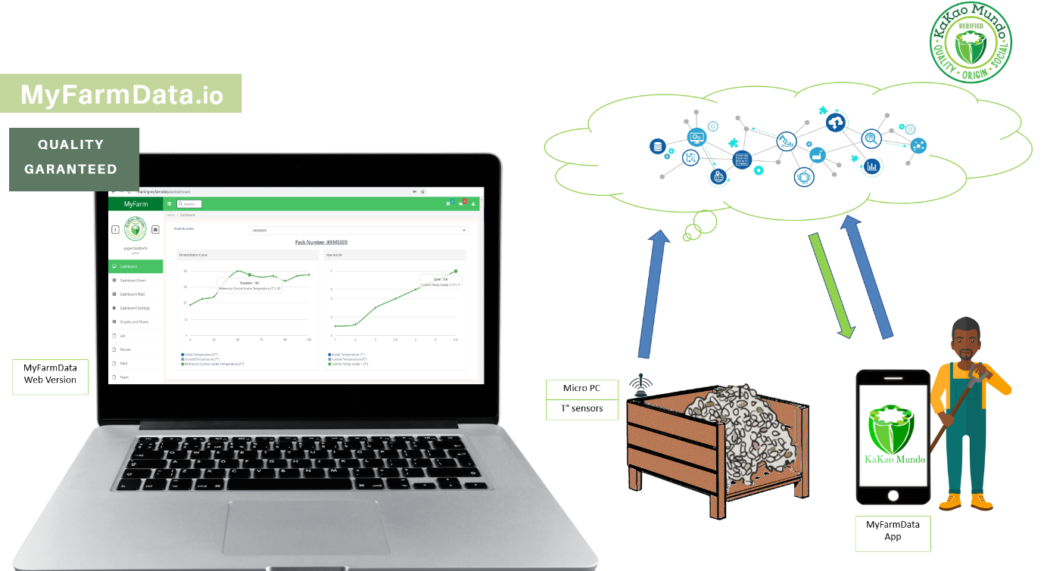

We bring some automation and quality control to the process of fermentation, we have integrated some micro PCs and Temperature sensors within the wood fermentation box to allow the automatic collect of data during the fermentation. These data are then interpreted against some rules (based on T° and duration) and our algorithm detects if a notification must be sent to the farmer for an immediate action.

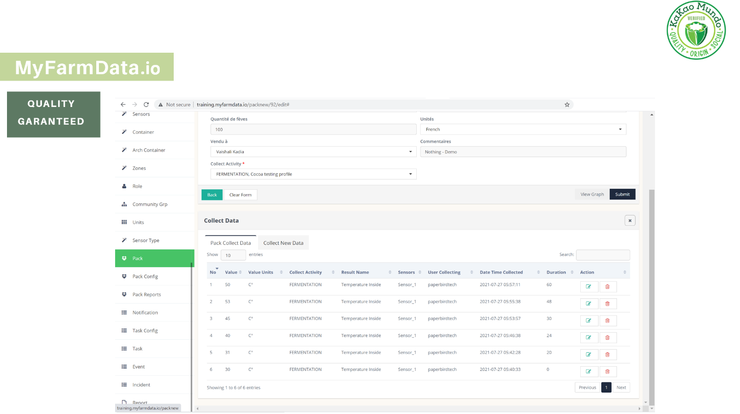

The pack of beans being manager have a unique identifier in our system. The data collected by our sensors are directly stored in that table.

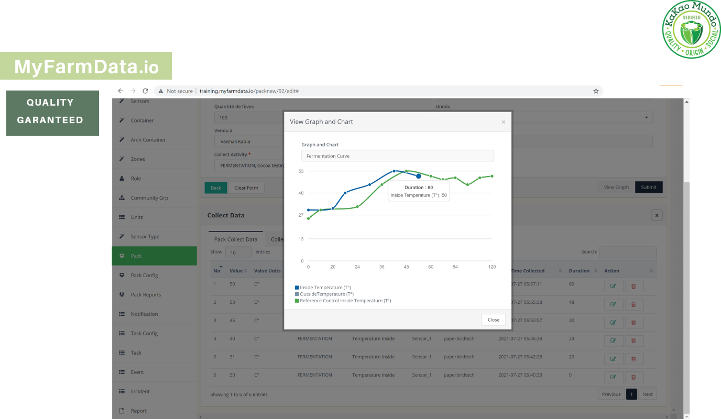

It is possible for the farmer to see the evolution of its fermentation Temperature curve and compare it with the reference fermentation curve (in green) for that specific cocoa family.

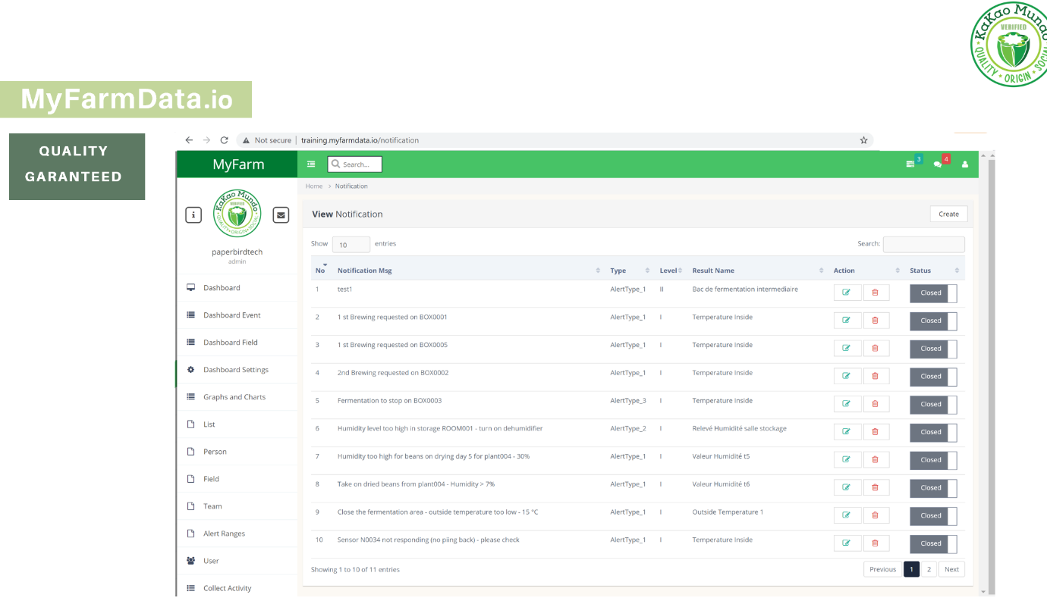

The notification manager allow to inform user (farmers) when an actions must be taken.

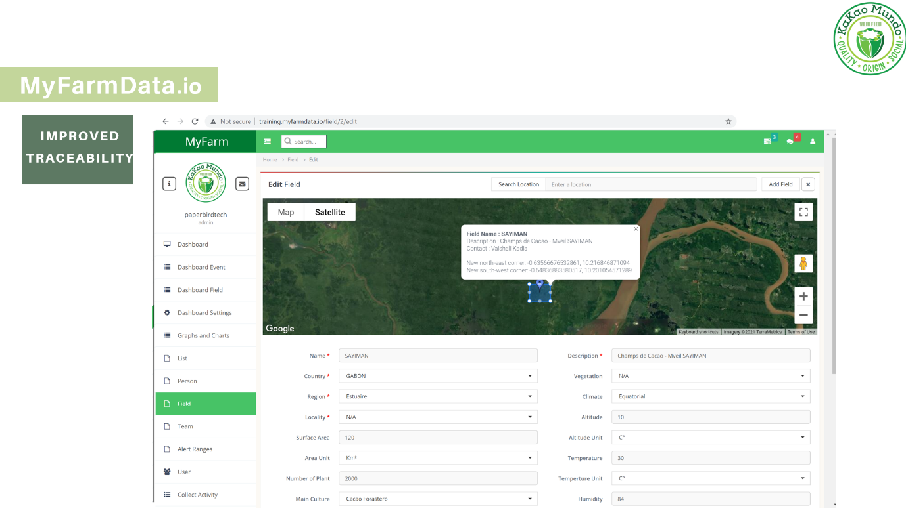

To improve the traceability we have put in place a system to register all of the data and parameters related to the farm and its Terroir.

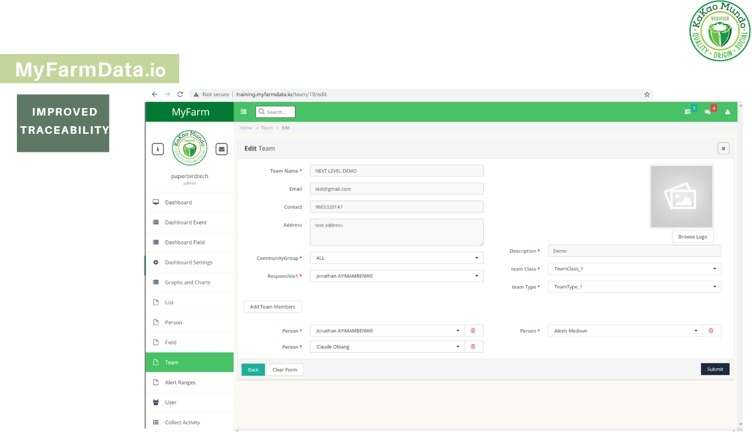

To improve the traceability we have put in place a system to register all of the data and parameters related to the people and teams involved in each task of the process in the cocoa lifecycle (from the farm to the bar).

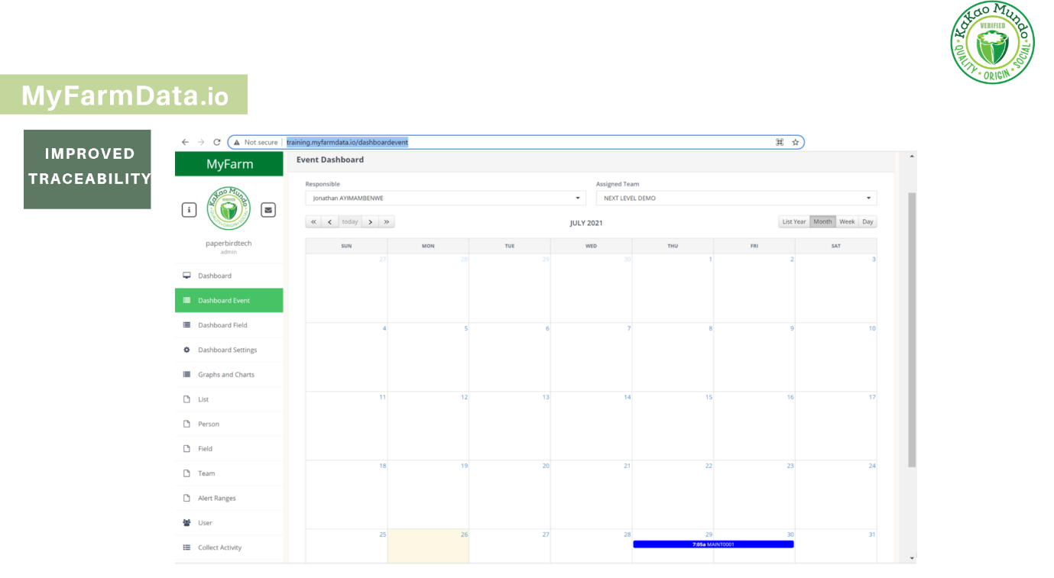

A task manager allow to have a calendar and to view the tasks planned for a specific team of people or for a responsible. The tasks can be anything related to cocoa activity , from maintenance of the fields, harvest , transportation to reception of the products.

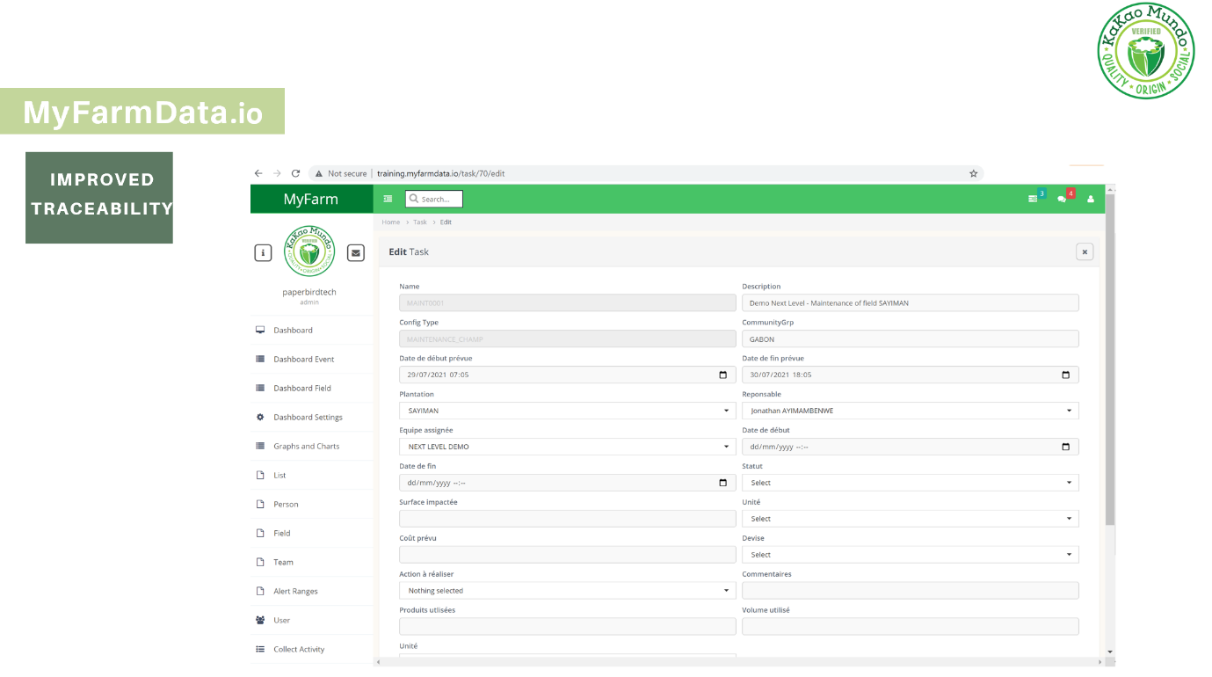

Example of one maintenance task.

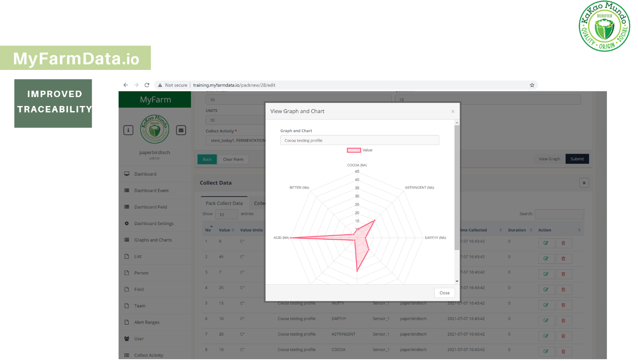

The chocolate maker also have access to the system, and can enter information about the lot they purchased. That way a tasting profile can be determined per fields and regions. It is also the moment where they can raise an incident via our incident manager to help us investigate on the default and let the farmers know how to increase the quality.