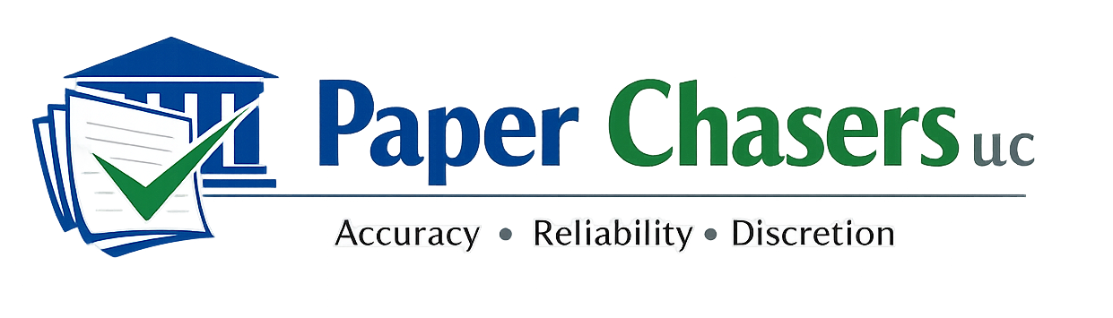

1020 Oviatt Street, Suite #5
Kaukauna, Wisconsin 54130
(920) 572-8646
WEB: www.paperchasersllc.com
EMAIL: paperchasersllc.wi@gmail.com

Comprehensive Services Rate Sheet
Northeast Wisconsin

Service Area: Outagamie, Brown, Winnebago, and Calumet Counties (and surrounding areas by request)

PROCESS SERVING

Outagamie County (Primary Coverage)
• Standard Service (up to 3 attempts, 7–10 days) – $100.00
• Rush Service (first attempt within 48 hours) – $150.00
• Same-Day Attempt – $195.00

Brown, Winnebago, Calumet Counties
• Standard Service – $115.00
• Rush Service (first attempt within 48 hours) – $165.00
• Same-Day Attempt – $210.00

Add-Ons
• Additional Attempts (beyond 3) – $25.00 each
• Mileage beyond 25 miles (when applicable) – $0.65 per mile

LEGAL & BUSINESS COURIER SERVICES

Same-Day Delivery (Business Hours)
• Local Zone (within 20 miles) – $85.00 flat
• Extended Local (21–40 miles) – $110.00 flat
• Beyond 40 miles – $0.70 per mile (round trip)

Rush / Priority Options
• Priority (delivery within 3 hours) – Add $35.00
• Immediate Dispatch (leave within 30 minutes) – Add $55.00

Scheduled Delivery (Next Business Day)
• Local Zone – $65.00
• Extended Local – $85.00

Court & Government Filings
• Same-Day Filing / Retrieval (in-county) – $95.00
• Multiple Stop Filing (same trip) – Add $25.00 per additional stop

Special Handling
• Wait Time (after 15 minutes) – $25.00 per 15-minute increment
• After-Hours (before 8am / after 5pm) – Add $45.00
• Oversized / Large Volume Documents – Quoted upon request

SKIP TRACING
• Basic Skip Trace – $50.00
(Results provided prior to service attempt when requested.)

DOCUMENT PREPARATION, LEGAL RESEARCH & DRAFTING SUPPORT

Attorney Clients (Under Attorney Direction)
• Drafting Support (briefs/motions/memos) – $90.00 per hour
• Legal Research & Written Summaries – $75.00 per hour

Pro Se Assistance (Non-Attorney Support)
• Court Form Completion Assistance – $65.00 per hour
• Document Formatting & Filing Preparation – $65.00 per hour

Flat-Fee Options (Defined Scope)
• Standard Pro Se Form Package (routine forms) – $250.00 and up
• Research Memo (attorney clients only) – $450.00 and up
• Draft Brief/Motion (attorney clients only) – $800.00 and up

*** Compliance Notice ***
Paper Chasers LLC provides non-attorney legal support services. We do not provide legal advice, legal strategy, or legal representation. Individuals are responsible for selecting their forms and determining their legal positions.

WISCONSIN CLEMENCY APPLICATION ASSISTANCE

Standard Clemency Application Package – $450.00
Includes:
• Initial consultation (up to 90 minutes)
• Narrative drafting based on client interview
• Application form completion
• Editing and formatting
• Final review session

Complex / Multi-Case Clemency Package – $650.00 and up
(For multiple convictions, extensive history, or expanded narrative drafting)

Add-Ons
• Expedited completion (7-day turnaround) – Add $100.00
• Additional revision session – $75.00

*** Clemency Compliance Notice ***
Paper Chasers LLC provides document preparation and narrative drafting assistance only. We do not provide legal advice, guarantee outcomes, or represent clients before the Wisconsin Clemency Advisory Board. Clients are responsible for all statements submitted.

PAYMENT TERMS
• Payment due upon completion unless prior arrangement established
• ACH / Check preferred
• Debit/Credit accepted (3% processing fee may apply)
• Returned check fee – $50.00
• Sales tax applicability may vary by service; confirm on invoice

