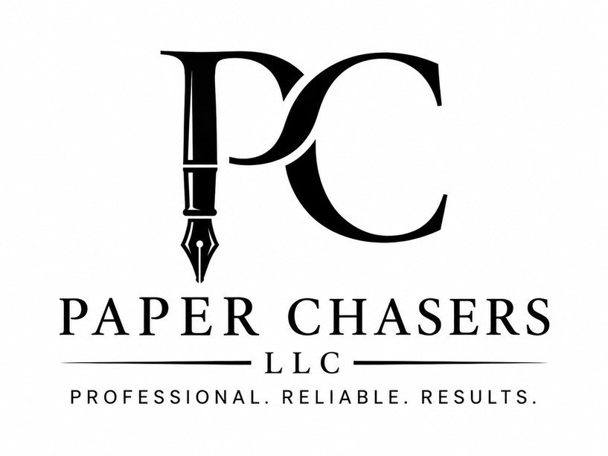

2418 West Charles Street
Appleton, Wisconsin 54914
(920) 572-8646
WEB: www.paperchasersllc.com
EMAIL: paperchasersllc.wi@gmail.com

Reliable. Responsive. Professional.

Paper Chasers LLC provides dependable legal support and field services throughout Outagamie, Brown, Winnebago, and Calumet Counties. We work with attorneys, businesses, and individuals who require accurate, timely, and professionally handled services.

CORE SERVICES

Process Serving
• Standard, Rush, and Same-Day attempts
• Prompt affidavit turnaround
• Documented and reliable communication

Legal & Business Courier Services
• Same-day document delivery
• Court filings and retrieval
• Priority and after-hours options available

Legal Support & Document Preparation
• Drafting support under attorney direction
• Legal research and written summaries
• Form typing from client-provided information
• Structured, defined-scope flat fee options

Wisconsin Clemency Application Assistance
• Structured client interview process
• Narrative drafting and document preparation
• Professional, organized submission support

WHY PAPER CHASERS LLC
• Competitive, transparent pricing
• Direct availability by phone or text
• Clear documentation and communication
• Local knowledge and responsive turnaround

For service inquiries, scheduling, or to request our full rate sheet:
Phone/Text: (920) 572-8646
Website: www.paperchasersllc.com

