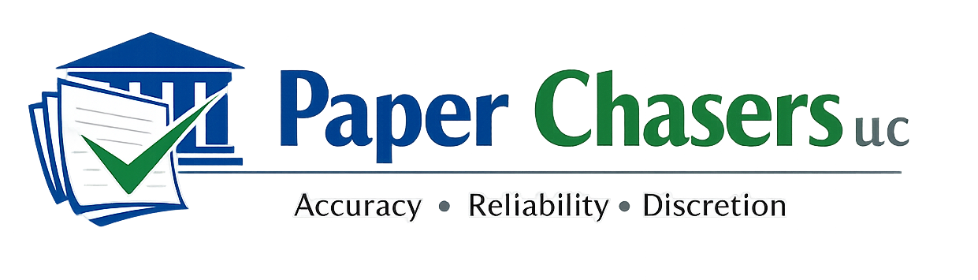

2418 West Charles Street
Appleton, Wisconsin 54914
(920) 572-8646
WEB: www.paperchasersllc.com
EMAIL: paperchasersllc.wi@gmail.com
Wisconsin Clemency Application Assistance
Northeast Wisconsin

Professional. Structured. Confidential.

Paper Chasers LLC provides structured, non-attorney assistance for individuals preparing Wisconsin Clemency Applications. Our process is designed to help clients clearly present their history, rehabilitation, and personal growth in a professional and organized manner.

WHAT WE PROVIDE
• Structured client interview (guided question process)
• Timeline reconstruction and case history organization
• Narrative drafting based on client responses
• Completion of required clemency application forms
• Editing, formatting, and final packet assembly
• Final review session prior to submission

OUR APPROACH
We work collaboratively with each client to ensure their application accurately reflects their rehabilitation, community involvement, and readiness for relief. Our goal is to present information in a clear, organized, and professional format consistent with application requirements.

PRICING STRUCTURE
Standard Clemency Application Package – $450.00
Complex / Multi-Case Applications – $650.00 and up
Expedited Completion (7-day turnaround) – Add $100.00
Additional Revision Session – $75.00

IMPORTANT NOTICE
Paper Chasers LLC provides document preparation and narrative drafting assistance only. We do not provide legal advice, guarantee outcomes, or represent clients before the Wisconsin Pardon Advisory Board. Clients remain fully responsible for the content and submission of their application.

To schedule a consultation or request additional information:
Phone/Text: (920) 572-8646
Website: www.paperchasersllc.com

