**CARBON MONOXIDE SENSOR**

• Carbon monoxide sensor ranging 5PPM to 5000PPM.

• Superior sensor performance.

• Operating range 0 – 60 Deg C

• Fully calibrated and processed digital output, RS485 Output

• Wide voltage support 12V to 24V DC

• Excellent long-term stability

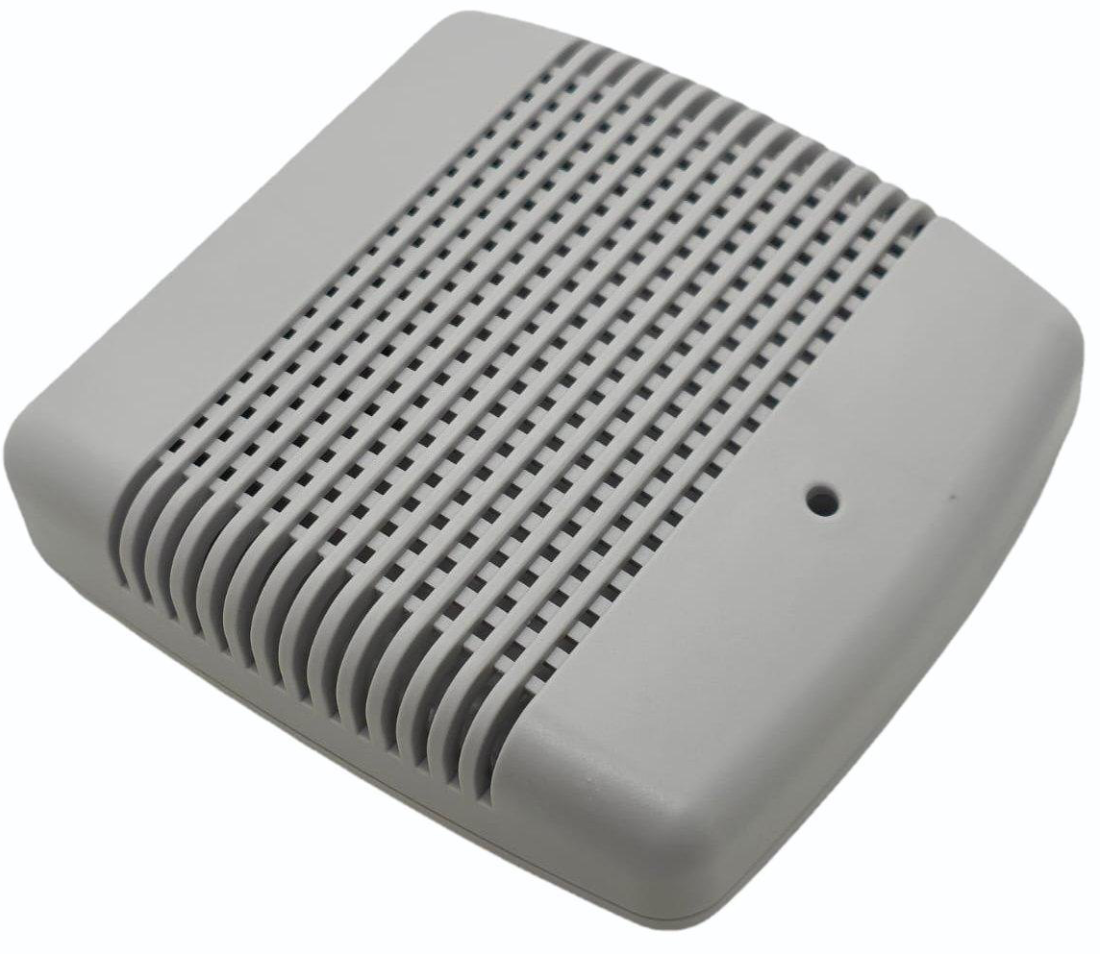

**Fig.1 - Product Image**

**1. Product Overview**

**WIN-SN-CO-M** is a compact, high-precision Carbon Monoxide sensor designed for applications requiring low power consumption and small form factor. It ensures reliable measurements over a wide range. Its RS485 communication interface simplifies integration into small, embedded systems, making it ideal for IoT, HVAC, and wearable devices. The sensor's long-term stability ensures consistent performance in harsh environments, making it a cost-effective solution for long-term deployment.

|  |  |  |
| --- | --- | --- |
| Measuring Parameter | Measuring Range | Operating Temperature |
| Carbon Monoxide | **5PPM-5000PPM** | **0°C ~ 60°C.** |

**2. Sensor Operation & Communication Details-**

The first step is to power up the sensor with the selected VDD supply voltage (range between 12V and 24V). After power-on, the sensor needs some time to reach the idle state and it is ready to receive commands sent by the host (MCU).

**3. Default Configuration setting**

**Communication Speed** 9600 – 115200 (SW selectable)

**Data Bits** 8

**Parity** None

**Stop bit** 1

**CRC** Yes

**Function code** 0X03 (Read Holding Register)

**Recommended Cable Electrical Characteristics: -**

**22 AWG Cable** Shielded and twisted pair should be used.

**Tinned Copper** Recommended

**Nominal Conductor DCR** 14.7 ohm / 1000 ft

**Nominal Capacitance** 11 pf / feet (conductor to conductor)

**High Frequency Non-Insertion Loss** 0.5db / 100ft

**Important Note:**

**Carbon monoxide concentration are provided in the multiple of 100, for the sake of higher resolution, you need to divide it by 100 to obtain the actual reading. Example. PPM 675/100 = 6.91 PPM**

**Baudrate is provided in devised of 10. Example. Baudrate 960*10=9600.**

**If wanted to change baud rate/ Slave Id/ Parity / Stop bit then refer below image. Please insert in Modbus table as shown in fig. Once updated reboot the sensor or press reset button on the PCB. And connect to MB Poll by updated setting.**

**Step by step Guide to set the desired Baud rate, Slave ID, Parity, Stop bit.**

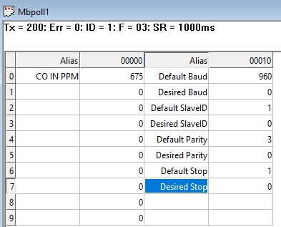 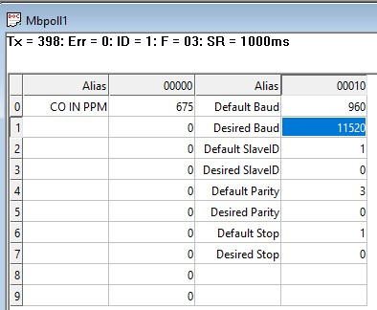

*Fig1 Fig2*

Fig1 showing the default setting of the product that is baud rate 9600, Slave ID 1, Parity None, Stop bit 1.

1. For changing baud rate from 9600 to 115200 Write 11520 at desired baud rate column as shown in fig2. Now press the reset button or restart the product.

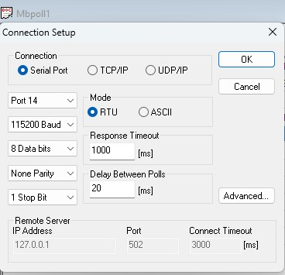 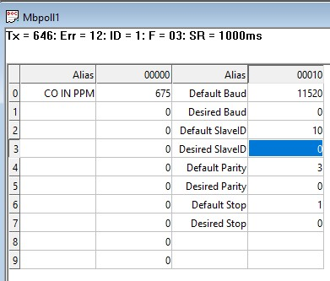

*Fig 3 Fig4*

1. *Now connect the Modbus by new baud rate as shown in fig.3. Once you click ok in fig 3 you will connect to Modbus with desired Baud rate of 115200. As shown in fig.4.*

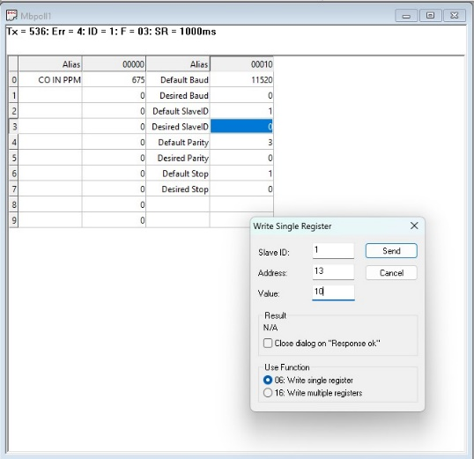 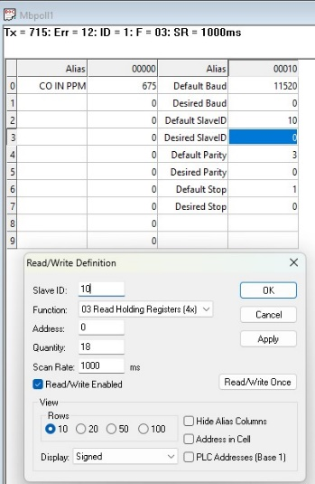

*Fig 5 Fig 6*

1. To change slave ID from 1 to 10, Write 10 at the Desired Slave ID column. Again press reset or restart the product. And once you connect with slave ID 10 you will connect to Modbus as shown in fig 6.

 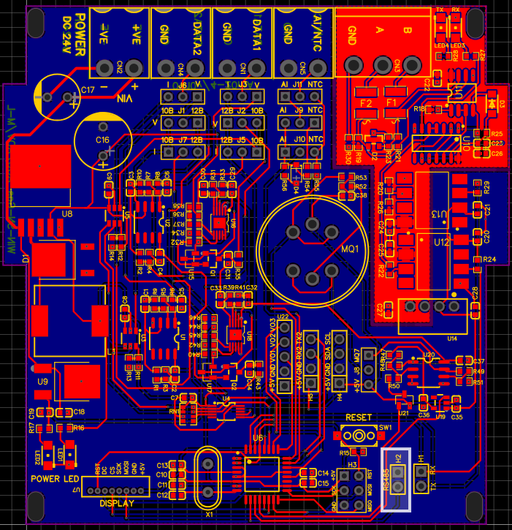

*Fig 7 Fig 8*

1. Now the Modbus is connected with desired Baud rate of 115200 and desired slave ID of 10. As shown in fig 7.
2. In case of forgetting changed slave ID, Changed baud rate you need to restore factory setting by removing jumper as shown in fig8. And press reset button. Product will be goes in default setting as shown in fig1.

**4. Contact Information**

***Augmatic Technologies Pvt. Ltd.,***

***Plot no 6, Shah Industrial Estate II,***

***Kotambi,***

***Vadodara – 391510.***

***Email – Sales@wittelb.com***