**1. Product Overview**

**WIN-SN-CO2-M** is a compact, high-precision Carbon Dioxide sensor designed for applications requiring low power consumption and small form factor. It ensures reliable measurements over a wide range. Its RS485 communication interface simplifies integration into small, embedded systems, making it ideal for IoT, HVAC. The sensor's long-term stability ensures consistent performance in harsh environments, making it a cost-effective solution for long-term deployment.

• Carbon Dioxide sensor ranging 400PPM to 2000PPM.

• Superior sensor performance.

• Operating range -10°C to 60°C for temperature and 0% to 80% RH for humidity

• Fully calibrated and processed digital output, RS485 Output

• Wide voltage support 12V to 24V DC

• Excellent long-term stability

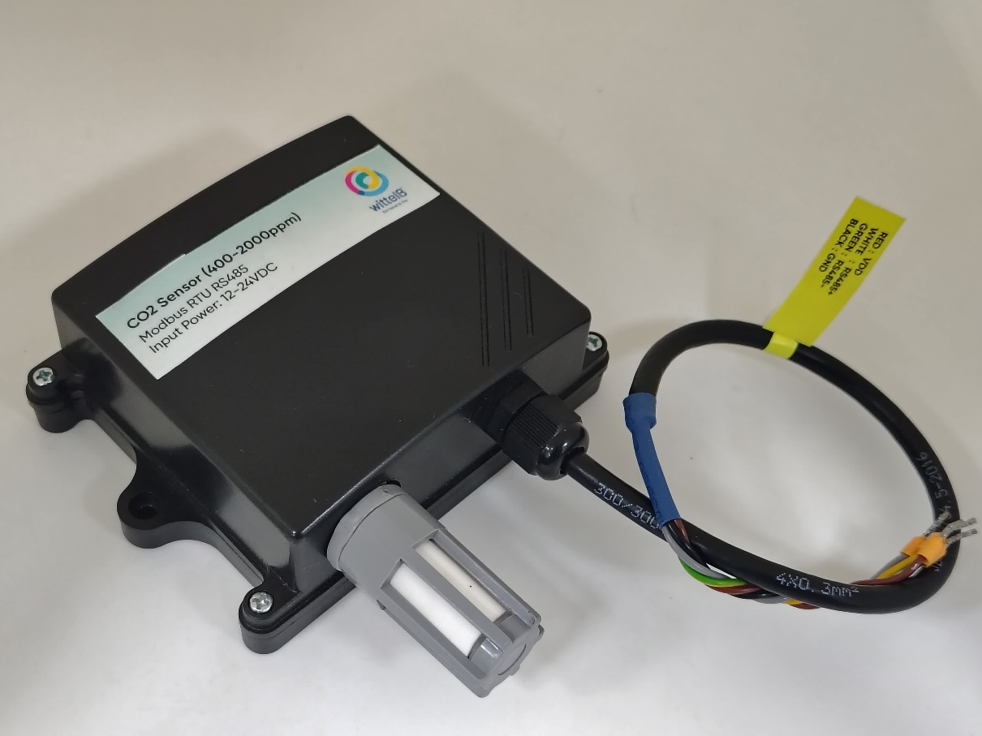

**Fig.1 - Product Image**

|  |  |  |
| --- | --- | --- |
| Measuring Parameter | Measuring Range | Accuracy |
| Carbon Dioxide Output Range | **0 – 40000 PPM** | **±50.0 ppm ±5.0 %m.v.** |
| Carbon Dioxide Measurement Range | **400 – 2000 PPM** | **±50.0 ppm ±5.0 %m.v.** |

**Sensor specification**

**2. Sensor Communicationns**

1. Start the Sensor: The first step is to power up the sensor with the selected supply voltage (range between 12V and 24V).

**3. Precautions**

1. Read all instructions before using the sensor board.
2. Keep the sensor board away from water and moisture to prevent damage.
3. Do not disassemble or modify the sensor board.
4. Use only the specified power sources.

**4. Power Supply Connection**

* **DC Connection**

1. Use 12-24V@ 1A, Power supply.
2. Don’t make loose connection.

**5. Configuration setting**

* Communication Speed 9600 – 115200 Kbps (SW Selectable)
* Data Bits 8
* Parity None
* CRC Yes
* Slave ID Software setting(1-247)
* Function Code 0X03 (Read Holding Register)

**Recommended Cable Electrical Characteristics: -**

**22 AWG Cable** Shielded and twisted pair should be used.

**Tinned Copper** Recommended

**Nominal Conductor DCR** 14.7 ohm / 1000 ft

**Nominal Capacitance** 11 pf / feet (conductor to conductor)

**High Frequency Non-Insertion Loss** 0.5db / 100ft

|  |  |  |  |  |  |
| --- | --- | --- | --- | --- | --- |
| ID | Function  Description | Register  Description | Modbus Function Code | Protocol | Data  Type |
| 1 | **Display Baud Rate (Default: 960)** | **40010** | **0x03** | **RS485** | **16-bit int** |
| 2 | **Enter New Baud Rate** | **40011** | **0x03** | **RS485** | **16-bit int** |
| 3 | **Display Slave ID (Default: 1)** | **40012** | **0x03** | **RS485** | **16-bit int** |
| 4 | **Enter New Slave ID** | **40013** | **0x03** | **RS485** | **16-bit int** |
| 5 | **Display Parity (Default: None-3 And for Odd-1, Even-2)** | **40014** | **0x03** | **RS485** | **16-bit int** |
| 6 | **Enter New Parity** | **40015** | **0x03** | **RS485** | **16-bit int** |
| 7 | **Display Stop Bit (start-2/stop bit-1)** | **40016** | **0x03** | **RS485** | **16-bit int** |
| 8 | **Enter New Start/ Stop Bit** | **40017** | **0x03** | **RS485** | **16-bit int** |

**6. Modbus RS485 Data Storage register**

|  |  |  |  |  |  |
| --- | --- | --- | --- | --- | --- |
| ID | Function Description | Register Description | Modbus Function Code | Protocol | Data Type |
| 1 | **CO2** | **40000** | **0x03** | **RS485** | **16-bit int** |

**Important Note:**

1. If you want to enter the baud rate 9600/19200/38400/57600/115200etc, enter it like this 960/1920/3840/5760/11520etc.
2. After that press the reset button or reboot the system.
3. Then you will get the present value of 11520 at 40010 baud rate (115200) and 2 at 40012 slave id.

**7. Modbus Configuration**

Here is an example of receiving data on Mb poll software.

* Open Mb-poll software connect using configuration setting (Default baud rate is 9600 and slave id is 1).
* After connecting you will get data as shown below

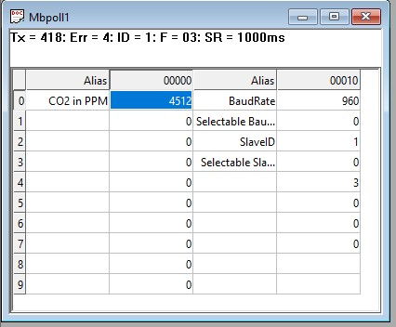

* As you can see in the image above, the resistor 40010 – 960 represents the present bund rate (9600) of the board and 40012 – 1 represents the present slave id of the board.
* To change the baud rate and slave id you must enter a value on the 40011 resistors for the baud rate and 40013 for the slave id as shown in the image below.
* Now you can see data. In below image set 115200 baud rate and slave ID 10.

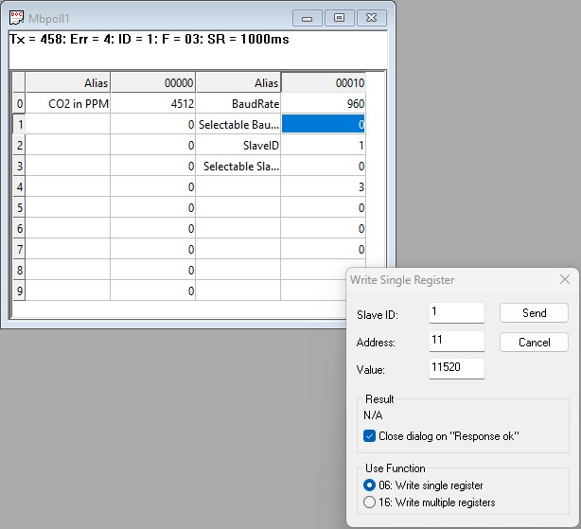

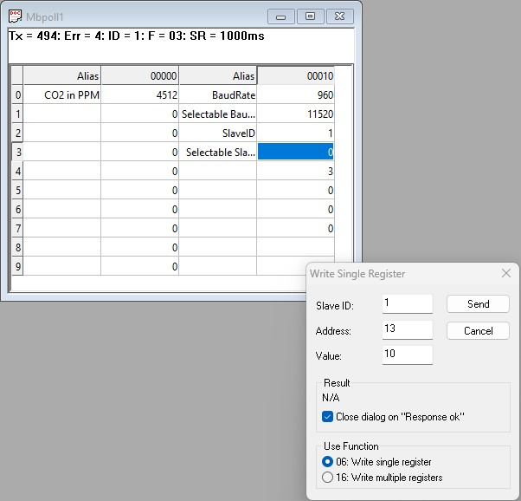

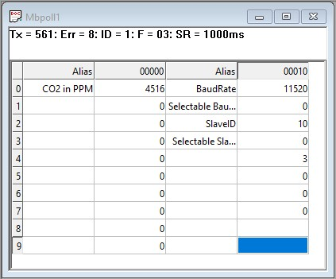

**Hard reset Setting**

Somehow you forgot the baud rate or slave id of the board then remove the jumper (as shown in the image) from the board reboot the system or press the reset button (given on the board). Then you will get the default baud rate of 9600 and slave id 1.

**7. Contact Information**

***Augmatic Technologies Pvt. Ltd.,***

***Plot no 6, Shah Industrial Estate II,***

***Kotambi,***

***Vadodara – 391510.***

***Email – Sales@wittelb.com***