Supplementary Material
Integrated transcriptomic immune profiling identifies survival-associated immune ecotypes in pediatric diffuse high-grade glioma
Supplementary Figures S1–S16 and Supplementary Tables S1–S25. The tables are supplied as a separate workbook, Supplementary_Tables_Cancers.xlsx, whose README sheet repeats the index below and whose Crosswalk sheet maps every item of the previous version onto this one.
Contents
Figure S1. Brain-tuned myeloid signatures versus the LM22 macrophage and monocyte axes.
Figure S2. CIBERSORTx LM22 quality control in the same-resource pooled set.
Figure S3. ssGSEA TPM-harmonization concordance.
Figure S4. Re-clustering of the high-confidence CIBERSORTx subset.
Figure S5. Clustering-definition and held-out-feature sensitivity.
Figure S6. PERMANOVA variance partition, immune ecotype versus integrated molecular group.
Figure S7. Immune-theme composites across the ecotypes.
Figure S8. Per-signature immune programs and post-hoc comparisons.
Figure S9. Pathway enrichment from the molecular-group-adjusted gene lists.
Figure S10. Unadjusted one-versus-rest differential expression.
Figure S11. Subtype-stratified survival.
Figure S12. Location-stratified Kaplan–Meier curves.
Figure S13. Proportional-hazards diagnostics.
Figure S14. Survival missingness and inverse-probability-weighting sensitivity.
Figure S15. Single-cell support for the cellular interpretation of the immune signatures and of the ecotype axis, full analysis.
Figure S16. Spatial organization of the immune programs in H3.3 K27M pediatric diffuse midline glioma, full analysis.
Table S1. Immune signature gene lists
Table S2. Feature composition of the clustering matrices
Table S3. Anatomical-location classification mapping
Table S4. Analysis-set reconciliation
Table S5. Immune-ecotype assignment of the main cohort
Table S6. Cluster-number sweep, k = 2 to 10
Table S7. Gap statistic, k = 1 to 10
Table S8. Cluster-number criteria and the k each selects
Table S9. Feature-definition sensitivity of the k = 3 assignment
Table S10. PERMANOVA on circular and held-out feature blocks
Table S11. Cross-method concordance, main cohort and pooled set
Table S12. Brain-tuned myeloid signatures versus LM22 macrophage and monocyte axes
Table S13. Location and molecular-group contingency analyses
Table S14. Kruskal-Wallis tests of the immune features and theme composites
Table S15. Dunn post-hoc comparisons
Table S16. Molecular-group-adjusted differential expression, all three contrasts
Table S17. Overlap of the three adjusted contrasts
Table S18. Genes shared by both Immune-desert-referenced contrasts
Table S19. Pathway enrichment from the adjusted gene lists
Table S20. Cox models and proportional-hazards diagnostics
Table S21. Survival evaluability and missingness
Table S22. Single-cell signature attribution
Table S23. Cell type expressing the ecotype-axis genes
Table S24. Spatial autocorrelation and spot-level ecotype assignment
Table S25. Software versions, parameters and random seeds

Supplementary figures
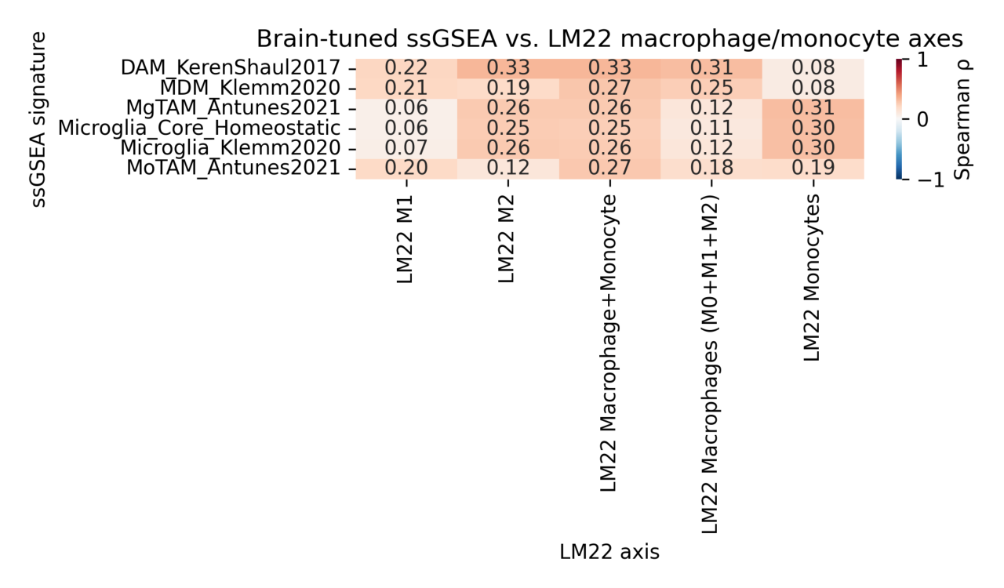
Figure S1. Brain-tuned myeloid signatures versus the LM22 macrophage and monocyte axes. Spearman correlations between the brain-tuned microglia and monocyte-derived-macrophage ssGSEA signatures and the CIBERSORTx LM22 macrophage and monocyte axes in the main cohort (n = 349). Concordance is axis- and method-specific and provides partial computational cross-checking only; it does not validate LM22 as a CNS-specific cell-abundance reference. Statistics are in Supplementary Table S12.

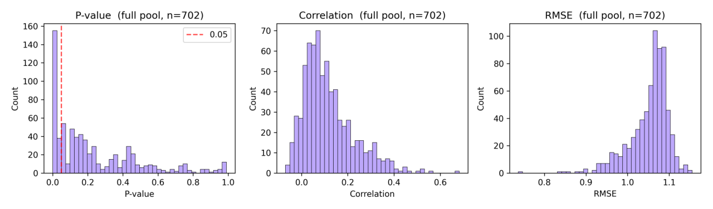
Figure S2. CIBERSORTx LM22 quality control in the same-resource pooled set. The histograms of Figure 2A computed on the full 702-biospecimen OpenPedCan pool: median permutation P = 0.15, median fit correlation 0.09, and 193 of 702 biospecimens (27.5%) reaching P < 0.05. This is an internal sensitivity analysis on the same resource and not independent external validation.

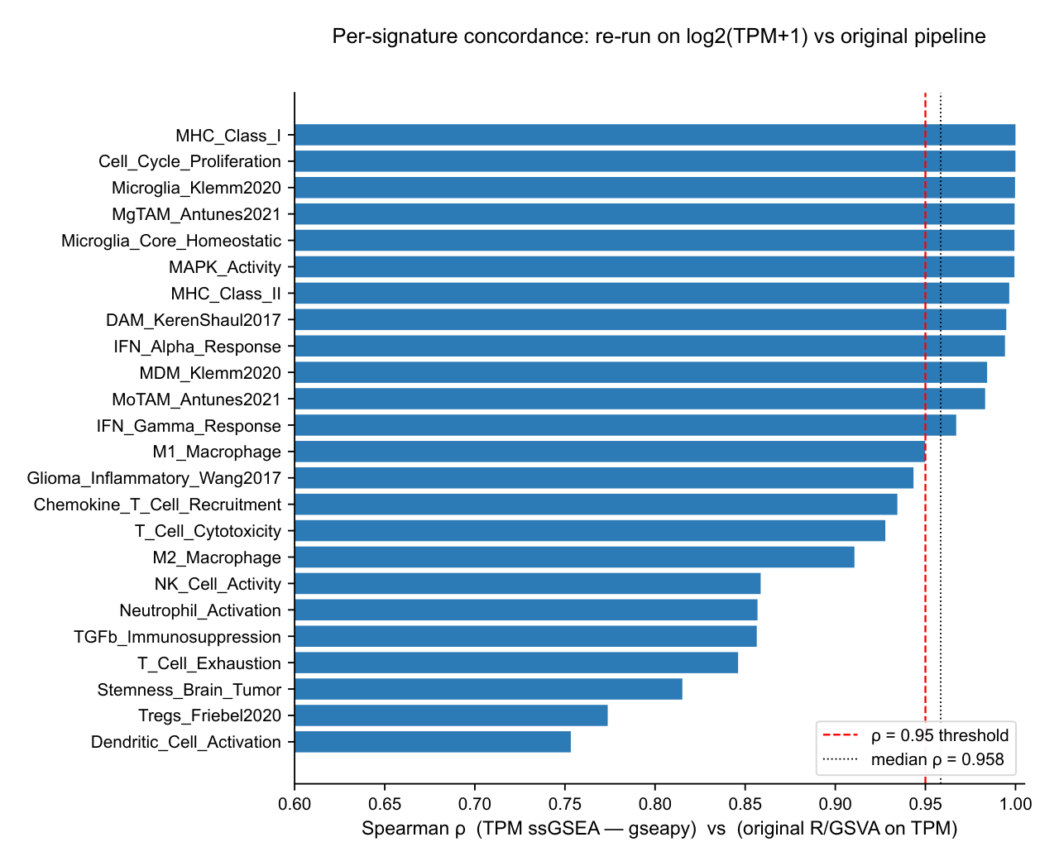
Figure S3. ssGSEA TPM-harmonization concordance. Per-signature Spearman correlation between the original R/GSVA ssGSEA scores and a Python (gseapy v1.3) re-run on the same log₂(TPM + 1) matrix, across all 24 brain-tuned signatures (median ρ = 0.958).

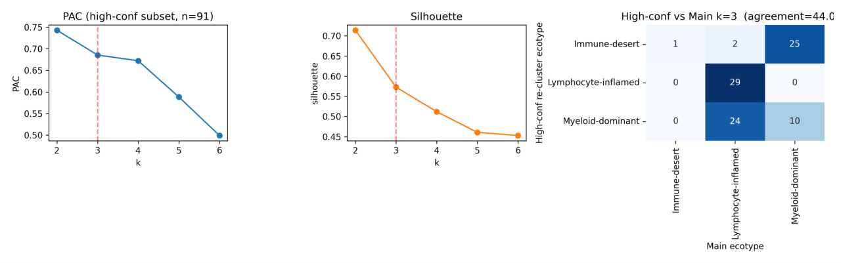
Figure S4. Re-clustering of the high-confidence CIBERSORTx subset. Three-ecotype structure recovered in the subset of biospecimens with LM22 permutation P < 0.05 (n = 91). Direct mapped-label agreement with the locked main assignment is 44%, which indicates sensitivity to this selection and re-clustering rather than robustness.

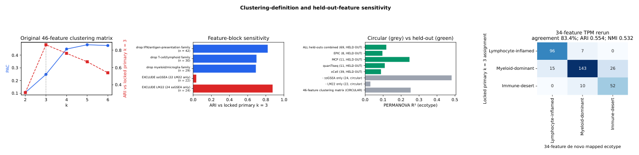
Figure S5. Clustering-definition and held-out-feature sensitivity. Cluster-number metrics on the 46-feature matrix; feature-block sensitivity; circular versus held-out PERMANOVA; and the de novo 34-feature TPM-harmonized confusion matrix against the locked assignment. These panels indicate partial feature-definition stability, not validation of a finalized classifier. Statistics are in Supplementary Tables S9 and S10.

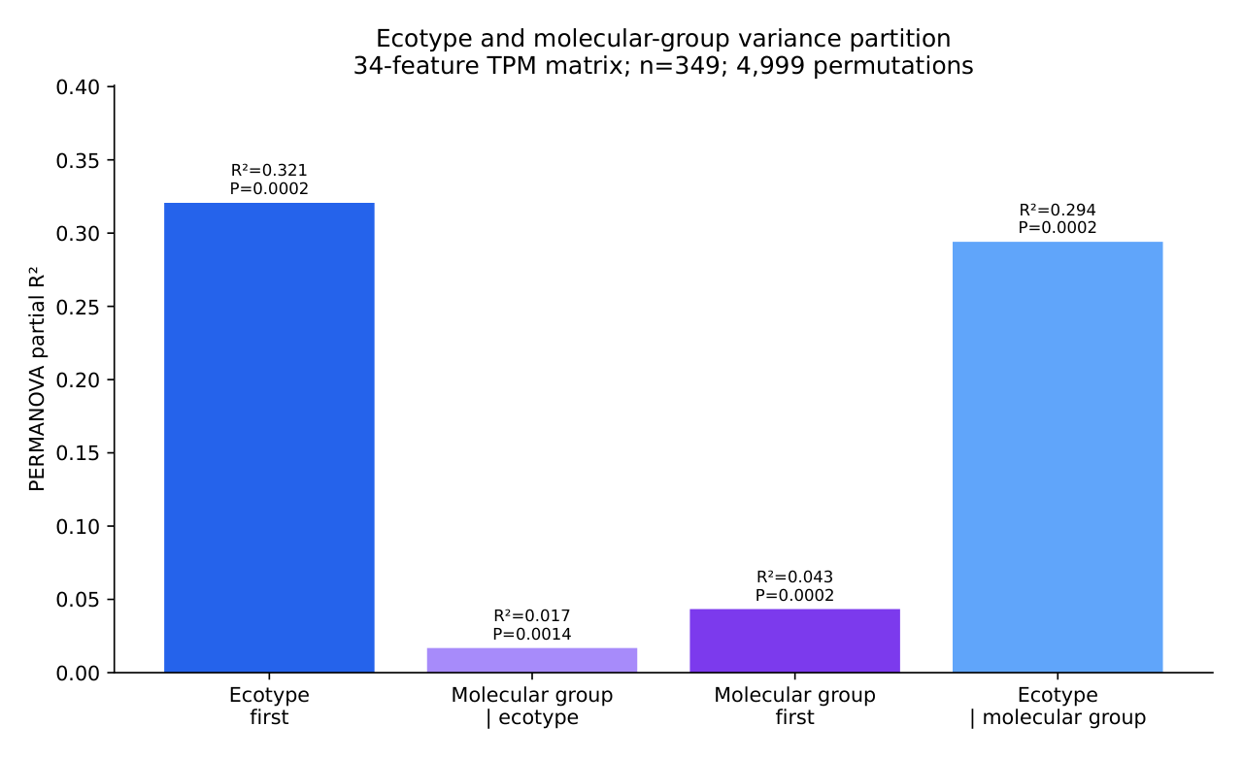
Figure S6. PERMANOVA variance partition, immune ecotype versus integrated molecular group. Computed on the 34-feature TPM-harmonized matrix (Euclidean distance, 4,999 permutations). Ecotype entered first explained R² = 0.3206 (P = 0.0002) and molecular group after ecotype R² = 0.0168 (P = 0.0014); with molecular group entered first, ecotype retained R² = 0.2940 (P = 0.0002).

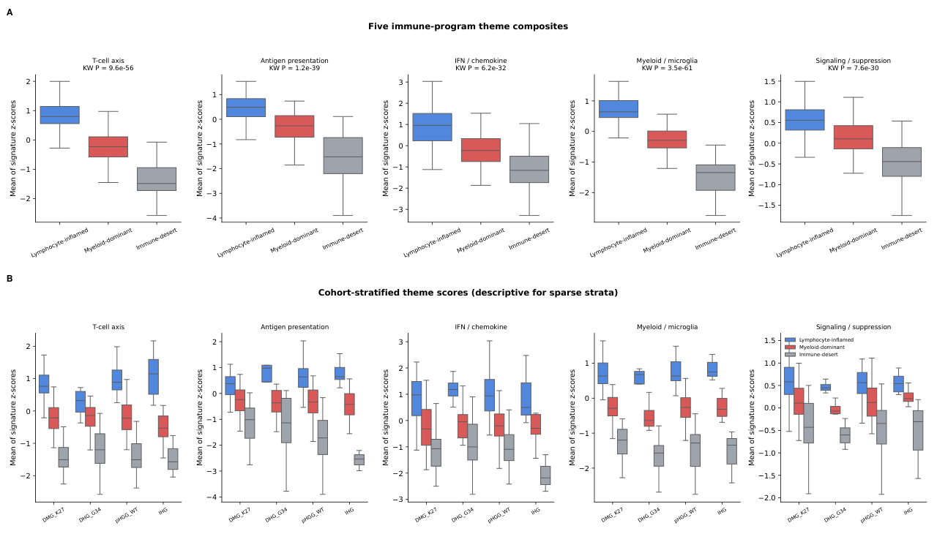
Figure S7. Immune-theme composites across the ecotypes. (A) Five immune-theme composites calculated from per-signature z-scores. (B) The same composites stratified by integrated molecular group; within-group Kruskal–Wallis tests are Benjamini–Hochberg adjusted, but the DHG, H3 G34-mutant and infant-type hemispheric panels are descriptive because of sparse ecotype strata. Statistics are in Supplementary Table S14.

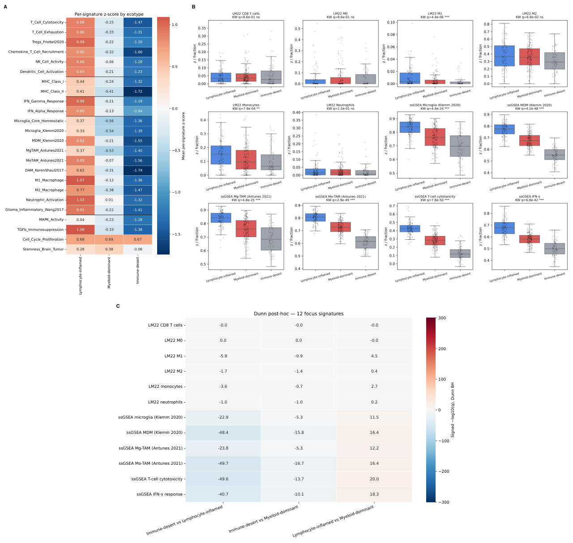
Figure S8. Per-signature immune programs and post-hoc comparisons. (A) Mean per-signature z-score by ecotype for all 24 brain-tuned ssGSEA signatures. (B) Twelve focus signatures, ending with the interferon-γ response. (C) Dunn post-hoc signed −log₁₀(q) heatmap for the same twelve signatures; the color scale is capped at ±300 for readability. Statistics are in Supplementary Tables S14 and S15.

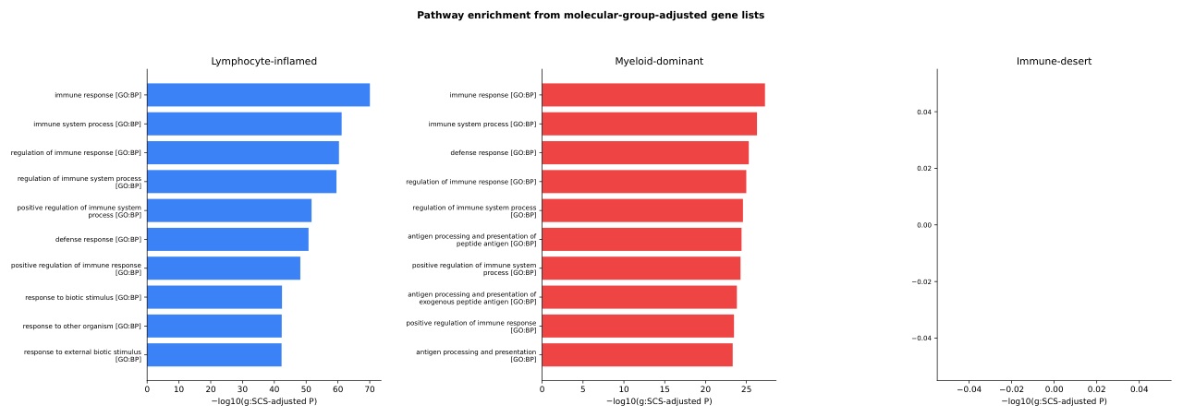
Figure S9. Pathway enrichment from the molecular-group-adjusted gene lists. g:Profiler enrichment of the up-regulated gene lists of Figure 6A–C. Lymphocyte-inflamed and Myeloid-dominant show immune, defense-response and antigen-processing terms; no Immune-desert term passed the displayed adjusted criterion, so that panel is blank. Full results are in Supplementary Table S19.

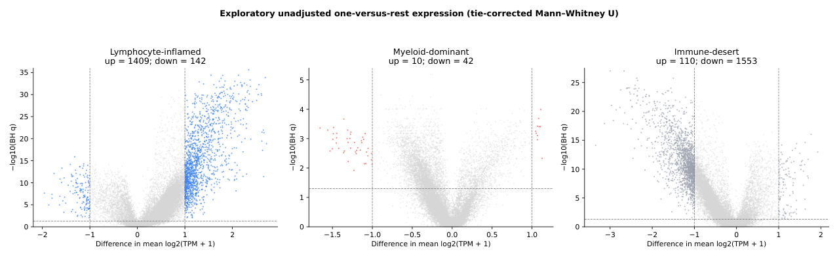
Figure S10. Unadjusted one-versus-rest differential expression. Exploratory one-versus-rest analysis using two-sided tie-corrected asymptotic Mann–Whitney U tests with continuity correction and within-contrast Benjamini–Hochberg adjustment; the y-axis maxima are approximately 36, 5 and 27 for Lymphocyte-inflamed, Myeloid-dominant and Immune-desert. Figure 6A–C uses the molecular-group-adjusted models.

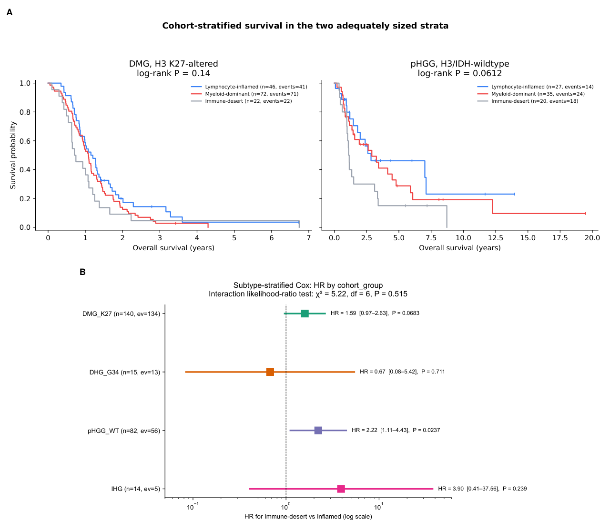
Figure S11. Subtype-stratified survival. (A) Kaplan–Meier curves by ecotype in the two adequately sized strata: DMG, H3 K27-altered (n = 140, log-rank P = 0.140) and pediatric high-grade glioma, H3/IDH-wildtype (n = 82, P = 0.0612). (B) Within-subtype Cox hazard ratios for Immune-desert versus Lymphocyte-inflamed, with the interaction likelihood-ratio test. Strata with very small ecotype-specific sample and event counts are descriptive only and are not evidence of subtype generalizability. Model output is in Supplementary Table S20.

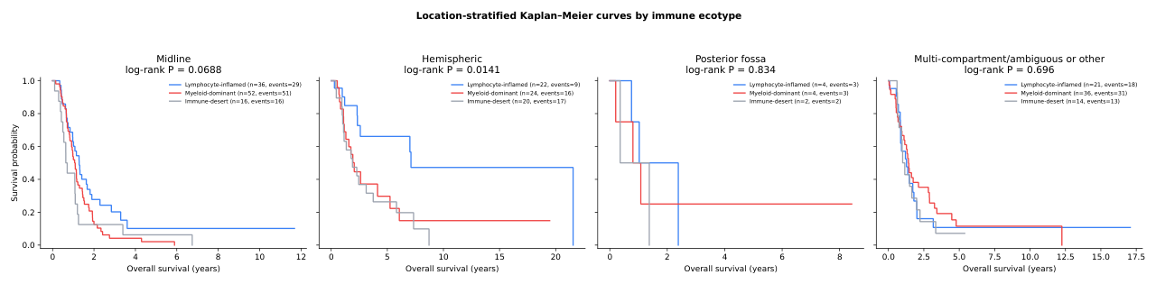
Figure S12. Location-stratified Kaplan–Meier curves. Overall survival by ecotype within the midline, hemispheric, posterior-fossa and multi-compartment/ambiguous or other location classes. Colors follow the study-wide blue, red and gray palette; sparse panels are descriptive.

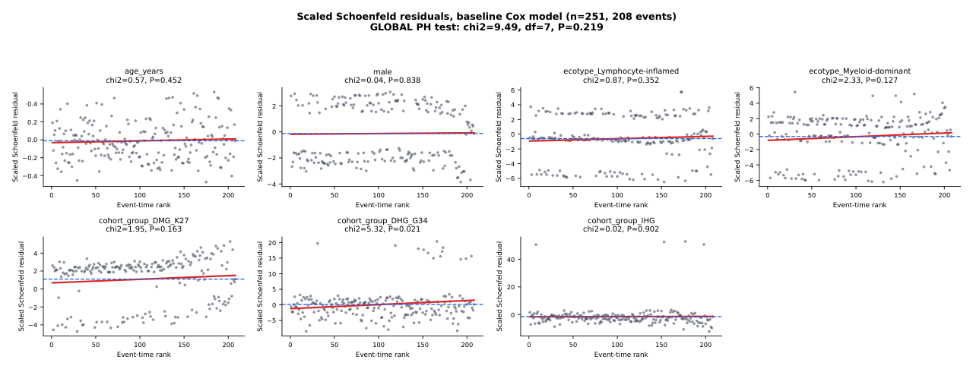
Figure S13. Proportional-hazards diagnostics. Scaled Schoenfeld residuals against event-time rank for every covariate of the baseline multivariable Cox model (n = 251, 208 events). Red line, linear fit; blue dashed line, the fitted coefficient. Per-covariate Grambsch–Therneau χ² and P are shown above each panel; the global test is χ² = 9.49, df = 7, P = 0.219. Only DHG, H3 G34-mutant was nominally non-proportional (P = 0.021), which does not survive Benjamini–Hochberg correction across the seven covariates (q = 0.147). Full output is in Supplementary Table S20.

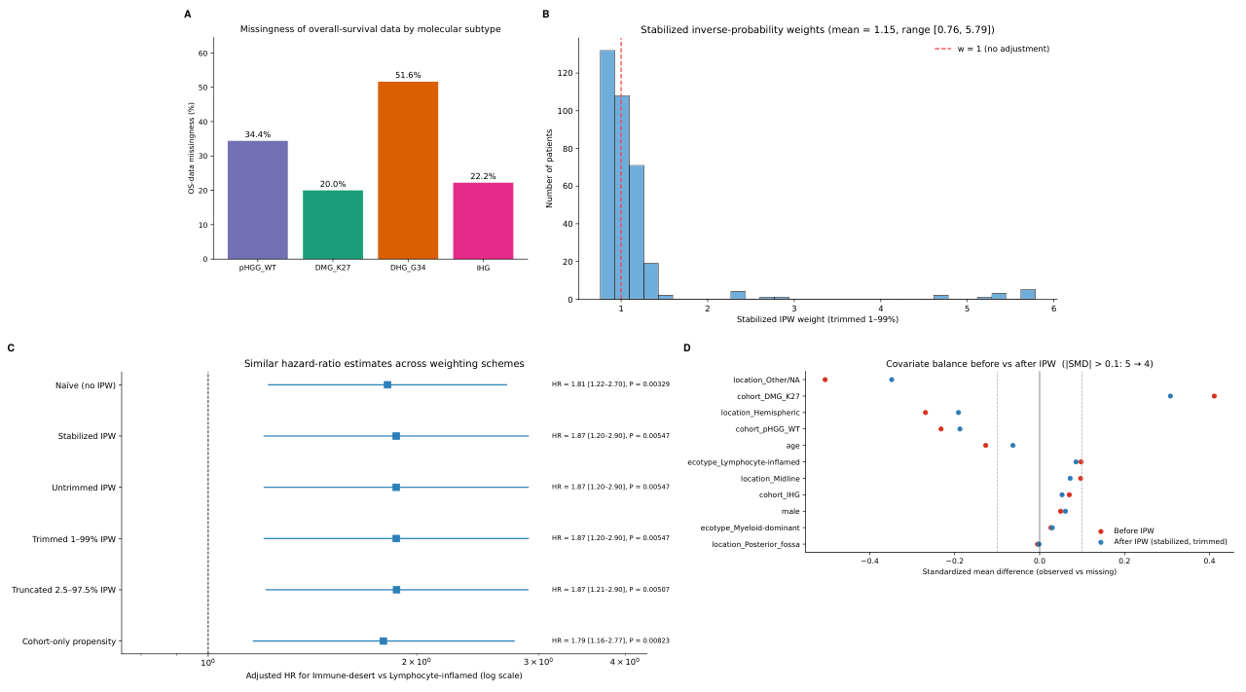
Figure S14. Survival missingness and inverse-probability-weighting sensitivity. (A) Proportion of tumors with overall-survival annotation by integrated molecular group. (B) Trimmed stabilized weights (mean 1.15, range 0.76–5.79). (C) Hazard-ratio estimates across the weighting schemes. (D) Covariate balance before and after weighting. Overall survival was evaluable for 251 of 349 tumors (71.9%); missingness is differential with respect to the measured confounders and non-differential with respect to immune ecotype (χ² = 1.54, df = 2, P = 0.463). The analysis conditions on measured covariates; a missing-not-at-random mechanism cannot be excluded and is stated in the limitations. Statistics are in Supplementary Table S21.

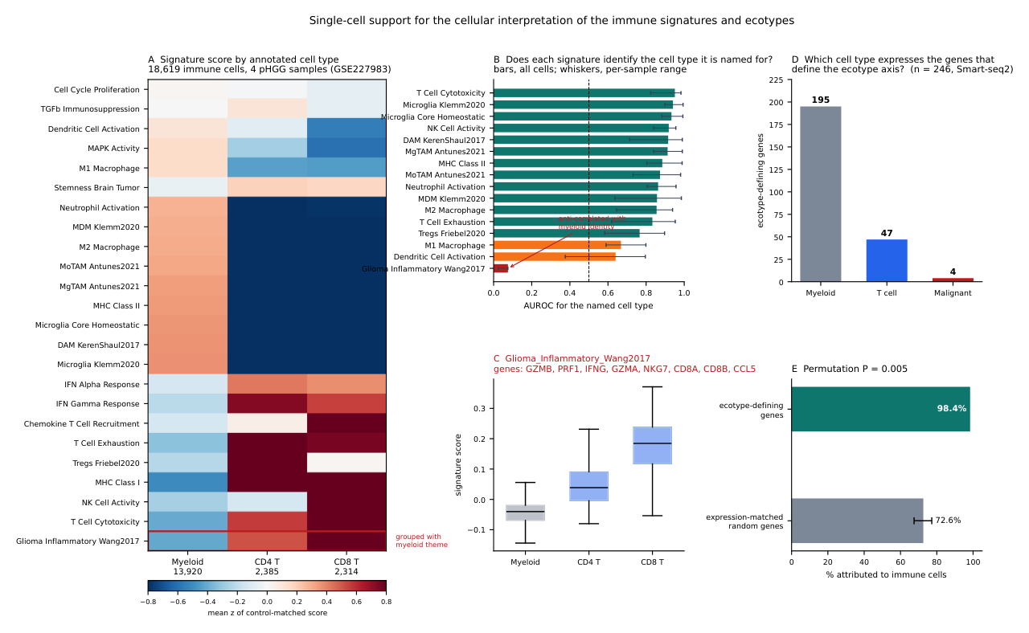
Figure S15. Single-cell support for the cellular interpretation of the immune signatures and of the ecotype axis, full analysis. (A) Mean z-score of each of the 24 brain-tuned signatures by annotated cell type in 18,619 immune cells from four pediatric high-grade gliomas (GSE227983; H3 K27-altered n = 1, H3-wildtype hemispheric n = 3; posterior fossa ependymoma excluded). Scores are control-gene-matched, using 25 expression bins and 50 control genes per signature gene. Cell annotations are those published by the original authors and were verified here against canonical lineage markers. The red outline marks Glioma_Inflammatory_Wang2017. (B) Area under the receiver-operating-characteristic curve for each directional signature in identifying the cell type it is named for; bars across all cells, whiskers the per-sample range (also shown as Figure 5A). (C) Glioma_Inflammatory_Wang2017 by cell type; it identifies T cells rather than myeloid cells (AUROC 0.075 for myeloid identity). (D) Cell type expressing each of the 246 detectable genes defining the Lymphocyte-inflamed versus Immune-desert contrast, in matched Smart-seq2 immune and malignant cells compared on one platform. (E) Percentage of those genes attributed to immune cells against 200 draws of expression-matched random genes (permutation P = 0.005). The signatures and the ecotype axis are immune-cell-associated, with many genes preferentially expressed in myeloid cells. Statistics are in Supplementary Tables S22 and S23.

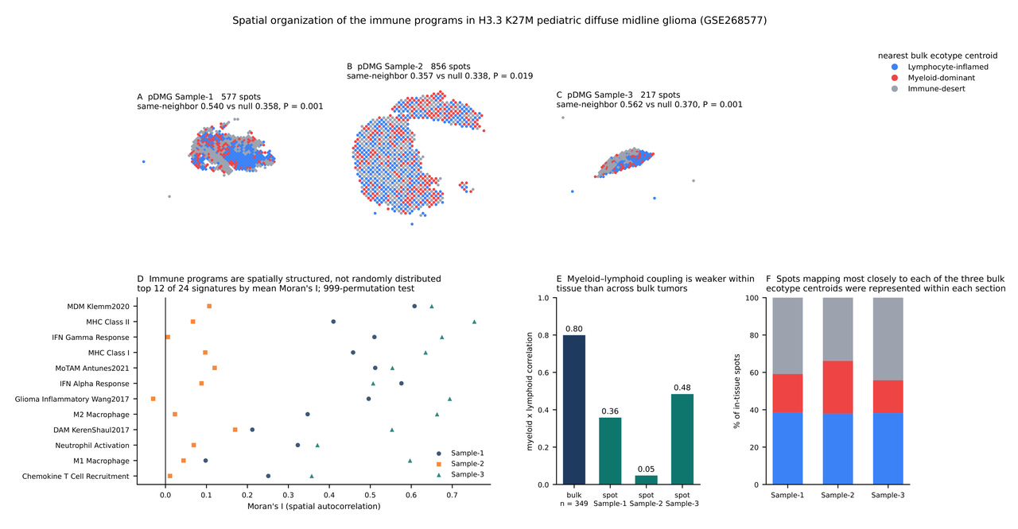
Figure S16. Spatial organization of the immune programs in H3.3 K27M pediatric diffuse midline glioma, full analysis. Three H3.3 K27M pediatric diffuse midline glioma sections profiled by 10x Visium (GSE268577). In-tissue spots were normalized to counts per 10,000, log₂-transformed and scored with the same control-gene-matched method used for the single-cell data; spots are unsorted, so cell composition is meaningful in this dataset. (A–C) Each in-tissue spot colored by the bulk ecotype centroid it maps most closely to, assigned by Pearson correlation across the 24 brain-tuned signatures after z-scoring within dataset; Sample-1 (577 spots), Sample-2 (856) and Sample-3 (217). Neighboring spots share an assignment more often than chance in all three sections: 0.540, 0.357 and 0.562 against permutation nulls of 0.358, 0.338 and 0.370 (999 label permutations; P = 0.001, 0.019 and 0.001). Spots mapping most closely to each of the three bulk ecotype centroids were represented within each section, so a bulk ecotype label reflects a spatial average over regions of a specimen rather than a property of a whole tumor. (D) Moran’s I on the hexagonal first-order neighbor graph for the twelve signatures with the highest mean value across sections; 999 permutations per signature. Ten of the 24 signatures are spatially autocorrelated at a false-discovery rate below 0.05 in all three sections, most strongly the myeloid and antigen-presentation programs. (E) Correlation between the myeloid and lymphoid theme composites, in the bulk cohort and per spot within each section. The close coupling seen across bulk tumors (r = 0.80) is weaker within tissue (r = 0.36, 0.05 and 0.48), consistent with an aggregation contribution. (F) Proportion of in-tissue spots assigned to each ecotype per section. Sample-2 is the weakest section across every analysis. Statistics are in Supplementary Tables S22 and S24.

Supplementary tables
Supplied as Supplementary_Tables_Cancers.xlsx; one worksheet per table, named for the table number.
Table S1. Immune signature gene lists. Complete membership of every gene signature used in the study, with its source annotation. Supports: Methods; Figures 2, 3, 5.
Table S2. Feature composition of the clustering matrices. Every feature of the 46-feature primary clustering matrix (22 CIBERSORTx LM22 fractions plus 24 brain-tuned ssGSEA signatures) and of the 34-feature TPM-harmonized sensitivity matrix (10 quanTIseq axes plus the 24 ssGSEA signatures), with block membership. Supports: Methods; Figure 3; Figure S5.
Table S3. Anatomical-location classification mapping. Mapping of the source CNS region and primary site annotations onto the four location classes. Supports: Methods; Figure 4.
Table S4. Analysis-set reconciliation. Reconciliation of the main cohort (n = 349), the location-annotated set (n = 332), the sequential PERMANOVA set (n = 258) and the survival-evaluable set (n = 251). Supports: Figure 1B.
Table S5. Immune-ecotype assignment of the main cohort. Locked exploratory k = 3 assignment for all 349 biospecimens. Supports: Figures 3, 4, 6, 7.
Table S6. Cluster-number sweep, k = 2 to 10. Consensus clustering of the 46-feature matrix, 1,000 bootstrap replicates, 80% item resampling, seed 42. Supports: Figure 3A-C, 3E.
Table S7. Gap statistic, k = 1 to 10. Gap statistic against 50 uniform reference datasets, with the one-standard-error criterion. Supports: Figure 3D.
Table S8. Cluster-number criteria and the k each selects. Each cluster-number criterion, the k it selects and the criterion family it belongs to. Supports: Figure 3A-E.
Table S9. Feature-definition sensitivity of the k = 3 assignment. De novo k = 3 clustering on the primary and on the TPM-harmonized matrices compared with the locked assignment. Supports: Figure S5.
Table S10. PERMANOVA on circular and held-out feature blocks. One-way PERMANOVA of ecotype and molecular group against the feature blocks used to define the clusters and against blocks that were not. Supports: Figure S5.
Table S11. Cross-method concordance, main cohort and pooled set. Spearman correlations between CIBERSORTx LM22 and the peer methods in the n = 349 main cohort and in the same-resource n = 702 pool. Supports: Figure 2B; Figures S1, S2.
Table S12. Brain-tuned myeloid signatures versus LM22 macrophage and monocyte axes. Spearman correlations between the brain-tuned microglia and monocyte-derived-macrophage signatures and the LM22 macrophage and monocyte axes. Supports: Figure S1.
Table S13. Location and molecular-group contingency analyses. Contingency statistics for ecotype by anatomical location and by integrated molecular group, with Monte-Carlo P values and midline-versus-hemispheric odds ratios. Supports: Figure 4.
Table S14. Kruskal-Wallis tests of the immune features and theme composites. Per-feature and per-theme Kruskal-Wallis tests across the three ecotypes with Benjamini-Hochberg adjustment. Supports: Figures S7, S8.
Table S15. Dunn post-hoc comparisons. Pairwise Dunn comparisons for every feature, with within-feature Benjamini-Hochberg adjustment. Supports: Figure S8.
Table S16. Molecular-group-adjusted differential expression, all three contrasts. Gene-wise ordinary least squares on log2(TPM + 1) with ecotype and integrated molecular group, 18,586 annotated genes, n = 349. Supports: Figure 6A-C.
Table S17. Overlap of the three adjusted contrasts. Partition of the up-regulated gene sets of the two Immune-desert-referenced contrasts. Supports: Figure 6D.
Table S18. Genes shared by both Immune-desert-referenced contrasts. The 426 genes up-regulated in both Lymphocyte-inflamed and Myeloid-dominant versus Immune-desert, with both adjusted effect sizes. Supports: Figure 6D-F.
Table S19. Pathway enrichment from the adjusted gene lists. g:Profiler enrichment of the molecular-group-adjusted up-regulated gene lists. Supports: Figure S9.
Table S20. Cox models and proportional-hazards diagnostics. Multivariable Cox models, Grambsch-Therneau tests on scaled Schoenfeld residuals, and the comparison with and without location adjustment. Supports: Figure 7B; Figures S11, S13.
Table S21. Survival evaluability and missingness. Survival evaluability by baseline characteristic and ecotype by evaluability within each molecular group. Supports: Figure S14.
Table S22. Single-cell signature attribution. AUROC of each directional signature for the cell type it is named for, and the effect of correcting the two misassigned theme memberships. Supports: Figure 5A; Figure S15.
Table S23. Cell type expressing the ecotype-axis genes. Mean expression and detection rate of each detectable ecotype-axis gene in matched malignant, myeloid and T cells. Supports: Figure 5B; Figure S15.
Table S24. Spatial autocorrelation and spot-level ecotype assignment. Moran's I for every signature in each section, and the spot-level assignment and spatial coherence statistics. Supports: Figure 5C-E; Figure S16.
Table S25. Software versions, parameters and random seeds. Execution environment, package versions, parameters and seeds for every analysis. Supports: Methods.
Items deposited in the study repository
The following analyses were part of the earlier revision package and are not included in this submission. They are deposited, with the code and the executed notebooks that produce them, at https://github.com/paperhwi/pediatric_glioma_immuneprofiling.
- Supplementary Figures S1, S2 and S7A–C (previous numbering) — same-resource pooled n = 702 cross-method concordance, consensus heatmap and re-clustering sensitivity
- Supplementary Figure S14A–C (previous numbering) — same-resource BRAF/RTK-altered cohort-family projection and pathway-score sensitivity
- Supplementary Figure S15 (previous numbering) — immune-checkpoint-related transcript expression by ecotype
- Supplementary Figure S16 (previous numbering) — CAR-T target-related transcript expression by ecotype
- Supplementary Figure S17 (previous numbering) — audit copy of the molecular-group-adjusted differential-expression analysis
- Supplementary Figure S18 (previous numbering) — Kaplan–Meier curves for the very small DHG, H3 G34-mutant and infant-type hemispheric strata
- Supplementary Figure S19 and Tables S20–S23 (revision numbering) — hematopoietic stem and progenitor programs across the ecotypes
- Supplementary Figure S10A (previous numbering) — subtype-stratified Kaplan–Meier curves including the very small strata
- Supplementary Tables S1 and S11 (previous numbering) — auxiliary molecular alteration flags, and the Table 1 ecotype rows and contingency counts
Abbreviations
AUROC, area under the receiver-operating-characteristic curve; BH, Benjamini–Hochberg; CI, confidence interval; CNS, central nervous system; DAM, disease-associated microglia; DHG, diffuse hemispheric glioma; DMG, diffuse midline glioma; df, degrees of freedom; FDR, false-discovery rate; HR, hazard ratio; IHG, infant-type hemispheric glioma; IPW, inverse-probability weighting; MDM, monocyte-derived macrophage; PAC, proportion of ambiguous clustering; PERMANOVA, permutational multivariate analysis of variance; pDMG, pediatric diffuse midline glioma; pHGG, pediatric high-grade glioma; ssGSEA, single-sample gene set enrichment analysis; TAM, tumor-associated macrophage; TPM, transcripts per million; UMAP, uniform manifold approximation and projection.

