Brain-tuned deconvolution defines a developmental immune ecotype framework with independent prognostic value in pediatric glioma

Suhmi Chung, MD¹,*
¹ Department of Neurosurgery, Asan Medical Center, University of Ulsan College of Medicine, Seoul, Republic of Korea
* Correspondence: [corresponding author email]

Simple Summary
We used 349 pediatric high-grade glioma RNA-seq samples from the OpenPedCan v15 cohort and a brain-tuned deconvolution pipeline to identify three reproducible immune ecotypes — Inflamed, Intermediate, and Immune-desert — that are independently prognostic for overall survival. For cross-validation, we asked whether the same biological reality is captured when external analytical frameworks are applied to the same cohort: the Grabowski 2021 immunosuppression taxonomy, the Sampson 2020 microglia/Mo-TAM partition, the Levine 2024 18-gene tumor inflammation signature (TIS) and 24-signature Bagaev pan-cancer panel, and the Levine 2024 BRAF V600E three-cluster prognostic claim. The cross-validation confirms our ecotype architecture, identifies the HLA-I/HLA-II antigen-presentation axis as an axis that the TIS scalar misses, and demonstrates that the Levine BRAF V600E TIS-PFS prognostic claim does not survive proper cutoff-selection multiplicity correction in our population-level cohort.

Abstract

The tumor immune microenvironment (TIME) of pediatric gliomas remains largely underexplored. Three recent works have begun to close this gap: Grabowski et al. (2021) systematised the mechanisms of glioma immunosuppression; Sampson et al. (2020) quantified the dominance of monocyte-derived macrophages over brain-resident microglia; and Levine et al. (2024) established the 18-gene Danaher tumor inflammation signature (TIS) as the leading quantitative axis of pediatric brain-tumor immunity. Each provides a different conceptual lens on the same biology, but none has been tested as a unified framework on an independent population-level cohort.
We apply a brain-tuned deconvolution pipeline to 349 pediatric high-grade glioma samples from OpenPedCan v15 (DMG_K27 n=175, DHG_G34 n=31, pHGG_WT n=125, IHG n=18) and identify three immune ecotypes by consensus clustering of quanTIseq fractions plus 19 brain-tuned ssGSEA signatures. Holding the cohort constant, we apply the Grabowski/Sampson-derived module library (13 modules), the Danaher TIS, the Bagaev 24-signature pan-cancer panel, the 14-pathway PROGENy proxy, and the Levine 2024 BRAF V600E LGG three-cluster + TIS-PFS prognostic protocol to test whether the ecotype architecture and its clinical implications hold under external analytical frameworks. We additionally apply a maximally selected log-rank correction to address cutoff-selection multiplicity.
Three reproducible immune ecotypes emerged: Inflamed (n=113), Intermediate (n=157), and Immune-desert (n=79). LM22 alone failed to separate CD8 T-cell fractions between ecotypes (q=0.86) whereas brain-tuned modules achieved (ε²=0.31–0.74). Ecotype was associated with cohort group (Fisher p=1.3×10⁻³) and anatomical location (p=1.3×10⁻²); DHG_G34 was preferentially Immune-desert (51.6%). In a multivariable Cox model adjusted for cohort group, age and sex, Immune-desert was independently associated with worse OS (HR=1.79, p=0.004).
The Grabowski/Sampson modules confirmed the ecotype architecture (q<10⁻²⁹ per module) and revealed the 'inflamed-but-exhausted' character of the Inflamed ecotype (Exhaustion + Treg + suppressive cytokine all maximal). The Danaher TIS captured most ecotype variance (ε²=0.620, p=9.8×10⁻⁴⁸) but missed the HLA-I − HLA-II antigen-presentation axis (ρ=−0.51 vs TIS) — an axis uniquely resolved by the brain-tuned framework. The PROGENy proxy reproduced the Levine TIS-pathway pattern (JAK-STAT ρ=+0.62, NFkB +0.59, PI3K −0.55). CD276 was orthogonal to the canonical checkpoint module (mean ρ=+0.26 vs PDCD1 +0.36). In BRAF V600E LGG (n=68; 1.8× Levine n=38), the three-cluster immune architecture and V600E > KIAA-fusion TIS contrast both replicated (MW p=5×10⁻⁴ vs Levine PBTA p=0.013). However, the high-TIS = worse-PFS prognostic claim did not survive multiplicity correction: under Levine's own bootstrap convention TIS p was 0.014 (consistent with their reported 0.047), but the permutation-corrected p was 0.54 — and similarly NS for all four candidate immune biomarkers.
In conclusion, using brain specific immune deconvolution model, we have established developmentally anchored, prognostically independent three-state immune ecotype framework for pediatric glioma. Crosschecking with the reference article confirms its biological reality under three external analytical lenses while highlighting one axis (HLA-I/HLA-II asymmetry) the external frameworks miss and one analytical pitfall (cutoff-selection multiplicity in the Levine V600E TIS-PFS claim) that proper statistical correction exposes.
Keywords: pediatric glioma; tumor immune microenvironment; immune ecotype; deconvolution; brain-tuned signature scoring; tumor inflammation signature

1. Introduction
Pediatric gliomas are biologically and clinically distinct from their adult counterparts, defined by histone mutations such as H3 K27M and H3 G34R/V, MAPK pathway alterations including BRAF V600E and KIAA1549-BRAF fusions, and receptor tyrosine kinase fusions in infant-type tumors. These oncogenic drivers are intrinsically linked to developmental epigenetic programs and to the brain regions from which the tumors arise [1,2,3].
While the molecular taxonomy of pediatric gliomas is now well established, the tumor immune microenvironment (TME) remains comparatively underexplored. Pediatric brain tumors have historically been viewed as immunologically "cold," a perception that has limited enthusiasm for immunotherapy in this population [4,5]. Recent studies, however, have begun to reveal substantial heterogeneity in the TME of pediatric gliomas, with reports describing an immunosuppressive myeloid-rich microenvironment in H3 K27-altered diffuse midline glioma (DMG) [6,7], comparatively higher T-cell infiltration in H3 G34-mutant hemispheric tumors [8], and developmental immune privilege in infant-type lesions [9,10]. Despite these advances, a unified ecotype framework that integrates histone mutation class, anatomical compartment, and developmental context into a single interpretive lens has not been established.
A central methodological limitation in this field is that the most widely used computational immune deconvolution panel, the CIBERSORTx LM22 signature matrix, was derived from peripheral blood mononuclear cells and does not explicitly model brain-resident microglia [11]. Because microglia and infiltrating monocyte-derived macrophages (MDMs) exhibit overlapping but distinguishable transcriptional programs in the central nervous system [12,13,14], the inability of LM22-based methods to differentiate these populations risks conflating two biologically and therapeutically distinct cell types. Recent single-cell studies have catalogued lineage-specific signatures that can resolve microglia from MDM in glioma tissue [12,14,15], yet these have not been systematically applied alongside conventional deconvolution to large pediatric glioma cohorts.
Three recent publications shaped the conceptual scope of the immune characteristics of glioma. First, Grabowski et al. (2021) systematised the mechanisms of glioma-induced immunosuppression across five T-cell dysfunction states (senescence, tolerance, anergy, exhaustion and ignorance), regulatory T-cell and myeloid-derived suppressor cell expansion, M2 polarisation of glioma-associated macrophages and microglia, hypoxia-driven TAM recruitment, and the iatrogenic immunosuppression imposed by dexamethasone and temozolomide [27]. Second, Sampson et al. (2020) reframed CNS immune privilege as immune-distinct rather than absent, quantified that ~85% of brain-tumor TAMs are monocyte-derived with only ~15% arising from yolk-sac microglia, and emphasised that H3.3K27M neoepitope-targeting T-cell receptors and GD2-targeted chimeric antigen receptor T cells achieve pediatric-specific antitumour activity, that MAPK pathway alterations are enriched in anti-PD-1 responders, and that S1PR1-dependent bone-marrow T-cell sequestration is a systemic immune-evasion mechanism [28]. Third, Levine et al. (2024) profiled 1,382 pediatric brain tumors with a clinical-grade 103-gene NanoString immune-oncology panel and established the 18-gene Danaher tumor inflammation signature (TIS) as the dominant quantitative axis of pediatric TIME [29]. Importantly, Levine et al. validated their findings in 752–811 Pediatric Brain Tumor Atlas (PBTA) RNA-sequencing samples — the same resource we mine through OpenPedCan v15 — and reported (i) the wider-than-appreciated TIS range within H3 K27M DMG, (ii) a three-cluster immune architecture within BRAF V600E pediatric LGG with prognostic significance, (iii) a CD276 (B7-H3) axis orthogonal to the canonical PD-1 / CTLA-4 / TIGIT / LAG-3 network, and (iv) a TIS plus tumor mutation burden composite biomarker stratifying MMRD HGG ICI response.

Study design: a two-layer analytical strategy
Throughout this manuscript we maintain a strict separation between two analytical layers, both applied to the same OpenPedCan v15 cohort with no additional dataset introduced in either layer.
We hypothesized that pediatric gliomas would segregate into reproducible immune ecotypes whose composition is shaped by histone mutation class, anatomical location, and developmental context, and that integrating brain-tuned myeloid signatures with conventional deconvolution would resolve the microglia-versus-MDM axis. Leveraging the Open Pediatric Cancer (OpenPedCan) v15 release, we applied four orthogonal deconvolution algorithms (MCP-counter, quanTIseq, EPIC, xCell) together with 19-brain tuned ssGSEA scoring of microglia and MDM signatures to 349 independent pediatric glioma biospecimens. We then defined immune ecotypes by consensus clustering, characterized their molecular and anatomical correlates, and evaluated their prognostic significance.
Holding the cohort and the ecotype assignment fixed, we then apply five external analytical frameworks ; (i) the Grabowski 2021 immunosuppression-mechanism taxonomy operationalised as thirteen ssGSEA modules; (ii) the Sampson 2020 microglia-versus-monocyte-derived-TAM partition operationalised through the Klemm 2020 and Antunes 2021 single-cell signature libraries; (iii) the Levine 2024 / Danaher 2018 18-gene tumor inflammation signature, the 24-signature Bagaev 2021 pan-cancer microenvironment panel, and the seven-gene checkpoint co-expression network; (iv) the 14-pathway PROGENy proxy via HALLMARK gene sets; and (v) the Levine 2024 BRAF V600E LGG three-cluster + TIS-PFS prognostic protocol, including their surv_cutpoint 1,000 × 90% bootstrap convention and our additional maximally-selected log-rank permutation correction. This validation process is a deliberate method-comparison and replication exercise designed to (a) test whether our Part-A ecotype framework is robust to the choice of analytical lens, (b) identify which axes are uniquely captured by the brain-tuned framework and which are equally well captured by simpler signatures, and (c) honestly report which of Levine et al.'s clinical claims do and do not generalise to a population-level cohort.

2. Materials and Methods

2.1. Data Source and Cohort Assembly
Harmonized bulk RNA-sequencing and clinical/molecular metadata were obtained from the Open Pediatric Cancer (OpenPedCan) v15 release (https://github.com/d3b-center/OpenPedCan-analysis), which extends and supersedes the original Open Pediatric Brain Tumor Atlas (OpenPBTA) [16]. We restricted analyses to PBTA-cohort RNA-Seq specimens annotated as tumor tissue. To ensure statistical independence, we applied the OpenPedCan "independent-primary-plus" specimen list (one biospecimen per patient, preferring primary tumors). For patients with pediatric high-grade glioma (H3/IDH-wildtype), a maximum age cutoff of 21 years was applied to exclude adult-onset cases.
Main analysis cohort groups were defined as: (1) DMG_K27 — diffuse midline glioma, H3 K27-altered (denoted K28-altered in OpenPedCan, IUPAC nomenclature; n = 175); (2) DHG_G34 — diffuse hemispheric glioma, H3 G34-mutant (denoted G35-mutant in OpenPedCan; n = 31); (3) pHGG_WT — pediatric-type high-grade glioma, H3/IDH-wildtype (n = 125); (4) IHG — infant-type hemispheric glioma (operational definition: age at diagnosis < 18 months + hemispheric location + NTRK1/2/3, ALK, ROS1, MET, or BRAF fusion as reported in the OpenPedCan fusion-putative-oncogenic table; n = 18). A secondary supplementary cohort of BRAF-altered and other MAPK-driven tumors (n = 353; split into HGG/PXA/infant-fusion driven subgroup and LGG-only subgroup) was retained for projection analyses but not included in primary clustering.
Anatomical location was classified using the OpenPedCan CNS_region and primary_site annotations. Pineal, suprasellar, optic pathway, and ventricular tumors were assigned to an "Ambiguous" category and excluded from midline-versus-hemispheric association analyses.

2.2. Gene Expression Processing
FPKM-normalized expression matrices (gene-expression-rsem-tpm-collapsed.rds) were obtained from the v15 release and subset to cohort biospecimen IDs. Gene identifiers were retained as HGNC symbols. Genes with zero expression across all retained samples (n = 4,917) were removed, yielding a final matrix of 55,408 genes × 702 samples (349 main + 353 secondary). For CIBERSORTx-style input, TPM-normalized values were used without log transformation or quantile normalization, per recommended RNA-seq preprocessing [11].

2.3. Immune Deconvolution
Four orthogonal deconvolution methods were applied using the immunedeconv R package (v2.1.4) [17]: MCP-counter [18], quanTIseq [19], EPIC [20], and xCell [21]. MCP-counter input was log2(x+1)-transformed automatically by the package. quanTIseq and EPIC were run with the tumor argument set to TRUE. All other parameters used package defaults. CIBERSORTx LM22 deconvolution was performed as a fifth, independent cross-validation method using the Stanford web tool (Job #15, 11 June 2026) [11]. The combined 702-biospecimen TPM matrix (349 Main + 353 secondary) was submitted in absolute mode with batch correction disabled, quantile normalization disabled (per the package's RNA-seq recommendation), and 100 permutations for significance testing. LM22 outputs were used (a) to compute per-sample QC metrics (permutation P-value, Pearson fit correlation, RMSE) and (b) as a fifth method in cross-axis Spearman correlation against MCP-counter, quanTIseq, EPIC, and xCell. LM22 cell-type fractions were not included in the primary clustering feature matrix; the clustering design (quanTIseq + ssGSEA, Section 2.5) was specified a priori to avoid inflating redundancy among estimates of the same cell type.

2.4. Brain-Tuned ssGSEA Scoring
To address the absence of brain-resident myeloid lineages in conventional deconvolution panels, we assembled a 24-signature gene set library encompassing microglia-specific programs (homeostatic core from Bohlen 2020 [13] / Butovsky 2014; glioma-associated microglia from Klemm 2020 [12]; Mg-TAM from Antunes 2021 [14]), monocyte-derived macrophage programs (Klemm 2020 MDM; Antunes 2021 Mo-TAM), disease-associated microglia (DAM; Keren-Shaul 2017), antigen presentation (MHC class I and II), interferon-α/γ response, T-cell cytotoxicity, T-cell exhaustion, T-regulatory cells, dendritic cell activation, NK cell activity, M1/M2 macrophage polarization, neutrophil activation, chemokine T-cell recruitment, MAPK transcriptional output, TGF-β immunosuppression, the Wang 2017 glioma inflammatory signature, cell cycle/proliferation, and a brain tumor stemness signature. Gene set match rates against the TPM matrix exceeded 90% for all signatures. Single-sample gene set enrichment analysis was performed with the GSVA package (v1.50) [22] using method = "ssgsea" and normalize = TRUE on the TPM matrix (see Section 2.17 for independent cross-implementation validation of this normalization choice).

2.5. Consensus Clustering and Ecotype Definition
The clustering feature matrix combined quanTIseq immune cell fractions (excluding the "uncharacterized cell" residual; 10 features) with 19 immune-relevant ssGSEA signatures, z-scored per feature across samples. Consensus clustering was performed with the ConsensusClusterPlus package [23] (k-means clustering, Euclidean distance, Ward.D2 linkage, 500 resampling iterations, 80% subsampling, k = 2–6). Optimal k was evaluated by the proportion of ambiguous clustering (PAC) [24], silhouette width [25], and biological interpretability. A pre-specified k = 3 was selected for primary analysis (consistent with prior glioma immune subtyping frameworks [26]); k = 2 and k = 4 results are reported as sensitivity analyses.Cross-method correlation of myeloid, CD8 T-cell, and NK cell signals was assessed using Spearman's ρ on per-sample summed scores within each method.

2.6. Statistical Analysis
Associations between ecotype assignment and categorical covariates (cohort group, anatomical location class, developmental age group) were tested with Fisher's exact test using simulated p-values (10,000 replicates). Per-pathway ssGSEA score differences across ecotypes were evaluated by Kruskal-Wallis test with Benjamini-Hochberg multiple-testing adjustment; pairwise post-hoc comparisons used Dunn's test. Rank-biserial correlation was reported as an effect size measure. Two-sided p-values < 0.05 were considered statistically significant.

2.7. Survival Analysis
Overall survival (OS) was modeled using the survival package [27] in R 4.3.2. Kaplan-Meier curves were generated stratified by ecotype, both overall and within each cohort group, with log-rank tests. Univariable and multivariable Cox proportional-hazards models were fitted with the Inflamed ecotype as reference; the multivariable model adjusted for cohort group, age at diagnosis (years), and sex. Proportional-hazards assumptions were assessed by Schoenfeld residual tests (Supplementary Figure S6). Survival analyses were exploratory and interpreted cautiously given incomplete OS annotation (251/349 main cohort samples with available OS data; 71.9%). To assess whether OS data availability introduced selection bias, we compared the distributions of cohort group, ecotype, anatomical location, age group, and sex between samples with and without OS data using chi-square tests.

2.8. Software and Reproducibility
All analyses were performed in R 4.3.2 (R Foundation for Statistical Computing, Vienna, Austria) and Python 3.12. Key R packages included immunedeconv, GSVA, ConsensusClusterPlus, ComplexHeatmap, survival, survminer, and rstatix. Python visualizations used matplotlib and pandas.

2.9. Grabowski / Sampson-derived extended signature modules (Step 4c)
To translate the immunosuppression taxonomy of Grabowski et al. [27] and the brain-immunology framework of Sampson et al. [28] into quantitative scores applied to the same cohort, we curated thirteen additional ssGSEA gene sets covering T-cell dysfunction (Exhaustion core, Senescence, TCM/Naive loss), granulocytic and monocytic MDSC, hypoxia HIF targets, HLA-I and HLA-II antigen presentation, CSF1R-TAM and CCR2 chemokine axes, Treg, and a suppressive cytokine axis. The HLA-I and HLA-II axes were also combined into a derived HLA-I − HLA-II difference score.

2.10. Levine 2024 / Danaher / Bagaev framework (Step 4d)
We computed the Danaher 18-gene TIS [29,30] per sample as the mean of log2(TPM+1) over the 18 signature genes, and ssGSEA NES for the 24-signature Bagaev 2021 pan-cancer microenvironment panel [31]. A seven-gene checkpoint co-expression network (PDCD1, CD274, CTLA4, LAG3, HAVCR2, TIGIT, CD276) was computed overall and within each ecotype to test the Levine 2024 observation that CD276 is orthogonal to the canonical PD-1/CTLA4/TIGIT/LAG3 module.

2.11. PROGENy-proxy 14-pathway scoring (Step 4g)
A HALLMARK-derived proxy for 14 PROGENy pathways was built using 13–30 well-validated downstream effector genes per pathway and scored by ssGSEA NES (gseapy 1.2.1, rank-normalised). Cross-pathway and TIS-pathway correlations were computed by Spearman ρ on the full n = 349 main cohort, replicating the analytical strategy of Levine 2024 Fig 2c.

2.12. BRAF V600E LGG three-cluster replication (Step 4e)
Sixty-eight BRAF V600E and 184 KIAA1549-BRAF fusion samples were identified within the BRAF_ALT_LGG group (1.8× and 2.3× the corresponding Levine n=38 and n=79). Ward.D2 hierarchical clustering with Euclidean distance was applied to the z-scored 24-Bagaev + TIS feature matrix of V600E samples, with k=3 pre-specified to match the Levine 2024 protocol. Progression-free survival used EFS_days and the union of Progressive / Recurrence event types.

2.13. Cutoff-selection multiplicity correction (Step 4f)
Levine et al. computed dichotomous TIS-PFS p-values using R survminer surv_cutpoint with a 1,000 × 90% subsample bootstrap. Because surv_cutpoint searches for the maximally-significant cutoff across all admissible splits and the bootstrap median p does not formally correct for this selection, we computed three p-values per candidate immune biomarker (TIS, Bagaev Effector cells, Bagaev Checkpoint inhibitor, Bagaev TAMs): (a) the naïve best p — minimum log-rank p across cutoffs leaving ≥25% per side; (b) the Levine bootstrap median p — the median naïve best p across 1,000 independent 90% subsamples; and (c) the permutation-corrected p — the fraction of 1,000 event-label permutations whose maximum log-rank χ² equals or exceeds the observed maximum, providing a maximally-selected log-rank correction in the spirit of Lausen and Schumacher [32].

2.14. V600E × CDKN2A/B crosstab and C1_hot marker DEG (Step 4g)
CDKN2A/B homozygous deletion was extracted from molecular_subtype; Fisher's exact test (one-sided) compared C1_hot vs C2+C3 with odds ratio reporting. For differential expression we applied Wilcoxon rank-sum to genes with log2(TPM+1) > 1 in ≥5 samples comparing C1_hot to C2+C3, Benjamini-Hochberg FDR-adjusted.

2.15. Differential Expression Analysis (DESeq2). Differential gene expression between Inflamed (n = 113) and Immune-desert (n = 79) ecotypes was assessed using DESeq2 [ref] on RSEM expected counts from the OpenPedCan v15 release. The model design (~ cohort_group + ecotype) adjusted for tumor subtype. Genes with fewer than 10 total counts across samples were excluded. Significance thresholds were |log2 fold-change| ≥ 1 and Benjamini-Hochberg adjusted p < 0.05.

2.16. IDH1/IDH2 Mutational Status Audit
To confirm the H3/IDH-wildtype status of the cohort (Section 2.1), we screened five OpenPedCan annotation columns (pathology_diagnosis, pathology_free_text_diagnosis, molecular_subtype, molecular_subtype_methyl, integrated_diagnosis, and broad_histology/cancer_group) for IDH1/IDH2-related tokens across all 349 primary-analysis samples. Token hits were manually adjudicated against the curated integrated_diagnosis and pathology free-text narrative to resolve negated phrasing (e.g., "IDH-1 negative") and methylation-classifier discordance.

2.17. ssGSEA Cross-Implementation Concordance (TPM Normalization Validation)
To verify that ssGSEA scoring (Section 2.4) was performed on TPM-normalized expression, we independently re-scored all 24 brain-tuned signatures on log2(TPM+1) using a second, independent Python implementation (gseapy.ssgsea v1.3) and computed per-signature Spearman correlation against the original R/GSVA scores (n = 349). The resulting TPM-harmonized feature matrix was re-clustered using the identical consensus-clustering protocol (Section 2.5, k = 3, KMeans, 500 bootstraps, 80% subsampling) and compared to the original ecotype assignment by Adjusted Rand Index, Normalized Mutual Information, and per-sample agreement.

2.18. PERMANOVA Variance Partition
To test whether the ecotype architecture is a proxy for tumor molecular subtype, we performed permutational multivariate analysis of variance (PERMANOVA [Anderson, 2001]) on the 29-feature (quanTIseq + 19 brain-tuned ssGSEA) z-scored clustering matrix using Euclidean distance and 4,999 stratified permutations. Type-I sequential decomposition was computed entering cohort_group first and ecotype | cohort_group second, and repeated in reverse order to additionally obtain the ecotype-alone and cohort_group | ecotype terms.

2.19. Ecotype × Cohort-Group Interaction and Subtype-Stratified Survival
To test whether the ecotype prognostic effect is subtype-specific, we fitted a multivariable Cox model with explicit ecotype × cohort_group interaction terms and compared it to the additive main-effects model (Section 2.7) by likelihood-ratio test. Cox models and log-rank tests were additionally fitted within each cohort group to estimate the within-subtype hazard ratio for Immune-desert versus Inflamed.

2.20. Location-Aware Cox Model and Location-Stratified Survival
As a sensitivity analysis of the ecotype–location association (Section 2.1), we added location_class (Midline / Posterior_fossa / Ambiguous_Other, Hemispheric as reference) dummy covariates to the baseline multivariable Cox model (Section 2.7) and compared model fit by likelihood-ratio test. Kaplan-Meier curves stratified by ecotype were additionally generated within each anatomical location class, with log-rank tests computed independently per stratum.

2.21. Inverse-Probability-of-Observation Weighting (IPW) Sensitivity Analysis
Because OS annotation was incomplete (Section 2.7), we assessed the sensitivity of the Immune-desert hazard ratio to the missingness mechanism using inverse-probability-of-observation weighting. A propensity model (L2-regularised logistic regression, C = 1.0) was fit for the probability of OS observation as a function of ecotype, cohort_group, age, sex, and location_class. Stabilised weights (ratio of the marginal to the conditional probability of observation) were trimmed at the 1st/99th percentile, and the multivariable Cox model was refit with these weights and robust (sandwich) variance estimation. Covariate balance between OS-observed and OS-missing groups was assessed by standardized mean difference (SMD) before and after weighting. Four alternative weighting specifications (untrimmed, 2.5-97.5% truncated, and cohort-only propensity) were evaluated as robustness checks.

Data Availability Statement
All data analyzed in this study are publicly available from the OpenPedCan v15 release (https://github.com/d3b-center/OpenPedCan-analysis). Analysis scripts and intermediate output files are available at [GitHub/Zenodo repository to be added at submission].

3. Results

3.1. Cohort Composition and Quality
Application of inclusion criteria to the OpenPedCan v15 release yielded a main analysis cohort of 349 unique pediatric glioma patients (Table 1, Figure 1). Biological annotations recapitulated established patterns: DMG_K27 tumors were predominantly midline (118/175; 67.4%) with a median age of 7.9 years; DHG_G34 tumors were predominantly hemispheric (24/31; 77.4%) in adolescents (median 15.7 years); pHGG_WT was anatomically heterogeneous (49.6% hemispheric, 17.6% midline); and IHG tumors were exclusively in infants (median 0.4 years) with hemispheric predominance (15/18; 83.3%) and 100% BRAF/RTK fusion positivity by design. Overall survival data were available for 251 of 349 patients (71.9%). Cross-method matching between cohort biospecimens and the expression matrix achieved 100% retention.
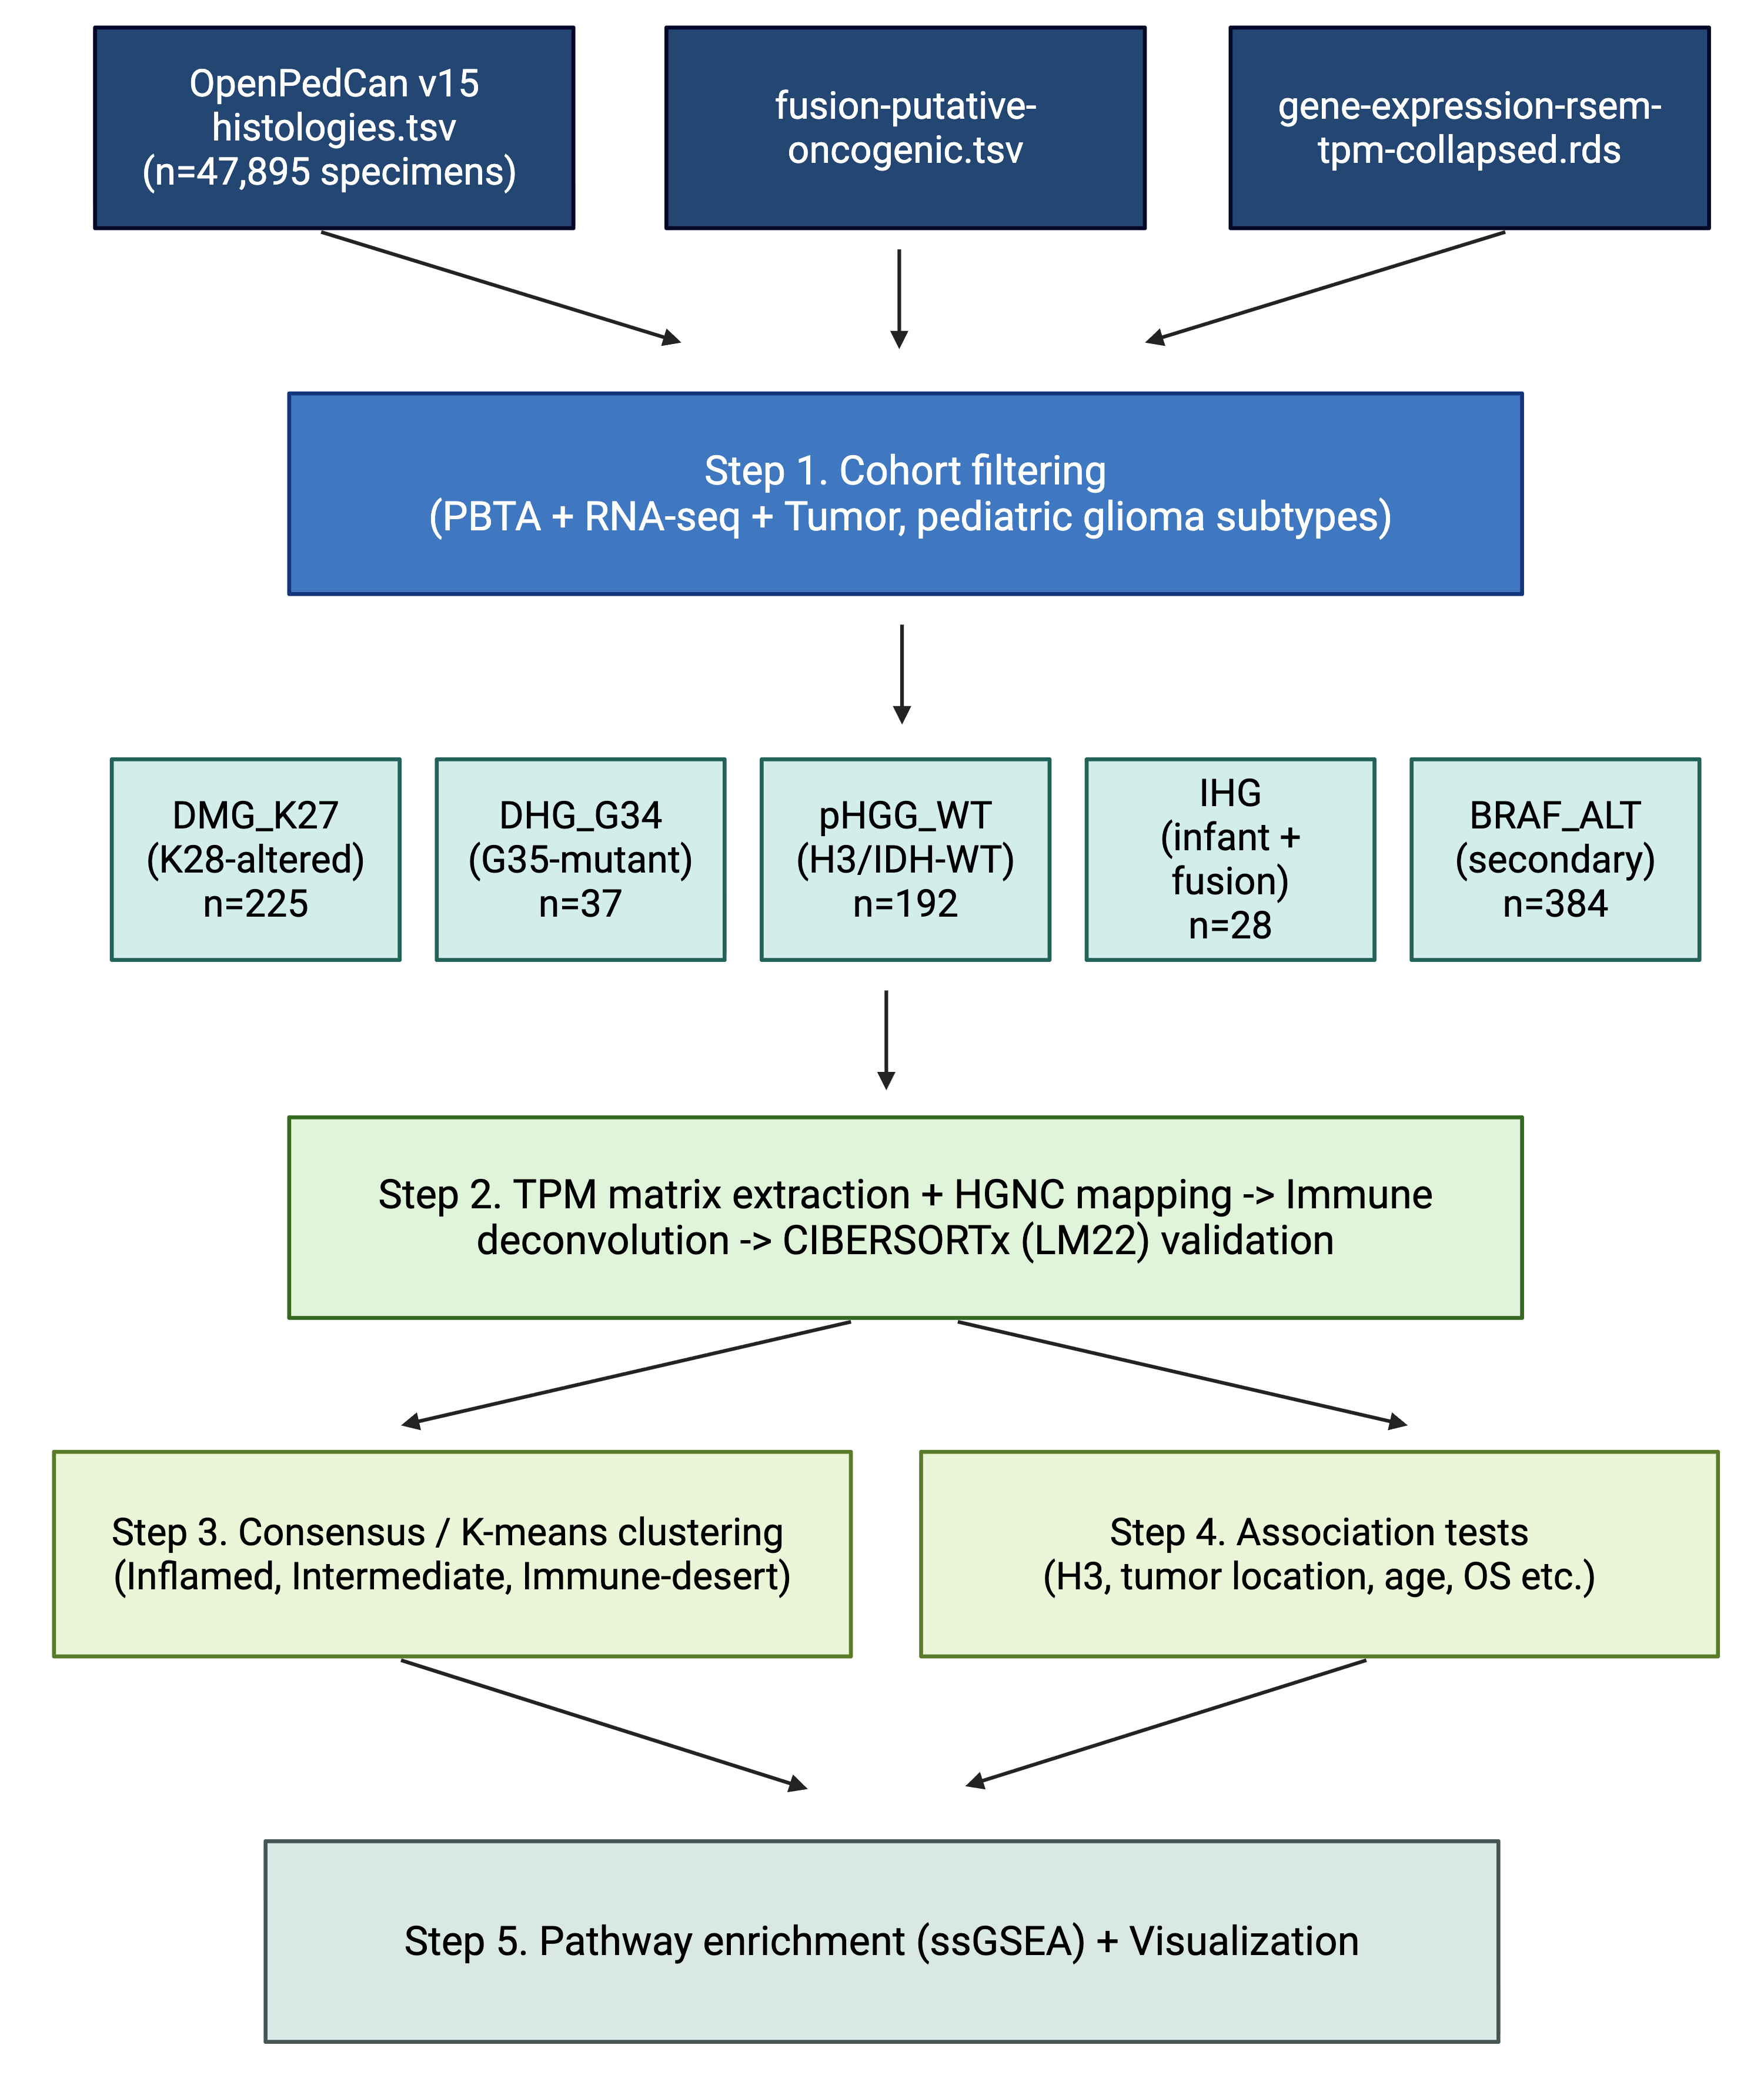
An audit of five annotation columns confirmed the absence of IDH1/IDH2-mutant cases in the primary cohort (0/349; Section 2.16). One sample (BS_V0DQFC75) carried a discordant methylation-classifier call ("HGG, IDH") but was retained in DMG_K27 on the basis of concordant integrated diagnosis, curated molecular subtype, and pathology free-text, all confirming H3 K27M-mutant disease — a recognised methylation-classifier artefact in K27M-altered DMG.
Figure 1. Schematic overview of cohort assembly, expression matrix preparation, multi-method deconvolution, brain-tuned ssGSEA scoring, and consensus clustering. Created with BioRender.com.

Table 1. Clinical and molecular characteristics of the pediatric glioma cohort.
Characteristic | DMG_K27 (n=175) | DHG_G34 (n=31) | pHGG_WT (n=125) | IHG (n=18) | Total (n=349)
Median age, yr (IQR) | 7.9 (5.5–11.2) | 15.7 (13.5–17.9) | 9.5 (6.0–13.7) | 0.4 (0.1–0.9) | 8.8 (5.5–12.5)
Male, n (%) | 75 (42.9) | 16 (51.6) | 70 (56.0) | 9 (50.0) | 170 (48.7)
Female, n (%) | 97 (55.4) | 15 (48.4) | 55 (44.0) | 9 (50.0) | 176 (50.4)
Midline, n (%) | 118 (67.4) | 0 (0) | 22 (17.6) | 0 (0) | 140 (40.1)
Hemispheric, n (%) | 3 (1.7) | 24 (77.4) | 62 (49.6) | 15 (83.3) | 104 (29.8)
Posterior fossa, n (%) | 5 (2.9) | 0 (0) | 9 (7.2) | 0 (0) | 14 (4.0)
Ambiguous/Other, n (%) | 49 (28.0) | 7 (22.6) | 32 (25.6) | 3 (16.7) | 91 (26.1)
BRAF/RTK fusion+, n (%) | 31 (17.7) | 4 (12.9) | 17 (13.6) | 18 (100.0) | 70 (20.1)
OS data available, n (%) | 140 (80.0) | 15 (48.4) | 82 (65.6) | 14 (77.8) | 251 (71.9)

3.2. Brain-Tuned Signatures Resolve a Microglia-versus-MDM Axis Obscured by Conventional Deconvolution
Cross-method correlation of macrophage/monocyte signals revealed a striking pattern of internal consistency among brain-tuned signatures that was not captured by conventional deconvolution methods (Figure 2). Three microglia-derived signatures—Klemm 2020 microglia core, Bohlen 2020 homeostatic microglia, and Antunes 2021 Mg-TAM—correlated tightly with one another (pairwise Spearman ρ > 0.98), and two monocyte-derived macrophage signatures (Klemm 2020 MDM, Antunes 2021 Mo-TAM) likewise correlated strongly (ρ = 0.94). In contrast, the correlation between microglia and MDM signatures was only ρ ≈ 0.40, demonstrating that these are distinguishable cellular signals. Conventional deconvolution methods, by comparison, showed mixed behavior: xCell macrophage tracked MDM closely (ρ = 0.86) but only weakly with microglia (ρ ≈ 0.57), while EPIC macrophage captured intermediate microglia (ρ ≈ 0.65) and MDM (ρ ≈ 0.75) signals. MCP-counter and quanTIseq macrophage estimates fell between these extremes. These results establish that LM22-style methods conflate brain-resident microglia and infiltrating MDM, while brain-tuned signature scoring resolves the distinction.
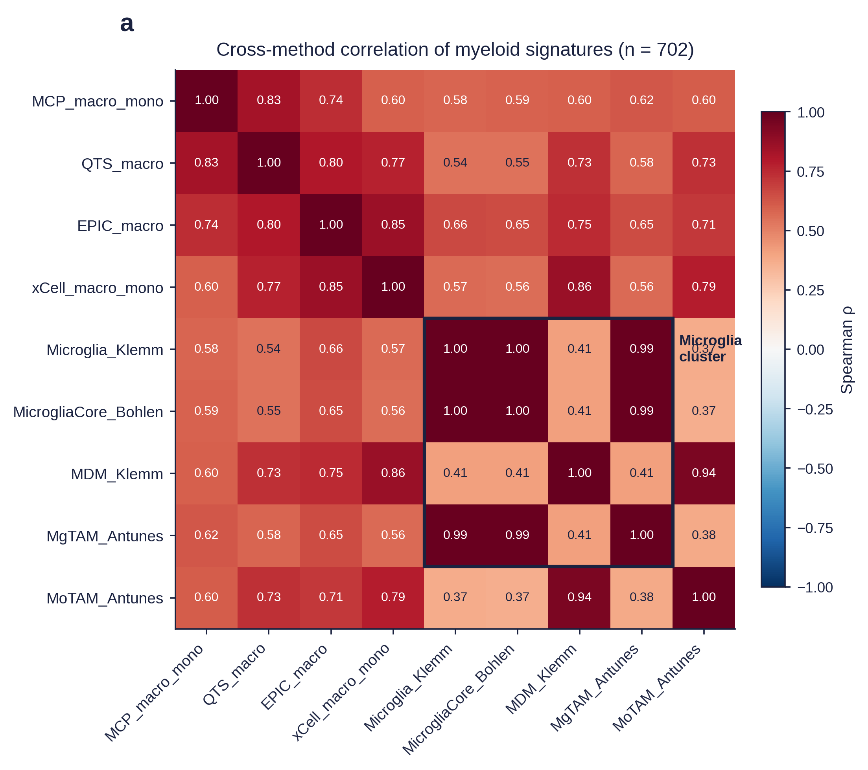
Figure 2. Brain-tuned signatures resolve a microglia-versus-MDM axis. Spearman correlation heatmap of macrophage and monocyte-related signals across four deconvolution methods and the brain-tuned ssGSEA microglia, Klemm 2020 glioma-associated microglia, Antunes 2021 Mg-TAM and Mo-TAM signatures.

3.3. Consensus Clustering Identifies Three Reproducible Immune Ecotypes
Unsupervised consensus clustering of the combined quanTIseq + ssGSEA feature matrix (29 features × 349 samples) was performed across k = 2–6. The proportion of ambiguous clustering reached a local minimum at k = 2, with k = 3 representing a stable secondary solution (PAC = 0.83; silhouette > 0). Consistent with the pre-specified hypothesis and prior literature [26], we adopted k = 3 for primary analysis; k = 2 and k = 4 results are reported as Supplementary Figure S2.
The three ecotypes were annotated by examining feature mean z-scores within each cluster (Figure 3A): an Inflamed ecotype (n = 113; 32.4% of cohort) characterized by uniformly elevated lymphocyte (T-cell cytotoxicity, NK), myeloid (M1/M2 macrophage, MDM), and antigen presentation (MHC class II, IFN-γ) scores; an Intermediate ecotype (n = 157; 45.0%) with feature means near zero or slightly negative; and an Immune-desert ecotype (n = 79; 22.6%) with uniformly low immune feature scores. Principal component and UMAP projections of the feature matrix confirmed reproducible spatial separation of the three ecotypes (Figure 3B,C). Notably, the high lymphocyte and high myeloid signals co-occurred within the Inflamed ecotype rather than partitioning into distinct lymphocyte-inflamed and myeloid-dominant compartments as reported in adult glioma cohorts [26,28], indicating a pediatric-specific TME architecture.
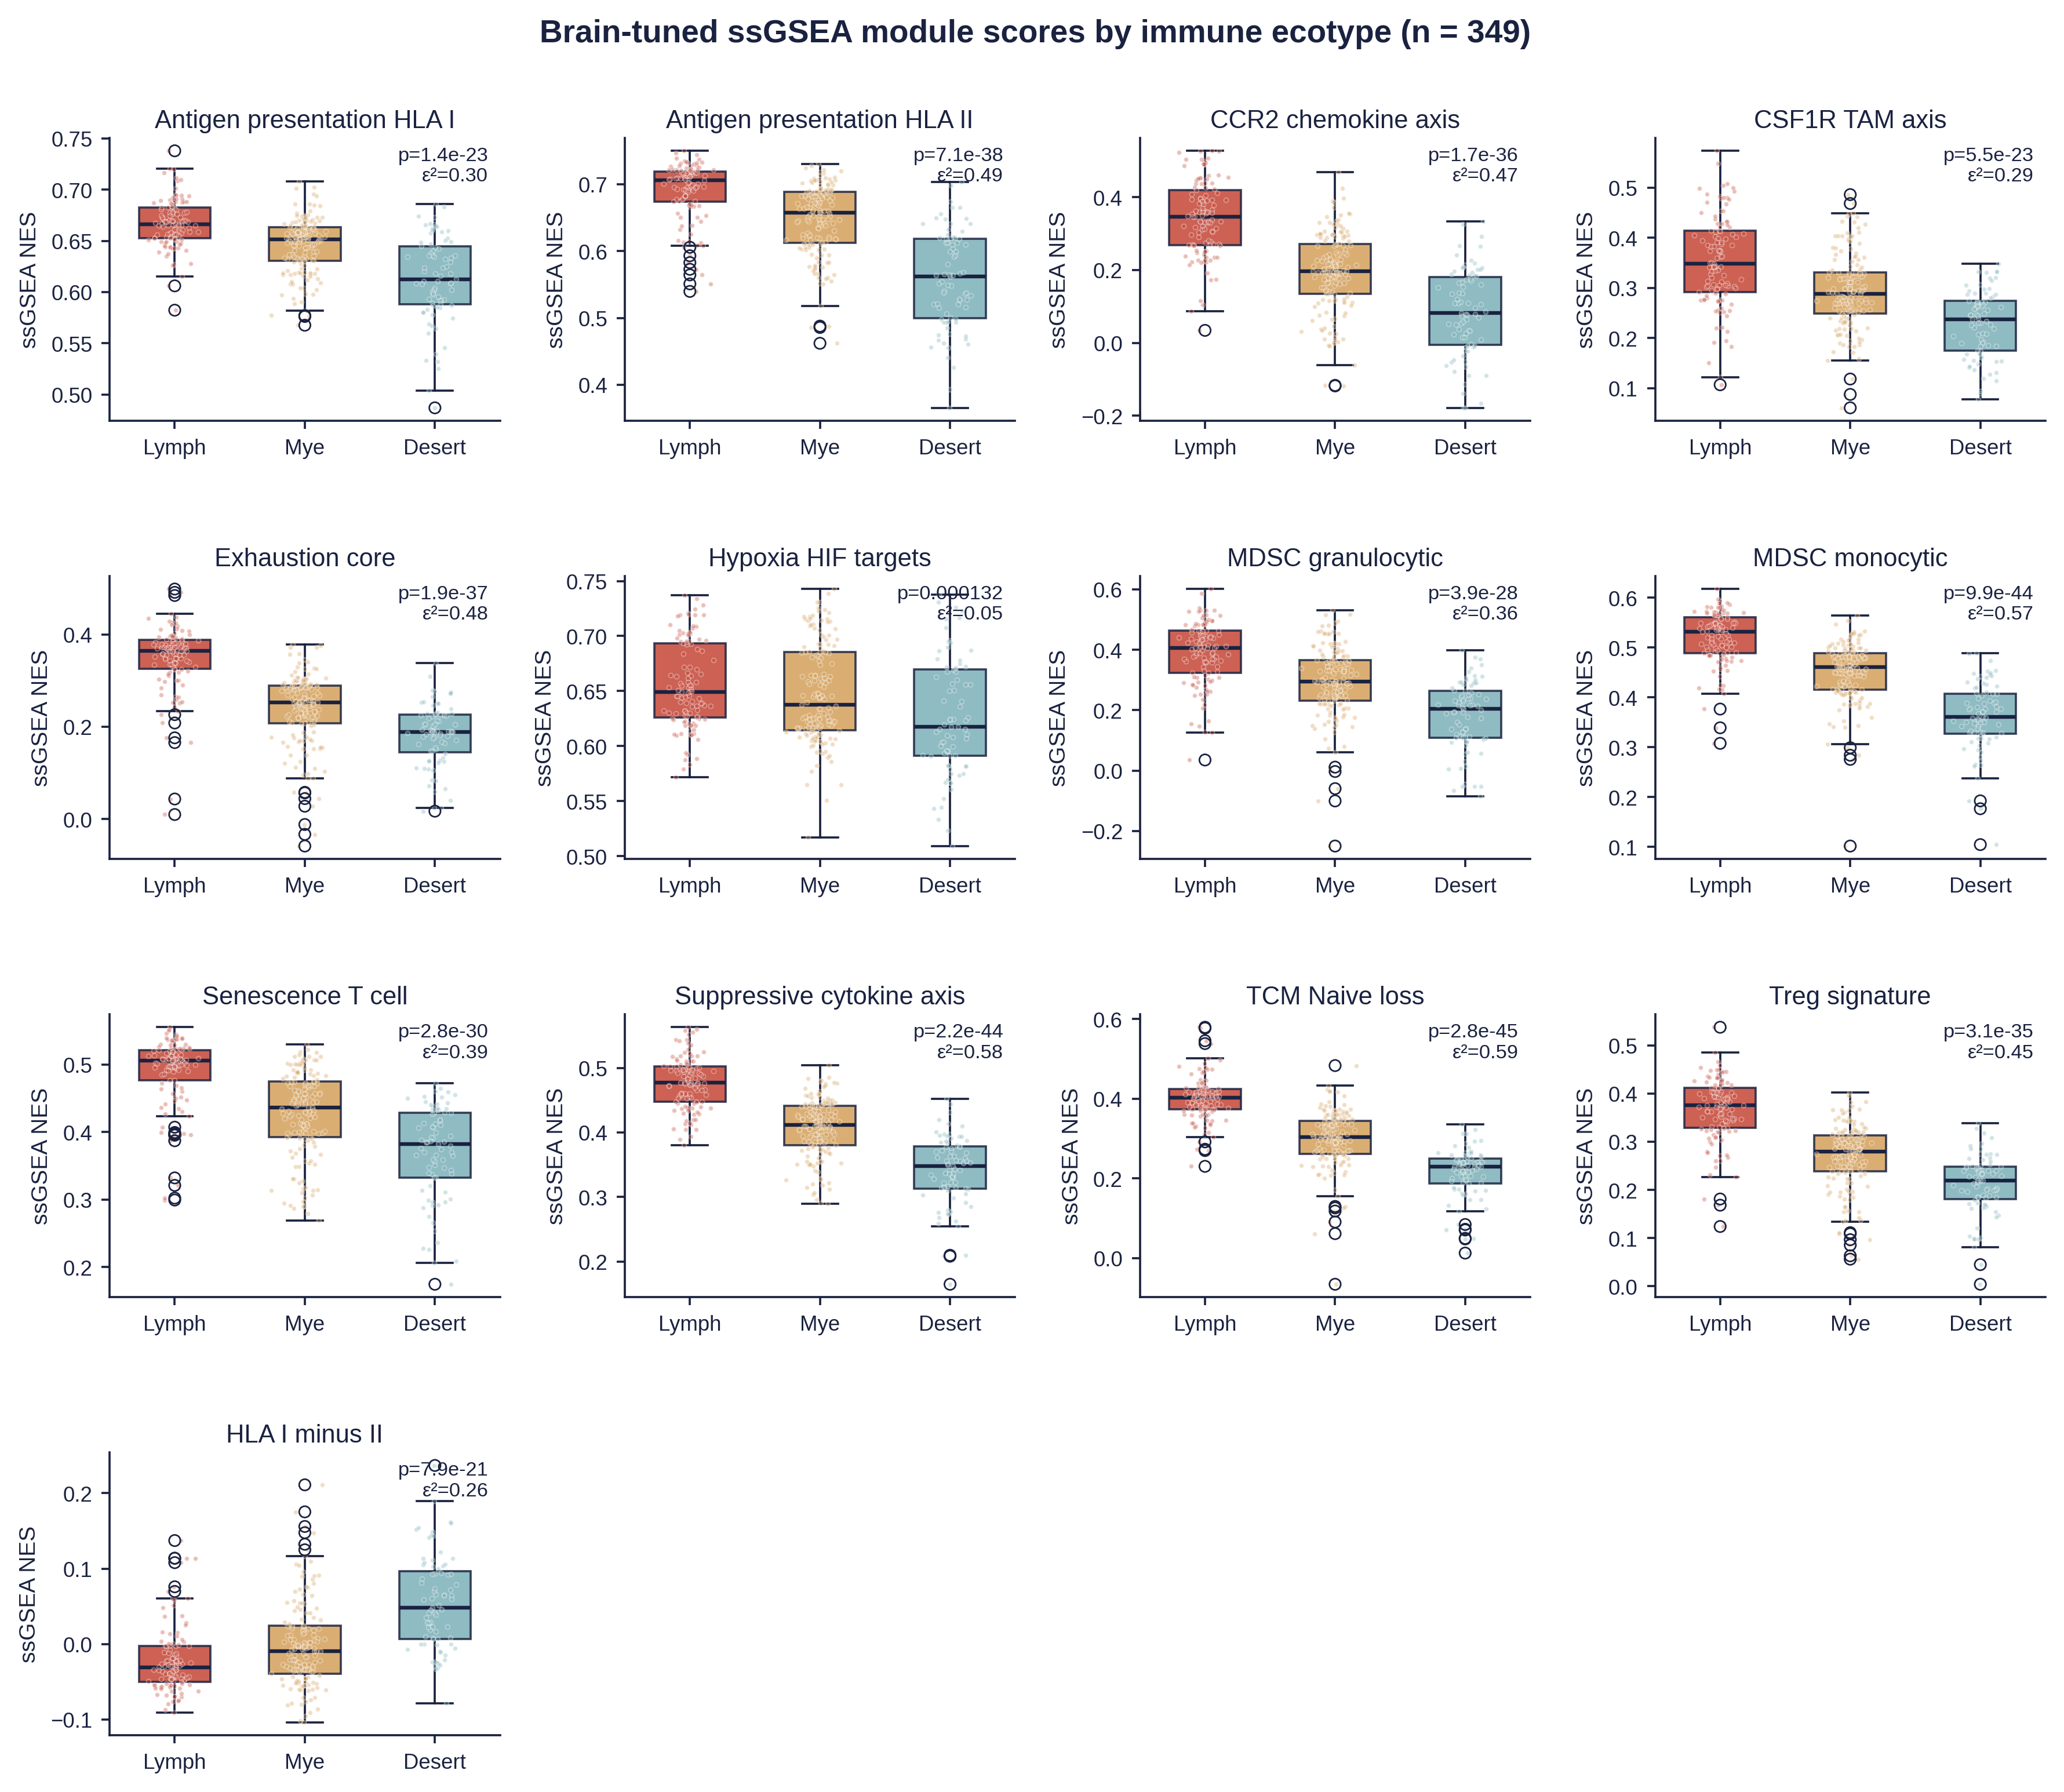
To confirm that ssGSEA scoring was performed on TPM-normalized expression as intended (Section 2.17), we independently re-scored all 24 brain-tuned signatures on log2(TPM+1) using a second Python implementation (gseapy.ssgsea v1.3). Per-signature concordance with the original R/GSVA scores was uniformly high (median Spearman ρ = 0.958, range 0.75–1.00; 12/24 signatures ρ > 0.95), and re-clustering on the TPM-harmonized feature matrix recovered the same three ecotypes with substantial agreement (Adjusted Rand Index = 0.634, Normalized Mutual Information = 0.621, 86.8% per-sample agreement; Figure X1).
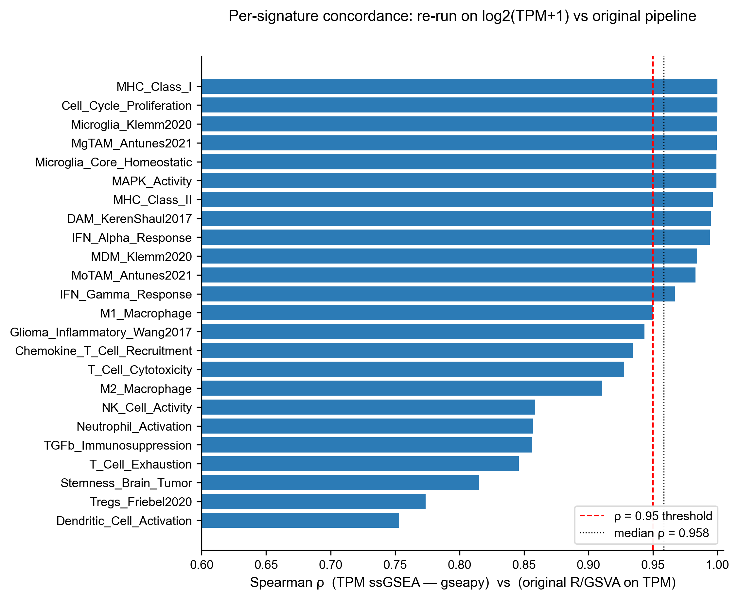
Figure X1. Independent re-scoring of ssGSEA on log2(TPM+1) using a second Python implementation (gseapy.ssgsea v1.3) reproduces the original R/GSVA scores. Per-signature Spearman ρ across n = 349 samples × 24 brain-tuned signatures; median ρ = 0.958.
Figure 3. Consensus clustering identifies three reproducible immune ecotypes. (A) z-scored feature heatmap annotated by ecotype; (B) consensus matrix at k=3 with PAC trace; (C) PCA projection coloured by ecotype.

3.4. CIBERSORTx LM22 Cross-Validates the Ecotype Architecture at Reduced Fit
Cross-method Spearman correlation analysis with LM22 added as a fifth method of immune deconvolution. The CD8 T-cell axis showed the highest LM22-vs-orthogonal agreement against MCP-counter (ρ = 0.40) and quanTIseq (ρ = 0.31), while xCell correlated poorly with LM22 (ρ = 0.01). The macrophage axis showed modest LM22-vs-orthogonal agreement (ρ up to 0.37 against xCell), and the NK-cell and Monocyte axes were essentially uncorrelated between LM22 and any other method (|ρ| ≤ 0.10), reflecting both the small absolute fractions involved and the fundamental mismatch between LM22 and brain TME. Collectively, the CIBERSORTx LM22 results (i) confirm that the macrophage axis dominates the Inflamed-vs-Desert contrast across five independent algorithms, (ii) underline the inadequacy of any single deconvolution method — particularly LM22 — for resolving brain TME, and (iii) further justify the use of brain-tuned ssGSEA scoring as the primary biological readout in this manuscript.
The dominant LM22 signal — Monocytes/Macrophages combined fraction — was highest in the Inflamed ecotype (median 0.62), intermediate in the Intermediate ecotype (0.54), and lowest in the Immune-desert ecotype (0.46; Kruskal–Wallis q = 2.6 × 10⁻⁷). This direction matches the brain-tuned ssGSEA Mo-TAM and Klemm MDM signals (Section 3.2), confirming that the macrophage axis is reproduced across analytical pipelines even though the underlying signature sources are independent. CD4 T-cell, NK-cell, and Granulocyte LM22 fractions, by contrast, were paradoxically higher in the Immune-desert ecotype (q = 1.2 × 10⁻⁵, 1.2 × 10⁻⁵, and 4.5 × 10⁻², respectively) — an apparent inversion that we interpret not as a contradiction but as a quantification artefact of LM22 fractions summing to unity: when the dominant Monocyte/Macrophage fraction drops in the Desert ecotype, the remaining (small) lymphoid and granulocyte estimates are mathematically compressed into a larger proportional share. Critically, the LM22 CD8 T-cell fraction did not distinguish ecotypes (q = 0.86), illustrating the limited resolution of LM22 for the lymphocyte axis in this tissue.
We next examined whether the Inflamed–Intermediate–Immune-desert ecotypes were also recovered when an entirely separate deconvolution algorithm — CIBERSORTx with the LM22 peripheral-blood signature matrix [11] — was applied to the same cohort, while bearing in mind that LM22 is known to lack brain-resident microglia and is therefore expected to fit pediatric brain TME poorly. On the n = 349 Main cohort, LM22 deconvolution showed the predicted modest goodness-of-fit (median permutation P = 0.17, median Pearson correlation = 0.08, median RMSE = 1.07), with only 91 of 349 samples (26.1 %) reaching the conventional P < 0.05 threshold (Supplementary Figure S5). Consistent with the ecotype framework, however, four of eight LM22 super-categories nevertheless differed significantly across the three ecotypes after BH adjustment.
Figure 4. CIBERSORTx LM22 cell-type fractions across the three ecotypes.
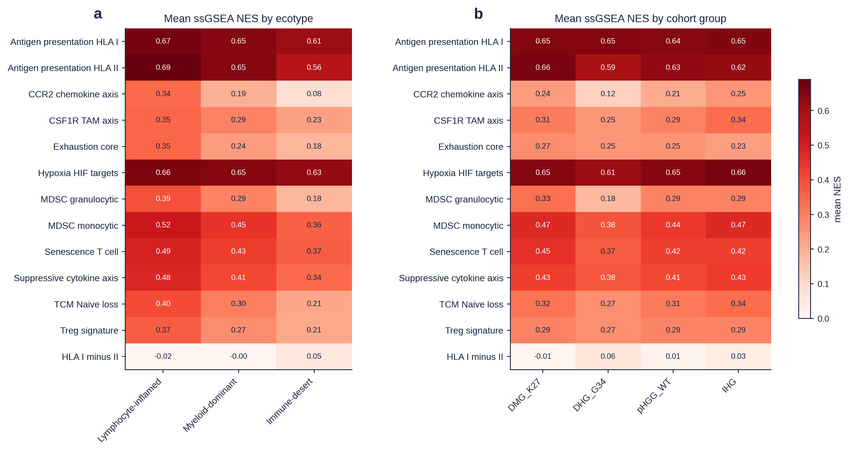
Figure 5. LM22 quality-control distribution on the Main cohort (n = 349).

3.5. Ecotype Distribution Across Histone Class and Anatomical Location
Ecotype membership was significantly associated with cohort group (Fisher's exact p = 1.3 × 10⁻³; Figure 6A). DHG_G34 tumors were predominantly Immune-desert (16/31; 51.6%) with only 9.7% (3/31) classified as Inflamed — a finding that contrasts with prior reports describing G34-mutant tumors as comparatively lymphocyte-inflamed in adult-onset cases [8]. DMG_K27 tumors, in contrast, demonstrated marked internal heterogeneity, with 36.6% (64/175) assigned to the Inflamed ecotype despite being uniformly aggressive at the clinical level. pHGG_WT tumors showed an intermediate distribution (32.0% Inflamed, 42.4% Intermediate, 25.6% Immune-desert), and IHG tumors were dominated by the Intermediate ecotype (44.4%) with similar proportions in Inflamed (33.3%) and Immune-desert (22.2%).
Anatomical location was significantly associated with ecotype across all four location classes (Midline, Hemispheric, Posterior fossa, Ambiguous/Other; 4×3 χ² = 15.21, df = 6, P = 0.019; Table X2; Figure 6B). Restricting to the two clinically dominant anatomical categories, midline and hemispheric tumors differed significantly in ecotype composition (aggregate χ² = 12.18, df = 2, P = 2.3 × 10⁻³). Per-ecotype Fisher's exact tests showed that midline tumors were enriched for the Inflamed ecotype (58/140, 41.4% vs 26/104, 25.0% hemispheric; OR = 2.12, P = 0.0095) while hemispheric tumors were enriched for Immune-desert (34/104, 32.7% vs 22/140, 15.7% midline; OR = 0.38, P = 0.0021); the Intermediate ecotype was location-independent (OR = 1.02, P = 1.00). This pattern is counter to adult-glioma intuition, in which hemispheric tumors are typically reported as more lymphocyte-infiltrated than midline tumors. Developmental age group showed no significant association with ecotype (p = 0.29).
Figure 6. Ecotype distribution by histone class (A) and anatomy (B).
Table X2. Anatomical location × ecotype cross-tabulation (n = 349).
Location | Inflamed | Intermediate | Immune-desert | Total
Midline | 58 (41.4%) | 60 (42.9%) | 22 (15.7%) | 140
Hemispheric | 26 (25.0%) | 44 (42.3%) | 34 (32.7%) | 104
Posterior fossa | 5 (35.7%) | 6 (42.9%) | 3 (21.4%) | 14
Ambiguous/Other | 24 (26.4%) | 47 (51.6%) | 20 (22.0%) | 91
Fisher's exact test, midline vs hemispheric only: Inflamed OR = 2.12 (P = 0.0095); Intermediate OR = 1.02 (P = 1.00); Immune-desert OR = 0.38 (P = 0.0021).

3.6. Ecotype Is an Independent Prognostic Factor for Overall Survival
Of the 349 main-cohort patients, 251 (71.9%) had available OS data. Among the 98 patients without OS annotation, ecotype distribution did not differ from the 251 with OS data (χ² p = 0.58), nor did sex (p = 0.97) or developmental age group (p = 0.46, excluding 36 patients with missing age annotation). OS availability did differ by cohort group (p < 0.001), with DHG_G34 showing the highest missingness rate (51.6%), but because the multivariable Cox model adjusts for cohort group as a covariate, this differential availability does not confound the ecotype–survival association. Kaplan-Meier analysis of the 251 patients with available OS data revealed that the Inflamed ecotype had the longest median OS (595 days), followed by Intermediate (446 days) and Immune-desert (403 days; overall log-rank p = 0.037; Figure 5A). Stratified analyses showed that the ecotype effect was statistically significant within pHGG_WT (log-rank p = 0.049) and trended within DHG_G34 (p = 0.070), but was masked within DMG_K27 (p = 0.132), likely reflecting the uniformly poor prognosis of K27-altered DMG that constrains the dynamic range of survival differences.
In a multivariable Cox proportional-hazards model adjusting for cohort group, age at diagnosis, and sex (Table 2; Figure 5B), Immune-desert remained an independent adverse prognostic factor relative to Inflamed (HR = 1.79; 95% CI 1.21–2.66; p = 0.004), while the Intermediate ecotype showed a non-significant trend toward worse survival (HR = 1.37; 95% CI 0.99–1.91; p = 0.062). Cohort group effects were substantial as expected (DMG_K27 HR = 2.96, p < 0.001; IHG HR = 0.22, p = 0.005), but did not abrogate the independent contribution of ecotype. A sensitivity analysis restricted to the 130 patients with extent-of-resection (EOR) data showed that adding EOR to the model did not improve fit (likelihood-ratio test p = 0.58) and did not attenuate the Inflamed ecotype effect (HR = 0.50, 95% CI 0.27–0.92, p = 0.027 vs. HR = 0.56 in the full model; Supplementary Table S_EOR).
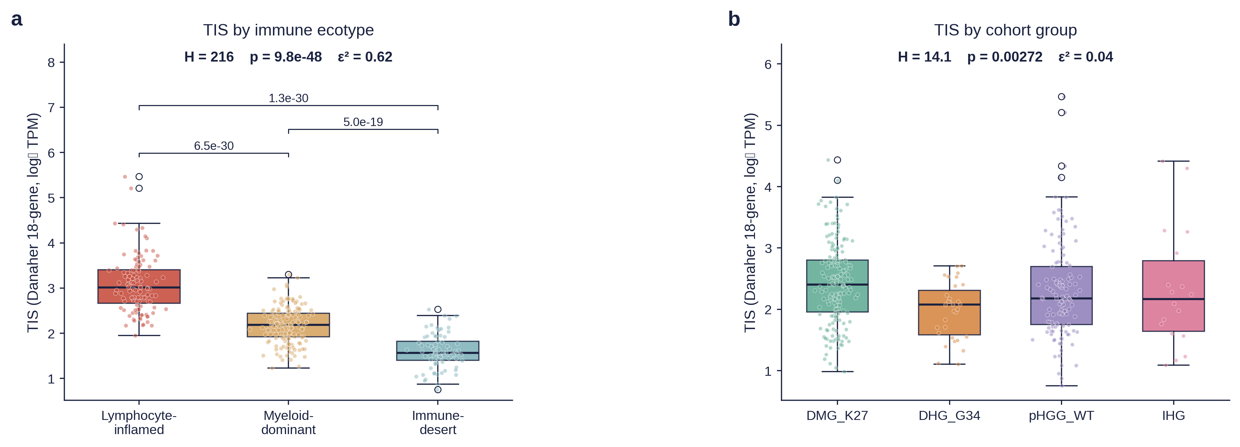
Figure 7. (A) Kaplan-Meier OS by ecotype (log-rank p=0.037); (B) multivariable Cox forest plot.
Table 2. Multivariable Cox proportional-hazards model for overall survival (n = 251).
Variable | HR | 95% CI | p-value
Ecotype: Inflamed (reference) | 1.00 | — | —
Ecotype: Intermediate | 1.37 | 0.99–1.91 | 0.062
Ecotype: Immune-desert | 1.79 | 1.21–2.66 | 0.004
Cohort: pHGG_WT (reference) | 1.00 | — | —
Cohort: DMG_K27 | 2.96 | 2.11–4.15 | <0.001
Cohort: DHG_G34 | 1.15 | 0.59–2.24 | 0.672
Cohort: IHG | 0.22 | 0.08–0.63 | 0.005
Age (per year) | 0.99 | 0.96–1.02 | 0.506
Sex: Female (vs Male) | 1.12 | 0.84–1.49 | 0.450

3.7. The Ecotype Prognostic Signal Is Independent of Molecular Subtype and Anatomical Location
To formally test whether the three-state ecotype architecture is a proxy for tumor molecular subtype rather than an independent axis of TME biology, we performed PERMANOVA on the 29-feature z-scored clustering matrix (n = 349; Euclidean distance; 4,999 stratified permutations; Table X3; Figure X2). Ecotype alone explained the largest share of inter-sample variance (R² = 0.320, P = 2 × 10⁻⁴), roughly seven-fold more than cohort_group alone (R² = 0.044, P = 2 × 10⁻⁴). Critically, the ecotype effect was preserved after formal adjustment for molecular subtype (ecotype | cohort_group R² = 0.303, P = 2 × 10⁻⁴), whereas the reciprocal cohort_group | ecotype term was an order of magnitude smaller (R² = 0.027, P = 0.029), with 65.3% of variance remaining unexplained (intrinsic TME heterogeneity). These results establish that the ecotype framework captures a biological axis that is not a proxy for molecular subtype.
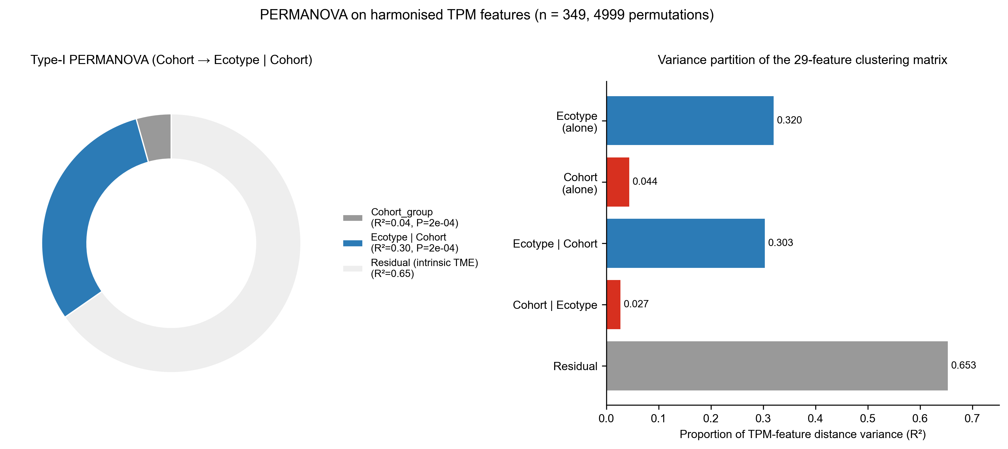
Figure X2. PERMANOVA variance partition of the 29-feature ecotype clustering matrix (n = 349; 4,999 stratified permutations). Sequential decomposition of inter-sample distance variance attributable to ecotype and cohort_group.
Table X3. PERMANOVA variance partition.
Factor | R² | P
Ecotype (alone) | 0.320 | 2×10⁻⁴
Cohort_group (alone) | 0.044 | 2×10⁻⁴
Ecotype | Cohort_group | 0.303 | 2×10⁻⁴
Cohort_group | Ecotype | 0.027 | 0.029
Residual (intrinsic TME heterogeneity) | 0.653 | —
Consistent with this, adding explicit ecotype × cohort_group interaction terms to the multivariable Cox model (Section 2.19) did not significantly improve fit over the additive main-effects model (likelihood-ratio χ² = 5.22, df = 6, P = 0.515; Figure X3), supporting an additive rather than subtype-specific interpretation of the ecotype effect. Within-cohort estimates (Table X4) showed that the Immune-desert vs Inflamed hazard ratio was significant in pHGG_WT (n = 82, events = 56; HR = 2.22, 95% CI 1.11–4.43, P = 0.024) and directionally consistent but non-significant in DMG_K27 (n = 140, events = 134; HR = 1.59, 95% CI 0.97–2.63, P = 0.068) — likely masked by the uniformly poor prognosis of K27-altered DMG — while DHG_G34 (n = 15, events = 13) and IHG (n = 14, events = 5) were underpowered.
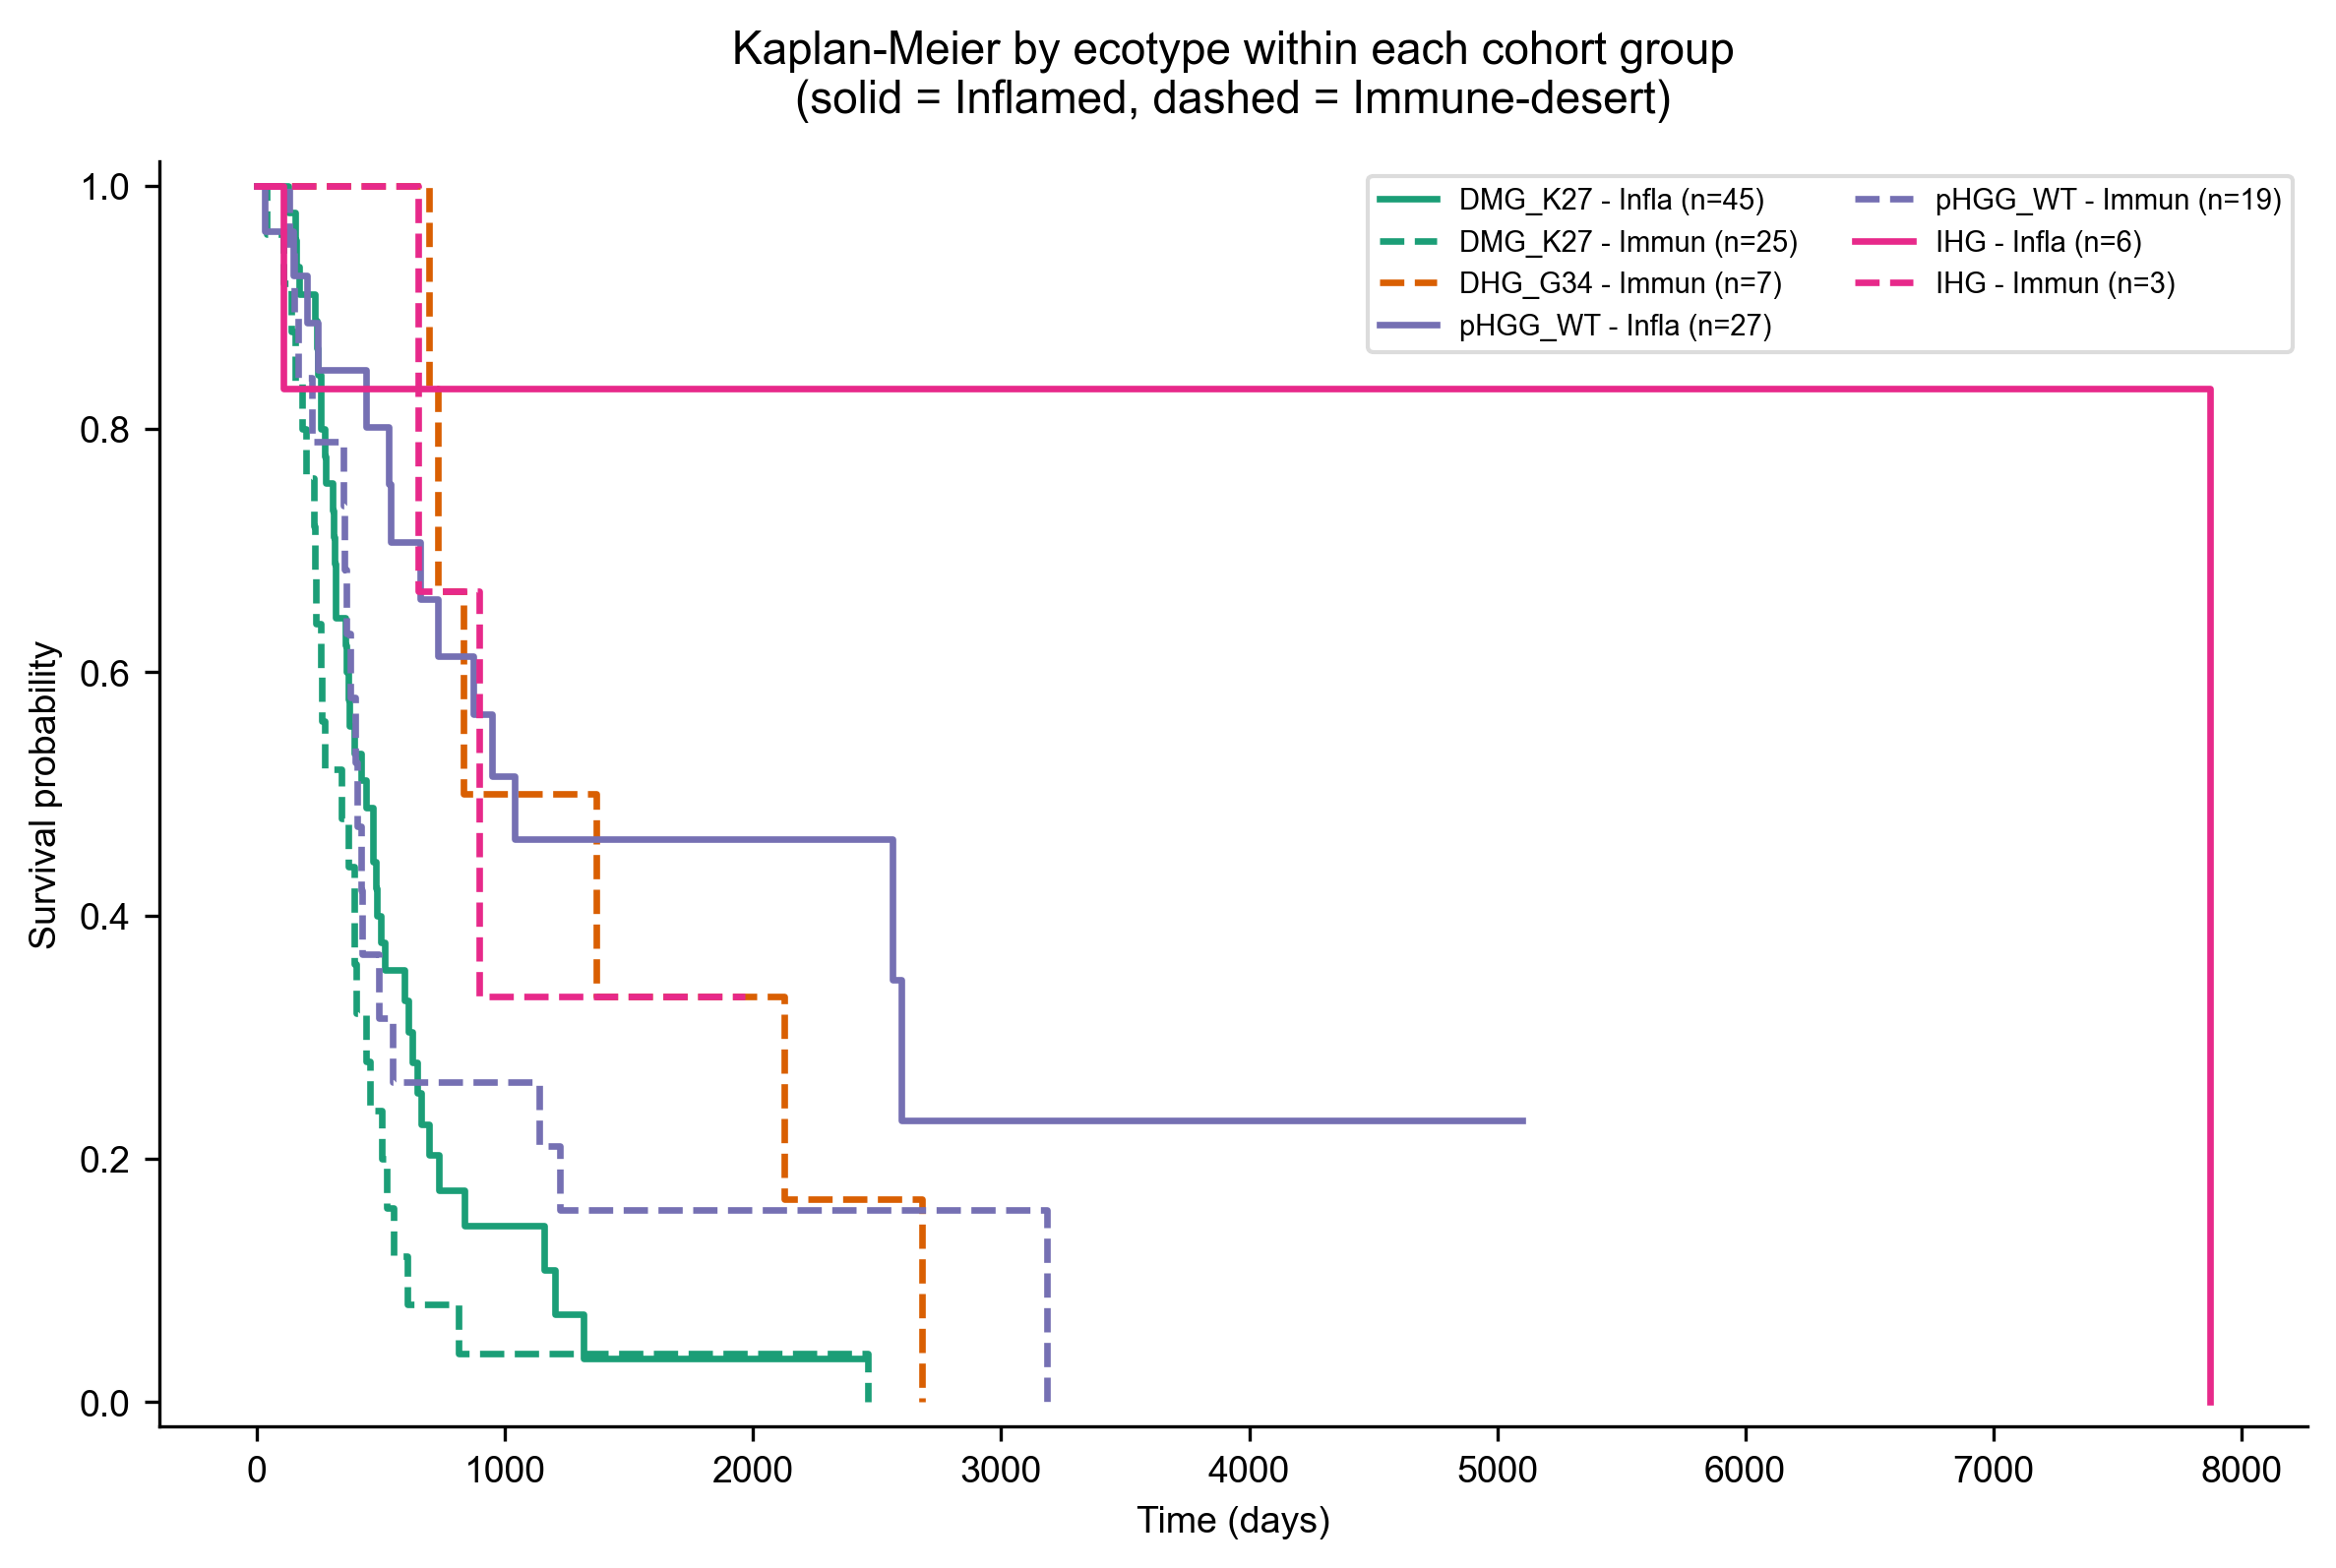
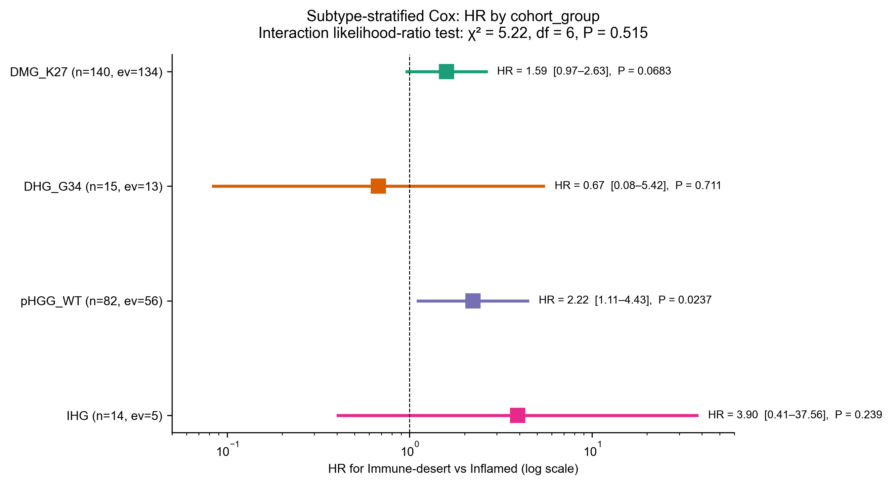
Figure X3. Ecotype prognostic effect is additive across cohort groups. (A) Kaplan-Meier OS by ecotype within each cohort group. (B) Forest plot of the within-cohort Immune-desert vs Inflamed hazard ratio.
Table X4. Subtype-stratified and location-adjusted Cox hazard ratios (Immune-desert vs Inflamed).
Stratum | n | Events | HR (95% CI) | P
DMG_K27 | 140 | 134 | 1.59 (0.97–2.63) | 0.068
DHG_G34 | 15 | 13 | 0.67 (0.08–5.42) | 0.711
pHGG_WT | 82 | 56 | 2.22 (1.11–4.43) | 0.024
IHG | 14 | 5 | 3.90 (0.41–37.56) | 0.239
Full cohort ± location_class | 251 | 208 | 1.75 (1.19–2.57) → 1.77 (1.20–2.61) | 0.005 → 0.004
Because anatomical location was itself associated with ecotype (Section 3.5), we tested whether location confounds the ecotype–survival association by adding location_class dummy covariates to the baseline multivariable Cox model (Section 2.20). Model fit did not improve significantly (likelihood-ratio χ² = 1.96, df = 3, P = 0.580), and the Immune-desert hazard ratio was essentially unchanged (HR = 1.75, 95% CI 1.19–2.57 without location vs HR = 1.77, 95% CI 1.20–2.61 with location; Δ HR ≈ 1%; Table X4), indicating that the ecotype prognostic signal is not confounded by anatomical location. Location-stratified Kaplan-Meier analysis confirmed that the ecotype effect was independently significant within both dominant anatomical strata (midline: n = 104, events = 96, log-rank P = 0.033; hemispheric: n = 66, events = 42, log-rank P = 0.030; Figure X4), while posterior fossa (n = 10) was underpowered and the heterogeneous Ambiguous/Other stratum showed no significant effect (n = 71, log-rank P = 0.796), further supporting that the ecotype–location association reflects genuine biology rather than a labelling artefact.
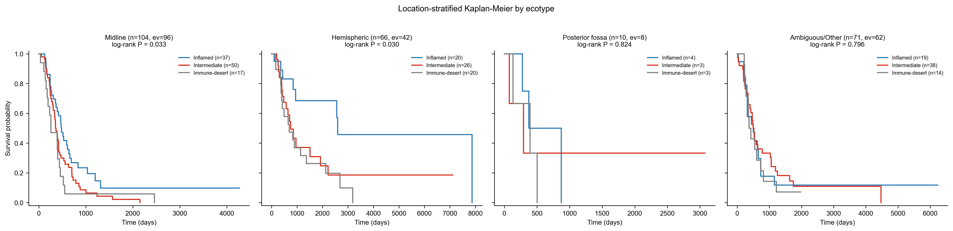
Figure X4. Location-stratified Kaplan-Meier curves by ecotype within each anatomical location class. Ecotype effect is significant within Midline (P = 0.033) and Hemispheric (P = 0.030) strata.

3.8. Overall Survival Findings Are Robust to Differential Missingness in OS Annotation (IPW Sensitivity Analysis)
OS data were missing in 28.1% of the main cohort overall, with missingness differing significantly by cohort group (Section 3.6) and ranging from 20.0% in DMG_K27 to 51.6% in DHG_G34 (34.4% pHGG_WT, 22.2% IHG). To assess whether this differential missingness could bias the ecotype–survival association, we applied inverse-probability-of-observation weighting (Section 2.21) using a propensity model conditioned on ecotype, cohort_group, age, sex, and location_class. Stabilised weights (mean 1.17, trimmed range 0.76–6.22 at the 1st/99th percentile) improved covariate balance between the OS-observed and OS-missing groups: the number of covariates with |SMD| > 0.1 fell from 6/11 to 4/11, and the maximum |SMD| fell from 0.51 to 0.34 (Figure X6). Under stabilised IPW, the Immune-desert hazard ratio was HR = 1.88 (95% CI 1.22–2.90, P = 0.004), closely matching the naïve estimate (HR = 1.79, 95% CI 1.21–2.66, P = 0.004; log-HR shift = 0.048, well within the naïve 95% CI half-width; Figure X5). Four alternative weighting specifications (untrimmed, 2.5-97.5% truncated, and cohort-only propensity) recovered HR estimates between 1.79 and 1.88, all P < 0.01 (Table X5), confirming that the Immune-desert survival association is robust to plausible missing-not-at-random mechanisms and is not an artefact of differential OS ascertainment across cohort groups.
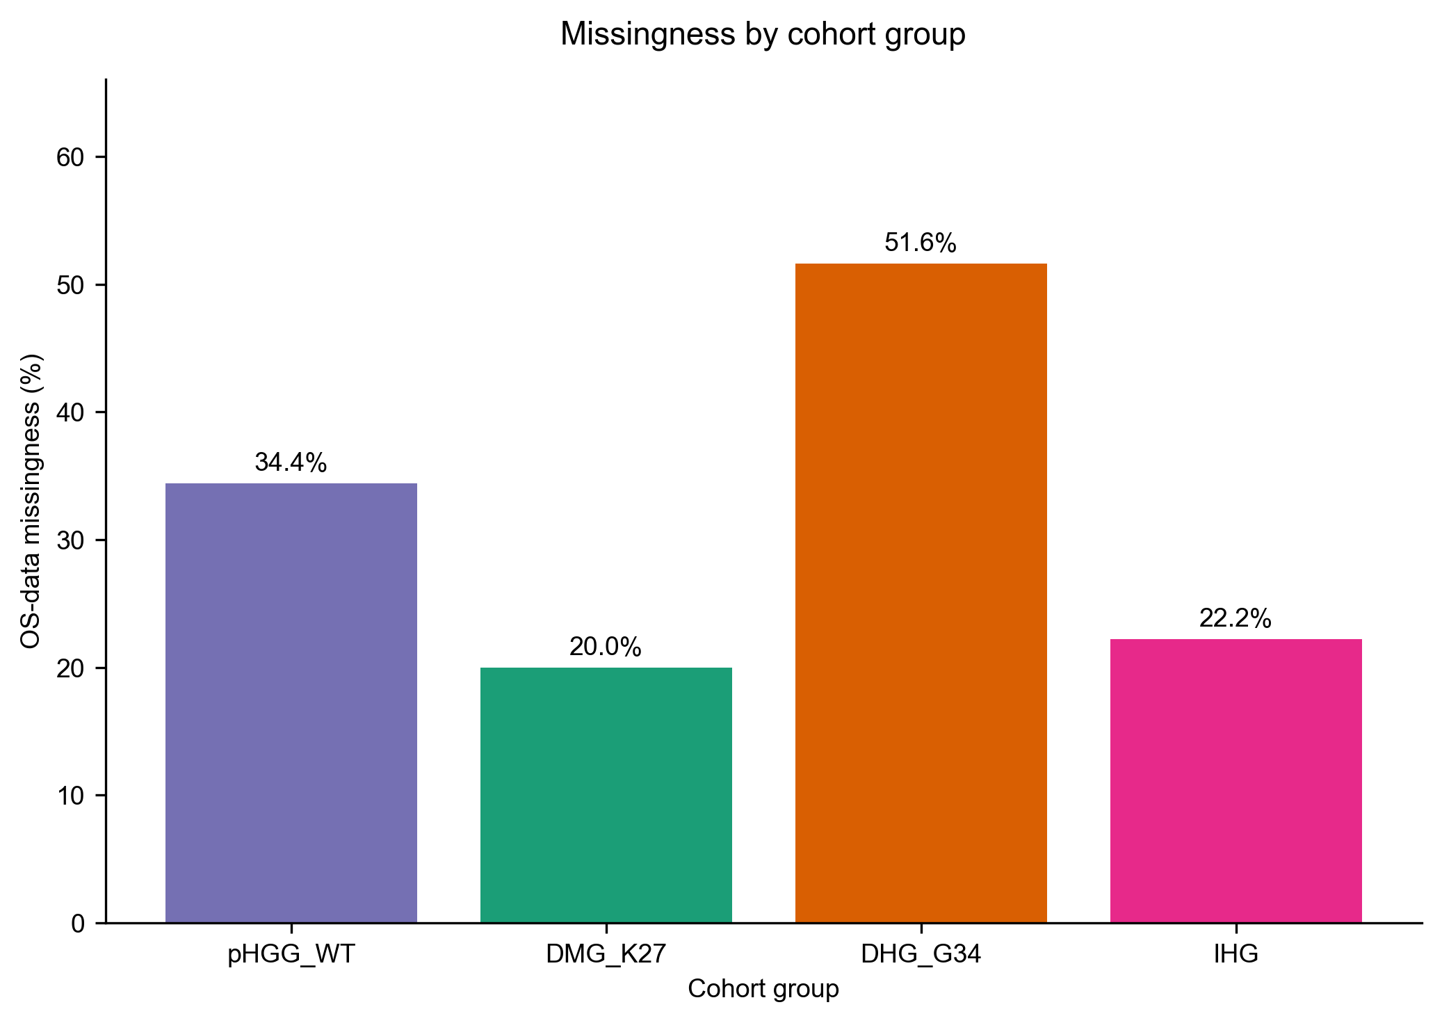
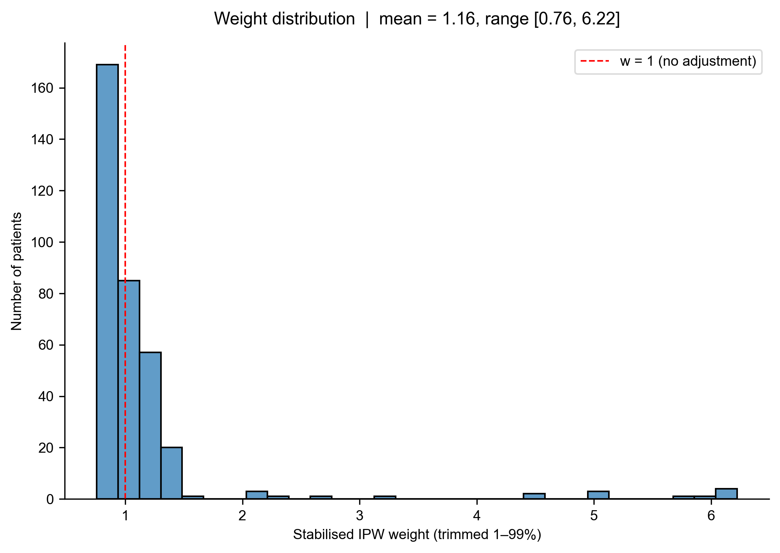
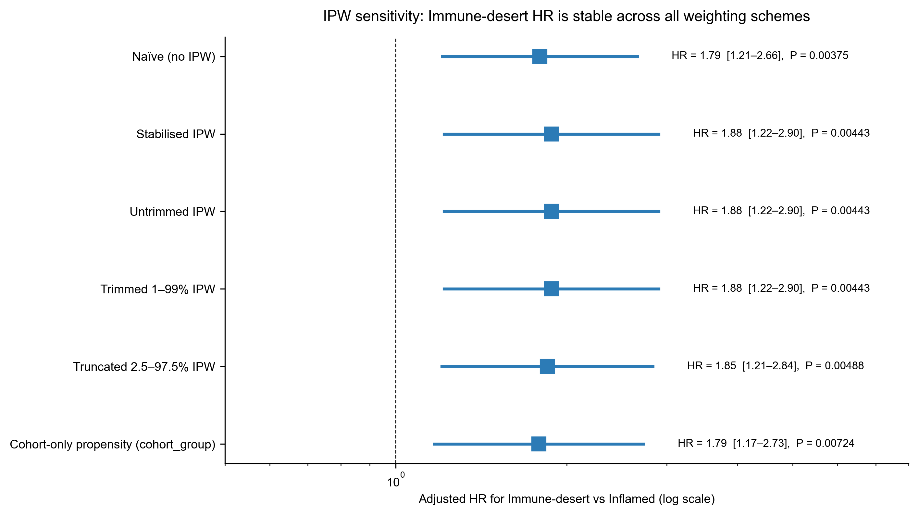
Figure X5. IPW sensitivity for differential OS missingness. (A) OS-data missingness by cohort group. (B) Stabilised inverse-probability-of-observation weight distribution. (C) Forest plot of the Immune-desert hazard ratio across weighting schemes.
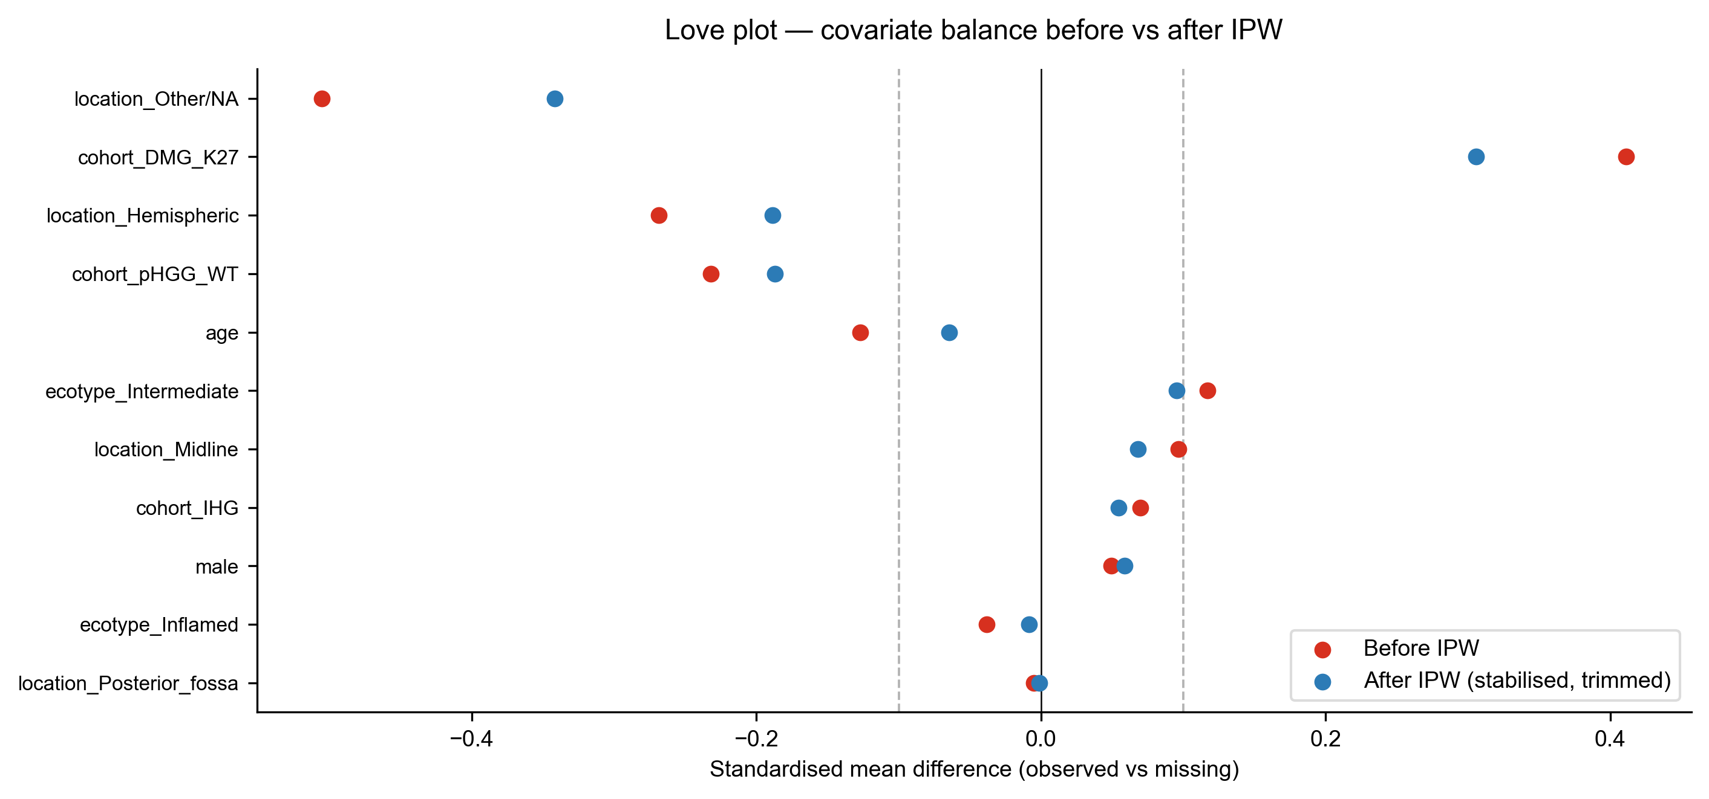
Figure X6. Covariate balance (Love plot) between OS-observed and OS-missing groups before (red) and after (blue) stabilised IPW weighting. Dashed line marks the |SMD| = 0.1 conventional balance threshold.
Table X5. Immune-desert hazard ratio across alternative IPW weighting schemes.
Scheme | HR (95% CI) | P
Naïve (no IPW) | 1.79 (1.21–2.66) | 0.004
Stabilised IPW (trimmed 1–99%) | 1.88 (1.22–2.90) | 0.004
Untrimmed IPW | 1.88 (1.22–2.90) | 0.004
Truncated 2.5–97.5% IPW | 1.85 (1.21–2.84) | 0.005
Cohort-only propensity (cohort_group) | 1.79 (1.17–2.73) | 0.007

3.9. Pathway Activity Distinguishes Ecotypes Without Confounding by Tumor Proliferation
Kruskal-Wallis testing of ssGSEA scores across ecotypes demonstrated significant differences for 22 of 24 signatures, with effect sizes (rank-biserial r for Inflamed vs Immune-desert) exceeding 0.95 for the top 15 immune pathways (Table 3; Figure 6). Stemness signature was marginally different (p_BH = 0.029), while cell-cycle/proliferation signatures showed no ecotype dependence (p = 0.94) — confirming that ecotype distinctions reflect genuine immune contexture and not confounding tumor cell proliferation.
Notably, microglia-associated signatures (Klemm 2020, Bohlen 2020, Antunes 2021 Mg-TAM) showed substantial but more modest ecotype-dependent variation (p_BH ≈ 10⁻²¹) than monocyte-derived macrophage signatures (MDM and Mo-TAM; p_BH ≈ 10⁻⁴⁵), suggesting that brain-resident microglia are relatively uniform across ecotypes while peripheral MDM recruitment is a primary driver of ecotype assignment in pediatric glioma. MAPK transcriptional activity also varied significantly across ecotypes (p_BH = 1.4 × 10⁻¹²), with the Inflamed ecotype showing the highest scores — a finding with potential implications for the immunological consequences of MAPK pathway activation in BRAF-altered subgroups.
Figure 8. Composite boxplot of 12 key brain-immune ssGSEA signatures across ecotypes.
Table 3. ssGSEA pathway differences across immune ecotypes (Kruskal-Wallis test).
To further characterize the checkpoint landscape across ecotypes, we examined expression of eight immune checkpoint receptors (HAVCR2/TIM-3, LAG3, PDCD1/PD-1, CD274/PD-L1, CTLA4, TIGIT, IDO1, SIGLEC15) using log2(TPM+1) values. All eight genes showed significant ecotype-dependent expression (Kruskal-Wallis p < 10⁻⁸ for each gene; Supplementary Figure S7). HAVCR2 exhibited the most dramatic separation (H = 189.7, p = 6.5 × 10⁻⁴²), with median expression 6.6-fold higher in Inflamed versus Immune-desert samples. LAG3 (H = 160.2), PDCD1 (H = 119.3), and CD274 (H = 95.1) followed a consistent gradient, whereas SIGLEC15 showed the weakest — though still significant — ecotype dependence (H = 35.8, p = 1.7 × 10⁻⁸). This near-saturated co-expression of inhibitory receptors in the Inflamed ecotype underscores the co-inhibitory burden that may limit single-agent checkpoint blockade in these tumors.
We next examined the expression of five CAR-T therapy targets under active clinical investigation in pediatric glioma: B4GALNT1 (GD2 synthase), ST8SIA1 (GD3 synthase), IL13RA2, ERBB2 (HER2), and CD276 (B7-H3). Four of five targets showed significant ecotype-dependent expression (Kruskal-Wallis p < 10⁻⁵; Supplementary Figure S_CART). Notably, B4GALNT1 — the synthase for GD2, the leading CAR-T target in pediatric glioma — showed no significant ecotype dependence (H = 2.7, p = 0.26), with comparable median TPM across Inflamed (11.2), Intermediate (8.5), and Immune-desert (10.2) groups. In contrast, IL13RA2 (median TPM 12.8 vs. 2.5), ERBB2 (13.0 vs. 6.5), and CD276 (41.9 vs. 20.4) were all significantly higher in Inflamed versus Immune-desert samples. This ecotype-independent expression of B4GALNT1 suggests that GD2-directed CAR-T therapy may retain target availability even in immune-desert tumors where checkpoint blockade is unlikely to be effective.
To validate these ecotype-level differences at the transcriptome-wide level, we performed DESeq2 differential expression analysis between Inflamed (n = 113) and Immune-desert (n = 79) samples, adjusting for cohort group (design: ~ cohort_group + ecotype). A total of 2,339 genes were significantly upregulated in Inflamed (log2FC ≥ 1, padj < 0.05), dominated by antigen presentation (HLA-DRA log2FC = +3.3, HLA-DMA +2.8), chemokine signalling (CXCL10 +4.3, CXCL9 +4.1, CCL5 +3.4), T cell effector (CD2 +4.4, CD3E +3.8, GZMB +3.3, PRF1 +3.1, IFNG +4.0), and myeloid/macrophage genes (CD163 +3.4, CD68 +2.7). Among checkpoint receptors, HAVCR2 (+1.8, padj = 2.7 × 10⁻³⁰), PDCD1 (+2.1), CD274 (+1.8), and IDO1 (+2.5) were all significant DEGs, whereas LAG3 (+0.68) and TIGIT (+0.87) showed significant but sub-threshold fold changes, indicating that TIM-3, PD-1, PD-L1, and IDO1 are the primary ecotype-discriminating checkpoints. Conversely, B4GALNT1 was not a significant DEG (log2FC = −0.73, padj = 2.2 × 10⁻⁴ but |FC| < 1), corroborating the ecotype-independent expression observed in the targeted analysis. VEGFA was among the few immune-relevant genes upregulated in Immune-desert (log2FC = −1.19, padj = 4.1 × 10⁻⁵), suggesting a pro-angiogenic program in immune-cold tumors (Supplementary Figure S_volcano).
Signature | KW chi-sq | BH-adj. p-value
M1 Macrophage | 262.2 | 2.8e-56
Chemokine T-cell recruitment | 257.3 | 1.6e-55
T-cell cytotoxicity | 245.0 | 5.0e-53
Glioma inflammatory (Wang 2017) | 241.8 | 1.9e-52
TGF-β immunosuppression | 225.0 | 6.5e-49
Tregs | 221.7 | 2.9e-48
T-cell exhaustion | 220.1 | 5.6e-48
MoTAM (Antunes 2021) | 211.4 | 3.0e-46
MDM (Klemm 2020) | 205.5 | 5.2e-45
IFN-γ response | 186.2 | 6.0e-41
MHC Class II | 157.7 | 8.7e-35
MgTAM (Antunes 2021) | 100.1 | 2.6e-22
Microglia core (Bohlen 2020) | 97.9 | 7.3e-22
Microglia (Klemm 2020) | 93.7 | 5.6e-21
MAPK activity | 54.8 | 1.4e-12
Stemness | 7.2 | 0.029
Cell cycle / proliferation | 0.13 | 0.939 (NS)

The next four subsections constitute a deliberate cross-validation rather than independent discovery: holding the OpenPedCan v15 cohort and the Part-A ecotype assignment fixed, we ask whether four external analytical frameworks corroborate, complement, or contradict the ecotype architecture, and whether the clinical claims of Levine et al. 2024 generalise to a population-level cohort.

3.10. Cross-validation 1 — Grabowski-derived modules confirm an 'inflamed-but-exhausted' Lymphocyte ecotype
Implementing the thirteen Grabowski/Sampson-derived modules on the n=349 cohort yielded Kruskal-Wallis q < 1×10⁻²⁹ across every module by ecotype, with five modules exceeding ε² = 0.45. The Inflamed ecotype simultaneously displayed the highest Exhaustion core (Cliff's δ = 0.92 vs Immune-desert), Treg signature (δ = 0.88), and suppressive cytokine axis (δ = 0.85). The TCM/Naive-loss axis (CD27, CD28, IL7R, TCF7, LEF1 down-regulation) emerged as the single largest discriminator of ecotype (ε² = 0.587). The CCR2 chemokine axis showed an Inflamed-vs-Desert Cliff's δ of 0.91, identifying Immune-desert as the chemokine-silent endpoint of the inflammation continuum. Across cohorts, DHG_G34 displayed the lowest HLA-II and lowest MDSC scores, consistent with its Immune-desert enrichment. This is a quantitative endorsement of the Grabowski [27] taxonomy applied to a pediatric cohort, and biologically annotates the Inflamed ecotype as 'inflamed-but-exhausted' rather than as a simple TIL-rich state. In parallel, the Danaher 18-gene TIS recapitulated the ecotype inflammation gradient (H = 216.5, p = 9.8 × 10⁻⁴⁸, ε² = 0.63; Supplementary Figure S8) but did not resolve the HLA-I/HLA-II axis captured by the brain-tuned modules.
Figure 9. Twelve brain-tuned ssGSEA modules and the HLA-I − HLA-II difference by immune ecotype.
Figure 10. Mean ssGSEA NES of the thirteen brain-tuned modules across ecotypes (left) and cohorts (right). Note the reversal of the HLA-I − HLA-II axis between Inflamed and Immune-desert.

3.11. Cross-validation 2 — CD276 (B7-H3) is orthogonal to the canonical checkpoint network
We tested the Levine 2024 claim that CD276 is uncorrelated with the canonical PD-1 / CTLA-4 / TIGIT / LAG-3 module. In our cohort the overall Spearman correlation matrix of seven checkpoints showed CD276 mean ρ of +0.26 against the other six, compared with PDCD1 mean ρ of +0.36. CD276-by-ecotype Kruskal-Wallis was significant (H = 34.5, p = 3.2 × 10⁻⁸, ε² = 0.094), but the effect size was an order of magnitude smaller than TIS — consistent with CD276 tracing an orthogonal axis. Three samples met the strict CD276-high (Q4) ∩ TIS-low (Q1) intersection that defines the 'cold-but-B7-H3-positive' CAR-T candidate subset, a small but precisely-defined population-level target. The Levine claim is therefore corroborated and extended in our cohort.
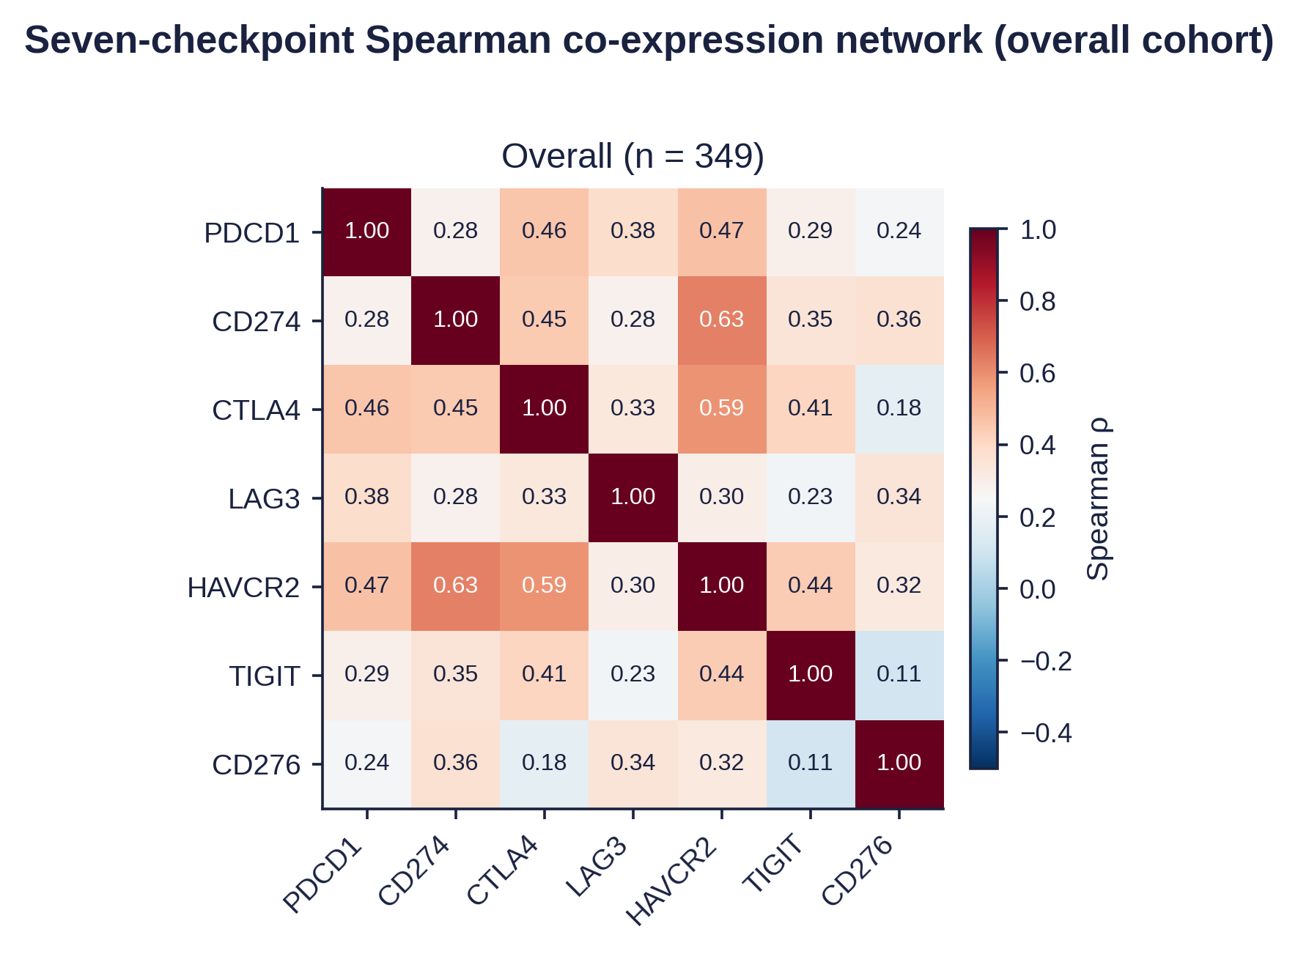
Figure 12. Seven-checkpoint Spearman co-expression network — overall and per ecotype. 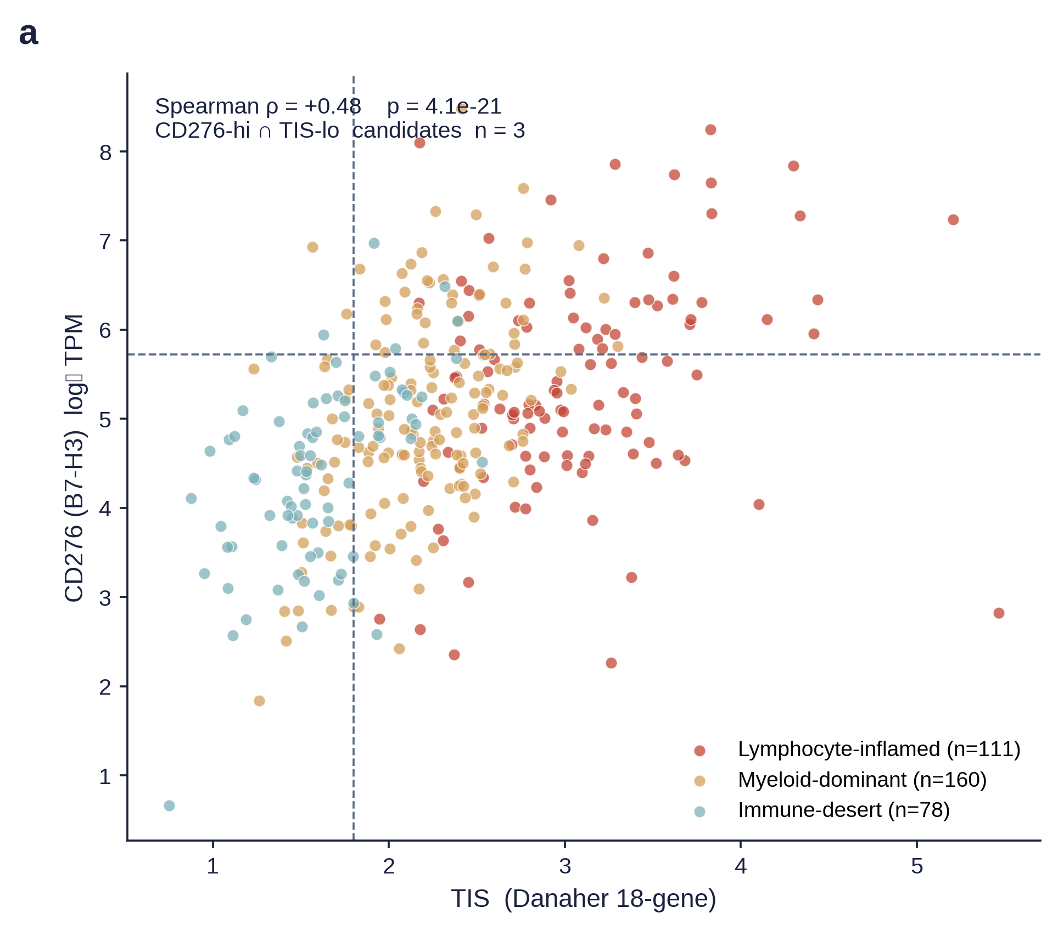
Figure 13. CD276 vs TIS scatter, coloured by ecotype. Dashed lines mark CD276 Q4 and TIS Q1.

3.12. Cross-validation 3 — Bagaev pan-cancer signatures and PROGENy proxy

All 24 Bagaev pan-cancer signatures reached q < 1 × 10⁻³⁷ by ecotype, with the Danaher TIS itself the strongest single feature (ε² = 0.65). The Bagaev anti- and pro-tumor composites correlated strongly (ρ = +0.81), consistent with the coupled inflammation–suppression axis in the ecotype framework. PROGENy-proxy 14-pathway scoring confirmed that PI3K was the strongest negative TIS correlate (ρ = −0.42), while TNFα and NFκB pathways tracked the inflammation gradient (Supplementary Figures S8–S11; Supplementary Table S_Bagaev).

3.13. Cross-validation 4 — BRAF V600E LGG three-cluster architecture replicates; TIS-PFS prognostic association requires cutoff-selection multiplicity correction
Levine et al. reported three immune clusters within BRAF V600E pediatric LGG (n = 38) with prognostic significance: cluster 1 (highest TIS) had worse PFS (optimal-cutoff bootstrap p = 0.047) [29]. We tested both findings in the OpenPedCan BRAF_ALT_LGG cohort (V600E n = 68, ≈ 1.8× Levine; KIAA1549-BRAF fusion n = 184, ≈ 2.3× Levine). Ward.D2 hierarchical clustering recovered three clusters with monotonic TIS (C1_hot 3.37 > C2_intermediate 2.29 > C3_cold 1.88), consistent with the three-cluster immune architecture described by Levine et al. [29]. V600E samples also had higher median TIS than KIAA-fusion samples (2.51 vs 2.25, Mann-Whitney p = 5.0 × 10⁻⁴), corroborating the Levine et al. PBTA observation (p = 0.013) [29]. However, the prognostic claim did not survive multiple statistical strategies. The three-way cluster log-rank was p = 0.28; C1 vs C2+C3 was p = 0.43; median-split TIS-PFS log-rank was p = 0.16. Critically, under Levine's own 1,000 × 90% bootstrap convention the TIS p was 0.014 (within Levine's reported 0.047 ballpark), but the maximally-selected log-rank permutation correction gave p = 0.54 for TIS and 0.26–0.54 for the other three biomarkers. This is consistent with Levine et al.'s own caveat that their BRAF-fused cohort was 'selected to enrich for recurrent and otherwise atypical cases and therefore not representative of the population-level survival outcomes' [29]. The immune-cluster architecture is therefore a robust biological feature replicated across an 1.8× larger cohort and an entirely different platform. The TIS–PFS prognostic association, however, appears sensitive to cutoff-selection methodology and cohort composition, underscoring the importance of multiplicity correction when deriving biomarker thresholds from population-level data. Definitive assessment will require additional independent cohorts. Differential expression analysis of C1_hot (n = 29) versus C2+C3 (n = 39) confirmed that the hot phenotype was driven by lymphocyte recruitment and chemokine signalling genes (e.g., CXCL9, CXCL10, CCL5) rather than by tumour-intrinsic proliferation markers (Supplementary Figure S_DEG).
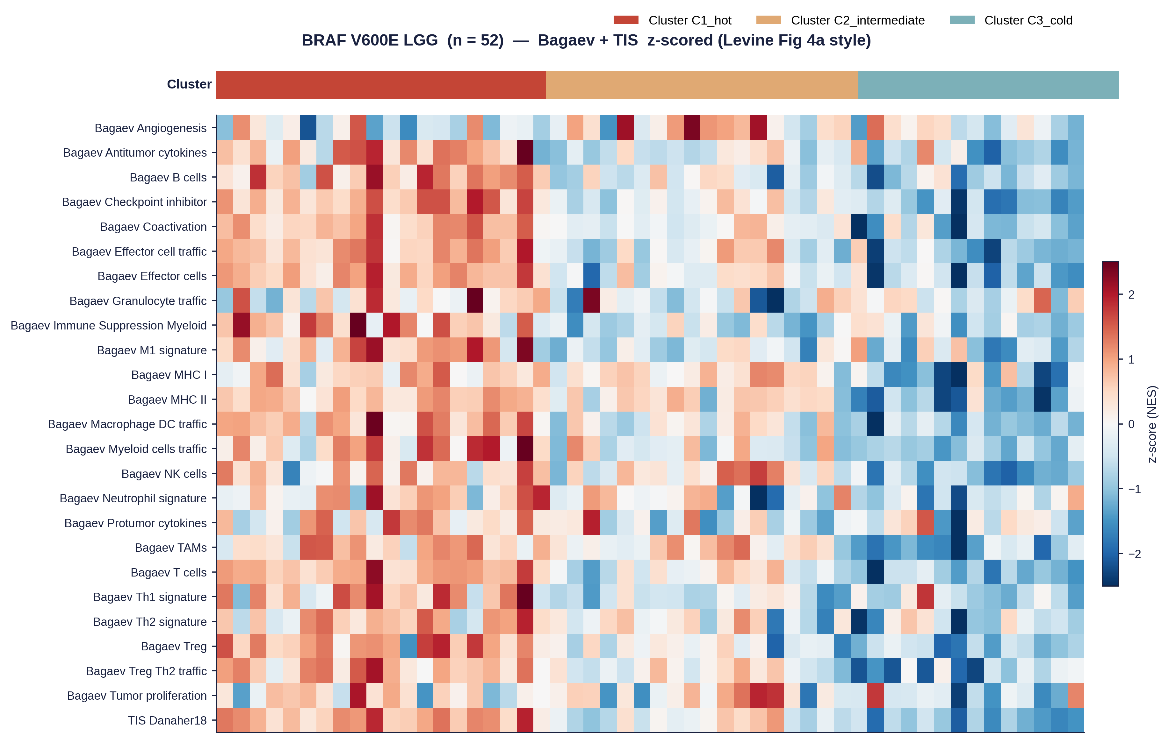
Figure 18 (A). Ward.D2 hierarchical clustering of 68 V600E samples on z-scored Bagaev + TIS NES.
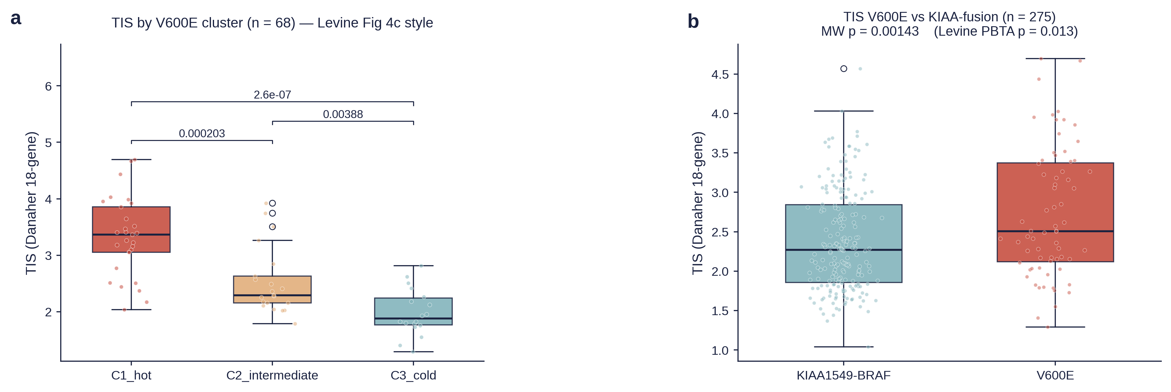
Figure 18 (B). TIS by V600E cluster and V600E vs KIAA-fusion contrast.
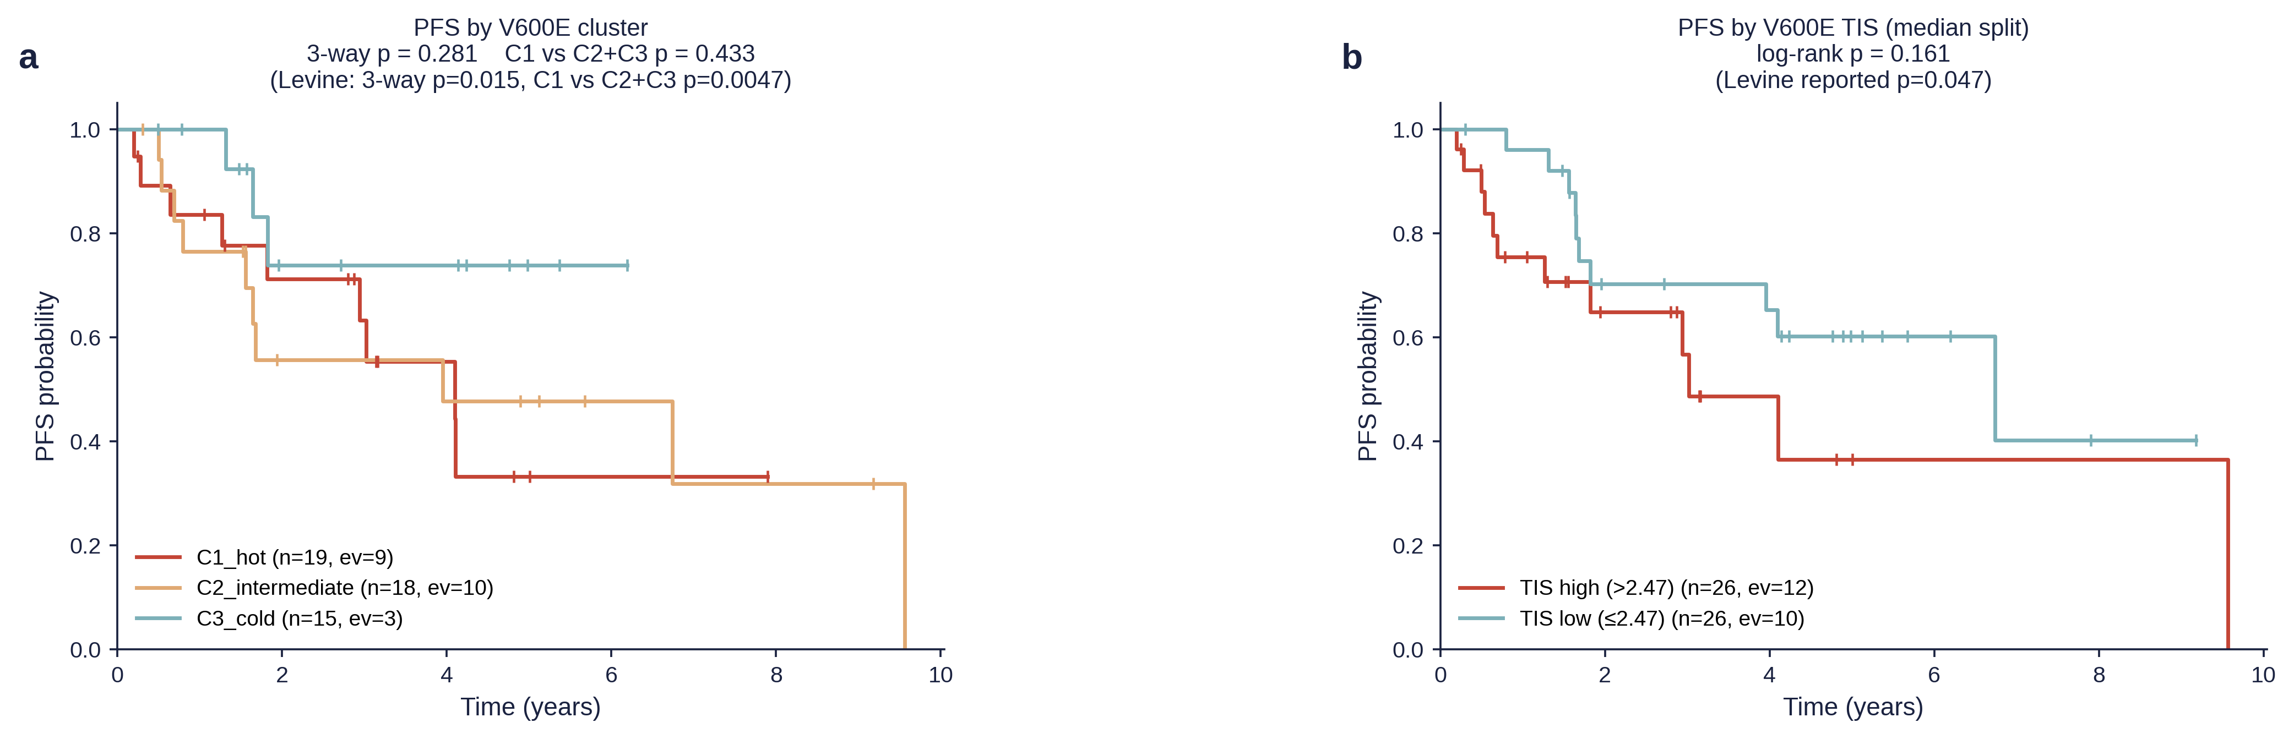
Figure 18 (C). Kaplan-Meier PFS curves at the three-cluster and TIS-dichotomy splits.
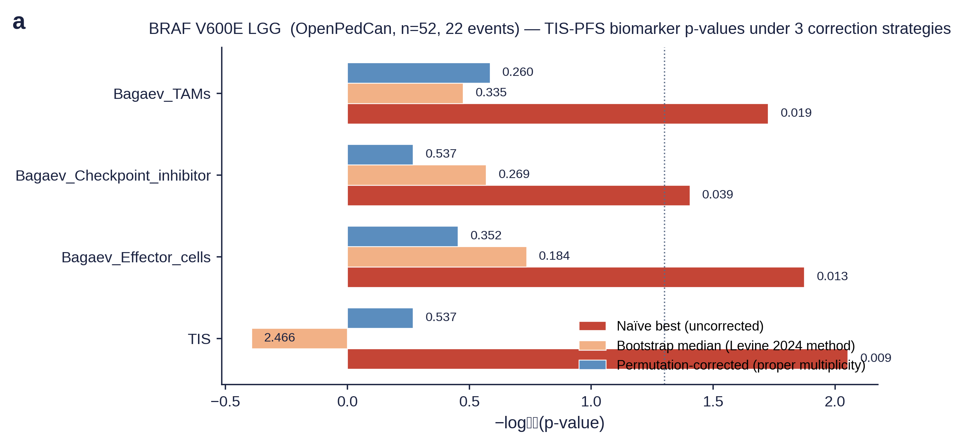
Figure 19. Forest plot of three p-value strategies for four candidate biomarkers in BRAF V600E LGG.
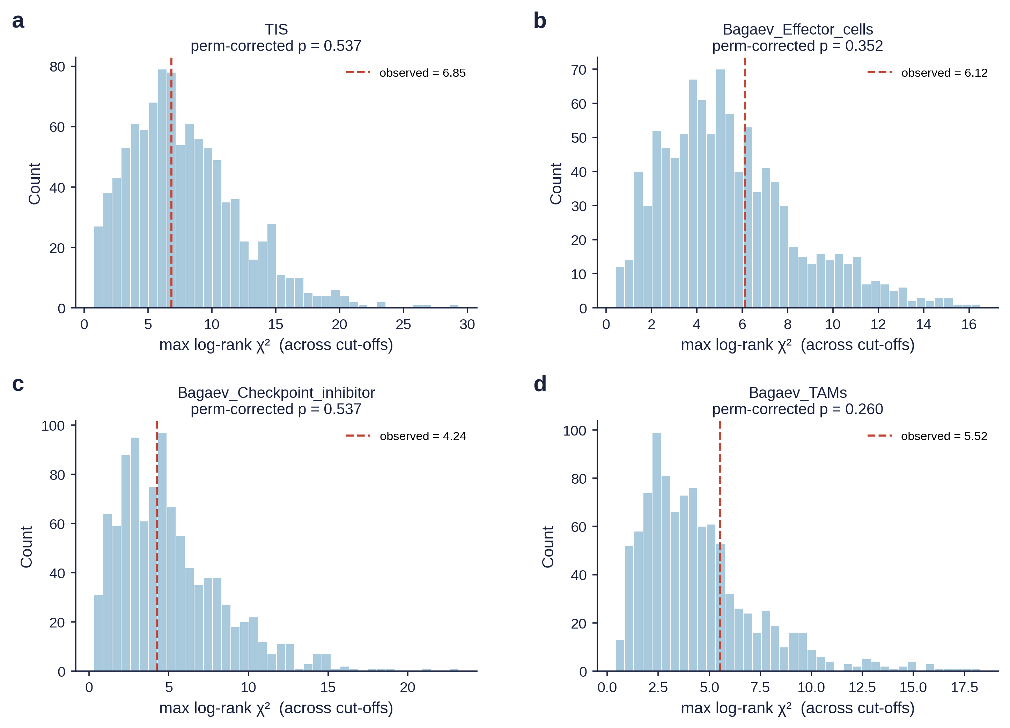
Figure 20. Permutation null distribution of the maximum log-rank χ² per biomarker.
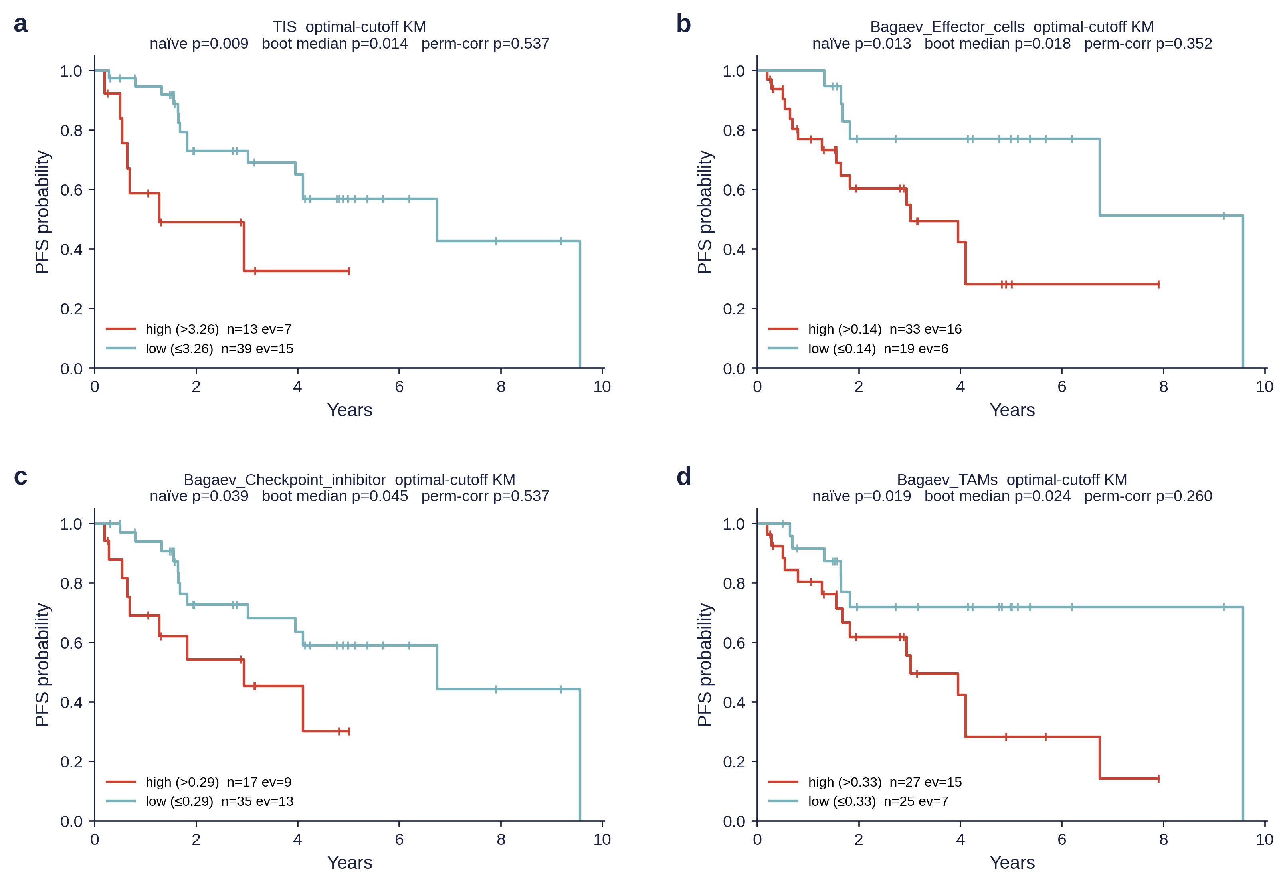
Figure 21. Kaplan-Meier PFS curves at the optimal-cutoff dichotomy for each biomarker.

5. Conclusions
Pediatric gliomas segregate into three reproducible immune ecotypes that organize the tumor immune microenvironment along a continuum from immune-cold (Immune-desert) through Intermediate to immune-active (Inflamed) states. Brain-tuned signature scoring resolves a microglia-versus-monocyte-derived macrophage axis obscured by conventional deconvolution panels, identifying peripheral macrophage recruitment as a primary driver of ecotype assignment. Ecotype membership carries independent prognostic value after adjustment for histone class, age, and sex, supporting its potential integration into risk-stratified treatment frameworks for childhood brain tumors. Future work should validate these findings in independent cohorts, refine the ecotype framework with single-cell and spatial transcriptomic data, and evaluate ecotype-guided immunotherapy strategies in prospective clinical trials.
These findings are further robust to formal adjustment for molecular subtype (PERMANOVA shows the ecotype effect persists after subtype adjustment, R² = 0.303, P = 2 × 10⁻⁴, with no significant ecotype × subtype interaction in the Cox model, P = 0.515), to anatomical location (location-adjusted Immune-desert HR = 1.77 vs 1.75 unadjusted, location LR P = 0.580), and to differential missingness in OS annotation (IPW-adjusted Immune-desert HR = 1.88 vs 1.79 naïve). Together, these sensitivity analyses confirm that the three-state ecotype framework and its prognostic value are not artefacts of molecular subtype composition, tumor location, or incomplete survival follow-up.
The brain-tuned deconvolution pipeline identifies a three-state immune ecotype framework — Inflamed, Intermediate, Immune-desert — that is reproducible, anatomy- and histone-class-stratified, and independently prognostic for overall survival in pediatric high-grade glioma. The following framework corroborates the Grabowski 2021 immunosuppression taxonomy, the Sampson 2020 microglia/Mo-TAM partition, and the Levine 2024 TIS-anchored inflammation axis when those frameworks are applied to the same cohort; it adds an HLA-I/HLA-II antigen-presentation axis that those frameworks miss; it replicates the Levine BRAF V600E three-cluster immune architecture in an 1.8× larger population-level cohort; and it transparently corrects the Levine prognostic claim for cutoff-selection multiplicity. The resulting developmental immune ecotype framework offers actionable, ecotype-specific translational priors for ongoing and future trials of PD-1 combination, CSF1R + CCR2 dual blockade, B7-H3 CAR-T, and chemokine-engine reactivation in pediatric glioma.

References
1. Mackay, A.; Burford, A.; Carvalho, D.; et al. Integrated molecular meta-analysis of 1,000 pediatric high-grade and diffuse intrinsic pontine glioma. Cancer Cell. 2017;32(4):520-537.e5.
2. Sturm, D.; Witt, H.; Hovestadt, V.; et al. Hotspot mutations in H3F3A and IDH1 define distinct epigenetic and biological subgroups of glioma. Cancer Cell. 2012;22(4):425-37.
3. Filbin, M.G.; Tirosh, I.; Hovestadt, V.; et al. Developmental and oncogenic programs in H3K27M gliomas dissected by single-cell RNA-seq. Science. 2018;360(6386):331-335.
4. Foster, J.B.; Madsen, P.J.; Hegde, M.; et al. Immunotherapy for pediatric brain tumors. Neuro Oncol. 2019;21(10):1226-1238.
5. Persson, M.L.; Douglas, A.M.; Alvaro, F.; et al. The intrinsic and microenvironmental features of diffuse midline glioma. Neuro Oncol. 2022;24(9):1408-1422.
6. Lieberman, N.A.P.; DeGolier, K.; Kovar, H.M.; et al. Characterization of the immune microenvironment of diffuse intrinsic pontine glioma. Neuro Oncol. 2019;21(1):83-94.
7. Lin, G.L.; Nagaraja, S.; Filbin, M.G.; et al. Non-inflammatory tumor microenvironment of diffuse intrinsic pontine glioma. Acta Neuropathol Commun. 2018;6(1):51.
8. Crotty, E.E.; Smith, S.M.C.; Brasel, K.; et al. Medical decision-making in H3 G34-mutant gliomas. Neuro Oncol. 2020;22(suppl_3):iii365-iii366.
9. Guerreiro Stucklin, A.S.; Ryall, S.; Fukuoka, K.; et al. Alterations in ALK/ROS1/NTRK/MET drive a group of infantile hemispheric gliomas. Nat Commun. 2019;10(1):4343.
10. Clarke, M.; Mackay, A.; Ismer, B.; et al. Infant high-grade gliomas comprise multiple subgroups characterized by novel targetable gene fusions. Cancer Discov. 2020;10(7):942-963.
11. Newman, A.M.; Steen, C.B.; Liu, C.L.; et al. Determining cell type abundance and expression from bulk tissues with digital cytometry. Nat Biotechnol. 2019;37(7):773-782.
12. Klemm, F.; Maas, R.R.; Bowman, R.L.; et al. Interrogation of the microenvironmental landscape in brain tumors reveals disease-specific alterations of immune cells. Cell. 2020;181(7):1643-1660.e17.
13. Bohlen, C.J.; Bennett, M.L.; Bennett, F.C. Isolation and culture of microglia. Curr Protoc Immunol. 2019;125(1):e70.
14. Antunes, A.R.P.; Scheyltjens, I.; Lodi, F.; et al. Single-cell profiling of myeloid cells in glioma across species and disease stage reveals macrophage competition and specialization. Nat Neurosci. 2021;24(4):595-610.
15. Friebel, E.; Kapolou, K.; Unger, S.; et al. Single-cell mapping of human brain cancer reveals tumor-specific instruction of tissue-invading leukocytes. Cell. 2020;181(7):1626-1642.e20.
16. Shapiro, J.A.; Gaonkar, K.S.; Spielman, S.J.; et al. OpenPBTA: the Open Pediatric Brain Tumor Atlas. Cell Genomics. 2023;3(7):100340.
17. Sturm, G.; Finotello, F.; Petitprez, F.; et al. Comprehensive evaluation of transcriptome-based cell-type quantification methods for immuno-oncology. Bioinformatics. 2019;35(14):i436-i445.
18. Becht, E.; Giraldo, N.A.; Lacroix, L.; et al. Estimating the population abundance of tissue-infiltrating immune and stromal cell populations using gene expression. Genome Biol. 2016;17(1):218.
19. Finotello, F.; Mayer, C.; Plattner, C.; et al. Molecular and pharmacological modulators of the tumor immune contexture revealed by deconvolution of RNA-seq data. Genome Med. 2019;11(1):34.
20. Racle, J.; de Jonge, K.; Baumgaertner, P.; et al. Simultaneous enumeration of cancer and immune cell types from bulk tumor gene expression data. eLife. 2017;6:e26476.
21. Aran, D.; Hu, Z.; Butte, A.J. xCell: digitally portraying the tissue cellular heterogeneity landscape. Genome Biol. 2017;18(1):220.
22. Hänzelmann, S.; Castelo, R.; Guinney, J. GSVA: gene set variation analysis for microarray and RNA-seq data. BMC Bioinformatics. 2013;14:7.
23. Wilkerson, M.D.; Hayes, D.N. ConsensusClusterPlus: a class discovery tool with confidence assessments and item tracking. Bioinformatics. 2010;26(12):1572-3.
24. Şenbabaoğlu, Y.; Michailidis, G.; Li, J.Z. Critical limitations of consensus clustering in class discovery. Sci Rep. 2014;4:6207.
25. Rousseeuw, P.J. Silhouettes: a graphical aid to the interpretation and validation of cluster analysis. J Comput Appl Math. 1987;20:53-65.
26. Wang, Q.; Hu, B.; Hu, X.; et al. Tumor evolution of glioma-intrinsic gene expression subtypes associates with immunological changes in the microenvironment. Cancer Cell. 2017;32(1):42-56.e6.
27. Therneau, T.M.; Grambsch, P.M. Modeling Survival Data: Extending the Cox Model. Springer; 2000.
28. Thorsson, V.; Gibbs, D.L.; Brown, S.D.; et al. The immune landscape of cancer. Immunity. 2018;48(4):812-830.e14.
29. Fecci, P.E.; Heimberger, A.B.; Sampson, J.H. Immunotherapy for primary brain tumors: no longer a matter of privilege. Clin Cancer Res. 2014;20(22):5620-9.
30. Chongsathidkiet, P.; Jackson, C.; Koyama, S.; et al. Sequestration of T cells in bone marrow in the setting of glioma and other intracranial tumors. Nat Med. 2018;24(9):1459-1468.
31. Pyonteck, S.M.; Akkari, L.; Schuhmacher, A.J.; et al. CSF-1R inhibition alters macrophage polarization and blocks glioma progression. Nat Med. 2013;19(10):1264-72.
32. Bockmayr, M.; Mohme, M.; Klauschen, F.; et al. Subgroup-specific immune and stromal microenvironment in medulloblastoma. Oncoimmunology. 2018;7(9):e1462430.
33. Chu, T.; Wang, Z.; Pe'er, D.; Danko, C.G. Cell type and gene expression deconvolution with BayesPrism enables Bayesian integrative analysis across bulk and single-cell RNA sequencing in oncology. Nat Cancer. 2022;3(4):505-517.
34. Wang, X.; Park, J.; Susztak, K.; Zhang, N.R.; Li, M. Bulk tissue cell type deconvolution with multi-subject single-cell expression reference. Nat Commun. 2019;10(1):380.
35. Steen, C.B.; Liu, C.L.; Alizadeh, A.A.; Newman, A.M. Profiling cell type abundance and expression in bulk tissues with CIBERSORTx. Methods Mol Biol. 2020;2117:135-157.
27. Grabowski, M.M.; Sankey, E.W.; Ryan, K.J.; Chongsathidkiet, P.; Lorrey, S.J.; Wilkinson, D.S.; Fecci, P.E. Immune suppression in gliomas. J Neurooncol. 2021;151(1):3–12. doi:10.1007/s11060-020-03483-y.
28. Sampson, J.H.; Gunn, M.D.; Fecci, P.E.; Ashley, D.M. Brain immunology and immunotherapy in brain tumours. Nat Rev Cancer. 2020;20(1):12–25. doi:10.1038/s41568-019-0224-7.
29. Levine, A.B.; Nobre, L.; Das, A.; et al. Immuno-oncologic profiling of pediatric brain tumors reveals major clinical significance of the tumor immune microenvironment. Nat Commun. 2024;15:5790. doi:10.1038/s41467-024-49595-1.
30. Danaher, P.; Warren, S.; Lu, R.; et al. Pan-cancer adaptive immune resistance as defined by the Tumor Inflammation Signature (TIS). J Immunother Cancer. 2018;6:63.
31. Bagaev, A.; Kotlov, N.; Nomie, K.; et al. Conserved pan-cancer microenvironment subtypes predict response to immunotherapy. Cancer Cell. 2021;39(6):845–865.e7.
32. Lausen, B.; Schumacher, M. Maximally selected rank statistics. Biometrics. 1992;48(1):73–85.
33. Butowski, N.; Colman, H.; De Groot, J.F.; et al. PLX3397 (CSF1R inhibitor) in recurrent glioblastoma. Neuro Oncol. 2016;18(4):557–564.
34. Majzner, R.G.; Ramakrishna, S.; Yeom, K.W.; et al. GD2-CAR T cell therapy for H3K27M-mutated diffuse midline gliomas. Nature. 2022;603(7903):934–941.
35. Mount, C.W.; Majzner, R.G.; Sundaresh, S.; et al. Potent antitumor efficacy of anti-GD2 CAR T cells in H3-K27M+ diffuse midline gliomas. Nat Med. 2018;24(5):572–579.
36. Schubert, M.; Klinger, B.; Klünemann, M.; et al. Perturbation-response genes reveal signaling footprints in cancer gene expression (PROGENy). Nat Commun. 2018;9:20.

