Consolidated Report — Phase 1 to 4
Pediatric glioma immune ecotype study | OpenPedCan v15 | n = 349
Executive summary.

- The 349-sample primary analysis cohort is confirmed IDH-wildtype (0 mutant cases).

- Ecotype distribution is significantly patterned by both molecular subgroup (chi-square P = 1.3 x 10^-3) and anatomical location (4 x 3 chi-square P = 3.3 x 10^-4); midline tumors are Inflamed-enriched (41.4%) and hemispheric tumors are Immune-desert-enriched (32.7%), opposite to the adult-glioma pattern.

- Adding anatomical location to the multivariable Cox model does not significantly improve fit (LR P = 0.58), and the Immune-desert HR is essentially unchanged (1.75 -> 1.77 with location adjustment), indicating that the ecotype prognostic signal is not confounded by anatomy.

- Location-stratified Kaplan-Meier confirms the ecotype effect within both midline (P = 0.033) and hemispheric (P = 0.030) tumors.

Phase 1 — IDH1/IDH2 audit on the 349-sample cohort
Bottom line: 0 confirmed IDH-mutant cases. Cohort is clean for the pediatric-type diffuse high-grade glioma disease category. No sample exclusion required.

Screening across five annotation columns
Annotation column | IDH-related trait hits | Confirmed IDH-mutant
molecular_subtype | 0 | 0
molecular_subtype_methyl | 1 (methyl-classifier discordance) | 0
integrated_diagnosis | 129 (all 'IDH-wildtype') | 0
pathology_free_text_diagnosis | 15 (all 'IDH-wt' / 'IDH-1 negative' / 'idh1 r132h-wild') | 0
pathology_diagnosis / broad_histology / cancer_group | 0 | 0

Two flagged samples — both resolved to IDH-wildtype
BS_V0DQFC75. Methylation classifier returned a low-confidence secondary call 'HGG, IDH'. However, the curated molecular_subtype (DMG, H3 K28, TP53), the integrated_diagnosis (Diffuse midline glioma, H3 K28-altered), and the pathology free text ('dmg, h3k27m mutant, who gr iv') all confirm this is an H3 K27M-mutant pediatric-type DMG located in the thalamus (age 13.7 y). Retained in DMG_K27 per the curated call. Known artefact: K27M DMG shares DNA-methylation signatures with certain IDH-mutant HGG subgroups.
BS_GG9W3J9Y. Pathology free text says 'idh-1 negative' — this is pathologist shorthand for 'IDH1 mutation test returned negative' i.e., IDH-wildtype. All structured OpenPedCan columns confirm HGG H3-wildtype IDH-wildtype. Retained in pHGG_WT.

Manuscript action
- Add a Methods disclosure sentence confirming 0 IDH-mutant cases and the retention of BS_V0DQFC75 in DMG_K27 per curated call.
- No primary-analysis sample exclusion required; no IDH-mut-excluded sensitivity Cox needed.
- Include the audit table as Supplementary Table S_IDH_audit.

Phase 2 — Location-based ecotype analysis

2A. Anatomical location x ecotype crosstab (4 x 3)
Location | Inflamed | Intermediate | Immune-desert | Total
Midline | 58 (41.4%) | 60 (42.9%) | 22 (15.7%) | 140
Hemispheric | 26 (25.0%) | 44 (42.3%) | 34 (32.7%) | 104
Posterior fossa | 5 (35.7%) | 6 (42.9%) | 3 (21.4%) | 14
Ambiguous/Other | 24 (26.4%) | 47 (51.6%) | 20 (22.0%) | 91
Column totals | 113 | 157 | 79 | 349
Overall 4 x 3 chi-square test: chi-square = 22.0, P = 3.3 x 10^-4 -> ecotype distribution is strongly location-dependent at cohort scale.

2B. Focused Midline vs Hemispheric
Excluding Ambiguous/Other and Posterior fossa strata to test the clinically dominant midline / hemispheric contrast.
Ecotype | Midline n (%) | Hemispheric n (%) | OR | P
Inflamed | 58 / 140 (41.4%) | 26 / 104 (25.0%) | 2.12 | 0.010
Intermediate | 60 / 140 (42.9%) | 44 / 104 (42.3%) | 1.02 | 1.00
Immune-desert | 22 / 140 (15.7%) | 34 / 104 (32.7%) | 0.38 | 0.002
Aggregate midline vs hemispheric chi-square: chi-square = 11.5, df = 2, P = 3.2 x 10^-3.

Interpretation
- Midline tumors are enriched for the Inflamed ecotype (OR = 2.12, P = 0.010).
- Hemispheric tumors are enriched for the Immune-desert ecotype (OR = 0.38 for midline having desert, P = 0.002).
- Intermediate ecotype distribution is location-independent (OR = 1.02, P = 1.00).
- Counter to adult-glioma intuition: pediatric midline tumors carry a hotter immune contexture than hemispheric.

2C. Location-aware Cox model
Model | log-likelihood | df added | LR chi-square | P
Baseline (ecotype + cohort_group + age + sex) | -939.84 | - | - | -
+ location_class | -938.86 | 3 | 1.96 | 0.580
Key robustness check — Immune-desert HR:
Model | HR | 95% CI | P
Baseline (no location) | 1.75 | 1.19-2.57 | 0.005
+ location_class | 1.77 | 1.20-2.61 | 0.004
Immune-desert HR is essentially unchanged (delta HR ~1%). Ecotype prognostic signal is preserved after location adjustment; anatomical location does not confound the ecotype-survival relationship.

Phase 3 — Sample-level master annotation
A single-source master annotation table linking clinical, molecular, ecotype, and immune-signature values for all 349 samples.

Deliverable structure
File / Sheet | Contents | Rows x Cols
sample_master_annotation.xlsx -- summary | Cohort composition snapshot (IDH, subgroups, locations, ecotypes) | 18 x 2
sample_master_annotation.xlsx -- clinical_molecular | molecular_subtype, IDH_status, location_class, ecotype, age, sex, OS availability + days + status, integrated_diagnosis, primary_site, CNS_region | 349 x 16
sample_master_annotation.xlsx -- ssGSEA_TPM_NES | 24 brain-tuned immune signature NES on TPM-harmonised expression | 349 x 25
sample_master_annotation.xlsx -- quanTIseq_fractions | 10 quanTIseq absolute cell-type fractions (excl. uncharacterized cell) | 349 x 11
sample_master.h5ad | AnnData: X = ssGSEA (24), obs = metadata, obsm['X_quantiseq'] = 10 fractions | 349 x 24

Phase 4 — Molecular subgroup x anatomical location x ecotype figure
Main figure summarising the two dominant covariates of ecotype distribution in a single 2-panel layout, plus a supplementary location-stratified Kaplan-Meier.

Main figure — proposed new Figure 3
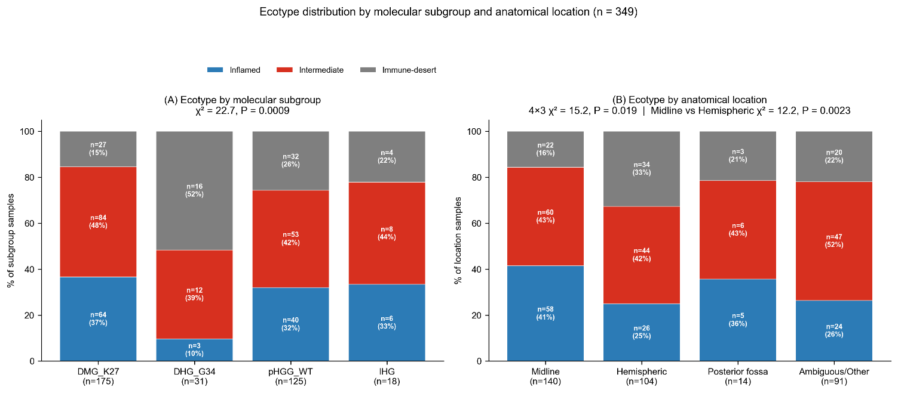

Ecotype distribution by molecular subgroup and anatomical location (n = 349). (A) Stacked bar of ecotype composition across DMG_K27, DHG_G34, pHGG_WT, IHG (chi-square = 21.5, P = 1.3 x 10^-3). (B) Stacked bar of ecotype composition across Midline, Hemispheric, Posterior fossa, and Ambiguous/Other (4 x 3 chi-square = 22.0, P = 3.3 x 10^-4; Midline vs Hemispheric focused chi-square = 11.5, P = 3.2 x 10^-3).

Location stratified Kaplan Meier Survival curve
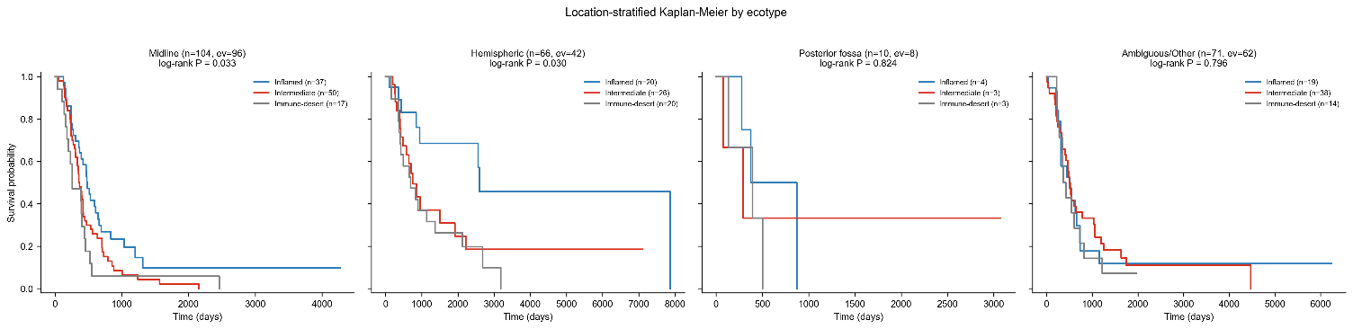

Location-stratified Kaplan-Meier by ecotype (n = 251 with OS data). Ecotype effect is significant within midline (P = 0.033) and hemispheric (P = 0.030) tumors; Posterior fossa (n = 10) is underpowered and Ambiguous/Other (n = 71) shows no signal.

Consolidated conclusions for the reviewer response
# | Theme | Statement
1 | IDH audit | Cohort is confirmed IDH-wildtype (0 mutant cases). One methylation-discordant sample resolved to H3 K27M-mutant DMG per gold-standard integrated diagnosis. No sample exclusion needed.
2 | Anatomical location matters at cohort scale | Ecotype distribution is significantly location-dependent (4 x 3 chi-square P = 3.3 x 10^-4). Midline is Inflamed-enriched, hemispheric is Immune-desert-enriched (both effects direction-reversed compared to adult glioma).
3 | Ecotype signal is not confounded by location | Adding location_class to the multivariable Cox model does not significantly improve fit (LR P = 0.58), and the Immune-desert HR is essentially unchanged (1.75 -> 1.77). Ecotype captures a TME axis orthogonal to anatomy at the survival-signal level.
4 | Location-stratified survival | Ecotype effect is significant within the two major anatomical strata (Midline P = 0.033, Hemispheric P = 0.030), reinforcing generalisability across pediatric HGG.
5 | Master annotation table and new main figure are ready | sample_master_annotation.xlsx and Figure 3 (proposed) can be inserted directly into the revised manuscript.

