INFO-6024 Assignment 1

Group One: Mitchell Dawdy, Jordan McCarthy, Curtis Tremblay

# Game Title

Feral. Like Stray, this is a game about a “[community cat](https://www.alleycat.org/resources/feral-and-stray-cats-an-important-difference/)”. In our case though, the gameplay is completely focused on the player vs. their environment rather than having a socialization component.

# Game Story

The game is not story driven, meaning that the primary focus of the game is not to progress through a storyline, rather, the story serves as a secondary feature to give the player a better understanding of the goal of the game. With that in mind, the story is simple and straightforward.   
  
The player controls Luna, a cat that lives in the streets of New York. One day, Luna’s kittens were snatched by humans and taken to the pound. The player must overcome various challenges to recover Luna’s kittens.

# Game Concept Art

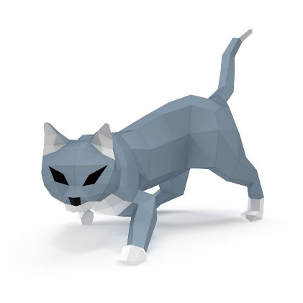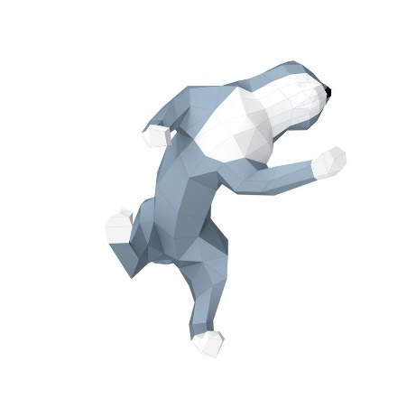

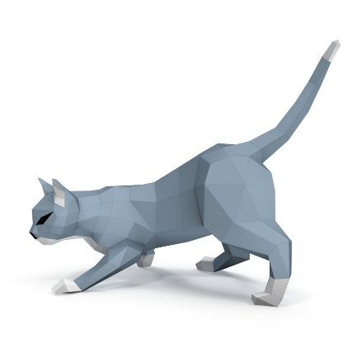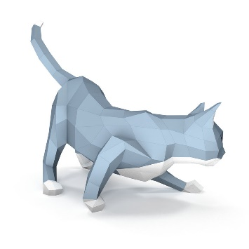

Sample images of our protagonist “Luna”

Via: <https://free3d.com/3d-model/hunting-cat-paper-8845.html>

Sample interior setting


Sample interior setting. Interiors will mainly be puzzle based.

Via: <https://www.moddb.com/mods/portal-2-lab-rat/images/offices>



Sample exterior setting. Exteriors may be a mix of platforming and puzzles.

Via: <https://cutewallpaper.org/download.php?file=/22/anime-city-night-wallpapers/free-download-new-york-city-art-prints-and-posters-wall-murals-buy-a-poster-2560x1600-for-your-desktop-mobile-amp-tablet-explore-47-city-night-time-wallpapers-city-night-wallpaper.jpg>

# Game Mechanics

This game will be a 3D puzzle platformer. Players will attempt to climb a mountain by overcoming vertical platforming challenges. Similar to Getting Over It With Bennett Foddy/Jump King, the players have infinite lives and a failure moves the player back to an earlier game state, requiring them to repeat the platforming challenges they have encountered along the way. In order to minimize player frustration, we will be minimizing ‘downtime’ by having the player always land on their feet, so they can immediately continue playing the game even if they fall.   
  
Along the way, various puzzles will be encountered which will allow the player to unlock shortcuts to recover their progress should they fail a platforming challenge. This will give the player some leverage to bypass difficult platforming challenges and act as some form of safety net, making the platforming slightly more forgiving than comparable games.

In addition to the general platforming, there will be some climbing mechanics like those found in Spider-Man, Legend of Zelda: Breath of the Wild, or Shadow of the Colossus that will attempt to capture the dynamic movements of house cats. The player will be able to climb on surfaces and carry some vertical momentum to assist with platforming.

Our goal is that the player movement feels light and nimble, giving the player multiple ways of traversing the environment. Through interacting with their surroundings (ex. Climbing walls, balancing on slacklines), the player should have a large degree of horizontal and vertical mobility.

# Game Mechanic Specifics

* **Picking up & Holding Objects**: Player will hold LMB to pick up an item off the ground. When the player releases LMB, the item will be dropped. This will function like the game Skyrim where there is no holding animation, but instead the object will float directly in front the player’s camera
* **Throwing Objects:** Player will press RMB while holding an object to throw it in the direction the player is looking. When an object is thrown, a force will be applied to the object. The distance and velocity that the object will travel is dependent on the object’s mass. This mechanic will be integral for progressing in the game for situations where you must get an object to an untraversable location. There will also be a feature where some items will be breakable, meaning that when an item is thrown and hits the ground, it shatters.
* **Jumping:** Players have 2 jump charges that can be used by pressing SPACE (double jump). Jump charges are recharged when the player collides with the ground.
* **Climbing:** Players can hold SPACE and a directional key (WASD) while colliding with a vertical wall to climb. The distance that the player can climb will be proportional to the player’s vertical and horizontal velocity when beginning to climb.
* **Pressure Plates:** An intractable object in the world that will have specific behaviour when a correct item is placed on top.
* **Slacklines/Balancing:** A mini-game type activity where the player will perform a “balancing act” across tight-rope-like terrain. The player will use A and D to ensure that their character is not leaning too far in one direction.
* **Interactive Doors:** There will be various doors in the world that the player will have to open. Some of the behaviours of doors are as follows: Inserting a key into a keyhole, pressing E to open, displaying the status of the door (ie: Locked, Press ‘E’ to open), etc.

# Target Audience

This game is targeted towards a casual platformer fan/streamer market. Given the simple subject matter and somewhat frustrating platforming, it is meant to be accessible to a wide breadth of players, though it will be quite challenging for younger gamers. Similar games have seen success with this market by providing a low barrier of entry but requiring a relatively high level of skill to complete the game.  
  
The story and themes have also been streamlined so that most casual players/viewers should be able to identify and relate to the game world very quickly, making it comparatively accessible when viewed alongside other games in the genre.  
  
Given the clear goal of the game and a focus on movement techniques, an extended lifespan could be found in the speedrunning community. Given a relatively open-ended challenge, various techniques could be developed to help players complete the game in shorter times once they have mastered the game’s controls.

# Monetary Strategies

This game is being targeted as a one-time purchase. It will be priced competitively with games of similar scope and gameplay such as: Human Fall Flat, Portal, Getting Over It With Bennett Foddy, Jump King, Grow Home, or Celeste at a suggested retail price of $15. This will allow it to compete with similar platformers/puzzle games which have been successful over the past several years.  
  
Additional revenue could either be generated via additional DLC levels following the release of the game, or by re-using some of the movement mechanics developed for this game to offset the development costs of a larger AAA title.

# Basic Technical Strategies

This will be a 3D single player game. While no leaderboards/network communication is targeted for the initial version, this may be possible to add in the future if a sufficient community is built up for the game.  
  
Given that our team does not have a dedicated artist, all animations/interactions will be simplistic (ex. ‘Held’ objects will hover in front of the character rather than being physically held by the character). Models will be based on broadly available assets so that we do not require specific character/environment models.  
  
The player character will require some animations for movement, however the environments will be mostly static to minimize animation requirements. Similarly, there will be physics requirements for the player movement and puzzles, though there will be limited to no enemy characters which will require animations/physics. This will allow us to focus on a smooth player experience without needing to dedicate resources to other areas of gameplay.  
  
Since gameplay will be constrained to a single environment, we will only require a small number of music tracks/sound effects.  
  
Additional animations and sound effects could be added to provide additional charm and draw attention to the game via online video sharing (like Untitled Goose Game or Stray).