芜湖经济技术开发区简介

About WEDA(Wuhu Economic & Technological Development Area)

芜湖经济技术开发区于1993年4月经国务院批准设立，规划面积118.28平方公里，现有常住和就业人口20万，集综合保税区、汽车电子产业园、汽车零部件出口基地、新型工业化产业示范基地、高新技术创业服务中心、外贸码头、知识产权试点园区和生态工业示范园区等多个国家级发展平台予一体。来区投资企业3804家，其中境外世界500强投资企业31家，国内上市公司投资企业61家。2017年在全国国家级经开区考评中名列前20强，进入全国第一方阵。在全省省级以上开发区综合考核评价中名列前茅。

展望未来，经开区将全面贯彻党的十九大精神，坚持以习近平新时代中国特色社会主义思想为指导，不忘初心，牢记使命，认真落实五大发展理念和省五大发展行动计划，突出人才优先发展主战略，着力打造经济、城市两个升级版，实现人才结构高端化、产业层次高端化、城区品质高端化良性互动，将经开区打造成为具有国际竞争力的先进制造业基地和宜居宜业产业新城。

Wuhu Economic & Technological Development Area (WEDA) was established with the approval of State Council in April 1993. According to the planning, the area covers a range of 118.28 square kilometers, and it has a population of 200 thousand. It has integrated several national development platforms like the comprehensive bonded area, automotive electronic industrial park, auto parts export base, new industrialization demonstration base, high-tech innovation service center, foreign trade ports, intellectual property pilot park and ecological industrial demonstration base. Currently, there are 3804 enterprises including 31 world top 500 enterprises form abroad and 61 listed companies. In 2017, WEDA ranked top 20 of the national economic & technological development areas among the first level zones in China and ranked highly in Anhui Province.

Looking ahead, WEDA will fully implement the spirit of the 19th National Congress of CPC and adhere to General Secretary Xi Jinping’s guiding principle of socialism with Chinese characteristics in the new era. We should remain true to our original aspiration and keep our mission firmly in our mind. The five development concepts and the provincial five major development action plans need to be conscientiously implemented. We must highlight the priority of talent development strategy and upgrade the levels of economy and the city. With the sound interaction of high-leveled talent structure, industrial level and urban quality, WEDA is meant to be cultivated as an advanced manufacturing base and a modern industrial town of habitability and enterprise-adaptability.

规划图

GENERAL PLANNING

北区总体规划

GENERAL PLANNING FOR THE NORTH ZONE

东区总体规划

GENERAL PLANNING FOR THE EAST ZONE

2017年发展概述

DEVELOPMENT IN 2017

2017年，经开区党工委、管委会深入学习贯彻"十九大"精神和习近平总书记系列重要讲话精神特别是视察安徽重要讲话精神，全面落实市委、市政府决策部署，主动适应经济新常态，一心一意谋发展、聚精会神抓党建，经济持续健康发展，各项事业呈现新面貌新气象。全年实现地区生产总值505亿元，同比增长9.4%；实现规模以上工业产值1862.5亿元，同比增长13.7%；实现规模以上工业增加值370.4亿元，同比增长9.6%；完成固定资产投资427.1亿元，同比增长12.1%；完成进出口额39.3亿美元，同比增长26.3%；完成财政收入81.4亿元。

In 2017, the party Working Committee and the Administrative Committee of WEDA further followed the spirit of the 19th National Congress of CPC and series of General Secretary Xi Jinping’s important speeches, especially the inspection speech in Anhui. We’ve fully implemented the decisions and arrangements of the municipal party committee and the municipal government. We’ve initiatively adopted the new normal economy, concentrated on the development and the party construction. The economy has maintained the sustainable development and various undertakings have taken on a new look. Annually, the regional GDP is amount to RMB 50.5 billion, with average growth rate of 9.4%; industrial output value amounted to RMB 186.25 billion, with average growth rate of 13.7%; industrial output added value amounted to RMB 37.04 billion, with average growth rate of 9.6%; investment in fixed assets amounted to RMB 42.71 billion, with average growth rate of 12.1%; import &export volume amounted to US$ 3.93 billion, with average growth rate of 26.3%; financial revenue amounted to RMB 8.14 billion.

2018年发展展望

DEVELOPMENT PROSPECTS IN 2018

2018年，经开区将全面深入贯彻党的十九大和习近平总书记系列重要讲话精神，坚持新发展理念，深入实施五大发展行动计划，以大力推进战略性新兴产业集聚作为转变发展方式、优化经济结构、转换增长动力的重要抓手，明确用力方向，突出抓好新型产业培育、产业结构升级；全面加快园区建设，加快提升承载能力；不断加强党的建设，为园区发展提供组织保障。

发展主要目标：地区生产总值增长10%；规模以上工业增加值增长10%；固定资产投资增长12%；财政收入增长10%。

In 2018, WEDA will further implement the spirit of the 19th National Congress of CPC and series of General Secretary Xi Jinping’s important speeches. The five development concepts are to be further followed and the strategic emerging industry cluster is to be promoted as the essential means of transforming developmental way, optimizing economic structure and shifting the increase power. We will confirm the developmental target, highlight cultivating new industries and updating the industrial structure. The area construction and the carrying capacity promotion are bound to speed up. The party construction is to be enhanced to provide organizational guarantee for the area development.

Main target of development: 10% growth of the regional GDP; 10% growth of the industrial output value; 12% growth of the investment in fixed assets; 10% growth of the financial revenue.

主导产业

LEADING INDUSTRIES

目前经开区已形成三大主导产业，分别是以奇瑞汽车为龙头的汽车及零部件产业，以美的、日立为代表的家用电器产业，以海螺型材、鑫科新材料为代表的新材料产业。2017年汽车零部件、家用电器、新材料三大产业产值分别为688.5亿元、475.9亿元、260.7亿元，占总产值76.5%。

汽车及零部件产业：支持龙头企业间以多种形式开展合作，加快推进智能化改造，建设一批智能工厂和数字化车间，带动整体行业优化提升。

家用电器产业：着力推动智能家电产业发展，支持家电企业产品优化升级，通过技术改造等方式，引入新技术、新工艺、新装备，加快自主创新，发展壮大家电产业集群。

新材料产业：鼓励龙头企业通过兼并重组不断引进国外先进技术，同时加大研发投入和自主创新，不断提高产品附加值和市场竞争力，加快产业优化升级步伐。

Currently there are three major leading industries: automobile and auto parts led by Chery Auto, domestic electrical appliances led by Midea and Hitachi, new materials industry represented by Conch and Xinke new materials. In 2017, the production values of the auto parts, domestic electrical appliances, new materials were RMB68.85 billion, RMB47.59 billion and RMB26.07 billion respectively, 76.5% of the total industrial output value.

The industry of automobile and auto parts: supporting leading enterprises cooperate in various forms, accelerating the development of intelligent transformation, constructing several intelligent factories and digital workshops and driving the overall industry to optimize and upgrade.

The industry of domestic electrical appliances: promoting the industrial development of intelligent appliances, supporting products’ optimization and updating, introducing new technology & equipment through technological transformation, speeding up the initiative innovation and developing the industrial cluster of household appliances.

The industry of new materials: encouraging leading industries to import foreign advanced technology through merging and reorganization, increasing researching & developing investment and independent innovation, continuously improving product added value and market competitiveness and accelerating the industrial optimizing & updating.

战略性新兴产业

STRATEGIC EMERGING INDUSTRIES

目前，经开区正在加快打造光电信息显示产业，大力培育轨道交通产业，培育新的增长点，打造经开区经济发展新引擎。

光电信息显示产业方面，积极推动兴飞通讯、映日科技、聚飞光电等光电信息显示产业企业新上项目、扩大产能，2017年实现工业产值502.1亿元，同比增长25.9%。

轨道交通产业方面，支持中车实施跨坐式单轨及APM车辆工程，加快推进城市轨道交通系统测试国家工程实验室组成之一的单轨列车专用测试线和APM列车专用测试线建设。目前，国内首列最先进无人驾驶胶轮APM车辆已在经开区基地完成调试，跨坐式单轨及APM车辆工程项目主体厂房已部分建成，新誉、今创、力钧、雷尔伟等关键零部件项目正在积极建设中。

At present, WEDA is speeding up cultivating photoelectric information display industry and rail transit industry which are its new engines of economic development.

Photoelectric information display industry: promoting new programs of Xingfei Communication, Yingri Science & Technology, Jufei Photoelectrical Co. Ltd. In 2017, the value of industrial output reached RMB50.21 billion, an increase of 25.9%.

Rail transit industry: supporting the implementation of cross-seat monorail and APM vehicle engineering, promoting the construction of special test line for monorail trains & APM train. The 1st most advanced driverless rubber wheel APM vehicle has finished debugging in WEDA base. The body workshops of monorail and APM vehicle have been partially completed and the key parts’ program have been constructed initiatively.

科技创新

INNOVATIONS IN SCIENCE & TECHNOLOGY

2017年，经开区紧紧围绕合芜蚌国家自主创新示范区建设，基于国家知识产权试点园区、省知识产权示范园区等平台建设，以科技项目为引领，推进高新技术产业发展；以知识产权工作为抓手，提升企业自主创新能力；以高层次科技人才项目引进为契机，建设人才高地；以产学研合作为推动力，提升企业研发能力、自主创新能力。加大招引高层次科技人才团队力度，促进人才聚集，累计引进创新团队9个，培养引进高层次创新创业人才1300余人。截至目前，经开区拥有高新技术企业119家，省级以上研发机构91家，万人拥有有效发明专利量195.8件，在全国开发区中名列前茅。拥有国家级研发机构16家、省级以上研发平台91家、院士工作站7家。

目前经开区正在着力打造新一代汽车电子公共研发创新中心、安徽省平板显示玻璃基板工程技术研究中心、安徽新材料产业研究院等一批高端研发平台，快速提升经开区产业创新能力。

In 2017, WEDA focused on construction of Hefei-Wuhu-Bengbu Initiative Innovation Demonstration Area. On the base of constructing “National Intellectual Property Pilot Park” and “the First Batch of Provincial Intellectual Property Park”, WEDA is bound to promote industrial upgrading with technological innovation, enhance the enterprises’ initiative innovation through focusing on the work of intellectual property, import high-leveled technological talents and promote the enterprises’ research & development capacity through industry-college-institute cooperation. Till now, WEDA has imported 9 innovative teams and over 1300 high-leveled innovative talents. Currently, there are 119 high-tech enterprises, 16 national research & development institutions 91 research & development institutions above the provincial level and 7 academician workstations. It boasts 195.8 valid patents per 10 thousand citizens ranking highly in national development zones.

At present, WEDA is focusing on cultivating the new generation of automotive electronic public research and development innovation center, Anhui technology research center of panel display glass substrate engineering and Anhui new materials industry research institute aiming at promoting the industrial innovation rapidly.

开放合作

OPENING UP & COOPERATION

2015年9月1日，芜湖综合保税区正式获国务院批复设立。芜湖跨境电子商务产业园一期项目已全部建成并投入使用，入驻产业园企业已达41家。芜湖综合保税区将着力打造先进的“出口加工制造基地、保税物流基地、区域性国际贸易基地”和“跨境电子商务中心、进口商品展示交易中心、高新技术产品研发中心”。到2020年，芜湖综合保税区将力争实现年进出口额30亿美元，并成为功能配套齐全、辐射带动能力强，中部地区一流的综合保税区。

2017年经开区累计实现进出口总额39.3亿美元，其中出口额27.1亿美元，进口额12.2亿美元，同比分别增长26.3%、17.3%和52.3%。

On the 1st of September, Wuhu Comprehensive Bonded Zone established with the approval of State Council. The international electronic industrial park has completed the construction of the first phase which has come into use. There are 41 enterprises in the industrial park. Wuhu Comprehensive Bonded Zone will strive to construct advanced “export-oriented processing base, bonded logistic base, regional international trading base” and “international E-commerce center, imported merchandise exhibition & trading center, high-tech product research & developing center”. By the year of 2020, Wuhu Comprehensive Bonded Zone will realize annual import & export value of US$ 3 billion and will become a first class bonded zone in middle area of China with complete auxiliary facilities, strong influence and leading role to peripheral areas.

In 2017, WEDA achieved total import & export value of US$ 3.93 billion including the export value of US$ 2.71 billion & import value of US$ 1.22 billion, with the grow of 26.3%, 17.3% and 52.3% from the previous year.

综合优势

COMPREHENSIVE ADVANTAGES

区位交通优越

芜湖承东启西，临江达海，区位优势明显，是华东地区仅次于上海和南京的第三大综合交通枢纽，皖江城市带承接产业转移示范区的双核心城市之一。

Prominent advantage of geography & transportation

Wuhu forms a connecting link between the east and the west and it is close to river and ocean. It is the third largest integrated transport hub next to Shanghai and Nanjing in the east of China. Wuhu is one of the two core cities in Anhui demonstration zone for industrial diversion along the Yangtze River.

科教资源丰富

经开区所在的芜湖市是全国科技进步先进市、全国创业先进城市，也是合芜蚌自主创新综合实验区中心城市。芜湖有10所高等院校和30所职业技术学校，在校学生约20万人，能够为企业输送大批高素质的人才。

Abundant resources of science & education

Wuhu is the national advanced city of scientific & technological development, the national advanced city for entrepreneurship and the centered city of Hefei-Wuhu-Bengbu comprehensive experiment area of initiative innovation. There are 10 universities and colleges, 30 vocational schools with around 200,000 students, which guarantee sustainable supply of qualified talents for all circles.

政府服务高效

提供“并联审批，一次性告知、一站式办理”，审批期限由过去的15.5天降到现在的3.2天，对工业园区企业和科研开发项目投资兴业阶段实行零收费。易户网、易企网，让群众企业足不出户办成事，推行“互联网+政府服务”，实现行政权力和公共服务事项网上运行。

Efficient Service of the government

The government provides the easiest method of “parallel approval” and “one-station” service. The approval period has shortened from 15.5 days to 3.2 days. The process is free of charge for companies to be established in the industrial zones and for those science research projects which are in the early development stage. The network of Ewoho and Eqoho guarantee the public and enterprises lots of convenience at home. The policy of “internet+government service” ensures online operation of the administration and the public service.

支持政策优惠

作为皖江城市带的核心城市之一，经开区企业享受国家、省、市有关支持企业发展政策。经开区构建了较为完备的促进企业发展的政策体系，对投资强度大、科技含量高、经济带动性强的投资项目，采取“一企一策”的方式，给予特殊的优惠政策。

Advantages of supporting policy

Since Wuhu is one of the core cities in Anhui demonstration zone for industrial diversion along the Yangtze River, the enterprises in WEDA may enjoy the national, provincial and municipal policies that support the development of enterprises. WEDA has constructed a relatively complete policy system of promoting the development of enterprises. Particularly, for those investment projects of large capital, high technology and strong economic positive influence, it will enjoy special favorable policy.

主要投资成本

MAIN INVESTMENT COSTS

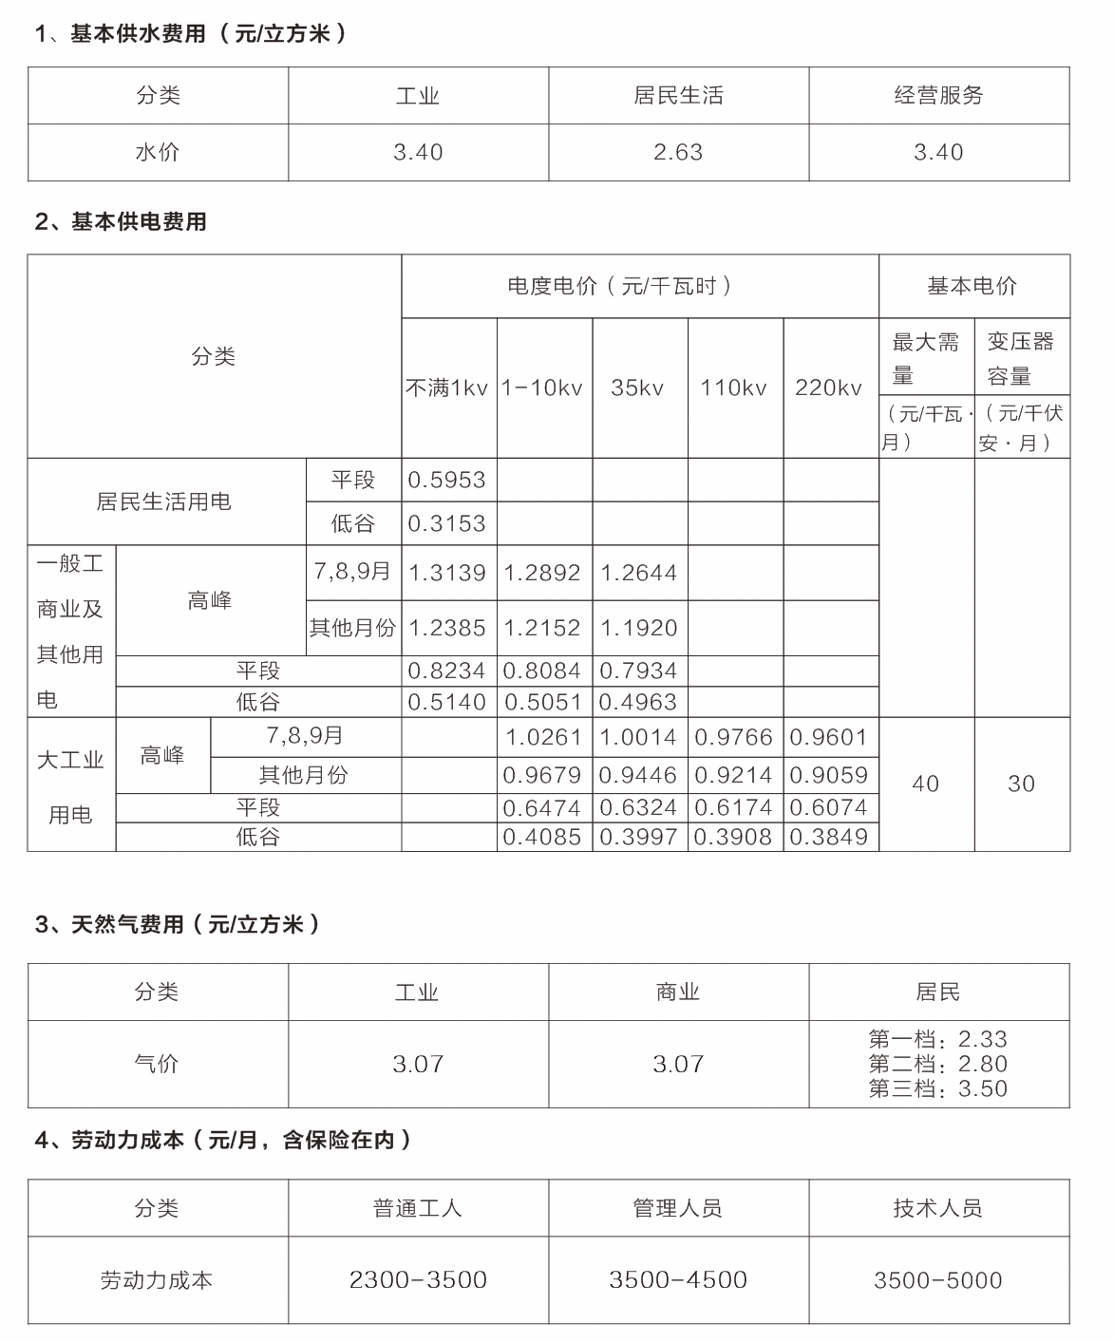

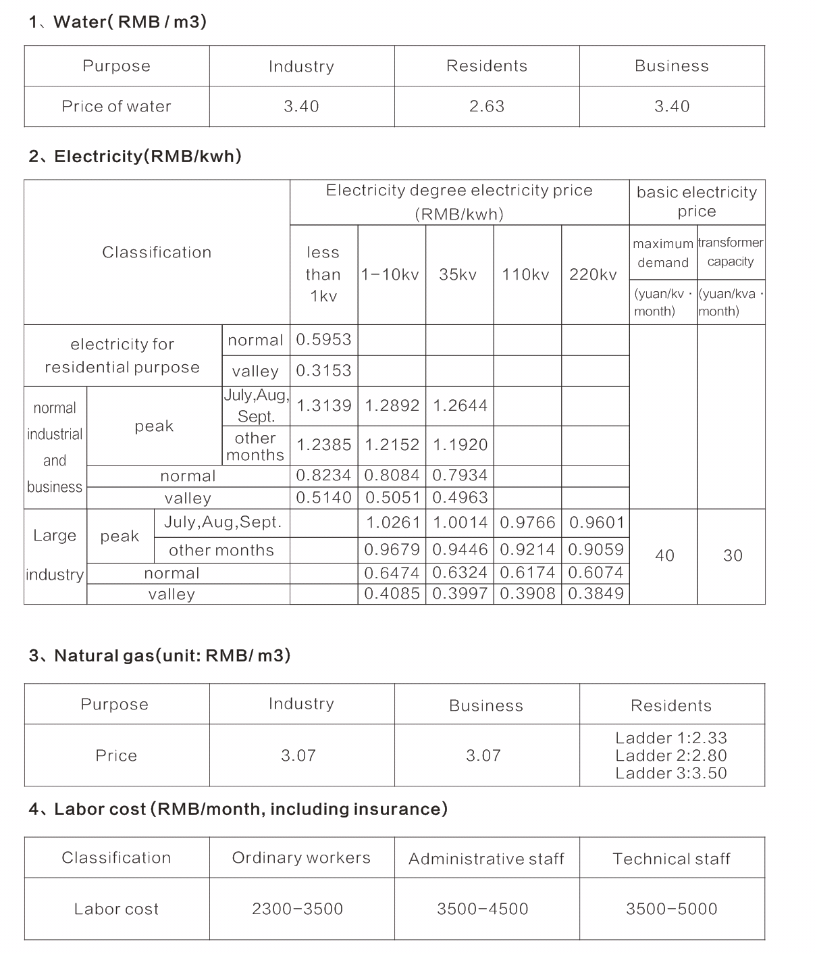

2017年利润前二十名工业企业

TOP 20 ENTERPRISES ON THE LIST OF INDUSTRIAL PROFITS IN 2017

芜湖美智空调设备有限公司

Wuhu Melgen Air Conditioning Equipment Co., Ltd.

芜湖东旭光电装备技术有限公司

Wuhu Dongxu Photoelectric Equipment Technology Co., Ltd.

信义光伏产业(安徽)控股有限公司

Xinyi PV Industry (Anhui) Holdings Limited

安徽三安光电有限公司

Anhui San’an Photoelectrical Co. Ltd.

芜湖美的厨卫电器制造有限公司

Wuhu Midea Kitchen & Bathroom Electric Appliance Manufacturing Co. Ltd.

安徽美芝精密制造有限公司

Anhui Meizhi Precision Manufacturing Co., Ltd.

芜湖长信科技股份有限公司

WuhuC Changxin Technologies Co., Ltd.

马瑞利汽车零部件(芜湖)有限公司

Marjorie Auto Parts (Wuhu) Co., Ltd.

大陆汽车电子(芜湖)有限公司

Continental Automotive Electronics (Wuhu) Co., Ltd.

信义节能玻璃(芜湖)有限公司

Xinyi Energy-saving Glass(Wuhu) Co., Ltd.

安徽楚江科技新材料股份有限公司

Anhui Truchum Advanced Materials and Technology Co., Ltd.

芜湖美的厨房电器制造有限公司

Wuhu Midea Kitchen Electric Appliance Manufacturing Co. Ltd.

大陆汽车车身电子系统(芜湖)有限公司

Continental Automobile Body Electronic System Wuhu Co., Ltd.

芜湖万里扬变速器有限公司

Wuhu Wanliyang Transmission Co., Ltd.

芜湖伯特利汽车安全系统有限公司

Wuhu Bethel Automotive Safety Systems Co., Ltd.

江森自控日立空调(芜湖)有限公司

Johnson Controls Hitachi Air-conditioning (Wuhu) Co., Ltd.

信义电子玻璃(芜湖)有限公司

Xinyi Electronic glass(Wuhu) Co., Ltd.

芜湖富春染织有限公司

Wuhu Fuchun Dyeing & Weaving Co., Ltd.

芜湖中燃城市燃气发展有限公司

Wuhu City Gas Development Co. Ltd.

瑞鹄汽车模具有限公司

Rayhoo Motor Dies Co., Ltd

来区投资的世界500强名录

WORD TOP 500 ENTERPRISES IN WEDA

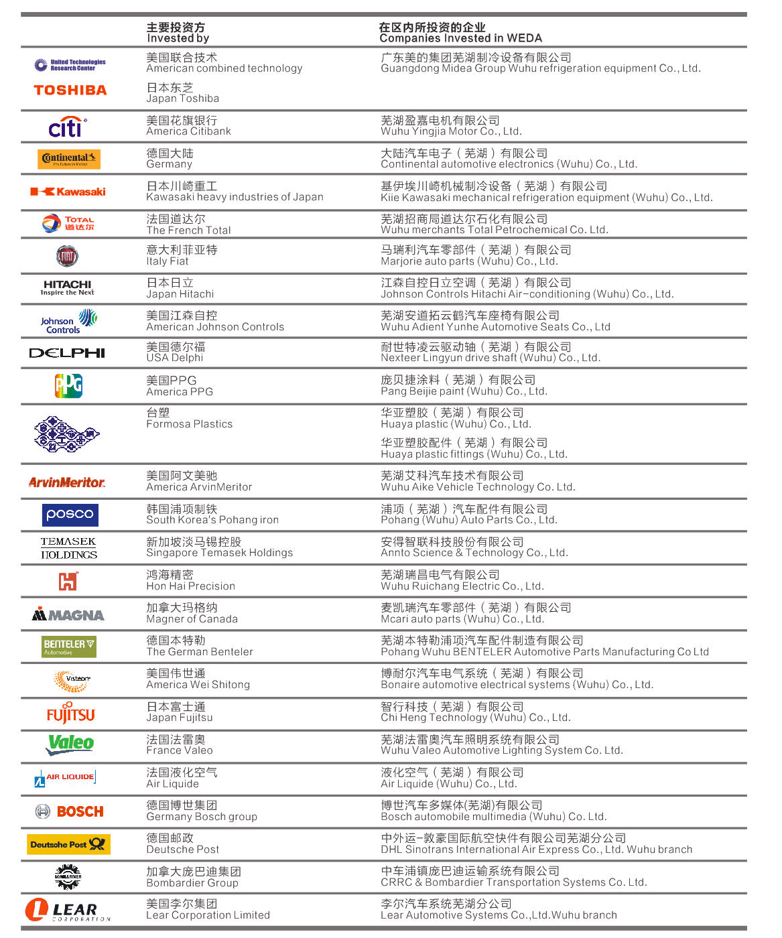

2017年大事记

MEMORABILIA OF 2017

1月份/January

1月，国内知名新媒体大数据权威平台清博指数发布2016年“开发区网络影响力200强排行榜”榜单，芜湖经开区位列安徽省开发区之首。

1月23日，芜湖富春染织股份有限公司股票在全国中小企业股转系统公开挂牌转让，是2017年芜湖市首家挂牌“新三板”企业。

In January, WEDA ranked No.1 among the development areas of Anhui province according to the list Top200 of “2016 Development areas’ internet influence” released by Qingbo index---the national famous new media data platform.

On the 23rd of January, the stock of Wuhu Fuchun Dyeing & Weaving Co., Ltd. was listed in the national small and medium-sized enterprise stock transfer system. It is the first 2017 listing “three new board listed” enterprise in Wuhu.

2月份/February

经开区管委会荣获“2015年度及‘十二五’全省节能工作先进单位”称号。

经开区荣获全市2016年度招商引资载体单位一等奖。

The administrative committee of WEDA was rewarded with the title of “Advanced unit of energy conservation in 2015 & the 12th five-year plan”.

WEDA won the first prize of the city’s carrier unit of investment promotion in 2016.

3月份/March

3月22日，芜湖万里扬变速器有限公司投资30亿元人民币的CVTⅡ代、6MT等年产100万台（套）变速箱项目与经开区管委会签订投资协议。

3月，世界500强加拿大庞巴迪与中国中车合资设立的中车浦镇庞巴迪运输系统有限公司落户。

On the 22nd of March, Wuhu Wanliyang Transmission Co., Ltd. signed the investment contract with WEDA administrative committee. The program is focusing on the investment of RMB3 billion on the transmissions of CVTⅡ& 6MT whose annual production is 1 million sets.

In March, Bombardier Transport System Co., Ltd. settled in WEDA. The joint venture was set up by the world’s top 500 Canadian Bombardier and CRRC.

4月份/April

4月，由芜湖德豪润达光电科技有限公司牵头组织的SEMI中国HB-LED标准技术委员会2017年度春季会议在芜召开，来自全球近40家企业及科研院所80余位专家代表参会。

In April, organized by Optoelectronics Technology Co. of Wuhu Dehao Runda, Ltd., 2017 spring meeting of SEMI China HB-LED Standards Technical Committee was held in Wuhu. Over 80 expert representatives from almost 40 enterprises & research Institutions all over the world attended the meeting.

5月份/May

5月，2017年经开区东区、北区、综保区等30个重点项目集中开工，计划投资127.7亿元。

5月9日，投资总额1.76亿元的科创中心及龙山科技园三期工程项目开工建设。

In May, 30 key programs of WEDA started including the east area, the north area and the Comprehensive Bonded Zone. The investment is planned to be RMB12.77 billion.

On the 9th of May, Science & Innovation Center (investment of RMB0.176 billion) and the 3rd phase of Longshan Science & Technology Park started.

6月份/June

6月，我省发布的《安徽省公路建设规划（2017-2021年）》显示，芜湖泰山路长江公路大桥计划于2021年开工建设，这是继芜湖城南过江隧道之后芜湖计划建设的第五条过江通道。

6月29日，芜湖市参加全省调结构补短板重点项目集中开工动员大会在经开区大陆汽车动力系统项目开工现场举行。

In June, revealed by Anhui highway construction planning（2017-2021）,Wuhu Taishan Road Yangtze River Bridge will be planned to construct in 2021. It will be the 5th cross-river pathway as the previous Wuhu cross-river pathway in the south of the city.

On the 29th of June, the mobilization meeting of key program construction was held on the construction spot of Continental Automotive Engine program.

7月份/July

7月，2016年全国219个国家级开发区综合发展水平排名中，经开区在全国综合排名第20位，比2011年前进1位。

7月，国土资源部公布全国472个开发区2016年土地集约利用情况结果，芜湖经开区位列全国第58位。

7月30日，经开区管委会与大陆汽车（上海）投资有限公司签订大陆汽车动力系统项目投资协议。

In July, WEDA was No.20 among 219 national development areas in the ranking of 2016 comprehensive development, up one notch from 2011.

In July, according to the condition of land intensive utilization in 2016 released by Ministry of Land and Resources, WEDA ranked No. 58 among 472 national development areas.

On the 30th of July, the administrative committee of WEDA signed the investment contract with Continental Automotive (Shanghai) Investment Co. Ltd. on the program of Continental Automotive Engine System.

8月份/August

8月4日，由安徽省商务厅和芜湖市政府主办，芜湖经开区管委会承办的中德（安徽）产业合作圆桌会在北京举办。

On the 4th of August, sponsored by Anhui Department of Commerce and Wuhu municipal government, organized by WEDA administrative committee, Sino-Germany (Anhui) Industrial Cooperation round-table conference was held in Beijing.

9月份/ September

9月7日，安徽众源新材料股份有限公司A股正式在上海证券交易所上市交易，成为经开区第7家本土培育上市公司。

9月28日，安徽省2017年（2016年数据）百强民营企业榜单发布，经开区19家企业荣登百强榜。

On the 7th of September, Anhui Zhongyuan New Materials Co. Ltd.’s A-shares were officially listed on the Shanghai stock exchange. It is the 7th local listed company in WEDA.

On the 28th of September, 19 enterprises in WEDA ranked 2017 Top100 of private enterprises in Anhui.

10月份/October

10月，芜湖高新技术创业服务中心成为经开区首个省级服务业集聚区。

10月26日，市政府与德国大陆集团签署合作协议，大陆集团在经开区新增建设汽车动力总成项目，计划固定资产新投资额不低于15.5亿元人民币。

In October, Wuhu High-technology & Innovation service center became the first provincial service industry cluster.

On the 26th of October, the municipal government signed the cooperative contract with German Continental Group. The group will start the program of automotive power assembly. The new investment in fixed assets will be planned not less than RMB1.55 billion.

11月份/ November

11月，同济大学发展研究院公布2016年中国产业园区持续发展100强榜单，芜湖经开区排第30位。

In November, WEDA ranked No.30 among 2016 Top100 China’s industry parks of sustainable development released by the Development Research Institute of Tongji University.

12月份/ December

12月，在全省园区工作会议上，经开区被评为2017年全省园区非公党建工作先进单位。

12月12日，经开区管委会与苏宁公司签约在经开区投资设立皖南地区电商运营中心和天天快递皖南总部项目。计划2018年上半年开工，建成后年销售50亿元。

12月21日，安徽省首个网易云区域服务中心在经开区落地启动。

In December, WDA was rewarded as 2017 non-public advanced unit of party construction in Anhui.

On the 12th of December, the administrative committee of WEDA signed the contract with Suning Corporation to establish E-commerce operation center of the south region in Anhui and the program of TTK Express Headquarter in the south region of Anhui. The program will be started in the first half year of 2018 and the annual sale volume will be RMB5 billion after its completion.

On the 21st of December, the first Netease cloud regional service center of Anhui started in WEDA.