CSE 564 Software Design - TEAM 3

The final blueprint versions start from Page 4.

The first three Layouts are just initial drafts that we made, out of which some needed improvements

**Blueprint 1**

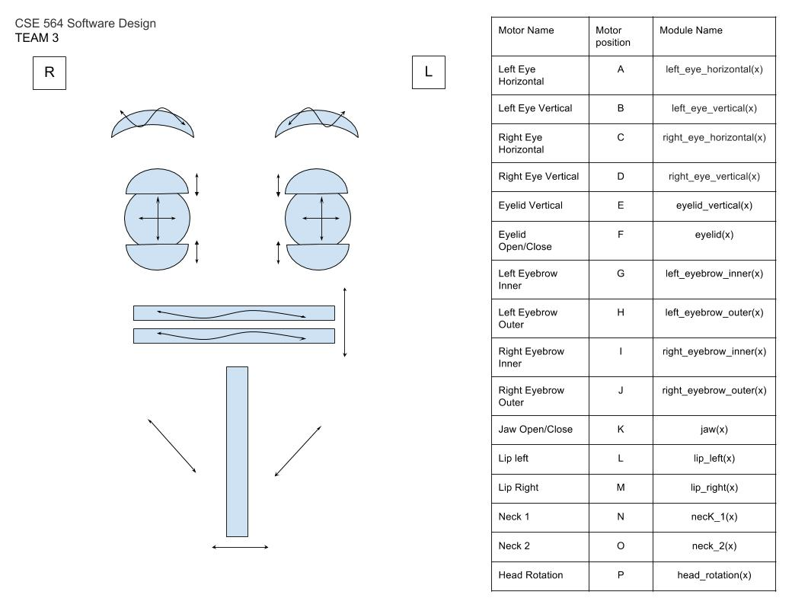

**Motor Positions**

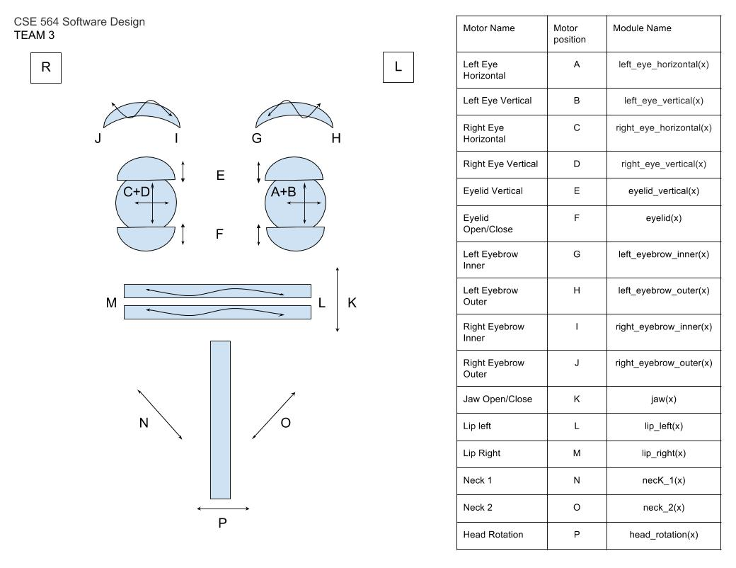

|  |  |  |  |
| --- | --- | --- | --- |
| Label | Name | Label | Name |
| A | Left Eye Horizontal | **I** | Right Eyebrow Inner |
| B | Left Eye Vertical | **J** | Right Eyebrow Outer |
| C | Right Eye Horizontal | **K** | Jaw Open/Close |
| D | Right Eye Vertical | **L** | Lip Left |
| E | Eyelid Vertical | **M** | Lip Right |
| F | Eyelid Open/close | **N** | Neck1 |
| G | Left Eyebrow Inner | **O** | Neck2 |
| H | Left Eyebrow Outer | **P** | Head Rotation |

**Wiring Diagram**

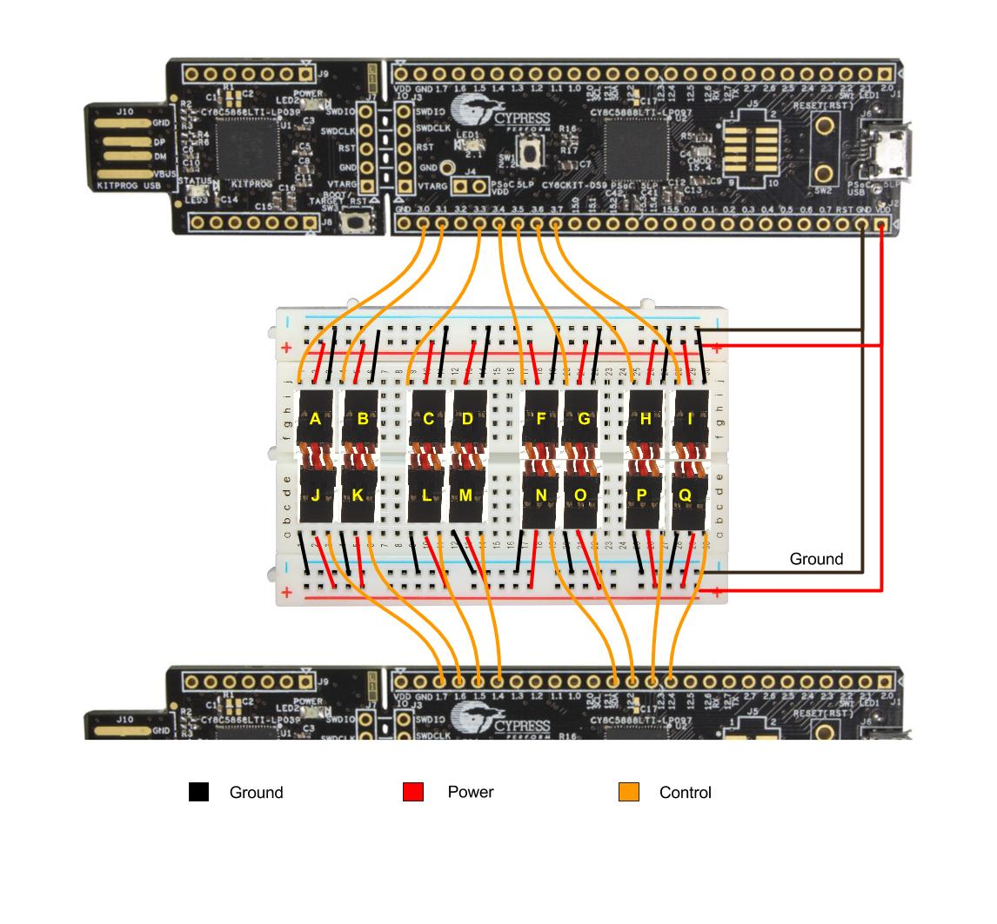

|  |  |  |  |
| --- | --- | --- | --- |
| Label | Name | Label | Name |
| A | Left Eye Horizontal | **I** | Right Eyebrow Inner |
| B | Left Eye Vertical | **J** | Right Eyebrow Outer |
| C | Right Eye Horizontal | **K** | Jaw Open/Close |
| D | Right Eye Vertical | **L** | Lip Left |
| E | Eyelid Vertical | **M** | Lip Right |
| F | Eyelid Open/close | **N** | Neck1 |
| G | Left Eyebrow Inner | **O** | Neck2 |
| H | Left Eyebrow Outer | **P** | Head Rotation |

**Final Drafts of Blueprints**

After taking reviews from the Professor on our previous blueprints, we came up with final 4 versions of blueprints:

**Blueprint 1**: Face Design

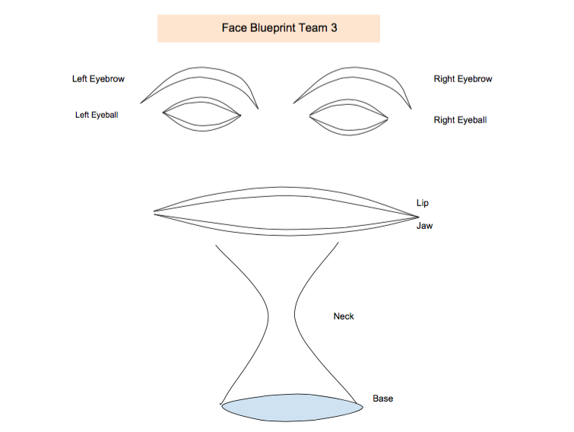

**Blueprint 2**: Motor Movement Directions



**Blueprint 3**: Wiring Diagram with Standardized Nomenclature

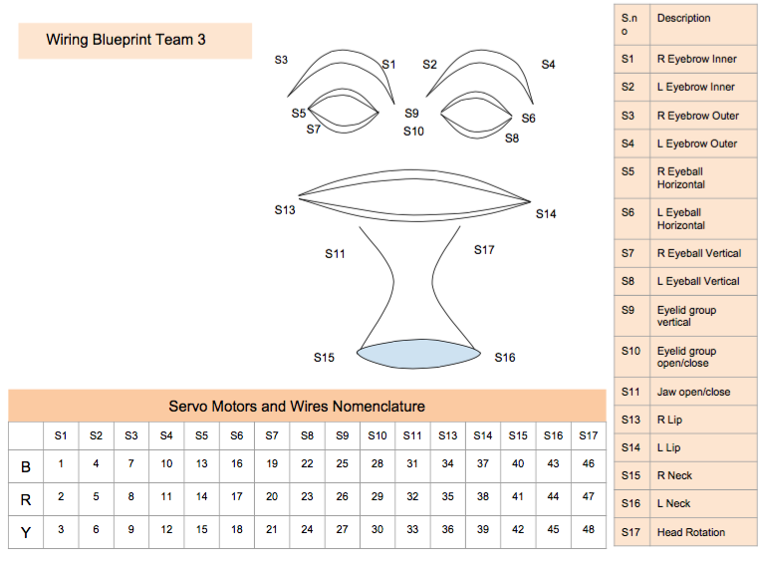

**Blueprint 4**: Pulse Width Modulation Layout Diagram

