**CSE 564 - Building a Socially Expressive Robot**

**Team Number: 3**

Student Names:

Abhijith Krishnan Radhakrishna Kurup

1211577910

Abhishek Nagaraj

1211417906

Anant Srivastava

1209427008

Ankit Patel

1205972621

Ismael Mercado

1205147771

Prateek Shrivastava

1211160064

Shibani Singh

1209404128

N D B Vachan

1211214768

Date: 10/25/2016

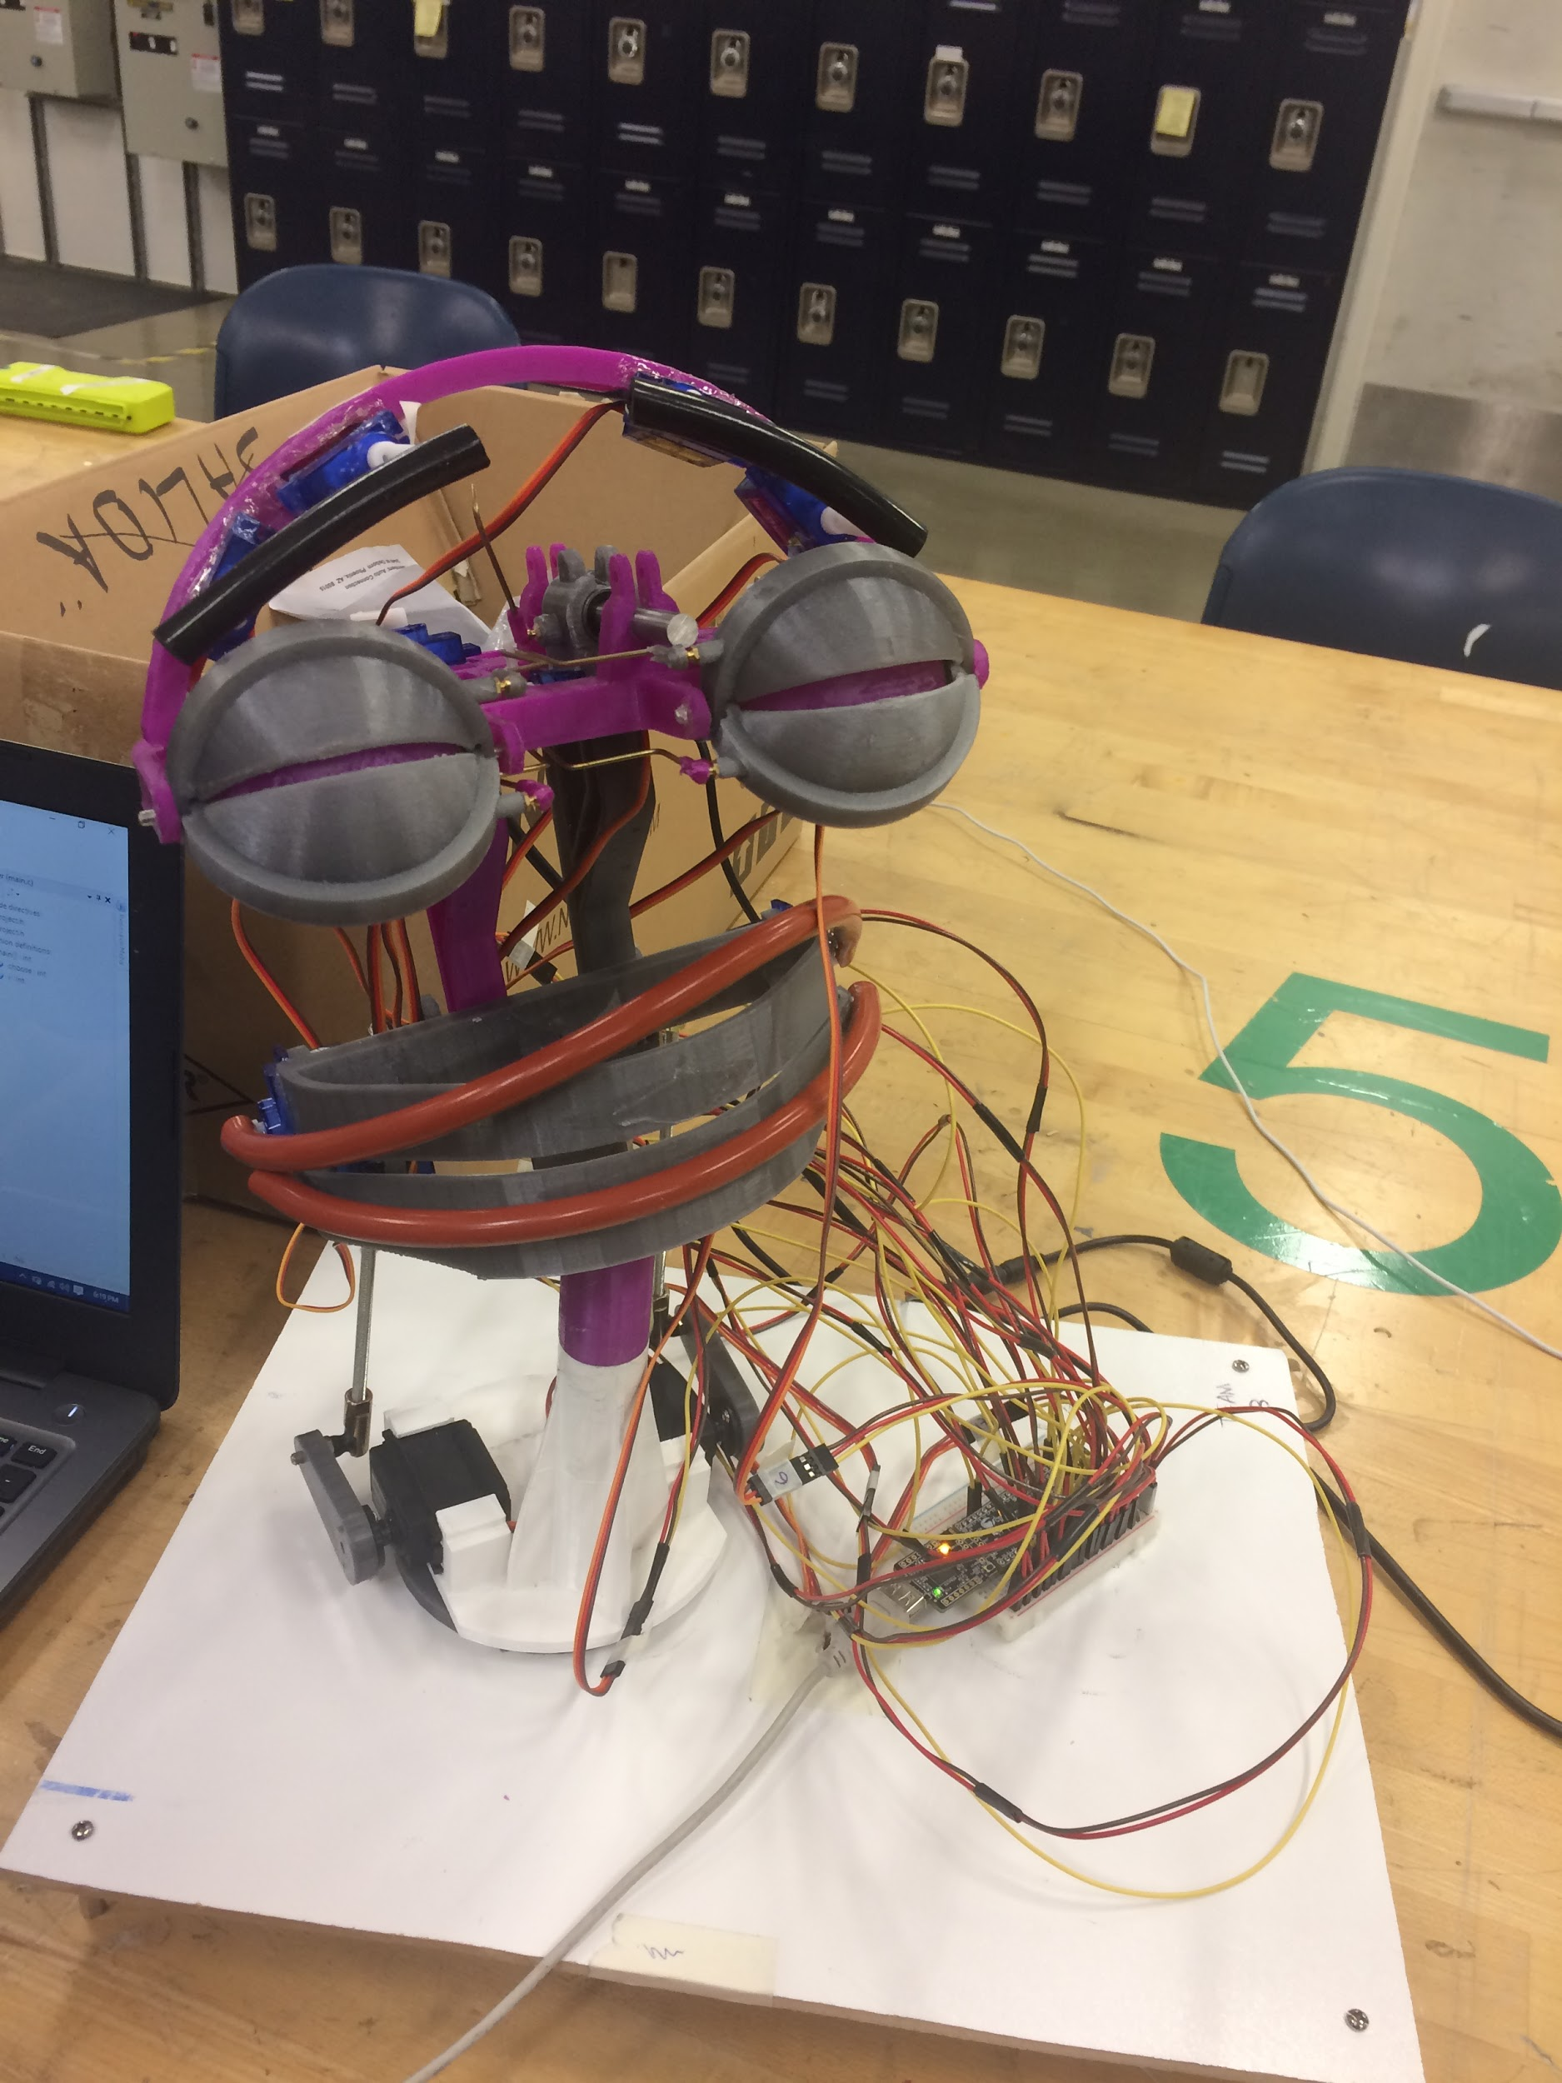

Figure 0 : Robot in happy days

i. Table of Contents

ii. List of Figures

iii. List of Tables

TABLE OF CONTENTS

|  |  |  |
| --- | --- | --- |
| Topic # | Title | Page Number |
| 1.0 | Introduction   * An overview of the physical agent | 4 |
| 2.0 | Robot Construction | 4 |
| 3.0 | Design Specification | 7 |
| 4.0 | Design Process | 11 |
| 4.1 | Above and Beyond - Casing | 11 |
| 5.0 | Performance Results and Discussion | 12 |
| 6.0 | Conclusions | 13 |
| 7.0 | Recommendations | 14 |

TABLE OF FIGURES

|  |  |  |
| --- | --- | --- |
| Topic # | Title | Page Number |
| 1 | List of Basic Object for 3D Printing | 5,6 |
| 2 | Facial Design - Layout 1 | 7 |
| 3 | Motor Movement Directions - Layout 2 | 8 |
| 4 | Wiring Diagram - Draft 1 | 9 |
| 5 | Wiring Diagram - Final Layout 3 | 10 |
| 6 | PWM Layout | 11 |
| 7 | Connections | 12 |

*1.0 Introduction:*

1.1 An Overview of the Physical Agent

It is important to know the significance of facial expressions displayed by a robot, and the effects this has on human-robot interaction. To support the natural communication modalities of humans, robots sharing a similar morphology should communicate in a required manner. Facial expression, body posture, gesture, gaze direction, and voice are some very important examples where robot design can help improve the human robot interaction span[1].

Our aim is to build a simplistic physical agent, a robot that can express its emotions at a given time. In our efforts to build the required agent, we plan out our project work in progressive sections. These sections include designing the face of the robot, 3-D printing of various segments(eyelids, eyeballs, head structures, base, neck, etc.), creating blueprints for the four layouts that will be described in **Section 3**, setting up the hardware components with wiring and servo motors, and last but not the least, building the software to give life to our agent.

*2.0 3-D printing*

With an aim to build a physical agent, the robot, we were required to print the general skeleton of the robot ourselves using the 3-D printing and we utilized the tried and tested design given by the professor.

The first step towards building our robot using the 3-D printing technology was to learn the working of a 3D printer and in our first session in the startup lab, we were given a detailed seminar on the preventive measures to use the printer and this was followed up by the start up labs staff on the demonstration of how to print the plastic parts.

2.1 Software Setup

Lulzbot Mini 3D printer was used for printing all the parts of the robot in this project. Each 3-D printer is connected to a computer which contains the ‘Cura’ software used to model the items which need to be printed. The basic elements list was provided to us by the professor along with the object file for each of the parts.

Our project utilized the PLA plastic for printing the robot parts as it provides enough strength for the parts to support the head of the robot. The orientation is another important issue which needs to be handled carefully so that the object is printed with the intended dimensions.

2.2. Printer Setup

As mentioned in the previous section, Lulzbot Mini printer was used for all the 3D printing need during this project. After the software setup, the print bed is covered with hair spray to make sure that the objects which are printed to stick to the base.

After making sure that the x, y and the z axis are at 90 degrees to each other, the printing is started and the nozzle goes through a heating and cooling cycle. The robotic parts which are printed using the 3D printer are listed in the images below.

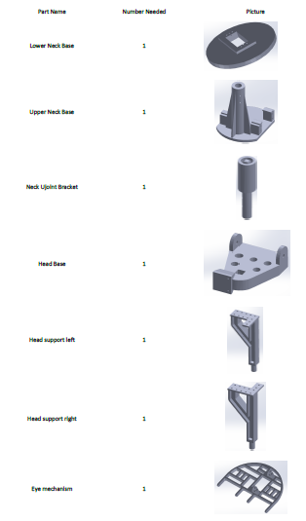

Figure 1-a: List of Basic Robot Parts

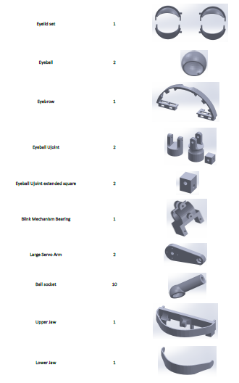

Figure 1-b: List of Basic Robot Parts

2.3 Printing Process

After arranging the objects on the plane using the Cura software, it allows the user to select the type of plastic being used, the quality of print and the orientation of each object. When the printing process begins, the printer first prints the outline of the parts and then builds on them. The whole process of printing the robot parts took close to 16 hours which was followed by removing the support plastic from every part.

*3.0 Design Specification*

For the design of the whole working specimen of our physical agent, we built four final layouts.

3.1 Layouts

The initial layout that we came up with included both the movements of the agent and the facial design with labels assigned to each motorised segment of the agent. Fig. 1 shows our initial layout, i.e. the robot face design. We considered the instructions by Prof. Gaffar and after reviewing other layouts, we decided on having two different layouts, one for the design(eyeballs, eyelids, eyebrows, lips, neck, etc.) and the other one for the motor movement directions.

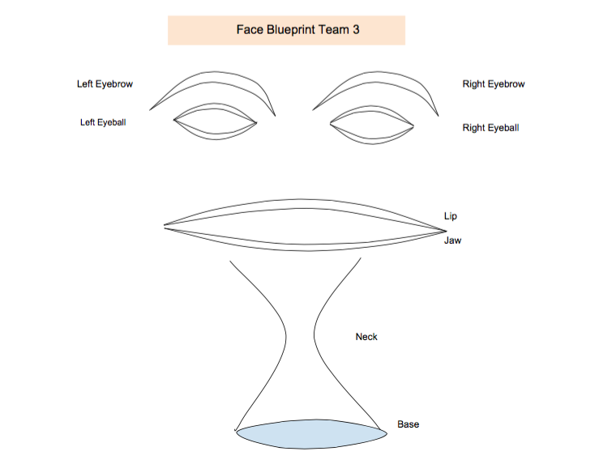

**Figure 2**: Face Design (First Layout)

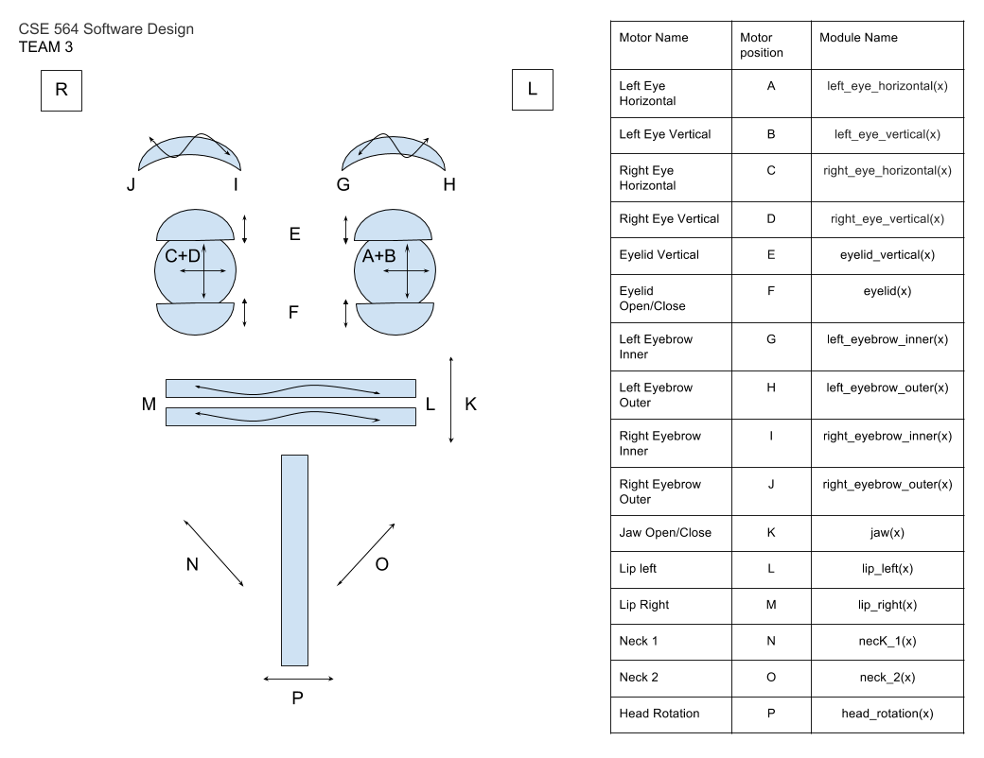

**Figure 3:** Draft of the first layout inclusive of the facial design with labels and the motor movement directions. (Second Layout)

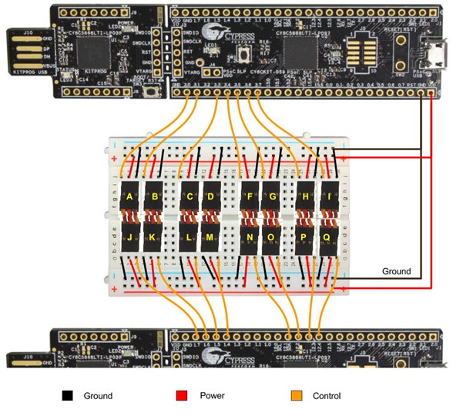

|  |  |  |  |
| --- | --- | --- | --- |
| **Label** | **Name** | **Label** | **Name** |
| **A** | Left Eye Horizontal | **I** | Right Eyebrow Inner |
| **B** | Left Eye Vertical | **J** | Right Eyebrow Outer |
| **C** | Right Eye Horizontal | **K** | Jaw Open/Close |
| **D** | Right Eye Vertical | **L** | Lip Left |
| **E** | Eyelid Vertical | **M** | Lip Right |
| **F** | Eyelid Open/close | **N** | Neck1 |
| **G** | Left Eyebrow Inner | **O** | Neck2 |
| **H** | Left Eyebrow Outer | **P** | Head Rotation |

**Figure 4:** Wiring Diagram Draft 1

We can see in the above figure, that it is slightly difficult to figure out the wired connections on the chip, and the alphabetical labelling from A to P was not standardized among the teams, so we had to work on that, after which we came up with the wiring diagram in Figure 3.

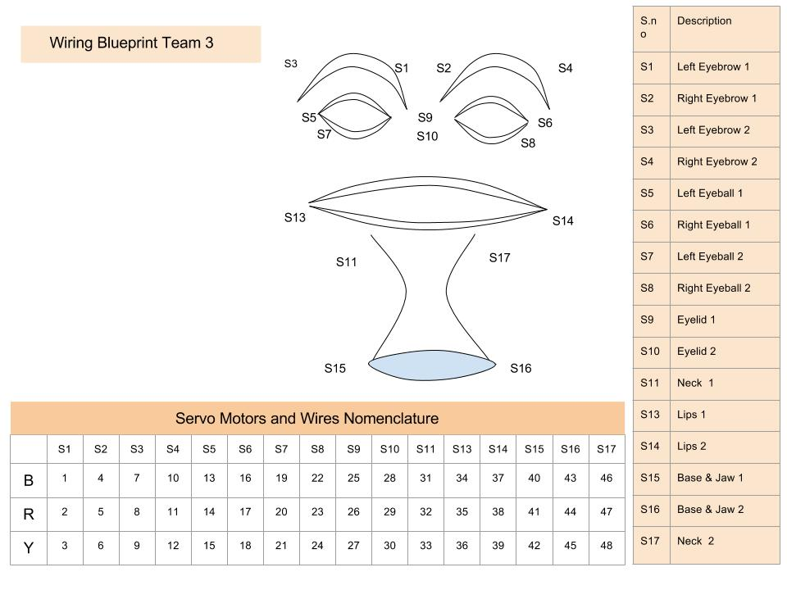

**Figure 5:** Wiring Diagram final draft (Third Layout)

The final draft of the wiring diagram clearly shows labelling in a numbered format (S1, S2, S3, S4 and so on). The odd numbered labels are on the left part of the agent’s face, the even numbered labels are on the right part. All motors have been labelled with a descriptive nomenclature along with the numbered labels. The PWM Layout below shows paired motors on each module. Every PWM module consists of a name (defining a part of the face), a clock, a reset, and two output pins.

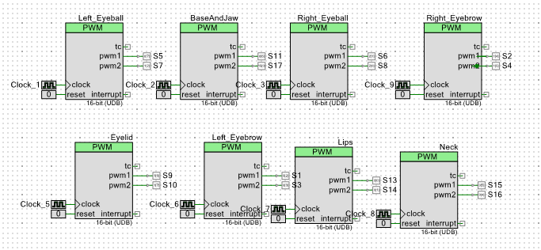

Figure 6 : PWM Design (Fourth Layout)

These four layouts together consist of information on the complete project planning. The 3D printing was the first step to implement the face design, the next step was to fix the motors in the motor slots that the pre-designed print had.

*4.0 Design Process*

We paid attention to the different teams presentations on their blueprints and saw that a few teams had blueprints that the professor found had the level of detail and readability ideally. Our team had a blueprint that used good diagrams, but lacked a consistent naming scheme, so we borrowed elements of the naming scheme that another team had. Getting familiarized with the actual construction was done by seeing the professor explain his process and what parts that we needed to pay special attention to. This included insights only realized by having built a robot from scratch before. We found that the professor emphasized neat wire management, because it is very easy to get the wires confused and ultimately make it harder to effectively program expressions. The first part of cable management meant color coding and the professor had already ensured that we get unique colors.

*4.1 Above and Beyond - Casings*

Our team went a step further with the wiring process by purchasing pin encasings to consolidate the wires that would be driving one motor. This meant purchasing a 3x encasing for power and control on one end and having a 2x encasing on the other, along with a 1x encasing for control to afford us some flexibility when it came to pin placement on the board. This process was quite tedious, because with 16 motors and 3 wires each, we had to bundle the correct colors and encase them uniformly. However, this small investment in time paid big dividends in construction and programming of the robot. We could label wire chucks quite quickly and swap them if there was any doubt that one was working correctly. There were also some shortcuts that we found in the part production phase. When it came to cutting bars and cleaning components, we leveraged people who had training to use the power equipment, and prefered the powered approach as often as we could.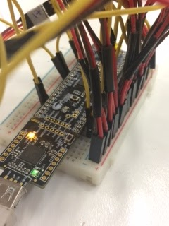

Figure 5. Connections

*5.0 Performance Results and Discussion*

Compared with other teams, we were one of the slowest team at the beginning of the course, once we did the blueprint, the ideas started to flow and the project was most clear. We as a team were able to catch up to other teams and even improve over the original design of the robot. Also during the testing face, having custom wires for our motors simplify and speed up the wiring mapping and also the testing process.

During the testing, we encountered difficulties with our hardware as some of the motors broke and some of the cables started to fail on us. We were able to change some of the faulty motors.

At the end we were able to program the robot to mimic the some expressions, blink, move eyebrows, smile, jaw open and sad face.

The smile and sad expression were the most complete. Smile consisted on opening the eyes at max, moving the lips upwards and opening the jaw. While sad consisted on frowning the eyebrows and half close eyes.

Even though we completed the wiring and coding weeks before finals we struggled in trying to code expression mainly due to the fact that the motors broke easily and some of them were irreplaceable. Furthermore with the power we gave no more than four would work, this we accredit to the quality of the servo motors we got (build on the premise that we broke 9 motors working on 5V power supply ).

We have used PSoC Creator to write our Programmable Array and we have been making changes to the code to get the maximum amount of expression cases we have.

It remains quite difficult to figure out the angles required to get the response desired. The orientation of the motor, and the varying sensitivity to the motor drive value makes this process mostly trial and error. Furthermore, forming a cohesive expression requires a sequence of correct motor responses - the angle and timing both. Spending some time initially just on the working of the servo motors (understanding the parameters and how they linked to the movement) would have helped, but since the motors were already glued to the face plastic, we could just simulate angles when the motors stopped responding. Also, not more that 4 motors were supported by the power supply. Motors breaking down restricted us from trying a myriad of ideas we had in mind to produce expressions. Some cables failed to work too, so we had to swap them with others motors’ cables.

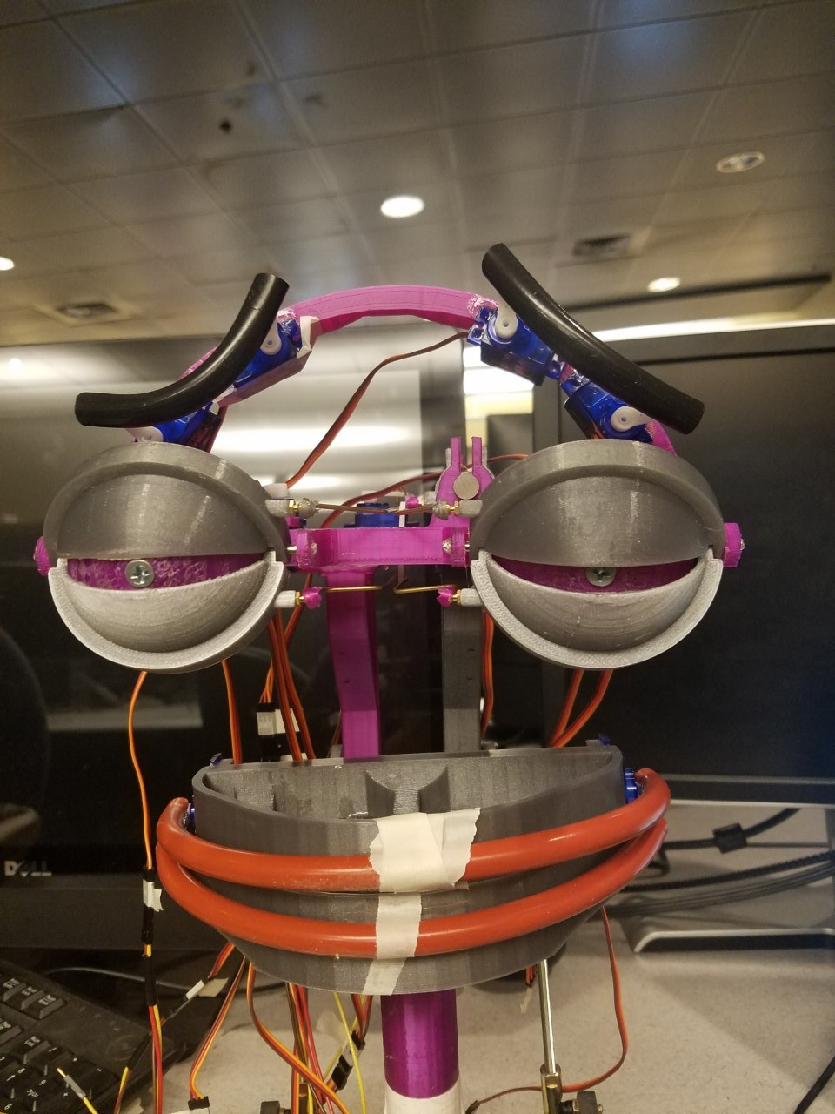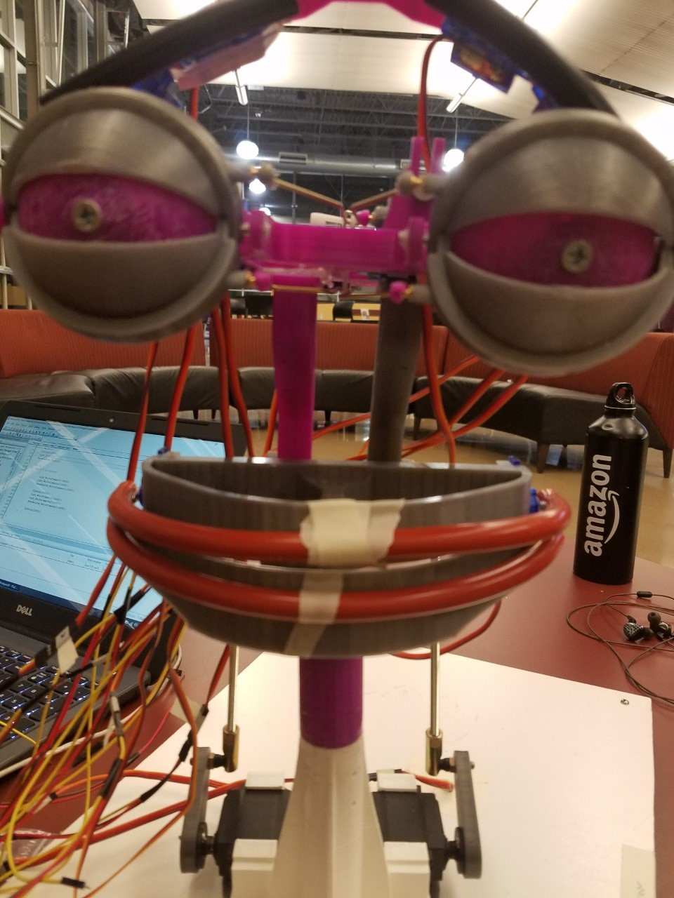

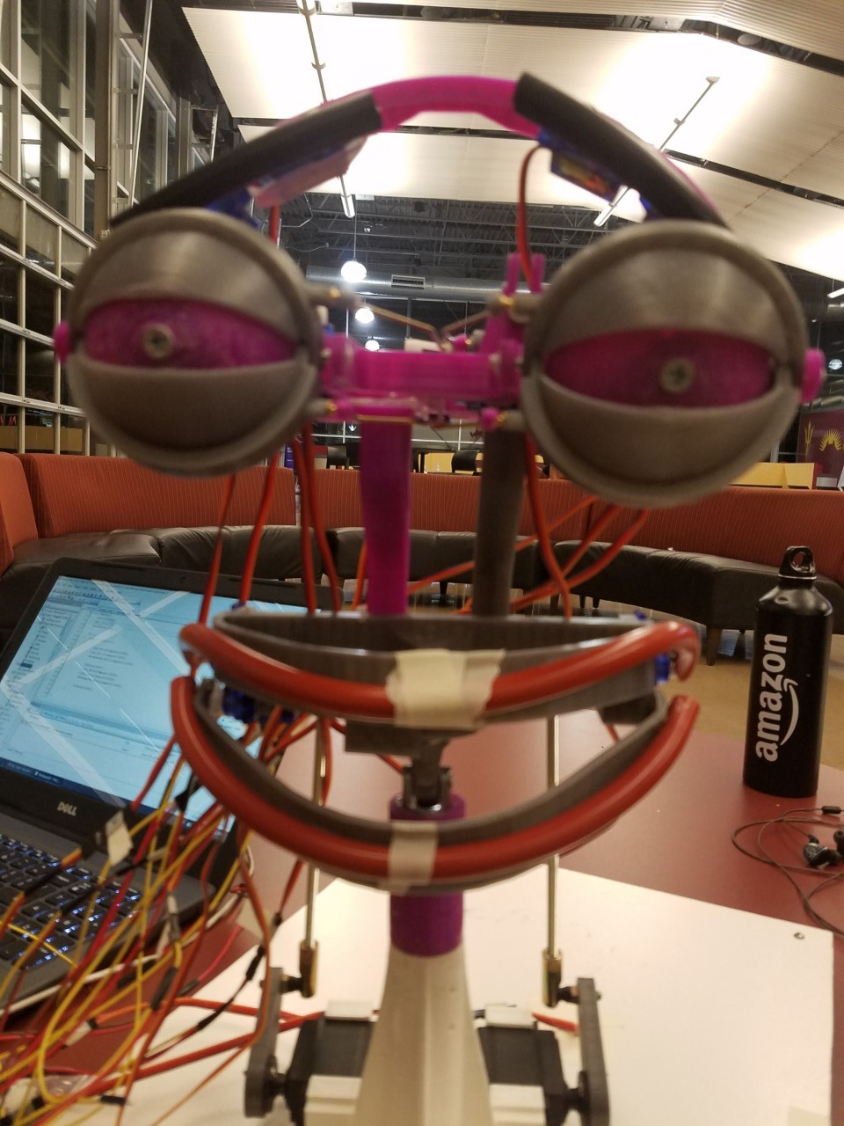

Control Face Sad Smile

*6.0 Conclusion*

We have learnt the itinerary for making a robotic face in a bottom-up design. From the 3D printing of the exoskeleton to understanding and purchasing tools online and from designing to programming the robotic agent, we have been a part of this process and we have been learning all along. This has been a team effort despite the team size larger than the norm, this is credited to the instructor who managed to relay useful information and the efforts of students. This is also a good lesson in team management and To be able to successfully program our bot to mimic facial expression opens a lot of ideas and theories in our minds. We have a few ideas to extend on this project further, we could fix cameras in place of the eyes and develop a recognition system or we are interested in learning algorithms which can train the agent to act accordingly.

And not to mention a complete analysis of the pipeline is necessary to minimize cost. We were unfortunate when calibrating the servos and in turn damaged 6 servos.

*7.0 Recommendations*

Future teams should ensure that all parts are accounted for before beginning construction. There was some disarray when team received only some of their parts and received them in a staggered manner. Blueprinting and labeling is a very important aspect of the design process, not only for creating readable software, but to help account for hardware and allow easy troubleshooting or replacement. In terms of the multi-team format, while we primarily had one person relay and implement the professor's lessons, perhaps another student should offload some of the pressure from the professor so that more teams can be helped at once. This happened somewhat organically with few students, but the lack of responsibility towards that end makes itself apparent.

*Reference*

1. C. Breazeal, "Emotion and sociable humanoid robots," *nt. J. Human-Computer Studies 59 (2003) 119–155*, Nov. 2002.