**Московский авиационный институт**

**(Национальный исследовательский университет)**

Институт: «Информационные технологии и прикладная математика»

Кафедра: 806 «Вычислительная математика и программирование»

Дисциплина: «Компьютерная графика»

**Лабораторная работа № 2**

Тема: Каркасная визуализация выпуклого многогранника. Удаление невидимых линий.

Студент: Попов Матвей

Группа: 08-308

Преподаватель: Чернышов Л.Н.

Дата:

Оценка:

Москва, 2022

1. Постановка задачи

Разработать формат представления многогранника и процедуру его каркасной отрисовки в ортографической и изометрической проекциях. Обеспечить удаление невидимых линий и возможность пространственных поворотов и масштабирования многогранника. Обеспечить автоматическое центрирование и изменение размеров изображения при изменении размеров окна.

**Вариант 22**: 6 – гранная прямая правильная усеченная пирамида

1. Описание программы

Программа написана на языке программирования python с применением модулей tkinter и numpy, состоит из 5 файлов: main.py, object.py (отвечает за инициализацию пирамиды), camera.py (отвечает за отрисовку), roberts.py (отвечает за удаление невидимых линий), matrix.py (отвечает за повороты пирамиды и масштабирование).

**Установка зависимостей (ввести в консоли):**

pip install numpy

pip install tkinter

**Запуск программы:**

python main.py

1. Результаты выполнения тестов

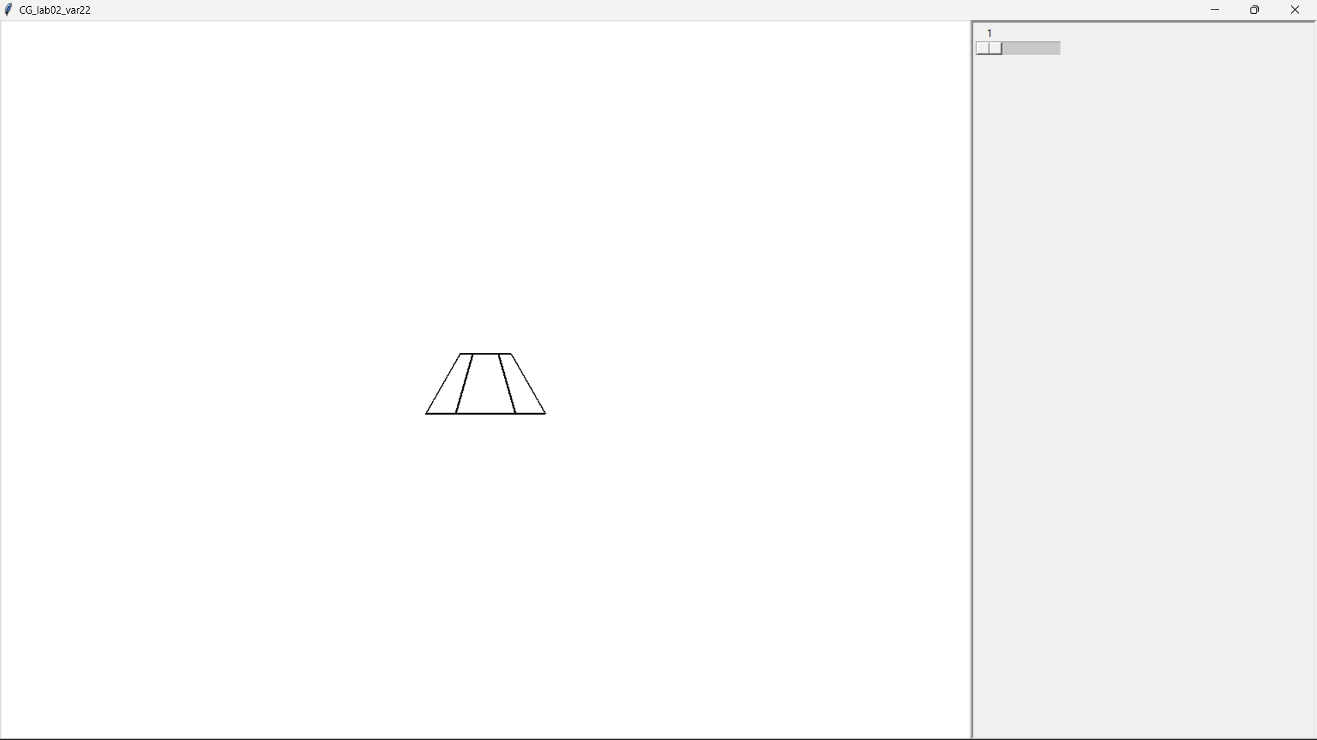

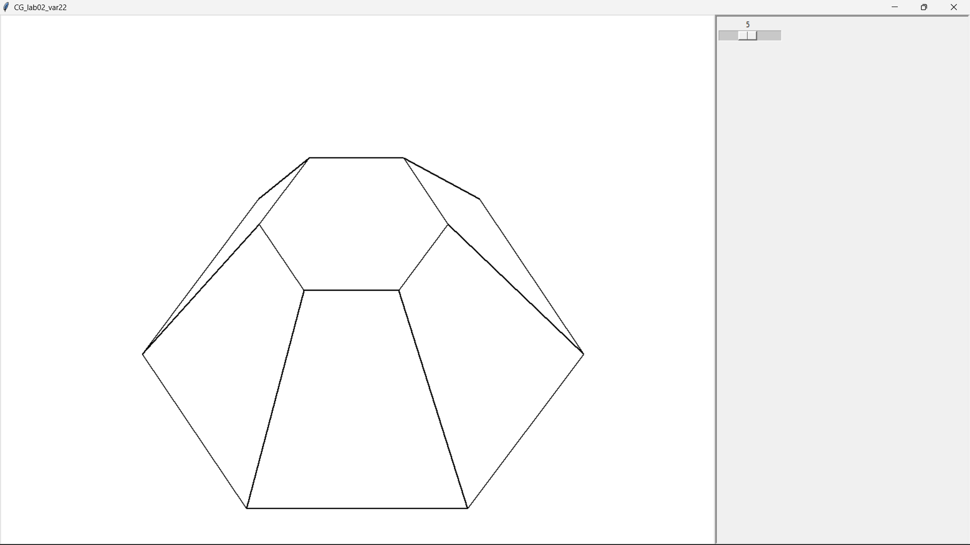

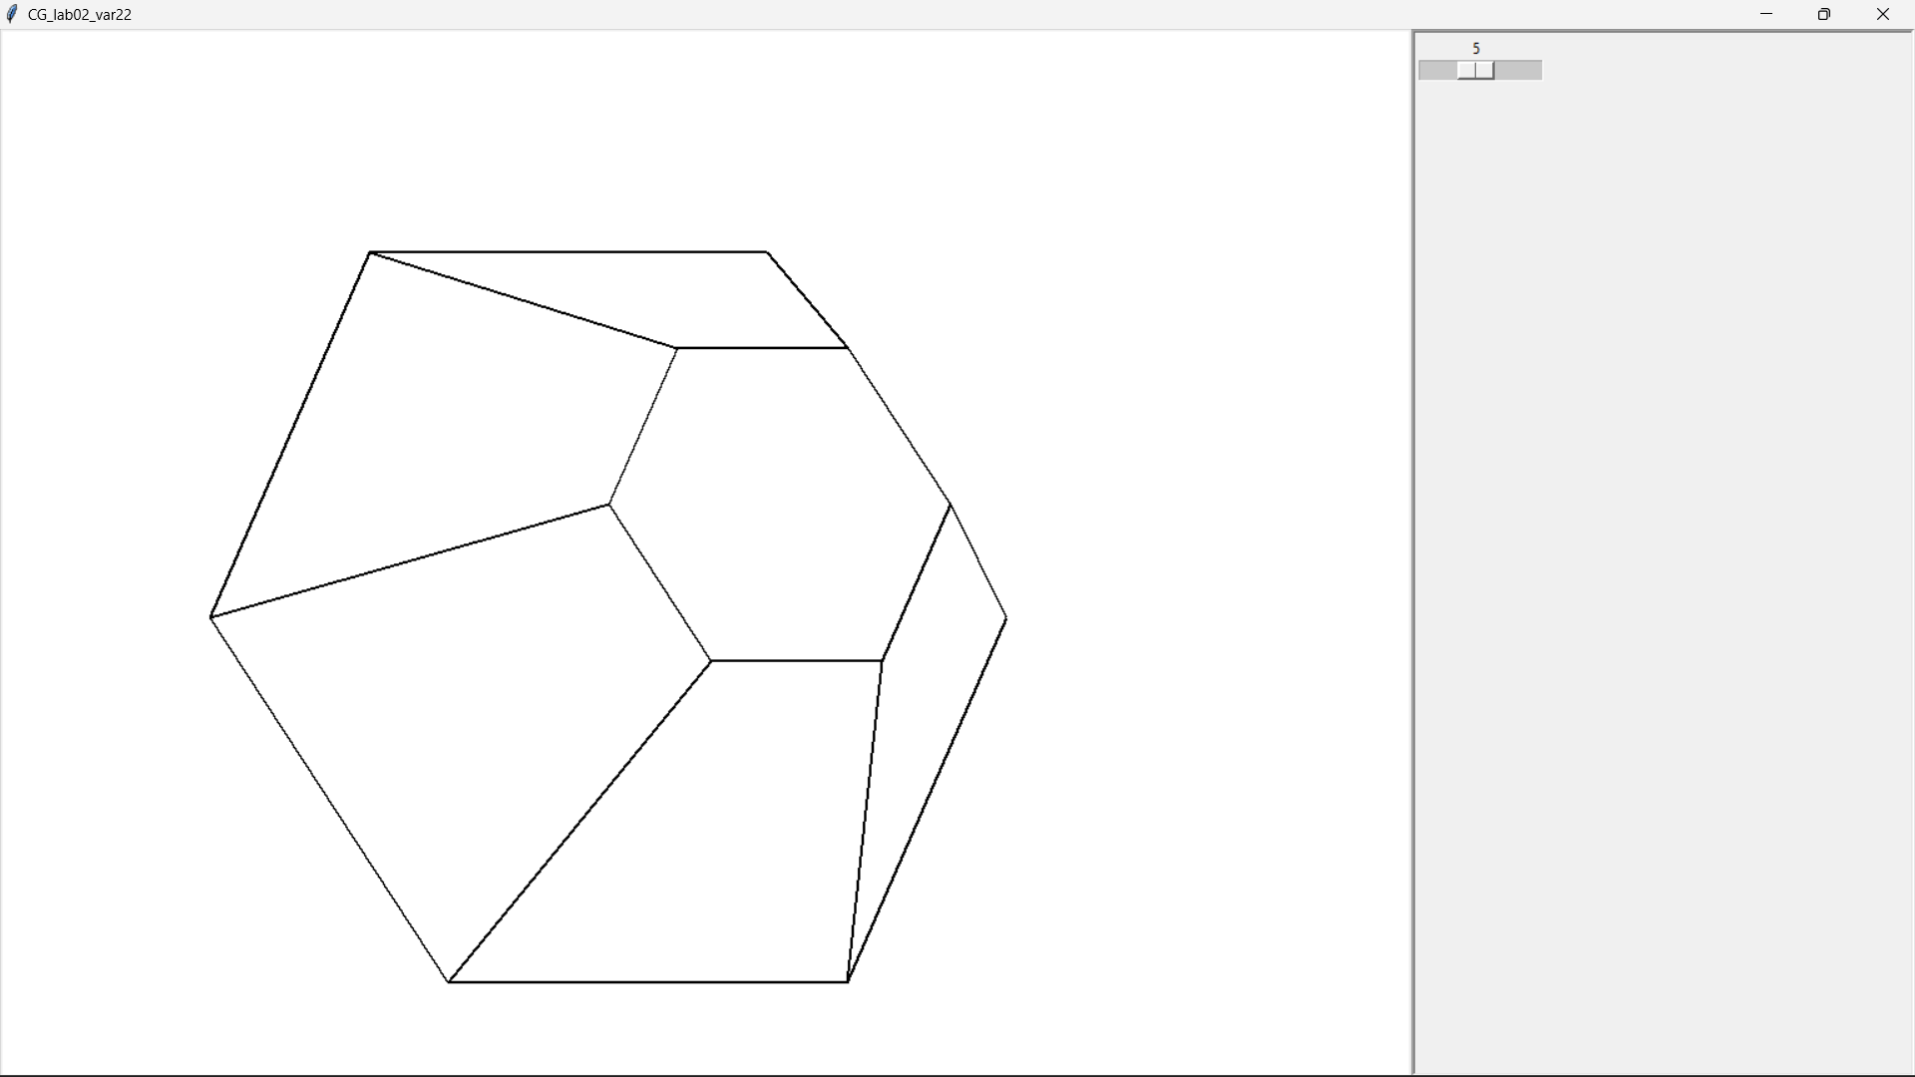

1. Листинг программы

main.py

import tkinter as tk

import numpy as np

import matrix as mtx

import camera as cm

import roberts as rb

import object as obj

from functools import partial

def MVPMatrix(object):

return mtx.ModelMatrix(object) @ camera.ViewMatrix() @ camera.projectionMatrix()

def OMVPMatrix(object):

return mtx.ModelMatrix(object) @ camera.ViewMatrix() @ camera.orthogonalMatrix()

def redraw(event, object):

camera.height = canvas.winfo_height()

camera.width = canvas.winfo_width()

camera.v_fov = camera.h_fov * (camera.height/camera.width)

drawOrthogonalProjection(object)

def changeStartModel(event, object):

object.scretchStartModel(sx=scaleX.get(), sy=scaleY.get(), sz=scaleZ.get())

drawOrthogonalProjection(object)

def changeScaleModel(event, object):

object.scale = scale.get()

drawOrthogonalProjection(object)

def keyMove(event, object):

if event.keycode == 37:

object.rotY += 3

elif event.keycode == 38:

object.rotX -= 3

elif event.keycode == 39:

object.rotY -= 3

elif event.keycode == 40:

object.rotX += 3

drawOrthogonalProjection(object)

def drawLine(a, b):

canvas.create_line(a[0], a[1], b[0], b[1], width=2)

def drawOrthogonalProjection(object):

canvas.delete("all")

robAlgo = rb.RobertsAlgo(object.points @ mtx.ModelMatrix(object), object.polygon, camera.ViewMatrix(), camera.position)

vertex = object.points @ OMVPMatrix(object)

for i in range(len(object.polygon)):

if robAlgo[i] <= 0:

continue

for j in range(len(object.polygon[i])):

drawLine(vertex[object.polygon[i][j]], vertex[object.polygon[i][(j + 1) % len(object.polygon[i])]])

def drawPerspectiveProjection(object):

vertex = object.points @ MVPMatrix()

vertex /= vertex[:, -1].reshape(-1, 1)

vertex = vertex @ camera.toScreenMatrix()

for i in range(len(polygon)):

for j in range(len(polygon[i])):

a = vertex[object.polygon[i][j]]

b = vertex[object.polygon[i][(j+1)%len(object.polygon[i])]]

if not(a and b):

continue

drawLine(a, b)

if __name__=="__main__":

window = tk.Tk()

window.title("CG_lab02_var22")

window.columnconfigure(0, weight=4, minsize=550)

window.columnconfigure([1, 2], weight=1, minsize=10)

window.rowconfigure([0, 1, 2, 3], weight=1, minsize=100)

canvas = tk.Canvas(window, bg='white')

frame = tk.Frame(window, relief="sunken", borderwidth=3)

labelscale = tk.Label(master=frame, text='Scale')

scale = tk.Scale(frame, orient='horizontal', resolution=1, from_=1, to=10)

canvas.grid(row=0, column=0, sticky="nsew", rowspan=4)

frame.grid(row=0, column=1, sticky="nsew", rowspan=4, columnspan=2)

scale.grid(row=3, column=2, sticky="nsew", columnspan=3)

window.geometry("+550+150")

window.minsize(window.winfo_width(), window.winfo_height())

camera = cm.Camera(canvas)

trapeze = obj.Object(sx=10, sy=10, sz=10)

drawOrthogonalProjection(trapeze)

scale.bind("<ButtonRelease-1>", partial(changeScaleModel, object=trapeze))

window.bind("<Key>", partial(keyMove, object=trapeze))

window.bind("<Configure>", partial(redraw, object=trapeze))

window.mainloop()

object.py

import numpy as np

import matrix as mtx

class Object:

def __init__(self, sx, sy, sz):

self.rotX = 0

self.rotY = 0

self.rotZ = 0

self.dx = 0

self.dy = 0

self.dz = 0

self.scale = 1

self.startPoints = []

self.points = []

self.polygon = []

self.readModel()

self.scretchStartModel(sx, sy, sz)

def readModel(self):

self.startPoints.append(np.array(list(map(float, [3.0, -3, 0.0])) + [1]))

self.startPoints.append(np.array(list(map(float, [1.5, -3, 2.59807621135331594])) + [1]))

self.startPoints.append(np.array(list(map(float, [-1.5, -3, 2.59807621135331594])) + [1]))

self.startPoints.append(np.array(list(map(float, [-3, -3, 0])) + [1]))

self.startPoints.append(np.array(list(map(float, [-1.5, -3, -2.59807621135331594])) + [1]))

self.startPoints.append(np.array(list(map(float, [1.5, -3, -2.59807621135331594])) + [1]))

self.startPoints.append(np.array(list(map(float, [7.0, 4, 0.0])) + [1]))

self.startPoints.append(np.array(list(map(float, [3.5, 4, 6.062177826491])) + [1]))

self.startPoints.append(np.array(list(map(float, [-3.5, 4, 6.062177826491])) + [1]))

self.startPoints.append(np.array(list(map(float, [-7.0, 4, 0])) + [1]))

self.startPoints.append(np.array(list(map(float, [-3.5, 4, -6.062177826491])) + [1]))

self.startPoints.append(np.array(list(map(float, [3.5, 4, -6.062177826491])) + [1]))

self.polygon.append(list(map(int, [0, 1, 7, 6])))

self.polygon.append(list(map(int, [1, 2, 8, 7])))

self.polygon.append(list(map(int, [2, 3, 9, 8])))

self.polygon.append(list(map(int, [3, 4, 10, 9])))

self.polygon.append(list(map(int, [4, 5, 11, 10])))

self.polygon.append(list(map(int, [0, 5, 11, 6])))

self.polygon.append(list(map(int, [0, 1, 2, 3, 4, 5])))

self.polygon.append(list(map(int, [6, 7, 8, 9, 10, 11])))

def scretchStartModel(self, sx, sy, sz):

self.points = self.startPoints @ mtx.stretchingMatrix(sx, sy, sz)

camera.py

import math

import numpy as np

class Camera:

def __init__(self, canvas):

self.position = [0, 0, 10, 0]

self.right = [1, 0, 0]

self.up = [0, 1, 0]

self.forward = [0, 0, 1]

self.h_fov = math.pi/3

self.height = canvas.winfo_height()

self.width = canvas.winfo_width()

self.v_fov = self.h_fov * (self.height/self.width)

self.near_plane = 0.1

self.far_plan = 100

self.aspect = self.width/self.height

def ViewMatrix(self):

rx, ry, rz = self.right

ux, uy, uz = self.up

fx, fy, fz = self.forward

x, y, z, w = self.position

matrix = np.array([

[rx, ux, fx, 0],

[ry, uy, fy, 0],

[rz, uz, fz, 0],

[-x, -y, -z, 1]

])

return matrix

def projectionMatrix(self):

a = 1/(math.tan(self.h_fov/2))

b = (self.far_plan+self.near_plane)/(self.far_plan-self.near_plane)

c = -2*self.near_plane*self.far_plan /(self.far_plan-self.near_plane)

matrix = [

[a/self.aspect, 0, 0, 0],

[0, a, 0, 0],

[0, 0, b, 1],

[0, 0, c, 0]

]

return matrix

def orthogonalMatrix(self):

matrix = np.eye(4, dtype=float)

matrix[3, 0] = self.width//2

matrix[3, 1] = self.height//2

return matrix

def toScreenMatrix(self):

matrix = np.eye(4, dtype=float)

matrix[0, 0] = self.width//2

matrix[1, 1] = -self.height//2

matrix[3, 0] = self.width//2

matrix[3, 1] = self.height//2

return matrix

roberts.py

import numpy as np

def RobertsAlgo(modelMatrix, polygon, matrixT, position):

D = np.array([[-1],[-1],[-1]])

matrixV = np.zeros((4, len(polygon)))

for i in range(len(polygon)):

curMatrix = modelMatrix[polygon[i][:3]][:3, :3]

matrix = np.linalg.inv(curMatrix) @ D

matrixV[0][i] = matrix[0]

matrixV[1][i] = matrix[1]

matrixV[2][i] = matrix[2]

matrixV[3][i] = -1

matrixVT = np.linalg.inv(matrixT) @ matrixV

final = position @ matrixVT

return final

matrix.py

import numpy as np

import math

def rotXMatrix(a):

rads = math.pi/180 * a

matrix = np.eye(4, dtype=float)

matrix[1, 1] = math.cos(rads)

matrix[1, 2] = math.sin(rads)

matrix[2, 1] = -math.sin(rads)

matrix[2, 2] = math.cos(rads)

return matrix

def rotYMatrix(a):

rads = math.pi/180 * a

matrix = np.eye(4, dtype=float)

matrix[0, 0] = math.cos(rads)

matrix[0, 2] = -math.sin(rads)

matrix[2, 0] = math.sin(rads)

matrix[2, 2] = math.cos(rads)

return matrix

def rotZMatrix(a):

rads = math.pi/180 * a

matrix = np.eye(4, dtype=float)

matrix[0, 0] = math.cos(rads)

matrix[0, 1] = math.sin(rads)

matrix[1, 0] = -math.sin(rads)

matrix[1, 1] = math.cos(rads)

return matrix

def stretchingMatrix(a, b, c):

matrix = np.eye(4, dtype=float)

matrix[0, 0] = a

matrix[1, 1] = b

matrix[2, 2] = c

return matrix

def transferMatrix(dx, dy, dz):

matrix = np.eye(4, dtype=float)

matrix[3, 0] = dx

matrix[3, 1] = dy

matrix[3, 2 ] = dz

return matrix

def ModelMatrix(object):

modelMatrix = np.eye(4, dtype=float)

if object.rotX!=0:

modelMatrix = modelMatrix @ rotXMatrix(object.rotX)

if object.rotY!=0:

modelMatrix = modelMatrix @ rotYMatrix(object.rotY)

if object.rotZ!=0:

modelMatrix = modelMatrix @ rotZMatrix(object.rotZ)

if object.scale>1:

modelMatrix = modelMatrix @ stretchingMatrix(object.scale, object.scale, object.scale)

if object.dx!=0 or object.dy!=0 or object.dz!=0:

modelMatrix = modelMatrix @ transferMatrix(object.dx, object.dy, object.dz)

return modelMatrix

ЛИТЕРАТУРА

1. Numpy documentation [Электронный ресурс]

URL: <https://numpy.org/> (дата обращения: 15.10.2022)

1. Tkinter documentation [Электронный ресурс]

URL: <https://docs.python.org/3/library/tkinter.html> (дата обращения 15.10.2022)

1. Алгоритм Робертса [Электронный ресурс]

URL: <http://compgraph.tpu.ru/roberts.htm> (дата обращения 15.10.2022)