Домашняя работа №4

Попов Матвей, М8О-114СВ-24

# Задание 2



## Запрос

ALTER TABLE progress

ADD COLUMN test_form text,

ADD CHECK (

( test_form ='экзамен' AND mark IN ( 3, 4, 5 ))

OR

( test_form ='зачет' AND mark IN ( 0, 1 ))

);

INSERT INTO progress (record_book, subject, acad_year, term, mark, test_form)

VALUES (12345, 'МАТАН', '2020', 2, 3, 'экзамен');

INSERT INTO progress (record_book, subject, acad_year, term, mark, test_form)

VALUES (54321, 'БД', '2024', 1, 4, 'зачет');

INSERT INTO progress (record_book, subject, acad_year, term, mark, test_form)

VALUES (54321, 'ИИ', '2024', 1, 1, 'зачет');

ALTER TABLE progress

DROP CONSTRAINT progress_mark_check;

ALTER TABLE progress

ADD CHECK (

( test_form ='экзамен' AND mark IN ( 3, 4, 5 ))

OR

( test_form ='зачет' AND mark IN ( 0, 1 ))

);

INSERT INTO progress (record_book, subject, acad_year, term, mark, test_form)

VALUES (54321, 'ИИ', '2024', 1, 1, 'зачет');

## Результат

Результаты запросов на вставку:









# Задание 9

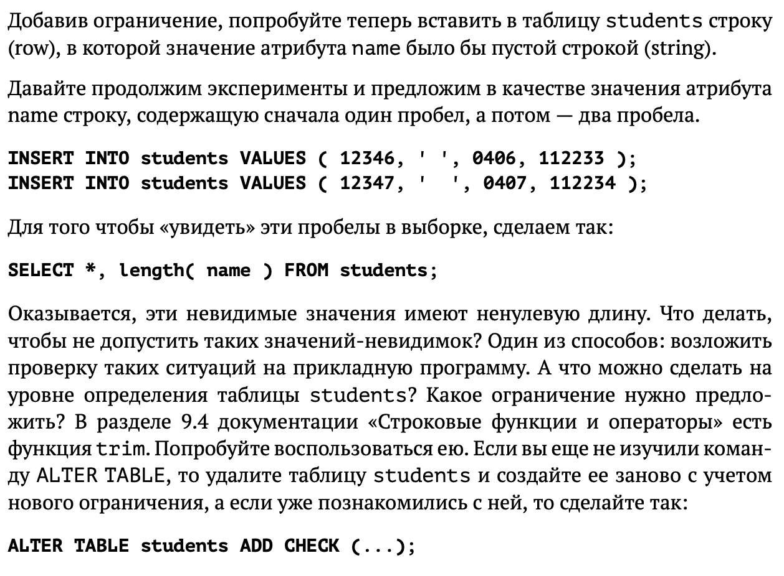

## Запрос

ALTER TABLE students ADD CHECK ( name <>'' );

INSERT INTO students VALUES ( 12346,' ', 0406, 112233 );

INSERT INTO students VALUES ( 12347,' ', 0407, 112234 );

SELECT *, length( name ) FROM students;

TRUNCATE TABLE students;

ALTER TABLE students ADD CHECK (trim(name) <> '');

INSERT INTO students VALUES ( 12346,' ', 0406, 112233 );

SELECT *, length( name ) FROM students;

## Результат

Результаты запросов на выборку:





# Задание 17

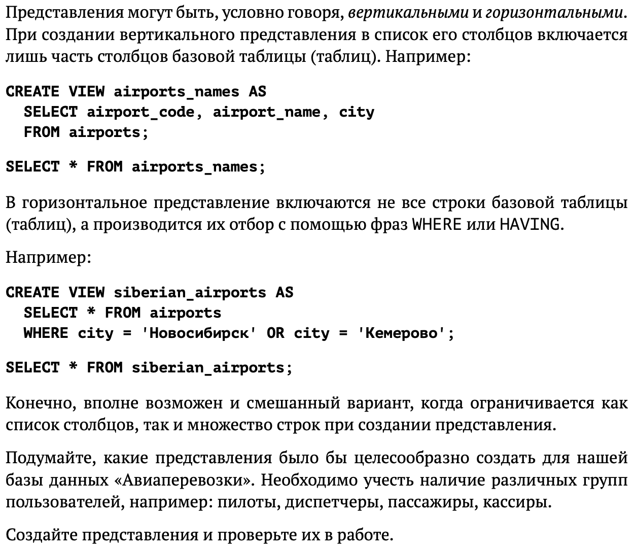

## Запрос

## Результат

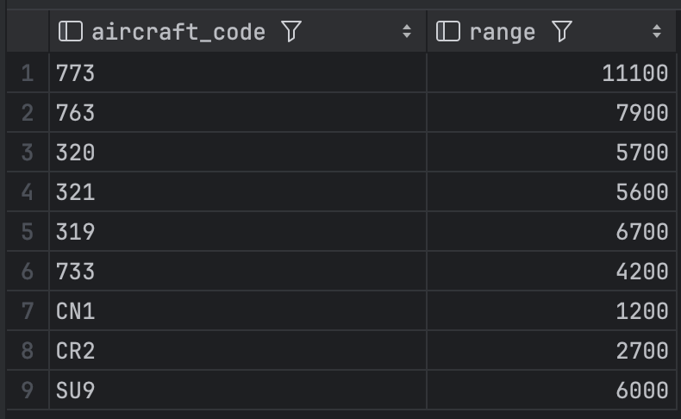

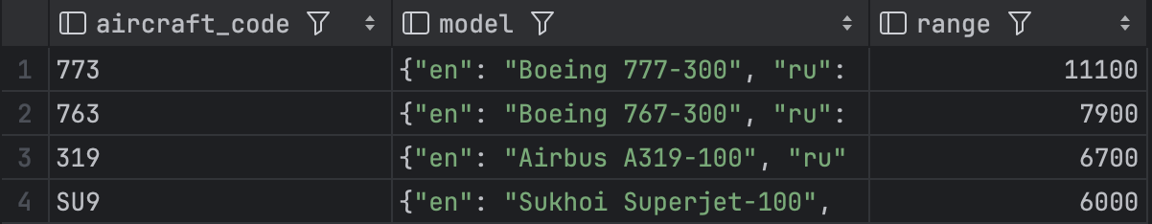

# Задание 18



## Запрос

ALTER TABLE airports_data

ADD COLUMN location jsonb;

UPDATE airports_data

SET location =

'{"city": "Москва",

"country": "Россия",

"coordinates": {

"lattitude": 37.4,

"longitude": 56.0

}}

'

WHERE airport_code = 'SVO';

SELECT location FROM airports_data

WHERE airport_code = 'SVO';

SELECT location->'city' FROM airports_data

WHERE airport_code = 'SVO';

SELECT location #> '{coordinates, longitude}' FROM airports_data

WHERE airport_code = 'SVO';

## Результат



