Домашняя работа №5

Попов Матвей, М8О-114СВ-24

# Задание 2

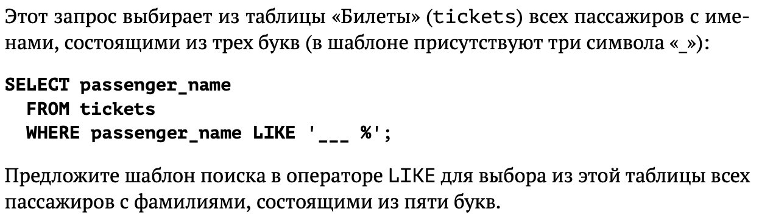

## Запрос

SELECT passenger_name FROM tickets

WHERE passenger_name LIKE '% _____';

## Результат

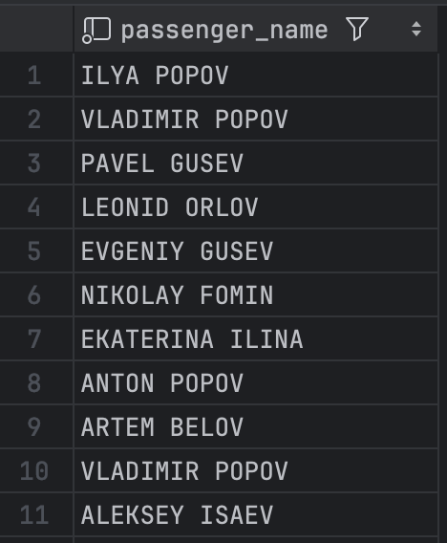С

# Задание 7

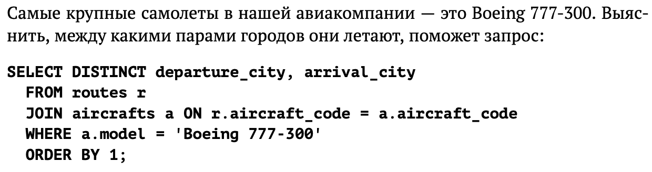

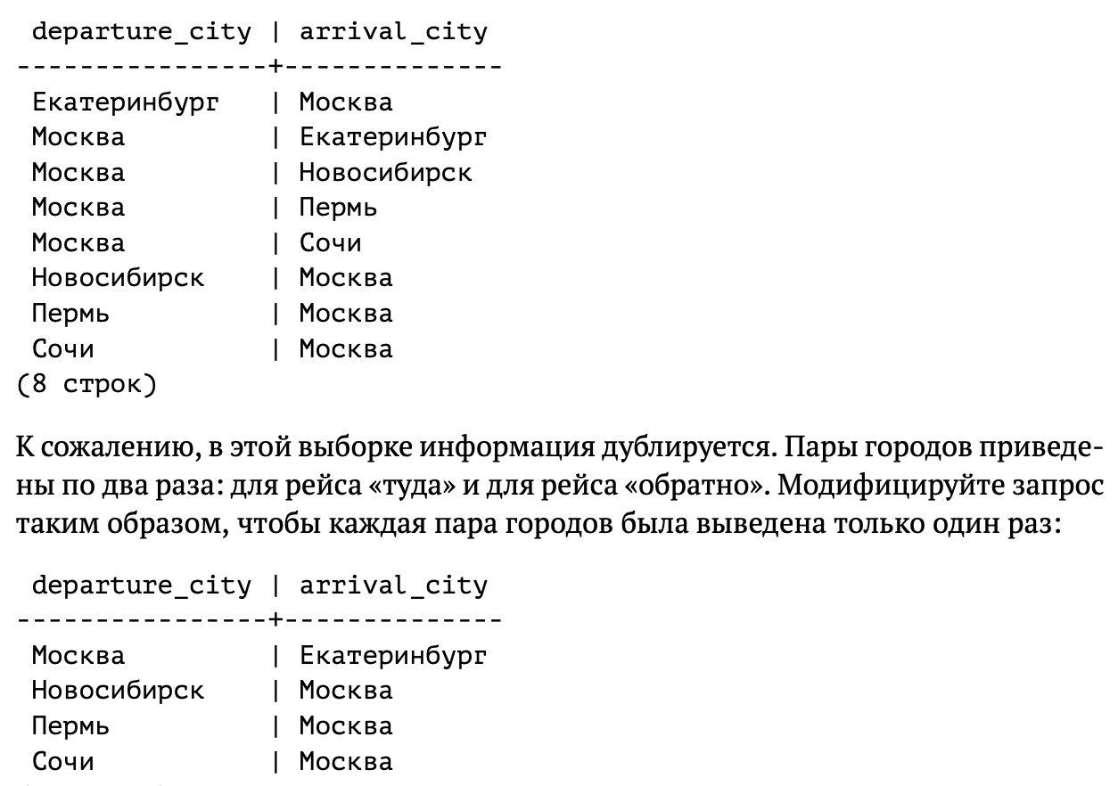

## Запрос

SELECT DISTINCT departure_city, arrival_city

FROM routes r

JOIN aircrafts a ON r.aircraft_code = a.aircraft_code

WHERE a.aircraft_code = '773'

AND departure_city > arrival_city

ORDER BY 1;

## Результат

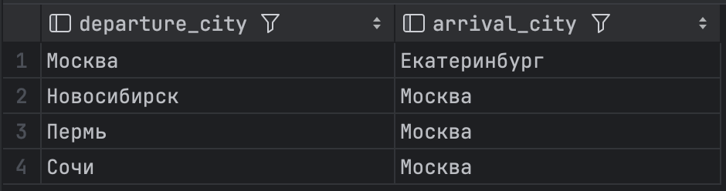

# Задание 9

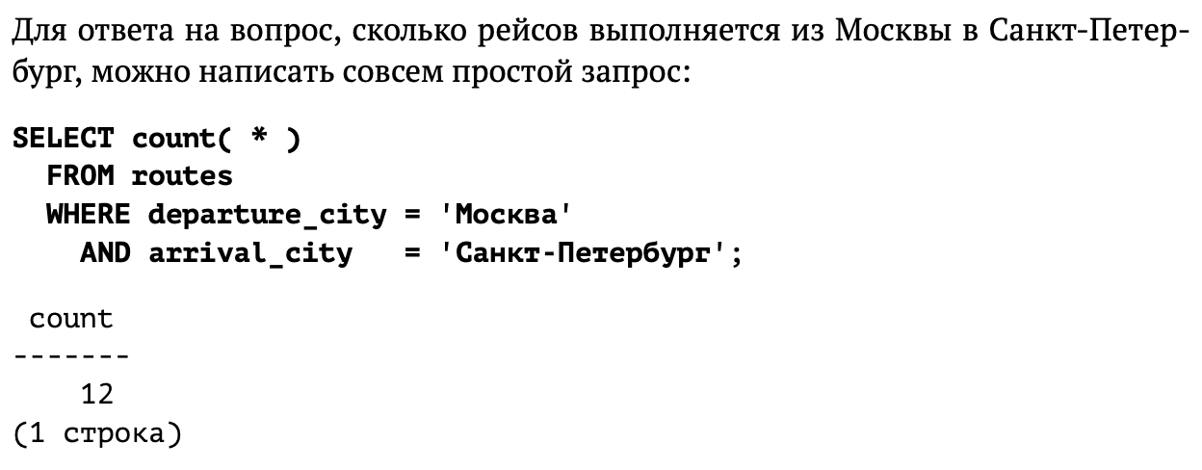

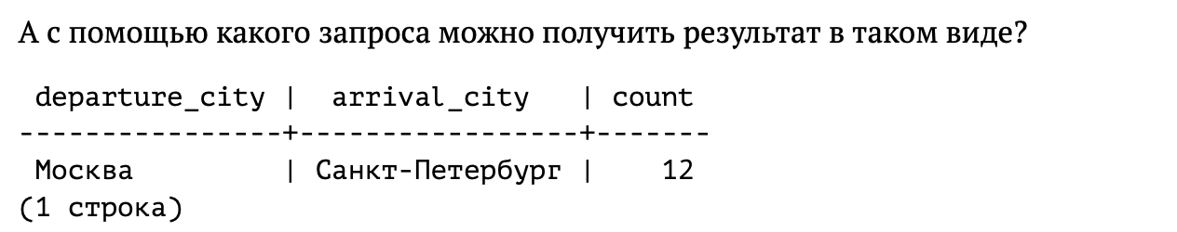

## Запрос

SELECT departure_city, arrival_city, COUNT(*) FROM routes

WHERE departure_city = 'Москва' AND arrival_city = 'Санкт-Петербург'

GROUP BY departure_city, arrival_city;

## Результат



# Задание 13

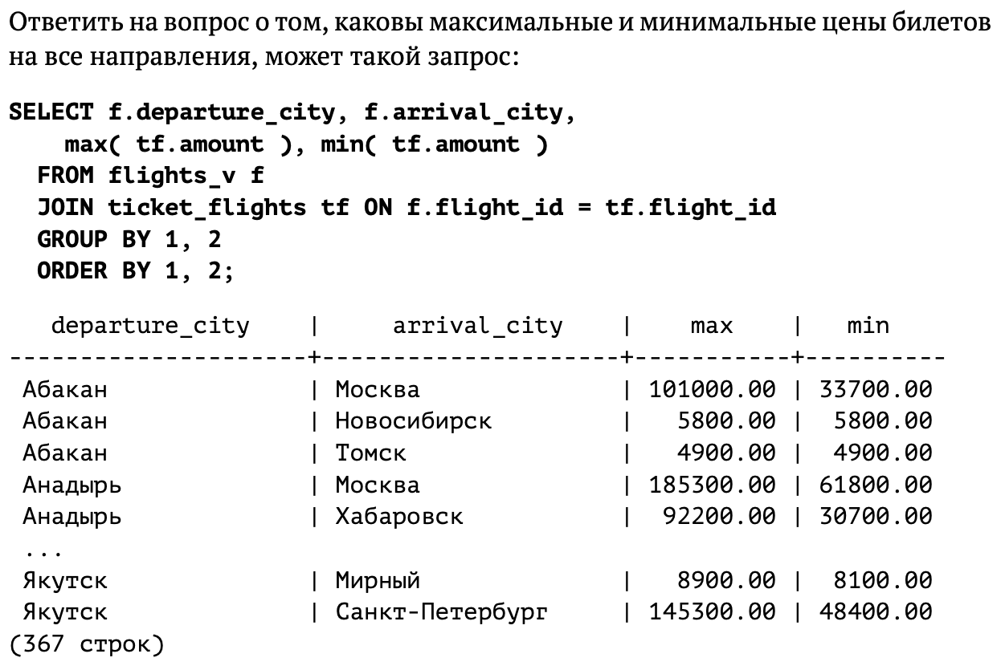

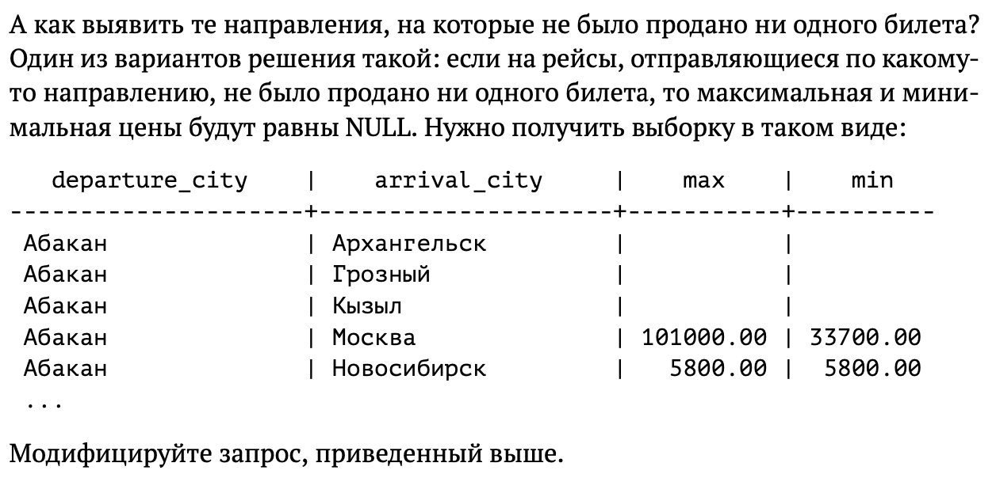

## Запрос

SELECT f.departure_city, f.arrival_city,

max( tf.amount ), min( tf.amount )

FROM flights_v f

LEFT JOIN ticket_flights tf ON f.flight_id = tf.flight_id

GROUP BY 1, 2

ORDER BY 1, 2;

## Результат

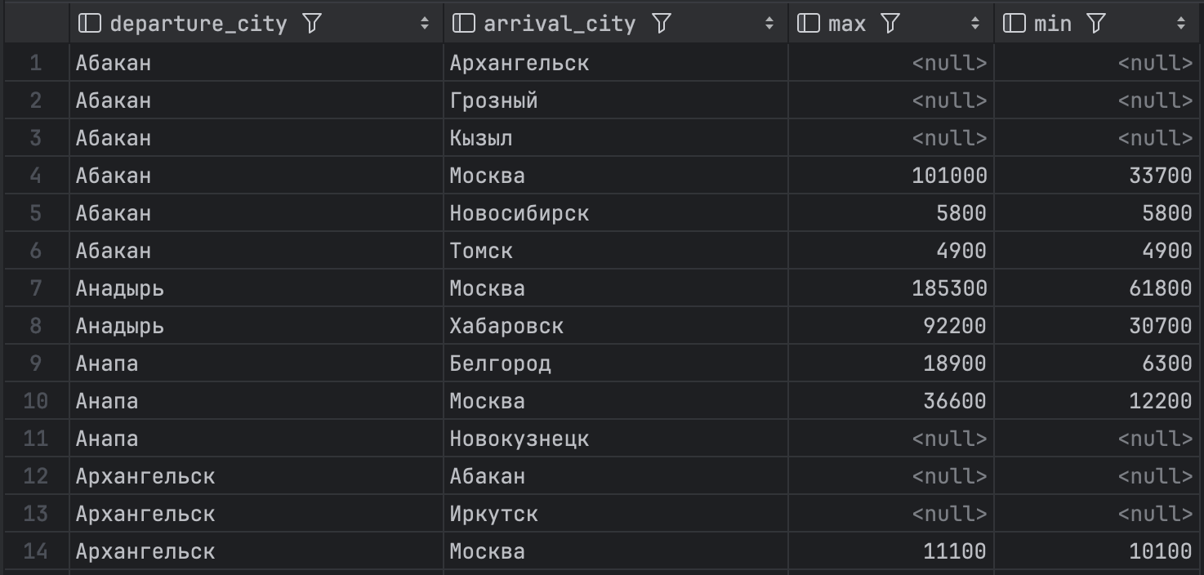

# Задание 19

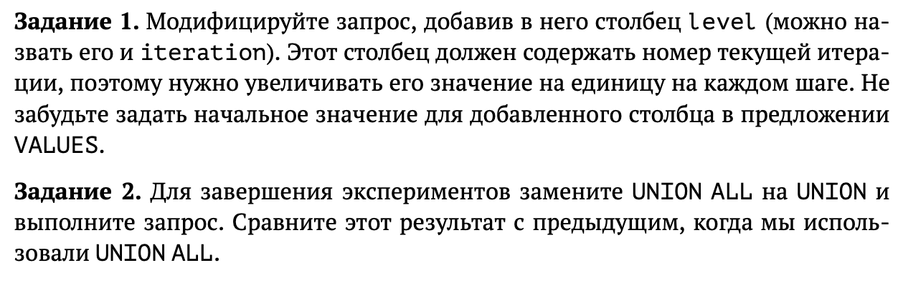

## Запрос

WITH RECURSIVE ranges ( min_sum, max_sum, level )

AS (

VALUES( 0, 100000, 1 ),

( 100000, 200000, 2 ),

( 200000, 300000, 3 )

UNION ALL

SELECT min_sum + 100000, max_sum + 100000, level + 1

FROM ranges

WHERE max_sum < ( SELECT max( total_amount ) FROM bookings )

)

SELECT * FROM ranges;

WITH RECURSIVE ranges ( min_sum, max_sum, level )

AS (

VALUES( 0, 100000, 1 ),

( 100000, 200000, 2 ),

( 200000, 300000, 3 )

UNION

SELECT min_sum + 100000, max_sum + 100000, level + 1

FROM ranges

WHERE max_sum < ( SELECT max( total_amount ) FROM bookings )

)

SELECT * FROM ranges;

## Результат

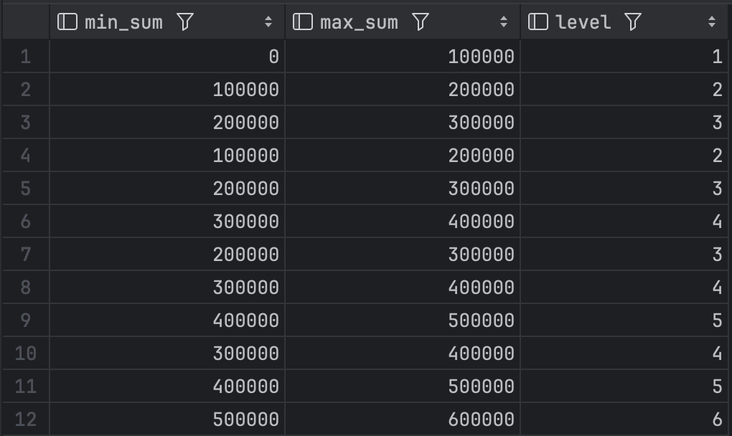

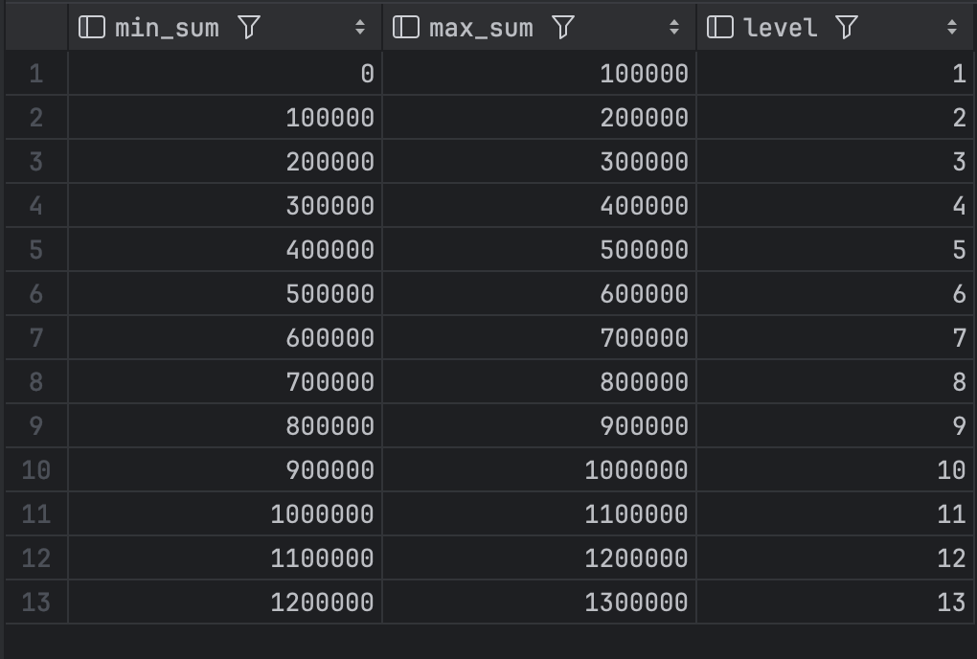

# Задание 21

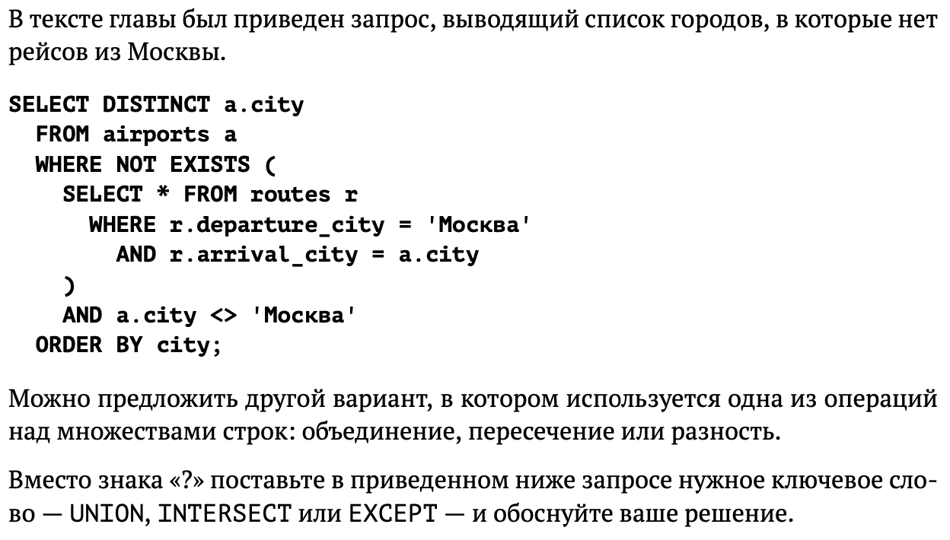

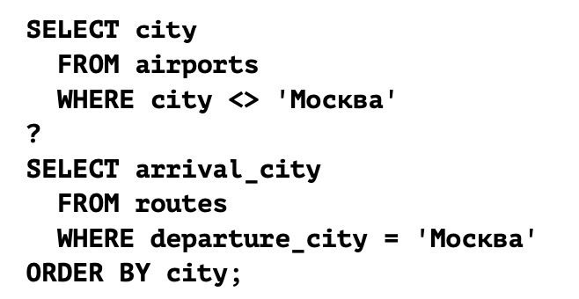

## Запрос

SELECT city

FROM airports

WHERE city <>'Москва'

EXCEPT

SELECT arrival_city

FROM routes

WHERE departure_city ='Москва'

ORDER BY city;

## Результат

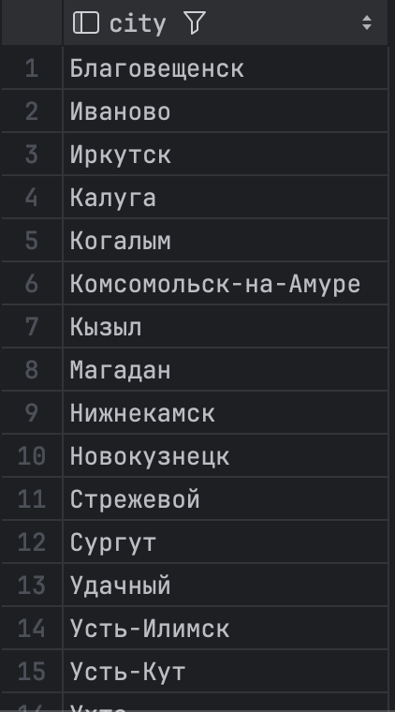

# Задание 23

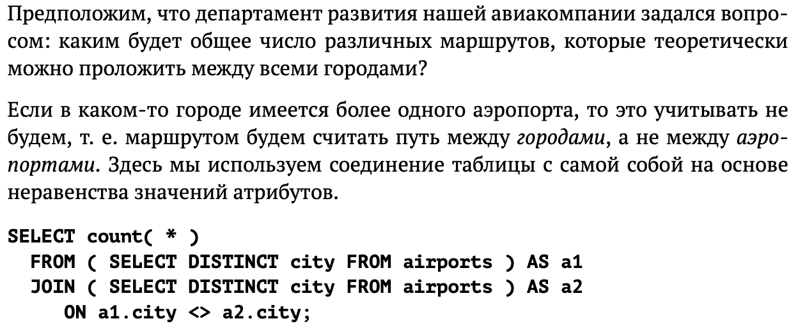

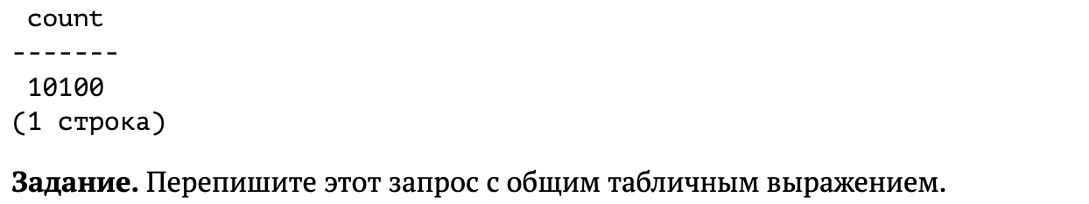

## Запрос

WITH cities AS (

SELECT DISTINCT city FROM airports

)

SELECT count(*)

FROM cities a1

JOIN cities a2 ON a1.city <> a2.city;

## Результат

