Домашняя работа №6

Попов Матвей, М8О-114СВ-24

# Задание 1



## Запрос

ALTER TABLE aircrafts_log

ADD COLUMN "current_timestamp" timestamp;

WITH add_row AS

( INSERT INTO aircrafts_tmp

SELECT * FROM aircrafts

RETURNING *

)

INSERT INTO aircrafts_log

SELECT add_row.aircraft_code, add_row.model, add_row.range,

current_timestamp,'INSERT',current_timestamp

FROM add_row;

WITH add_row AS

( INSERT INTO aircrafts_tmp

VALUES ('SU9', 'Sukhoi SuperJet-100', 3000 )

ON CONFLICT DO NOTHING

RETURNING *

)

INSERT INTO aircrafts_log

SELECT add_row.aircraft_code, add_row.model, add_row.range,

current_timestamp,'INSERT',current_timestamp

FROM add_row;

WITH update_row AS

( UPDATE aircrafts_tmp

SET range = range * 1.2

WHERE model ~ '^Bom'

RETURNING *

)

INSERT INTO aircrafts_log

SELECT ur.aircraft_code, ur.model, ur.range,

current_timestamp,'UPDATE',current_timestamp

FROM update_row ur;

## Результат

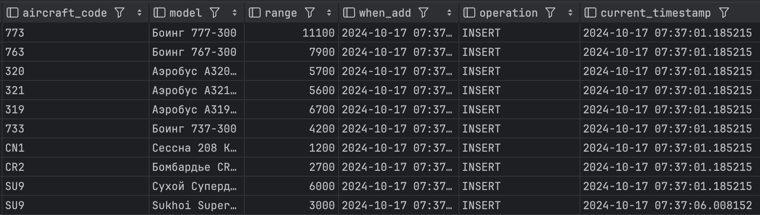

# Задание 2

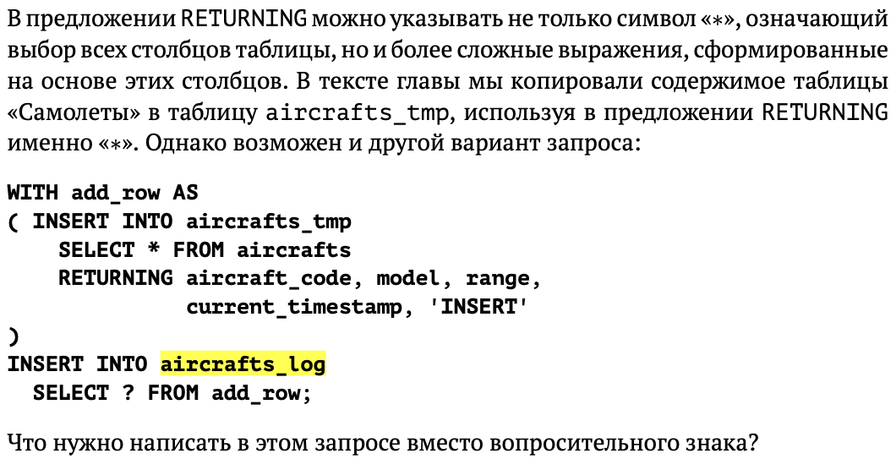

## Запрос

WITH add_row AS

( INSERT INTO aircrafts_tmp

SELECT * FROM aircrafts

RETURNING aircraft_code, model, range,

current_timestamp,'INSERT'

)

INSERT INTO aircrafts_log

SELECT * FROM add_row;

## Результат

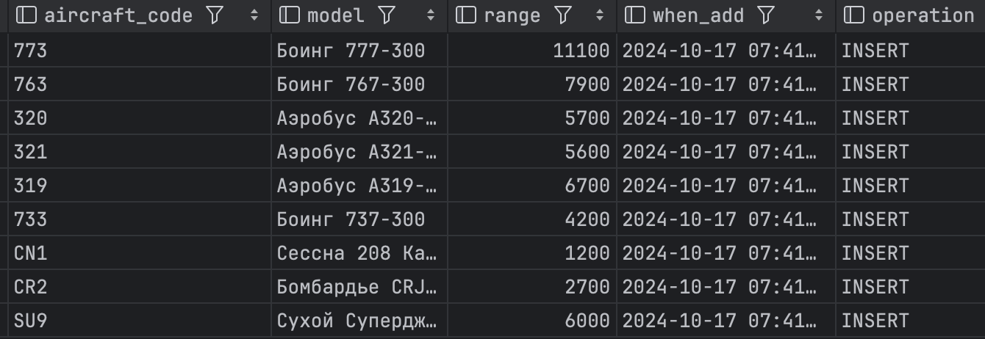

# Задание 4

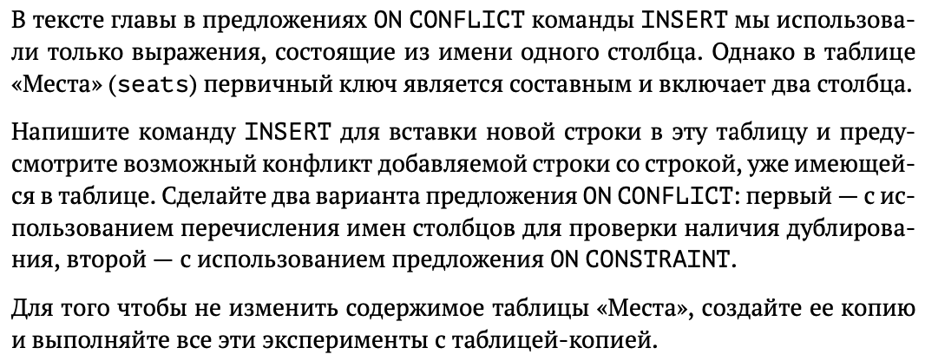

## Запрос

CREATE TABLE seats_copy (LIKE seats INCLUDING ALL);

INSERT INTO seats_copy

SELECT * FROM seats;

INSERT INTO seats_copy (aircraft_code, seat_no, fare_conditions)

VALUES (319, '2A', 'Business')

ON CONFLICT (aircraft_code, seat_no)

DO NOTHING;

INSERT INTO seats_copy (aircraft_code, seat_no, fare_conditions)

VALUES (319, '2A', 'Business')

ON CONFLICT ON CONSTRAINT seats_copy_pkey

DO NOTHING;

## Результат

